Research Funding & Innovation Intelligence Platform

Milestone 2: Funding Discovery & Research Intelligence

System Architecture
The platform's backend has been extended with a dual-layer recommendation engine. A legacy CSV-based keyword matching system (app/services/recommendations.py) provides weighted domain/keyword/tech-area intersection scoring. A modern ML-powered engine (app/services/recommendations_ml.py) uses TF-IDF cosine similarity (with optional SentenceTransformer dense embeddings) for semantic matching. Live data is fetched from 5 external research APIs (NSF, NIH, Semantic Scholar, OpenAlex, PatentsView) with automatic mock fallback generation when APIs are unavailable. Endpoints are exposed via the /recommendations and /intelligence FastAPI router prefixes.

User Interaction and Input Handling
Users interact with funding discovery through a search-driven interface. Each tab (Funding, Research Papers, Patents) features a search bar and action button. Recommendations only populate after a search query is submitted — the matched recommendations section remains empty with a guidance message ('Enter a search query above to view matched recommendations') until the user actively searches. This ensures results are always relevant to the user's current query intent. Search inputs support Enter key submission and display animated loading spinners during API calls.

Funding Tab - Before Search
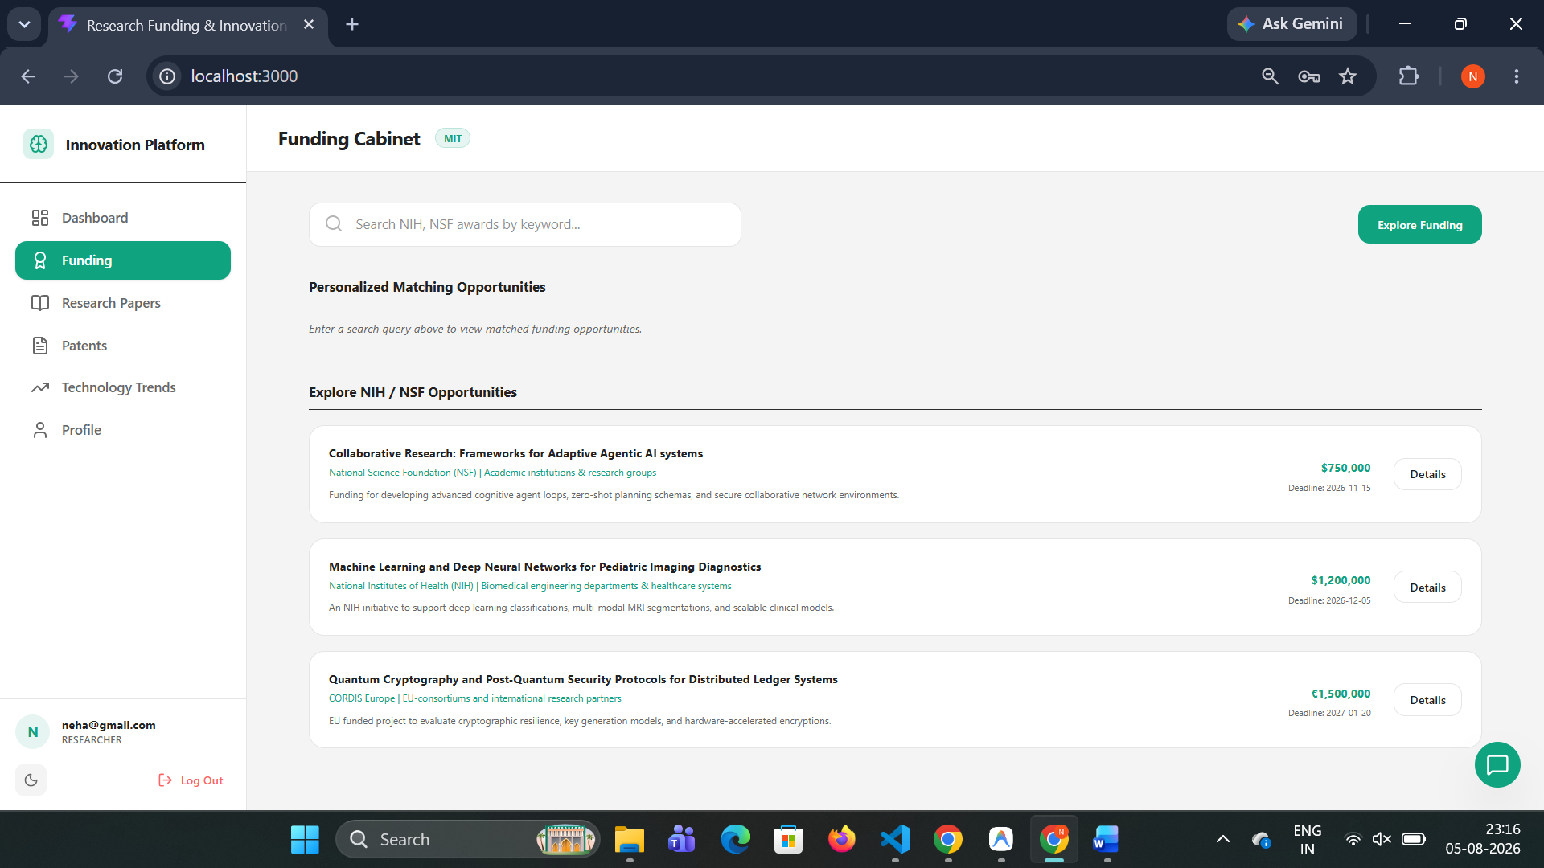
Funding Tab - After Search
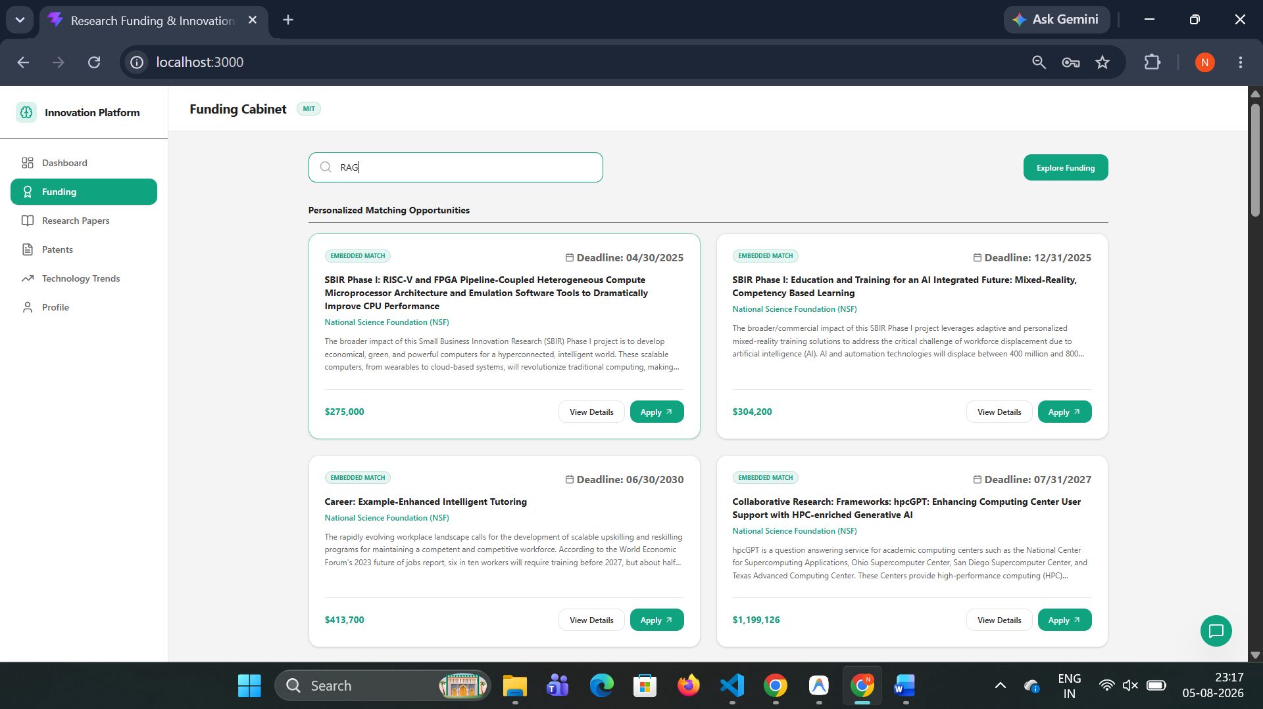

1. ML-Powered Cosine Similarity Recommendation Engine

app/services/recommendations_ml.py — Embedding Matcher
The recommendation engine uses a 3-tier fallback strategy for computing similarity scores between a user's research profile and candidate items (grants, papers, patents):
Tier 1 — SentenceTransformers (if installed): Loads the all-MiniLM-L6-v2 model (384-dimensional dense embeddings). Encodes the user's profile text and all candidate texts into dense vectors. Computes cosine similarity via numpy dot product divided by vector magnitudes.
Tier 2 — Pure Python TF-IDF (fallback): The ResilientTFIDFSimilarity class builds a corpus from the profile and all candidates. For each word, IDF = log(1 + num_docs / (1 + DF)). TF-IDF vectors are sparse dictionaries. Cosine similarity = dot_product / (mag1 × mag2). Tokenization includes: lowercase, punctuation removal, stop word filtering (36 English stop words), and minimum word length filtering (>1 character).
Tier 3 — Passthrough (final fallback): Returns the first N candidates in original order if both ML approaches fail.
Text Extractors (defined in routers/recommendations.py):
• grant_text_extractor(g) → title + description
• paper_text_extractor(p) → title + abstract
• patent_text_extractor(pat) → patent_title + abstract

2. Legacy Grant Matching Engine

app/services/recommendations.py — Weighted Keyword Matching
• get_recommendations_for_user(db, user_id): Loads grants from datasets/processed/grants/grants_processed.csv. Scores each grant against the user's profile using weighted keyword intersection.
• calculate_match(profile, grant): Weighted scoring formula: Match Score = (Domains Intersect × 0.4) + (Keywords Intersect × 0.4) + (Tech Areas Intersect × 0.2) Includes fallback word-level overlap matching capped at 15%.
• get_match_breakdown(db, user_id, grant_id): Returns detailed diagnostics with matched fields and a custom match_rationale text explanation.

3. Live External API Integration & Mock Fallbacks

app/services/external_apis.py — Unified Search Engine
API | Base URL | Data Type
NSF Award Search | api.nsf.gov/services/v1/awards.json | Funding Opportunities
NIH RePORTER | api.reporter.nih.gov/v2/projects/search | NIH Project Grants
Semantic Scholar | api.semanticscholar.org/graph/v1/paper/search | Research Papers
OpenAlex | api.openalex.org/works | Research Papers (fallback)
PatentsView (USPTO) | api.patentsview.org/patents/query | US Patents

All external API calls use a strict 1.2-second timeout and fail silently to fallback data. The search functions implement a 4-tier fallback strategy:
1. Empty query → return full static LOCAL_MOCK dataset (3 grants, 3 papers, 2 patents)
2. Non-empty query → filter static mocks by title/description substring match
3. If no mock match → try live API calls (NSF+NIH, Semantic Scholar→OpenAlex, PatentsView)
4. If live APIs return empty → generate synthetic mock results using the query string interpolated into templated titles and descriptions with deterministic IDs
Research Papers Tab
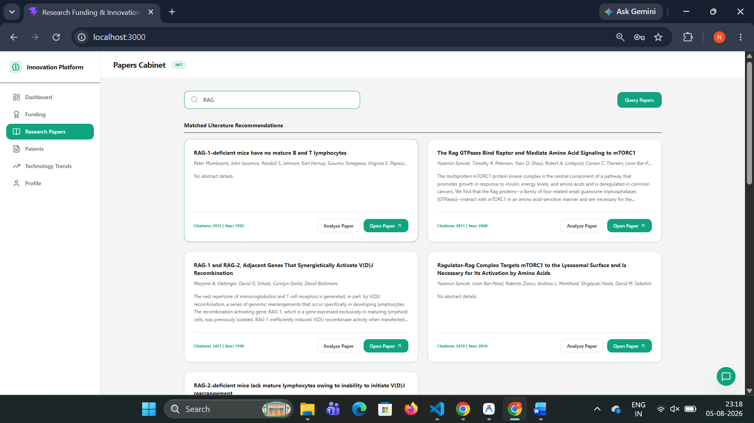

4. Research Trend Analytics & Topic Velocity Mappers

app/services/intelligence.py — Publication Trend Logic
• get_publication_timeline(): Groups publications by calendar year from processed CSV data to generate growth timelines.
• get_trending_topics(): Scans publications for 10 hardcoded domain keywords and computes topic growth velocity: Velocity = (Recent Year Publications / Total Publications) × 100 Status classification: ≥60% → EMERGING, ≥40% → STEADY, <40% → MATURING
• get_top_collaborators(): Parses semicolon-separated author lists, counts publications per author, maps to domains. Returns top 10 researchers.

Technology Trends Tab
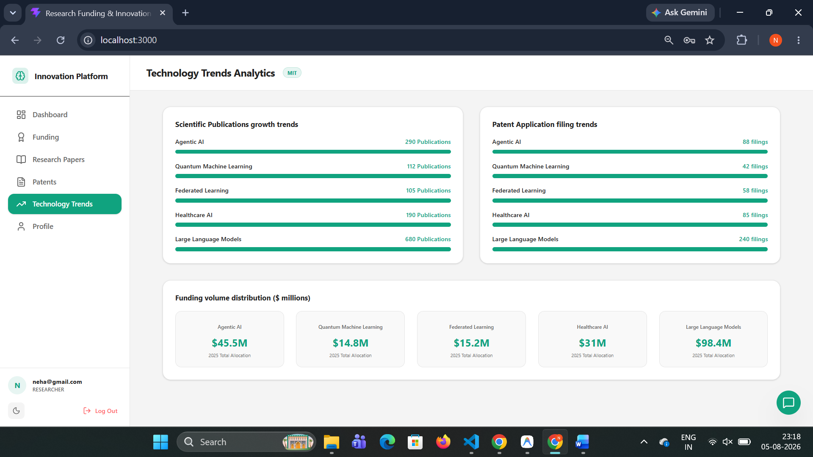

5. REST API Router Endpoints

Recommendations Router (app/routers/recommendations.py — prefix: /recommendations)
Method | Path | Description
GET | /recommendations/dashboard | Unified ML dashboard: recommended_grants, recommended_papers, recommended_patents, tech_highlights, ai_insight
GET | /recommendations/funding?q=... | Search funding. Empty q → empty recommended list + full explore mocks. Non-empty q → ML-matched recommendations + explore results.
GET | /recommendations/papers?q=... | Search papers. Same empty/non-empty behavior as funding.
GET | /recommendations/patents?q=... | Search patents. Same empty/non-empty behavior as funding.
GET | /recommendations/trends | Static trends data: publications_growth, patents_growth, funding_trends across 5 topics.
GET | /recommendations/grants | Legacy endpoint for test suite. Returns grant list with match_score and match_rationale.
GET | /recommendations/grants/{id}/match | Legacy match breakdown for a specific grant.

Intelligence Router (app/routers/intelligence.py — prefix: /intelligence)
Method | Path | Description
GET | /intelligence/trends/publications | Returns publication volume aggregates grouped by year.
GET | /intelligence/trends/topics | Lists trending keywords with velocity growth percentages.
GET | /intelligence/trends/collaborators | Recommends key co-investigators mapped to related topics.

6. Frontend Interface — Funding & Papers Cabinets

Funding Cabinet
The Funding tab features a search bar with placeholder text 'Search NIH, NSF awards by keyword...' and an 'Explore Funding' action button. Results are displayed in two sections:
• Personalized Matching Opportunities: 2-column grid of grant cards with 'Embedded Match' badge, deadline, title, agency, description, funding amount, 'View Details' modal button, and 'Apply' link.
• Explore NIH / NSF Opportunities: Compact list rows of all search results.

Research Papers Cabinet
The Papers tab features a search bar and 'Query Papers' button. Results appear in two sections:
• Matched Literature Recommendations: 2-column grid with paper title, authors, abstract, citations, year, 'Analyze Paper' modal button, and 'Open Paper' external link.
• Literature Explorer: Compact list rows of all search results.

Funding Detail Modal
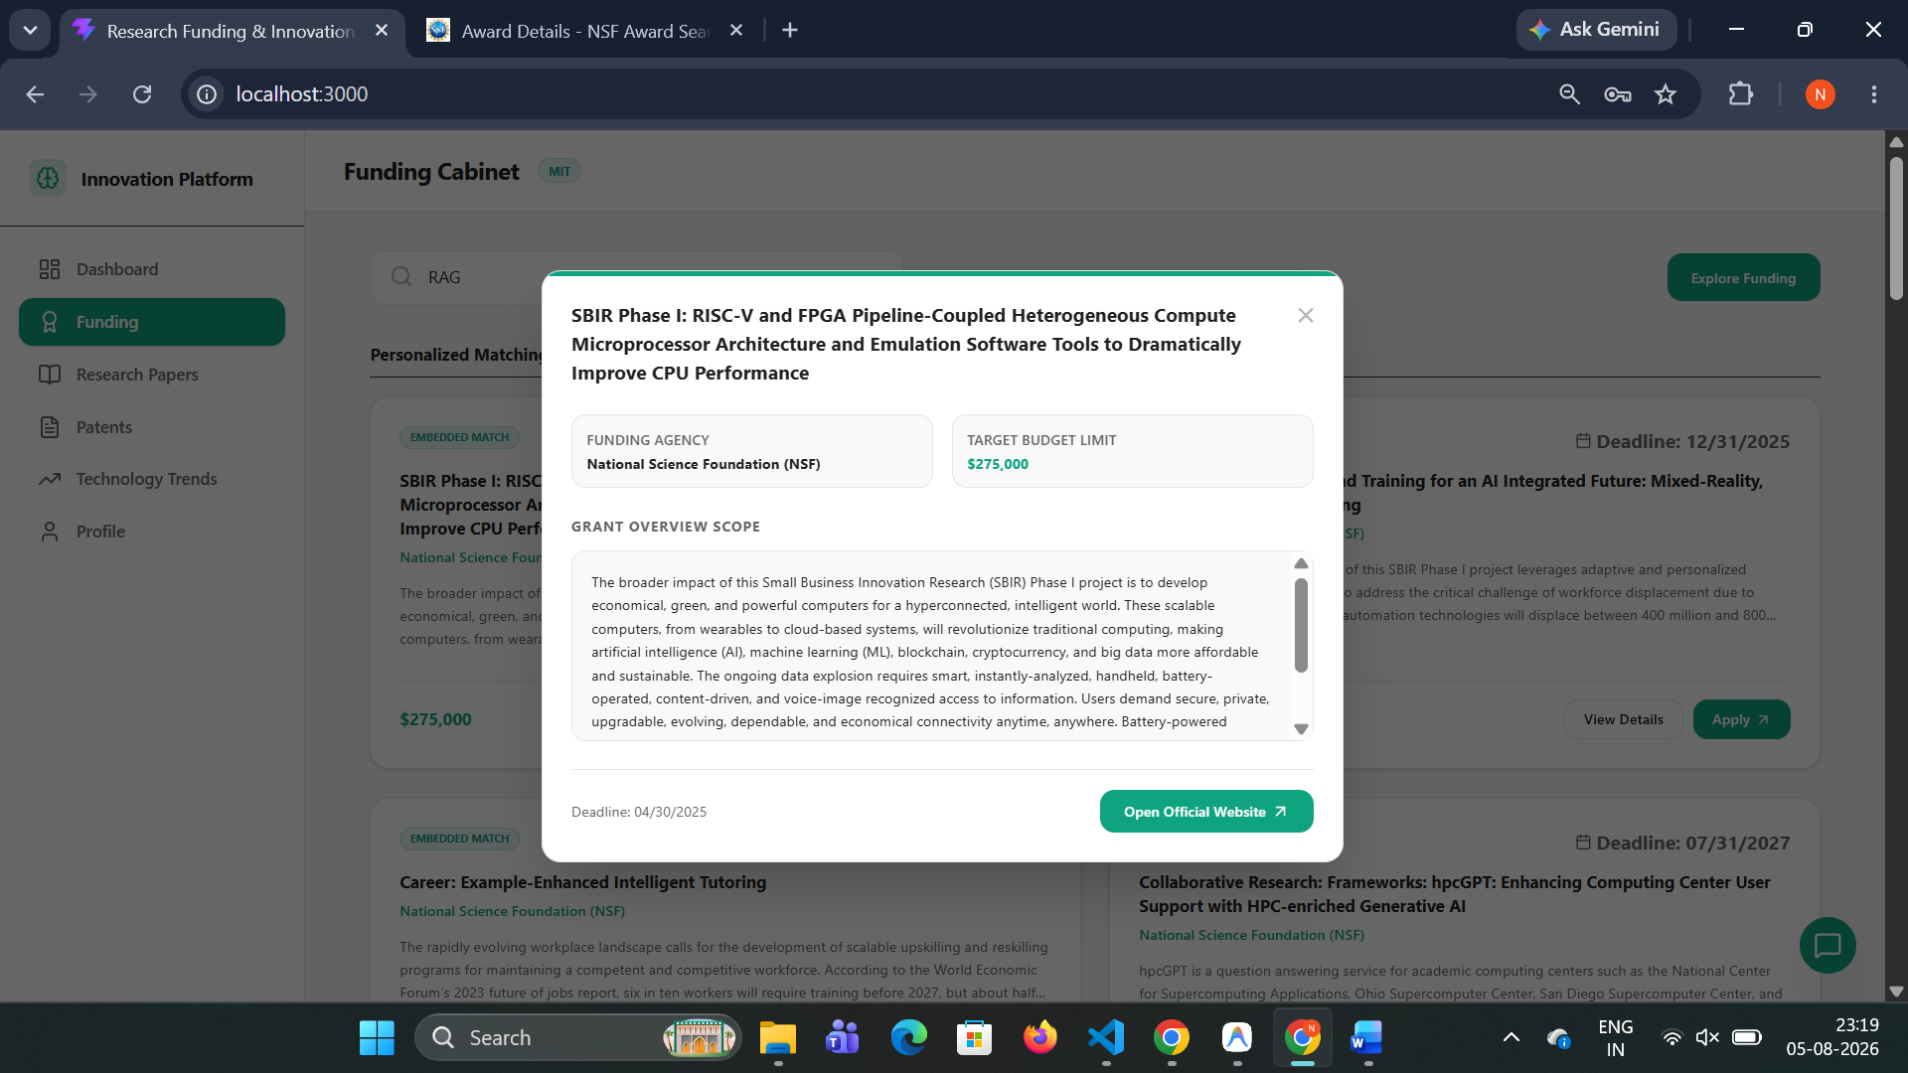
Paper Analysis Modal
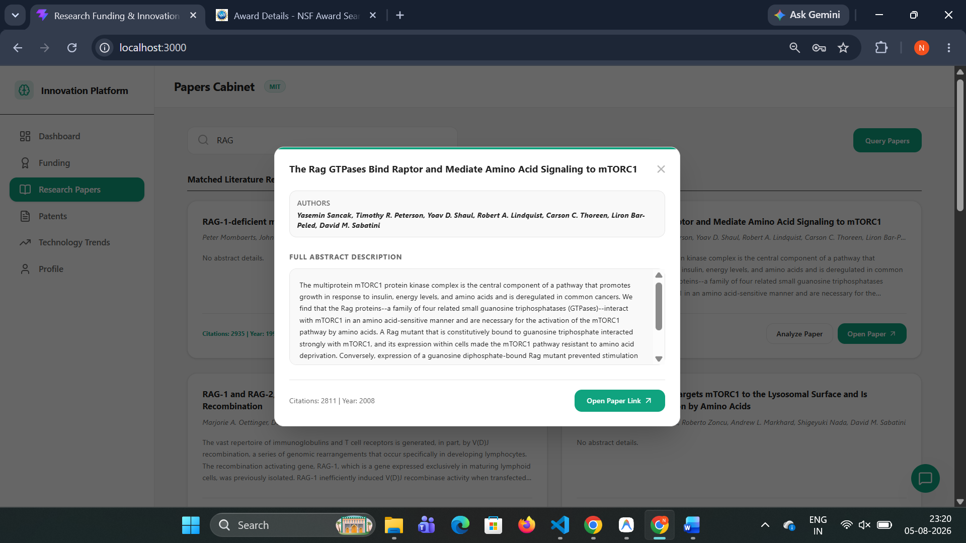

7. Verification and Integration Testing
The test suite (tests/verify_endpoints.py) validates Milestone 2 endpoints:
• Fetches the researcher's matching grant recommendations via GET /recommendations/grants.
• Fetches matching diagnostics breakdowns for a specific grant, verifying match percentage and rationale.
• Fetches publication yearly timelines via GET /intelligence/trends/publications.
• Fetches topic velocity growth percentages via GET /intelligence/trends/topics.
• Validates the unified dashboard feed via GET /recommendations/dashboard.
• Tests the search-only recommendation behavior (empty query returns empty recommended list).

