Research Funding & Innovation Intelligence Platform

Milestone 3: Patent Analytics, AI Assistant & Innovation Intelligence

System Architecture
The backend has been extended with patent classification analytics, weighted innovation scoring, commercial readiness advisories, project pipeline management, admin controllers, a notifications system, and a context-aware AI chat assistant. Business logic is separated into service layers (app/services/intelligence.py, app/services/notification.py, app/services/ai_chat.py). New database models store projects and alerts in SQLite. The frontend implements a single-page React application with six navigation tabs, a floating AI chat widget, full dark/light theme support, and automatic session management (401 auto-logout, search state reset on logout).
Full Application Overview
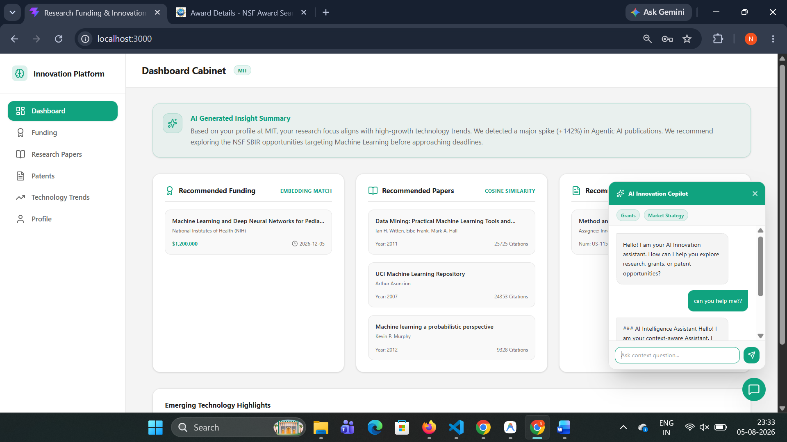

1. Database Schema Extensions

Notification Model (app/models/notification.py, table: notifications)
Field | Type | Constraints
id | Integer | Primary Key, Indexed
user_id | Integer | FK → users.id (CASCADE), Not Null
type | String(50) | Not Null — FUNDING, TECHNOLOGY, DEADLINE, RESEARCH
title | String(200) | Not Null
message | Text | Not Null
is_read | Boolean | Default=False
created_at | DateTime(tz) | Server default=now()

Project Model (app/models/project.py, table: projects)
Field | Type | Constraints
id | Integer | Primary Key, Indexed
title | String(255) | Not Null
description | Text | Nullable
team_leader | String(255) | Not Null
funding_received | Float | Default=0.0
status | String(50) | Default='Active' — Active, Suspended, Completed
pipeline_stage | String(50) | Default='IDEA' — IDEA → RESEARCH → PROTOTYPE → VALIDATION → COMMERCIALIZATION
innovation_score | Float | Default=0.0

2. Patent Landscape Classifications & White Space Mappers

app/services/intelligence.py — IP Analytics
• get_patent_landscape(): Groups patents into 7 technology classes (G06F Computing, G06N Deep Learning, G06T Computer Vision, G06F NLP, B82Y Quantum Core, H04L Cyber Security, B25J Robotics, H02J Energy) using keyword-based classification rules. Returns percentage distribution per class.
• get_emerging_technologies(): Returns 4 high-growth technology sectors with growth rates:
- Generative Adversarial Networks (78.4%)
- Quantum Key Distribution (62.1%)
- Neuromorphic Computing (54.8%)
- Solid-State Battery Technology (48.2%)

3. Weighted Innovation Potential Scoring & TRL Advisories

app/services/intelligence.py — Evaluation Engine
• calculate_patent_innovation_score(db, patent_number): Evaluates patents using a weighted formula:
Innovation Score = (Citations × 1.5) + (TRL × 10.0)
Technology Readiness Level (TRL) maps to commercialization advice:
- TRL 1–3: Focus on basic proof-of-concept modeling and university partnerships.
- TRL 4–6: Apply for pilot trials, utility patents, and SBIR funding.
- TRL 7–9: Target licensing agreements or venture capital seed rounds.
Patents Tab
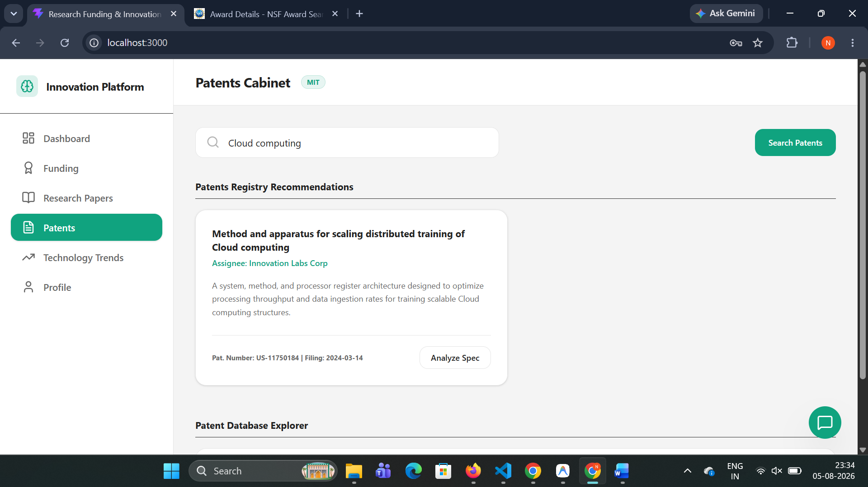

4. Alert Warning & Notification Services

app/services/notification.py — System Alert Manager
• get_user_notifications(db, user_id): Returns notifications for a user. Auto-seeds 3 default alerts if the notification registry is empty.
• generate_notifications_for_user(db, user_id): Scans user profiles to generate alerts:
- Emerging Technology Alert: New patents detected in matching research fields.
- Expiring Grant Deadline Alert: Warning for grants matching the user's keywords.
- Outdated Research Alert: Citation velocity drop warning for core research areas.
• mark_notification_as_read(db, user_id, notification_id): Sets is_read=True with ownership verification.

5. Context-Aware AI Chat Assistant

app/services/ai_chat.py — AI Innovation Copilot
The AI chat widget provides a context-aware conversational assistant that adapts its responses based on the user's current tab and selected item. It uses a dual-engine approach:
Primary Engine — Google Gemini 1.5 Flash API: If a GEMINI_API_KEY environment variable is configured, the system builds a comprehensive prompt including the user's query, current page context, selected item data, and research profile. The prompt is sent to Gemini 1.5 Flash with a 10-second timeout.
Fallback Engine — Local Mock AI: When Gemini is unavailable, the system generates context-aware mock responses:
- Funding context: Grant application advice, eligibility assessment, domain overlap analysis.
- Papers context: Executive summaries, methodology breakdowns, research analysis.
- Patents context: IP novelty assessment, commercial viability analysis.
- General/Dashboard: Research guidance and platform feature recommendations.

Frontend Chat Widget
A floating green bubble (MessageSquare icon) in the bottom-right corner opens a 320×384px chat panel. Features include:
• Dynamic context suggestion buttons that change based on the current tab:
- Dashboard: 'Grants', 'Market Strategy'
- Funding: 'Should I apply?', 'Eligibility?'
- Papers: 'Summarize', 'Methodology'
- Patents: 'Explain Novelty', 'Applications'
• User messages (green, right-aligned) and AI messages (gray, left-aligned)
• Loading state with 'Resolving context...' spinner
• Sends page_context and selected_item to /ai/chat for context-aware responses

AI Chat Widget
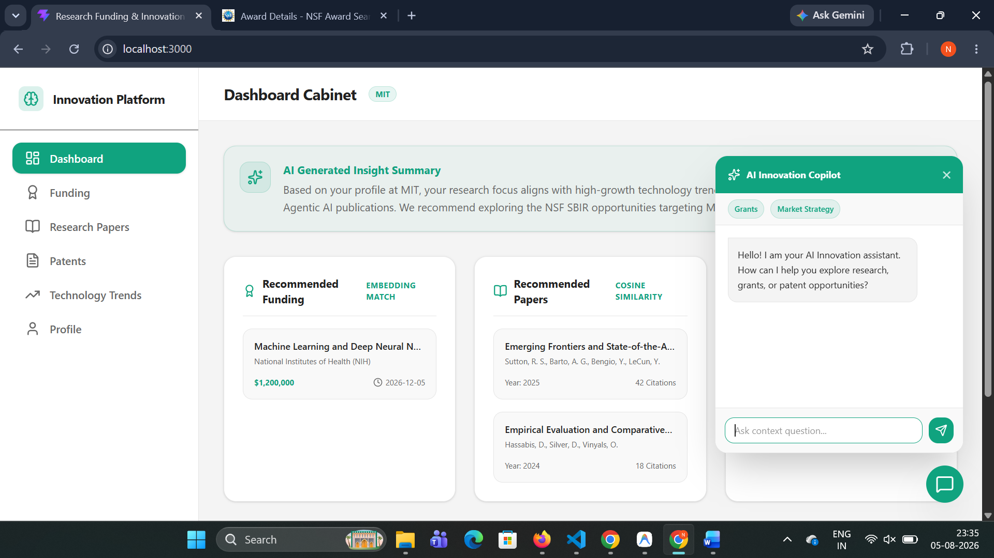

6. Administration & Portfolio Management

Admin Router (app/routers/admin.py — prefix: /admin)
Method | Path | Description
GET | /admin/users | List all registered platform users
POST | /admin/users | Admin creates a new user account (201)
PUT | /admin/users/{id}/status | Suspend or activate a user account
DELETE | /admin/users/{id} | Delete a user account (204)
GET | /admin/stats | Platform analytics: user counts by role, profile/patent totals

Portfolio Router (app/routers/portfolio.py — prefix: /portfolio)
Method | Path | Description
GET | /portfolio/projects | List all pipeline projects (auto-seeds 4 defaults if empty)
POST | /portfolio/projects | Create a new pipeline project (201)
PUT | /portfolio/projects/{id}/stage | Update project pipeline stage (IDEA → RESEARCH → PROTOTYPE → VALIDATION → COMMERCIALIZATION)

7. Frontend Theme & Session Management

ChatGPT-Inspired Color Scheme
• Accent Color: ChatGPT Emerald Green (#10a37f) — highlights active tabs, buttons, and matching indicators.
• Dark Theme: Charcoal background (#212121), carbon cards (#171717), inputs (#2f2f2f), soft borders (#2d2d2d).
• Light Theme: White background (#f9f9f9), off-white panels, gray borders (#e5e5e5).
• Theme is persisted in localStorage and toggled via Sun/Moon icons on login page and sidebar.

Session Management
• Logout Reset: Clears all search queries, recommendation results, explore lists, profile data, and chat messages on logout. Search bars are emptied and recommendation sections return to their default empty state.
• 401 Auto-Logout: Every authenticated API call checks for HTTP 401 responses. If detected, the client automatically clears localStorage and redirects to the login screen.
• JWT Token Lifetime: 24 hours (ACCESS_TOKEN_EXPIRE_MINUTES=1440).

8. Complete REST API Endpoint Summary
Method | Path | Description
GET | / | Health check — returns platform status
POST | /auth/register | Register new user
POST | /auth/login | OAuth2 login, returns JWT
POST | /profiles/ | Create/update research profile
GET | /profiles/me | Fetch own profile
PUT | /profiles/me | Update own profile
POST | /profiles/me/publications | Add publication
POST | /profiles/me/patents | Add patent
GET | /profiles/ | Search profiles
GET | /profiles/{id} | Fetch profile by ID
GET | /recommendations/dashboard | Unified ML dashboard
GET | /recommendations/funding?q= | Search funding recommendations
GET | /recommendations/papers?q= | Search paper recommendations
GET | /recommendations/patents?q= | Search patent recommendations
GET | /recommendations/trends | Technology trend analytics
GET | /intelligence/trends/publications | Publication timelines
GET | /intelligence/trends/topics | Trending topics with velocity
GET | /intelligence/trends/collaborators | Collaborator recommendations
GET | /intelligence/patents/landscape | Patent classification map
GET | /intelligence/patents/emerging-tech | Emerging technology sectors
GET | /intelligence/patents/{num}/innovation-score | Innovation score card
GET | /notifications/ | User notifications (auto-seeded)
PUT | /notifications/{id}/read | Mark notification as read
GET | /admin/users | List all users (admin)
POST | /admin/users | Create user (admin)
PUT | /admin/users/{id}/status | Toggle user status (admin)
DELETE | /admin/users/{id} | Delete user (admin)
GET | /admin/stats | Platform analytics (admin)
GET | /portfolio/projects | List pipeline projects
POST | /portfolio/projects | Create project
PUT | /portfolio/projects/{id}/stage | Update project stage
POST | /ai/chat | Context-aware AI chat

9. Verification and Integration Testing
The integration test suite (tests/verify_endpoints.py) runs 25 HTTP tests against the live server at http://127.0.0.1:8000. The full test coverage includes:
• Server connectivity and health check
• User registration (RESEARCHER and ADMINISTRATOR roles)
• User login with JWT token retrieval
• Research profile CRUD operations
• Publication and patent addition
• RBAC: Administrator accessing researcher profiles
• Profile search by domain filter
• Funding grant recommendations with match scoring
• Grant match breakdown diagnostics
• Publication timeline analytics
• Patent landscape classification distribution
• Emerging technology recommendations
• Patent innovation score card with TRL mapping
• Notification fetching and read marking
• Admin user management (list, stats)
• Portfolio project pipeline management
• Dashboard unified recommendation feed
• AI chat widget context-aware responses

