Project Name: Research Funding & Innovation Intelligence Platform
Milestone 1: Project Initialization, Design Process & Core Setup
System Architecture
The backend is designed using a modular, decoupled architecture, separating core concerns into independent directories. The FastAPI application routes requests through resource-oriented routers (app/routers), processes logic inside business services (app/services), models relational tables with SQLAlchemy ORM (app/models), and validates incoming/outgoing data using Pydantic contracts (app/schemas). System configs, DB session pools, and security tools are grouped in the configuration module (app/core). This decoupled design ensures high performance, unit-testability, and the ability to scale seamlessly to add new AI models and search features in future weeks.
User Interaction and Input Handling
The API interacts with users and external services over HTTP endpoints. On launching the server, FastAPI automatically hosts interactive Swagger UI documentation at /docs. User inputs (such as registrations, logins, and profile creations) are passed as JSON bodies. These inputs undergo type-checking, length constraints, and format validation using Pydantic schemas. If a client sends invalid inputs, the application safely responds with an structured 422 Unprocessable Entity error rather than crashing, ensuring robust API reliability.
1. Database Configuration and Docker Connection
The database architecture uses a containerized PostgreSQL environment configured via Docker Compose. Using Docker guarantees environment parity, allowing developers to boot up a fully isolated PostgreSQL database on any machine with one command.
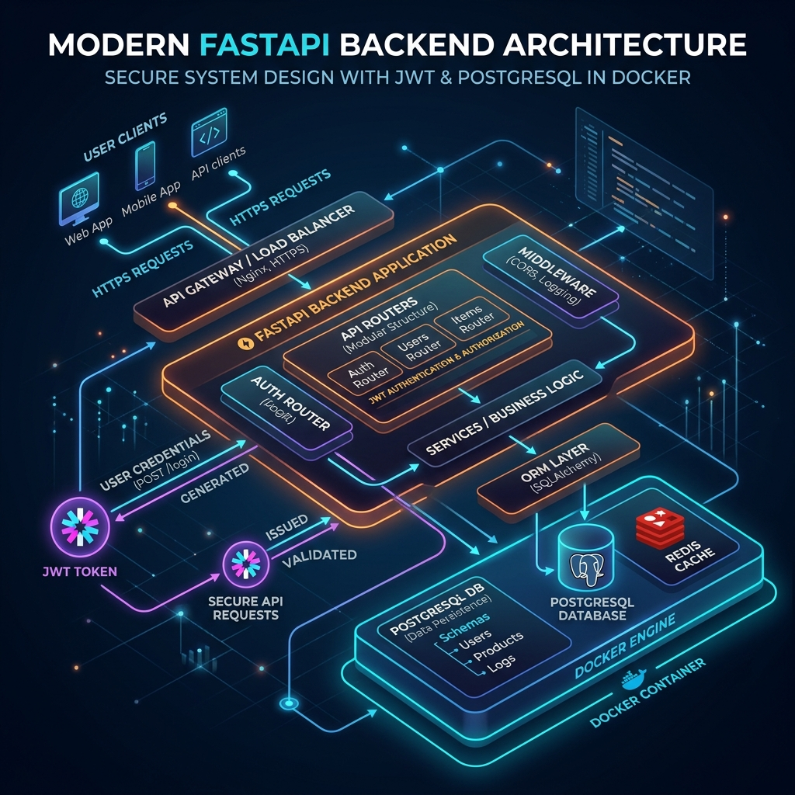
Figure 1.1: System Architecture Diagram
docker-compose.yml – Database Infrastructure Layer
This file specifies how the database server runs:
- postgres:16-alpine: Lightweight, secure container image.
- ports: 5432:5432: Maps the host computer's port 5432 to the container's PostgreSQL port.
- volumes: postgres_data: Persists data on your local hard drive so records aren't lost when the container stops.

2. Declarative ORM Database Design (Models)
The database structure is built using SQLAlchemy declarative models. It defines the tables, data types, constraints, and relationships.
app/models/user.py – User Accounts
Stores primary authentication data:
- id: Integer primary key.
- email: Unique string index representing user identity.
- hashed_password: Cryptographically secure bcrypt hash string.
- role: Access role (e.g. RESEARCHER, ADMINISTRATOR).
- profile: One-to-one relationship linking to ResearchProfile.
app/models/profile.py – Research Profile Metadata
Contains academic details, linked publications, and patents:
- ResearchProfile: Holds first name, last name, organization, biography, and JSON collections for research_domains, keywords, and technology_areas.
- Publication: Holds research papers with titles, authors, journal, publication year, DOI, and URL. Linked to ResearchProfile (Many-to-One).
- Patent: Holds intellectual property data with titles, unique patent numbers, filing dates, status, and URL links. Linked to ResearchProfile (Many-to-One).
3. JWT Authentication System
Secures the platform through JSON Web Tokens (JWT) and OAuth2 security definitions.
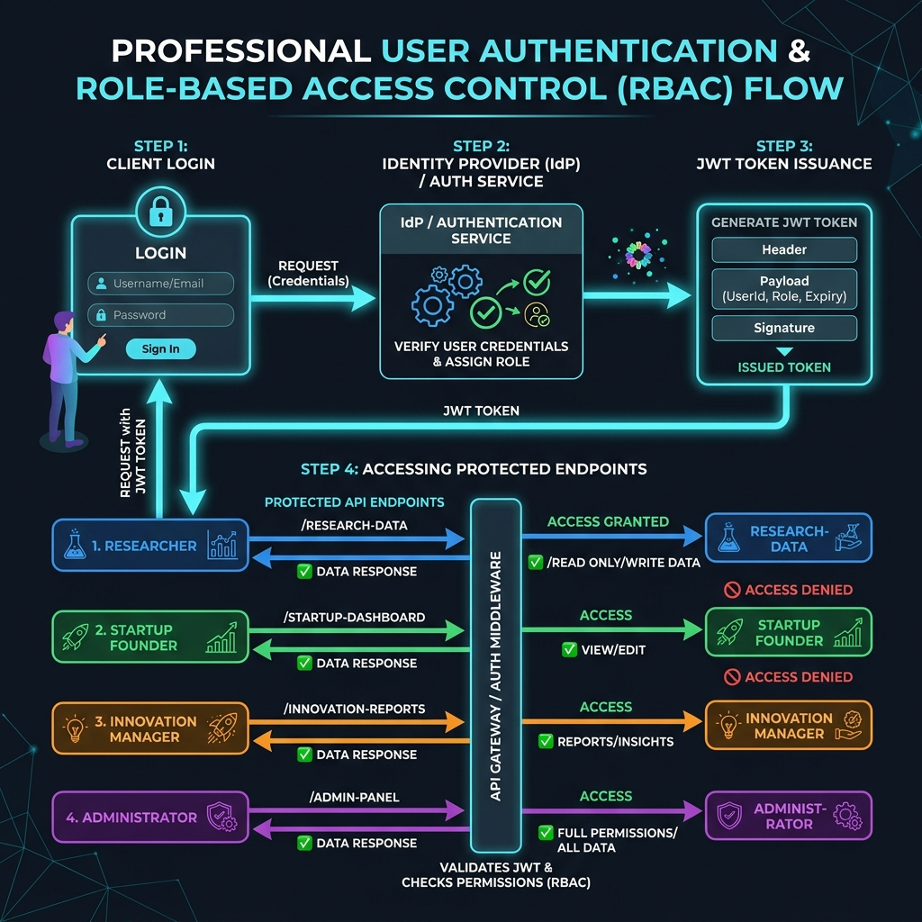
Figure 1.2: JWT Authentication and RBAC Flow Infographic
app/core/security.py – Cryptography Services
- get_password_hash(password): Hashes plain password string using bcrypt with a salt factor.
- verify_password(plain, hashed): Safe timing verification of input password against database hash.
- create_access_token(data, expires_delta): Compiles access tokens signed with HMAC-SHA256 signature containing user identity claims (sub, role) and expiry timestamps.
app/routers/auth.py – Authentication Router
- POST /auth/register: Registers a new user account, encrypts their password, and saves them to the DB.
- POST /auth/login: Accepts OAuth2 compatible credentials form, verifies password hashes, and returns a JWT token.
4. Role-Based Access Control (RBAC)
Enforces endpoint boundaries depending on who is logged in.
app/dependencies.py – Guard Verification
- get_current_user(): Extracts the bearer token from the request header, decodes the signature, verifies expiration, and returns the active User model.
- RoleChecker: Reusable dependency checker class that validates if the logged-in user's role belongs to the list of allowed permissions.
Assigned Roles:
- RESEARCHER: Access to own profile, add publications/patents, view trends.
- STARTUP_FOUNDER: Access to own profile, add patents/tech areas, search profiles.
- INNOVATION_MANAGER: Access to pipeline analytics, view and search profiles.
- ADMINISTRATOR: Full read/write administrative access to system services.
5. Research Profile Management
Provides CRUD endpoints to manage researcher identities, publication history, and patent portfolios.
app/services/profile.py – Profile Logic
- create_research_profile(): Prevents creating duplicate profiles for a single user account.
- update_research_profile(): Updates specific fields dynamically (e.g. organization, biography) using partial updates.
- add_publication(): Links a new publication to the user's research profile.
- add_patent(): Validates that the patent number is globally unique before linking it to the user's profile.
app/routers/profile.py – CRUD Router
- POST /profiles/: Creates a profile for the authenticated user.
- GET /profiles/me: Fetches own profile data.
- PUT /profiles/me: Modifies profile data.
- POST /profiles/me/publications: Appends academic publications.
- POST /profiles/me/patents: Appends registered patents.
- GET /profiles/: Searches profiles filtering by organization name or technical domains.
6. Data Ingestion & Preprocessing Pipeline
To aggregate real-world data, I built a data integration suite to query, parse, clean, and store academic literature, patent registries, and funding opportunities.
app/services/data_pipeline.py – Unified Ingestion Service
- Consolidates all dataset ingestion and preprocessing logic into a single, full-fledged file that is simple to study and interpret.
- Scholarly Data: Queries literature metadata from the Semantic Scholar search API using HTTPX and normalizes records (titles, authors, years, DOIs, URLs).
- Patents Data: Normalizes raw patent datasets (USPTO and Google Patents) extracting assignee, filing date, and abstracts.
- Grants Data: Standardizes funding opportunities (Grants.gov, NSF, and NIH) extracting award amount, deadline, funder, and description.
- JSON Storage: Automatically compiles results, removes duplicates, and saves unified files (research_papers.json, patents.json, grants.json) to local preprocessed storage.
7. Verification and Local Testing
Verification is managed via a dedicated automated suite.
tests/verify_endpoints.py – Integration Test Runner
The test script runs HTTP queries against the server to verify API functionality:
- Connects to the local server.
- Registers a new researcher user and an administrator user.
- Performs authentication logins and extracts access tokens.
- Verifies profile creations, details retrieval, and update requests.
- Validates relationship constraints by appending publications and patents.
- Evaluates role security restrictions (checking for correct 403 Forbidden responses when access roles mismatch).

Submitted by
Neha S

