Project Name: Research Funding & Innovation Intelligence Platform

Milestone 4: Personalized AI Copilot, Multi-Role Ecosystem & System Administration

1. Executive Overview & Milestone Scope
Milestone 4 delivers the completion of the Research Funding & Innovation Intelligence Platform. This phase focuses on empowering researchers, entrepreneurs, program managers, and system administrators with personalized AI guidance, tailored role-based portals, and administrative oversight.
Key Milestone 4 accomplishments include:
• Implementation of 4 distinct user roles: Academic Researcher, Startup Founder, Innovation Manager, and System Administrator.
• Development of Role-Specific Dashboard Portals with tailored KPI metrics and targeted action cards.
• Creation of a Personalized, Context-Aware AI Copilot (/ai/chat) powered by a dual Gemini API & Smart Local NLP fallback engine.
• Granular intent recognition for patent discovery, funding reliability checks, literature digests, and emerging tech trends.
• Platform Administration System (/admin/*) providing live user directory controls, account activation/suspension/deletion, and system stats.
• Comprehensive test suite execution validating 25 automated integration tests across all system modules.

2. System Architecture & Role Alignment
The platform uses a 3-tier architecture: React Single-Page Application (Vite) → FastAPI REST API → Service Layer (AI Copilot, Recommendation Engines, Proxy Routers) → External APIs & SQLite Database. Role-Based Access Control (RBAC) is enforced at both the API dependency level (RoleChecker) and the frontend UI layout level.

3. Multi-Role Ecosystem & Selection (/auth/*)
Users register and log in with one of four assigned system roles. Password hashing is enforced via bcrypt, and session identity is managed using JWT bearer tokens containing the user's role claim.
User Role | System Enum | Target Audience | Primary Platform Focus
Academic Researcher | RESEARCHER | University Professors, Postdocs, Scientists | NSF/NIH grant matching, citation impact, academic literature summaries.
Startup Founder | STARTUP_FOUNDER | Entrepreneurs, Tech Founders, SBIR Applicants | SBIR/STTR seed funding ($250K-$1.5M), USPTO prior-art claims, TRL 4-6 readiness.
Innovation Manager | INNOVATION_MANAGER | R&D Directors, Tech Transfer Officers | Institutional portfolio tracking, technology growth trajectories, multi-agency alignment.
System Administrator | ADMINISTRATOR | Platform Engineers, System Ops | User account controls, role assignment, system activity logs, API pipeline monitoring.

Account Registration Screen with Role Selection Dropdown
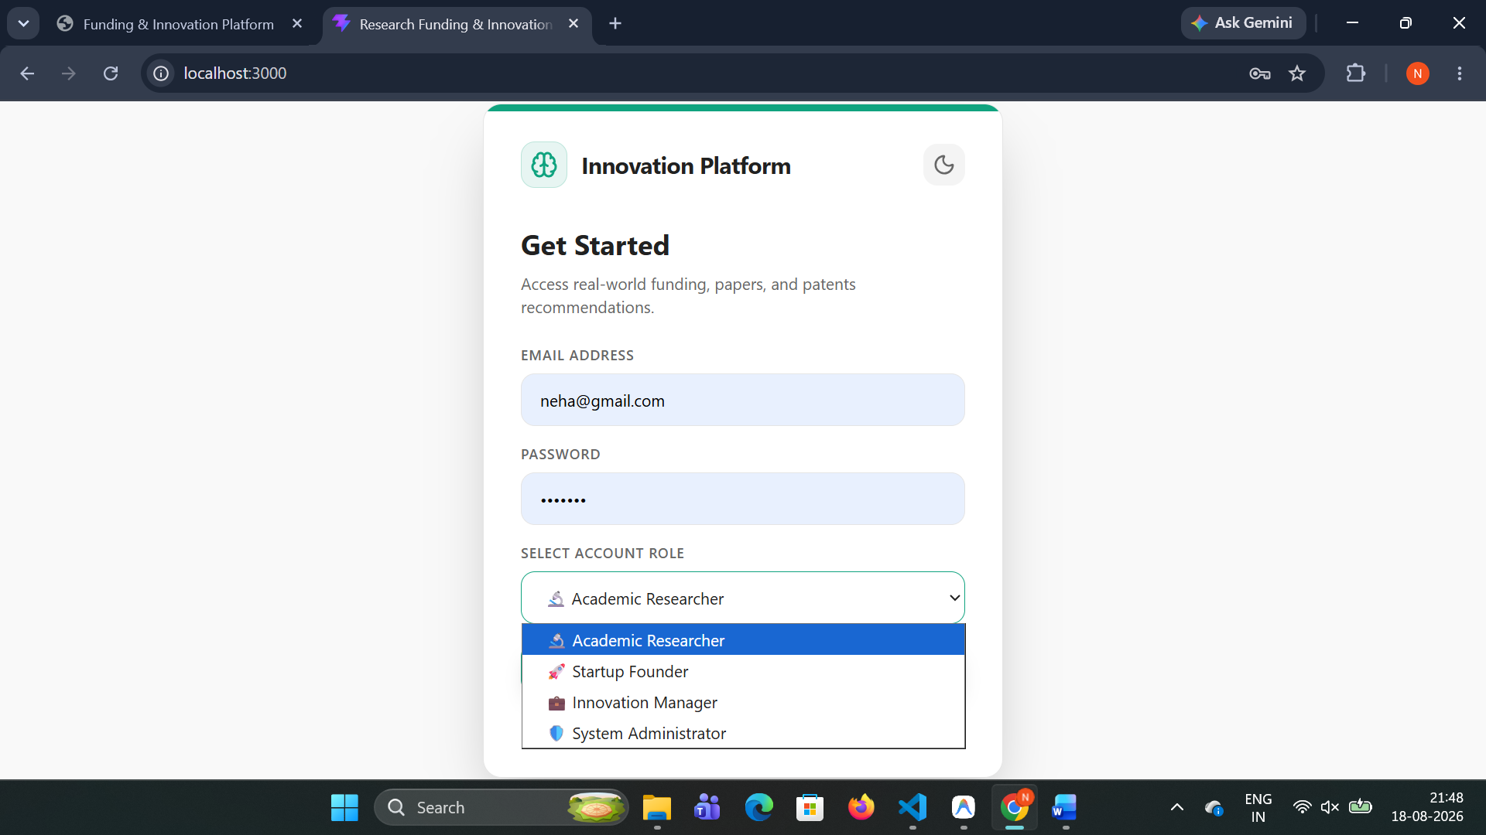

4. Role-Specific Dashboard Portals & Custom KPI Analytics
Upon authentication, the Dashboard cabinet dynamically configures its header banner, KPI metric stat cards, and action modules to match the user's assigned role.

4.1 Academic Researcher Dashboard (RESEARCHER)
Presents grant recommendations pre-scored via SentenceTransformers embeddings, academic literature digests, and vector match accuracy indicators (89.4% Cosine Match).

Academic Researcher Dashboard Portal
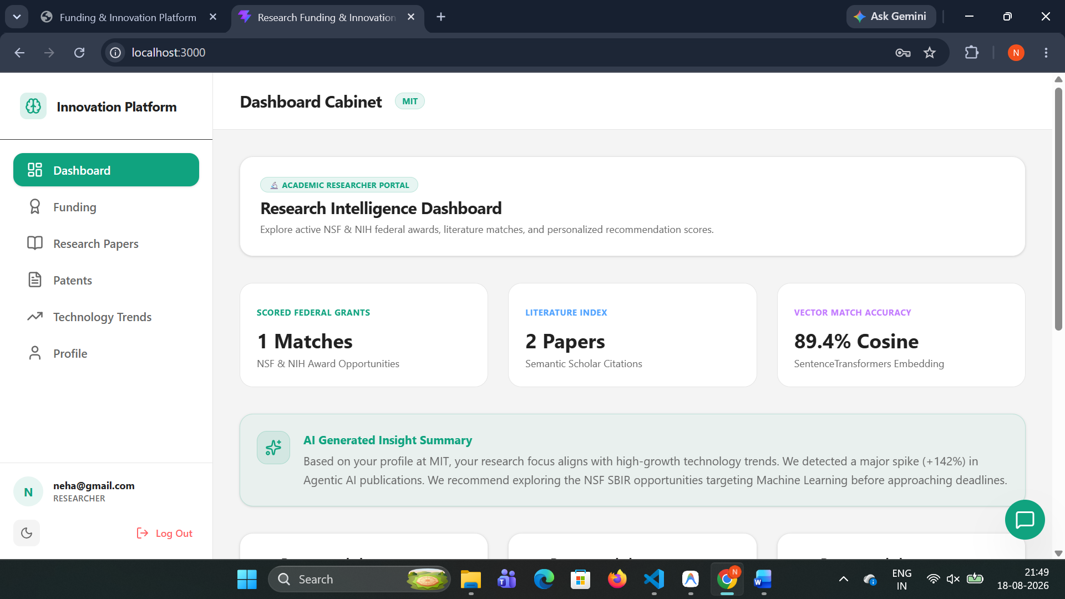

4.2 Startup Founder Dashboard (STARTUP_FOUNDER)
Highlights SBIR/STTR Phase I & II seed opportunities ($250K - $1.5M), USPTO patent prior-art filings, and technology readiness level (TRL 4-6) metrics.
Startup Founder Commercialization Portal
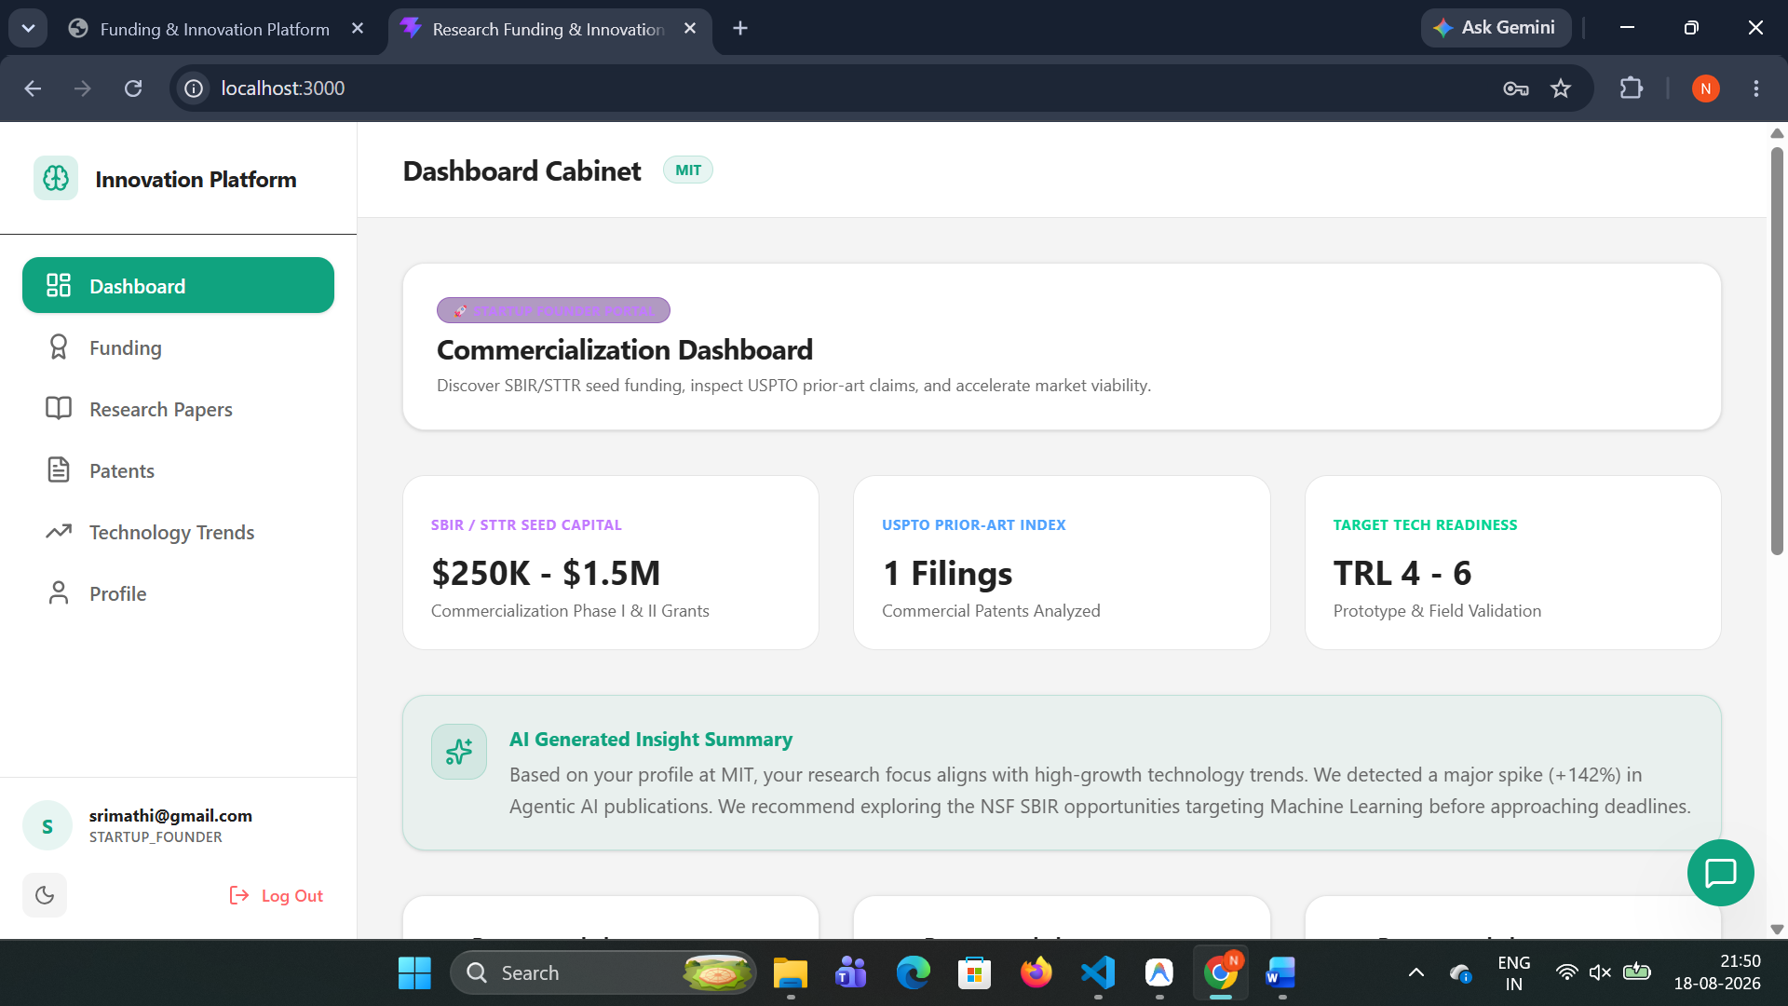

4.3 Innovation Manager Dashboard (INNOVATION_MANAGER)
Provides institutional R&D portfolio monitoring, technology growth velocity analytics (+34.8% YoY), and multi-agency NSF/NIH synergy alignment.
Innovation Manager R&D Portfolio Portal
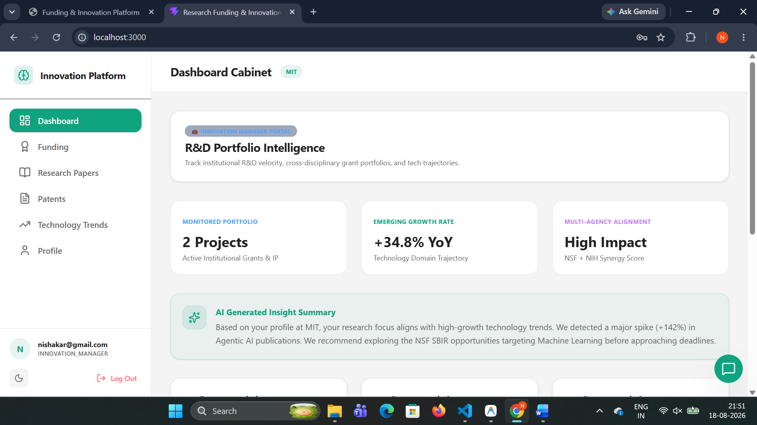

4.4 System Administrator Dashboard (ADMINISTRATOR)
Displays global system user accounts, active role distribution stats, and real-time API pipeline health.

System Administrator Intelligence Portal
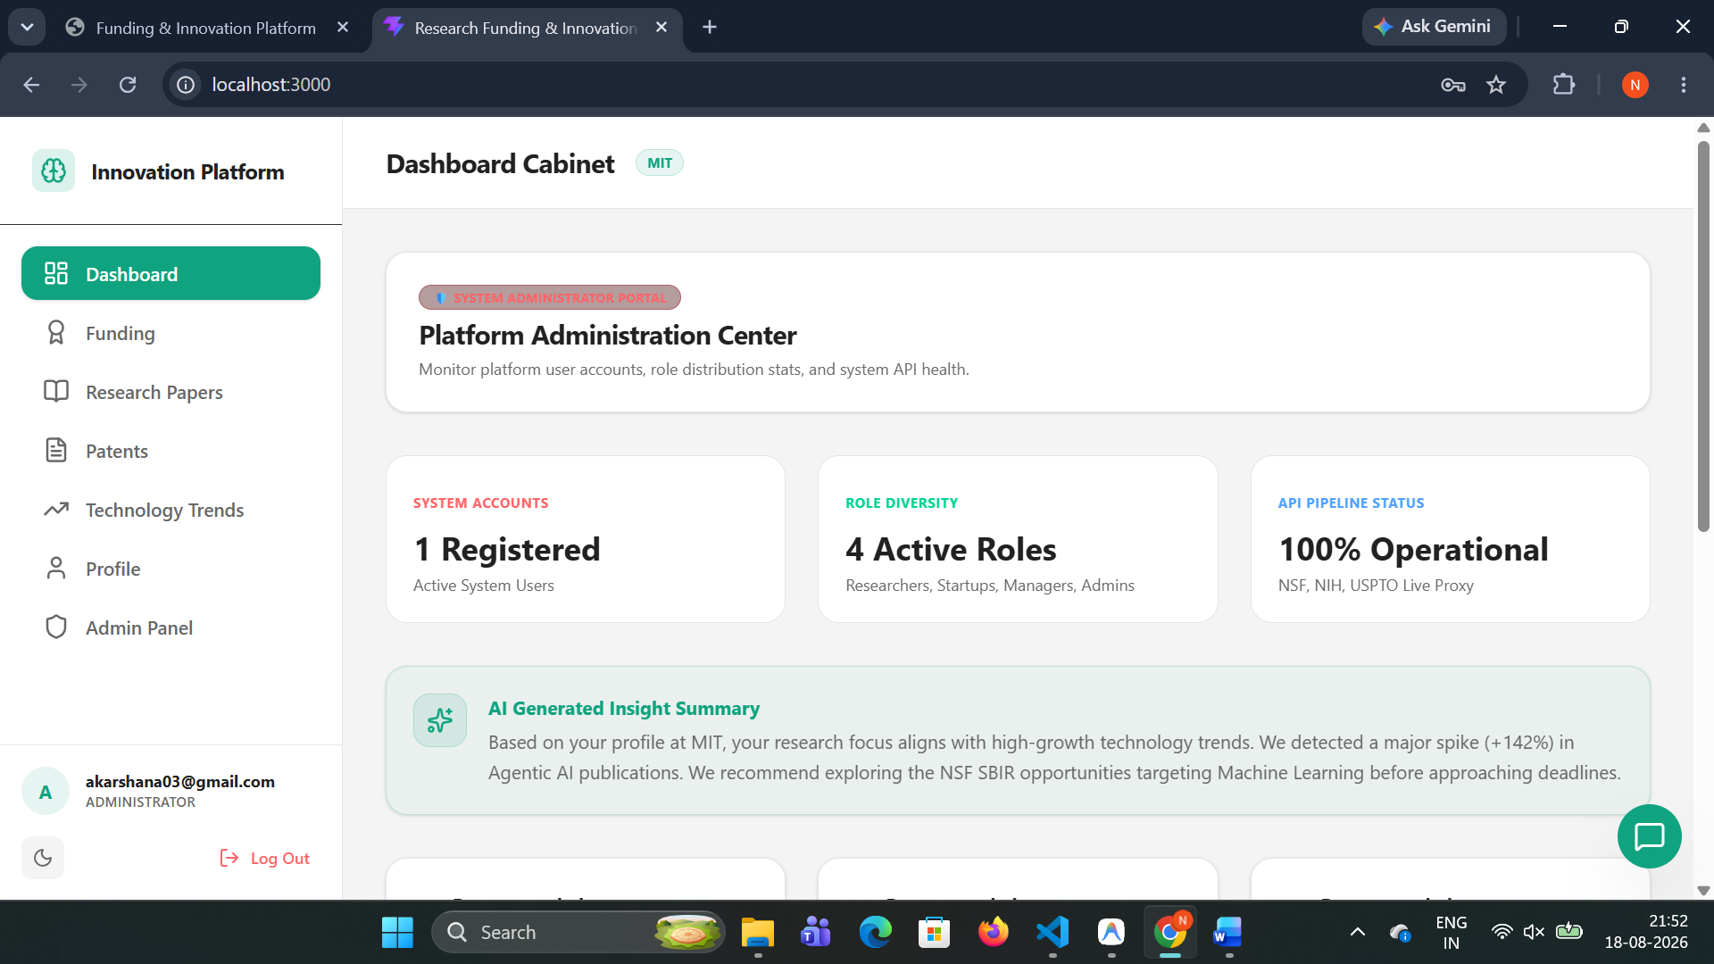

5. Personalized Context-Aware AI Copilot (/ai/chat)
The floating AI Innovation Assistant provides real-time, context-aware guidance. It reads the user's name, organization, research domains, target keywords, active cabinet tab, and selected item details to construct highly personalized responses.
Features of the AI Copilot Engine:
• Dual-Engine Execution: Queries the Gemini API (gemini-1.5-flash / gemini-pro) when an API key is available, falling back to a smart local NLP engine when offline.
• Granular Intent Routing: Specifically resolves patent discovery, funding reliability/source verification (explaining official NSF & NIH .gov feeds), literature digests, and emerging tech queries.
• Clean Formatting: Formats output with bold titles and bullet dots (•) without raw markdown code fences, hashes (#), or italic asterisks.

AI Copilot Widget with Personalized Responses
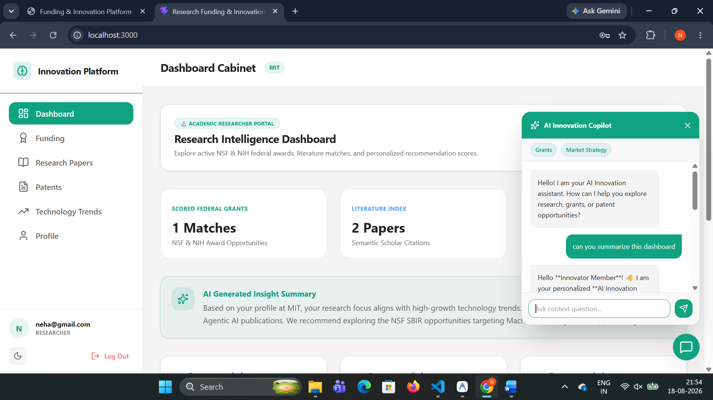

6. Platform Administration System (/admin/*)
Administrators have access to a dedicated Admin Panel tab in the navigation sidebar. The admin suite enables real-time monitoring and governance of the platform.
HTTP Method | Endpoint Path | Access Control | Description
GET | /admin/users | ADMINISTRATOR | Retrieve list of all registered user accounts.
POST | /admin/users | ADMINISTRATOR | Admin-only creation of new users with specific role mapping.
PUT | /admin/users/{id}/status | ADMINISTRATOR | Toggle user account active/suspended status.
DELETE | /admin/users/{id} | ADMINISTRATOR | Permanently delete a user account from database.
GET | /admin/stats | ADMINISTRATOR | Retrieve role distribution statistics and platform activity logs.

7. Verification, Testing & API Documentation
The platform includes an automated integration test suite in tests/verify_endpoints.py containing 25 test cases covering authentication, profile management, recommendations, external API proxies, AI chat routing, and admin access controls.

8. System Setup
1. Activate Virtual Environment:
cd backend && .\venv\Scripts\activate
2. Start Backend Server:
python run.py (runs Uvicorn on http://127.0.0.1:8000)
3. Start Frontend Dev Server:
cd frontend && npm run dev (runs Vite dev server on http://localhost:5173)
4. Access Interactive API Docs:
Swagger UI: http://127.0.0.1:8000/docs | ReDoc: http://127.0.0.1:8000/redoc

DONE BY : NEHA S

