Vendor Reliability Intelligence Platform:
Vendor Reliability Intelligence & Procurement
Risk Management Platform

Dashboard layout Explanation
Team 3

MILESTONE – 1

BY
RAVI E
(TEAM 3)

Introduction
Vendor Reliability Intelligence Platform is a web-based procurement and supplier management system designed to improve vendor evaluation, procurement operations, and supply chain decision-making. The platform enables organizations to monitor vendor performance, manage procurement workflows, track purchase orders, oversee contract compliance, and analyze procurement risks through centralized dashboards. This document presents the Milestone 1 deliverables, including user workflow diagrams and dashboard layouts prepared during the planning and UI design phase of the project.

Milestone 1 Deliverables
This document contains the design deliverables completed during Milestone 1 (Requirements Analysis, UI Design, and System Planning) of the Vendor Reliability Intelligence Platform project.
The deliverables include:
- User Flow Diagrams
- Dashboard Layout Designs
- UI Planning Documentation
- Workflow Explanations

Dashboard Layout Designs
The following dashboard layouts represent the primary interfaces of the Vendor Reliability Intelligence Platform. Each dashboard is designed according to the responsibilities of its intended users and provides real-time insights into procurement activities, vendor performance, and system administration.

1. Procurement Dashboard
Primary Users: Procurement Managers, Supply Chain Managers, and Finance Officers.
Core Purpose:
To monitor procurement operations, purchasing activities, and supplier performance across the organization. The dashboard provides real-time visibility into total procurement spending, active purchase orders, pending approvals, supplier locations, spend distribution, requisition status, delivery schedules, and monthly spending trends. It helps procurement teams optimize purchasing decisions, control budgets, and ensure timely delivery of goods and services.
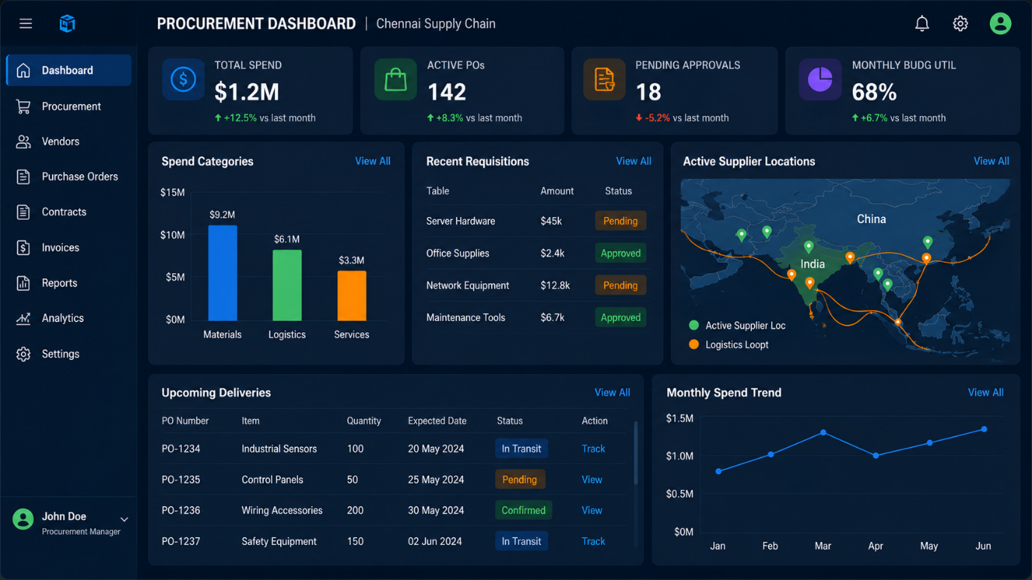

2. Vendor Portal Dashboard
Primary Users: Approved Vendors, Product Suppliers, and Logistics Partners.
Core Purpose:
To enable vendors to efficiently manage purchase orders, monitor delivery performance, maintain contract compliance, and communicate with procurement teams. The dashboard displays vendor reliability scores, quality ratings, order status, upcoming deliveries, contract information, recent communications, and document expiry alerts. It helps vendors improve operational performance while maintaining compliance with procurement requirements.
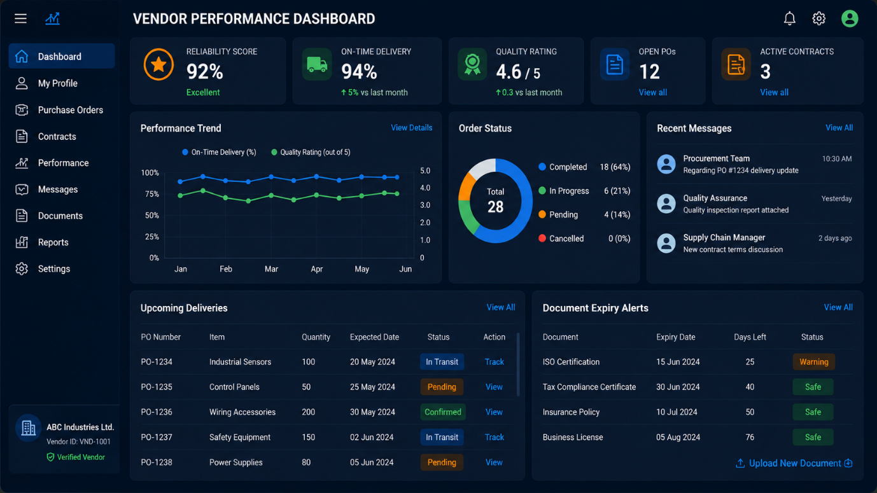
3. Admin Control Suite
Primary Users: System Administrators and Security Auditors.
Core Purpose:
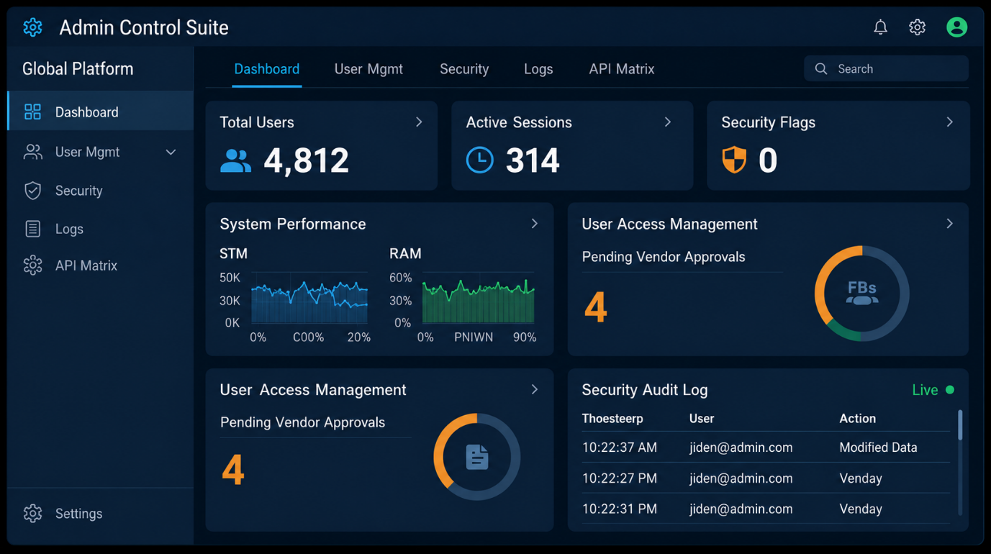
To manage platform administration, monitor system health, and ensure secure access to procurement operations. The dashboard provides an overview of user management, active sessions, security alerts, vendor approval requests, system performance metrics, resource utilization, and real-time security audit logs. It enables administrators to maintain platform

Conclusion:
The dashboard layouts created during Milestone 1 provide a visual foundation for the Vendor Reliability Intelligence Platform. Each dashboard is tailored to the responsibilities of its intended users, enabling efficient monitoring of procurement operations, vendor performance, and system administration. These layouts improve usability, support informed decision-making through centralized data visualization, and act as a reference for developing the application's frontend interface in the upcoming project milestones.

