Vendor Reliability Intelligence Platform:
Vendor Reliability Intelligence & Procurement
Risk Management Platform

User Flow Diagram Explanation
Team 3

MILESTONE - 01

BY
RAVI E
(TEAM 3)

Introduction
Vendor Reliability Intelligence Platform is a web-based procurement and supplier management system designed to improve vendor evaluation, procurement operations, and supply chain decision-making. The platform enables organizations to monitor vendor performance, manage procurement workflows, track purchase orders, oversee contract compliance, and analyze procurement risks through centralized dashboards. This document presents the Milestone 1 deliverables, including user workflow diagrams and dashboard layouts prepared during the planning and UI design phase of the project.
Milestone 1 Deliverables
This document contains the design deliverables completed during Milestone 1 (Requirements Analysis, UI Design, and System Planning) of the Vendor Reliability Intelligence Platform project.
The deliverables include:
- User Flow Diagrams
- Dashboard Layout Designs
- UI Planning Documentation
- Workflow Explanations

Workflow 1: User Security & Access Control Flow:
Objective: To illustrate how administrators securely manage users, approve vendors, monitor platform security, and oversee overall system operations.
- This workflow governs system entry and security. It ensures that only authenticated users get in and that they only see the data and features assigned to their specific organizational role (Role-Based Access Control - RBAC).

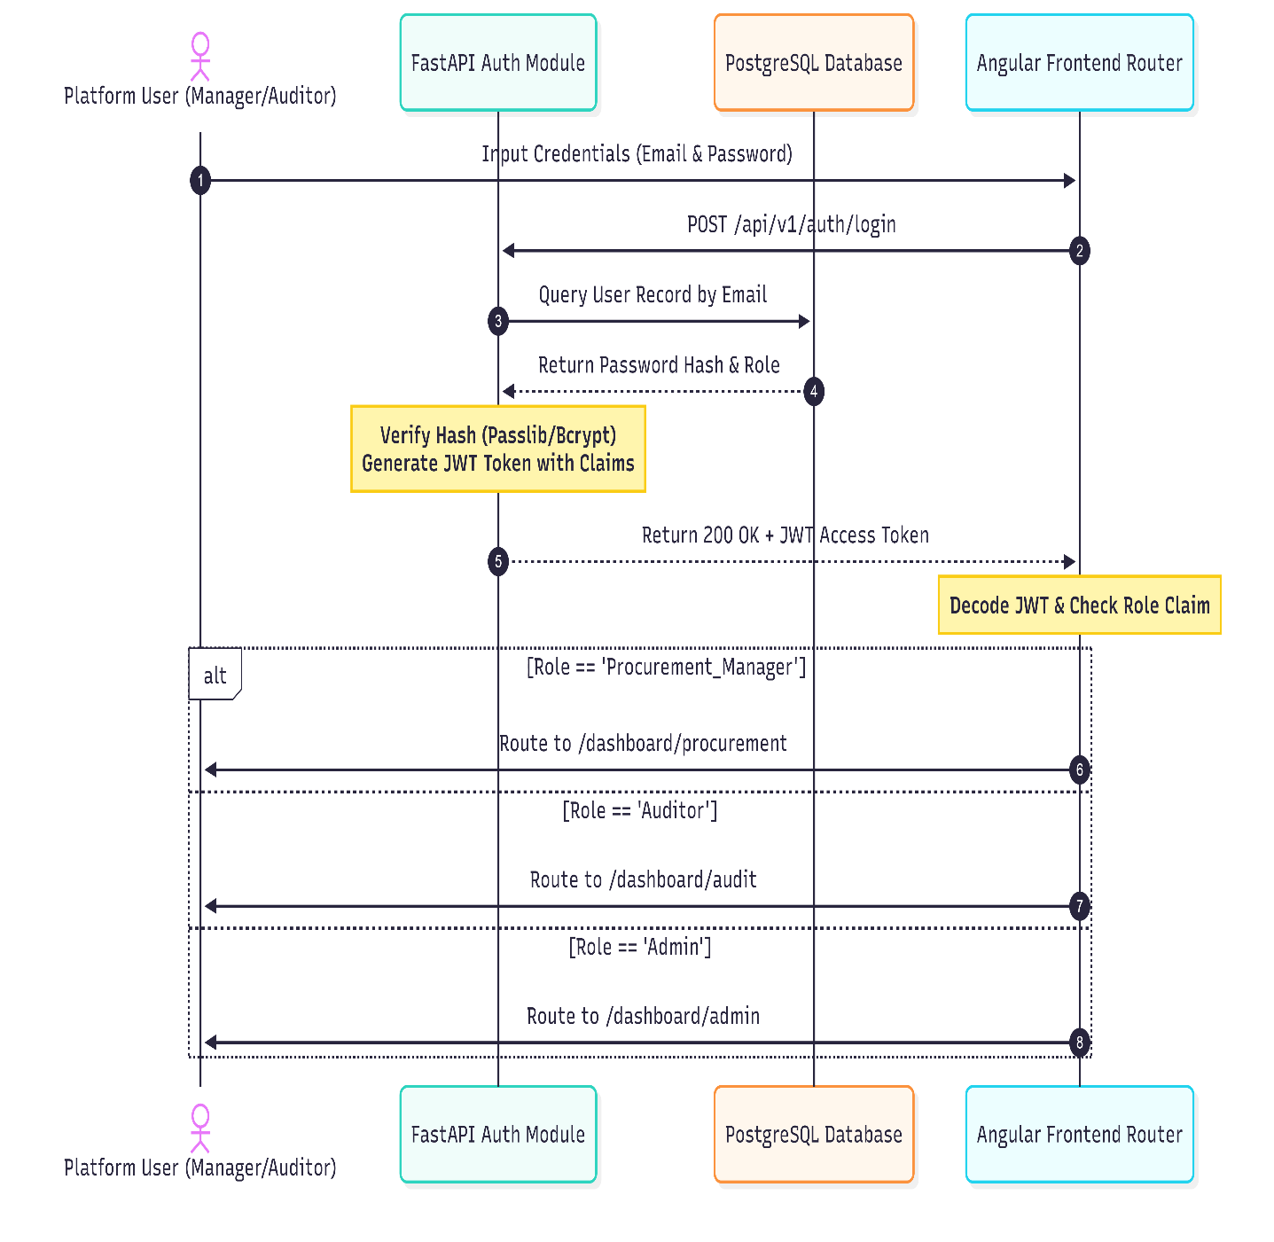

Workflow 2: Vendor Onboarding & Verification Flow:
Objective:
To demonstrate the procurement lifecycle from creating procurement requests to tracking purchase orders and monitoring deliveries.
- This workflow handles the entry point for third-party suppliers, detailing how a raw applicant transitions into an active, verified vendor on the platform.

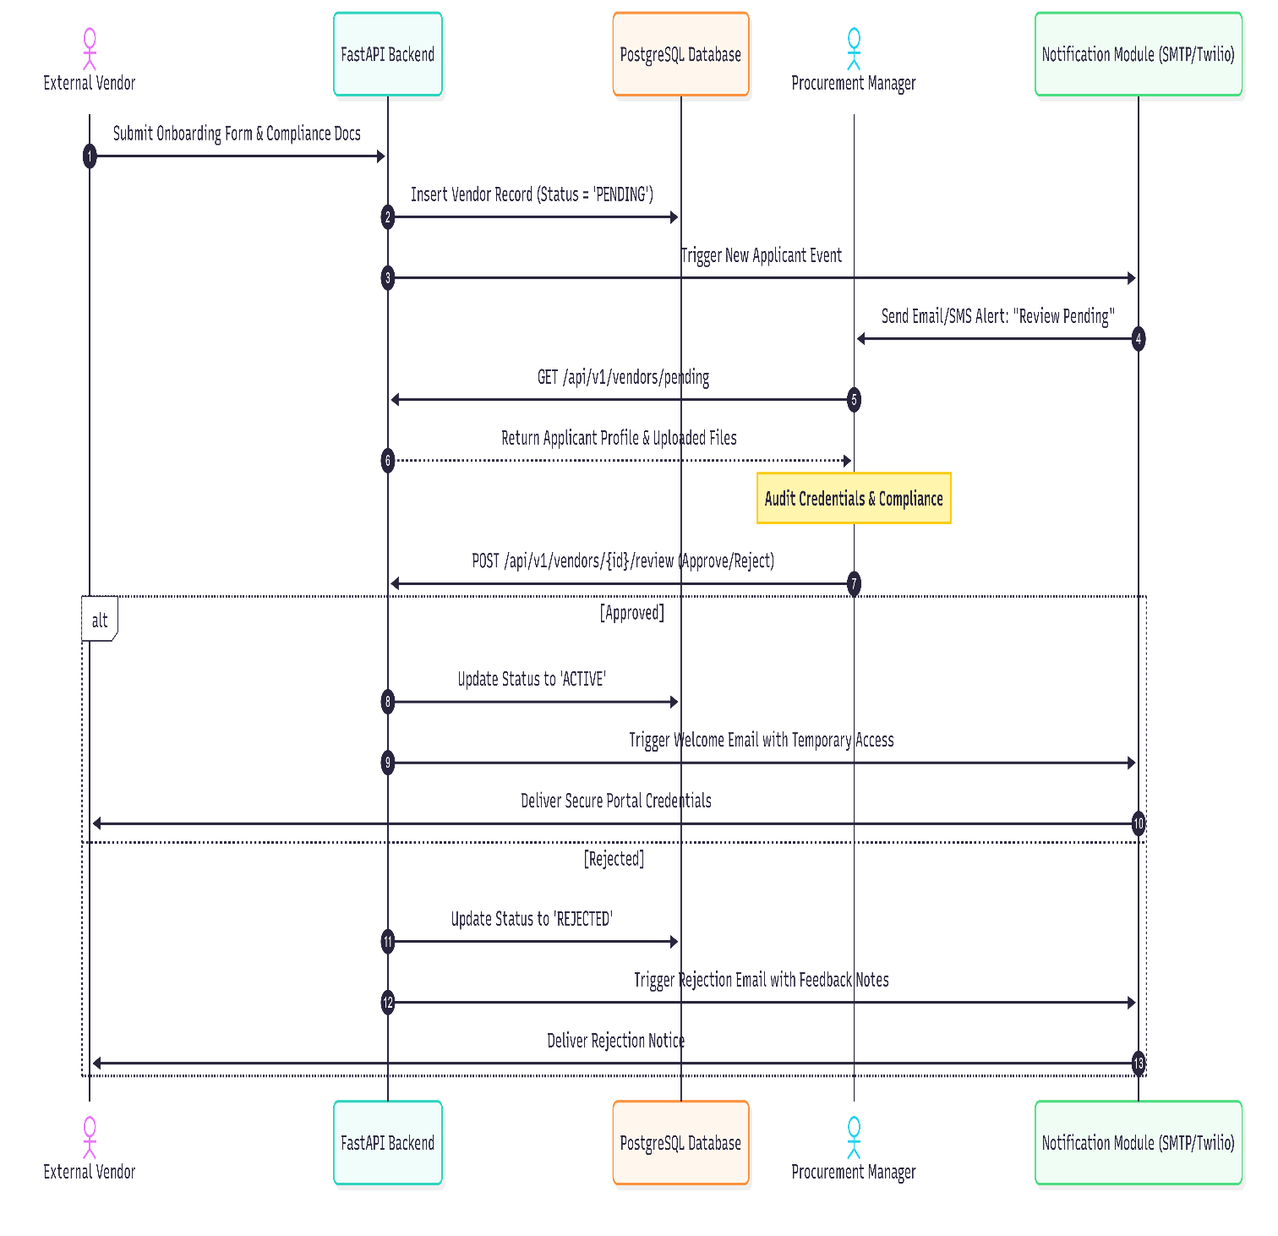

Workflow 3: Procurement Lifecycle & Purchase Order Flow:
Objective:
To show how vendors manage their profiles, process purchase orders, monitor performance, and maintain compliance documentation.
- This represents the primary day-to-day operational loop of the platform—turning an internal material requirement into an actively tracked purchase order dispatched to a high-performing supplier.

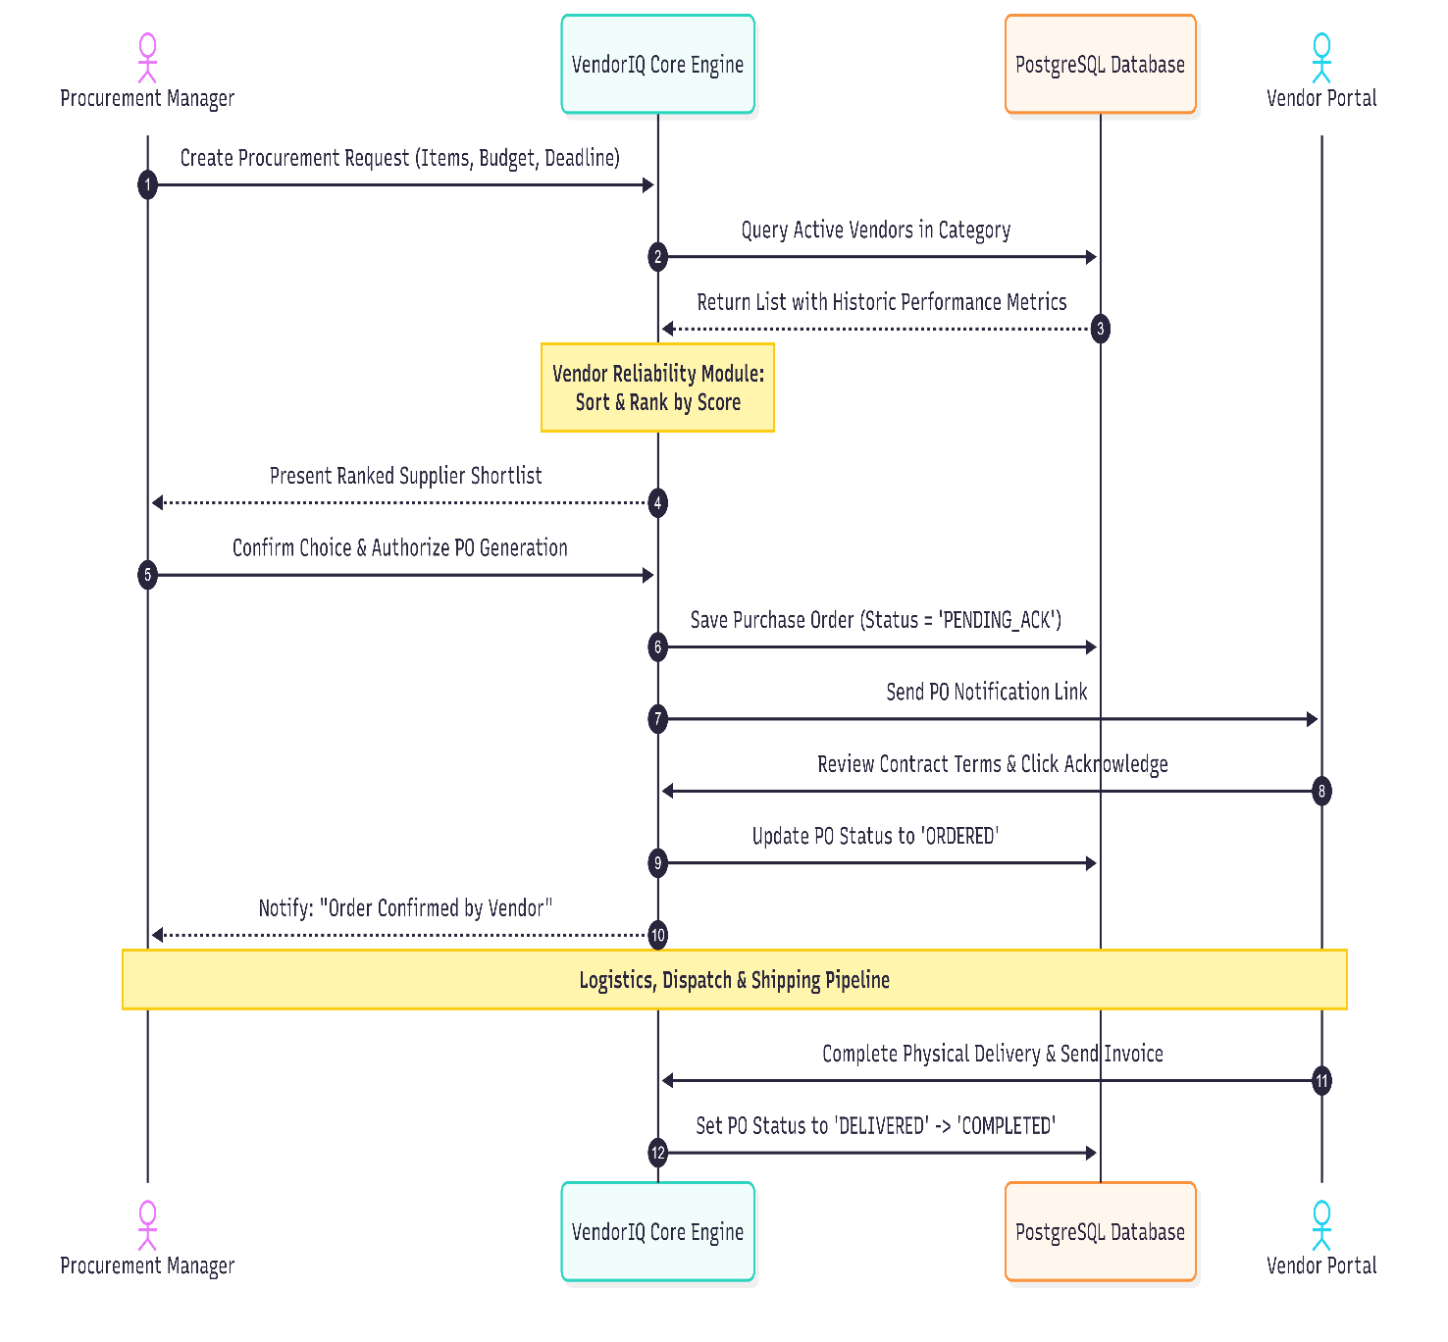

Workflow 4: Performance Analytics & Report Generation Flow:
Objective:
To describe how finance officers review invoices, approve payments, and generate procurement financial reports.
- This background workflow turns raw transaction histories into analytical data insights, providing the business intelligence and reporting metrics required for stakeholder evaluations.
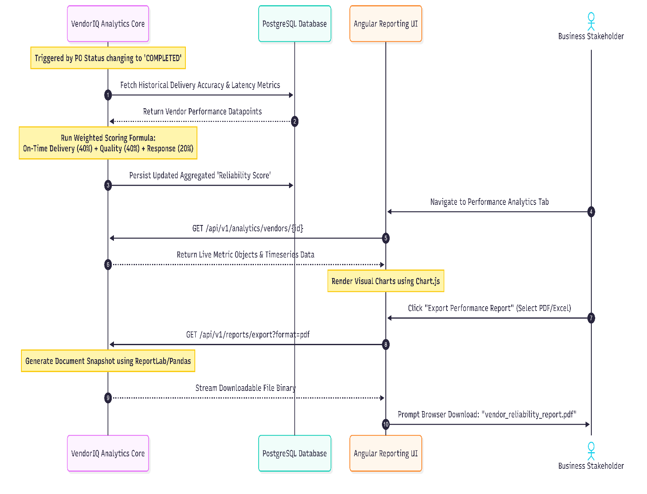

Conclusion:
The user flow diagrams developed during Milestone 1 provide a clear representation of how different users interact with the Vendor Reliability Intelligence Platform. By outlining the workflows for Administrators, Procurement Managers, Vendors, Finance Officers, and Auditors, these diagrams establish a structured understanding of system navigation and business processes. They serve as a blueprint for implementing user-centric features and ensure consistency throughout the development phase.

