Palmistry & Tarot Intelligence Platform
Project Objectives, Reading Workflows, System Architecture & Database Schema

1. Project Overview
The Palmistry & Tarot Intelligence Platform is an AI-powered application designed to analyze palm images and tarot card selections and generate personalized spiritual insights. The platform combines computer vision, symbolic analysis, tarot reading workflows, AI interpretation, and interactive guidance. The intended insight areas include personality traits, relationships, career growth, life trends, strengths, opportunities, and self-reflection.
For Milestone 1, the project focuses on defining the reading workflows, designing the system architecture and database schema, preparing the frontend and backend foundations, and establishing authentication, user profiles, and reference datasets. Palm-analysis intelligence and advanced AI interpretation are planned for later milestones.

2. Project Objectives
- Develop a platform that accepts palm images and tarot card selections as inputs for spiritual reading workflows.
- Provide a structured palm-analysis workflow covering image upload, preprocessing, feature extraction, palm-line detection, and pattern recognition.
- Provide a structured tarot workflow covering deck selection, card shuffling, card selection, spread generation, and card interpretation.
- Generate personalized insights related to personality, relationships, career, finance, health and wellness, personal growth, and life opportunities.
- Maintain user profiles containing interests, spiritual goals, reading preferences, and session history.
- Provide secure authentication and role-based access for User, Tarot Reader, Spiritual Consultant, and Administrator roles.
- Maintain reading history and prepare the platform for dashboards, reports, recommendations, and analytics.
- Use the specified technology stack as the implementation foundation: Python/FastAPI, React.js, PostgreSQL, computer-vision tools, NLP/interpretation tools, and development/deployment tools.

3. Reading Workflows

3.1 Overall User Reading Workflow
The overall application workflow begins with authentication and profile context. The user then selects either a palm reading or tarot reading. The selected workflow produces a reading that can be stored in the user's history and later used by the personalization and analytics modules.
START → Register/Login → JWT Authentication → Dashboard → Select Reading Type → Palm Reading OR Tarot Reading → Generate/Display Reading → Save Reading → Reading History → END

3.2 Palmistry Reading Workflow
- User logs in and opens the Palm Reading module.
- User uploads a palm image.
- The image is preprocessed for subsequent computer-vision analysis.
- The system performs hand/palm localization and feature extraction.
- Palm lines and palm characteristics are analyzed. The project specification identifies the Life Line, Head Line, Heart Line, Fate Line, Sun Line, Palm Shape, and Finger Structure as palm features to be analyzed.
- The extracted features are passed to the interpretation stage.
- A palm interpretation is generated and associated with the user's context.
- The resulting palm reading is stored in the reading history.

3.3 Tarot Reading Workflow
- User logs in and opens the Tarot Reading module.
- User selects a tarot reading/spread.
- The system selects or loads the tarot deck.
- Cards are shuffled through the application's card-selection workflow.
- Cards are selected according to the chosen spread.
- The selected cards are mapped to their interpretation information.
- A reading is generated for the selected spread and user context.
- The reading is stored in the user's reading history.
Supported spreads specified in the project document:
- Single Card Reading
- Three Card Reading
- Relationship Spread
- Career Spread
- Celtic Cross Spread
- Life Path Spread

3.4 Personalization / Future Reading Synthesis Workflow
The project specification describes a later AI interpretation stage that combines palm interpretation, tarot interpretation, user context, and consistency information to generate personalized guidance.
Palm Analysis + Tarot Interpretation + User Context → Context-Aware Insight Generation → Personalized Guidance → Personality / Relationship / Career / Finance / Wellness / Growth / Opportunity Insights

4. Flow Diagram
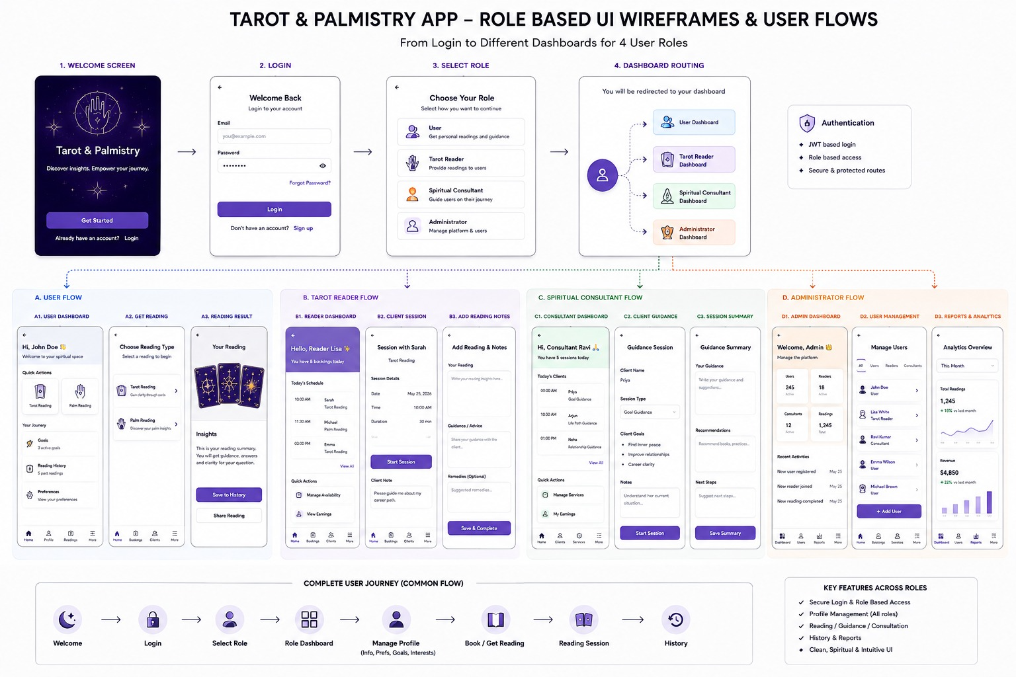
The flow diagram illustrates the complete workflow of the Palmistry & Tarot Intelligence Platform. It shows how a user logs in, selects either a palmistry or tarot reading, provides the required input, and proceeds through analysis and interpretation. The system then generates a personalized reading, saves the result in the user's history, and provides recommendations and insights. The diagram also shows the overall frontend, backend, AI/ML services, database, and file-storage architecture and how these components interact to process user readings.

5. Major Architecture Components
Frontend Layer: React.js provides the user interface for registration, login, dashboard, profile, palm reading, tarot reading, reading history, and later analytics.
Backend/API Layer: Python and FastAPI expose the application's APIs and coordinate authentication, profile management, reading workflows, database operations, and later AI services.
Authentication Layer: JWT authentication protects user-specific and role-specific APIs. The project also lists OAuth2 login as an authentication requirement.
Palm Analysis Layer: OpenCV, MediaPipe, YOLO, TensorFlow, and PyTorch are listed for computer-vision and machine-learning tasks such as hand/palm processing, feature extraction, detection, and classification.
Tarot Intelligence Layer: The tarot engine manages deck selection, shuffling, card selection, spreads, and interpretation.
AI/NLP Layer: LangChain, Hugging Face Transformers, OpenAI APIs, and Sentence Transformers are listed for interpretation and context-aware insight generation.
Database Layer: PostgreSQL is the primary database; MongoDB is listed as a secondary database option.
Analytics Layer: Chart.js and Plotly are listed for dashboard and visualization functionality in later stages.
DevOps Layer: Docker, Docker Compose, GitHub Actions, and AWS/Azure are listed for containerization, CI/CD, and deployment.

6. Database Schema
The following relational schema is proposed for the core application foundation. It directly supports the Week 1–2 requirements for authentication, role-based access, profiles, and reading history, while also providing storage structures for the later palm and tarot modules.
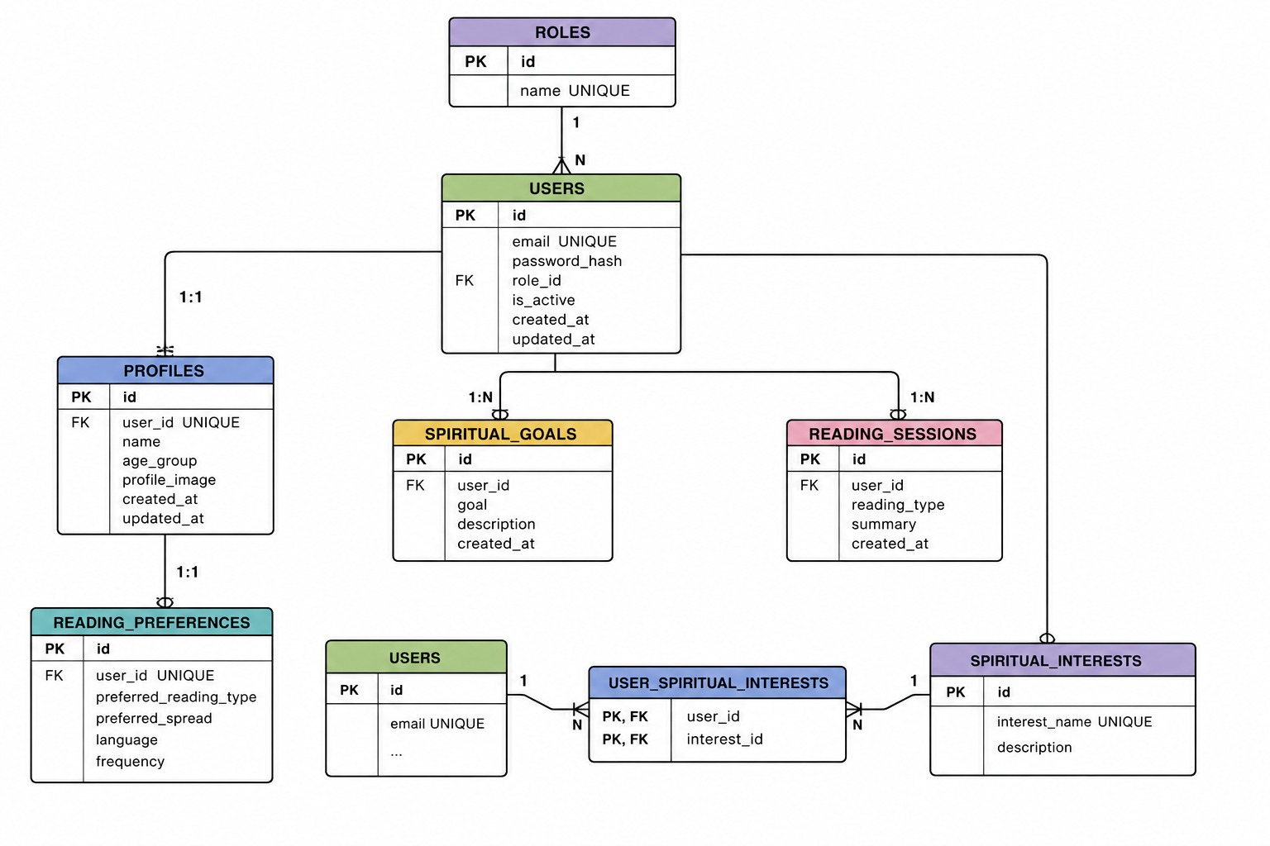

7. Database Relationships
- One User has one primary User Profile.
- One User can have many Palm Readings.
- One User can have many Tarot Readings.
- One User can have many Reading History records.
- Each Reading History record references a palm or tarot reading.
- The user role stored in the users table supports role-based authorization.
Relationship summary: USERS 1—1 USER_PROFILES; USERS 1—M PALM_READINGS; USERS 1—M TAROT_READINGS; USERS 1—M READING_HISTORY.

8. Reference Datasets Required
Dataset | Purpose | Milestone 1 Action
Palmistry Image Dataset | Palm line detection, palm feature extraction, palm classification | Identify, obtain, document source/license, and organize data.
Hand Landmark Dataset | Hand segmentation, palm structure analysis, finger pattern detection | Identify, obtain, document annotations/landmarks, and organize data.
Tarot Card Image Dataset | Tarot card recognition, card classification, card interpretation support | Identify, obtain, document source/license, and organize card images/metadata.

9. Quantitative Goals
The project specification states qualitative quantitative-goal categories rather than fixed numeric thresholds. The goals are therefore treated as evaluation objectives, not as numerical targets invented for this document.
- Palm Analysis: provide accurate palm feature extraction and interpretation generation.
- Tarot Intelligence: generate engaging and context-aware tarot reading experiences.
- Personalized Guidance: deliver relevant personality insights and growth recommendations.
- User Engagement: increase reading completion and platform engagement through interactive experiences.
- Platform Performance: support large-scale reading generation and analytics workflows while maintaining stable performance and responsiveness.

