INTERNSHIP PROJECT REPORT
on
Supportlytics
Optimizing IT Support Team Performance Using Analytics
Submitted as part of
Infosys Springboard Virtual Internship 7.0 (Batch 1)
Submitted by
ALAVALA NEHA
Under the Guidance of
Shanmukha Priya
Data Scientist, Infosys Springboard
Internship Duration: 19 June 2025 – 8 Weeks

Acknowledgement
I would like to express my sincere gratitude to Infosys Springboard for providing me the opportunity to undertake this internship. I am especially thankful to my mentor, Ms. Shanmukha Priya, Data Scientist, for continuous guidance, valuable feedback, and encouragement throughout the course of this project.
This internship gave me hands-on exposure to real-world data analytics workflows — from data cleaning and exploratory analysis to clustering, performance benchmarking, and dashboard development — and helped me strengthen my practical skills in Python, data visualization, and analytical thinking.

Abstract
Supportlytics is a data analytics project undertaken to optimize the performance of an IT support team by analyzing historical support ticket data. The project involved acquiring and cleaning a 12,000-record IT support ticket dataset, engineering features such as resolution duration and priority score, and performing exploratory data analysis to understand ticket volume, category, and priority trends.
Cluster and similarity analysis was used to group tickets into 15 problem clusters (e.g., Login & Access Failures, Application Crashes / Bugs, Network Connectivity Issues) and evaluate resolution consistency using similarity scores. Performance trend analysis compared resolution times across ticket priorities, types, teams, and countries to identify bottlenecks and high-priority unresolved issues. Geographic analysis mapped ticket concentration and category distribution across 15 countries and 3 regions (APAC, AMER, EMEA).
The findings were consolidated into a performance dashboard presenting key performance indicators — average resolution duration, most frequent categories, cluster similarity index, and SLA compliance by region — enabling data-driven recommendations for workflow and resource optimization.

1. Introduction

1.1 Project Statement
The objective of this project is to analyze IT support ticket data to identify key performance trends, optimize resolution times, and enhance service efficiency through data analysis and visualization. The goal is to uncover patterns in customer requests, technical issues, and support performance metrics to recommend improvements in workflow and resource allocation.

1.2 Expected Outcomes
- Understand and preprocess IT support ticket data for analysis.
- Explore trends in ticket volume, priority, resolution time, and category distribution.
- Identify clusters of similar issues using similarity scores and clustering techniques.
- Visualize performance metrics through dashboards and charts.
- Derive actionable insights to optimize IT support operations.
- Summarize findings in a final analytical report and presentation.

1.3 Tools & Technologies Used
- Python — pandas, NumPy for data processing
- Matplotlib, Seaborn — statistical visualizations
- Geographic coordinates (Latitude/Longitude) — regional mapping
- Power BI / Streamlit — interactive dashboard development
- Jupyter Notebook — development environment

1.4 Dataset Overview
The project uses an internal IT support ticket dataset (IT_Support_Ticket_Dataset_Cleaned.csv) containing 12,000 tickets across 36 fields, including Ticket_Type, Priority, Category, Cluster_ID, Cluster_Name, Similarity_Score, Created_Date, Resolution_Date, Country, Region, Team, SLA_Status, Reopened, and Status.
Unlike a purely synthetic dataset, this one carries realistic data-quality gaps: 941 tickets (7.8%) have no Resolution_Date because they are still Open or In Progress, and the Customer_Satisfaction field is populated for only a small subset of tickets — so SLA_Status and Reopened were used as the primary performance/quality signals instead of customer satisfaction scores.

2. Milestone 1 (Week 1–2): Data Setup, Cleaning & Feature Engineering

Module 1: Project Initialization and Dataset Setup
The dataset was loaded using pandas and its schema, data types, and missing values were explored. Initial distributions of Ticket_Type, Priority, and Category were calculated to understand the composition of the raw data.
import pandas as pd

df = pd.read_csv("IT_Support_Ticket_Dataset_Cleaned.csv")
df.shape # (12000, 36) records
df.info() # schema & dtypes
df.isnull().sum() # missing value check
df['Ticket_Type'].value_counts()
df['Priority'].value_counts()
df['Category'].value_counts()

Key finding: The dataset consists of 12,000 tickets spanning four ticket types — Incident (5,415), Request (4,122), Problem (1,819), and Change (644) — with no missing values in the core categorical columns. The only nulls occur in Resolution_Date / Resolution_Duration (941 rows) and Customer_Satisfaction, both explained by tickets that are not yet closed.

Module 2: Data Cleaning and Feature Engineering
Text fields were stripped of whitespace, duplicate records were checked, and date columns were converted to proper datetime format. Two engineered features were central to the analysis:
- Resolution_Duration — Resolution_Date minus Created_Date, in days (already provided in the source data and validated).
- Priority_Score — an ordinal encoding of Priority (Low=1, Medium=2, High=3, Critical=4) to support quantitative comparison (already provided in the source data and validated).
text_columns = df.select_dtypes(include='object').columns
for col in text_columns:
df[col] = df[col].str.strip()

df['Created_Date'] = pd.to_datetime(df['Created_Date'])
df['Resolution_Date'] = pd.to_datetime(df['Resolution_Date'])

priority_map = {'Low': 1, 'Medium': 2, 'High': 3, 'Critical': 4}
assert (df['Priority'].map(priority_map) == df['Priority_Score']).all()

df.to_csv('support_tickets_processed.csv', index=False)

Deliverables: A cleaned, validated dataset with confirmed Resolution_Duration and Priority_Score columns, ready for exploratory and cluster analysis.

3. Milestone 2 (Week 3–4): Exploratory & Cluster Analysis

Module 3: Exploratory Visualization
Ticket type distribution, top issue categories, and priority distribution across support teams were visualized to establish a baseline understanding of workload composition.
type_counts = df['Ticket_Type'].value_counts()
sns.barplot(x=type_counts.index, y=type_counts.values, palette='Blues_r')

top_categories = df['Category'].value_counts()
sns.barplot(y=top_categories.index, x=top_categories.values, palette='viridis')

sns.countplot(data=df, x='Team', hue='Priority') # priority by team

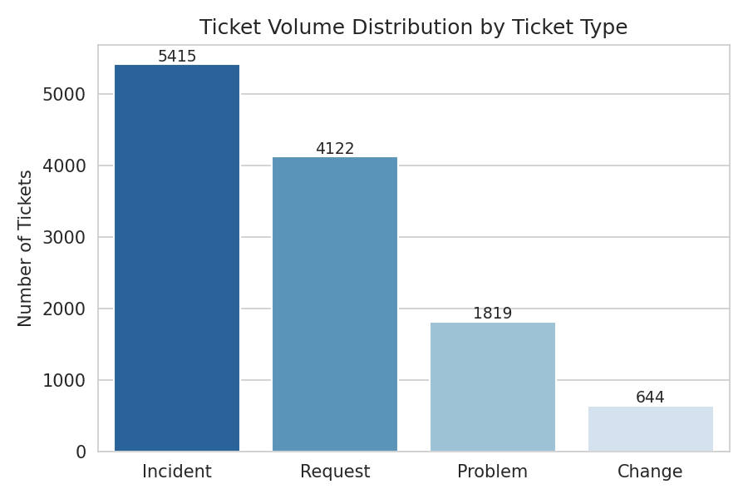
Fig 3.1: Ticket Volume Distribution by Ticket Type — Incidents dominate with 5,415 tickets, followed by Requests (4,122), Problems (1,819), and Changes (644).
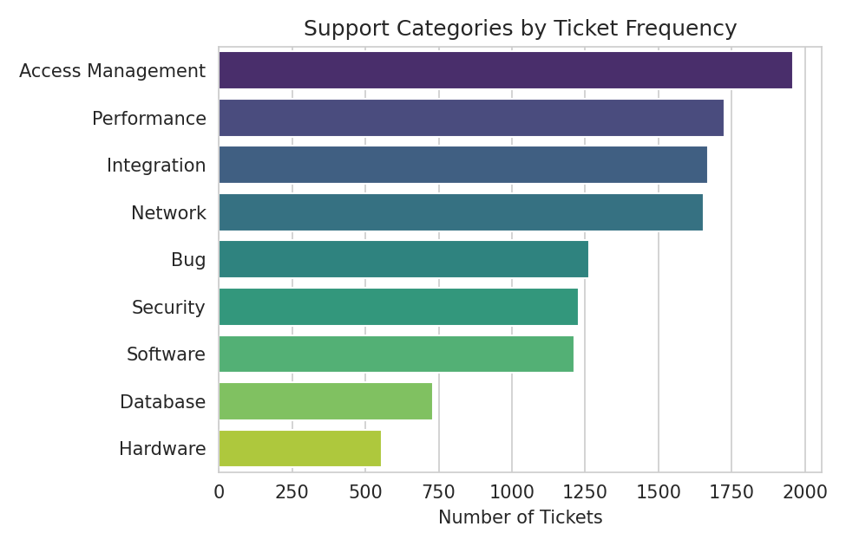
Fig 3.2: Support Categories by Ticket Frequency — Access Management is the largest category (1,959 tickets, 16.3% of all tickets), followed by Performance (1,727) and Integration (1,669).
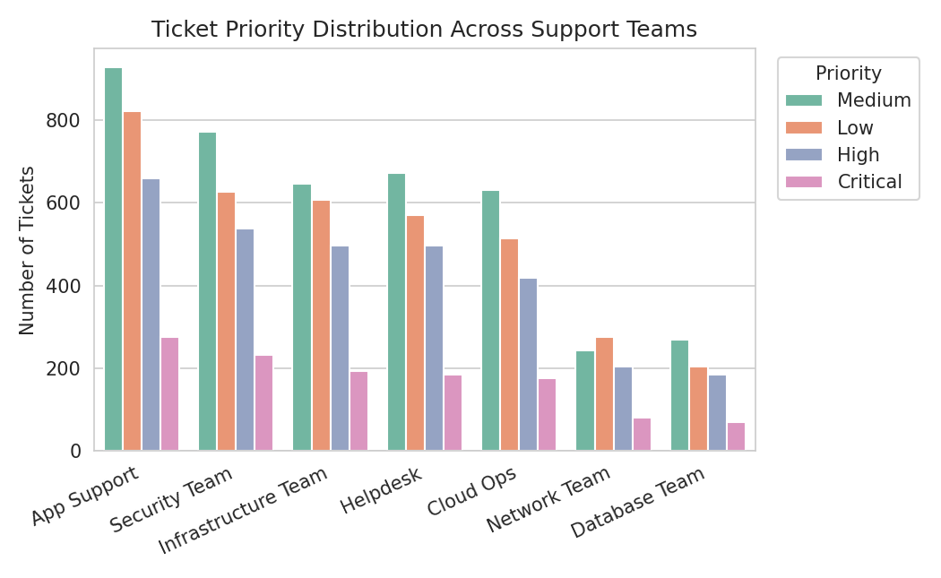
Fig 3.3: Ticket Priority Distribution Across Support Teams — App Support and Security Team carry the highest overall ticket volumes across all priority levels.
Key finding: Incidents make up 45.1% of ticket volume, making incident-handling efficiency a key lever for overall performance. Access Management is the single largest category at 16.3% of all tickets, ahead of Performance and Integration issues.

Module 4: Similarity and Cluster Insights
Tickets were grouped by Cluster_Name to study cluster size and average similarity score, indicating how consistently similar issues within a cluster were classified. Boxplots, bar charts, and a violin plot were used to analyze cluster quality and performance gaps.
similarity_summary = df.groupby('Cluster_Name').agg(
Ticket_Count=('Ticket_ID', 'count'),
Average_Similarity=('Similarity_Score', 'mean'),
Median_Similarity=('Similarity_Score', 'median'))

sns.boxplot(data=df, y='Cluster_Name', x='Similarity_Score') # spread by cluster
sns.violinplot(data=df, x='Priority', y='Similarity_Score') # score vs priority

Cluster Name | Tickets | Avg. Similarity | Median
Login & Access Failures | 1,354 | 0.575 | 0.57
Application Crashes / Bugs | 1,263 | 0.700 | 0.70
Network Connectivity Issues | 1,197 | 0.608 | 0.61
Performance Degradation | 973 | 0.758 | 0.76
API Integration Errors | 930 | 0.641 | 0.64
Software Installation Issues | 827 | 0.823 | 0.83
Slow Response Times | 754 | 0.901 | 0.91
Data Sync / Integration Delays | 739 | 0.847 | 0.85
Security Vulnerabilities | 734 | 0.671 | 0.67
Database Query Failures | 730 | 0.789 | 0.79
Permission / Role Errors | 605 | 0.950 | 0.97
Hardware Malfunctions | 557 | 0.734 | 0.73
Suspicious Login Attempts | 493 | 0.879 | 0.88
Server Downtime | 458 | 0.930 | 0.94
Patch & Update Failures | 386 | 0.962 | 0.99

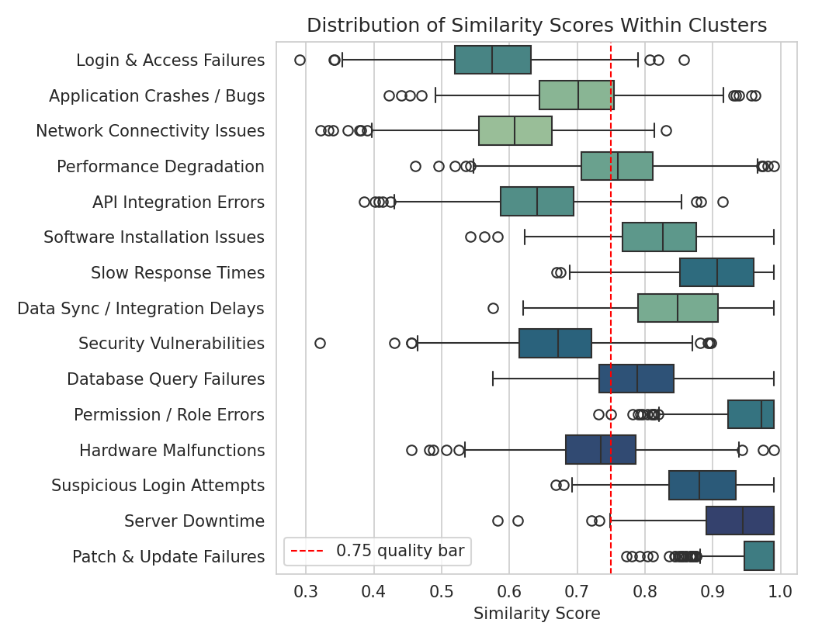
Fig 3.4: Distribution of Similarity Scores Within Clusters, ordered by cluster size, against the 0.75 quality threshold.
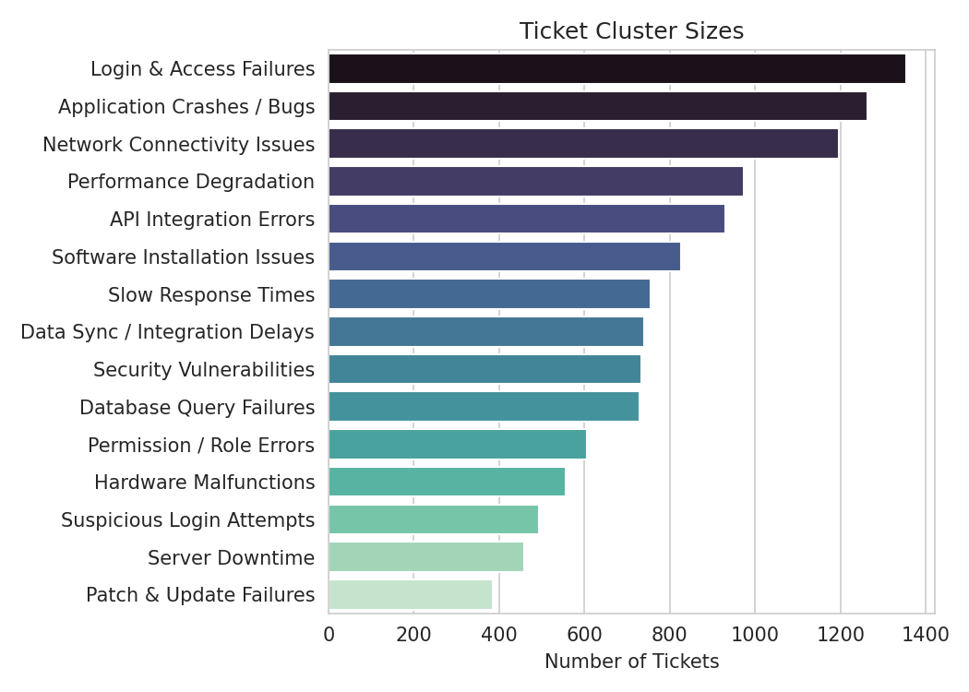
Fig 3.5: Ticket Cluster Sizes — Login & Access Failures is the largest cluster with 1,354 tickets.
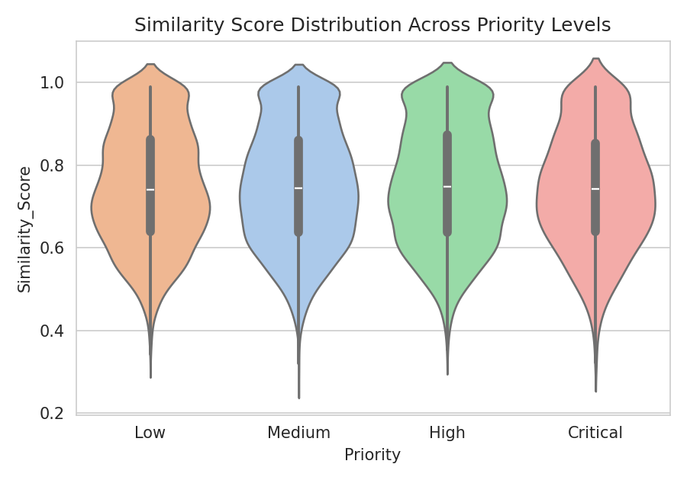
Fig 3.6: Similarity Score Distribution Across Priority Levels — similarity spread is broadly consistent regardless of priority, indicating priority does not bias classification confidence.
Key finding: Cluster quality is far less uniform than a 0.75-and-above baseline: average similarity ranges from 0.57 (Login & Access Failures) to 0.96 (Patch & Update Failures). Login & Access Failures — also one of the largest clusters at 1,354 tickets — sits well below the quality bar, meaning tickets grouped under it are more loosely related than the label suggests and may need re-clustering or sub-categorization.

4. Milestone 3 (Week 5–6): Performance & Geographic Insights

Module 5: Performance Trend Analysis
Average resolution times were compared across ticket priority and type, support teams were ranked by resolution speed, and high-priority unresolved tickets were isolated for escalation review.
df.groupby(['Ticket_Type', 'Priority'])['Resolution_Duration'].mean()

team_speed = df.groupby('Team')['Resolution_Duration'].mean().sort_values()

unresolved_high_priority = df[
df['Status'].isin(['Open', 'In Progress']) &
df['Priority'].isin(['High', 'Critical'])]
print(f"Total High & Critical Unresolved Tickets: {len(unresolved_high_priority)}")

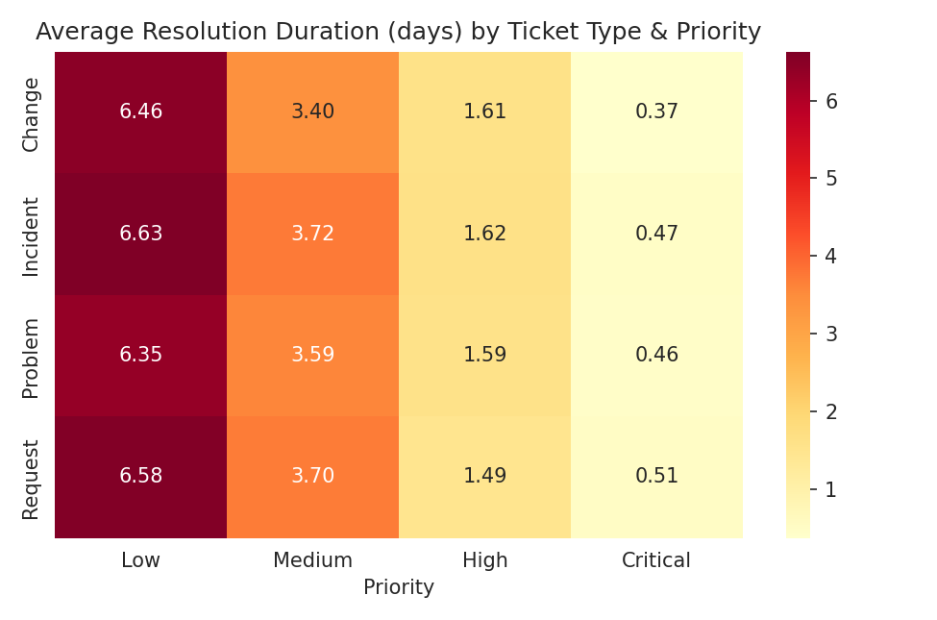
Fig 4.1: Average Resolution Duration (days) by Ticket Type and Priority — resolution time drops sharply as priority increases, from ~6.5 days at Low priority to well under a day at Critical.
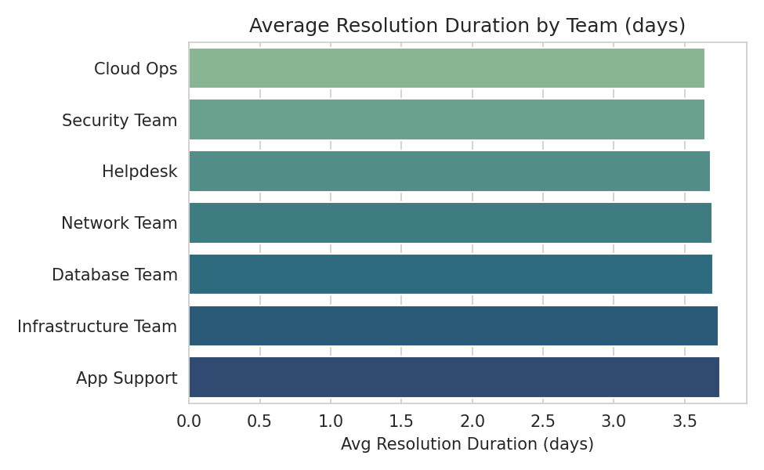
Fig 4.2: Average Resolution Duration by Team — Cloud Ops resolves tickets fastest (3.64 days on average), App Support the slowest (3.75 days).
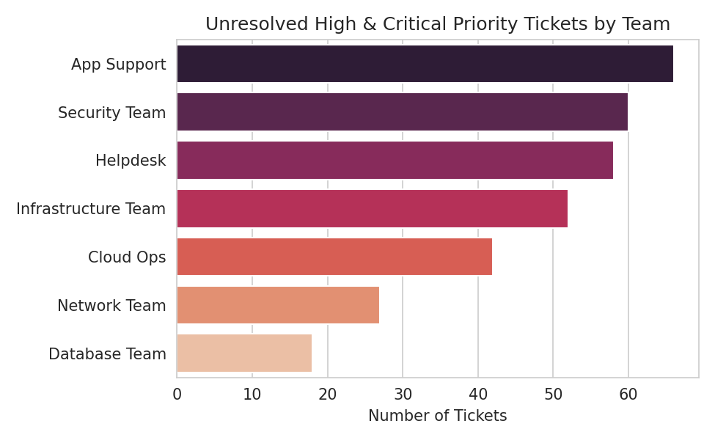
Fig 4.3: Unresolved High & Critical Priority Tickets by Team — App Support carries the largest backlog (66 tickets).
Key finding: A total of 323 High and Critical priority tickets remain unresolved (Open or In Progress), concentrated most heavily in App Support (66) and Security Team (60) — a direct risk to SLA compliance. Team resolution speed is fairly uniform overall (3.64–3.75 days), so the backlog is more a workload/staffing issue than a systemic slowness problem in any one team.

Module 6: Geographic and Category-Level Insights
Ticket concentration was mapped by country and category using a heatmap, ticket locations were plotted using latitude/longitude, and SLA breach rate was evaluated by country and region.
geo_heatmap_data = pd.crosstab(df['Country'], df['Category'])
sns.heatmap(geo_heatmap_data, annot=True, fmt='d', cmap='YlGnBu')

country_summary = df.groupby('Country').agg(
Total_Tickets=('Ticket_ID', 'count'),
Avg_Resolution_Duration=('Resolution_Duration', 'mean'))
sla_breach_rate = df.groupby('Country').apply(
lambda g: 100 * (g['SLA_Status'] == 'Breached').mean())

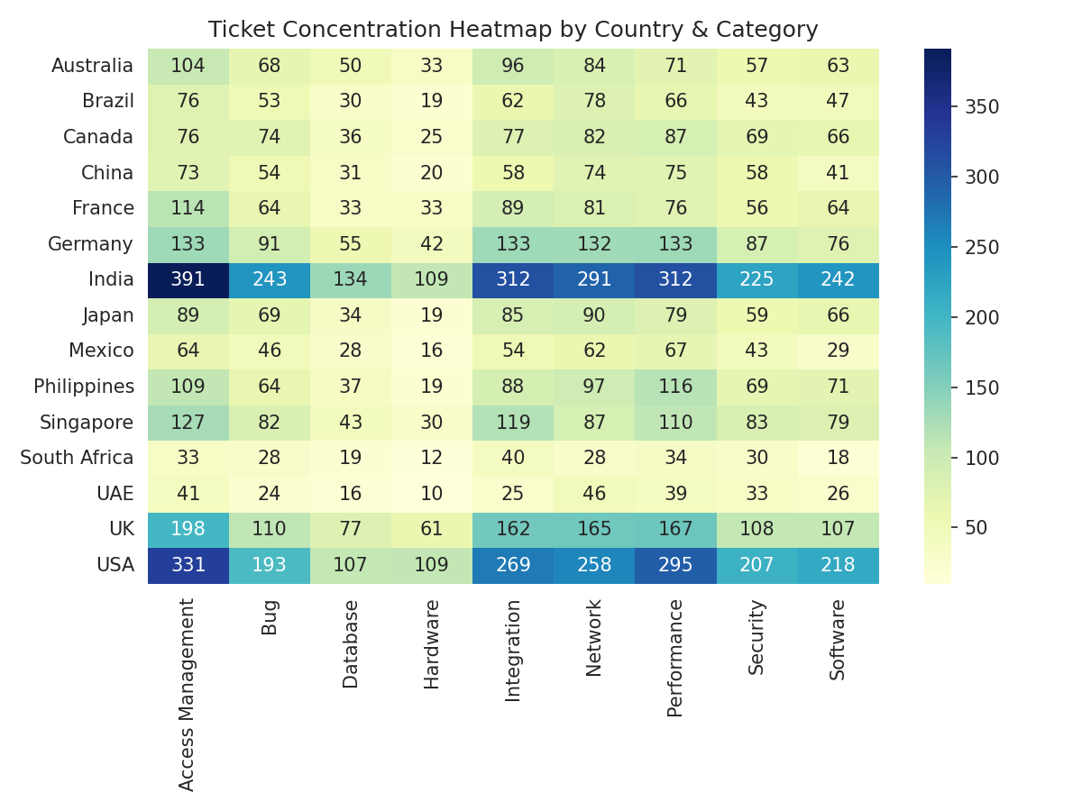
Fig 4.4: Ticket Concentration Heatmap by Country & Category.
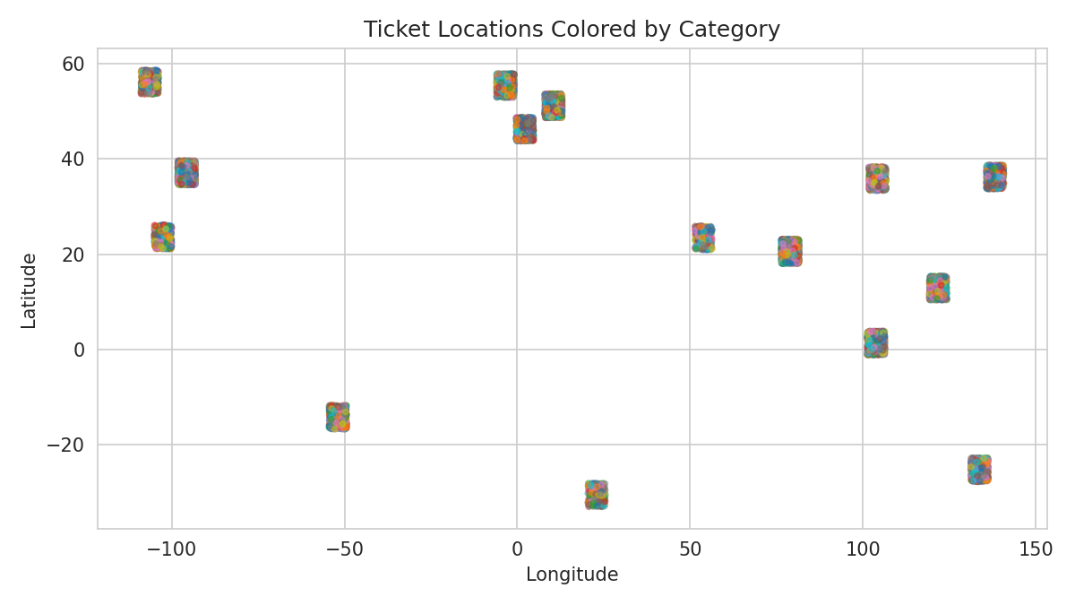
Fig 4.5: Ticket Locations Colored by Category — confirms tickets are drawn from geographically distinct regional hubs rather than a single location per country.
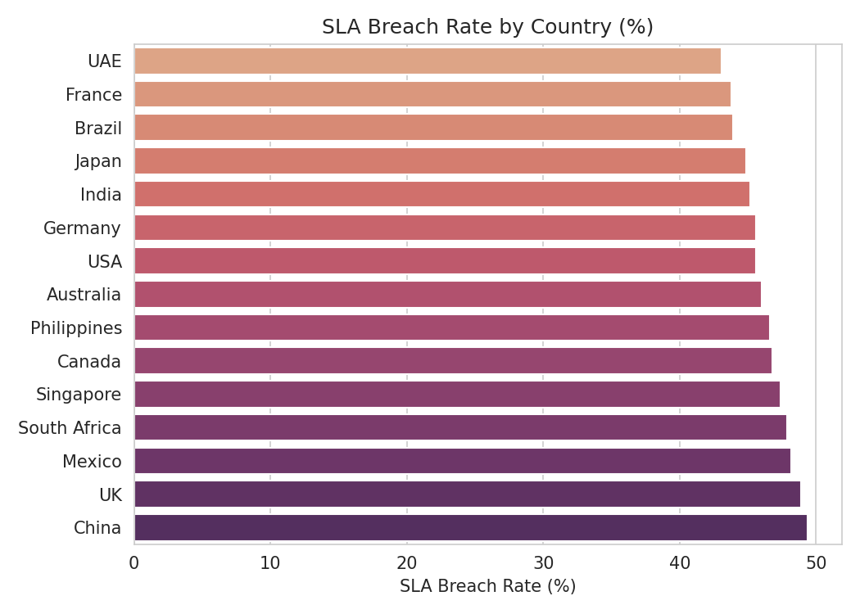
Fig 4.6: SLA Breach Rate by Country — China has the highest breach rate (49.4%), UAE the lowest (43.1%).
Country | Total Tickets | Avg. Resolution (days) | SLA Breach Rate
India | 2,259 | 3.68 | 45.2%
USA | 1,987 | 3.62 | 45.6%
UK | 1,155 | 3.70 | 48.9%
Germany | 882 | 3.64 | 45.6%
Singapore | 760 | 3.84 | 47.4%
Philippines | 670 | 3.95 | 46.6%
Australia | 626 | 3.59 | 46%
France | 610 | 3.53 | 43.8%
Canada | 592 | 3.76 | 46.8%
Japan | 590 | 3.50 | 44.9%
China | 484 | 3.80 | 49.4%
Brazil | 474 | 3.95 | 43.9%
Mexico | 409 | 3.81 | 48.2%
UAE | 260 | 3.43 | 43.1%
South Africa | 242 | 3.97 | 47.9%

Key finding: India records the highest ticket volume (2,259), while China has the weakest SLA performance at a 49.4% breach rate versus UAE's 43.1% — a gap worth investigating for regional staffing or process differences. Overall, 46.1% of all tickets breach SLA, which is high enough to be a headline operational concern rather than a country-specific one.

5. Milestone 4 (Week 7–8): Dashboard & Documentation

Module 7: Dashboard/Report Preparation
All performance insights were consolidated into a single-page operational dashboard, organized around four core KPIs: Ticket Volume by Type, Top Problem Clusters, Average Resolution Duration by Type × Priority, and SLA Breach Rate by Country.
import streamlit as st
import pandas as pd, plotly.express as px

st.set_page_config(page_title='Supportlytics | IT Operational Dashboard',
page_icon='bar_chart', layout='wide')
st.title('Supportlytics — IT Support Operational Dashboard')

# KPI cards: Avg Resolution Duration | Top Categories |
# Cluster Similarity Index | SLA Breach Rate by Country
# Interactive charts filtered by Country, Priority, and Category

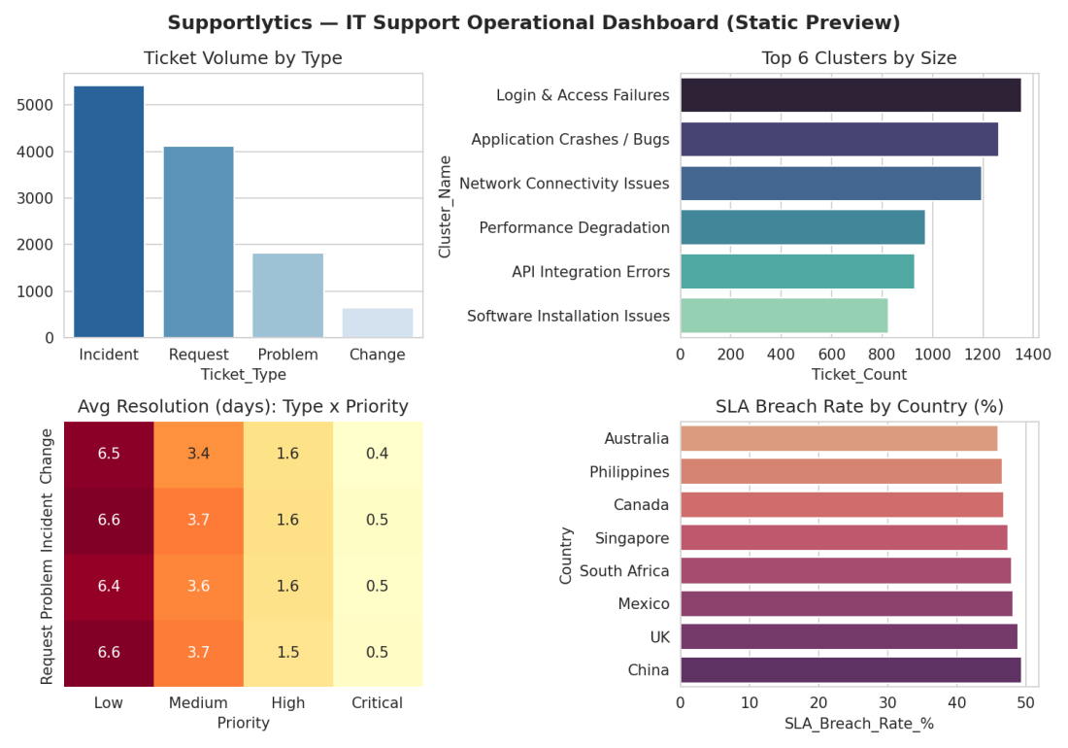
Fig 5.1: Static dashboard preview combining the four core KPIs. A live version can be built in Streamlit or Power BI using the same aggregations, with sidebar filters for Country, Priority, and Team.
Across the full dataset, Access Management remains the most frequent ticket category (16.3% share) and average resolution duration holds at 3.7 days overall, while SLA breach rate (46.1%) and cluster similarity vary enough by segment that filtering by team, country, or cluster surfaces materially different pictures.

Module 8: Documentation and Presentation
- Final project report compiled summarizing objectives, methodology, and insights (this document).
- Presentation slides prepared highlighting key findings and recommendations.
- Code, visualizations, and processed dataset organized for submission / GitHub upload.

6. Key Insights & Recommendations

6.1 Key Insights
- Incidents make up 45.1% of all ticket volume (5,415 of 12,000), making incident-handling efficiency the single biggest lever for overall performance.
- Access Management is the dominant category (16.3% of tickets), indicating a need for stronger self-service password/access tooling to deflect routine requests.
- Cluster quality is uneven: similarity ranges from 0.57 to 0.96 across clusters. Login & Access Failures, despite being one of the largest clusters (1,354 tickets), sits well below a 0.75 quality bar and is a strong candidate for re-clustering.
- 323 High/Critical priority tickets remain unresolved, concentrated in App Support and Security Team — a direct SLA risk.
- 46.1% of all tickets breach SLA overall, and China underperforms further at 49.4% versus UAE's 43.1%, suggesting a regional process or staffing gap.
- 7.3% of tickets are reopened after being marked resolved, a useful secondary signal of first-time-fix quality alongside resolution duration.

6.2 Recommendations
- Prioritize additional resourcing or automation in App Support and Security Team to reduce the backlog of unresolved High/Critical tickets.
- Investigate root causes behind the low similarity score in Login & Access Failures and consider splitting it into more specific sub-clusters or dedicated routing rules.
- Expand self-service documentation and automated workflows for Access Management issues, which dominate ticket volume.
- Review staffing and process consistency in China to close the regional SLA-compliance gap.
- Continue monitoring similarity scores and reopen rates over time; clusters or regions drifting outside acceptable thresholds should trigger a targeted review.

7. Conclusion
This project demonstrates an end-to-end analytics workflow — from raw ticket data to actionable business recommendations. Through systematic data cleaning, exploratory analysis, clustering, and performance benchmarking, the project surfaced concrete opportunities to reduce resolution times, rebalance team workloads, and address regional SLA gaps. The resulting dashboard gives IT support leadership an ongoing tool to monitor these KPIs and make data-driven operational decisions.
This project strengthened practical skills in Python-based data analysis, statistical visualization, clustering techniques, and dashboard development — forming a solid foundation for further work in data analytics and business intelligence.

8. Tools & References
- Python Libraries: pandas, NumPy, Matplotlib, Seaborn
- Development Environment: Jupyter Notebook
- Dataset: Internal IT Support Ticket System (IT_Support_Ticket_Dataset_Cleaned.csv)
- Program: [Your Internship / Course Program Name]

