SUPPORTLYTICS
Optimizing IT Support Team Performance Using Analytics
COMPLETE PROJECT DOCUMENTATION
Milestones 1–4 | Modules 1–8

Prepared by
ANJAN VIVEK JATANGI
B.Tech – Information Technology
TKR College of Engineering and Technology
Infosys Springboard Internship Project
2026

Table of Contents

Right-click and select Update Field after final editing.

List of Figures
Figure 1. End-to-End Supportlytics Workflow
Figure 2. Dataset Structure
Figure 3. Overview Dashboard — final Power BI page
Figure 4. Ticket Analysis Dashboard — final Power BI page
Figure 5. Clusters & Similarity Dashboard — final Power BI page
Figure 6. Performance Analysis Dashboard — final Power BI page
Figure 7. Geographical Analysis Dashboard — final Power BI page
Figure 8. Reports & Recommendations Dashboard — final Power BI page
Figure 9. Clustering / Similarity Visuals
Figure 10. Geographic Visualization

List of Tables
Table 1. Dataset Overview
Table 2. Important Dataset Fields
Table 3. Key Performance Indicators
Table 4. Technology Stack
Table 5. Final Dashboard KPI Summary
Table 6. Milestone and Module Alignment
Table 7. Final Deliverables

Executive Summary
Supportlytics is an end-to-end IT support analytics project designed to transform support-ticket data into operational insights. The project covers data preparation, feature engineering, exploratory analysis, similarity and clustering, performance analysis, geographic analysis, interactive Power BI reporting and business recommendations.
The completed dashboard contains six analytical pages: Overview, Ticket Analysis, Clusters & Similarity, Performance Analysis, Geographical Analysis, and Reports & Recommendations. The final analytical state contains 100,000 tickets, five clusters, an average resolution time of 38.99 hours and an average CSAT score of 2.24.

Chapter 1 — Introduction

1.1 Project Background
IT support teams generate large volumes of tickets across priorities, statuses, issue types, queues, product areas and regions. Supportlytics provides a consolidated analytical view to understand workload concentration, resolution efficiency, customer satisfaction and recurring issue patterns.

1.2 Problem Statement
Without a centralized analytical framework, it is difficult to determine which issues generate the highest workload, which priorities require attention, which queues or regions have longer resolution times, which issue groups recur and where resources should be allocated.

1.3 Objectives
- Analyze ticket volume and workload patterns.
- Clean and prepare support-ticket data.
- Engineer operational features.
- Analyze type, category, priority, queue and region.
- Identify recurring issues through similarity analysis.
- Group tickets into analytical clusters.
- Analyze resolution performance.
- Identify high-priority and unresolved workload.
- Analyze geographic patterns.
- Build an interactive Power BI dashboard.
- Generate actionable recommendations.
- Document the complete project.

1.4 Scope
- Data acquisition
- Data cleaning
- Feature engineering
- EDA
- Similarity and clustering
- Performance analysis
- Geographic analysis
- Power BI dashboard
- Business recommendations
- Documentation and presentation

Chapter 2 — Dataset Description

2.1 Dataset Overview
Aspect | Details
Dataset | IT Support Ticket Dataset
Records | 100,000 tickets
Priority | Low, Medium, High, Urgent
Geography | 5 regions
Customer metric | CSAT score
Performance | Resolution duration
Analytical fields | Cluster ID, Cluster Name, Similarity Score

2.2 Important Fields
Field | Purpose
Ticket ID | Unique ticket identifier
Created Date | Ticket creation time
Status | Current ticket state
Priority | Ticket urgency
Priority Score | Numerical priority representation
Issue Type | Support issue type
Category/Product Area | Functional issue area
Queue | Support ownership group
CSAT Score | Customer satisfaction
Reopened | Repeat handling indicator
Region/Country | Geographic grouping
Cluster ID / Name | Analytical group
Similarity Score | Ticket-profile similarity

2.3 Data Quality
- Reviewed missing and incomplete fields.
- Standardized relevant categorical/text fields.
- Prepared date fields for duration and trend calculations.
- Validated engineered fields before downstream analysis.

Chapter 3 — Technology Stack
Area | Technology
Programming | Python
Data Handling | Pandas, NumPy
Notebook | Jupyter Notebook
Visualization | Matplotlib, Seaborn, Plotly
Analytical Methods | Scikit-learn
Similarity | Cosine Similarity
Clustering | K-Means
Business Intelligence | Microsoft Power BI
Version Control | Git, GitHub, Git LFS
Data Format | CSV

Chapter 4 — Project Methodology

4.1 End-to-End Workflow
Raw Data → Data Quality Assessment → Data Cleaning → Feature Engineering → EDA → Similarity & Clustering → Performance Analysis → Geographic Analysis → Power BI Dashboard → Insights & Recommendations
Figure 1. End-to-End Supportlytics Analytical Workflow

4.2 Key KPIs
KPI | Purpose
Total Tickets | Overall workload
Open Tickets | Unresolved workload
Average Resolution Time | Resolution efficiency
Average CSAT | Customer satisfaction
Priority Score | Ticket urgency
High Priority Tickets | Operational attention
Reopened Tickets | Repeat handling
Similarity Score | Issue similarity
Cluster Count | Analytical grouping
Regional Performance | Regional comparison

Chapter 5 — Milestone 1: Data Foundation

5.1 Module 1 — Project Initialization & Dataset Setup
Defined objectives, KPIs and workflow; loaded the dataset using Pandas; inspected schema, data types and missing values; and performed baseline distribution analysis.

5.2 Module 2 — Data Cleaning & Feature Engineering
- Handled missing or incomplete values.
- Cleaned relevant text fields.
- Processed date fields.
- Created Resolution_Duration.
- Created Priority_Score.
- Validated derived fields.
- Prepared the processed dataset.

5.3 Deliverables
- Cleaned dataset
- Feature-engineering summary
- Data dictionary
- Analysis-ready dataset

Chapter 6 — Milestone 2: EDA & Clustering

6.1 Module 3 — Exploratory Data Analysis
- Analyzed ticket distribution by priority and status.
- Analyzed issue types and categories.
- Compared queues and workload.
- Examined product-area and regional patterns.
- Analyzed resolution duration and CSAT.
- Generated exploratory visualizations.

6.2 Module 4 — Similarity & Cluster Analysis
The documented workflow selected Priority Score, Resolution Duration, CSAT Score and Reopened Status; applied StandardScaler; calculated cosine similarity; used the Elbow Method; and applied K-Means with five clusters.
- Selected operational features.
- Standardized feature values.
- Calculated cosine similarity.
- Used Elbow Method to select K=5.
- Applied K-Means clustering.
- Compared cluster size, resolution time and CSAT.
Metric | Result
Total Clusters | 5
Highest Similarity | 0.89
Lowest Similarity | 0.57

Chapter 7 — Milestone 3: Performance & Geographic Insights

7.1 Module 5 — Performance Trend Analysis
- Compared resolution time by priority.
- Compared resolution time by issue type.
- Compared resolution time by queue.
- Analyzed reopened tickets.
- Analyzed resolution-time trends.
- Considered resolution time together with CSAT.
Metric | Value
Total Tickets | 100K
Average Resolution Time | 38.99 hours
Average CSAT | 2.24
Reopened Tickets | 5.045K

7.2 Module 6 — Geographic & Category-Level Insights
- Analyzed ticket distribution by region.
- Compared average resolution time by region.
- Created geographic visualizations.
- Examined category-level regional patterns.
- Compared cluster size with performance.
Metric | Result
Total Regions | 5
Top Ticket Region | MEA
Fastest Region | EU
Best Performing Region | EU

Chapter 8 — Milestone 4: Dashboard & Final Delivery

8.1 Module 7 — Dashboard / Report Preparation
The analytical outputs were consolidated into an interactive Power BI dashboard with six pages.
Page | Purpose
Overview | Executive support-performance snapshot
Ticket Analysis | Ticket workload and priority analysis
Clusters & Similarity | Cluster volume and similarity analysis
Performance Analysis | Resolution performance and trends
Geographical Analysis | Regional workload and performance
Reports & Recommendations | Business actions and expected impact

8.2 Module 8 — Documentation & Presentation
- Documented methodology and analytical workflow.
- Documented cleaning, feature engineering, EDA, clustering, performance and geographic analysis.
- Prepared final Power BI documentation.
- Prepared final presentation.
- Organized project resources for GitHub.

Chapter 9 — Final Power BI Dashboard

9.1 Overview
Shows 100K tickets, 2.24 average CSAT, 38.99 hours average resolution time and 1.90 average priority score. Supporting visuals cover status, issue type, product area and regional resolution time.
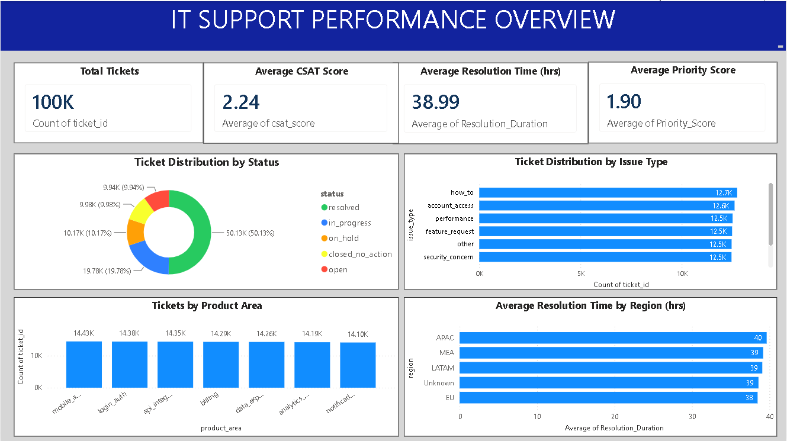
Figure — Overview Dashboard

9.2 Ticket Analysis
Shows 100K tickets, approximately 9.939K open tickets, 19.865K high-priority tickets and 2.24 average CSAT. Visuals compare priority, status, issue type and queue.
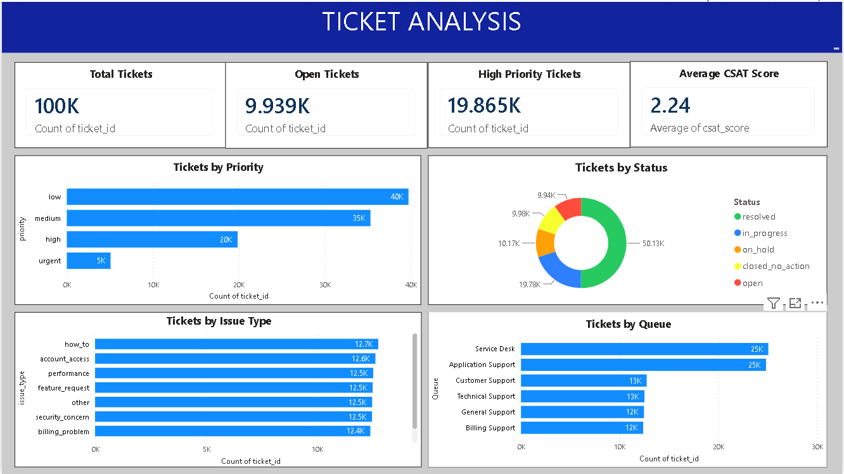
Figure — Ticket Analysis Dashboard

9.3 Clusters & Similarity
Shows five clusters, highest similarity 0.89, lowest similarity 0.57, cluster volume, average similarity, resolution time and cluster size versus resolution time.
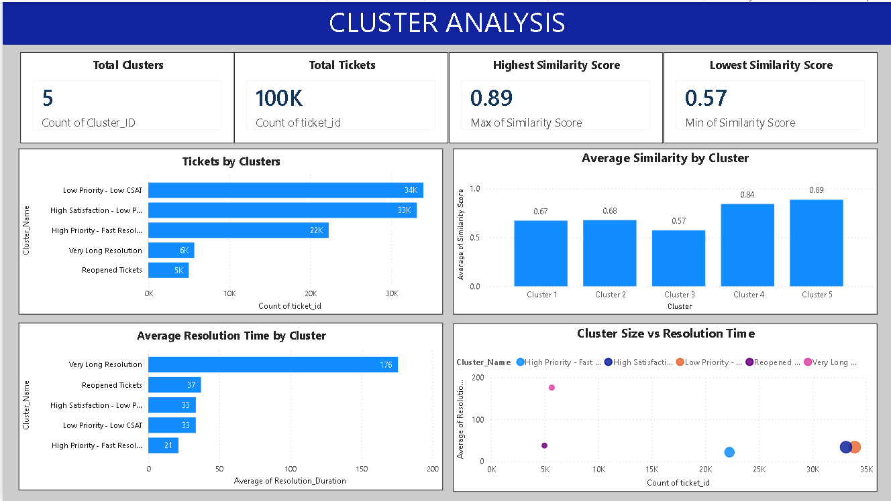
Figure — Clusters & Similarity Dashboard

9.4 Performance Analysis
Shows 100K tickets, 5.045K reopened tickets, 38.99 hours average resolution time and 2.24 average CSAT. Visuals compare resolution by priority, issue type and queue and show the time trend.
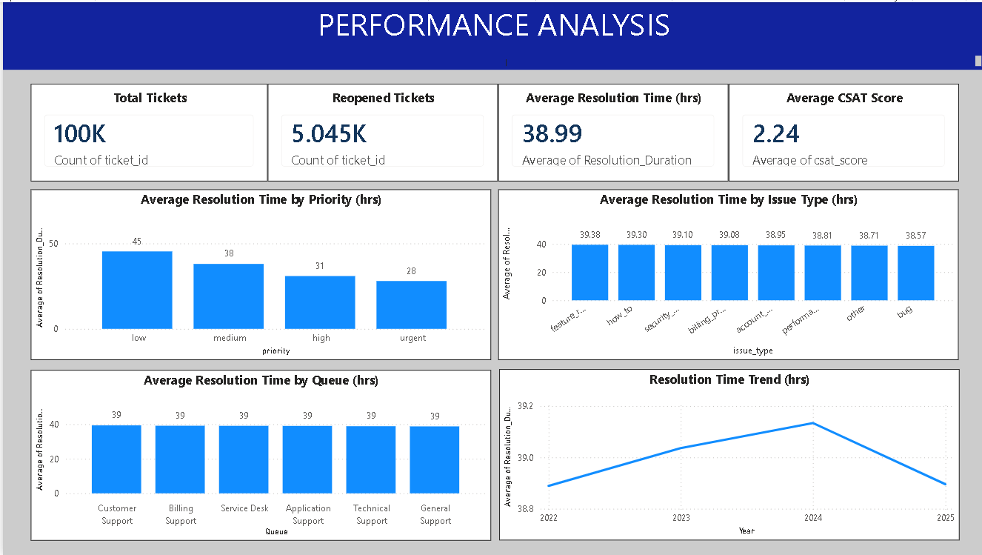
Figure — Performance Analysis Dashboard

9.5 Geographical Analysis
Shows five regions, MEA as top ticket region and EU as fastest and best-performing region. Includes geographic distribution and regional resolution-time comparison.
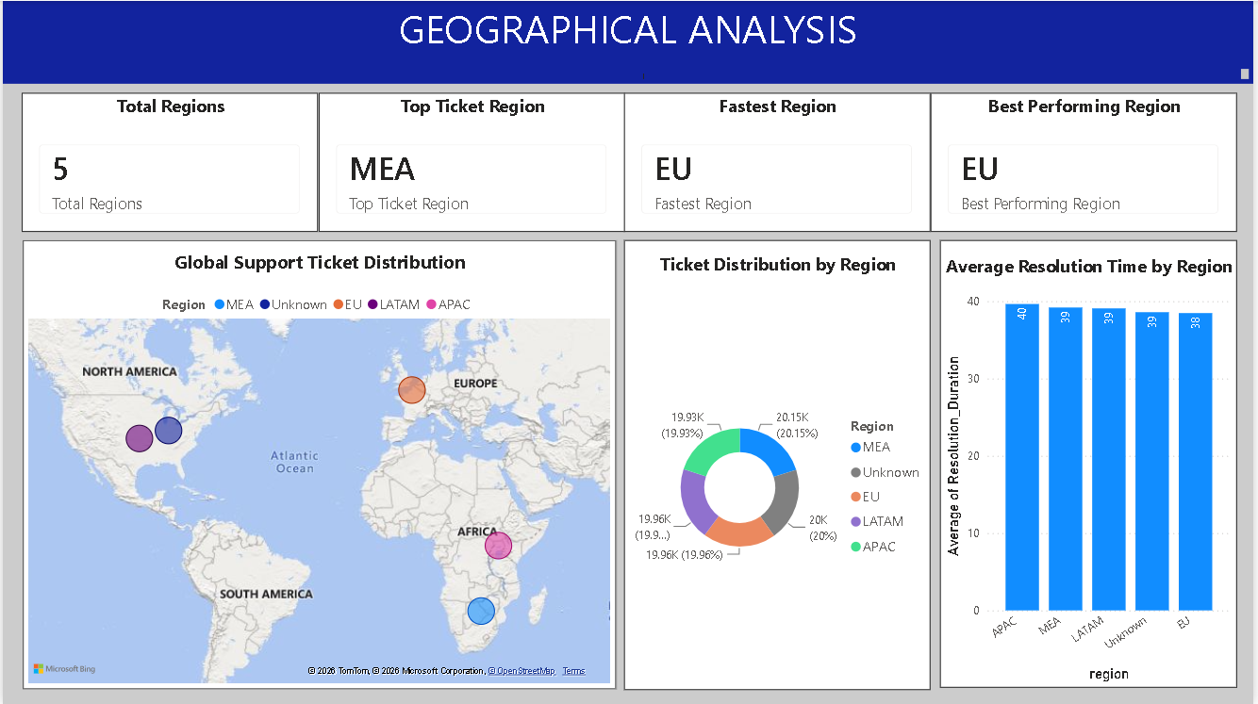
Figure — Geographical Analysis Dashboard

9.6 Reports & Recommendations
Converts the analysis into business recommendations and expected impact, including ticket-priority analysis and regional performance summary.
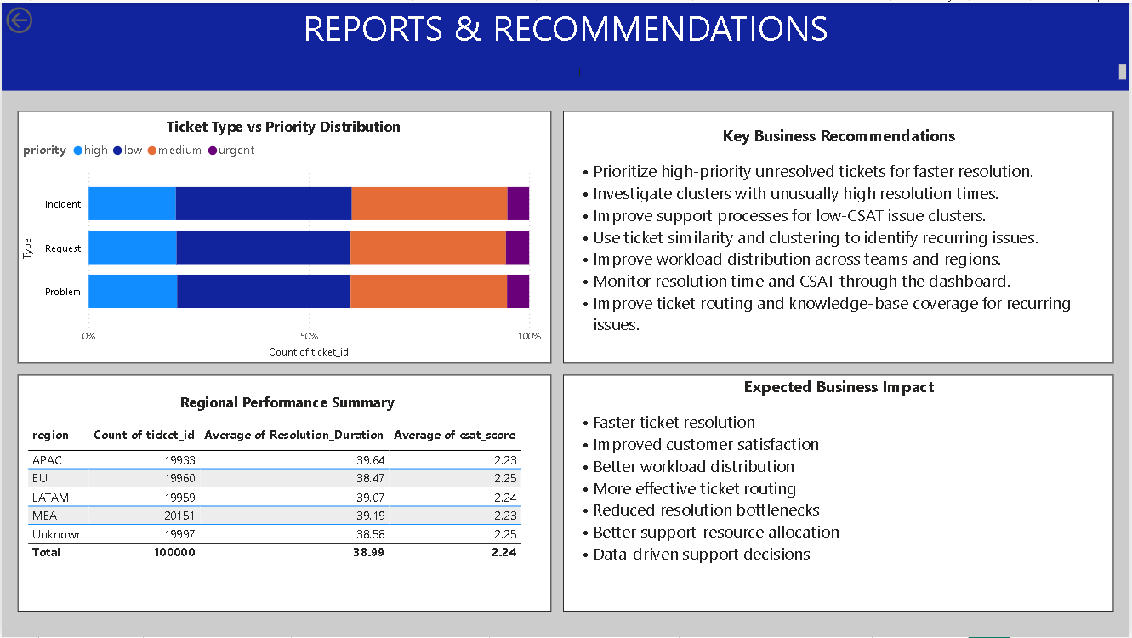
Figure — Reports & Recommendations Dashboard

9.7 Final Dashboard KPI Summary
KPI | Value
Total Tickets | 100K
Average CSAT | 2.24
Average Resolution Time | 38.99 hrs
Average Priority Score | 1.90
Open Tickets | 9.939K
High Priority Tickets | 19.865K
Reopened Tickets | 5.045K
Total Clusters | 5
Highest Similarity | 0.89
Lowest Similarity | 0.57
Regions | 5
Top Ticket Region | MEA
Fastest Region | EU
Best Performing Region | EU

Chapter 10 — Key Findings
- 100,000 support tickets were analyzed.
- Average resolution time is 38.99 hours.
- Average CSAT is 2.24.
- Approximately 9.939K tickets are open.
- Approximately 19.865K tickets are high priority.
- Approximately 5.045K tickets were reopened.
- Five analytical clusters are represented.
- Similarity ranges from 0.57 to 0.89.
- Five regions are represented.
- MEA has the highest ticket volume; EU is identified as fastest and best performing.

Chapter 11 — Business Recommendations

1. Prioritize high-priority unresolved tickets
Create focused monitoring and ownership for high-priority workload.

2. Investigate high-resolution-time clusters
Review causes, queue ownership and process bottlenecks.

3. Improve low-CSAT issue handling
Identify recurring issues with low customer satisfaction and improve resolution quality.

4. Use clustering for ticket routing
Use recurring ticket groups to support consistent routing and specialist ownership.

5. Improve workload distribution
Compare queue and regional workloads and allocate resources according to demand.

6. Monitor resolution time and CSAT together
Evaluate operational efficiency and customer experience together.

7. Improve knowledge-base coverage
Use recurring issue patterns to identify self-service and documentation gaps.

8. Use the dashboard for recurring reviews
Review KPIs regularly to identify emerging performance gaps.

Chapter 12 — Expected Business Impact
- Faster ticket resolution
- Improved customer satisfaction
- Better workload distribution
- More effective ticket routing
- Reduced resolution bottlenecks
- Improved regional visibility
- Better resource allocation
- More data-driven operational decisions

Chapter 13 — Milestone & Module Alignment
Milestone | Modules | Major Work | Evidence
Milestone 1 | 1–2 | Data foundation, cleaning, feature engineering | Cleaned dataset and engineered fields
Milestone 2 | 3–4 | EDA, similarity and clustering | Visualizations and clusters
Milestone 3 | 5–6 | Performance and geographic analysis | Performance and geographic visuals
Milestone 4 | 7–8 | Dashboard, documentation and presentation | Power BI dashboard, report, PPT and GitHub package

Chapter 14 — GitHub Repository Structure
Supportlytics/
├── README.md
├── LICENSE
├── .gitattributes
├── IT_Support_Project.ipynb
├── synthetic_it_support_tickets.csv
├── IT_Support_Cleaned.csv
├── IT_Support_Clustered.csv
├── Geo_Map.html
├── dashboard/
│ └── Supportlytics_Dashboard.pbix
├── documentation/
│ ├── Supportlytics_Complete_Project_Documentation.docx
│ └── Supportlytics_Complete_Project_Documentation.pdf
└── presentation/
└── Supportlytics_Milestone_4_Modules_7_8.pptx

14.1 Repository Deliverables
File | Purpose
README.md | Project overview and documentation
IT_Support_Project.ipynb | Main analysis notebook
IT_Support_Cleaned.csv | Cleaned dataset
IT_Support_Clustered.csv | Clustered/similarity dataset
Geo_Map.html | Geographic visualization
Power BI .pbix | Final six-page dashboard
Documentation | Complete project report
Final PPT | Milestone 4 presentation

Chapter 15 — Limitations & Considerations
- Dashboard values represent the final analytical state.
- Geographic visuals represent regional patterns rather than exact customer locations unless coordinate data supports that interpretation.
- Similarity and clustering results depend on selected features, preprocessing and clustering configuration.
- Dashboard recommendations should be validated against current support policies and SLA definitions.

Chapter 16 — Future Enhancements
- Real-time support monitoring
- Automated critical-ticket alerts
- Predictive resolution-time analysis
- Ticket escalation prediction
- Advanced ticket classification
- Automated performance reports
- Integration with IT service-management platforms
- Automated resource-allocation recommendations

Chapter 17 — Conclusion
Supportlytics provides an end-to-end analytical solution for understanding IT support operations. The project progresses from data preparation through exploratory analysis, similarity and clustering, performance analysis, geographic analysis and interactive Power BI reporting.
The final dashboard connects operational monitoring with detailed analysis and recommendations through six pages: Overview, Ticket Analysis, Clusters & Similarity, Performance Analysis, Geographical Analysis, and Reports & Recommendations.
Overall, the project demonstrates how data analytics and visualization can improve workload visibility, recurring-issue identification, resolution-performance monitoring and data-driven support decisions.

Final Deliverables Checklist
Deliverable | Evidence
Raw dataset | synthetic_it_support_tickets.csv
Cleaned dataset | IT_Support_Cleaned.csv
Clustered dataset | IT_Support_Clustered.csv
Notebook | IT_Support_Project.ipynb
Geographic visualization | Geo_Map.html
Power BI dashboard | Final six-page dashboard
README | GitHub documentation
Complete documentation | This Word report
Final presentation | Module 7 & 8 PPT

References & Project Resources
- Project brief: Optimizing IT Support Team Performance Using Analytics — Milestones 1–4.
- Supportlytics Jupyter Notebook and project datasets.
- Final Supportlytics Power BI dashboard.
- Final Supportlytics Module 7 & Module 8 presentation.
- GitHub repository containing project source files and deliverables.

Appendix A — Evidence to Insert
- Dataset preview screenshot
- Data-quality / missing-value screenshot
- Feature-engineering screenshot
- Selected EDA charts
- Elbow Method chart
- Cluster distribution chart
- Similarity chart
- Cluster resolution-time chart
- Overview dashboard screenshot
- Ticket Analysis dashboard screenshot
- Clusters & Similarity dashboard screenshot
- Performance dashboard screenshot
- Geographical dashboard screenshot
- Reports & Recommendations dashboard screenshot

Appendix B — Final Submission Checklist
- Update Table of Contents.
- Update List of Figures and List of Tables.
- Insert the six actual dashboard screenshots.
- Insert selected notebook/EDA charts.
- Verify KPI values against the final dashboard.
- Add the final GitHub URL if required.
- Export a PDF copy if the submission requires PDF.

Appendix C — Detailed Data Dictionary
This data dictionary documents the main fields used in the Supportlytics analysis and dashboard. Field names are aligned with the project datasets and the final analytical workflow.
Field | Type | Description
ticket_id | Identifier | Unique identifier for each support ticket.
created_at | Date/Time | Date and time when the ticket was created.
status | Categorical | Current ticket status such as resolved, in_progress, on_hold, closed_no_action or open.
priority | Categorical | Ticket urgency level: low, medium, high or urgent.
Priority_Score | Numeric | Numerical representation of ticket priority used for analysis.
issue_type | Categorical | Type of support issue or request.
Type | Categorical | Broad ticket type such as Incident, Request or Problem.
product_area | Categorical | Functional or product area associated with the ticket.
Queue | Categorical | Support queue or ownership group handling the ticket.
channel | Categorical | Channel through which the support ticket was received.
csat_score | Numeric | Customer satisfaction score associated with the ticket.
reopened | Binary/Numeric | Indicates whether the ticket was reopened.
Resolution_Duration | Numeric | Time taken to resolve the ticket, measured in hours.
Resolution_Category | Categorical | Classification of the resolution outcome/category.
resolution_summary | Text | Summary of the ticket resolution.
sla_plan | Categorical | SLA plan associated with the ticket.
agent_first_response | Date/Time | Date/time associated with the agent's first response.
region | Categorical | Geographical region assigned to the ticket.
Latitude | Numeric | Latitude used for geographic visualization.
Longitude | Numeric | Longitude used for geographic visualization.
customer_id | Identifier | Identifier associated with the customer.
platform | Categorical | Platform or environment associated with the ticket.
initial_message | Text | Initial customer/support message describing the issue.
Cluster_ID | Numeric | Numerical identifier assigned by the clustering process.
Cluster_Name | Categorical | Descriptive name assigned to an analytical cluster.
Cluster | Numeric/Categorical | Cluster assignment used in similarity and cluster analysis.
Similarity_Score | Numeric | Similarity measure used to compare ticket profiles.
High_CSAT | Derived | Derived indicator used for customer-satisfaction analysis.

Appendix D — System Architecture and Analytical Workflow
Supportlytics follows a sequential analytics architecture in which raw support-ticket data is transformed into cleaned analytical datasets, clustering and similarity outputs, performance and geographic insights, and finally an interactive Power BI dashboard.
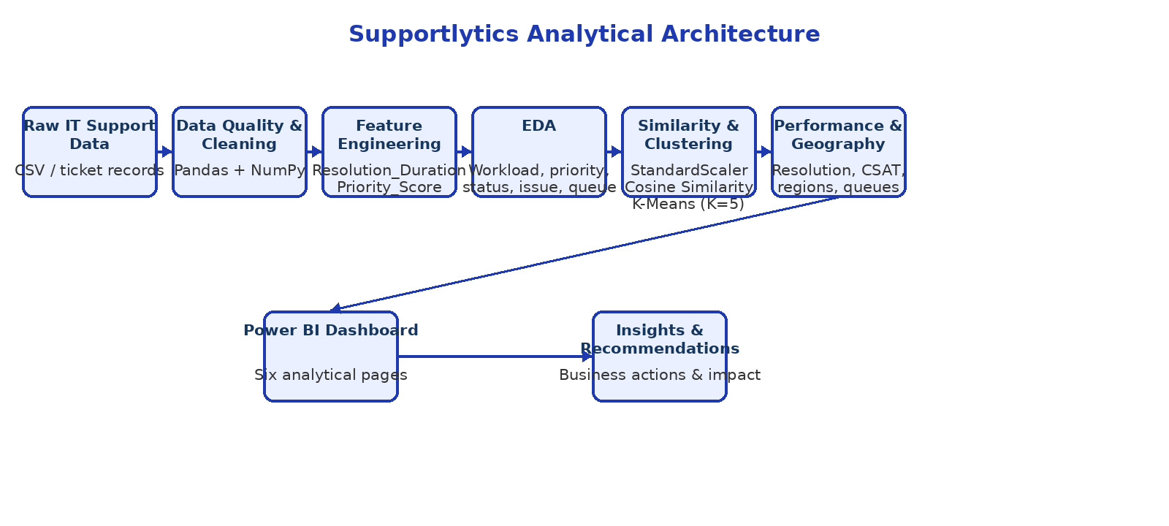
Figure — Supportlytics analytical architecture and end-to-end workflow

Architecture Components
- Data Layer: raw and processed CSV datasets provide the ticket-level analytical foundation.
- Processing Layer: Pandas and NumPy support data inspection, cleaning and feature engineering.
- Analytics Layer: exploratory analysis, similarity analysis and K-Means clustering identify operational patterns.
- Performance Layer: resolution time, CSAT, priority, queue and regional comparisons measure support performance.
- Visualization Layer: Microsoft Power BI consolidates the results into six interactive dashboard pages.
- Decision Layer: findings are converted into recommendations for prioritization, workload balancing, routing and process improvement.

Appendix E — Notebook Evidence and Reproducibility
The Jupyter Notebook is the primary reproducible analysis artifact. The following evidence list identifies what should be captured from the notebook to demonstrate how the final dashboard outputs were produced.
Module | Evidence Area | What to Capture / Verify | Source
Module 1 | Data loading and understanding | Dataset import, shape, columns, data types and initial inspection. | IT_Support_Project.ipynb
Module 2 | Cleaning and feature engineering | Missing-value handling, standardization, Resolution_Duration and Priority_Score. | IT_Support_Project.ipynb
Module 3 | Exploratory Data Analysis | Priority, status, issue type, product area, queue, region and performance charts. | IT_Support_Project.ipynb
Module 4 | Similarity and clustering | Feature selection, StandardScaler, cosine similarity, Elbow Method and K-Means K=5. | IT_Support_Project.ipynb
Module 5 | Performance analysis | Resolution time by priority, issue type and queue; reopened tickets and trends. | IT_Support_Project.ipynb
Module 6 | Geographic analysis | Regional distribution, resolution-time comparison and geographic visualization. | IT_Support_Project.ipynb
Module 7 | Dashboard preparation | Power BI model, KPI cards, visuals and six-page dashboard structure. | Power BI report
Module 8 | Documentation and presentation | Final report, PPT, README and GitHub project package. | Word / PPT / GitHub

Recommended Notebook Screenshots
- Dataset preview showing the first rows and main columns.
- Data-quality or missing-value inspection.
- Feature-engineering output showing Resolution_Duration and Priority_Score.
- Selected EDA charts for priority, status, issue type, queue and region.
- Elbow Method chart showing the basis for selecting five clusters.
- Cluster distribution and cluster-performance comparison.
- Similarity-score visualization.
- Final geographic visualization.

Appendix F — Tools, Environment and Final Project Links

F.1 Development Environment
Area | Tool / Technology | Purpose
Programming | Python | Data analysis and transformation
Data handling | Pandas, NumPy | Cleaning, transformation and aggregation
Notebook | Jupyter Notebook | Reproducible analytical workflow
Visualization | Matplotlib, Seaborn, Plotly | Exploratory and analytical visualizations
Machine learning | Scikit-learn | Standardization and K-Means clustering
Similarity | Cosine Similarity | Ticket-profile similarity analysis
Business Intelligence | Microsoft Power BI | Interactive dashboard and reporting
Data format | CSV | Raw and processed datasets
Version control | Git / GitHub | Project source and deliverable management

F.2 GitHub Repository
Final repository URL: [PASTE YOUR FINAL GITHUB REPOSITORY URL HERE]
The repository should contain the README, notebook, raw and cleaned datasets, clustered dataset, geographic visualization, Power BI dashboard, complete documentation and final Module 7 & Module 8 presentation.

F.3 Final Presentation
Final presentation: Supportlytics_Milestone_4_Modules_7_8.pptx
The presentation covers Milestone 4, including Module 7 — Dashboard / Report Preparation and Module 8 — Documentation & Presentation.

F.4 Final Project Outcome
Supportlytics successfully converts 100,000 IT support tickets into a structured analytical solution. The final workflow produces cleaned and enriched data, similarity and clustering outputs, performance and geographic analysis, and a six-page Power BI dashboard.
- 100,000 support tickets analyzed.
- Five analytical clusters produced.
- Average resolution time: 38.99 hours.
- Average CSAT score: 2.24.
- Highest similarity score: 0.89.
- Lowest similarity score: 0.57.
- Five regions represented in the final geographic analysis.
- MEA identified as the top ticket-volume region.
- EU identified as the fastest and best-performing region.
- Six-page Power BI dashboard completed.
- Milestone 4 documentation and presentation package completed.

F.5 Final Quality-Control Checklist
- Update the Word Table of Contents after all edits.
- Update the List of Figures and List of Tables.
- Verify that all six dashboard screenshots are present and correctly captioned.
- Verify dashboard KPI values against the final Power BI dashboard.
- Insert notebook evidence screenshots where required by the evaluator.
- Replace the GitHub URL placeholder with the actual repository URL.
- Confirm the final PPT is named and referenced correctly.
- Check page numbers, headings, spelling and alignment.
- Save the final Word document and export a PDF if required.

Appendix G — Python Visualization Evidence
This appendix contains the Python-generated visualizations used during exploratory, performance, geographic and clustering analysis. The charts complement the interactive Power BI dashboard by documenting the analytical work performed before final reporting.

G.1 Visualization Coverage
Analysis Area | Visualizations Included | Purpose
Workload / Queue | Queue Distribution; Priority × Queue | Understand workload concentration and routing demand.
Clustering | Elbow Method; Cluster Performance | Justify five clusters and compare cluster behavior.
Performance | Resolution Time by Priority × Issue Type; High-Priority Resolution | Identify resolution patterns and high-priority workload.
Geographic | Resolution Time by Region; Region × Priority; Issue Type × Region | Compare regional performance and workload concentration.
Priority | Total Tickets by Priority | Validate the overall priority distribution.

Figure 11. Queue Distribution
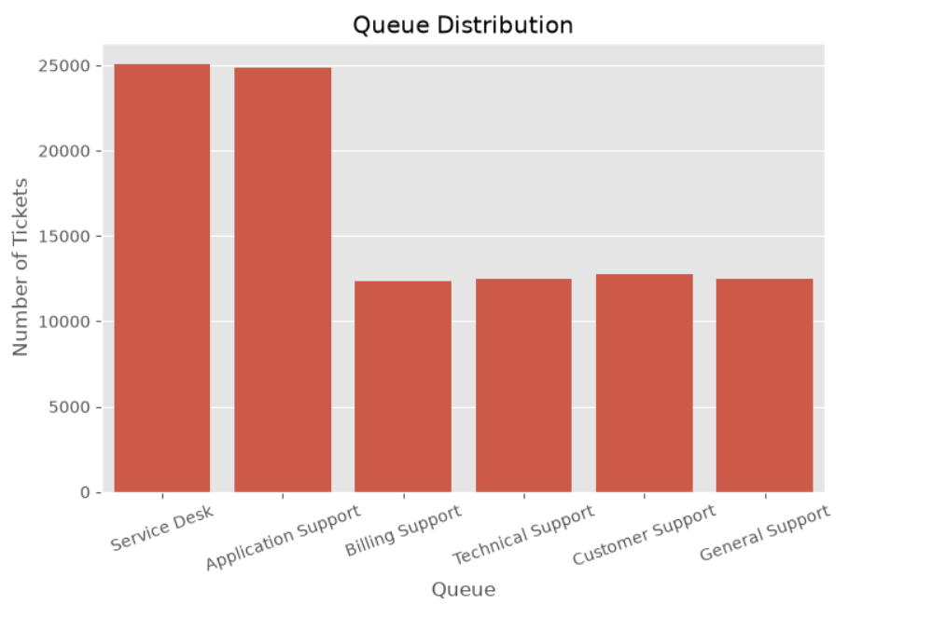
The chart compares ticket workload across support queues. Service Desk and Application Support handle the largest volumes, while the remaining queues carry smaller but still significant workloads.

Figure 12. Tickets by Priority and Queue
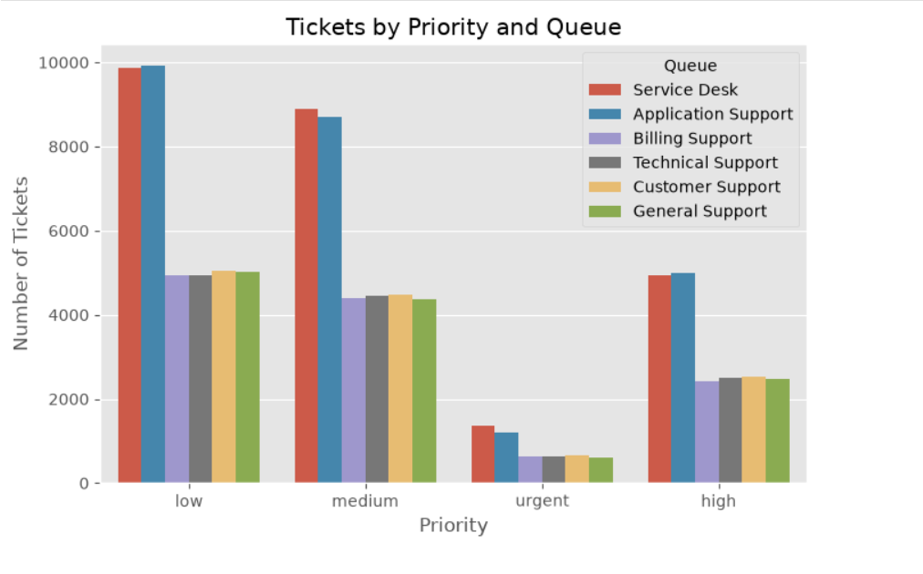
This grouped bar chart shows how low, medium, high and urgent tickets are distributed across support queues. It helps identify where priority-specific workload is concentrated.

Figure 13. Elbow Method for Cluster Selection
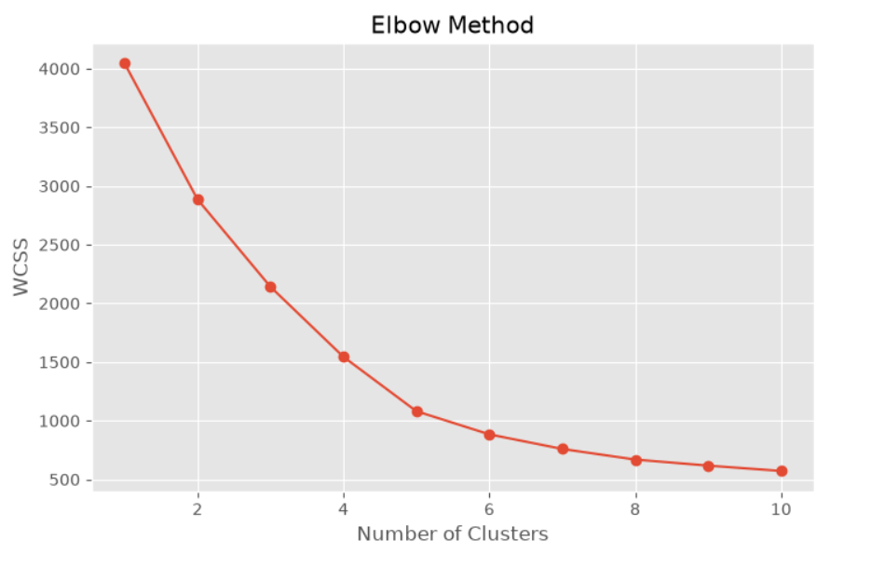
The Elbow Method plots WCSS against the number of clusters. The curve shows a strong reduction in WCSS at smaller K values and then a slower improvement, supporting the selected five-cluster configuration used in the final analysis.

Figure 14. Average Resolution Time by Priority and Issue Type
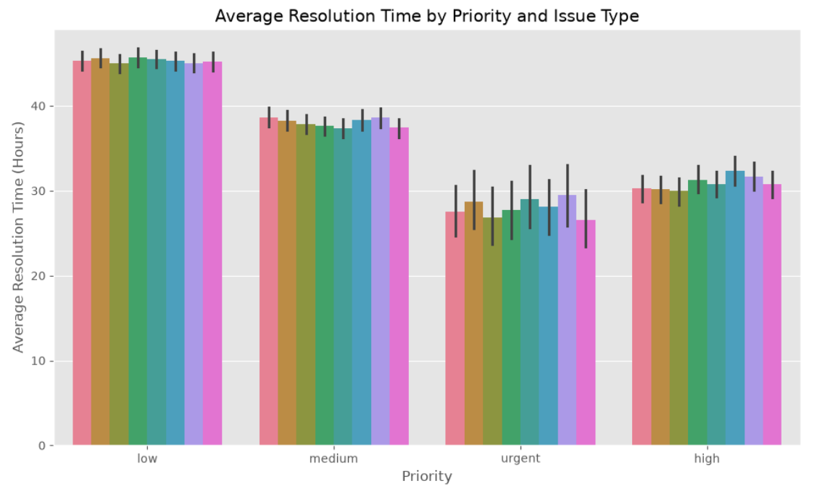
The visualization compares average resolution time across issue types within each priority level. It shows that urgent tickets generally have lower average resolution duration than low and medium priority groups in this dataset, while differences among issue types are comparatively smaller.

Figure 15. Average Resolution Time by Region
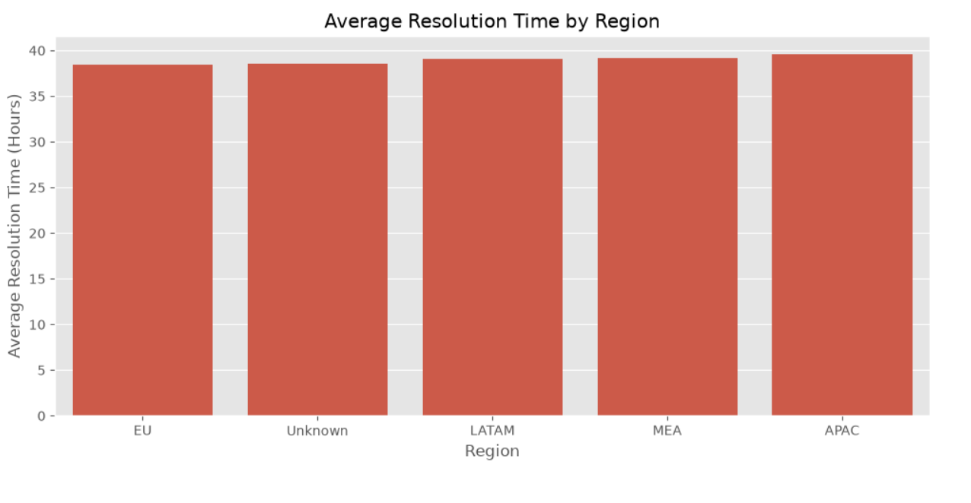
Regional resolution times are close to one another, with APAC showing the highest average and EU the lowest average in the plotted comparison. This supports the regional performance analysis in Power BI.

Figure 16. Resolved High-Priority Tickets by Issue Type
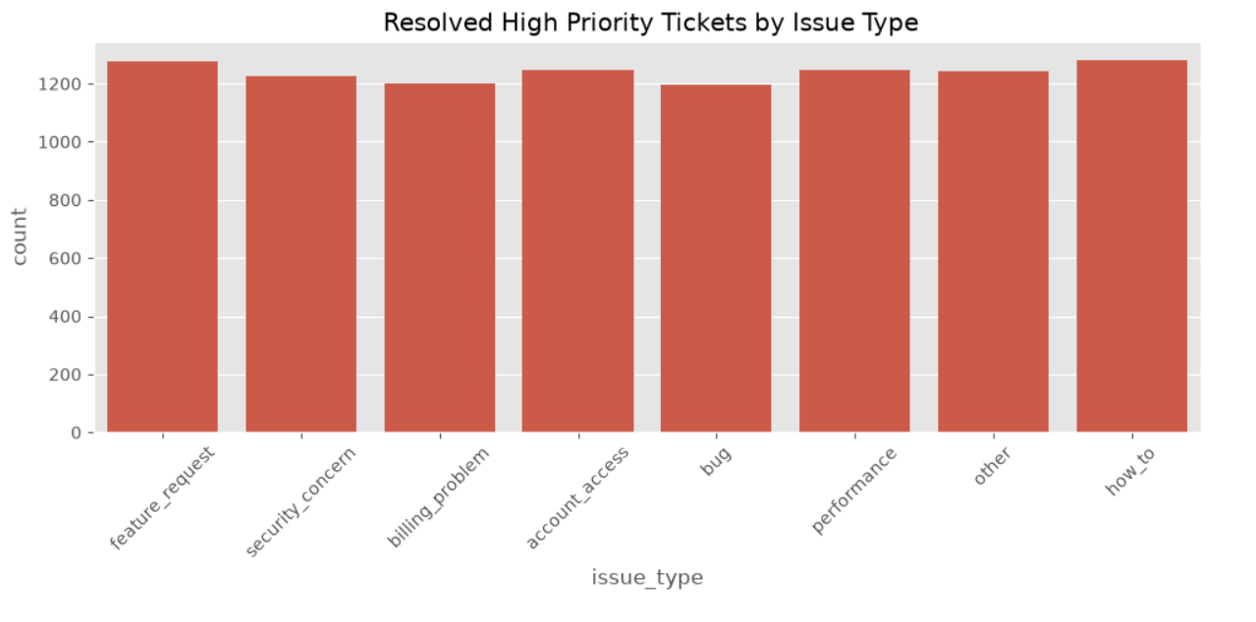
This chart compares resolved high-priority tickets across issue types. The counts are relatively close, indicating that high-priority workload is spread across several issue categories rather than being dominated by one category.

Figure 17. Ticket Concentration by Region and Priority
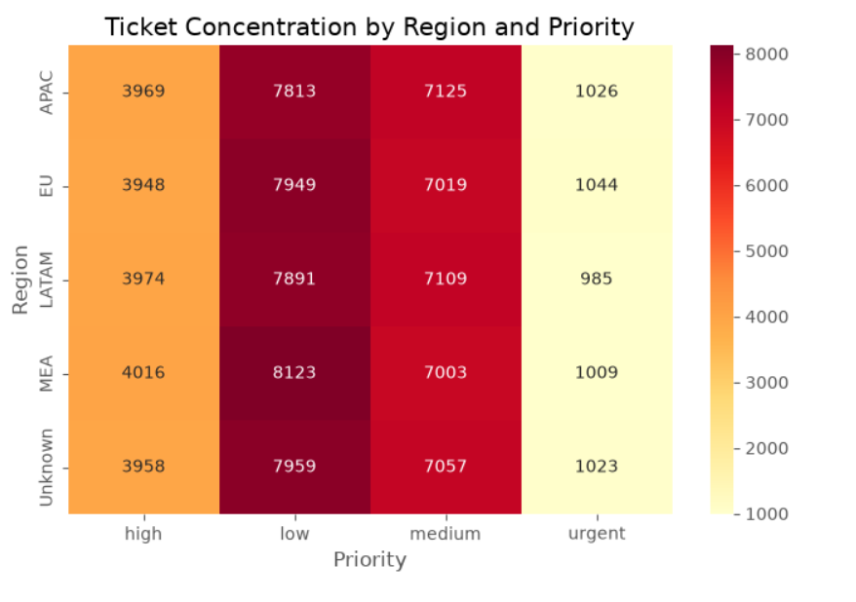
The heatmap shows the concentration of high, low, medium and urgent tickets across regions. Low-priority tickets form the largest concentration in every region, while urgent tickets are consistently the smallest group.

Figure 18. Issue Type Distribution by Region
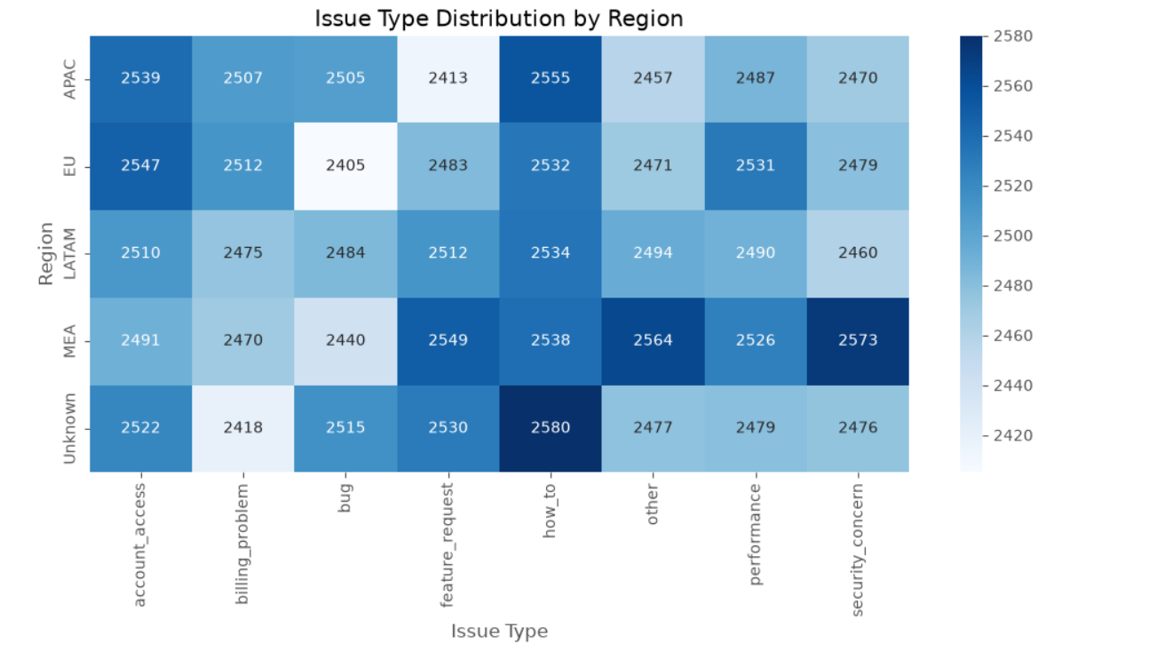
This heatmap compares issue-type volumes across regions. The values are relatively balanced, while some combinations show locally higher or lower concentrations that can support regional workload planning.

Figure 19. Cluster Performance Comparison
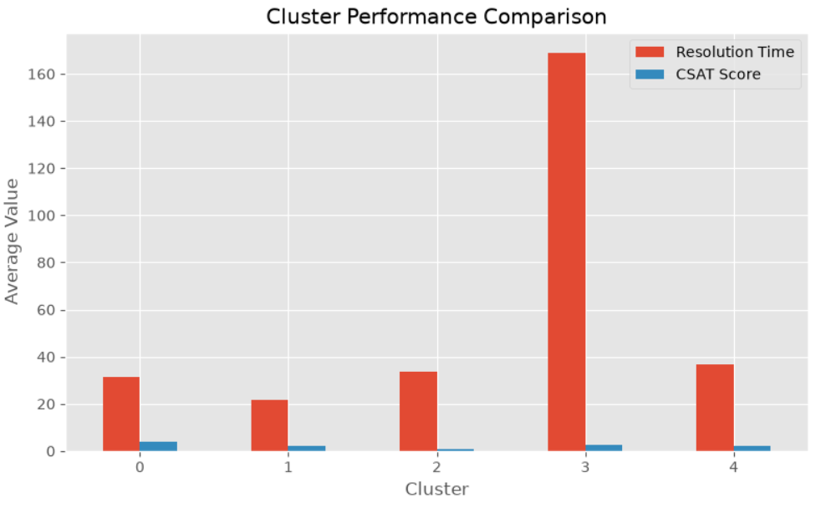
The chart compares average resolution time and CSAT across the five clusters. One cluster has a substantially higher resolution time, making it a clear candidate for deeper investigation of bottlenecks and ticket characteristics.

Figure 20. Total Tickets by Priority
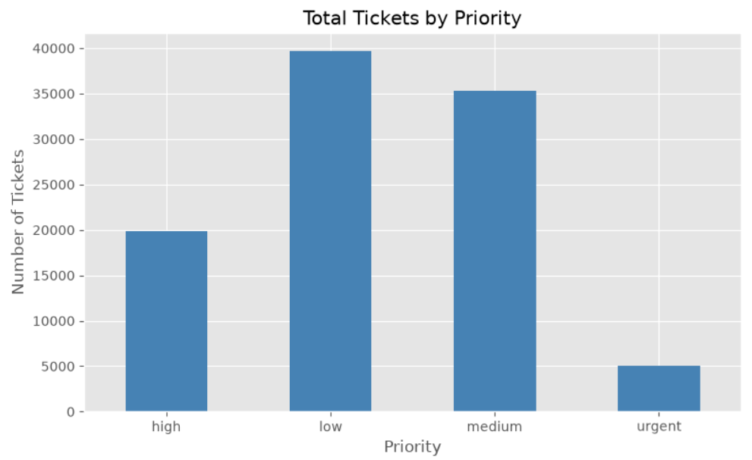
This chart confirms that low-priority tickets form the largest workload, followed by medium, high and urgent tickets. It supports the priority-distribution findings used in the dashboard and recommendations.

G.2 Overall Interpretation of Python Visualizations
- The analysis covers ticket workload, priority, queue, issue type, resolution performance, geography and clustering.
- Low-priority tickets represent the largest workload, while urgent tickets represent the smallest priority group.
- Service Desk and Application Support carry the largest queue volumes.
- Regional average resolution times are relatively close, with EU performing best in the final Power BI regional summary.
- The Elbow Method supports the use of five analytical clusters in the final project.
- Cluster comparison highlights a very long-resolution cluster that warrants investigation for process bottlenecks.
- The heatmaps provide additional relationship-level analysis that is not visible from simple one-dimensional distributions.
- The Python analysis feeds the final Power BI reporting layer, where the findings are presented as interactive dashboards and recommendations.

G.3 Final Documentation Note
The Python charts in this appendix should be read together with the six Power BI dashboard pages already included in this document. Python visualizations demonstrate the analytical process, while Power BI provides the final interactive reporting and decision-support layer.

