SUPPORTLYTICS
Optimizing IT Support Team Performance Using Analytics
Final Project Report

Project Domain: IT Support Analytics
Technology Stack: Python, Pandas, NumPy, Matplotlib, Seaborn, Plotly, Power BI
Dataset Source: Internal IT Support Ticket System
Project Type: Data Analytics, Visualization and Performance Optimization

Submitted By
Balu

1. Executive Summary
Supportlytics is an end-to-end analytics project designed to evaluate IT support ticket operations and identify opportunities to improve service efficiency. The project uses ticket attributes such as type, priority, category, country, queue, resolution duration, cluster information and similarity scores to understand workload patterns and support performance.
The analysis follows a complete data analytics workflow: data acquisition and understanding, data cleaning, feature engineering, exploratory analysis, cluster and similarity analysis, performance evaluation, geographic analysis, dashboard development and final reporting.
The final outcome is a performance-oriented analytical solution that converts raw support ticket records into visual insights and actionable recommendations. The dashboard and visualizations help stakeholders monitor resolution efficiency, ticket concentration, issue clusters, priority workload and regional performance.

2. Project Objectives
- Understand and preprocess the IT support ticket dataset for reliable analysis.
- Measure ticket volume, priority distribution, issue categories and ticket types.
- Calculate resolution duration and other performance-oriented features.
- Identify frequently occurring issue clusters and analyze their similarity scores.
- Compare resolution performance across priorities, countries, teams and categories.
- Identify high-priority unresolved issues and potential performance gaps.
- Create meaningful visualizations and an interactive performance dashboard.
- Provide actionable recommendations for workflow improvement and resource allocation.

3. Problem Statement
IT support teams handle large numbers of requests, incidents and problems across different categories, priorities and geographic regions. Without structured analysis, it can be difficult to identify workload concentration, slow-resolution areas, recurring technical issues and resource bottlenecks.
Supportlytics addresses this challenge by analyzing historical support ticket data to uncover performance trends and recurring patterns. The project aims to support data-driven decisions that can reduce resolution time, improve prioritization and increase overall service efficiency.

4. Project Scope
- Ticket-level data preparation and quality validation.
- Descriptive and exploratory analysis of support operations.
- Similarity and cluster-level issue analysis.
- Performance comparison by priority, type, category, country and queue.
- Geographic visualization of ticket concentration and issue categories.
- Dashboard creation using Power BI and supporting Python visualizations.
- Documentation of insights and recommendations.

5. Dataset Understanding
The project uses an internal IT Support Ticket System dataset. Each record represents a support ticket and contains operational information that can be used to evaluate ticket demand and resolution performance.
Data Area | Representative Fields | Purpose
Ticket Information | Ticket ID, Date, Type | Identify and classify support records
Priority | Priority, Priority Score | Measure urgency and workload
Issue Classification | Category, Cluster ID, Cluster Name | Identify recurring issue groups
Performance | Resolution Date, Resolution Duration | Measure support efficiency
Similarity | Similarity Score, Similarity Level | Measure issue similarity
Geography | Country, Latitude, Longitude | Analyze regional patterns
Operations | Queue / Team | Compare workload and handling performance

6. Key Performance Indicators (KPIs)
KPI | Definition | Business Use
Average Resolution Time | Average time taken to resolve tickets | Monitor service efficiency
Ticket Volume | Number of support tickets | Measure workload and demand
Priority Distribution | Tickets grouped by priority | Understand urgency and staffing needs
Resolution Rate | Resolved tickets relative to total tickets | Evaluate operational effectiveness
Cluster Similarity Index | Average similarity score of issue groups | Identify recurring / related issues
Top Categories | Most frequent issue categories | Prioritize recurring technical problems
Regional Performance | Ticket and resolution metrics by country/region | Identify geographic performance gaps

7. Methodology
- Load the raw CSV dataset using Pandas.
- Inspect schema, data types, duplicate records and missing values.
- Clean incomplete or inconsistent text and date fields.
- Convert date columns to appropriate datetime formats.
- Create Resolution_Duration / Resolution_Time from resolution and ticket dates.
- Create Priority_Score and categorize Similarity_Score into meaningful performance buckets.
- Encode categorical fields where required for analytical or clustering workflows.
- Perform exploratory analysis using Python visualization libraries.
- Analyze issue clusters, similarity scores and cluster-level resolution performance.
- Compare resolution performance by priority, type, category, country and queue.
- Build geographic and comparative visualizations.
- Combine the most important metrics into an interactive Power BI dashboard.
- Interpret the findings and translate them into operational recommendations.

8. Milestone-wise Implementation
Milestone 1 – Data Readiness — Dataset loading, schema inspection, missing-value handling, cleaning and feature engineering.
Milestone 2 – Visualization & Clustering — EDA, ticket distributions, category/cluster analysis, similarity analysis and performance-gap visualizations.
Milestone 3 – Performance & Geography — Resolution-time analysis, high-priority issue identification, regional analysis and geographic visualizations.
Milestone 4 – Dashboard & Documentation — Power BI dashboard, KPI layout, final report, presentation and GitHub documentation.

9. Data Cleaning and Feature Engineering
Data preparation was performed before analysis to ensure that the results were based on consistent and usable records. Missing, incomplete and incorrectly formatted fields were reviewed and handled according to their analytical importance.
- Checked column names, data types and structural consistency.
- Reviewed missing and incomplete values.
- Removed or corrected invalid date and text values where applicable.
- Converted date fields to datetime format.
- Created Resolution_Duration / Resolution_Time using the difference between resolution date and ticket date.
- Created Priority_Score for quantitative priority analysis.
- Grouped Similarity_Score into interpretable Similarity_Level buckets.
- Encoded categorical variables for analytical and clustering requirements.
- Saved a processed dataset for downstream analysis.

10. Exploratory Data Analysis
EDA was used to understand the distribution of support tickets and identify the areas that required deeper investigation.
- Ticket type distribution across Request, Problem and Incident.
- Ticket volume by country and priority.
- Most frequent issue categories such as Integration, Security and Bug.
- Ticket distribution across support queues.
- Frequency of issue clusters and cluster names.
- Resolution-duration patterns across ticket groups.
- Comparison of high-, medium- and low-priority workload.

11. Cluster and Similarity Analysis
Cluster and similarity analysis was used to determine whether support tickets were concentrated around recurring issue groups. Cluster_ID and Cluster_Name were analyzed together with Similarity_Score to identify common technical patterns.
- Calculated and compared average similarity scores within clusters.
- Analyzed cluster size to identify frequently occurring issue groups.
- Compared cluster composition with ticket type and category.
- Compared similarity levels with resolution performance.
- Used scatter plots and boxplots to identify performance gaps and outliers.
- Highlighted recurring clusters that may benefit from standard troubleshooting procedures or automation.

12. Performance Trend Analysis
Performance analysis focused on resolution efficiency and operational differences between ticket groups. Average resolution duration was compared across priority, ticket type, country, category and support queue.
- Compared average resolution times by priority.
- Compared resolution times across Request, Problem and Incident tickets.
- Identified countries or teams with comparatively faster handling performance.
- Reviewed unresolved high-priority tickets as operational risks.
- Identified categories and clusters with longer resolution durations.
- Used comparative charts to identify potential staffing and process gaps.

13. Geographic and Category-Level Analysis
Geographic analysis was used to understand where support demand was concentrated and whether regional differences were visible in ticket volume or resolution performance.
- Created regional ticket concentration heatmaps.
- Mapped issue categories using latitude and longitude where available.
- Compared ticket volume across countries.
- Compared regional resolution performance.
- Evaluated the relationship between cluster size and performance score.
- Used geographic patterns to support resource allocation recommendations.

14. Visualization Portfolio
Visualization | Purpose | Recommended Interpretation
Ticket Type Bar Chart | Show Request / Problem / Incident distribution | Identify dominant ticket types
Priority Distribution Chart | Compare workload by priority | Identify urgency concentration
Top Category Chart | Rank issue categories | Find recurring technical issues
Country Distribution Chart | Compare ticket volume geographically | Identify high-demand regions
Resolution Time by Priority | Compare average resolution duration | Detect priority-related performance gaps
Cluster Frequency Chart | Rank clusters by ticket count | Identify recurring issue groups
Similarity Boxplot | Compare similarity-score distributions | Detect clusters with unusual similarity
Cluster vs Performance Scatter Plot | Compare cluster size/similarity with performance | Identify high-volume problem areas
Regional Heatmap | Show geographic ticket concentration | Identify support-demand hotspots
Geographic Issue Map | Plot issue categories geographically | Understand regional issue patterns

15. Power BI Dashboard
The final dashboard consolidates the project findings into an interactive management view. The dashboard is designed to allow users to monitor operational KPIs and drill into priority, category, cluster and geographic dimensions. 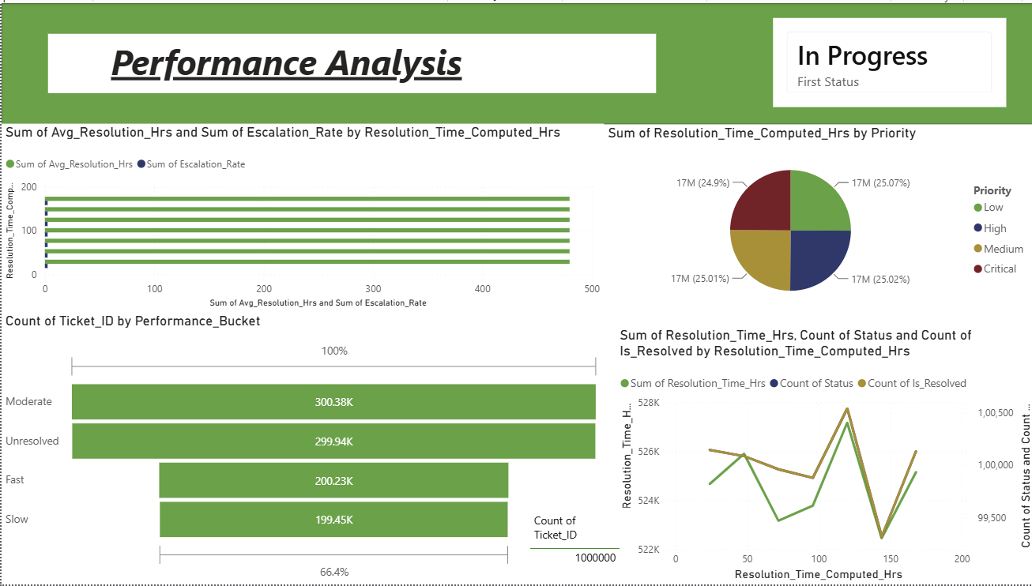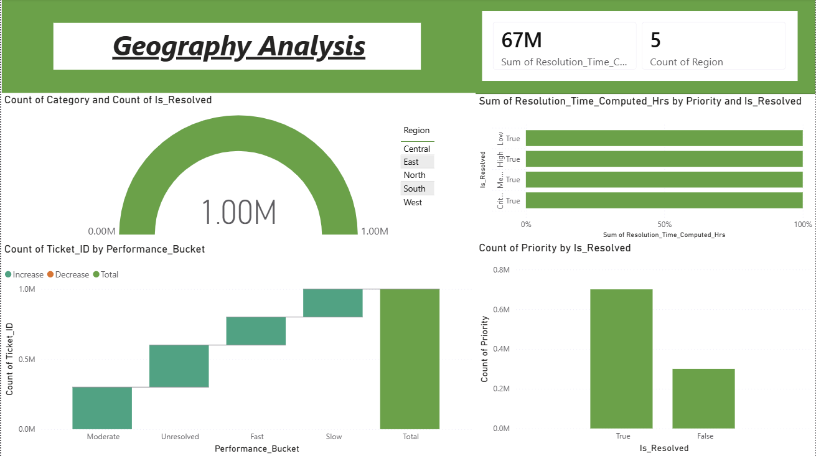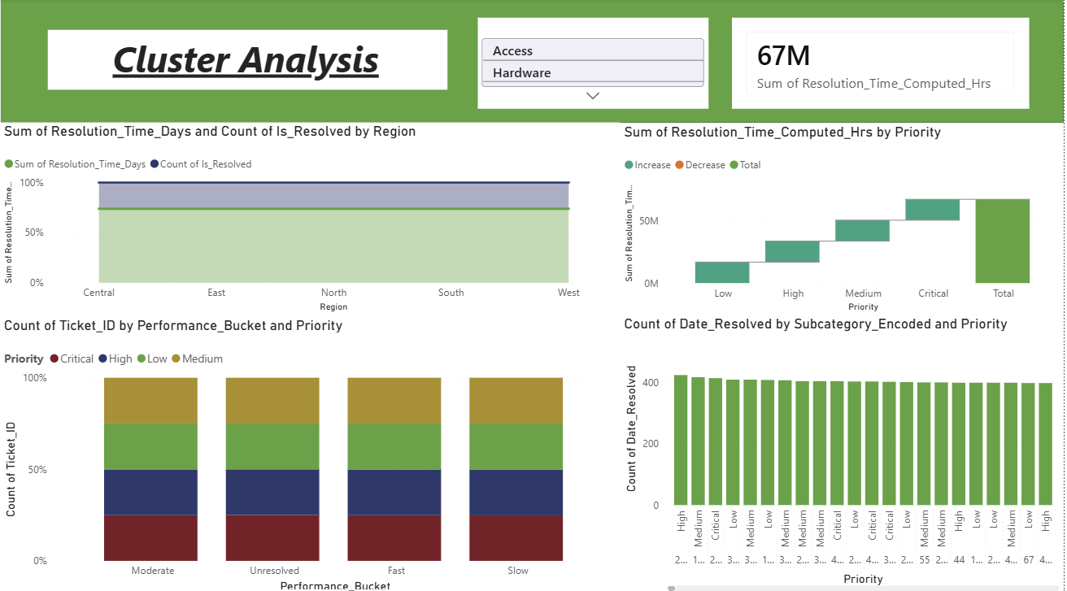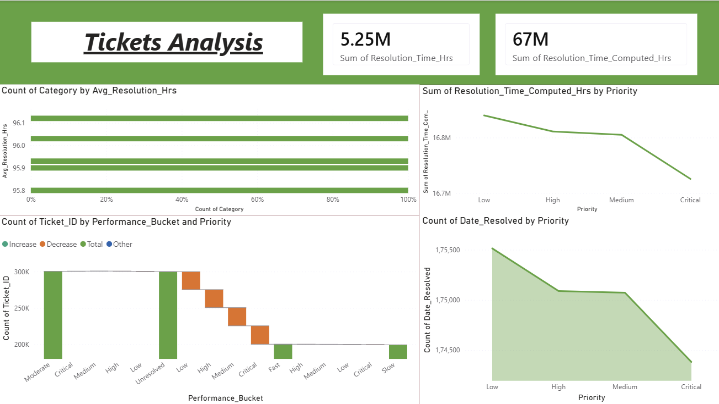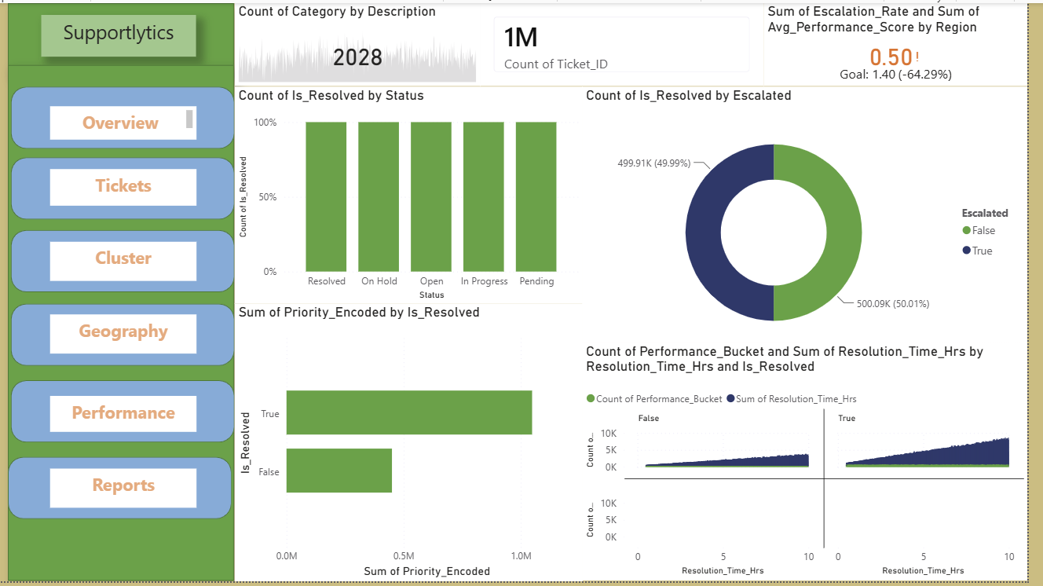
- KPI Card – Average Resolution Time
- KPI Card – Total Tickets
- KPI Card – Resolution Rate
- KPI Card – Cluster Similarity Index
- KPI Card – Top Performing Region
- Bar Chart – Most Frequent Categories
- Chart – Ticket Distribution by Priority and Type
- Chart – Resolution Efficiency by Priority
- Chart – Cluster Performance vs Similarity Score
- Map – Ticket and Category Distribution by Region
- Interactive filters for country, priority, type, category, queue and cluster.

16. Key Analytical Insights
The completed analysis is intended to convert descriptive patterns into operational insights. The exact numerical values should be taken directly from the final dataset and dashboard rather than being assumed in this report.
Insight Area | Finding to Report from Final Dashboard
Ticket Demand | State the highest-volume ticket type, category and region.
Priority | State which priority contributes the largest workload and whether high-priority tickets are being resolved efficiently.
Resolution | State the average resolution time and identify the groups with the longest resolution duration.
Clusters | State the largest recurring clusters and their average similarity / resolution performance.
Geography | State the highest-demand regions and any meaningful regional performance differences.
Unresolved Risk | State the number or proportion of unresolved high-priority issues shown in the completed analysis.

17. Recommendations
- Prioritize resource allocation toward categories and clusters with high ticket volume and long resolution durations.
- Create standardized troubleshooting playbooks for recurring issue clusters.
- Introduce stronger escalation rules for unresolved high-priority tickets.
- Monitor resolution duration by queue/team to identify training or staffing requirements.
- Use cluster and similarity analysis to identify opportunities for ticket auto-routing and knowledge-base recommendations.
- Review regional workload regularly and rebalance support capacity when sustained demand differences are observed.
- Track dashboard KPIs continuously rather than relying only on periodic reports.
- Use historical ticket patterns to support workforce planning and preventive technical improvements.

18. Technology Stack
Technology | Role in Project
Python | Primary programming and analytics environment
Pandas | Data loading, cleaning, transformation and aggregation
NumPy | Numerical operations and feature calculations
Matplotlib | Analytical visualizations
Seaborn | Statistical and comparative visualizations
Plotly | Interactive visualizations
Power BI | Interactive dashboard and KPI reporting
Jupyter Notebook | Analysis documentation and experimentation
GitHub | Source-code and project documentation management

19. Project Deliverables
- Cleaned and processed IT support ticket dataset.
- Feature engineering and data dictionary documentation.
- Jupyter Notebook / Python analysis files.
- Minimum eight analytical visualizations and supporting charts.
- Cluster and similarity analysis.
- Performance metrics and geographic analysis.
- Interactive Power BI dashboard.
- Final analytical report.
- Presentation slides.
- GitHub repository containing project code, visuals and documentation.

20. Conclusion
Supportlytics demonstrates how data analytics can be applied to IT support operations to move from raw ticket records to measurable performance insights. By combining data cleaning, feature engineering, exploratory analysis, cluster and similarity analysis, geographic visualization and dashboard reporting, the project provides a structured view of support workload and efficiency.
The solution can help support managers identify recurring technical issues, monitor resolution performance, recognize high-demand regions and prioritize operational improvements. The most important next step is to continue tracking the dashboard KPIs over time so that recommendations can be validated using future ticket data.

Dashboard Link: https://drive.google.com/file/d/18Lhv7gliv2hVgEDg5u8RL4jISgSYRSUu/view?usp=sharing

CSV File Link: https://drive.google.com/file/d/1sW7eXfe29a_bpz3svSOjc5z1SlTHHoln/view?usp=sharing

21. Future Scope
- Add automated daily or weekly dashboard refresh.
- Develop predictive models for ticket resolution time.
- Predict escalation risk for high-priority tickets.
- Implement intelligent ticket routing using historical clusters.
- Use NLP on ticket descriptions for automated category and cluster assignment.
- Build alerts for SLA-risk and overdue high-priority tickets.
- Integrate the dashboard with a live support-ticket system.

22. Appendix – Data Dictionary Template
Column | Data Type | Description | Usage
Ticket ID | Identifier | Unique ticket reference | Record identification
Date | Date/Time | Ticket creation date | Trend analysis
Resolution Date | Date/Time | Ticket resolution date | Resolution calculation
Type | Categorical | Request, Problem or Incident | Ticket classification
Priority | Categorical | Ticket urgency | Priority analysis
Category | Categorical | Technical issue category | Category analysis
Country | Categorical | Ticket country/region | Geographic analysis
Queue / Team | Categorical | Support queue or team | Team performance
Cluster ID | Categorical/Integer | Assigned issue cluster | Cluster analysis
Cluster Name | Categorical | Name of issue cluster | Cluster interpretation
Similarity Score | Numeric | Issue similarity measure | Similarity analysis
Resolution Duration | Numeric | Time from ticket creation to resolution | Performance KPI
Latitude / Longitude | Numeric | Geographic coordinates | Map visualization

End of Report

