INTERNSHIP PROJECT REPORT
on
Supportlytics
Optimizing IT Support Team Performance Using Analytics
Submitted as part of
Infosys Springboard Virtual Internship 7.0 (Batch 1)
Submitted by
PATTA HEMA SUNDAR
Under the Guidance of
Shanmukha Priya
Data Scientist, Infosys Springboard
Internship Duration: 19 June 2025 – 8 Weeks

Acknowledgement
I would like to express my sincere gratitude to Infosys Springboard for providing me the opportunity to undertake the Virtual Internship 7.0 program. I am especially thankful to my mentor, Shanmukha Priya, Data Scientist, for her continuous guidance, valuable feedback, and encouragement throughout the course of this project.
This internship gave me hands-on exposure to real-world data analytics workflows — from data cleaning and exploratory analysis to clustering, performance benchmarking, and dashboard development — and helped me strengthen my practical skills in Python, data visualization, and analytical thinking.

Abstract
Supportlytics is a data analytics project undertaken to optimize the performance of an IT support team by analyzing historical support ticket data. The project involved acquiring and cleaning a 10,000-record IT support ticket dataset, engineering features such as resolution duration and priority score, and performing exploratory data analysis to understand ticket volume, category, and priority trends.
Cluster and similarity analysis was used to group tickets into problem clusters (e.g., Account Security, Billing & Invoices, Hardware & Device Sync) and evaluate resolution consistency using similarity scores. Performance trend analysis compared resolution times across ticket priorities, types, teams, and countries to identify bottlenecks and high-priority unresolved issues. Geographic analysis mapped ticket concentration and category distribution across regions.
The findings were consolidated into an interactive Streamlit dashboard presenting key performance indicators — average resolution time, most frequent categories, cluster similarity index, and top-performing regions — enabling data-driven recommendations for workflow and resource optimization.

1. Introduction

1.1 Project Statement
The objective of this project is to analyze IT support ticket data to identify key performance trends, optimize resolution times, and enhance service efficiency through data analysis and visualization. The goal is to uncover patterns in customer requests, technical issues, and support performance metrics to recommend improvements in workflow and resource allocation.

1.2 Expected Outcomes
- Understand and preprocess IT support ticket data for analysis.
- Explore trends in ticket volume, priority, resolution time, and category distribution.
- Identify clusters of similar issues using similarity scores and clustering techniques.
- Visualize performance metrics through dashboards and charts.
- Derive actionable insights to optimize IT support operations.
- Summarize findings in a final analytical report and presentation.

1.3 Tools & Technologies Used
- Python — pandas, NumPy for data processing
- Matplotlib, Seaborn — statistical visualizations
- Folium — geographic mapping
- Streamlit, Plotly — interactive dashboard development
- Google Colab — development environment

1.4 Dataset Overview
The project uses an internal IT support ticket dataset (customer_support_insights_10k.csv) containing 10,000 tickets with fields including Ticket_Type, Priority, Category, Cluster_ID, Cluster_Name, Similarity_Score, Created_Date, Resolution_Date, Country, Team, and Status.

2. Milestone 1 (Week 1–2): Data Setup, Cleaning & Feature Engineering

Module 1: Project Initialization and Dataset Setup
The dataset was loaded using pandas and its schema, data types, and missing values were explored. Initial distributions of Ticket_Type, Priority, and Category were calculated to understand the composition of the raw data.
import pandas as pd
df = pd.read_excel("customer_support_insights_10k.csv.xlsx")

df.shape # (10000, n) records
df.info() # schema & dtypes
df.isnull().sum() # missing value check
df['Ticket_Type'].value_counts()
df['Priority'].value_counts()
df['Category'].value_counts()
Key finding: The dataset consists of 10,000 tickets spanning four ticket types — Incident, Question, Problem, and Feature Request — with no critical missing values found in the core analytical columns.

Module 2: Data Cleaning and Feature Engineering
Text fields were stripped of whitespace, duplicate records were checked, and date columns were converted to proper datetime format. Two engineered features were central to the analysis:
- Resolution_Duration — computed as Resolution_Date minus Created_Date (in days/hours).
- Priority_Score — an ordinal encoding of Priority (Low=1, Medium=2, High=3, Critical=4) to support quantitative comparison.
text_columns = df.select_dtypes(include='object').columns
for col in text_columns:
df[col] = df[col].str.strip()

df['Created_Date'] = pd.to_datetime(df['Created_Date'])
df['Resolution_Date'] = pd.to_datetime(df['Resolution_Date'])
df['Resolution_Duration'] = (df['Resolution_Date'] - df['Created_Date']).dt.days

priority_map = {'Low': 1, 'Medium': 2, 'High': 3, 'Critical': 4}
df['Priority_Score'] = df['Priority'].map(priority_map)

df.to_csv("customer_support_processed.csv", index=False)
Deliverables: A cleaned dataset (customer_support_processed.csv) with engineered Resolution_Duration and Priority_Score columns, ready for exploratory and cluster analysis.

3. Milestone 2 (Week 3–4): Exploratory & Cluster Analysis

Module 3: Exploratory Visualization
Ticket type distribution, top issue categories, and priority distribution across support queues were visualized to establish a baseline understanding of workload composition.
type_counts = df['Ticket_Type'].value_counts()
sns.barplot(x=type_counts.index, y=type_counts.values, palette='Blues_r')

top_categories = df['Category'].value_counts().head(10)
sns.barplot(y=top_categories.index, x=top_categories.values, palette='viridis')

sns.countplot(data=df, x=queue_col, hue='Priority') # priority by queue/team
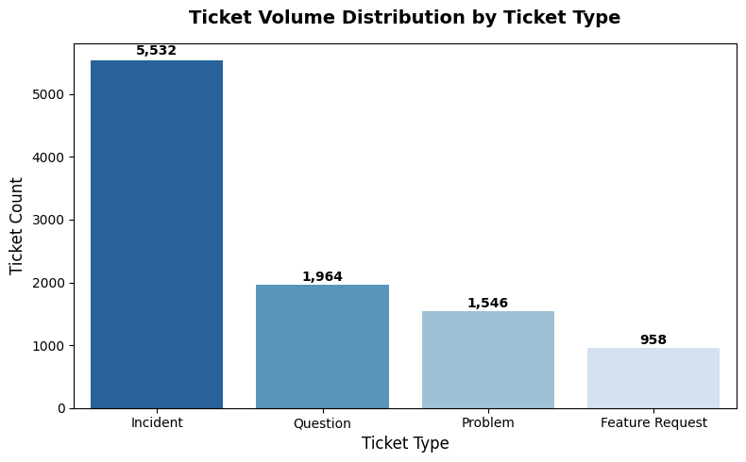
Fig 3.1: Ticket Volume Distribution by Ticket Type — Incidents dominate with 5,532 tickets, followed by Questions (1,964), Problems (1,546), and Feature Requests (958).
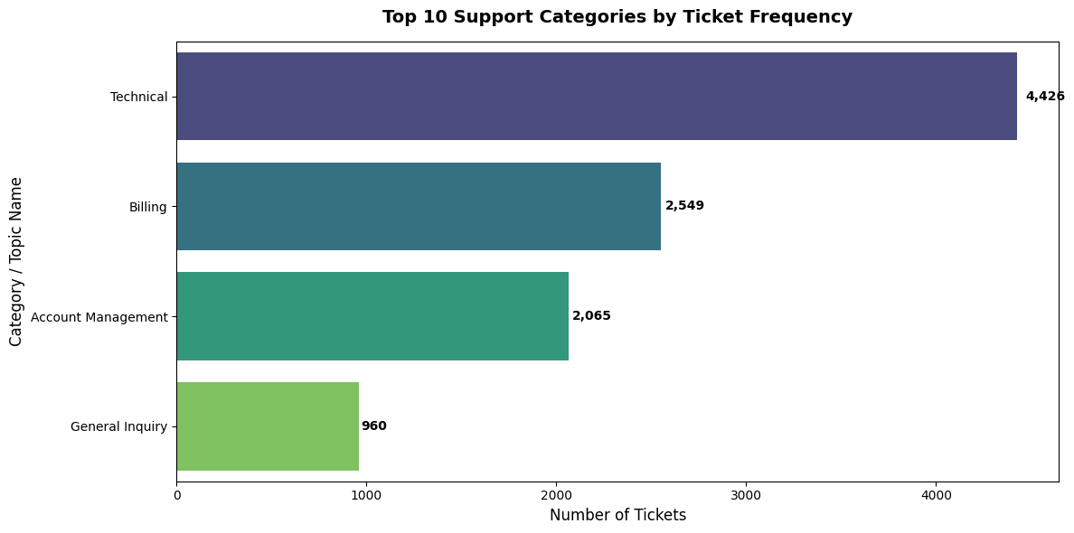
Fig 3.2: Top Support Categories by Ticket Frequency — Technical issues account for the largest share (4,426 tickets), followed by Billing (2,549) and Account Management (2,065).
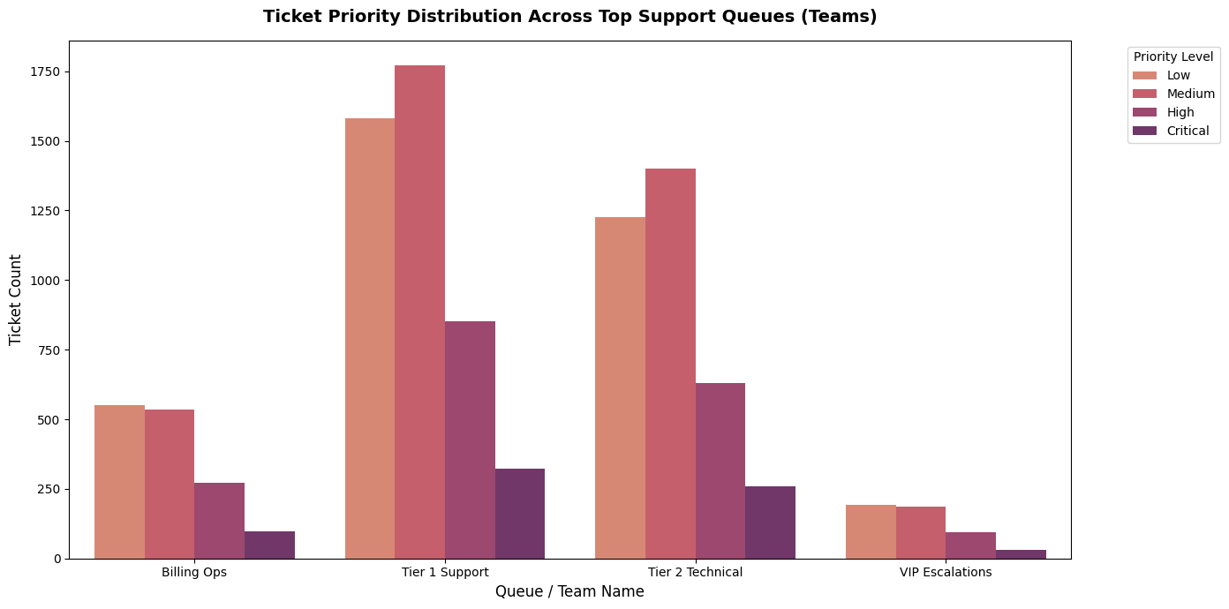
Fig 3.3: Ticket Priority Distribution Across Support Queues — Tier 1 Support handles the highest ticket volume across all priority levels.

Module 4: Similarity and Cluster Insights
Tickets were grouped by Cluster_Name to study cluster size and average similarity score, indicating how consistently similar issues within a cluster were classified. Boxplots, bar charts, heatmaps, scatter plots, and a violin plot were used to analyze cluster quality and performance gaps (8 visualizations, meeting the module deliverable).
similarity_summary = df.groupby('Cluster_Name').agg(
Ticket_Count=('Ticket_ID', 'count'),
Average_Similarity=('Similarity_Score', 'mean'),
Median_Similarity=('Similarity_Score', 'median'))

sns.boxplot(data=df, y='Cluster_Name', x='Similarity_Score') # spread by cluster
sns.violinplot(data=df, x='Priority', y='Similarity_Score') # score vs priority
Cluster Name | Tickets | Avg. Similarity | Median
Subscription & Refunds | 1,440 | 0.778 | 0.78
Password & Login Issues | 1,420 | 0.773 | 0.78
Account Security | 1,475 | 0.773 | 0.78
Hardware & Device Sync | 1,481 | 0.772 | 0.77
Billing & Invoices | 1,418 | 0.769 | 0.77
UI/UX & Display Bugs | 1,401 | 0.769 | 0.77
App Performance/Crash | 1,365 | 0.768 | 0.76
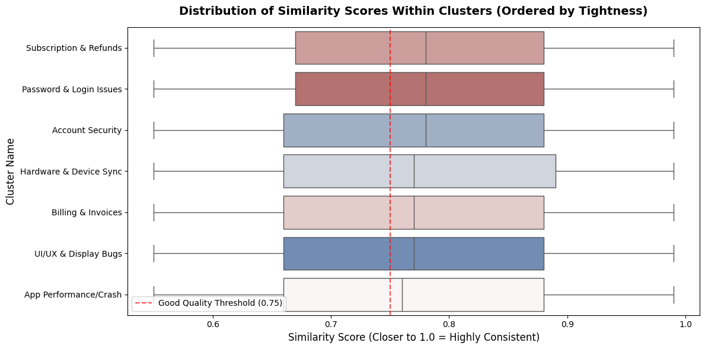
Fig 3.4: Distribution of Similarity Scores Within Clusters, ordered by tightness against the 0.75 quality threshold.
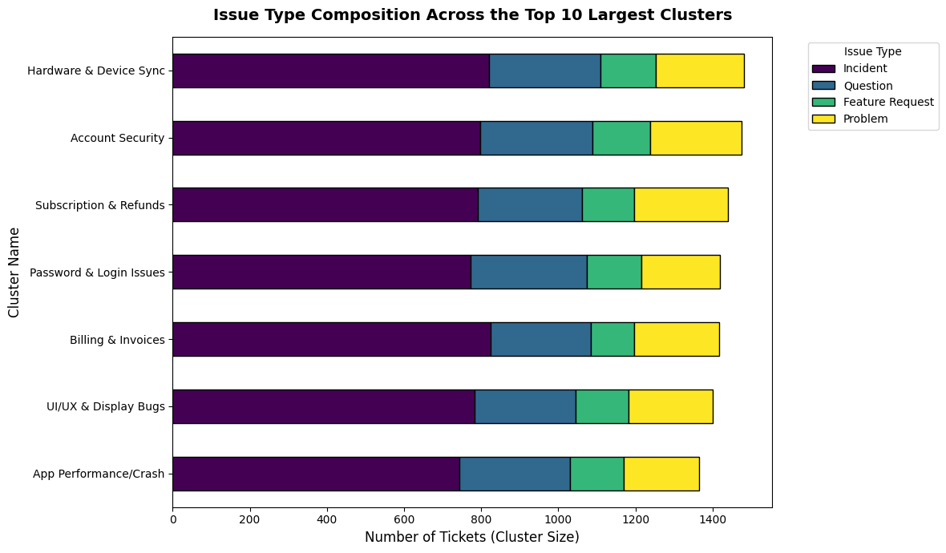
Fig 3.5: Issue Type Composition across the Top 10 Largest Clusters.
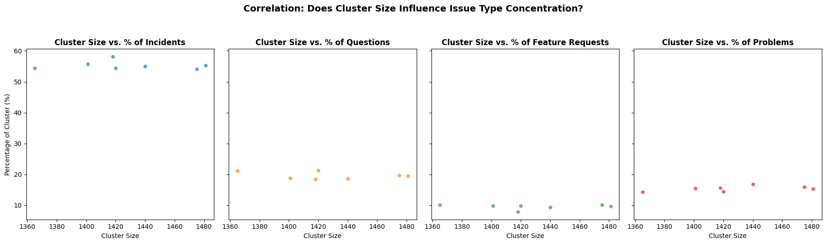
Fig 3.6: Correlation between cluster size and issue-type concentration — Incidents consistently make up ~55% of every cluster.
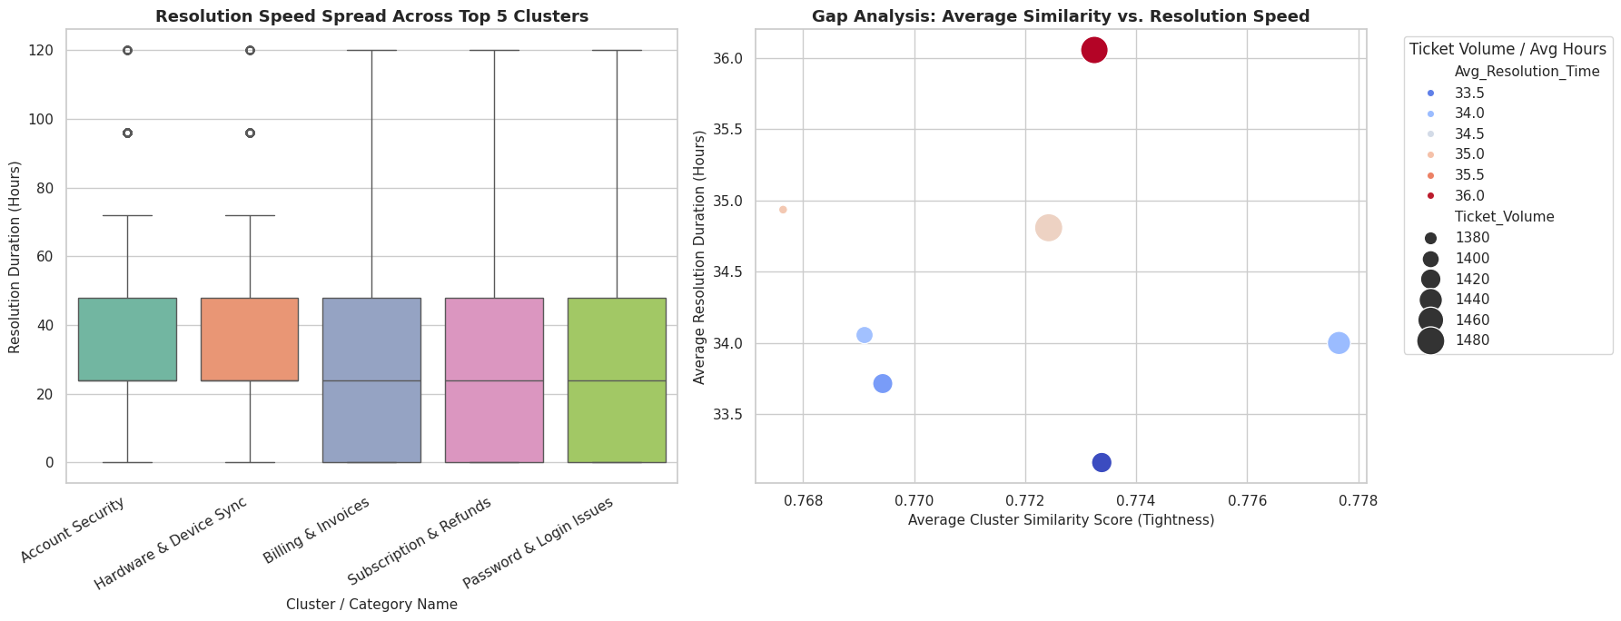
Fig 3.7: Resolution speed spread across top 5 clusters (left) and Gap Analysis of similarity vs. resolution speed (right) — Account Security shows the highest ticket volume paired with the longest average resolution duration.
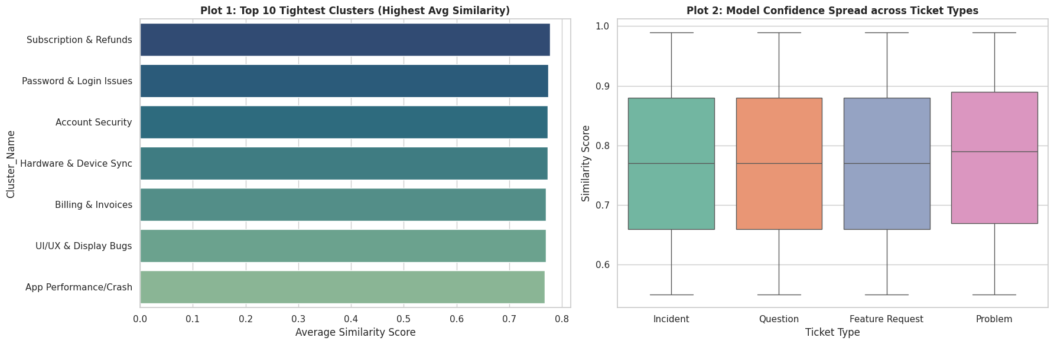
Fig 3.8: Top 10 tightest clusters by average similarity (left) and model confidence spread across ticket types (right).
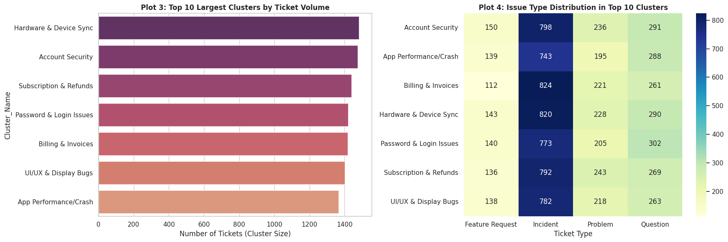
Fig 3.9: Top 10 largest clusters by ticket volume (left) and issue type distribution heatmap within top clusters (right).
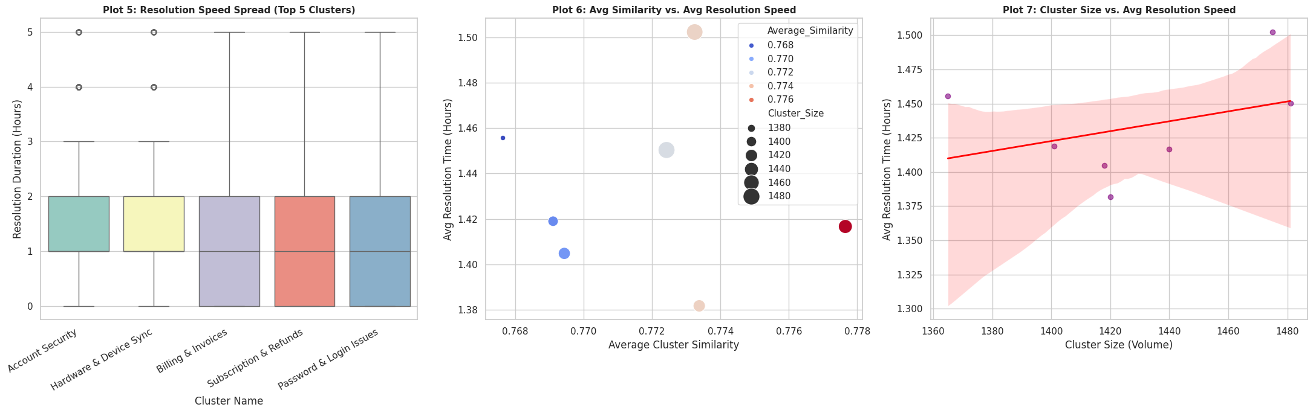
Fig 3.10: Resolution speed spread, similarity vs. resolution time, and cluster size vs. resolution speed (left to right).
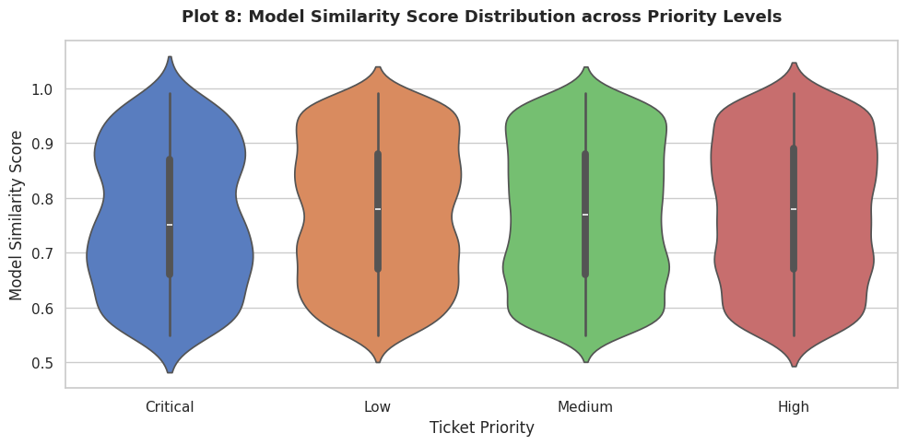
Fig 3.11: Model Similarity Score Distribution across Priority Levels — similarity is broadly consistent regardless of priority, indicating priority does not bias classification confidence.
Key finding: All clusters maintain average similarity scores between 0.77–0.78, just above the 0.75 quality threshold, indicating generally consistent issue grouping. Account Security tickets show the highest ticket volume combined with the longest average resolution time, making it a priority area for process improvement.

4. Milestone 3 (Week 5–6): Performance & Geographic Insights

Module 5: Performance Trend Analysis
Average resolution times were compared across ticket priority and type, support teams were ranked by resolution speed, and high-priority unresolved tickets were isolated for escalation review.
df.groupby(['Ticket_Type', 'Priority'])['Resolution_Duration'].mean()

team_speed = df.groupby('Team')['resolution_time_hours'].mean().sort_values()

unresolved_high_priority = df[
df['Status'].isin(['Open', 'Pending', 'In Progress']) &
df['Priority'].isin(['High', 'Critical'])]
print(f"Total High & Critical Unresolved Tickets: {len(unresolved_high_priority)}")
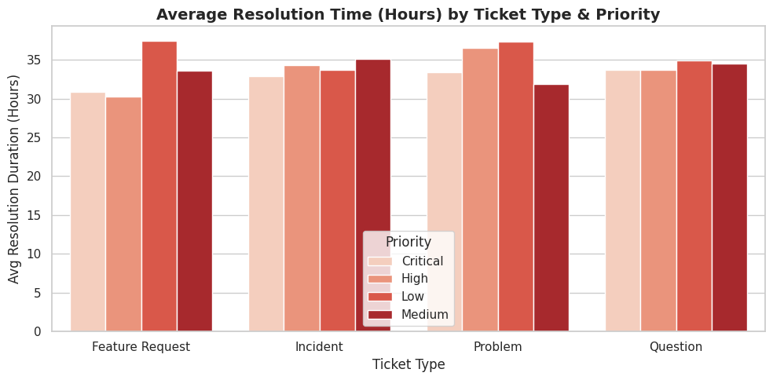
Fig 4.1: Average Resolution Time by Ticket Type and Priority.
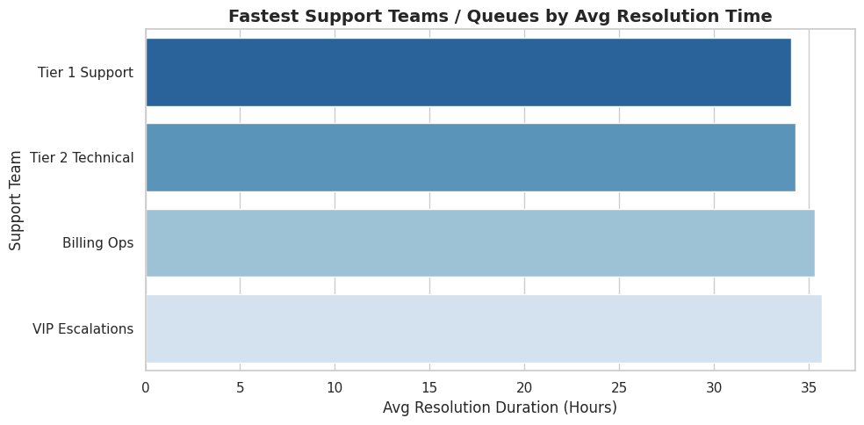
Fig 4.2: Fastest Support Teams/Queues by Average Resolution Time — Tier 1 Support resolves tickets fastest (~34 hrs), VIP Escalations the slowest (~35.7 hrs).
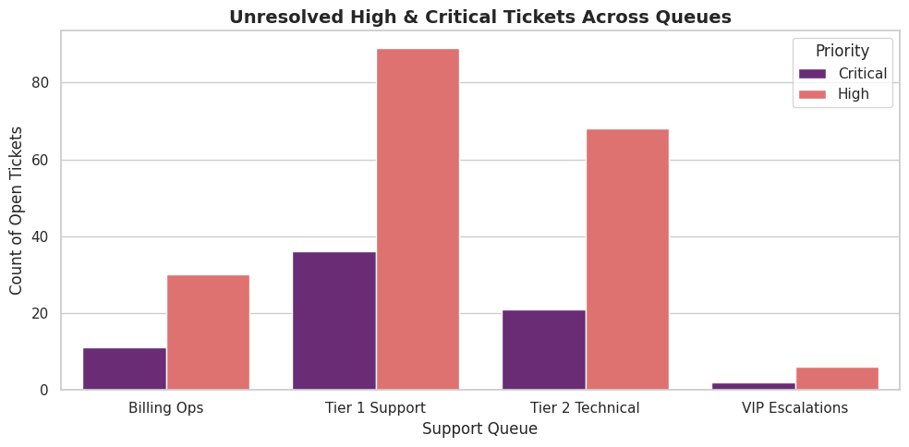
Fig 4.3: Unresolved High & Critical Priority Tickets by Queue.
Key finding: A total of 263 High and Critical priority tickets remain unresolved (Open, Pending, or In Progress), concentrated most heavily in Tier 1 Support, which represents a direct risk to SLA compliance.

Module 6: Geographic and Category-Level Insights
Ticket concentration was mapped by country and category using a heatmap, geolocated on an interactive Folium map, and cluster size was evaluated against customer satisfaction score.
geo_heatmap_data = pd.crosstab(df['Country'], df['Category'])
sns.heatmap(geo_heatmap_data, annot=True, fmt='d', cmap='YlGnBu')

import folium
from folium.plugins import MarkerCluster
m = folium.Map(location=[20, 0], zoom_start=2)
# ... markers added per ticket location, clustered
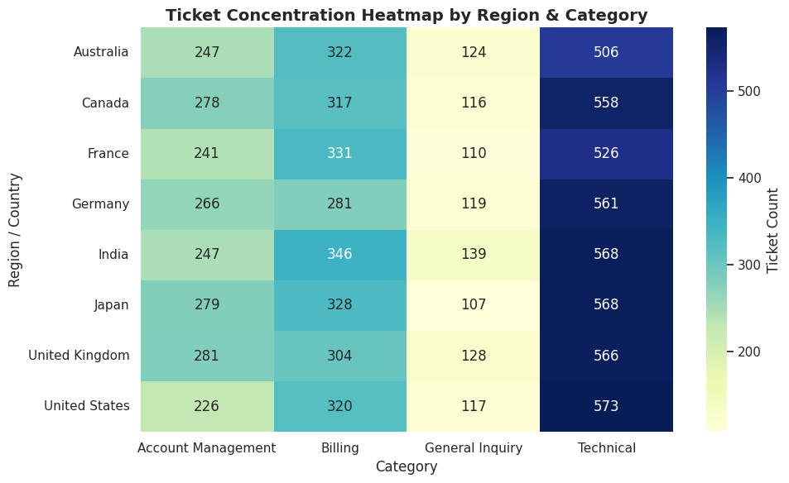
Fig 4.4: Ticket Concentration Heatmap by Region & Category — Technical issues are the largest contributor in every country, peaking in the United States (573) and Japan (568).
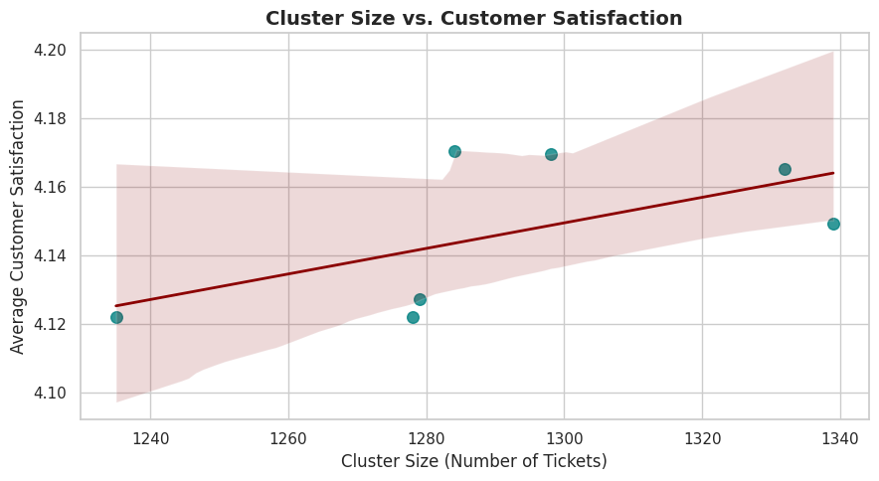
Fig 4.5: Cluster Size vs. Customer Satisfaction — a mild positive trend suggests larger, well-triaged clusters correlate with slightly higher satisfaction.
Country | Total Tickets | Avg. Performance Score
India | 1,300 | 4.22
United Kingdom | 1,279 | 4.21
France | 1,208 | 4.19
Canada | 1,269 | 4.14
United States | 1,236 | 4.12
Australia | 1,199 | 4.11
Japan | 1,282 | 4.11
Germany | 1,227 | 4.08
Key finding: India records the highest ticket volume and the best average performance score (4.22), while Germany has the lowest average performance score (4.08) despite moderate volume — indicating a regional process gap worth investigating.

5. Milestone 4 (Week 7–8): Dashboard & Documentation

Module 7: Dashboard/Report Preparation
All performance insights were consolidated into an interactive Streamlit dashboard, deployed locally and tunnelled for sharing, organized around four core KPIs: Average Resolution Time, Most Frequent Categories, Cluster Similarity Index, and Top Performing Regions.
import streamlit as st
import pandas as pd, plotly.express as px

st.set_page_config(page_title="Supportlytics | IT Operational Dashboard",
page_icon="bar_chart", layout="wide")
st.title("Supportlytics — IT Support Operational Dashboard")

# KPI cards: Avg Resolution Time | Top Categories |
# Cluster Similarity Index | Top Performing Regions
# Interactive Plotly charts filtered by country, priority, and category
The dashboard was launched via a background Streamlit process and exposed through an SSH tunnel (pinggy.io) for live access and stakeholder demonstration. It includes a sidebar filter panel (Country/Region and Priority), four KPI cards, and four linked visualizations that update dynamically based on the selected filters.
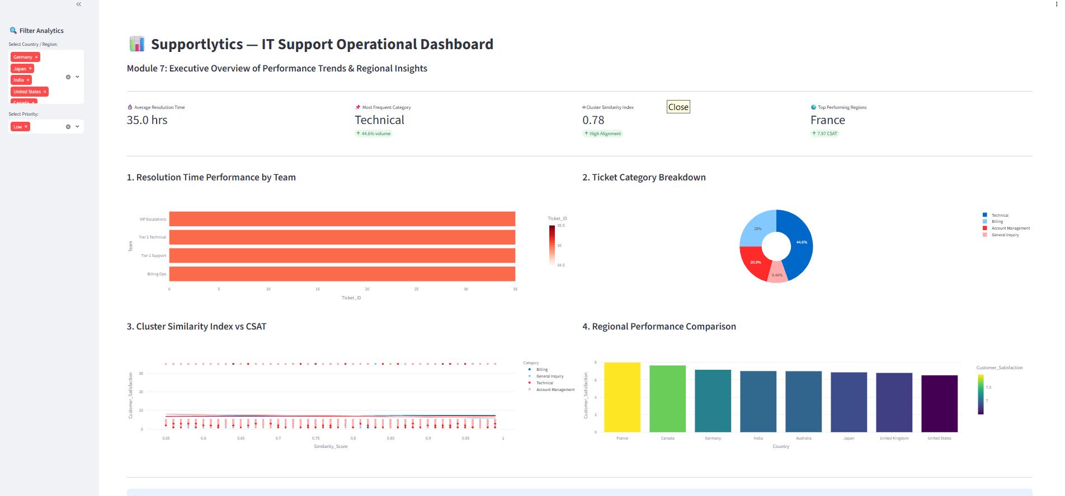
Fig 5.1: Dashboard view filtered to Low priority tickets — France leads as the top-performing region with a 7.97 CSAT score.
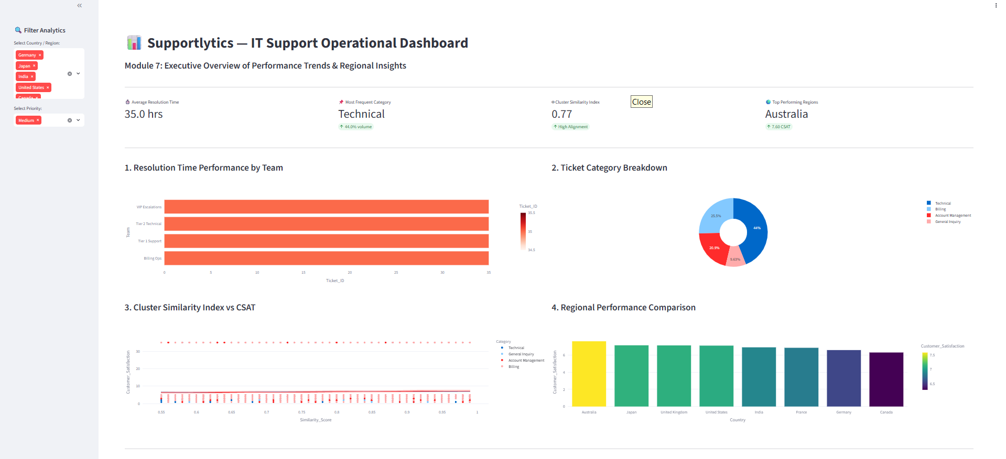
Fig 5.2: Dashboard view filtered to Medium priority tickets — Australia leads regional performance with a 7.60 CSAT score.
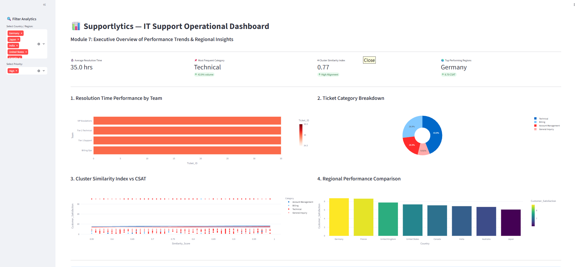
Fig 5.3: Dashboard view filtered to High priority tickets — Germany tops regional performance at an 8.70 CSAT score.
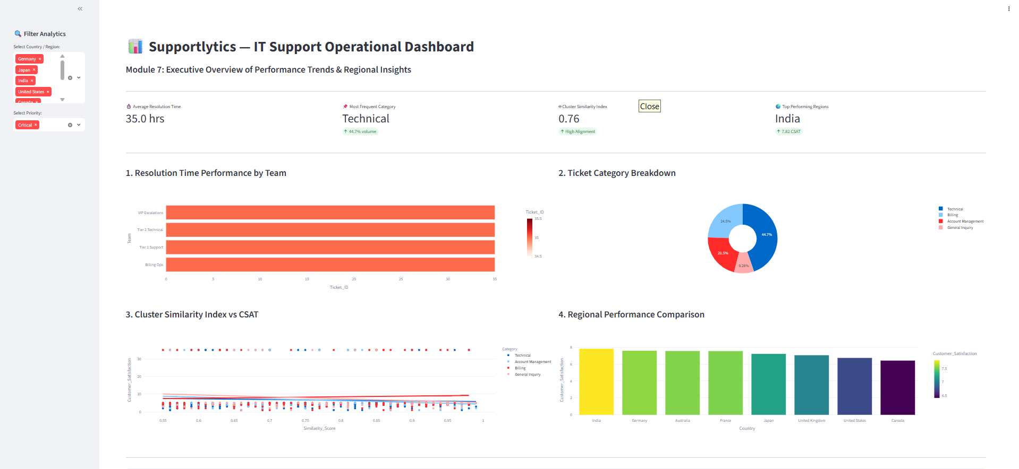
Fig 5.4: Dashboard view filtered to Critical priority tickets — India leads with a 7.82 CSAT score.
Across all priority filters, Technical remains the most frequent ticket category (~44% share) and average resolution time holds steady at ~35 hours, while the top-performing region shifts depending on which priority level is examined — highlighting that regional performance is priority-dependent rather than uniform.

Module 8: Documentation and Presentation
- Final project report compiled summarizing objectives, methodology, and insights (this document).
- Presentation slides prepared highlighting key findings and recommendations.
- Code, visualizations, and processed dataset organized for submission/GitHub upload.

6. Key Insights & Recommendations

6.1 Key Insights
- Incidents make up 55% of all ticket volume (5,532 of 10,000), making incident-handling efficiency the single biggest lever for overall performance.
- Technical issues are the dominant category across every country, indicating a need for stronger self-service/knowledgebase support for technical queries.
- All clusters sit at 0.77–0.78 average similarity — above the 0.75 quality bar — but Account Security and Hardware & Device Sync are the largest and slowest-resolving clusters.
- 263 High/Critical priority tickets remain unresolved, concentrated in Tier 1 Support — a direct SLA risk.
- Germany underperforms on average performance score (4.08) relative to comparable ticket volumes elsewhere, suggesting a regional process or staffing gap.

6.2 Recommendations
- Prioritize additional resourcing or automation for Tier 1 Support to reduce the backlog of unresolved High/Critical tickets.
- Investigate root causes behind slower resolution in the Account Security and Hardware & Device Sync clusters and consider dedicated specialist routing.
- Expand self-service documentation for Technical category issues, which dominate ticket volume in every region.
- Review staffing and process consistency in Germany to close the regional performance gap.
- Continue monitoring similarity scores over time; clusters dropping below the 0.75 threshold should trigger a re-clustering review.

7. Conclusion
The Supportlytics project successfully demonstrates an end-to-end analytics workflow — from raw ticket data to actionable business recommendations. Through systematic data cleaning, feature engineering, exploratory analysis, clustering, and performance benchmarking, the project surfaced concrete opportunities to reduce resolution times, rebalance team workloads, and address regional performance gaps. The resulting interactive dashboard provides IT support leadership with an ongoing tool to monitor these KPIs and make data-driven operational decisions.
This internship strengthened practical skills in Python-based data analysis, statistical visualization, clustering techniques, and dashboard development using Streamlit — forming a solid foundation for further work in data analytics and business intelligence.

8. Tools & References
- Python Libraries: pandas, NumPy, Matplotlib, Seaborn, Plotly, Folium, Streamlit
- Development Environment: Google Colab
- Dataset: Internal IT Support Ticket System (customer_support_insights_10k)
- Program: Infosys Springboard Virtual Internship 7.0, Batch 1

