PROJECT REPORT
OPTIMIZING IT SUPPORT TEAMPERFORMANCE USING ANALYTICS
(SUPPORTLYTICS)

A structured analytics project report coveringData Preparation → EDA → Similarity & Clustering → Performance → Geography → Power BI

Project Information | Details
Project Name | Optimizing IT Support Team Performance Using Analytics (Supportlytics)
Primary Dataset | Customer / IT Support Ticket CSV
Working Environment | Python, Jupyter Notebook, pandas, Matplotlib and Power BI
Dashboard | Supportlytics – Executive Overview and analytical pages
Implementation Plan | Milestone 1 to Milestone 4, Weeks 1–8
Report Format | Letter size, step-by-step documentation

Prepared as a complete academic/project documentation record

1. Executive Summary
Supportlytics is an analytics-driven IT support performance project designed to turn support-ticket data into operational insights. The project focuses on understanding ticket demand, cleaning and engineering useful features, exploring patterns, studying similarity and clusters, comparing resolution performance, examining geographic concentration, and presenting the results through an interactive Power BI dashboard.
The project brief defines the central objective as analyzing IT support ticket data to identify key performance trends, optimize resolution times, and enhance service efficiency through data analysis and visualization. It also emphasizes patterns in customer requests, technical issues, support performance metrics, workflow improvement, and resource allocation.
The implemented work shown in the supplied notebooks and dashboard follows the same overall sequence. The Jupyter work begins with CSV loading and inspection, proceeds to distributions and visualizations, and produces KPI values such as an average resolution time of 120.54 hours. The Power BI report then organizes the results into executive-level KPIs and analytical pages.

1.1 Objectives
- Understand and preprocess the IT support ticket dataset before analysis.
- Measure ticket volume, priority, category, status, resolution time and customer-satisfaction patterns.
- Create analytical features such as resolution duration and priority score.
- Explore frequent categories, issue clusters and regional ticket concentration.
- Compare operational performance across priorities, types and geographic regions.
- Build an interactive dashboard that communicates KPIs and findings clearly.
- Translate the analysis into actionable recommendations for IT support operations.

1.2 Expected Outcomes
- A structured and usable analytical dataset.
- A feature-engineering summary and data dictionary.
- At least eight meaningful visualizations for exploratory and performance analysis.
- A summary of important patterns and problem clusters.
- Geographic and category-level performance views.
- A final Power BI dashboard and a documented analytical narrative.

2. Project Scope, Workflow and Technology
The project is organized as a complete analytics pipeline rather than a single charting exercise. The supplied project brief moves from data acquisition and understanding to cleaning, feature engineering, EDA, clustering/similarity analysis, performance optimization, visualization, dashboard development, and final reporting.

2.1 End-to-End Analytical Workflow
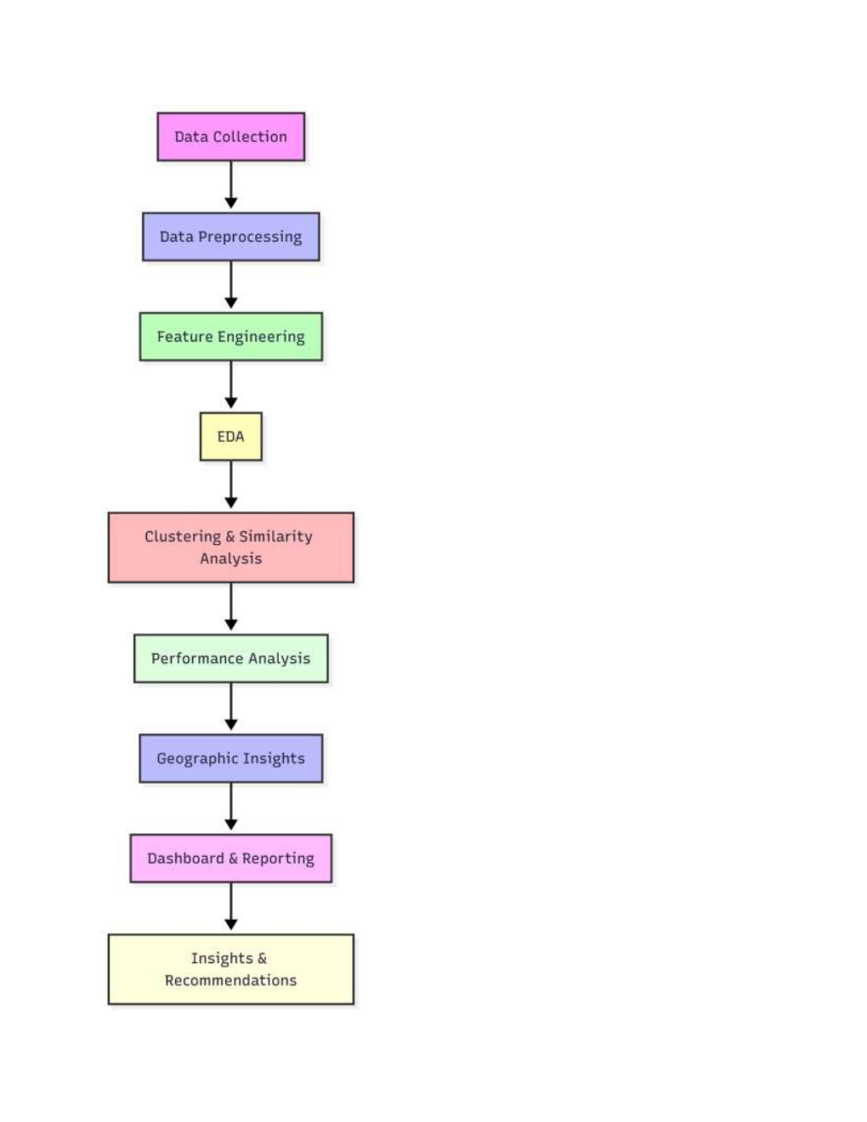
Figure 2.1: Project workflow reproduced from the supplied project brief (page 3).
The workflow diagram shows a sequential dependency: reliable data collection comes first, followed by preprocessing and feature engineering. EDA then establishes the baseline patterns. Similarity and clustering add structure to issue types, after which performance and geographic analysis provide operational context. Dashboard and reporting convert these findings into a form that can be consumed by decision-makers.

2.2 Technology Stack
Layer | Tools / Technologies | Role in Supportlytics
Data handling | pandas, NumPy | CSV loading, cleaning, transformation, aggregation
Visualization | Matplotlib, Seaborn, Plotly | EDA charts, distributions, heatmaps and comparisons
Dashboard | Microsoft Power BI | Interactive KPI and analytical dashboard
Notebook | Jupyter Notebook | Exploration, calculations, visual outputs and documentation
Optional dashboard | Streamlit | Alternative interactive presentation path
Documentation | PDF/README, GitHub | Final methods, insights, recommendations and code sharing

2.3 Core Metrics
- Resolution time / resolution duration: elapsed time required to resolve a ticket.
- First-response time: time taken before the support team first responds.
- Priority distribution: volume and performance segmented by ticket priority.
- Customer satisfaction score: a customer-experience indicator used in performance comparisons.
- Similarity score: an issue-level measure used to study how closely related tickets are.
- Cluster size: the number of tickets associated with a cluster or issue grouping.
- SLA breach indicator: a flag used to identify tickets that crossed the defined service threshold.

3. Milestone Roadmap: Weeks 1–8
The supplied milestone plan divides implementation into four milestones. This structure is used in this report as the main chapter organization so that every analytical activity can be traced back to the planned deliverable.

Milestone 1 — Weeks 1–2
- Project initialization and dataset setup: define objectives, KPIs and workflow; load the CSV; inspect schema, data types and missing values; calculate initial ticket distributions.
- Data cleaning and feature engineering: handle missing or incorrect text fields; create Resolution_Duration and Priority_Score; save processed data; prepare the data dictionary.

Milestone 2 — Weeks 3–4
- Exploratory visualization: ticket-type distribution, top categories and clusters, priority and queue views.
- Similarity and cluster insights: average similarity within clusters, cluster size versus issue type, boxplots/scatter plots, and a minimum of eight visualizations.

Milestone 3 — Weeks 5–6
- Performance trend analysis: resolution time by priority/type, fastest countries or teams, and high-priority unresolved issues.
- Geographic and category-level insights: regional heatmaps, geographic category mapping and the relationship between cluster size and performance.

Milestone 4 — Weeks 7–8
- Dashboard/report preparation: combine visual insights into Power BI or Streamlit and organize the KPI views.
- Documentation and presentation: finalize the report, presentation slides, code/visual uploads and final dashboard.

4. Milestone 1 — Module 1: Project Initialization and Dataset Setup
Milestone 1 establishes data readiness. Before any advanced visualization or performance conclusion is made, the dataset must be loaded correctly, its structure must be understood, and the main fields must be inspected.

4.1 Loading the Dataset
The supplied Jupyter screenshot shows pandas being imported and the CSV being loaded from a local Windows path. The notebook then displays the first five records with df.head(). This is an appropriate first validation step because it confirms that the file has been read and that the rows contain the expected support-ticket fields.
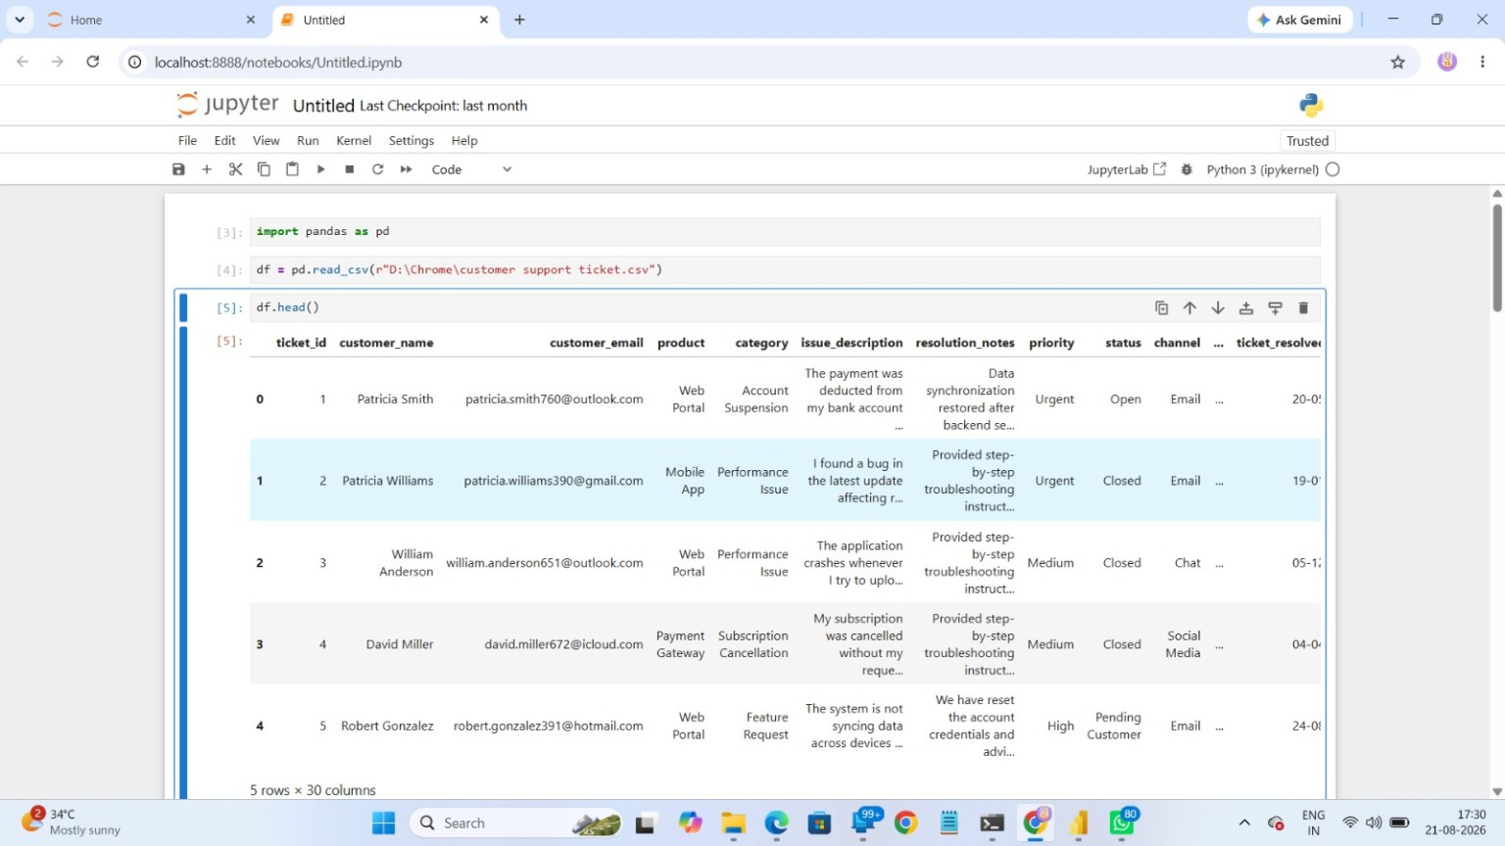
Figure 4.1: Jupyter Notebook showing CSV loading and df.head() output.

4.2 Initial Data Inspection
- Check the number of rows and columns so the analysis scope is known.
- Inspect column names to understand the available dimensions and measures.
- Review data types because dates, numeric measures and text fields need different handling.
- Check missing values before calculating KPIs or generating charts.
- Review category, priority and status values for spelling inconsistencies or unexpected labels.

4.3 Working Dataset Observed in the Screenshots
The notebook output shown in the supplied screenshots indicates 200,000 records and 30 columns. The visible sample includes customer, product, category, issue description, resolution notes, priority, status, channel and ticket-resolution information. The project brief identifies the dataset as originating from an internal IT support ticket system.

5. Milestone 1 — Schema, Data Dictionary and Initial Commands
A data dictionary connects raw column names with their analytical meaning. The columns visible in the supplied notebook output cover identity, customer attributes, ticket attributes, timing, service quality and technical context.
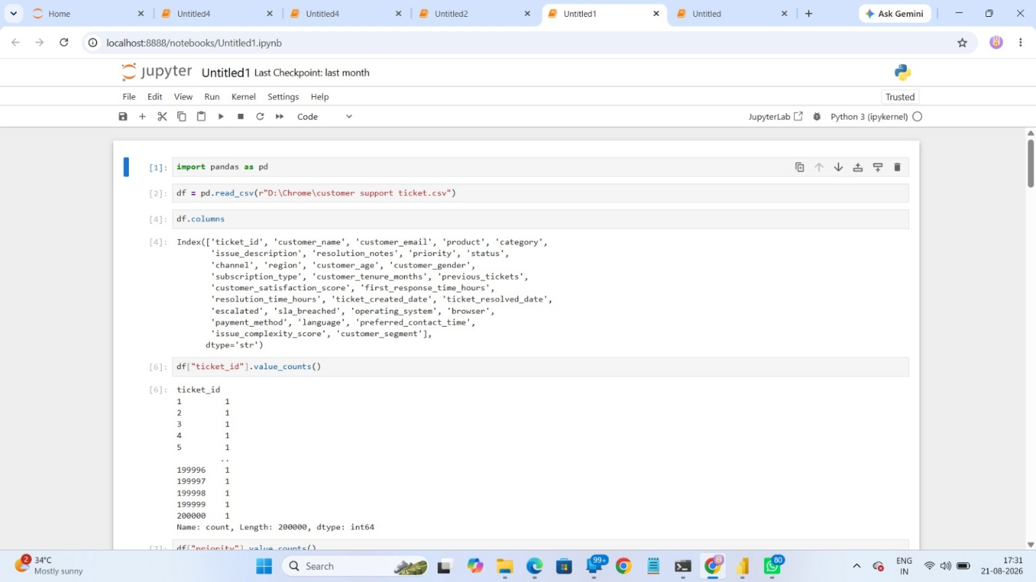
Figure 5.1: Jupyter Notebook showing the columns and ticket_id frequency output.

5.1 Visible Data Dictionary
Field | Analytical meaning
ticket_id | Unique ticket identifier
customer_name | Customer name / requester
customer_email | Customer email field
product | Product or application involved
category | Support issue category
issue_description | Customer-reported issue text
resolution_notes | Support resolution text
priority | Ticket priority level
status | Current ticket status
channel | Support contact channel
region | Geographic region
customer_age | Customer age field
customer_gender | Customer gender field
subscription_type | Subscription classification
previous_tickets | Previous ticket count
customer_satisfaction_score | Customer satisfaction measure
first_response_time_hours | First response time
resolution_time_hours | Resolution time measure
ticket_created_date | Ticket creation date
ticket_resolved_date | Ticket resolution date
escalated | Escalation indicator
sla_breached | SLA breach indicator
operating_system | Customer operating system
browser | Browser used
payment_method | Payment method
language | Customer language
preferred_contact_time | Preferred contact period
issue_complexity_score | Issue complexity measure
customer_segment | Customer segment

5.2 Core Inspection Commands
import pandas as pd
df = pd.read_csv(r"D:\Chrome\customer support ticket.csv")
df.head()
df.columns
df["ticket_id"].value_counts()

6. Milestone 1 — Module 2: Data Cleaning and Feature Engineering
Cleaning converts raw support data into an analysis-ready table. The project brief specifically requires handling missing or incorrect text fields and creating new analytical features such as Resolution_Duration and Priority_Score.

6.1 Cleaning Strategy
- Identify null values in text, date and numeric fields.
- Standardize text values using trimming and consistent casing where required.
- Convert date fields to datetime before calculating durations.
- Validate that resolution dates do not precede creation dates.
- Check numeric fields for impossible values and document any treatment.
- Retain an untouched/raw copy so transformations remain traceable.

6.2 Feature Engineering
Resolution_Duration is derived from the difference between ticket resolution date and ticket creation date. Priority_Score converts qualitative priority labels into a numeric representation suitable for comparison and, where appropriate, modeling or clustering. The exact scoring convention should be documented with the processed dataset.
Recommended reproducible implementation pattern
# Date conversion
df["ticket_created_date"] = pd.to_datetime(df["ticket_created_date"], errors="coerce")
df["ticket_resolved_date"] = pd.to_datetime(df["ticket_resolved_date"], errors="coerce")
# Resolution duration in hours
df["Resolution_Duration"] = (
df["ticket_resolved_date"] - df["ticket_created_date"]
).dt.total_seconds() / 3600
# Example priority mapping — document the final mapping used
priority_map = {"Low": 1, "Medium": 2, "High": 3, "Urgent": 4}
df["Priority_Score"] = df["priority"].map(priority_map)
# Save processed data
df.to_csv("cleaned_customer_support_tickets.csv", index=False)

6.3 Milestone 1 Deliverables
- Cleaned dataset ready for analysis.
- Feature-engineering summary describing each derived feature.
- Data dictionary covering field meaning and analytical use.
- Initial ticket distributions by type, priority and category.
7. Milestone 2 — Module 3: Exploratory Data Analysis
Milestone 2 moves from data readiness to pattern discovery. EDA answers basic but important questions: Which statuses dominate? Which categories appear frequently? How is ticket volume distributed? How do priorities compare?

7.1 Ticket Status Distribution
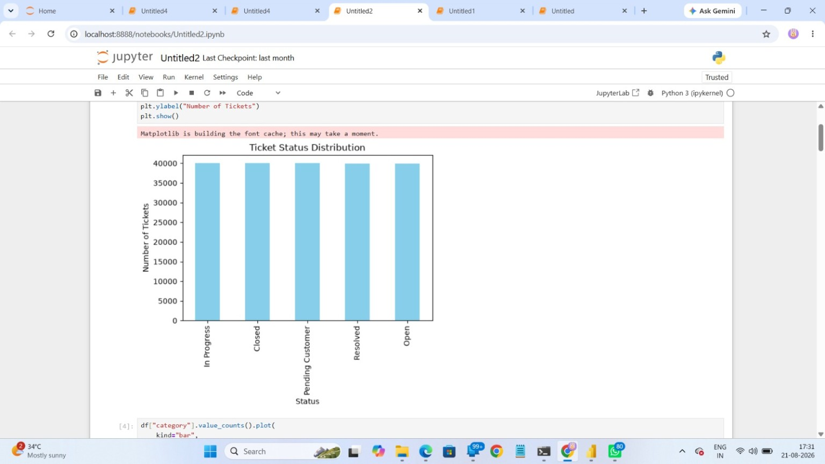
Figure 7.1: Ticket Status Distribution produced in Jupyter Notebook.
The supplied chart displays five status groups: In Progress, Closed, Pending Customer, Resolved and Open. The bars are visually very similar in height, indicating that the captured dataset is broadly balanced across these status labels rather than being dominated by a single status. This should be treated as a descriptive observation from the chart.

7.2 EDA Questions to Answer
- What are the most frequent ticket categories?
- How are tickets distributed by priority?
- Which channels generate the largest workload?
- How does status vary across categories or regions?
- Which issue types appear to consume the most resolution effort?
- Are there visible performance gaps that justify deeper cluster or geographic analysis?

7.3 Example EDA Commands
# Frequency analysis
df["status"].value_counts()
df["category"].value_counts()
df["priority"].value_counts()
# Simple visualization
df["status"].value_counts().plot(kind="bar", title="Ticket Status Distribution")
df["category"].value_counts().plot(kind="bar", title="Ticket Categories")

8. Milestone 2 — Module 4: Similarity and Cluster Insights
The project brief requires studying Cluster_ID and Cluster_Name, measuring issue similarity using Similarity_Score, identifying frequently occurring clusters, and comparing cluster size with issue type. The supplied notebook screenshot shows a cluster-size visualization organized around the issue categories.
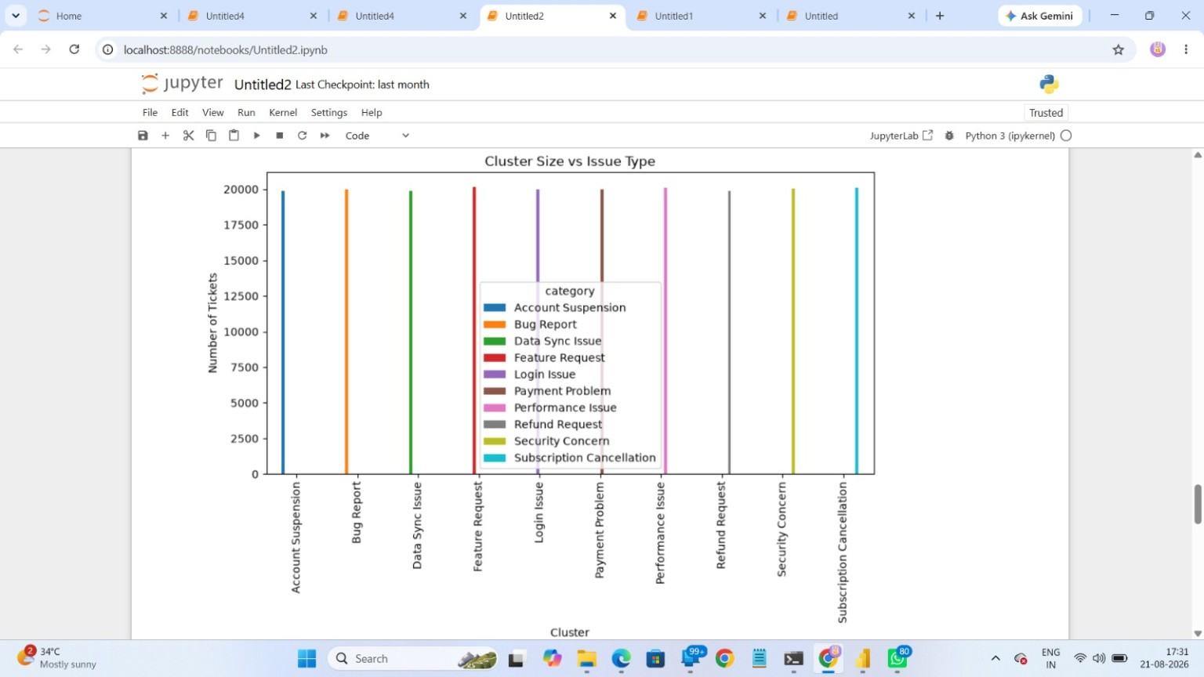
Figure 8.1: Cluster Size vs Issue Type visualization from the supplied notebook.

8.1 Interpretation Framework
- Cluster size indicates how much ticket volume is associated with an issue grouping.
- Similarity Score indicates how closely related tickets are within a cluster.
- A large cluster with high similarity can represent a recurring and well-defined operational problem.
- A large cluster with weaker similarity may indicate a broad category containing several different problem patterns.
- Resolution rate should be compared with cluster size so that high-volume problem areas are not overlooked.
- Boxplots and scatter plots are useful for detecting variation and outliers in cluster-level performance.

8.2 Important Reporting Note
The supplied screenshots do not expose the exact clustering algorithm, parameter settings or the complete Cluster_ID / Similarity_Score calculation. Therefore, this report documents the intended clustering analysis and the visible cluster-size output without claiming a specific algorithm or model configuration that is not shown in the supplied material.

8.3 Suggested Analysis Commands
# Cluster-level descriptive analysis
cluster_summary = (
df.groupby("category")
.agg(Ticket_Count=("ticket_id", "count"))
.sort_values("Ticket_Count", ascending=False)
)
# If the processed dataset contains similarity/cluster fields:
# df.groupby("Cluster_ID")["Similarity_Score"].mean()
# df.groupby("Cluster_ID")["resolution_time_hours"].mean()

9. Milestone 3 — Module 5: Performance Trend Analysis
Milestone 3 focuses on operational performance. The project requirements ask for average resolution time by priority and type, identification of the fastest countries or teams, and detection of high-priority unresolved issues.
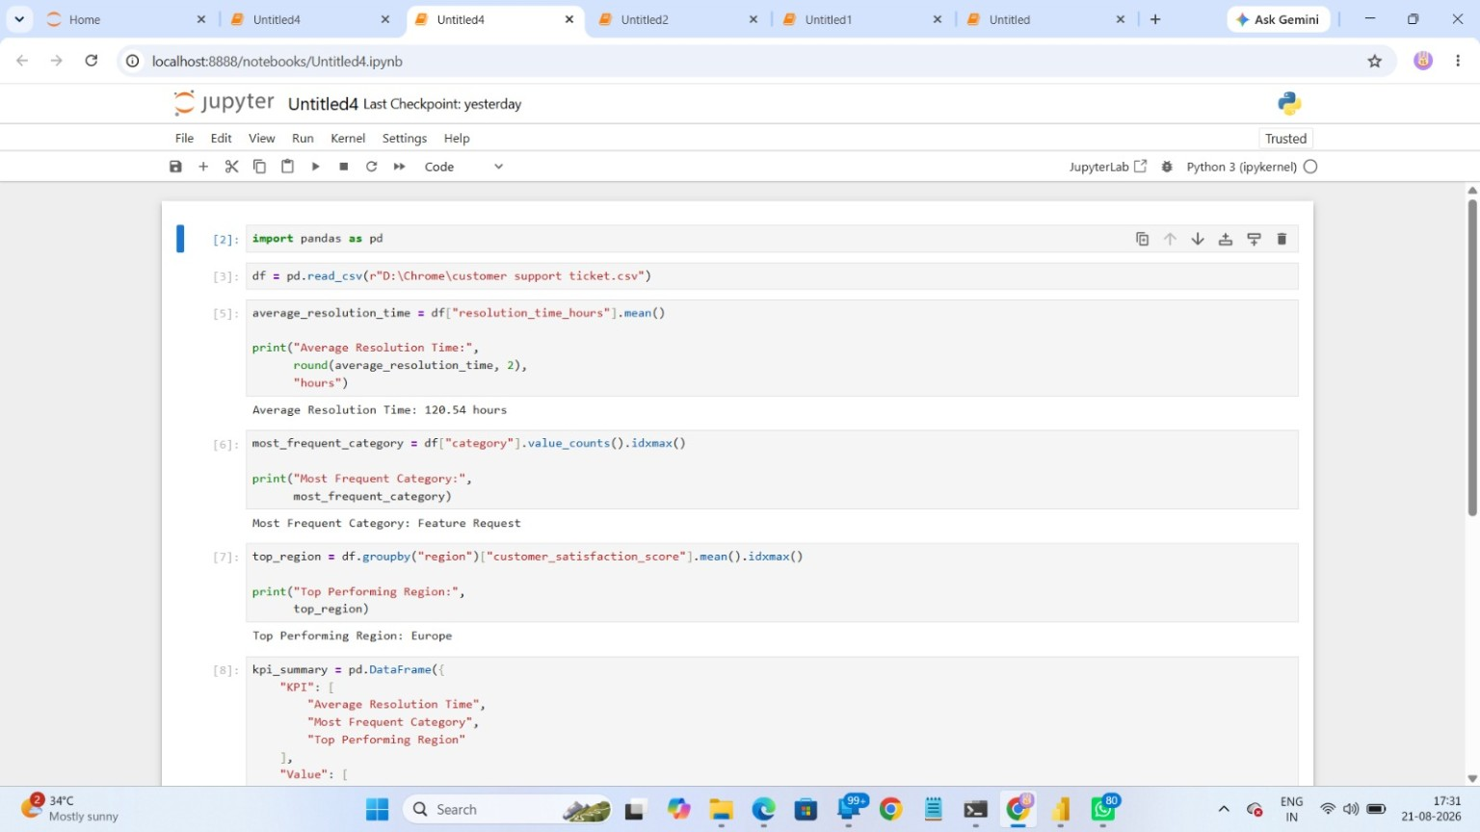
Figure 9.1: Jupyter KPI calculations showing average resolution time, most frequent category and top-performing region.

9.1 Observed KPI Results
KPI | Observed result in supplied notebook | Meaning
Average Resolution Time | 120.54 hours | Average time represented by the resolution_time_hours field.
Most Frequent Category | Feature Request | Category with the highest frequency in the visible KPI calculation.
Top Performing Region | Europe | Region with the highest mean customer satisfaction score in the visible calculation.
The KPI screenshot shows a direct pandas calculation of the mean resolution_time_hours, a value_counts().idxmax() calculation for the most frequent category, and a region-level mean customer_satisfaction_score comparison. These calculations are simple, transparent and easy to reproduce.

9.2 Performance Analysis Method
- Calculate average and median resolution time by priority.
- Compare resolution time across ticket categories or types.
- Compare regions using resolution time and customer satisfaction.
- Filter urgent/high-priority tickets and identify those that remain unresolved.
- Use distribution charts or boxplots to detect unusually slow cases.
- Translate the results into staffing, queue-management or process recommendations.

9.3 KPI Reproduction
average_resolution_time = df["resolution_time_hours"].mean()
print("Average Resolution Time:", round(average_resolution_time, 2), "hours")
most_frequent_category = df["category"].value_counts().idxmax()
print("Most Frequent Category:", most_frequent_category)
top_region = (
df.groupby("region")["customer_satisfaction_score"]
.mean()
.idxmax()
)
print("Top Performing Region:", top_region)

10. Milestone 3 — Module 6: Geographic and Category-Level Insights
Geographic analysis adds location as an operational dimension. The project brief requires heatmaps of ticket concentration by region, geographic mapping of issue categories using latitude/longitude where available, and evaluation of the relationship between cluster size and performance.
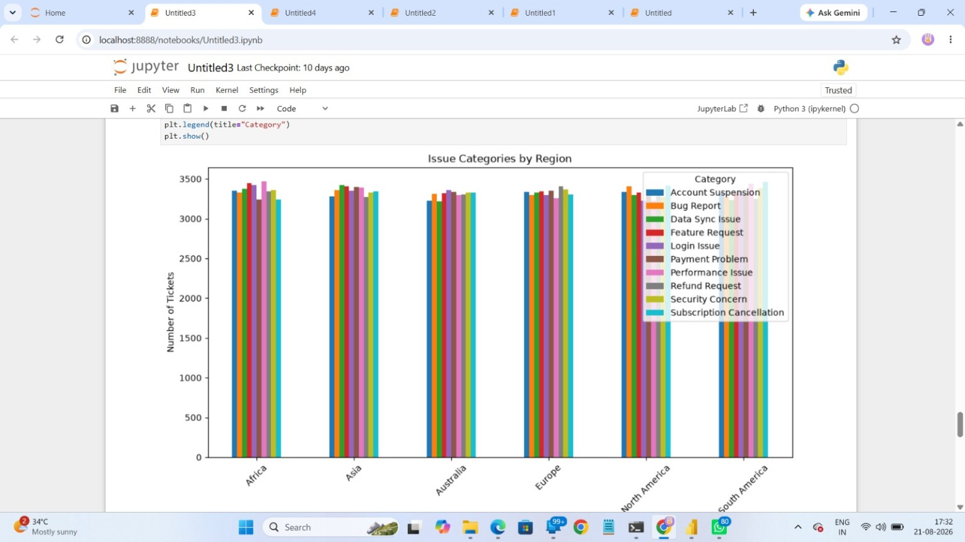
Figure 10.1: Issue Categories by Region — comparative category/region visualization.
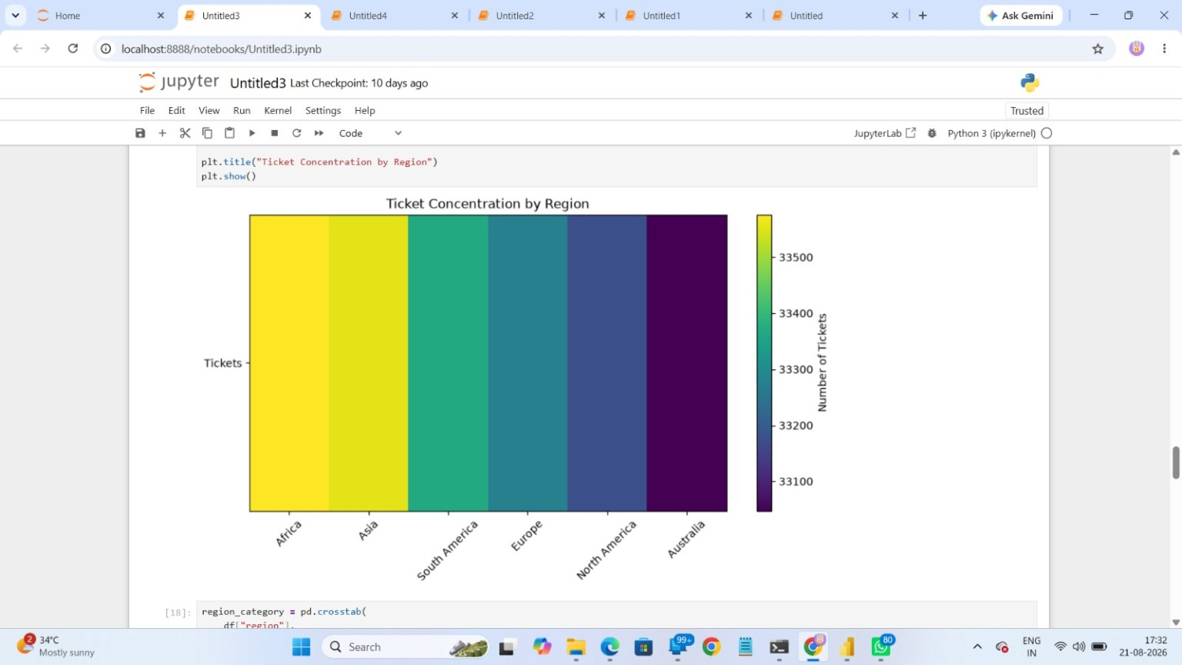
Figure 10.2: Ticket Concentration by Region — heatmap visualization.

10.1 Observed Geographic Pattern
The heatmap orders the visible regions as Africa, Asia, South America, Europe, North America and Australia. The color intensity indicates differences in ticket concentration, with Africa and Asia appearing toward the higher end of the displayed scale and Australia toward the lower end. The category-by-region chart also shows that category volumes are relatively close within each region, which supports comparative rather than isolated analysis.

10.2 Geographic Questions
- Which regions have the largest ticket workload?
- Do high-volume regions also show longer resolution times?
- Does customer satisfaction differ by region?
- Are certain categories concentrated geographically?
- Are high-priority or SLA-breached tickets concentrated in particular regions?

11. Milestone 4 — Module 7: Power BI Dashboard and Reporting
Milestone 4 converts analytical outputs into a decision-support interface. The supplied Power BI screenshot shows a Supportlytics Executive Overview with KPI cards, a ticket trend, category distribution, regional distribution and priority distribution.
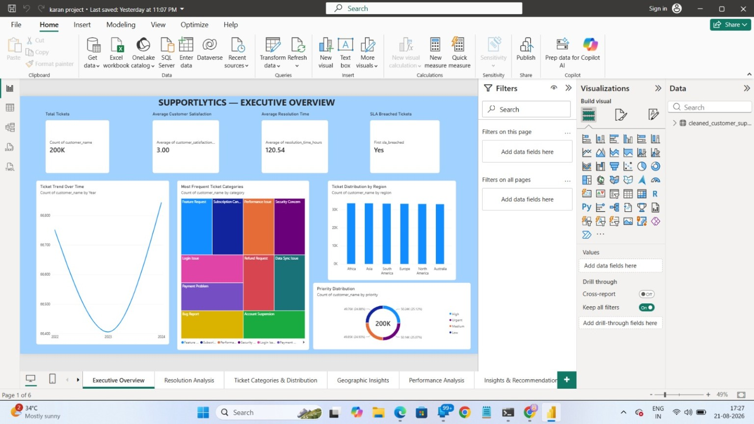
Figure 11.1: Supportlytics Executive Overview dashboard in Microsoft Power BI.

11.1 Dashboard Elements Visible in the Screenshot
- Total Tickets card showing approximately 200K records.
- Average Customer Satisfaction card showing 3.00.
- Average Resolution Time card showing 120.54.
- SLA Breached Tickets indicator.
- Ticket Trend Over Time line chart.
- Most Frequent Ticket Categories treemap.
- Ticket Distribution by Region bar chart.
- Priority Distribution donut chart.
- Additional report pages visible at the bottom: Resolution Analysis, Ticket Categories & Distribution, Geographic Insights, Performance Analysis, and Insights & Recommendations.

11.2 Dashboard Design Principle
The dashboard should tell a logical story. The executive page answers “How much work exists and where is it concentrated?” Subsequent pages should answer “How quickly is the work resolved?”, “Which categories create the workload?”, “Where are the geographic differences?”, and finally “What should the support team do next?”

11.3 Power BI Flow
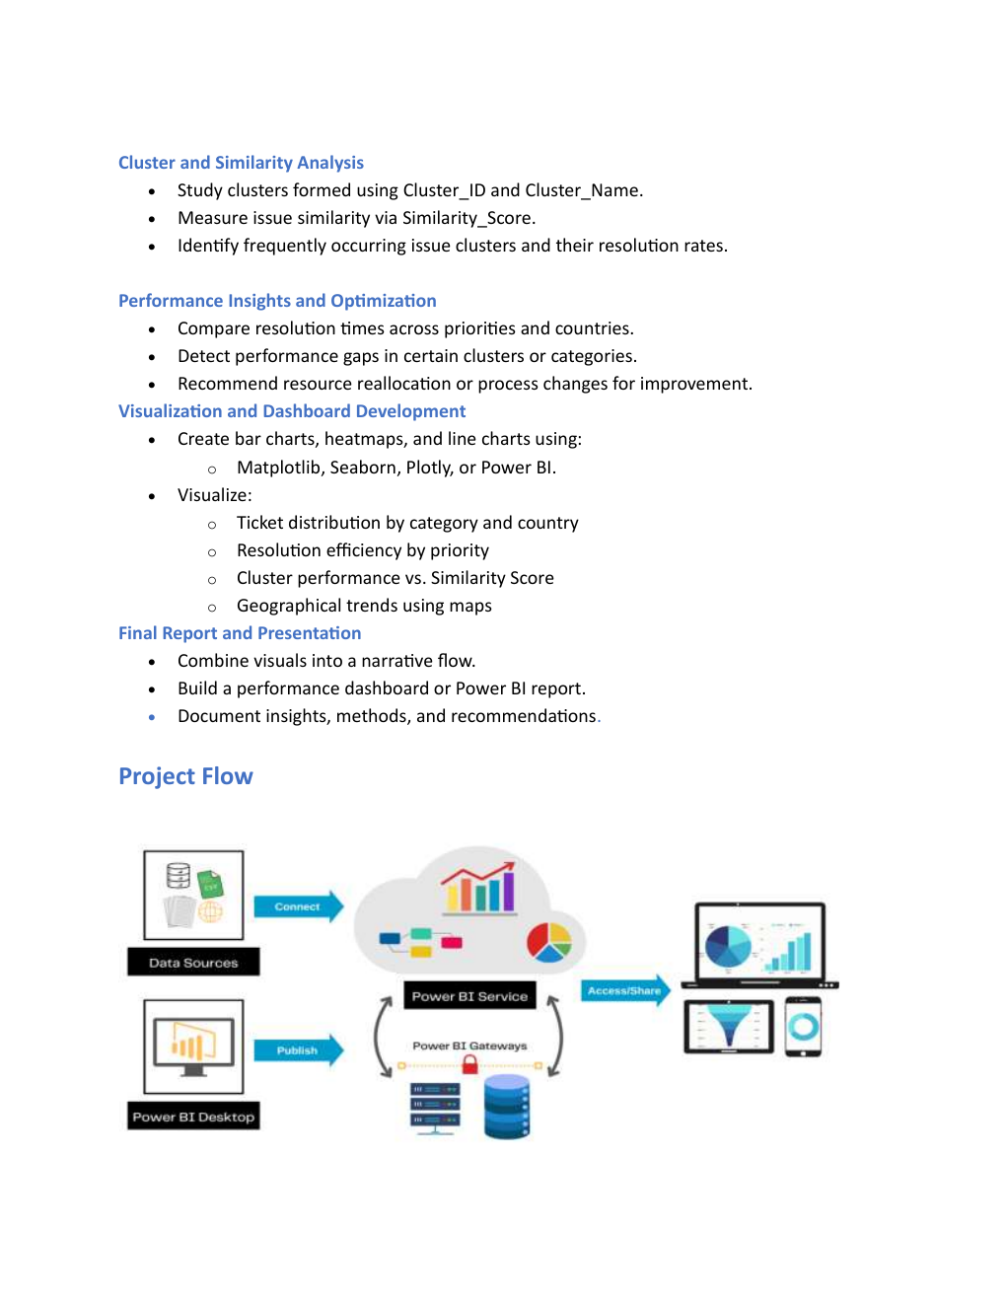
Figure 11.2: Power BI service flow shown in the supplied project brief.

12. Dashboard Page Structure and KPI Definitions
The visible Power BI navigation suggests a multi-page report rather than a single static dashboard. A professional Supportlytics report can use the following page responsibilities while preserving the structure already visible in the supplied work.
Dashboard page | Purpose | Recommended visuals / KPIs
Executive Overview | High-level operational snapshot | Total tickets, satisfaction, resolution time, SLA, trend, region, priority
Resolution Analysis | Understand speed and workload | Average/median resolution time, priority comparison, category comparison
Ticket Categories & Distribution | Understand demand composition | Treemap, bar charts, status/category cross-tab
Geographic Insights | Compare regional workload and outcomes | Heatmap, region bars, maps where coordinates are available
Performance Analysis | Find operational gaps | Boxplots, scatter plots, team/region comparison, unresolved high-priority view
Insights & Recommendations | Convert findings into actions | Key findings, recommended actions, expected operational impact

12.1 KPI Definitions
KPI | Definition | Why it matters
Total Tickets | Count of ticket records | Measures workload volume.
Average Resolution Time | Mean resolution time in hours | Indicates overall service speed.
Average Customer Satisfaction | Mean satisfaction score | Indicates customer experience.
Most Frequent Category | Category with maximum ticket count | Identifies the largest source of demand.
Cluster Similarity Index | Aggregate similarity measure for issue clusters | Shows how coherent recurring issue groups are.
Top Performing Region | Best region according to the selected performance measure | Supports benchmarking and learning.
SLA Breach | Tickets flagged as breaching SLA | Highlights service-level risk.

12.2 Interpretation Rules
- Never interpret a high ticket count as poor performance by itself; high volume can simply reflect demand.
- Pair resolution time with ticket priority and category before making staffing decisions.
- Use customer satisfaction alongside speed so that faster resolution is not mistaken for better service automatically.
- Use region comparisons carefully and confirm that differences are not caused by workload mix.
- Treat dashboard KPIs as indicators that should lead to deeper analysis, not as isolated conclusions.

13. Code and Command Reference
This section consolidates the main notebook-style commands required to reproduce the visible analysis. The commands are intentionally simple and transparent so the analytical workflow can be rerun on the cleaned dataset.
Core pandas analysis commands
# 1. Import library
import pandas as pd
import matplotlib.pyplot as plt
# 2. Load data
df = pd.read_csv(r"D:\Chrome\customer support ticket.csv")
# 3. Inspect data
df.head()
df.shape
df.columns
df.info()
# 4. Check missing values
df.isnull().sum()
# 5. Frequency analysis
df["status"].value_counts()
df["priority"].value_counts()
df["category"].value_counts()
# 6. Average resolution time
df["resolution_time_hours"].mean()
# 7. Most frequent category
df["category"].value_counts().idxmax()
# 8. Top region by satisfaction
df.groupby("region")["customer_satisfaction_score"].mean().idxmax()

Visualization commands corresponding to the supplied notebook outputs
# 9. Status distribution chart
df["status"].value_counts().plot(
kind="bar",
title="Ticket Status Distribution"
)
plt.xlabel("Status")
plt.ylabel("Number of Tickets")
plt.show()
# 10. Region-category comparison
region_category = pd.crosstab(df["region"], df["category"])
region_category.plot(kind="bar", figsize=(12,6))
plt.title("Issue Categories by Region")
plt.ylabel("Number of Tickets")
plt.show()
# 11. Regional concentration
region_counts = df["region"].value_counts()
plt.imshow([region_counts.values], aspect="auto")
plt.title("Ticket Concentration by Region")
plt.xlabel("Region")
plt.ylabel("Tickets")
plt.show()

13.1 Power BI Preparation Commands / Steps
- Export or save the cleaned CSV after feature engineering.
- Open Power BI Desktop and select Get Data → Text/CSV.
- Load the cleaned dataset and verify column data types.
- Create cards for Total Tickets, Average Satisfaction and Average Resolution Time.
- Add category, region and priority visuals.
- Create separate pages for resolution, categories, geography, performance and recommendations.
- Add filters/slicers for region, category, priority and status where useful.
- Validate dashboard values against the Jupyter calculations before finalizing.

14. Key Findings, Recommendations and Evaluation
The following findings are grounded in the values and visuals visible in the supplied notebook and Power BI screenshots. Where a precise numeric value is not displayed, the interpretation remains qualitative.

14.1 Key Findings
- The working dataset shown in the notebook contains 200,000 ticket records and 30 columns.
- The calculated average resolution time is 120.54 hours.
- Feature Request is the most frequent category in the visible KPI calculation.
- Europe is identified as the top-performing region when regions are compared using mean customer satisfaction score.
- The status visualization contains five major status groups and shows broadly similar bar heights.
- The region heatmap shows meaningful differences in ticket concentration across regions.
- The Power BI executive page consolidates workload, satisfaction, resolution time, SLA, category, region and priority views.
- The project brief explicitly expects cluster/similarity analysis, geographic analysis and actionable recommendations, making the dashboard more than a descriptive report.

14.2 Recommendations
- Prioritize recurring high-volume categories such as Feature Request for queue planning and self-service opportunities.
- Monitor average resolution time by priority so urgent cases receive appropriate escalation and staffing.
- Use high-similarity recurring clusters to develop standard troubleshooting or knowledge-base articles.
- Compare regional performance using both speed and customer satisfaction before reallocating resources.
- Create a focused monitoring view for high-priority unresolved tickets and SLA breaches.
- Use the dashboard as a management review tool, with periodic comparison of KPI trends rather than one-time reporting.
- Validate every dashboard KPI against the notebook calculation before publishing.

14.3 Evaluation Criteria Mapping
Milestone | Evaluation focus | How this project addresses it
Milestone 1 | Nulls, data types, usable dataset | Inspection, cleaning, feature engineering and data dictionary
Milestone 2 | Clarity and diversity of plots | Status, category, cluster, regional and heatmap visuals
Milestone 3 | Meaningful insights | Resolution KPI, region comparison, category frequency and geographic concentration
Milestone 4 | Logical storyline and professional reporting | Multi-page Power BI dashboard plus documentation and recommendations

15. Conclusion, Limitations and Future Scope
Supportlytics demonstrates a complete analytics workflow for improving IT support operations. The project starts with dataset readiness and proceeds through cleaning, feature engineering, exploratory visualization, similarity and cluster analysis, performance analysis, geographic insights and Power BI reporting. The visible results already establish useful operational indicators, including an average resolution time of 120.54 hours, Feature Request as the most frequent category, and Europe as the top region under the displayed customer-satisfaction comparison.

15.1 Project Conclusion
The main value of the project is not simply the number of charts produced. Its value is the connection between raw support tickets and operational decisions. By combining workload distribution, resolution speed, customer satisfaction, issue categories, similarity/clustering and geographic concentration, the support organization can identify where demand is coming from, where service is slower, and which recurring problems deserve process improvement.

15.2 Limitations of the Supplied Evidence
- The screenshots do not show the complete clustering algorithm, model parameters or the exact Similarity_Score calculation.
- One column in the 30-column notebook output is not legible in the captured image, so it has intentionally not been invented in the data dictionary.
- The screenshots provide selected outputs rather than the complete notebook, so this report documents the visible implementation and the project requirements without claiming unseen processing steps.
- The dashboard screenshot shows an SLA-breach indicator but does not expose the underlying count in the captured view.

15.3 Future Scope
- Implement a reproducible clustering pipeline with documented algorithm, features and validation metrics.
- Add predictive models for ticket resolution time or SLA-breach risk.
- Create automated alerts for urgent unresolved tickets.
- Add interactive drill-through from category → cluster → ticket-level records.
- Schedule dashboard refreshes and monitor KPI changes over time.
- Add knowledge-base recommendations based on recurring issue clusters.
- Extend geographic analysis to country/team level where reliable location fields are available.

15.4 Final Deliverables Checklist
- Cleaned analytical dataset.
- Feature engineering summary and data dictionary.
- Jupyter Notebook with reproducible analysis.
- Minimum eight analytical visualizations.
- Power BI dashboard with executive and analytical pages.
- Final project report and presentation.
- Code, visuals and report organized for repository submission.

End of Report

