SUPPORTLYTICS
Optimizing IT Support Team Performance Using Advanced Analytics
FINAL INTERNSHIP PROJECT REPORT

Item | Details
Name | Varsha B O
Program | B.E. – Data Science
Project | Supportlytics
Tools | Python, Pandas, NumPy, Matplotlib, Seaborn, Plotly, Power BI
Duration | Week 1 – Week 8

Prepared as a comprehensive record of the project work, analysis, dashboard development, findings and recommendations.

Executive Summary
Supportlytics is an analytics-driven IT support performance solution designed to transform raw support-ticket data into actionable operational insights. The project analyzes ticket volume, priority, issue type, customer segment, queue, status, resolution time, customer satisfaction, geographical distribution and issue clusters. The implementation progressed from dataset understanding and cleaning to feature engineering, exploratory analysis, cluster and similarity analysis, performance analysis, geographic analysis and finally an interconnected Power BI dashboard.
The final dashboard contains six analytical pages: Overview, Tickets Analysis, Cluster Intelligence, Geographical Insights, Performance Analysis and Executive Report. The final results include 100,000 tickets, an average resolution time of 45.01 hours, an average CSAT of 2.24, 5,045 reopened tickets, six clusters and an average similarity index of 0.81.
The analysis highlights MEA as the highest-ticket region, EU as the fastest region by average resolution time, strong cluster similarity/performance in APAC, the need for closer monitoring of high and urgent tickets, and different issue concentrations across clusters. These findings support recommendations related to workload allocation, escalation, queue optimization, regional benchmarking and customer-service improvement.

Table of Contents
1. Introduction
2. Problem Statement
3. Project Goal
4. Project Objectives
5. Scope of the Project
6. Internship Module-Wise Progress
7. Technologies and Tools
8. Dataset Description
9. Project Workflow
10. Data Acquisition and Understanding
11. Data Preprocessing
12. Feature Engineering
13. Exploratory Data Analysis
14. Cluster and Similarity Analysis
15. Performance Analysis
16. Geographic Analysis
17. Dashboard Development
18. Dashboard Pages and Detailed Interpretation
19. Key Insights
20. Recommendations
21. Business Impact
22. Challenges and Limitations
23. Future Scope
24. Conclusion
25. Deliverables and GitHub
26. Appendix A – Important Code
27. Appendix B – Screenshot Checklist
28. References
Note: In Microsoft Word, the Table of Contents can be converted to an automatic TOC using References → Table of Contents.

1. Introduction
IT support teams handle large numbers of tickets that vary by issue type, priority, customer segment, region, channel, queue and resolution status. Without a centralized analytical view, it becomes difficult to understand workload distribution, identify critical unresolved tickets, compare support performance and recognize recurring issue patterns.
Supportlytics addresses this requirement by combining Python-based data preparation and analysis with Power BI-based interactive visualization. The project follows an end-to-end analytics workflow and converts raw support-ticket records into operational and management-level insights.

2. Problem Statement
IT support teams handle large numbers of tickets with different priorities, issue types, customer segments, regions and resolution times. Without centralized analytics, it is difficult to:
- Identify high-volume issues.
- Detect high-priority unresolved tickets.
- Measure support performance.
- Compare regional performance.
- Identify similar issue groups.
- Monitor customer satisfaction.
The project therefore focuses on building an interactive analytical dashboard that converts raw support-ticket data into actionable business insights.

3. Project Goal
The primary goal is to build an interactive analytics dashboard that helps understand support workload, resolution efficiency, priority patterns, customer satisfaction, regional behavior and issue clusters, and then use these insights to recommend improvements in IT support operations.

4. Project Objectives
- Analyze IT support ticket patterns.
- Identify the most common issue types.
- Measure ticket resolution performance.
- Analyze priority and unresolved tickets.
- Identify similar ticket clusters.
- Compare regional performance.
- Analyze customer satisfaction.
- Build an interactive Power BI dashboard.
- Generate actionable recommendations.

5. Scope of the Project
- Data Preprocessing – clean and prepare IT support ticket data.
- Exploratory Analysis – analyze ticket trends, priorities and categories.
- Cluster Analysis – identify similar issues and problem clusters.
- Geographic Analysis – analyze regional ticket distribution and performance.
- Performance Analysis – evaluate resolution time, priority and CSAT.
- Interactive Visualization – develop interconnected Power BI dashboards.
- Executive Reporting – present key insights and recommendations.

6. Internship Module-Wise Progress
Period | Module | Work Completed
Week 1–2 | Module 1: Project Initialization and Dataset Setup | Objectives, KPIs, workflow, dataset loading, schema and initial distributions.
Week 1–2 | Module 2: Data Cleaning and Feature Engineering | Missing-value handling, standardization, duplicate checking, Resolution_Duration and Priority_Score.
Week 3–4 | Module 3: Exploratory Visualization | Ticket, priority, category, cluster and queue visualizations.
Week 3–4 | Module 4: Similarity and Cluster Insights | Cluster mapping, similarity scores, cluster size, issue concentration, CSAT and resolution analysis.
Week 5–6 | Module 5: Performance Trend Analysis | Resolution time by priority, issue, region and queue; high-priority unresolved analysis.
Week 5–6 | Module 6: Geographic and Category-Level Insights | Regional concentration, issue categories by region, maps and cluster-performance comparison.
Week 7–8 | Module 7: Dashboard/Report Preparation | Interconnected Power BI dashboard with operational and executive KPIs.
Week 7–8 | Module 8: Documentation and Presentation | Final report, presentation, dashboard documentation and project deliverables.
The module sequence follows the internship requirements and the work recorded in the project notebook.

7. Technologies and Tools
Technology | Purpose
Python | Data preparation, transformation and analytical calculations.
Pandas | Data loading, cleaning, grouping, cross-tabulation and feature creation.
NumPy | Numerical operations used in analysis.
Matplotlib | Static charts for exploratory and analytical visualizations.
Seaborn | Heatmap visualization for regional ticket concentration.
Plotly | Interactive geographic visualizations.
Folium | Geographic mapping support.
Power BI | Interactive multi-page dashboard and executive reporting.
Jupyter Notebook | Development environment and analysis record.
GitHub | Repository for code, visuals, report and documentation.

8. Dataset Description
The project uses a synthetic IT support ticket dataset containing 100,000 ticket records and 20 original columns. The dataset contains operational, customer, issue, priority, resolution, satisfaction, platform and regional information.
Field | Description
ticket_id | Unique ticket identifier.
created_at | Ticket creation timestamp.
customer_id | Customer identifier.
customer_segment | Customer segment such as individual, enterprise, education, etc.
channel | Support channel used for the ticket.
product_area | Product or functional area associated with the ticket.
issue_type | Type/category of the reported issue.
priority | Low, Medium, High or Urgent priority.
status | Current ticket status.
sla_plan | Applicable service-level plan.
initial_message | Initial customer request or message.
agent_first_reply | Initial response from the support agent.
resolution_summary | Summary of the resolution when available.
resolution_time_hours | Resolution duration in hours when available.
reopened | Binary indicator for reopened tickets.
customer_sentiment | Customer sentiment category.
csat_score | Customer satisfaction score.
has_attachment | Indicator showing whether an attachment exists.
platform | Platform used by the customer.
region | Geographical region.
Dataset size confirmed in the notebook: 100,000 rows × 20 columns.

9. Project Workflow
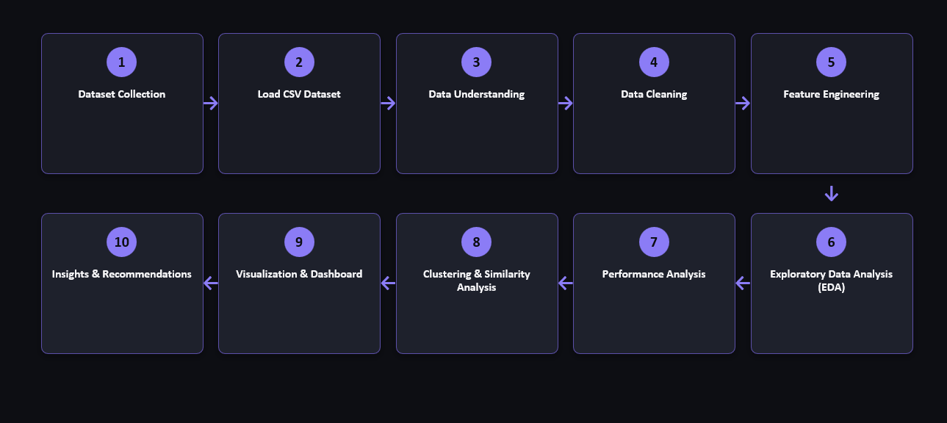
The workflow was designed so that each stage builds on the previous stage: cleaned data supports reliable feature engineering; engineered features support EDA and clustering; those results feed performance and geographic analysis; the resulting insights are presented through Power BI.

10. Data Acquisition and Understanding
The dataset was loaded using Pandas and initially inspected through df.head(), df.shape, df.columns, descriptive statistics, data types and missing-value counts. This established the structure of the data before any transformation was performed.
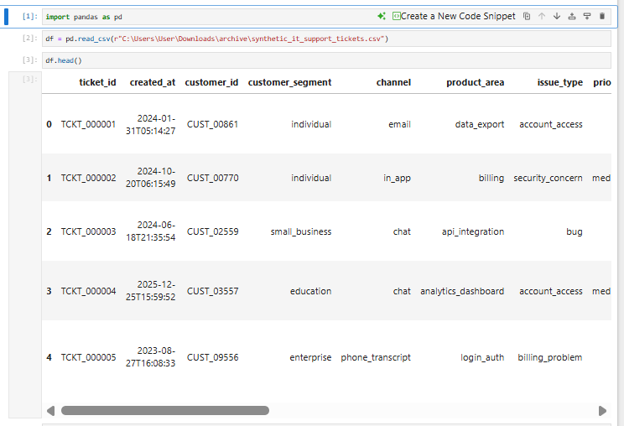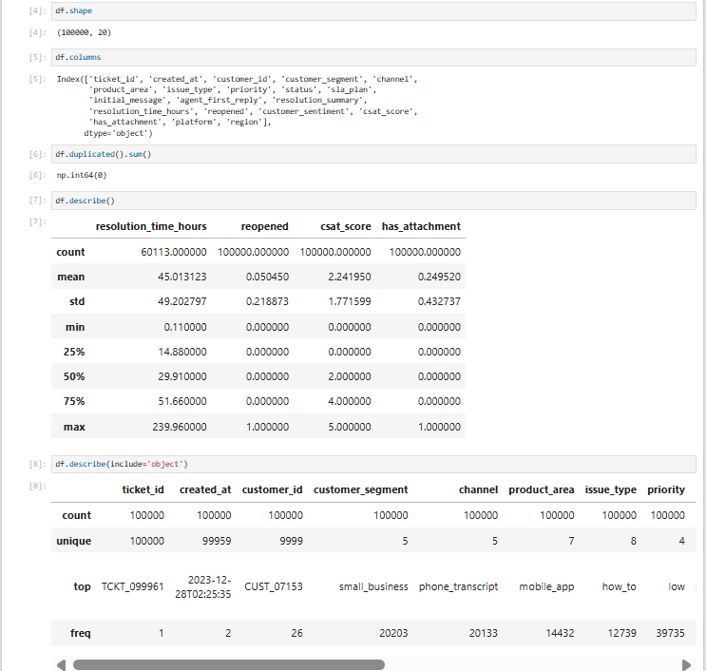

The notebook shows 100,000 rows and 20 original columns. Numeric analysis showed 60,113 non-null resolution-time values, an average resolution time of about 45.01 hours, an average CSAT of about 2.24, and a reopened mean of 0.05045.

11. Data Preprocessing

11.1 Missing-Value Analysis
Missing values were checked across all columns. The main missing fields were resolution_summary, resolution_time_hours and region. Resolution-related fields are naturally unavailable for some tickets that were not yet resolved, while region was missing for a subset of records.
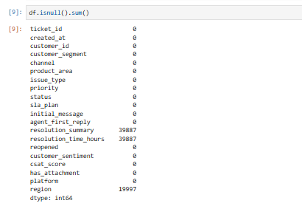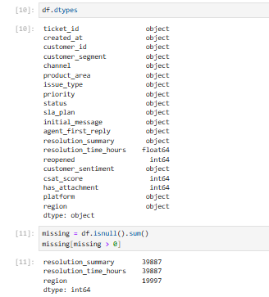
Column | Missing Values
resolution_summary | 39,887
resolution_time_hours | 39,887
region | 19,997

11.2 Text Missing-Value Handling
Text/object columns were selected and missing text values were replaced with the value 'Unknown'. This avoids blank text values during grouping and visualization.
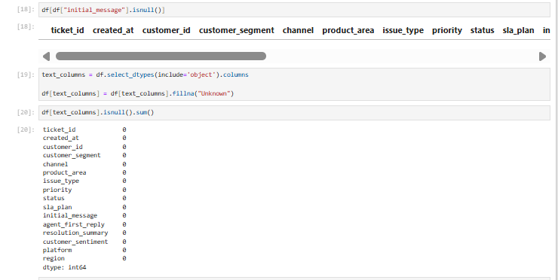

11.3 Text Standardization
Leading/trailing spaces were removed and text values were converted to lowercase before priority values were standardized. This improves consistency during grouping and mapping.
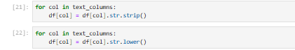

11.4 Duplicate Checking
Duplicate records were checked before dropping duplicates. The notebook recorded zero duplicate rows in the initial dataset.
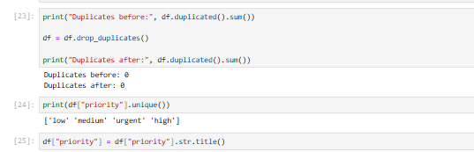

11.5 Processed Dataset
After cleaning and feature creation, the processed dataset was saved as a CSV file for subsequent analysis and dashboard use.
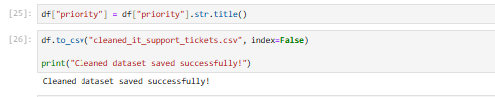

12. Feature Engineering

12.1 Resolution_Duration
A Resolution_Duration field was created from the existing resolution_time_hours column. This field provides a consistent metric for downstream performance analysis.
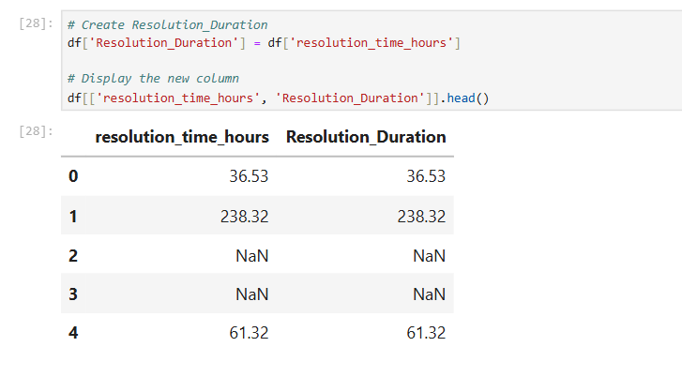

12.2 Priority_Score
Priority levels were converted into an ordinal score so that priority could be represented numerically in analytical calculations.
Priority | Priority Score
Low | 1
Medium | 2
High | 3
Urgent | 4

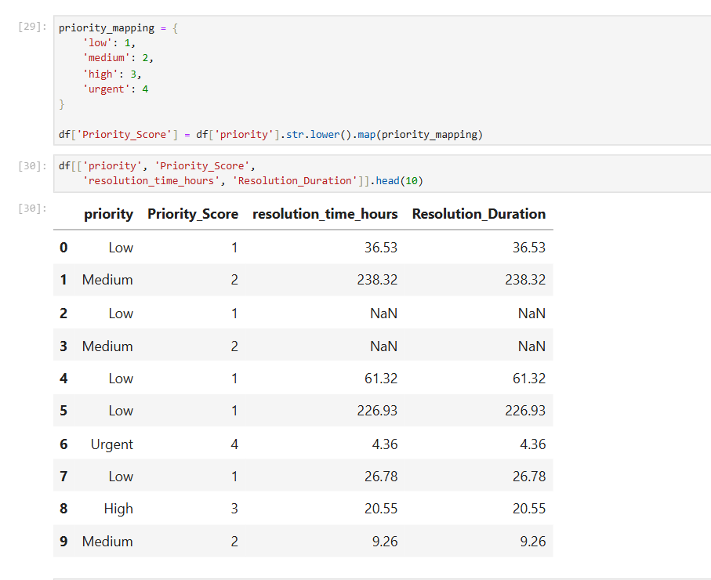

12.3 Support Queue Mapping
Issue types were mapped to functional support queues.
Issue Type | Queue
account_access | Account Management
billing_problem | Billing Support
bug | Development Team
performance | Infrastructure Team
security_concern | Security Team
feature_request | Product Development
how_to | Customer Support
other | General Support

12.4 Cluster Mapping
The notebook groups issue types into six analytical clusters. These cluster labels are based on the implemented issue-type mapping in the notebook; they should therefore be described as analytical groupings rather than as an independently trained clustering model.
Cluster | Description
Cluster 0 | Billing related issues
Cluster 1 | Security incidents
Cluster 2 | Account management and user guidance
Cluster 3 | Performance and technical issues
Cluster 4 | Feature enhancement requests
Cluster 5 | Miscellaneous support requests

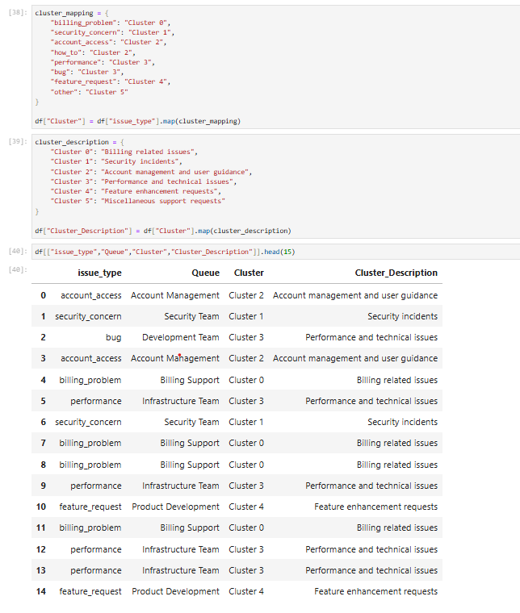

12.5 Similarity Score
A similarity score was assigned at cluster level using the mapping implemented in the notebook. The resulting score was then used for cluster-level comparison and dashboard reporting.
Cluster | Similarity Score
Cluster 0 | 0.92
Cluster 1 | 0.88
Cluster 2 | 0.84
Cluster 3 | 0.79
Cluster 4 | 0.75
Cluster 5 | 0.70
Because the score is assigned through a predefined mapping in the notebook, the report should not describe it as a learned machine-learning similarity model.

13. Exploratory Data Analysis
Exploratory analysis was performed to understand ticket distribution before deeper cluster, geographic and performance analysis. The notebook includes charts for issue type, priority, product area, cluster, queue and related distributions.
Visualization | Purpose | Interpretation
Ticket Distribution by Issue Type | Understand which issue categories generate the most tickets. | how_to is the most frequent issue type.
Ticket Distribution by Priority | Understand workload composition by priority. | Low-priority tickets form the largest priority group.
Ticket Distribution by Product Area | Identify product areas contributing to support demand. | Shows relative workload across product areas.
Cluster Distribution | Understand the number of tickets represented by each analytical cluster. | Provides the base for cluster-level comparisons.
Ticket Distribution by Queue | Understand workload assigned to support functions. | Helps identify queue workload differences.
Priority Distribution | Compare the relative volume of Low, Medium, High and Urgent tickets. | Useful for workload and escalation planning.
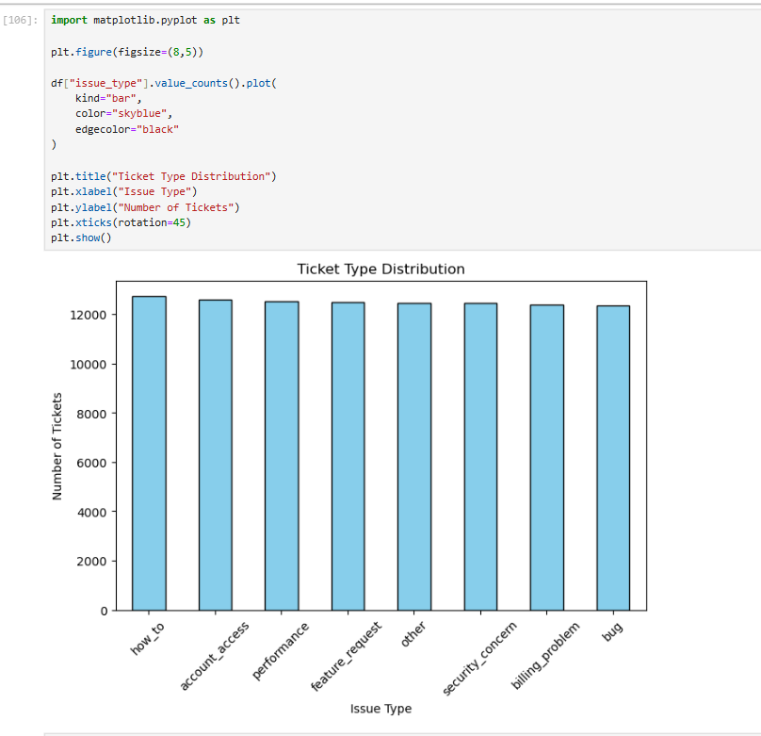
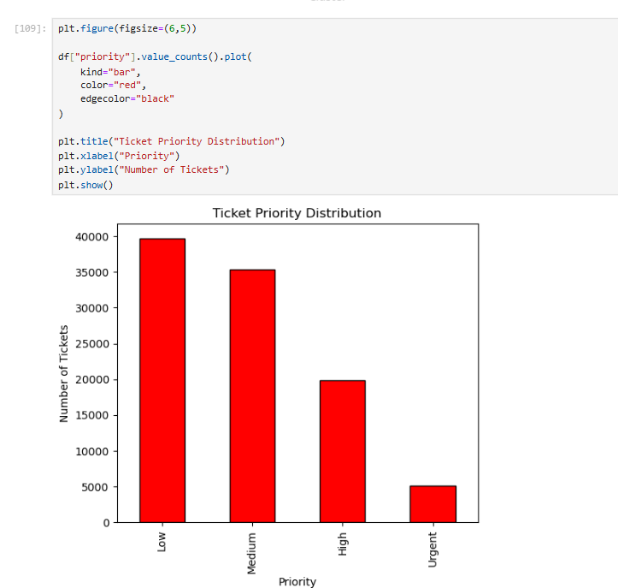
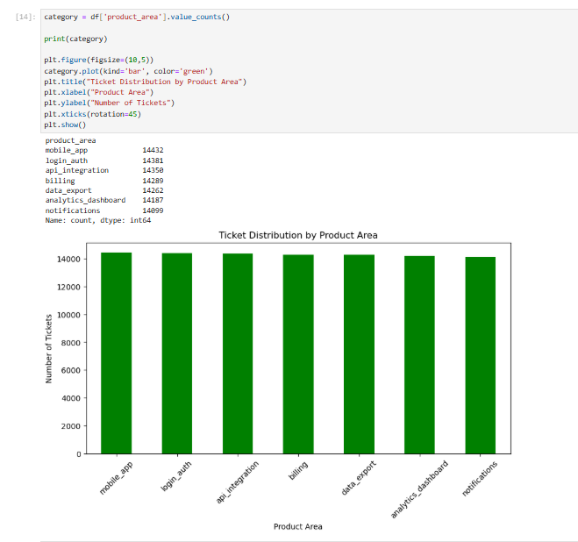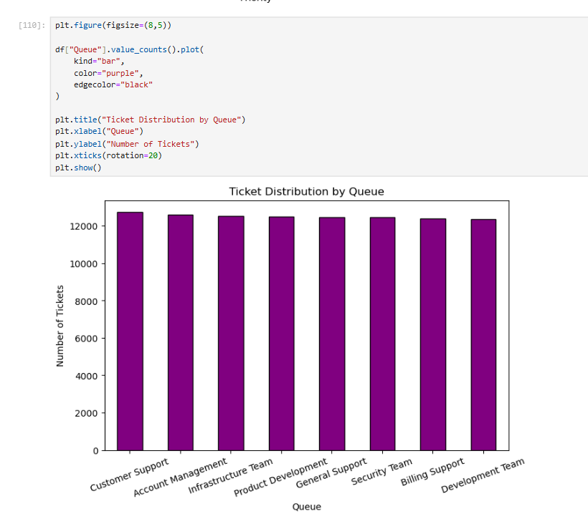

14. Cluster and Similarity Analysis
Cluster analysis groups related issue types into six analytical clusters and examines cluster size, issue concentration, priority mix, resolution time, customer satisfaction and similarity score. This makes it possible to understand whether different types of support work require different operational attention.
Cluster | Description | Issue Types
Cluster 0 | Billing related issues | billing_problem
Cluster 1 | Security incidents | security_concern
Cluster 2 | Account management and user guidance | account_access, how_to
Cluster 3 | Performance and technical issues | performance, bug
Cluster 4 | Feature enhancement requests | feature_request
Cluster 5 | Miscellaneous support requests | other

14.1 Cluster Size Distribution
Cluster size was calculated using value_counts(). The Power BI dashboard identifies Cluster 2 as the largest cluster.

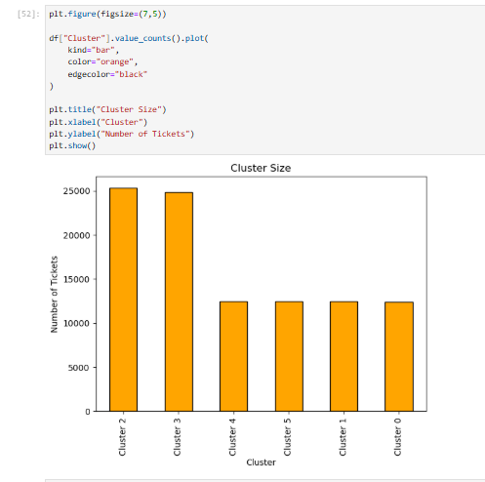

14.2 Similarity Score by Cluster
Average similarity score was calculated by cluster. The overall dashboard KPI reports an average similarity score/index of 0.81.

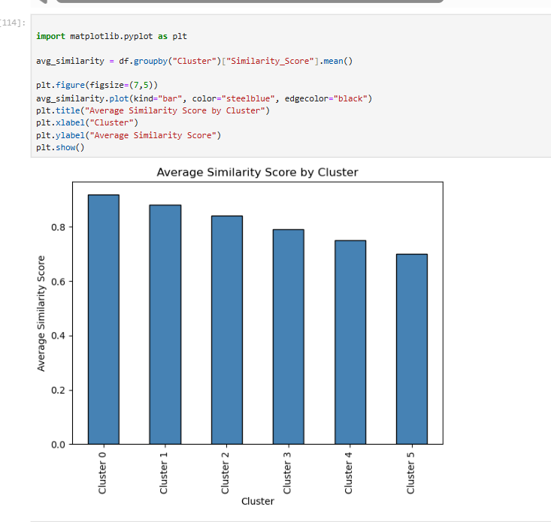

14.3 Cluster vs Issue Type
A cross-tabulation was used to compare clusters against issue types. This reveals which issue categories dominate individual clusters.

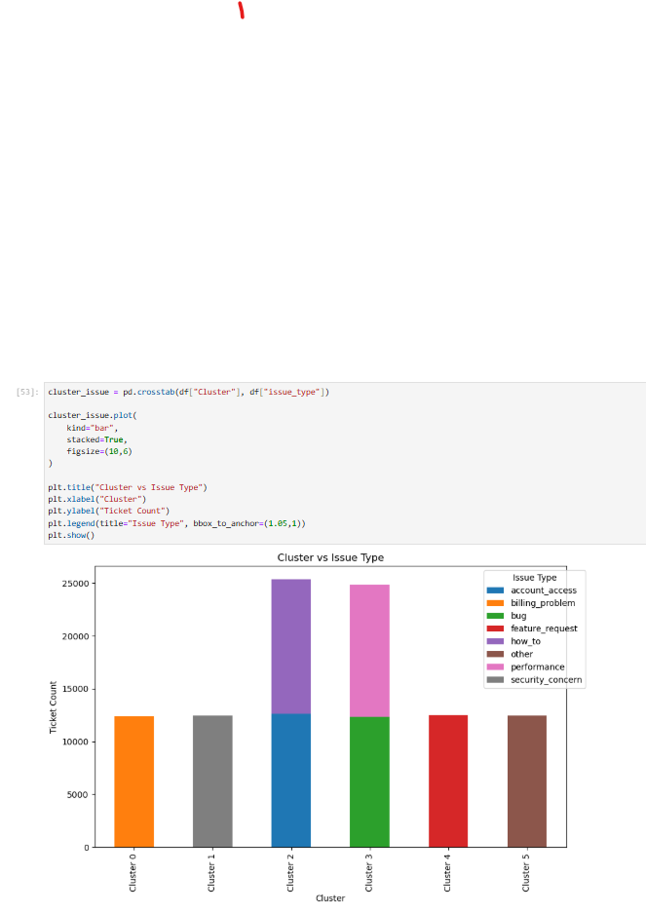

14.4 Resolution Time and CSAT by Cluster
Resolution time and CSAT were compared across clusters using boxplots. These views help identify differences in service efficiency and customer experience between issue groups.
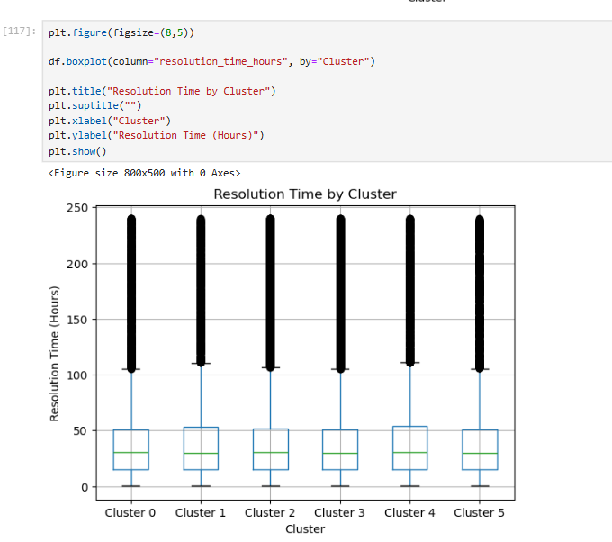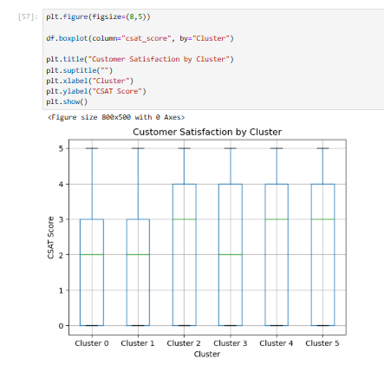

15. Performance Analysis
Performance analysis focuses on resolution efficiency, priority, issue type, region, queue and unresolved high-priority work.
Metric | Dashboard/Notebook Value | Purpose
Average Resolution Time | 45.01 hours | Overall resolution-time KPI.
Average CSAT | 2.24 | Overall customer satisfaction KPI.
Reopened Tickets | 5,045 | Tickets flagged as reopened.
Reopened Rate | 0.05 | Average of the binary reopened indicator.
High-Priority Unresolved | ≈13K in dashboard | High and urgent tickets whose status is not Resolved.

15.1 Resolution Time by Priority
The notebook groups resolution_time_hours by priority and calculates the mean. This comparison helps identify how resolution duration changes with priority level.
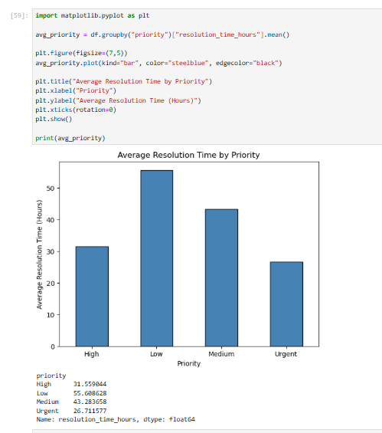

15.2 Resolution Time by Issue Type
Average resolution time was calculated for each issue type to identify categories with relatively higher or lower handling times.
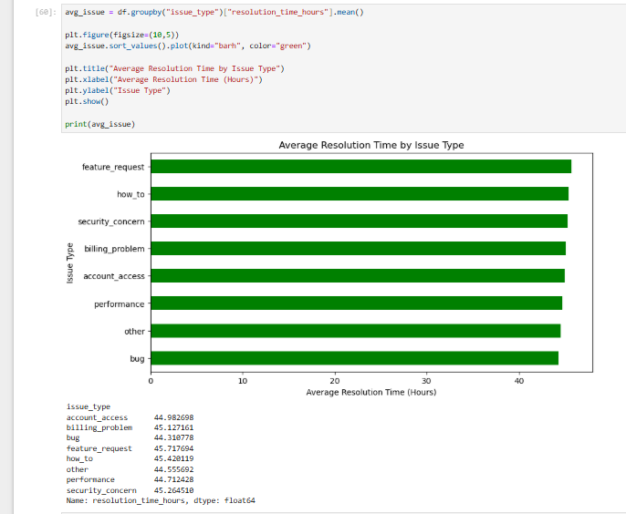

15.3 Resolution Time by Region
Average resolution time was calculated by region. In the final dashboard, EU is identified as the fastest region.
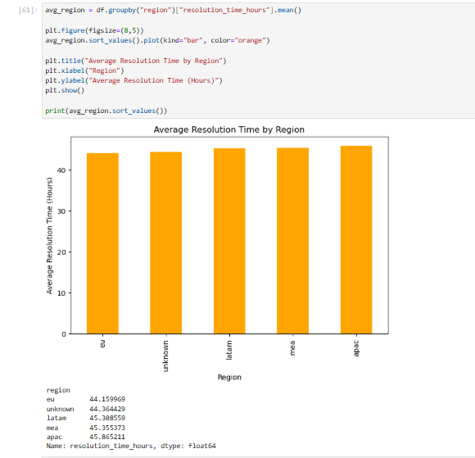

15.4 Resolution Time by Queue
Average resolution time was calculated by support queue. This supports workload and resource allocation decisions.
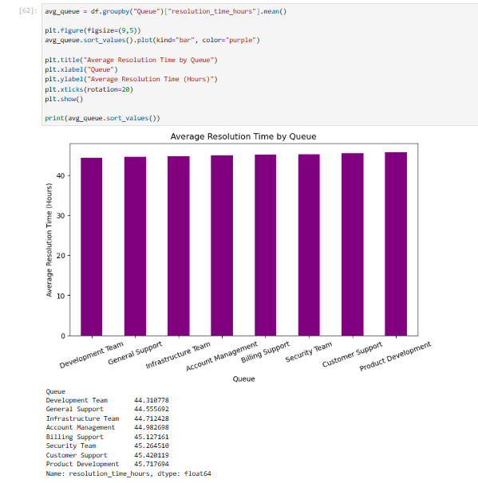

15.5 High-Priority Unresolved Tickets
High and urgent tickets were filtered and compared with ticket status to identify unresolved critical workload.
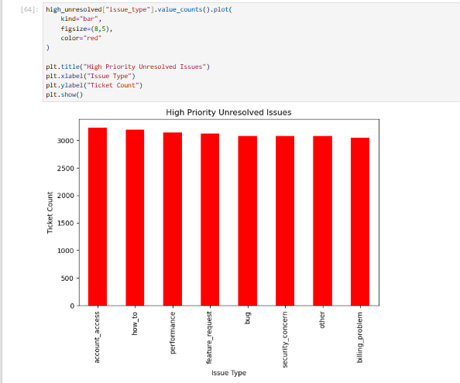
This analysis is particularly important because unresolved high-priority tickets can create service-level risk and customer dissatisfaction.

16. Geographic Analysis
Geographic analysis examines ticket concentration, issue categories, resolution time and customer satisfaction by region. The notebook maps regional labels to representative latitude/longitude coordinates and then creates geographic visualizations.
Region | Representative Coordinates Used in Notebook
EU | 54.5, 15.0
APAC | 22.0, 100.0
MEA | 26.0, 45.0
LATAM | -15.0, -60.0
Unknown | 0.0, 0.0
The geographic coordinates are representative region-level points. They should not be interpreted as precise customer locations.
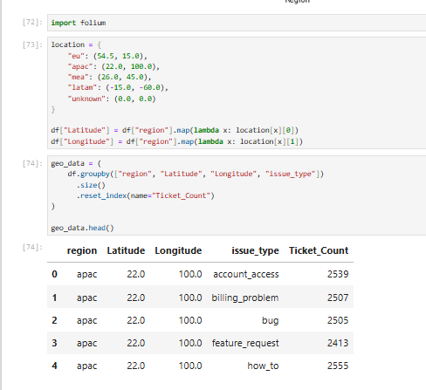

16.1 Ticket Concentration by Region
Regional ticket counts were calculated using value_counts() to compare overall support demand.
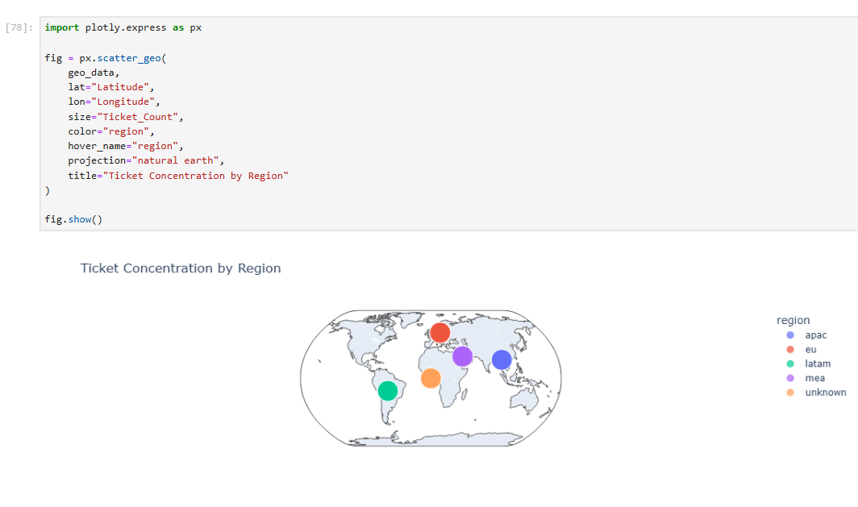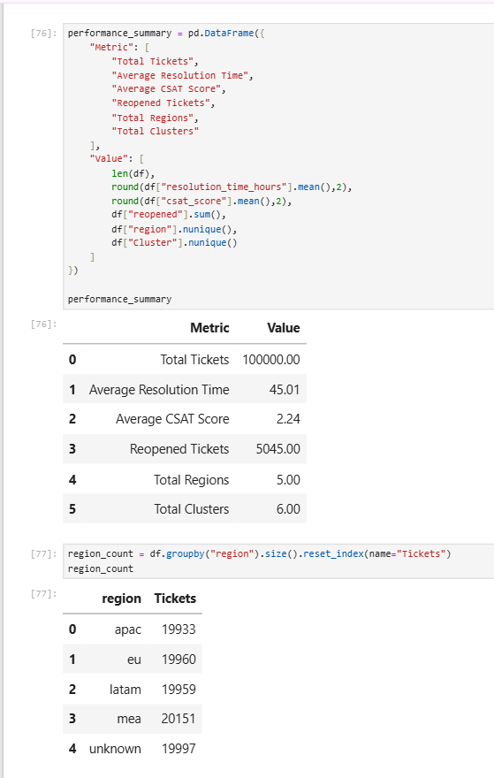

16.2 Issue Categories by Region
A region × issue-type cross-tabulation was used to examine which issue categories appear across regions.
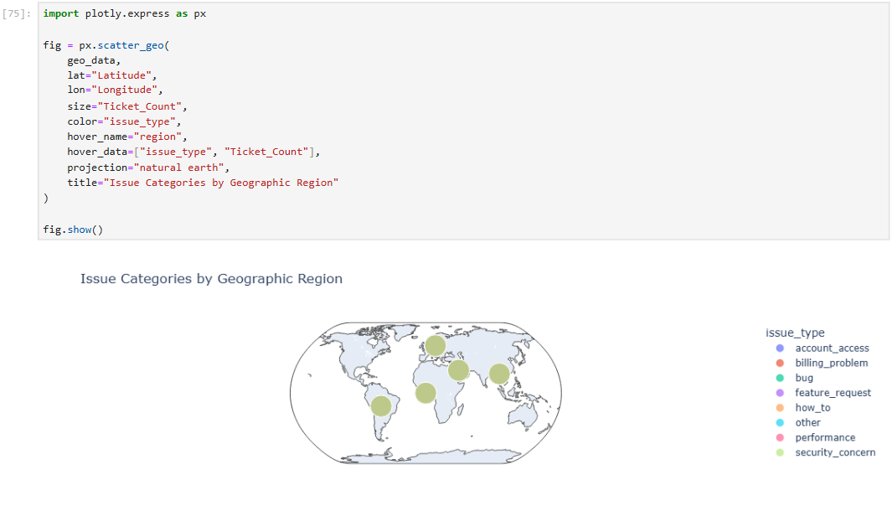

16.3 Geographic Issue Map
Plotly scatter_geo was used to visualize issue categories by geographic region, with marker size representing ticket count.
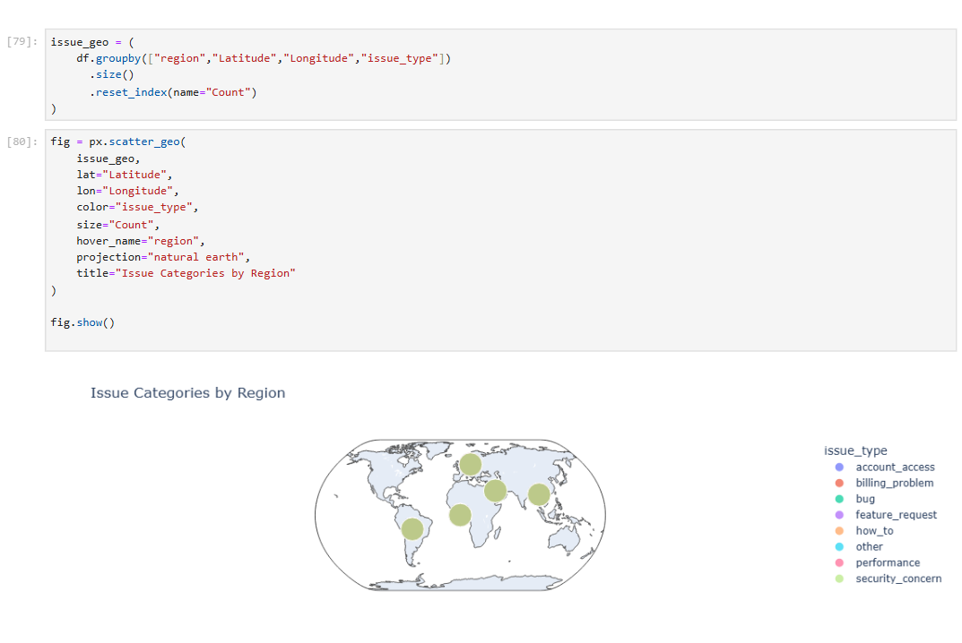

17. Dashboard Development
The final Power BI dashboard consolidates the analytical outputs into six interconnected pages. The dashboard is designed for progressive exploration: the Overview provides a summary, Tickets provides operational detail, Clusters provides issue-group intelligence, Geography provides regional context, Performance provides service-efficiency analysis, and Executive Report combines the most important findings for decision makers.

18. Dashboard Pages and Detailed Interpretation

18.1 Overview Dashboard
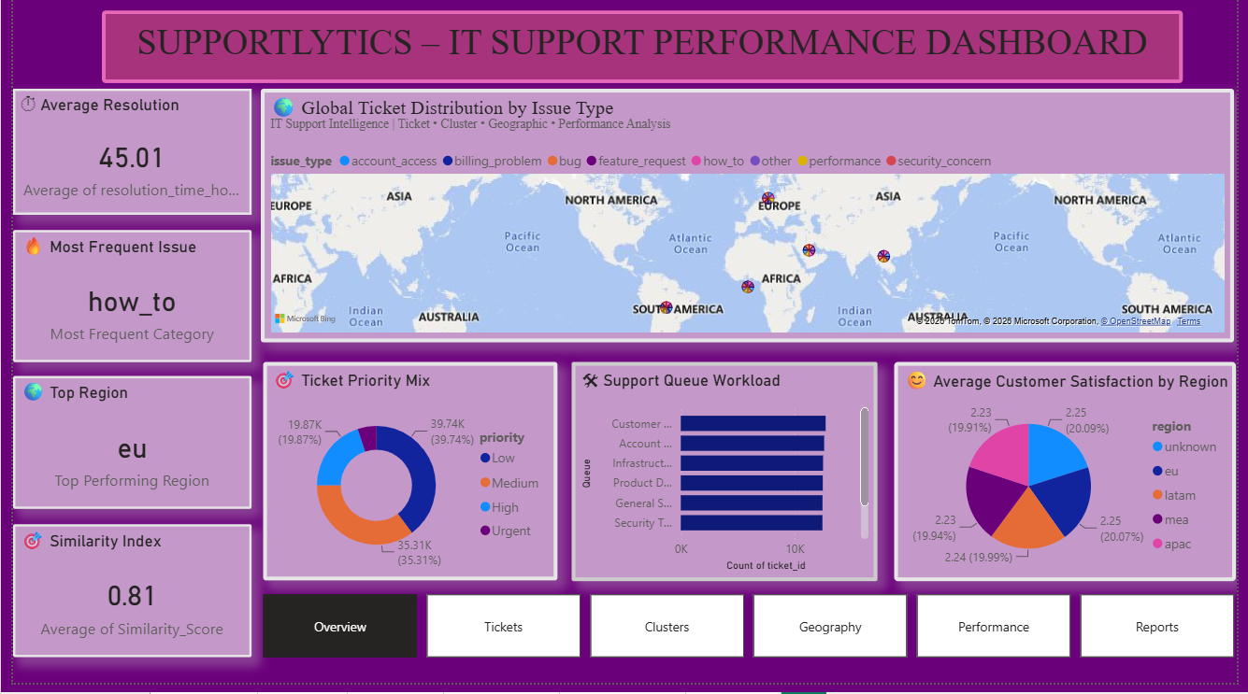
Figure 1. Supportlytics – Overview Dashboard
The Overview page provides the high-level analytical picture. It displays average resolution time, most frequent issue, top region, similarity index, global ticket distribution by issue type, ticket priority mix, support queue workload and average customer satisfaction by region.
- Average Resolution Time: 45.01 hours.
- Most Frequent Issue: how_to.
- Top/fast-performing regional indicators are highlighted through KPI cards.
- Similarity Index: 0.81.
- Priority mix provides a quick view of Low, Medium, High and Urgent workload.
- Queue workload shows how tickets are distributed among support functions.

18.2 Tickets Analysis Dashboard
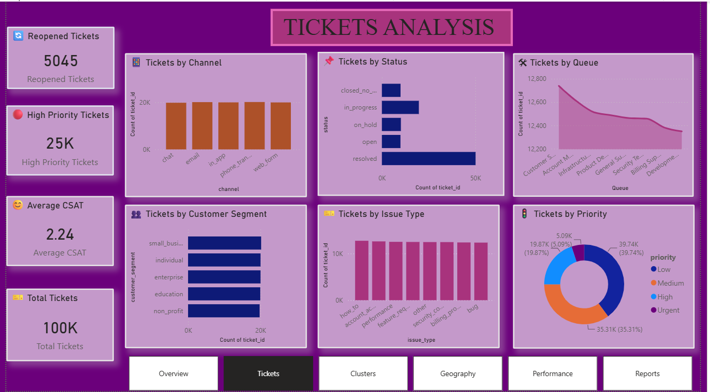
Figure 2. Tickets Analysis Dashboard
The Tickets Analysis page focuses on ticket volume and operational composition. It contains KPI cards for reopened tickets, high-priority tickets, average CSAT and total tickets, along with charts for channel, status, queue, customer segment, issue type and priority.
- Total Tickets: 100K.
- Reopened Tickets: 5,045.
- High Priority Tickets: approximately 25K.
- Average CSAT: 2.24.
- Resolved tickets form the largest status group in the dashboard.
- Ticket volume is distributed across multiple channels and customer segments.

18.3 Cluster Intelligence Dashboard
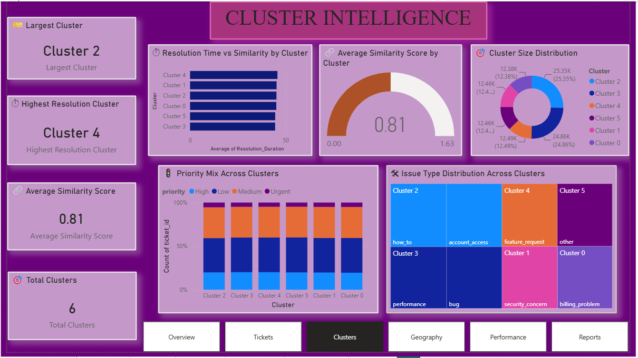
Figure 3. Cluster Intelligence Dashboard
The Cluster Intelligence page explains how ticket issues are grouped into six analytical clusters. It combines cluster size, resolution time, similarity score, priority mix and issue concentration.
- Largest Cluster: Cluster 2.
- Highest Resolution Cluster: Cluster 4.
- Average Similarity Score: 0.81.
- Total Clusters: 6.
- Priority composition is compared across all clusters.
- The treemap/categorical view shows different issue concentrations by cluster.

18.4 Geographical Insights Dashboard
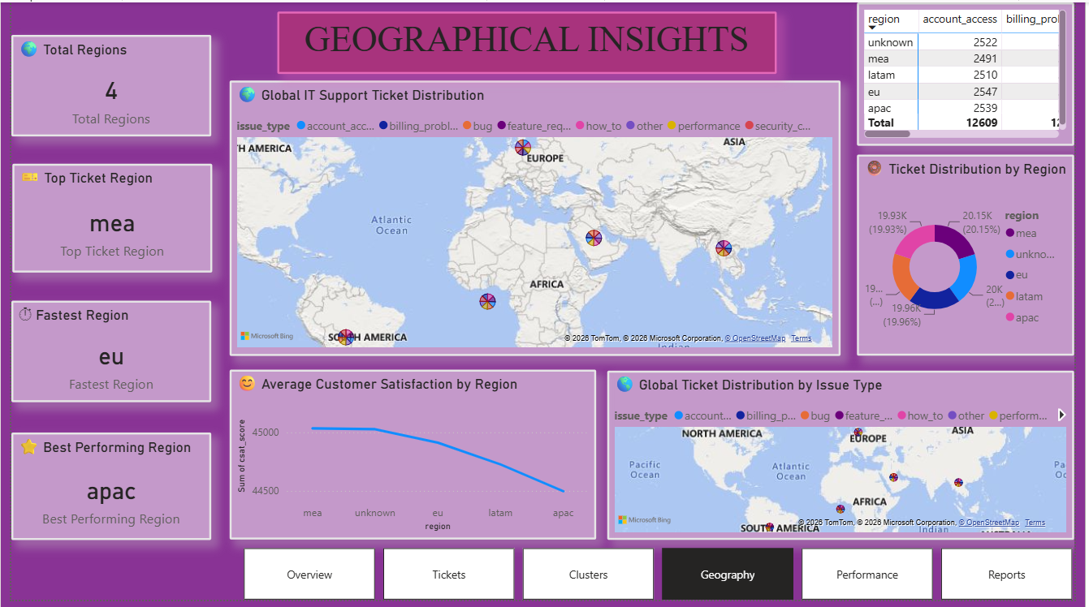
Figure 4. Geographical Insights Dashboard
The Geographical Insights page presents regional ticket distribution using maps and regional comparison visuals.
- Total Regions: 4.
- Top Ticket Region: MEA.
- Fastest Region: EU.
- Best Performing Region: APAC.
- Global maps show ticket distribution and issue-type distribution.
- Regional customer satisfaction is compared across regions.

18.5 Performance Analysis Dashboard
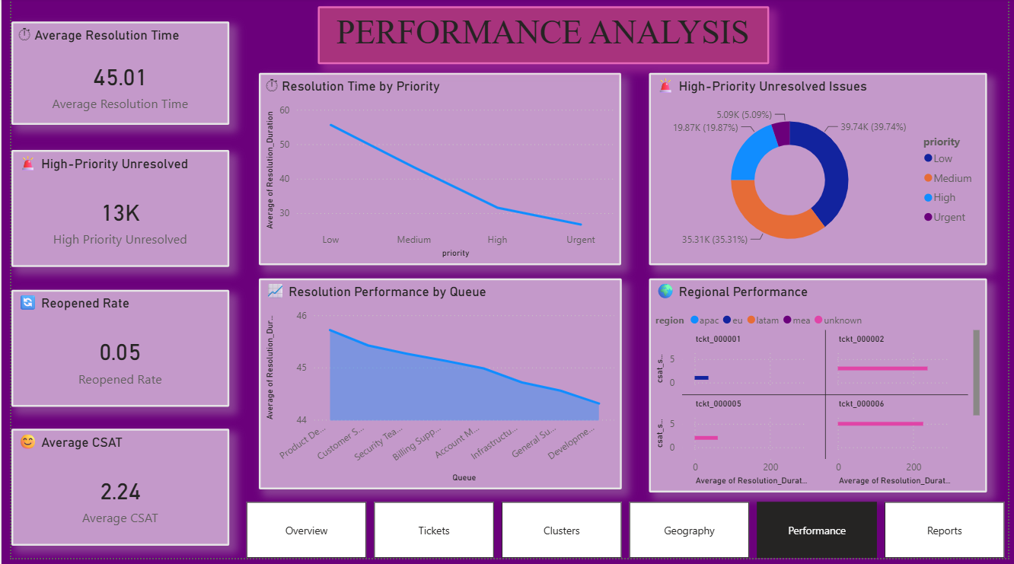
Figure 5. Performance Analysis Dashboard
The Performance Analysis page focuses on service efficiency and operational risk. It compares resolution time by priority, high-priority unresolved tickets, queue performance and regional performance.
- Average Resolution Time: 45.01 hours.
- High-Priority Unresolved: approximately 13K in the dashboard.
- Reopened Rate: 0.05.
- Average CSAT: 2.24.
- Resolution time decreases across the displayed priority categories in the dashboard.
- Queue-level differences help identify areas for workload or process optimization.

18.6 Executive Report Dashboard
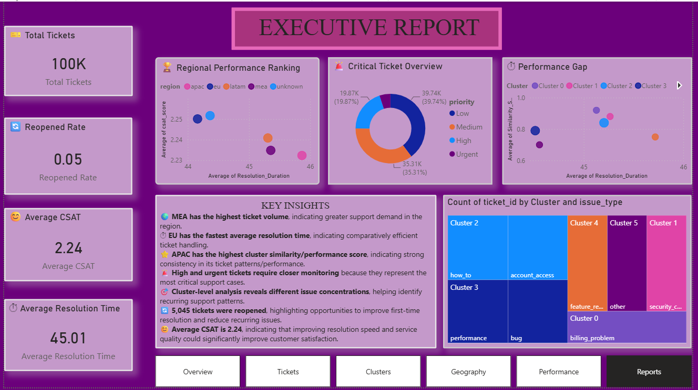
Figure 6. Executive Report Dashboard
The Executive Report is the management-facing summary of the project. It combines the core KPIs, regional performance ranking, critical ticket overview, cluster-level performance gaps and key insights.
- Total Tickets: 100K.
- Reopened Rate: 0.05.
- Average CSAT: 2.24.
- Average Resolution Time: 45.01 hours.
- Regional performance ranking provides a comparison of resolution and CSAT.
- Critical Ticket Overview summarizes priority composition.
- Performance Gap visualization compares cluster-level resolution and similarity/performance values.
- Key Insights section translates analysis into business recommendations.

19. Key Insights
- MEA has the highest ticket volume, indicating greater support demand in the region.
- EU has the fastest average resolution time, indicating comparatively efficient ticket handling.
- APAC has the highest cluster similarity/performance score in the final reporting view, indicating strong consistency in its ticket patterns/performance.
- High and urgent tickets require closer monitoring because they represent the most critical support cases.
- Cluster-level analysis reveals different issue concentrations, helping identify recurring support patterns.
- 5,045 tickets were reopened, highlighting an opportunity to improve first-time resolution and reduce recurring issues.
- Average CSAT is 2.24, indicating that service quality and resolution experience are areas where improvement can create customer value.

20. Recommendations
Observation | Recommended Action | Expected Benefit
MEA has highest ticket volume | Review staffing and workload allocation for MEA. | Better capacity management and reduced backlog risk.
High and urgent tickets require attention | Introduce stronger escalation and monitoring rules. | Faster handling of critical issues.
EU resolves tickets faster | Study EU workflows and identify transferable practices. | Replication of efficient processes.
APAC shows strong cluster performance | Identify successful issue-handling practices and standardize where suitable. | More consistent support performance.
Different clusters have different issue concentrations | Create specialized knowledge bases or routing rules for recurring clusters. | Improved first-contact resolution and routing.
5,045 tickets were reopened | Analyze root causes of reopened tickets and strengthen first-time resolution. | Lower repeat workload.
Average CSAT is 2.24 | Review negative customer experiences and resolution quality. | Improved customer satisfaction.
Queue performance differs | Balance workloads and align resources with queue demand. | Improved operational efficiency.

21. Business Impact
Area | Impact
Operational Efficiency | Better workload allocation and potential faster resolution.
Customer Experience | Improved handling of priority issues and opportunities to improve CSAT.
Management | Data-driven decision making and regional performance monitoring.
Support Team | Better queue management and identification of recurring issues.

22. Challenges and Limitations
- The dataset is synthetic, so results should be interpreted as analytical/project findings rather than production operational measurements.
- Resolution-related fields are missing for a substantial subset of tickets; therefore resolution-time analysis uses available values.
- Region is missing for a subset of records; geographic analysis focuses on records with usable regional information.
- The notebook uses representative coordinates for regions rather than precise customer locations.
- Cluster assignments and similarity scores are implemented through predefined mappings in the notebook; they are not presented as a separately trained clustering model.
- The current solution is based on prepared data and does not implement real-time ticket streaming.

23. Future Scope
- Real-time ticket monitoring.
- Automated alerts for high-priority tickets.
- Predictive ticket resolution-time modeling.
- Ticket escalation prediction.
- Sentiment-based support prioritization.
- Automated monthly performance reports.
- Integration with live IT service-management systems.

24. Conclusion
Supportlytics successfully transforms raw IT support ticket data into an interactive analytical solution. The project integrates data preprocessing, exploratory analysis, feature engineering, cluster and similarity analysis, geographic analysis, performance analysis and Power BI visualization. The resulting dashboards provide a consolidated view of ticket workload, priorities, issue clusters, regional performance, resolution efficiency and customer satisfaction. The findings support practical recommendations for workload allocation, priority management, queue optimization, regional benchmarking and continuous improvement of IT support.

25. Deliverables and GitHub
- Final Power BI visual dashboard.
- Jupyter Notebook containing analysis code.
- Processed/cleaned dataset, subject to internship data-sharing rules.
- Final project report in PDF/Word format.
- Presentation slides.
- Dashboard screenshots/visual assets.
- README and project documentation.
- GitHub repository containing permitted project files.

26. Appendix A – Important Code
The full notebook should remain as the primary code record. The report should contain representative code snippets rather than duplicating every notebook cell.

A.1 Data Loading and Inspection
import pandas as pd
df = pd.read_csv("synthetic_it_support_tickets.csv")
df.shape
df.columns
df.dtypes
df.isnull().sum()

A.2 Cleaning
text_columns = df.select_dtypes(include='object').columns
df[text_columns] = df[text_columns].fillna("Unknown")
for col in text_columns:
df[col] = df[col].str.strip()
df[col] = df[col].str.lower()
df = df.drop_duplicates()

A.3 Feature Engineering
df["Resolution_Duration"] = df["resolution_time_hours"]
priority_mapping = {
"low": 1, "medium": 2, "high": 3, "urgent": 4
}
df["Priority_Score"] = df["priority"].str.lower().map(priority_mapping)

A.4 Queue and Cluster Mapping
df["Queue"] = df["issue_type"].map(queue_mapping)
df["Cluster"] = df["issue_type"].map(cluster_mapping)
df["Cluster_Description"] = df["Cluster"].map(cluster_description)

A.5 Similarity Analysis
df["Similarity_Score"] = df["Cluster"].map(similarity_mapping)
avg_similarity = df.groupby("Cluster")["Similarity_Score"].mean()

A.6 Performance Analysis
avg_priority = df.groupby("priority")["resolution_time_hours"].mean()
avg_region = df.groupby("region")["resolution_time_hours"].mean()
avg_queue = df.groupby("Queue")["resolution_time_hours"].mean()

A.7 High-Priority Unresolved Tickets
high_unresolved = df[
(df["priority"].isin(["High", "Urgent"])) &
(df["status"] != "Resolved")
]

A.8 Geographic Visualization
fig = px.scatter_geo(
geo_data,
lat="Latitude",
lon="Longitude",
size="Ticket_Count",
color="issue_type",
hover_name="region",
projection="natural earth"
)

27. Appendix B – Screenshot Checklist
Use this checklist before submitting the report. The six final Power BI screenshots are already included in this Word document. The remaining screenshots are recommended evidence from the Jupyter Notebook.
Status | Evidence | Action
☑ | Overview Power BI dashboard | Included
☑ | Tickets Analysis Power BI dashboard | Included
☑ | Cluster Intelligence Power BI dashboard | Included
☑ | Geographical Insights Power BI dashboard | Included
☑ | Performance Analysis Power BI dashboard | Included
☑ | Executive Report Power BI dashboard | Included
☐ | Notebook: df.head() | Recommended
☐ | Notebook: df.shape and column list | Recommended
☐ | Notebook: missing-value output | Recommended
☐ | Notebook: cleaning/standardization output | Optional
☐ | Notebook: representative EDA charts | Recommended – 3 to 5 only
☐ | Notebook: cluster analysis chart | Recommended
☐ | Notebook: performance chart | Recommended
☐ | Notebook: geographic map output | Recommended if available
☐ | GitHub repository | Add after upload
☐ | Internship certificate | Add if available

28. References
- Project notebook: internDV.ipynb.
- Internship project specification: Data-Driven Optimization of IT Support Team Performance Using Advanced Analytics.
- Final presentation/report: final intern.pdf.
- Power BI dashboard screenshots prepared during the internship.

