SUPPORTLYTICS
IT Support Analytics Dashboard
Project Documentation

Project Information | Details
Project Name | SupportLytics
Domain | IT Support Analytics
Platform / Tool | Microsoft Power BI
Project Type | Internship / Academic Project
Primary Purpose | Analyzing IT support ticket data through KPIs and interactive visual insights
Dashboard Pages | 2 analytical pages

Prepared from the SupportLytics presentation and dashboard materials

EXECUTIVE SUMMARY
SupportLytics is an IT Support Analytics Dashboard developed using Microsoft Power BI. The project focuses on transforming raw IT support-ticket information into meaningful KPIs, visual comparisons, and operational insights.
The dashboard is organized into two analytical pages. Page 1, “IT Support Performance Overview,” provides a high-level snapshot of ticket volume, resolution performance, customer satisfaction, similarity score, priority, status, support clusters, issue types, and regions. Page 2, “Support Performance & Operational Analysis,” provides deeper operational analysis covering unresolved tickets, platform performance, regions, product areas, reopened tickets, customer sentiment, and priority.
The dashboard reports approximately 100K total tickets, 38.99 average resolution time, 2.24 average CSAT, 0.02 average similarity score, 20K high-priority tickets, and 5K urgent tickets. Page 2 highlights approximately 50K unresolved tickets.
The project demonstrates how Power BI can make a large support-ticket dataset easier to monitor, compare, interpret, and communicate for data-driven operational decisions.

TABLE OF CONTENTS
- 1. Project Introduction
- 2. Problem Statement and Motivation
- 3. Project Objectives
- 4. Dataset and Data Fields
- 5. Data Preparation and Analytical Methodology
- 6. Power BI Measures and Analytical Foundation
- 7. Dashboard Architecture
- 8. Page 1 – Headline Metrics
- 9. Page 1 – Full Dashboard
- 10. Ticket Status Analysis
- 11. Priority and Support Cluster Analysis
- 12. Regional and Issue-Type Analysis
- 13. Page 2 – Full Dashboard
- 14. Unresolved Tickets and Status Analysis
- 15. Platform Performance Analysis
- 16. Regional and Product Area Analysis
- 17. Reopened Tickets and Customer Sentiment
- 18. Priority Distribution
- 19. Dashboard Design and Visualization
- 20. Key Findings
- 21. Business and Operational Value
- 22. Technology and Tools
- 23. Conclusion
- 24. Appendix – Presentation Coverage

1. Project Introduction
SupportLytics is a Power BI-based analytical dashboard designed for IT support ticket analysis. The dashboard converts raw support-ticket information into a centralized visual reporting environment.

1.1 Purpose
The purpose is to make support-ticket information easier to understand by presenting important measures and distributions through KPI cards and interactive visualizations.

1.2 Analytical Coverage
- Ticket volume and workload
- Priority and urgency
- Ticket status
- Average resolution time
- Customer satisfaction (CSAT)
- Similarity score
- Regions
- Platforms
- Product areas
- Issue types
- Support clusters
- Reopened tickets
- Customer sentiment

1.3 Dashboard Structure
The dashboard contains two analytical pages. Page 1 provides the overall performance overview, while Page 2 provides deeper operational analysis.

2. Problem Statement and Motivation

2.1 The Challenge
Large volumes of IT support tickets can be difficult to analyze manually. Important information such as priority, status, resolution time, region, platform, and customer sentiment is distributed across the dataset.
Manual analysis makes it difficult to quickly identify support workload and operational patterns. A centralized analytical dashboard is therefore required to provide a clear view of support performance.

2.2 SupportLytics Response
- Centralized dashboard
- KPI monitoring
- Interactive visual analysis
- Multi-dimensional ticket analysis
- Operational performance monitoring

2.3 Intended Outcome
The intended outcome is a single visual interface through which support performance can be monitored and compared without manually reviewing individual ticket records.

3. Project Objectives
The project defines a broad set of objectives covering ticket volume, support performance, workload distribution, and customer-related analysis.
- Analyze overall support ticket volume.
- Monitor high-priority tickets.
- Monitor urgent tickets.
- Analyze ticket status.
- Analyze average resolution time.
- Analyze customer satisfaction.
- Analyze similarity score.
- Compare ticket volume across regions.
- Compare ticket volume across platforms.
- Analyze product-area distribution.
- Analyze issue-type distribution.
- Analyze support cluster distribution.
- Analyze reopened tickets.
- Analyze customer sentiment.
- Analyze priority distribution.
- Build an interactive Power BI dashboard.
- Present support data through clear visualizations.
These objectives are delivered through the two dashboard pages and their associated KPIs and charts.

4. Dataset and Data Fields
The Power BI Data pane contains the fields used to construct the SupportLytics analysis.
Field | Analytical Role / Meaning in Dashboard
ticket_id | Unique support-ticket identifier used for ticket counts.
has_attachment | Indicates whether a ticket contains an attachment.
initial_message | Initial support request content field.
issue_type | Category of the support issue.
platform | Platform associated with the ticket.
priority | Support priority category.
Priority_Score | Numerical priority representation available in the model.
product_area | Product area associated with the ticket.
region | Geographic region used for comparison.
reopened | Indicates reopened-ticket status.
Resolution_Duration | Resolution-duration field used for analysis.
resolution_summary | Summary of the resolution.
resolution_time_hours | Resolution time expressed in hours.
Similarity_Level | Similarity category for related/duplicate ticket analysis.
Similarity_Score | Similarity value used in the KPI.
sla_plan | SLA plan associated with the ticket.
status | Current ticket status.
customer_sentiment | Customer sentiment category.

5. Data Preparation and Analytical Methodology
The analytical approach follows a clear flow from raw support-ticket data to interactive Power BI reporting.
Stage | Description
Raw Support Ticket Data | Starting point containing support-ticket records and fields.
Data Preparation | Relevant fields are prepared for analysis.
Relevant Fields & Measures | Numerical and categorical fields are selected for analysis and comparison.
Power BI Data Model | Prepared data is organized within Power BI.
KPIs & Visualizations | Calculated measures and visual elements are created.
Support Performance Analysis | The final dashboard is used to interpret workload and operational patterns.

5.1 Analytical Approach
- Numerical fields are used for KPI calculations.
- Categorical fields are used for grouping and comparison.
- Measures are used to calculate important performance indicators.
- Power BI visuals present the results interactively.

6. Power BI Measures and Analytical Foundation
The project identifies three key calculated measures as part of its analytical foundation.
Measure | Purpose
High Priority Tickets | Measures tickets flagged as high priority.
Reopened Tickets | Measures tickets that require additional support after initial resolution.
Resolution Rate | Measures the rate of ticket resolution used for performance monitoring.

6.1 KPI Foundation
These measures, together with fields such as ticket_id, priority, status, region, platform, resolution_time_hours, and customer_sentiment, form the basis of the dashboard KPIs and visualizations.

6.2 Interpretation Principle
The dashboard combines direct field distributions with calculated performance indicators so that users can view both workload volume and operational performance.

7. Dashboard Architecture
SupportLytics uses a two-page dashboard structure that separates high-level monitoring from detailed operational analysis.
Page | Name | Primary Focus
Page 1 | IT Support Performance Overview | Headline KPIs and overall support distribution.
Page 2 | Support Performance & Operational Analysis | Unresolved workload and deeper operational comparisons.

7.1 Page 1 Visual Set
- Total Tickets
- Average Resolution Time
- Average CSAT
- Average Similarity Score
- High Priority Tickets
- Urgent Tickets
- Count of ticket_id by status
- Count of ticket_id by region
- Count of ticket_id by priority
- Count of ticket_id by issue_type
- Count of ticket_id by Cluster_Name

7.2 Page 2 Visual Set
- Unresolved Tickets (50K)
- Count of ticket_id by status
- Average of resolution_time_hours by platform
- Count of ticket_id by platform
- Count of ticket_id by region
- Count of ticket_id by product_area
- Reopened Tickets by platform
- Count of ticket_id by customer_sentiment
- Count of ticket_id by priority

8. Page 1 – Headline Metrics
Page 1 begins with six headline KPI cards that provide a quick summary of support performance.
KPI | Value | Interpretation
Total Tickets | 100K | Overall support-ticket volume in the dataset.
Average Resolution Time | 38.99 | Mean time taken to resolve a support ticket.
Average CSAT | 2.24 | Mean customer satisfaction score across resolved tickets.
Average Similarity Score | 0.02 | Mean similarity between related or duplicate ticket content.
High Priority Tickets | 20K | Tickets flagged as high priority requiring faster attention.
Urgent Tickets | 5K | Tickets flagged as urgent and requiring immediate response.

Together, these six KPIs provide the first-level performance snapshot before the user moves into categorical analysis.

9. Page 1 – Full Dashboard
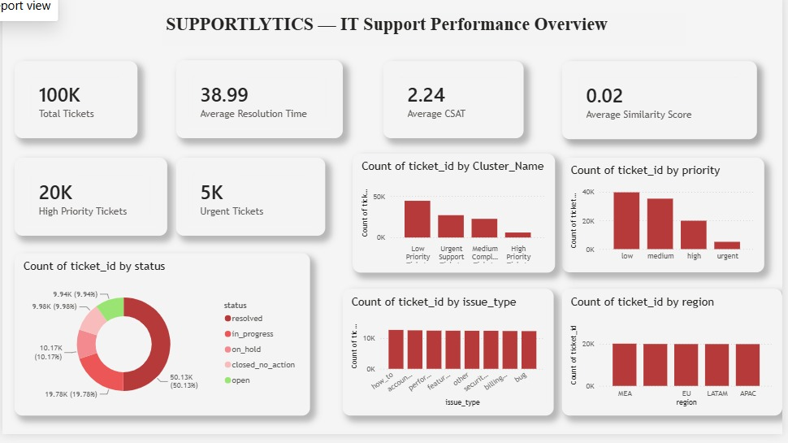
Figure 1. SupportLytics – IT Support Performance Overview
Page 1 combines the six KPI cards with five analytical charts. The page is designed as a high-level support-performance overview.

9.1 Visuals Included
- Six KPI cards at the top of the page.
- Ticket status distribution.
- Support cluster distribution.
- Priority distribution.
- Issue-type distribution.
- Regional ticket distribution.
The page allows a user to move from a quick KPI summary into category-level comparisons.

10. Ticket Status Analysis
The status visualization shows how support tickets are distributed according to their current status.
Status Category | Role in Analysis
resolved | Tickets that have been resolved.
in_progress | Tickets currently being worked on.
on_hold | Tickets temporarily placed on hold.
closed_no_action | Tickets closed without further action.
open | Tickets that remain open.

The largest status category is resolved, with approximately 50.13K tickets, representing about half of the total dataset. The in-progress category follows with approximately 19.78K tickets.
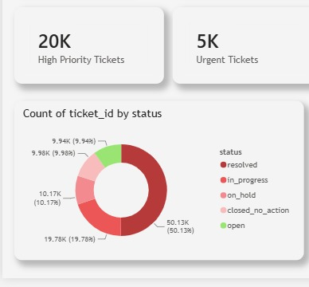
Figure 2. Ticket status distribution

11. Priority and Support Cluster Analysis

11.1 Priority Analysis
Priority analysis compares workload across four categories: low, medium, high, and urgent.
Priority | Observation
Low | Largest priority category in the displayed distribution.
Medium | Second-largest category.
High | Smaller share than low and medium.
Urgent | Smallest displayed priority group.

11.2 Support Cluster Analysis
Support cluster analysis groups tickets into Low Priority, Urgent Support, Medium Complex, and High Priority clusters. The Low Priority cluster is the largest, followed by Urgent Support, Medium Complex, and High Priority.

11.3 Interpretation
The distribution indicates that the workload is concentrated more heavily in low and medium priority tickets, while high and urgent cases represent smaller portions.
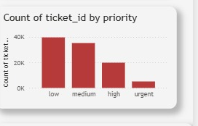
Figure 3. Priority distribution
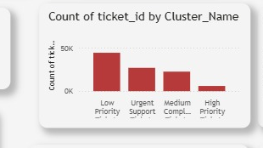
Figure 4. Support cluster distribution

12. Regional and Issue-Type Analysis

12.1 Regional Distribution
The region chart compares MEA, EU, LATAM, and APAC. The ticket volume is relatively even across the four displayed regions.

12.2 Issue-Type Distribution
Issue types include how_to, account, performance, feature, other, security, billing, and bug. The displayed issue-type distribution is also relatively balanced.
Dimension | Categories
Region | MEA, EU, LATAM, APAC
Issue Type | how_to, account, performance, feature, other, security, billing, bug

These views allow the organization to compare workload geographically and by type of support problem.
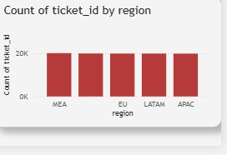
Figure 5. Issue-type distribution
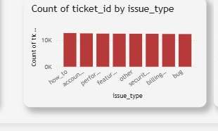
Figure 6. Regional distribution

13. Page 2 – Full Dashboard
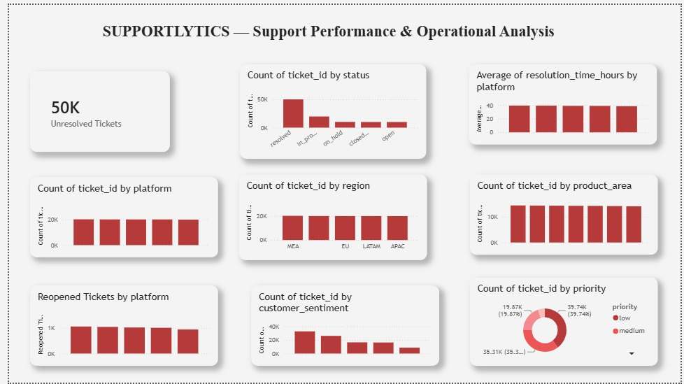
Figure 7. SupportLytics – Support Performance & Operational Analysis
Page 2 focuses on operational analysis. It introduces the unresolved-ticket workload and combines status, platform, region, product area, reopened-ticket, sentiment, and priority views.

13.1 Operational Questions Supported
- How large is the unresolved workload?
- How are tickets distributed by status?
- How does average resolution time compare by platform?
- How many tickets are associated with each platform?
- How does workload compare by region?
- How is workload distributed across product areas?
- How many tickets are reopened by platform?
- What is the customer sentiment distribution?
- How is the workload distributed by priority?

14. Unresolved Tickets and Status Analysis
Page 2 highlights approximately 50K unresolved tickets as a key operational figure.

14.1 Unresolved Workload
The unresolved-ticket KPI provides a direct view of the amount of work that remains to be addressed. It is an important operational indicator because it helps teams understand current support workload.

14.2 Status Perspective
The same five status categories are used: resolved, in_progress, on_hold, closed_no_action, and open. On Page 2, the status chart is interpreted from an operational-workload perspective.
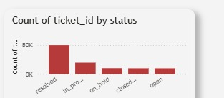
Figure 8. Page 2 status analysis

15. Platform Performance Analysis
Platform analysis provides two complementary views: ticket volume and average resolution time.
Visual | Purpose | Observation
Count of ticket_id by platform | Compare workload across platforms. | Ticket volumes are broadly even across the five platforms.
Average of resolution_time_hours by platform | Compare resolution performance. | Average resolution time is also fairly consistent across platforms.

Together, these visuals provide both a workload perspective and a resolution-performance perspective. No single platform appears to be a major outlier in either displayed measure.
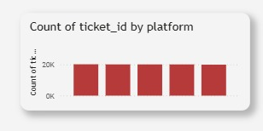
Figure 9. Ticket count by platform
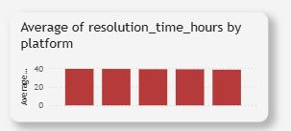
Figure 10. Average resolution time by platform

16. Regional and Product Area Analysis
The regional view on Page 2 compares ticket volume across MEA, EU, LATAM, and APAC.
The product-area view identifies how tickets are distributed across the product-area categories displayed in the dashboard.
Analysis | Interpretation
Region | Ticket distribution is relatively similar across MEA, EU, LATAM, and APAC.
Product Area | Displayed product areas have relatively similar ticket volumes.

These charts help identify whether a specific geography or product area appears to carry a noticeably larger support workload.
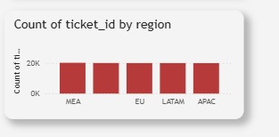
Figure 11. Regional distribution
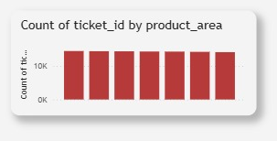
Figure 12. Product-area distribution

17. Reopened Tickets and Customer Sentiment

17.1 Reopened Tickets
Reopened-ticket analysis helps identify cases that require additional support after initial resolution. The reopened-ticket distribution is fairly even across the displayed platforms.

17.2 Customer Sentiment
Customer-sentiment analysis adds a customer-experience dimension to the operational dashboard. The displayed chart shows a higher-count category on the left, with counts tapering across the remaining sentiment bands.

17.3 Operational Use
Together, reopened tickets and sentiment provide additional information about support quality and customer interaction outcomes.
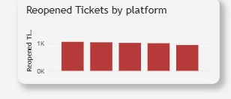
Figure 13. Reopened tickets by platform
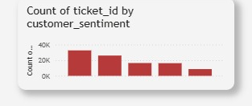
Figure 14. Customer sentiment distribution

18. Priority Distribution – Page 2
The Page 2 priority visualization compares support workload across low, medium, high, and urgent categories.
Priority | Displayed Value
Low | 39.74K (39.74%)
Medium | 35.31K (35.3%)
High / Urgent | Remaining share; the visible presentation segment includes 19.87K (19.87%) for one displayed segment.

The dashboard again demonstrates a low/medium-heavy workload pattern compared with the smaller high and urgent portions.
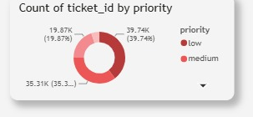
Figure 15. Page 2 priority distribution

19. Dashboard Design and Visualization
The dashboard follows a consistent visual language across both pages.
Design Element | Implementation
Two-page structure | Separates overview from operational detail.
KPI cards | Provides high-level monitoring at a glance.
Bar charts | Used for clear category comparisons.
Donut charts | Used for priority and status distributions.
Consistent layout | Maintains the same visual structure across both pages.
Red / maroon theme | Provides a consistent visual identity.
Rounded cards | Creates a clean card-based dashboard appearance.
Clear separation | Keeps high-level and operational analysis distinct.
Interactive Power BI environment | Enables comparison between dimensions.
Alignment and spacing | Maintains readability and consistent placement.

The design emphasizes readability and quick interpretation while keeping the two analytical pages visually consistent.

20. Key Findings
Finding | Dashboard Evidence
Overall ticket volume | Approximately 100K total tickets.
High-priority workload | Approximately 20K high-priority tickets.
Urgent workload | Approximately 5K urgent tickets.
Average resolution time | 38.99.
Average CSAT | 2.24.
Average similarity score | 0.02.
Unresolved workload | Approximately 50K on Page 2.
Regional comparison | Ticket distribution can be compared across MEA, EU, LATAM, and APAC.
Platform comparison | Ticket volume and resolution performance can be compared across platforms.
Product-area distribution | Displayed product areas have relatively similar ticket volumes.
Priority pattern | Low and medium priority tickets form larger portions than urgent tickets.
Status pattern | Resolved, in-progress, on-hold, closed/no-action, and open categories are visible.
Reopened tickets | Reopened tickets can be analyzed by platform.
Customer sentiment | Sentiment distribution provides an additional support-interaction dimension.

These findings are drawn directly from the dashboard values and displayed distributions.

21. Business and Operational Value
- Faster monitoring of ticket workload.
- Easier identification of high-priority and urgent tickets.
- Better visibility into unresolved tickets.
- Comparison of resolution performance across platforms.
- Understanding regional ticket distribution.
- Identification of frequently occurring product areas and issues.
- Monitoring reopened tickets.
- Understanding customer sentiment.
- Supporting data-driven operational decisions.
- Providing a centralized reporting interface.

21.1 Overall Value
SupportLytics gives IT support teams a single reporting environment for monitoring workload, priority, unresolved tickets, platform performance, regional patterns, product-area distribution, reopened tickets, and customer sentiment.

22. Technology and Tools
Technology / Feature | Use in Project
Microsoft Power BI | Primary analytics and dashboard platform.
Power BI Desktop | Environment used to develop the dashboard.
Power BI Data Model | Organizes fields and measures for analysis.
Power BI Visualizations | Creates KPI cards, bar charts, donut charts, and other visual elements.
DAX / Measures | Creates calculated performance indicators.
Filters & Interactions | Supports interactive exploration and comparison.
Fields & Calculated Measures | Provides the analytical building blocks of the dashboard.

The project is centered on the Power BI ecosystem, using its data model, measures, native visualizations, and interactive reporting capabilities.

23. Conclusion
SupportLytics transforms IT support ticket data into an interactive analytical dashboard. The dashboard provides both high-level KPIs and detailed operational analysis.
Page 1 focuses on overall IT support performance, while Page 2 focuses on detailed support operations.
The project covers ticket volume, status, priority, resolution time, CSAT, similarity score, platform, region, product area, issue type, support clusters, reopened tickets, and customer sentiment.
Power BI provides an effective way to visualize and analyze support-ticket data, making complex information easier to understand and communicate.

Final Outcome
The final dashboard provides a centralized view of support performance and enables users to compare important workload and operational dimensions through clear visualizations.

24. Appendix – Complete Dashboard Metric Reference
Metric / Visual | Page | Value / Categories
Total Tickets | Page 1 | 100K
Average Resolution Time | Page 1 | 38.99
Average CSAT | Page 1 | 2.24
Average Similarity Score | Page 1 | 0.02
High Priority Tickets | Page 1 | 20K
Urgent Tickets | Page 1 | 5K
Status | Pages 1 & 2 | resolved, in_progress, on_hold, closed_no_action, open
Priority | Pages 1 & 2 | low, medium, high, urgent
Cluster_Name | Page 1 | Low Priority, Urgent Support, Medium Complex, High Priority
Region | Pages 1 & 2 | MEA, EU, LATAM, APAC
Issue Type | Page 1 | how_to, account, performance, feature, other, security, billing, bug
Unresolved Tickets | Page 2 | 50K
Platform | Page 2 | Five displayed platforms
Product Area | Page 2 | Displayed product-area categories
Reopened Tickets | Page 2 | By platform
Customer Sentiment | Page 2 | Displayed sentiment categories

Appendix – Data Field Reference
Field | Included in Project
ticket_id | Yes
has_attachment | Yes
initial_message | Yes
issue_type | Yes
platform | Yes
priority | Yes
Priority_Score | Yes
product_area | Yes
region | Yes
reopened | Yes
Resolution_Duration | Yes
resolution_summary | Yes
resolution_time_hours | Yes
Similarity_Level | Yes
Similarity_Score | Yes
sla_plan | Yes
status | Yes
customer_sentiment | Yes

All eighteen fields listed in the presentation are preserved here as part of the project data foundation.

Appendix – Presentation-to-Documentation Coverage
Presentation Slide | Documentation Coverage
1 | Project title and project identity
2 | Project introduction and two-page structure
3 | Problem statement and motivation
4 | Project objectives
5 | Dataset and data fields
6 | Data preparation and analytical methodology
7 | Headline KPIs
8 | Page 1 full dashboard
9 | Ticket status analysis
10 | Priority and support cluster analysis
11 | Regional and issue-type analysis
12 | Page 2 full dashboard
13 | Unresolved tickets and status analysis
14 | Platform performance analysis
15 | Regional and product-area analysis
16 | Reopened tickets and customer sentiment
17 | Page 2 priority distribution
18 | Dashboard design and visualization
19 | Key observations
20 | Business and operational value
21 | Technology and tools
22 | Conclusion

This mapping ensures that the content of the 22-slide presentation is represented in the project documentation without intentionally omitting any presentation section.

SUPPORTLYTICS
Final Project Summary
SupportLytics is a two-page Microsoft Power BI dashboard for IT support analytics. It centralizes ticket KPIs and operational comparisons into an interactive reporting interface.

Project Snapshot
Item | Summary
Total Tickets | Approximately 100K
Average Resolution Time | 38.99
Average CSAT | 2.24
Average Similarity Score | 0.02
High Priority Tickets | Approximately 20K
Urgent Tickets | Approximately 5K
Unresolved Tickets | Approximately 50K on Page 2
Dashboard Pages | 2
Primary Tool | Microsoft Power BI

The project demonstrates the use of data modeling, calculated measures, KPI cards, categorical charts, distribution charts, and interactive dashboard design to communicate IT support performance.
END OF PROJECT DOCUMENTATION

