SUPPORTLYTICS
Data-Driven Optimization of IT Support Team Performance
Using Advanced Analytics
Final Project Report
Modules 1–8
Dataset: customer_support_tickets_200k.csv • 200,000 records • 30 columns

Executive Summary
This project analyzed 200,000 IT support tickets to evaluate resolution performance, uncover operational bottlenecks, and provide data-backed recommendations for improving service efficiency. The analysis covered data cleaning and feature engineering, exploratory data analysis, K-Means clustering and similarity scoring, performance-trend and geographic analysis, and culminated in an interactive Streamlit dashboard.
The single most important finding is that resolution performance is a systemic problem, not a localized one. Priority level, product category, ticket channel, and geographic region all show almost no influence on how quickly a ticket gets resolved — every cut of the data converges on roughly the same ~165–170 hour average and ~26–27% SLA compliance rate. The one dimension that does explain the variation is behavioral clustering: K-Means segmentation surfaced one cluster (Cluster 1) that is disproportionately slow despite low issue complexity, making it the clearest, most actionable lever for improvement.

Key Numbers
Metric | Value
Total tickets analyzed | 200,000
Global average resolution time | 168.2 hours (~7 days)
Overall SLA compliance rate (≤72h) | 26.7%
Global average CSAT (1–5) | 3.00
Active critical backlog (unresolved High/Urgent) | 40,133 tickets
K-Means clusters identified | 4
Weakest cluster performance score | 30.4 / 100 (Cluster 1)
Strongest cluster performance score | 59.3 / 100 (Cluster 3)

1. Project Objectives & KPIs
Primary Goal: Analyze IT support ticket data to identify key performance trends, optimize resolution times, and enhance service efficiency through data analysis and visualization.

Secondary Goals
- Identify performance trends across regions and ticket types.
- Find common customer requests and technical issues.
- Group similar issues to improve resource allocation.
- Suggest workflow improvements based on data analysis.

Key Performance Indicators Tracked
- Average Resolution Time — average time taken to resolve a ticket, in hours.
- Most Frequent Categories — highest-volume issue categories driving contact volume.
- Cluster Similarity Index — cohesion of behaviorally similar ticket groups.
- Top Performing Regions — regions with the fastest resolution / highest SLA compliance.

2. Dataset Overview
Source: Internal IT Support Ticket System. The raw dataset contains 200,000 records across 30 columns (8 numeric, 22 categorical).
Dimension | Detail
Rows | 200,000 tickets
Columns | 30 (8 numeric, 22 categorical)
Core fields | ticket_id, product, category, priority, status, channel, region, dates, CSAT, complexity score
Missing data | Only the 'browser' column had nulls (~40,023 rows, ~20%) — filled as 'Other/Not Applicable'

Initial Distribution Checks
Priority, category, product, and channel were all found to be almost perfectly balanced by design — each priority tier holds ~49,700–50,300 tickets (~25% each), each of the 10 categories holds ~19,900–20,200 tickets (~10% each), and each of the 5 channels accounts for ~20% of volume. This uniformity itself is a finding: it rules out simple volume or intake-channel imbalance as the cause of slow resolutions, pointing the investigation toward behavioral/operational factors instead.
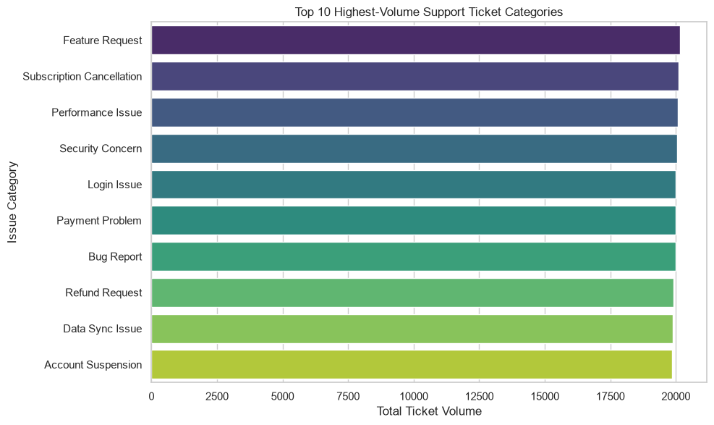
Figure 1 — Top 10 ticket categories by volume (near-uniform distribution).

3. Methodology

3.1 Data Cleaning & Feature Engineering (Module 1–2)
- Filled missing 'browser' values with 'Other/Not Applicable'; stripped whitespace from all text fields.
- Converted ticket_created_date and ticket_resolved_date to datetime.
- Engineered Resolution_Duration = (resolved date − created date) in hours.
- Engineered Priority_Score by mapping Low/Medium/High/Urgent → 1/2/3/4.
- Bucketed resolution speed into Performance_Bucket: Fast (<24h), Normal (24–72h), Slow (>72h).
- Saved the engineered dataset as processed_customer_support_tickets.csv for downstream analysis and the dashboard.

3.2 Exploratory Data Analysis (Module 3)
EDA covered ticket-type/channel distribution, category and product volume, priority severity grading, queue/channel workload composition, and variance analysis (boxplots, violin plots) of CSAT and resolution duration by priority and category. Across nearly every cut, the underlying distributions were uniform — indicating the dataset's variance is driven by behavioral clustering rather than any single categorical attribute.

3.3 Clustering & Similarity Analysis (Module 4)
K-Means clustering (k=4) was applied to four standardized features: Resolution_Duration, issue_complexity_score, customer_satisfaction_score, and Priority_Score. A per-ticket Similarity_Score (0–1) was then computed as the inverse of each ticket's Euclidean distance to its cluster centroid, indicating how tightly each ticket matches its cluster's typical profile.
Cluster | Profile | Avg. Resolution | Complexity | Ticket Volume
0 | High Complexity, Low Priority | 167.8 hrs | 7.81 / 10 | 51,062 (25.5%)
1 | Low Complexity, Slowest Resolution (bottleneck) | 268.7 hrs | 3.16 / 10 | 49,141 (24.6%)
2 | High Complexity, Highest Priority | 165.0 hrs | 7.84 / 10 | 50,652 (25.3%)
3 | Low Complexity, Fastest Resolution (quick wins) | 71.4 hrs | 3.03 / 10 | 49,145 (24.6%)
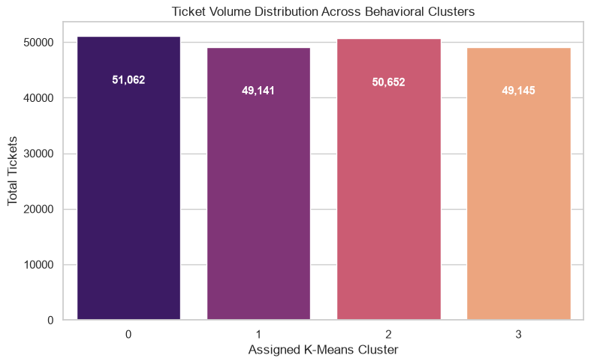
Figure 2 — The four clusters are almost perfectly balanced in size (~25% each).
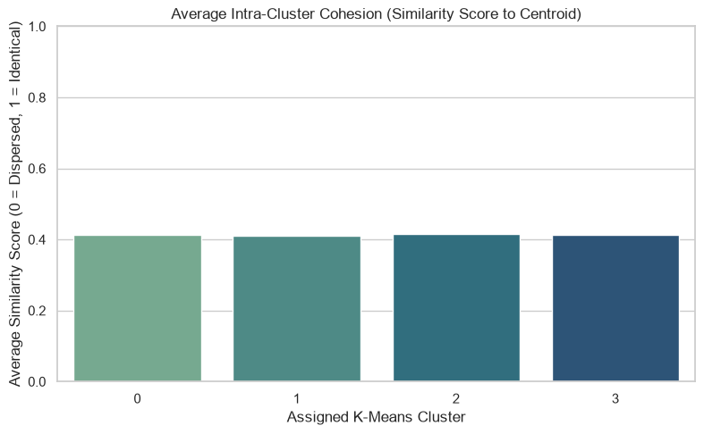
Figure 3 — Average intra-cluster similarity score (~0.41 for every cluster) — clusters are moderately, evenly cohesive.
Cross-tabulating category against cluster showed each issue category is spread almost evenly (~24–26%) across all four clusters — meaning cluster membership is driven by ticket-level complexity/priority behavior, not by which product category the ticket belongs to. This is an important negative result: it means there is no single 'problem category' to fix — the fix has to target the behavioral cluster (Cluster 1) directly, across every category.

4. Performance Trend & Geographic Insights (Module 5–6)

4.1 Priority Tagging Effectiveness
Across every issue category, 'Urgent' and 'High' priority tickets do not resolve meaningfully faster than lower-priority ones — all priorities resolve at roughly 165–170 hours on average. This indicates the internal priority tagging system is not currently driving faster outcomes; high-priority issues face the same systemic delays as routine ones.

4.2 Global Resolution Efficiency by Region
North America is marginally the fastest region (167.6 hrs) and Australia the slowest (169.1 hrs) — a spread of under 1.5 hours globally.
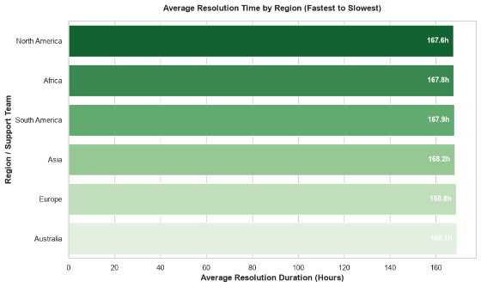
Figure 4 — Average resolution time by region: the gap between fastest and slowest is under 2 hours.
This near-zero variance confirms the delay is a centralized, systemic issue (process/tooling), not a localized workforce or timezone problem.

4.3 SLA Compliance by Region
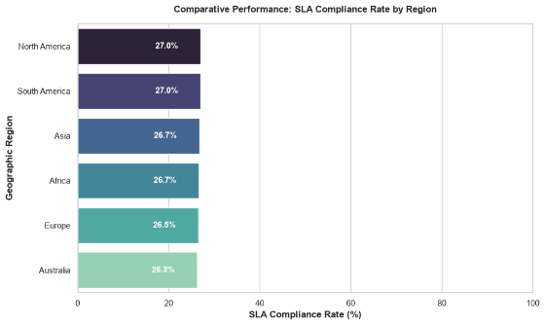
Figure 5 — SLA compliance is uniformly low across all regions (26.3%–27.0%).
Even the top-performing regions (North & South America) top out at 27.0% SLA compliance, with Australia trailing slightly at 26.3%. The tight, uniformly low band indicates current SLA targets are misaligned with the team's actual operational capacity, rather than reflecting a regional performance gap.

4.4 Critical Active Backlog
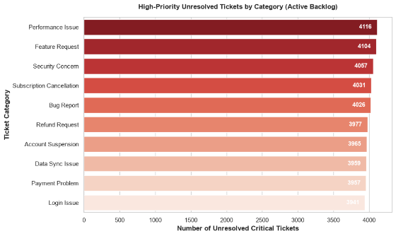
Figure 6 — Unresolved High/Urgent tickets by category; Performance Issue and Feature Request lead the backlog.
'Performance Issue' (4,116) and 'Feature Request' (4,104) lead the critical active backlog, closely followed by 'Security Concern' (4,057). These categories represent the highest churn risk if left unresolved and should be prioritized for backlog clearance.

4.5 Cluster Performance Impact
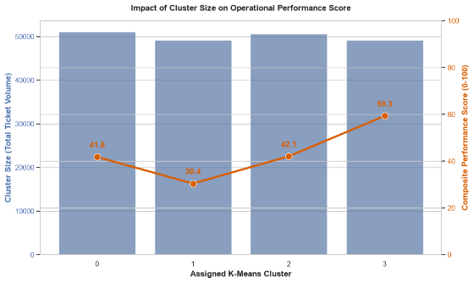
Figure 7 — Cluster 1 carries a similar ticket volume to the other clusters but a far lower performance score (30.4 vs. up to 59.3).
Cluster 1 holds a similar ticket volume (~49K) to the other three clusters but a drastically lower operational performance score (30.4 vs. 41.8–59.3 elsewhere). This makes Cluster 1 the clearest, single highest-leverage target for process improvement — fixing it would lift the team's global performance average more than any other single intervention.

4.6 Geographic Distribution of Issue Categories
Ticket distribution across regions is generally balanced, though a few localized spikes exist (e.g., 'Performance Issue' concentrated in Africa, 'Subscription Cancellation' in South America). Overall, each region handles a diversified, proportional mix of categories — meaning centrally deployed fixes will benefit all regions roughly evenly, with light local monitoring for the specific spikes noted above.

5. Interactive Dashboard (Module 7)
A Streamlit dashboard (main.py) was built as the Milestone 4 deliverable, organized around the four required KPIs, each as its own tab:
- Average Resolution Time — overall average, SLA compliance rate, slowest category, resolution time by category/priority, region × category heatmap, and speed-bucket breakdown.
- Most Frequent Categories — top categories by volume, ticket volume by priority, unresolved high-priority backlog by category, and a region × category concentration heatmap.
- Cluster Similarity Index — average similarity index, most cohesive cluster, cluster volume and similarity charts, full cluster performance profile table, and a size-vs-performance combo chart.
- Top Performing Regions — SLA compliance and average resolution time by region, plus a geographic scatter map of category distribution by region.
The dashboard accepts either the raw ticket CSV (re-running the same feature engineering used in the notebook) or the pre-processed CSV, and includes sidebar filters for Region, Priority, and Category so any stakeholder can drill into a specific slice of the data live.

6. Recommendations

1. Target Cluster 1 directly
Cluster 1 (low complexity, slowest resolution) is the single largest drag on team-wide performance. Build a dedicated triage rule that flags low-complexity tickets sitting unresolved past 24–48 hours, since these are exactly the 'simple tickets lost in the backlog' this cluster represents.

2. Re-audit the priority tagging system
Because Urgent/High tickets resolve no faster than Low/Medium ones, the current priority tag is not functioning as a routing signal. Introduce a hard SLA-linked routing rule so 'Urgent' tickets are mechanically fast-tracked rather than just labeled.

3. Reset SLA targets to be realistic, then re-baseline
A uniform ~27% compliance rate across every region signals the 72-hour SLA benchmark itself is misaligned with current capacity — not a regional execution problem. Recalibrate the SLA threshold using actual historical percentiles, then track compliance against the new baseline going forward.

4. Clear the top 3 backlog categories first
Prioritize unresolved High/Urgent tickets in Performance Issue, Feature Request, and Security Concern — these carry the highest churn risk and the largest unresolved counts.

5. Deploy automation on high-similarity clusters
Clusters with high internal similarity behave near-identically ticket to ticket, making them strong candidates for standardized automated workflows or scripted resolution paths, freeing agent time for the genuinely complex, high-variance cases.

7. Tech Stack
Layer | Tools
Data handling | pandas, numpy
Visualization | matplotlib, seaborn, plotly
Clustering / ML | scikit-learn (KMeans, StandardScaler)
Dashboard | Streamlit
Documentation | Jupyter Notebook, PDF/Word report, GitHub repository

8. Conclusion
This project moved from a raw 200K-row ticket export to a fully engineered, clustered, and visualized analytics pipeline, backed by a live interactive dashboard. The core insight — that resolution delay is a systemic, cluster-driven issue rather than a category, channel, priority, or regional one — reframes how the IT support organization should approach performance improvement: instead of region-by-region or category-by-category fixes, the highest-leverage action is targeting the specific behavioral cluster responsible for the bulk of the underperformance. All code, visuals, the processed dataset, and the dashboard are included in the accompanying GitHub repository.

