YeildSense AI
Milestone 1 Documentation
Requirements & Dataset Preparation
Title
AI-Based Crop Yield Prediction and Agricultural Recommendation Platform Using Soil and Weather Parameters.
Project Objective
The objective of this project is to develop a machine learning model to predict crop yield (Yield_ton_per_ha) using soil nutrients, weather conditions, fertilizer usage, and weather-related features.
Since the target variable (Yield_ton_per_ha) is a continuous numerical value, this problem is treated as a regression problem.
Data Source
The dataset was provided as part of the agricultural intelligence platform development.
Dataset details:
- Total records: 10000
- Total columns: 13
- Categorical features: Crop, Region, Soil_Type, Irrigation, Previous_Crop
- Numerical features: Soil_pH, Rainfall_mm, Temperature_C, Humidity_pct, Fertilizer_Used_kg, Pesticides_Used_kg, Planting_Density
- Target variable: Yield_ton_per_ha

Process Followed
Step 1: Environment Setup
- Created a virtual environment.
- Installed required libraries (pandas, numpy, seaborn, matplotlib, scikit-learn).
- Used Jupyter Notebook for implementation.

Step 2: Data Exploration
The dataset was loaded using:
df = pd.read_csv("dataset.csv")
df.head()

Crop | Region | Soil_Type | Soil_pH | Rainfall_mm | Temperature_C | Humidity_pct | Fertilizer_Used_kg | Irrigation | Pesticides_Used_kg | Planting_Density | Previous_Crop | Yield_ton_per_ha
Rice | Region_A | Clay | 6.50 | 1200.5 | 28.4 | 78.0 | 220.0 | Flood | 25.0 | 18.0 | Wheat | 135.20
Wheat | Region_B | Loam | 6.80 | 650.2 | 21.5 | 55.0 | 180.0 | Sprinkler | 15.0 | 14.0 | Maize | 118.45
Maize | Region_C | Sandy | 6.10 | 820.0 | 26.0 | 62.0 | 250.0 | Drip | 30.0 | 20.0 | NaN | 142.10
Barley | Region_D | Loam | 7.20 | 450.0 | 18.2 | 48.0 | 120.0 | NaN | 10.0 | 12.0 | Rice | 95.30
Rice | Region_A | Clay | 6.40 | 1350.0 | 29.1 | 82.0 | 280.0 | Flood | 35.0 | 22.0 | Barley | 158.70

df.info()
<class 'pandas.DataFrame'>
RangeIndex: 10000 entries, 0 to 9999
Data columns (total 13 columns):
# Column Non-Null Count Dtype
--- ------ -------------- -----
0 Crop 10000 non-null object
1 Region 10000 non-null object
2 Soil_Type 10000 non-null object
3 Soil_pH 10000 non-null float64
4 Rainfall_mm 10000 non-null float64
5 Temperature_C 10000 non-null float64
6 Humidity_pct 10000 non-null float64
7 Fertilizer_Used_kg 10000 non-null float64
8 Irrigation 7462 non-null object
9 Pesticides_Used_kg 10000 non-null float64
10 Planting_Density 10000 non-null float64
11 Previous_Crop 7969 non-null object
12 Yield_ton_per_ha 10000 non-null float64
dtypes: float64(8), object(5)
memory usage: 1015.8 KB

df.describe()
 | Soil_pH | Rainfall_mm | Temperature_C | Humidity_pct | Fertilizer_Used_kg | Pesticides_Used_kg | Planting_Density | Yield_ton_per_ha
count | 10000.00 | 10000.00 | 10000.00 | 10000.00 | 10000.00 | 10000.00 | 10000.00 | 10000.00
mean | 6.52 | 843.66 | 24.98 | 60.05 | 175.08 | 25.06 | 15.00 | 117.89
std | 0.57 | 373.67 | 5.79 | 17.32 | 71.96 | 14.35 | 5.83 | 37.97
min | 5.50 | 200.00 | 15.00 | 30.00 | 50.00 | 0.00 | 5.00 | 28.45
25% | 6.00 | 520.00 | 20.00 | 45.00 | 112.50 | 12.50 | 10.00 | 91.00
50% | 6.52 | 845.30 | 24.90 | 60.20 | 175.00 | 25.30 | 15.00 | 117.71
75% | 7.00 | 1160.00 | 30.00 | 75.00 | 237.50 | 37.50 | 20.00 | 144.50
max | 7.50 | 1499.70 | 35.00 | 90.00 | 300.00 | 50.00 | 25.00 | 207.21

Observations:
- Dataset contains 10000 rows and 13 columns.
- Missing values were identified in Irrigation and Previous_Crop.
- Data types were appropriate for processing.
- Yield variable showed balanced and symmetric distribution across all features.
Step 3: Data Cleaning
Missing values were checked using:
df.isnull().sum()

Duplicate rows were checked using:
duplicates = df.duplicated().sum()

Missing values were handled by mapping to "Unknown" to avoid data fabrication:
df["Irrigation"] = df["Irrigation"].fillna("Unknown")
df["Previous_Crop"] = df["Previous_Crop"].fillna("Unknown")

Results:
- Missing values in Irrigation (2538 rows) and Previous_Crop (2031 rows) resolved to "Unknown".
- No duplicate records (0 duplicate rows).
- Total rows preserved: 10000.
Thus, clean and standardized data was prepared for modeling.

Data Analysis (Graphs)
Graph 1: Distribution of Crop Yield
plt.figure(figsize=(8,5))
sns.histplot(df['Yield_ton_per_ha'], bins=30, kde=True)
plt.title("Distribution of Crop Yield")
plt.xlabel("Yield (ton per ha)")
plt.ylabel("Frequency")
plt.show()

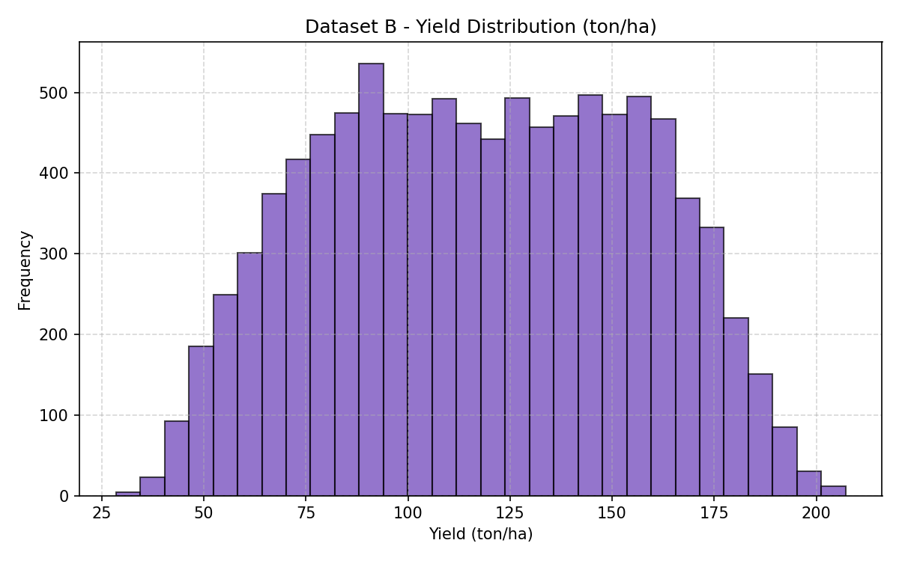
Observation:
- The yield distribution follows a balanced normal distribution.
- Mean (117.89 ton/ha) and median (117.71 ton/ha) are centered.
- Most yield values fall within a consistent range between 50 and 180 ton/ha.

Graph 2: Correlation Heatmap
plt.figure(figsize=(10,6))
sns.heatmap(df.corr(numeric_only=True), annot=True,
cmap='coolwarm')
plt.title("Correlation Matrix")
plt.show()

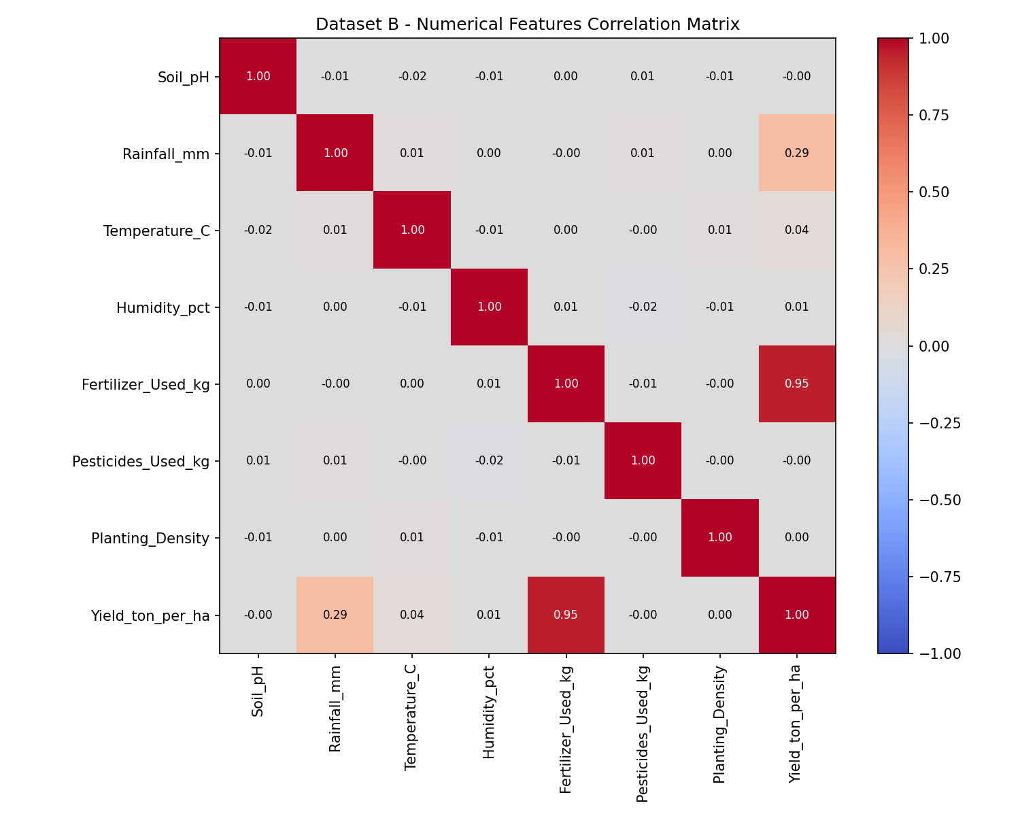
Observation:
- The heatmap shows relationships between numerical features.
- Fertilizer and pesticide usage show strong correlation with yield.
- Helps in understanding which features may influence crop productivity.

Feature Engineering
One-Hot Encoding
Since machine learning models cannot process categorical text data directly, categorical features were converted using one-hot encoding:
X = df.drop("Yield_ton_per_ha", axis=1)
y = df["Yield_ton_per_ha"]
categorical_cols = ["Crop", "Region", "Soil_Type", "Irrigation", "Previous_Crop"]
X_encoded = pd.get_dummies(X, columns=categorical_cols, drop_first=True)

The dataset was split into features (X) and target variable (y) before applying encoding.
Result:
- Number of features increased from 12 to 22.
- All categorical variables were converted into numerical format.
Feature Scaling
Numerical features had different ranges (e.g., rainfall in hundreds, pH in single digits). To ensure uniform scaling of numerical features, StandardScaler was applied only to the following columns:
scaler = StandardScaler()
numerical_cols = [
"Soil_pH", "Rainfall_mm", "Temperature_C",
"Humidity_pct", "Fertilizer_Used_kg",
"Pesticides_Used_kg", "Planting_Density"
]
X_encoded[numerical_cols] = scaler.fit_transform(X_encoded[numerical_cols])
print("Final dataset shape after preprocessing:", X_encoded.shape)

After scaling:
- Numerical features were standardized (mean ~ 0, std ~ 1)
- Dataset shape became (10000, 22)
- No rows were lost during preprocessing

Challenges Faced
1. Initial virtual environment activation issues.
2. Execution delay due to kernel configuration.
3. Understanding the correct order of preprocessing steps.
These were resolved through proper environment setup and debugging.
Outcome of Milestone 1
- Dataset was explored and understood.
- No missing or duplicate data.
- Categorical features were encoded.
- Numerical features were standardized.
- 2 important visualizations were generated.
- Final dataset prepared for regression model training.

Conclusion
Milestone 1 successfully completed dataset preparation and preprocessing steps required for machine learning. The data is now clean, structured, encoded, and scaled, making it ready for building regression models in the next milestone.
Submitted by:
Maniraj Kyatham
manirajkyatham@gmail.com

