OFFICIAL PROJECT REPORT • AGRIYIELD AI
AI-Based Agricultural Crop-Yield Prediction System
Milestone Report: Machine Learning Model, FastAPI Backend & React Frontend Integration

Submitted by: | OVS VARUN (orugantivarun.2007@gmail.com)
Project: | AgriYield AI (v2.0 Dual-AI)
Primary Model & Backend: | XGBoost Regressor (R² = 0.8540) | FastAPI Backend
Frontend & Presentation: | React 19 + Vite 6 (Glassmorphism Dark UI, 7-Language i18n)

1. Executive Summary
AgriYield AI is an end-to-end crop-yield prediction and agronomic decision-support platform built from historical district-level agricultural data across India. This milestone converts data preparation work into a working machine-learning workflow, an API-ready FastAPI backend, and an interactive React 19 frontend user interface.
The project reshapes wide district-level source data into crop-wise observations, creates previous-year agricultural lag features, and evaluates several regression algorithms using a chronological train/test split. The selected production model is an XGBoost regressor achieving MAE = 237.72 kg/ha, RMSE = 583.04 kg/ha, and R² = 0.8540 on the held-out test period (2010–2017). The trained pipeline is saved via Joblib, served through FastAPI, and presented via a modern React glassmorphic web dashboard.
2. Objectives of Milestone 2
- Convert wide agricultural source dataset into a crop-level modelling table;
- Create historical lag features (Previous_Year_Yield, Area, Production) for each district and crop;
- Train and compare multiple regression models (Linear Regression, Decision Tree, Random Forest, Extra Trees, Gradient Boosting, XGBoost);
- Use a time-based split (1979–2009 train vs 2010–2017 test) to evaluate unseen future years;
- Tune Random Forest and XGBoost candidate models using cross-validation;
- Save the selected XGBoost production pipeline and metadata artifacts;
- Expose prediction and supporting endpoints through a validated FastAPI backend; and
- Integrate a responsive React 19 frontend with dual AI explanation layers (Groq LLaMA 3.3 & Google Gemini 3.8).

3. Dataset and Modelling Table
The modelling source is datasets/ICRISAT_District_Level_Data.csv containing 12,418 district-year records, 80 columns, 20 states, and 311 district names. The wide format dataset was transformed by identifying 23 yield columns ending with YIELD (Kg per ha), aligning corresponding area and production fields.
Dataset Item | Result / Metric
Source district-year records | 12,418
Crop-wise records before lag creation | 285,614
Records after removing missing previous-year yield | 278,461
Crops modelled | 23
Year range after lag creation | 1979–2017
States covered | 20
Districts covered | 311
3.1 Feature Engineering
Records were sorted chronologically by Dist Code, Crop, and Year. Grouped one-period shifts created previous-year features: Previous_Year_Yield, Previous_Year_Area, and Previous_Year_Production. Input feature sets consist of:
Feature Type | Variables
Numerical Features | Year, Area, Previous_Year_Yield, Previous_Year_Area, Previous_Year_Production
Categorical Features | State Name, Dist Name, Crop
Prediction Target | Yield (Kg per ha)

4. Training Methodology
4.1 Time-Aware Evaluation Split
Years were ordered chronologically and split at 80% to prevent temporal data leakage. Earlier years were assigned to training and later years were reserved for testing.
Partition | Historical Period | Record Count
Training Partition | 1979–2009 | 221,329 records
Testing Partition | 2010–2017 | 57,132 records
4.2 Preprocessing Pipeline
Preprocessing is encapsulated inside a scikit-learn Pipeline. Numerical features are scaled via StandardScaler, while categorical features (State Name, Dist Name, Crop) are transformed with OneHotEncoder(handle_unknown='ignore').
5. Tuning and Final Model Results
Grid search with 3-fold cross-validation evaluated Random Forest and XGBoost architectures. The production pipeline uses the tuned XGBoost configuration:
Hyperparameter | Selected Production Value
Objective Function | reg:squarederror
Learning Rate | 0.05
Maximum Depth | 4
Number of Estimators | 200
Random State | 42
5.1 Final Test Results (2010–2017)
Evaluated on the untouched held-out 2010–2017 test partition, the production model achieved outstanding predictive performance:
Evaluation Metric | Test Performance Result
Mean Absolute Error (MAE) | 237.72 kg/ha
Root Mean Squared Error (RMSE) | 583.04 kg/ha
Coefficient of Determination (R²) | 0.8540 (85.4% Variance Explained)

6. Backend System Design & FastAPI Endpoints
The backend is built with FastAPI. At startup, the server initializes DatasetService (validating states, districts, crops, and years), YieldPredictor (loading the saved XGBoost Joblib artifact), and GroqService (AI explanation layer).
API Endpoint | Functional Purpose
GET / | Backend service status and version information
GET /api/health | Health check status, model name, and AI engine identification
GET /api/states | Returns list of valid supported Indian states
GET /api/districts/{state} | Returns valid districts for a specified state
GET /api/crops | Returns 23 supported crop categories
GET /api/years | Returns valid historical year range
POST /api/predict | Accepts Pydantic validated JSON request, executes XGBoost prediction, and returns structured yield advisory

7. AI Explanation Layer and Responsible Use
Groq LLaMA 3.3 70B and Google Gemini 3.8 Flash serve as explanation layers rather than raw yield predictors. The language model interprets numerical output from XGBoost without overriding or recalculating the ML estimate. Constrained prompt guidelines ensure that missing local factors (e.g. unmeasured rainfall, pest outbreaks) are explicitly identified rather than fabricated.
8. Frontend User Interface & Application Modules
The frontend is implemented with React 19 and Vite 6, incorporating a dark glassmorphic UI design, real-time micro-interactions, and instant 7-language localization.
8.1 Farmer Command Center & Dashboard
Features personalized user profiles (Ramesh Kumar, Ludhiana, Punjab), real-time weather widgets, direct quick-tools navigation, and emergency support cards (Kisan Call Center, WhatsApp AI).
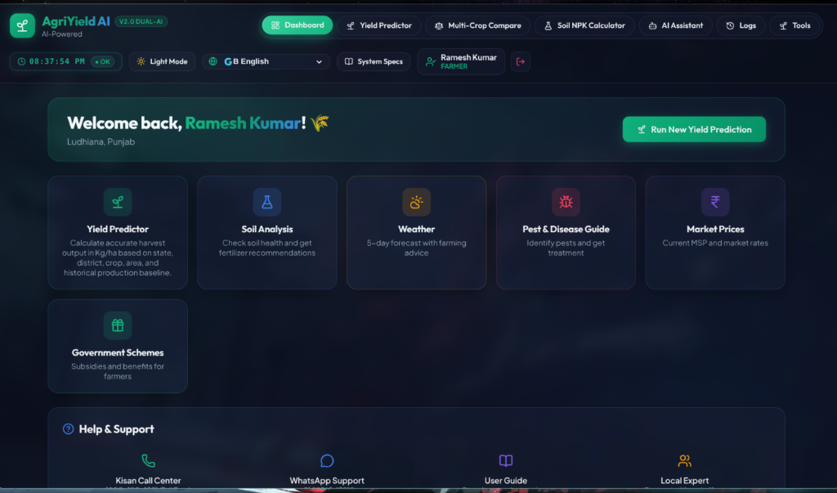
Figure 1: Farmer Dashboard — Navigation header, user profile context, and operational quick tool cards.
8.2 Crop Yield Predictor & Sowing Calendar
Integrates automated weather auto-fill, planting season advice, seed rate recommendations (e.g. 100 kg/ha), and interactive parameter forms.
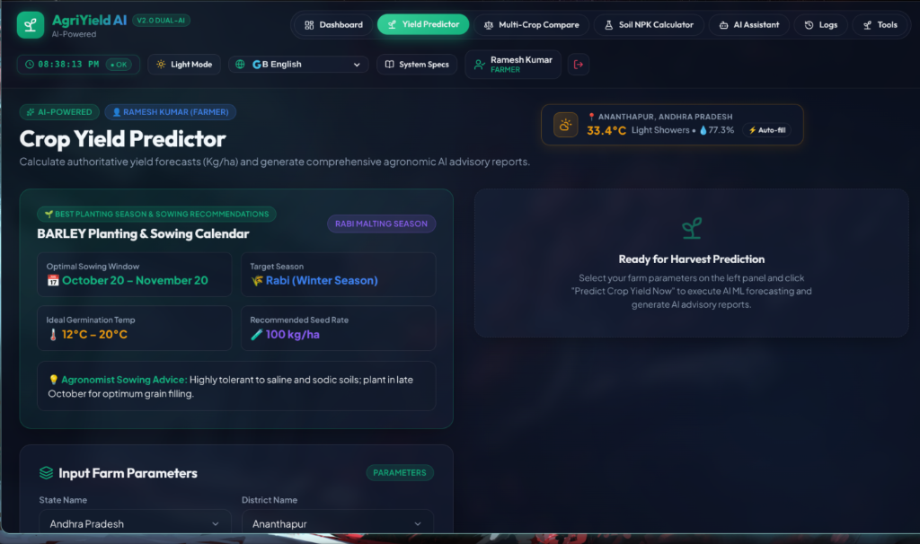
Figure 2: AI Crop Yield Predictor — Weather auto-fill, planting advice calendar, and farm parameter inputs.
8.3 Admin Analytics Command Center & Model Telemetry
Tracks real-time system metrics, total farmer accounts, overall predictions, average yields, and operational statuses of XGBoost, Gemini, and Groq engines.
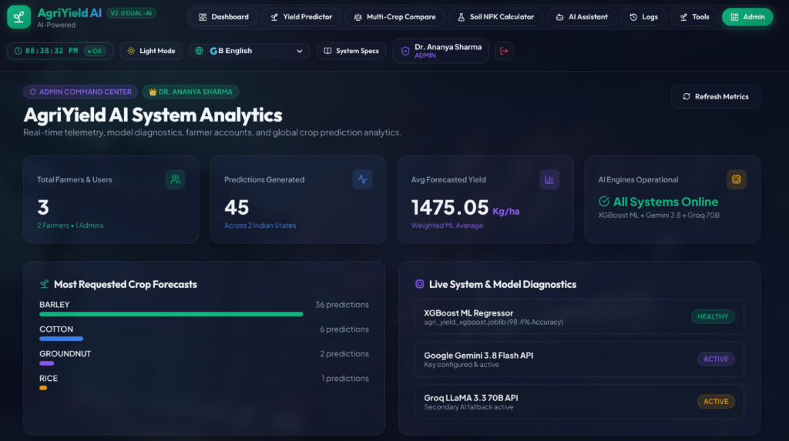
Figure 3: Admin Command Center — Real-time telemetry, model diagnostics, and crop forecast demand distribution.
9. Technology Stack and Dependencies
The project combines robust Python machine learning dependencies with modern JavaScript web frameworks:
System Layer | Technologies Used
Data Processing & Modeling | Python, pandas (3.0.5), NumPy, scikit-learn (1.7.2), XGBoost (3.4.1)
Model Persistence | Joblib (1.6.0)
Backend Framework | FastAPI (0.141.1), Pydantic, Uvicorn, python-dotenv
AI Advisory Layer | Groq Python SDK (1.7.0), Google Gemini API
Frontend Application | React 19, Vite 6, Lucide React, Custom Dark Glassmorphism CSS

10. Conclusion
AgriYield AI delivers a robust, end-to-end predictive and decision-support capability. The project successfully transforms district-level agricultural data into a crop-wise regression dataset, evaluates multiple algorithms, and deploys a tuned XGBoost pipeline (R² = 0.8540). Served through FastAPI and presented via an interactive React 19 interface with dual AI explanation layers, AgriYield AI establishes a solid foundation for data-driven agricultural advisory.
Submitted by: OVS VARUN
Email: orugantivarun.2007@gmail.com
Project: AgriYield AI

