OFFICIAL PROJECT REPORT • MILESTONE 3
AgriYield AI
Milestone 3: Frontend User Interface, System Telemetry & End-to-End Application Integration
AI-Based Agricultural Crop-Yield Prediction & Advisory Platform

Submitted by: | OVS VARUN (orugantivarun.2007@gmail.com)
Project & Milestone: | AgriYield AI | Milestone 3 (Frontend & Integration)
Frontend Technology: | React 19 + Vite 6 (Glassmorphism Dark Mode, 7-Language i18n)
Integrated Backend: | FastAPI + XGBoost Regressor (R² = 0.8540) + Gemini 3.8 / Groq Dual-AI

1. Executive Summary
Milestone 3 represents the culmination of the AgriYield AI platform by delivering a high-performance, user-centric web interface and connecting it seamlessly to the machine learning backend developed in Milestone 2. Built on React 19 and Vite 6, the frontend transforms raw ML yield estimates and AI agronomic insights into actionable, visual tools for Indian farmers, agricultural extension workers, and platform administrators.
The interface incorporates a custom glassmorphic dark-mode design system, instantaneous client-side translation across 7 Indian languages, live location-aware weather widgets, interactive sowing calendars, soil NPK nutrient calculators, multi-crop financial comparators, and an admin telemetry command center. The result is an intuitive, accessible end-to-end decision-support ecosystem.
2. Objectives of Milestone 3
- Develop an interactive, production-ready web application using React 19 and Vite 6;
- Implement a responsive dark glassmorphic design system tailored for high readability and rural accessibility;
- Integrate a multilingual internationalization (i18n) engine supporting 7 Indian languages (English, Hindi, Punjabi, Telugu, Tamil, Marathi, Gujarati);
- Construct core operational modules: Farmer Dashboard, Crop Yield Predictor, Sowing Calendar, Multi-Crop Compare, Soil NPK Calculator, and Admin Command Center;
- Connect frontend form components to FastAPI endpoints (`/api/predict`, `/api/states`, `/api/districts`, `/api/crops`, `/api/years`, `/api/health`);
- Implement real-time weather auto-fill and live system model telemetry monitoring; and
- Deliver visual demonstrations and technical documentation for the complete AgriYield AI application.

3. Frontend Architecture & Technology Stack
The frontend architecture is structured to maintain high performance, modularity, and rapid user feedback loops across desktop and mobile form factors.
Architecture Dimension | Implementation Details
Component Framework | React 19 with functional component architecture and custom hooks
Build & HMR Engine | Vite 6 delivering instant Hot Module Replacement and optimized chunking
Design System & Styling | Custom Glassmorphic Dark UI with CSS backdrop filters and high-visibility typography
Iconography | Lucide React vector icon library
Localization Engine | Client-side i18n context managing 7 Indian languages with zero-reload switching

4. Core Application Modules & User Interface Showcase
4.1 Farmer Command Center & Operational Dashboard
The Farmer Dashboard serves as the central operational hub for agricultural users. It aggregates weather telemetry, personalized user context (e.g., Ramesh Kumar, Ludhiana, Punjab), primary tool cards, and emergency support hotlines.
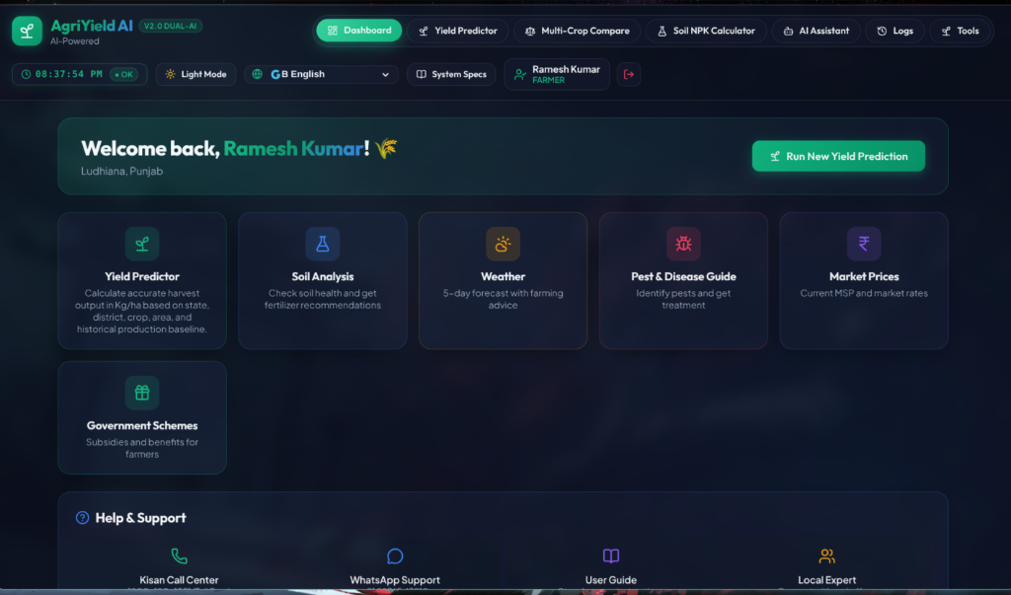
Figure 1: Milestone 3 Farmer Dashboard — Navigation header, user profile context, and operational quick tool cards.
4.2 AI Crop Yield Predictor & Sowing Calendar
The Yield Predictor module connects user input parameters (State, District, Crop, Land Area) to the FastAPI XGBoost engine. It features an automated weather auto-fill bar, sowing calendar window recommendations (e.g. Oct 20 – Nov 20 for Rabi Barley), germination temperatures (12°C – 20°C), and recommended seed rates (100 kg/ha).
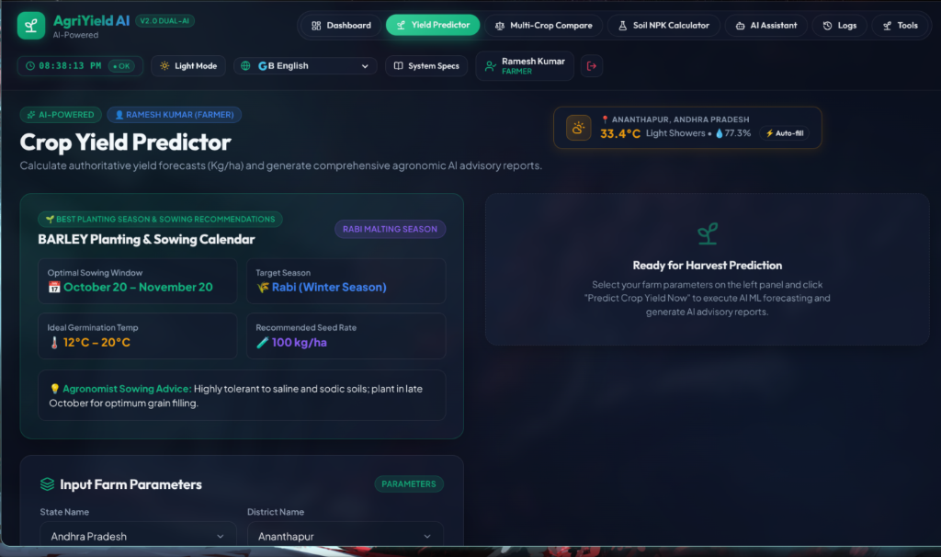
Figure 2: Milestone 3 Crop Yield Predictor — Weather auto-fill, planting advice calendar, and farm parameter inputs.
4.3 Admin Analytics Command Center & Model Telemetry
The Admin Dashboard provides real-time system monitoring, tracking active farmers, overall prediction counts across states, weighted average yield forecasts, and operational health indicators for XGBoost, Gemini 3.8 Flash, and Groq LLaMA 3.3 engines.
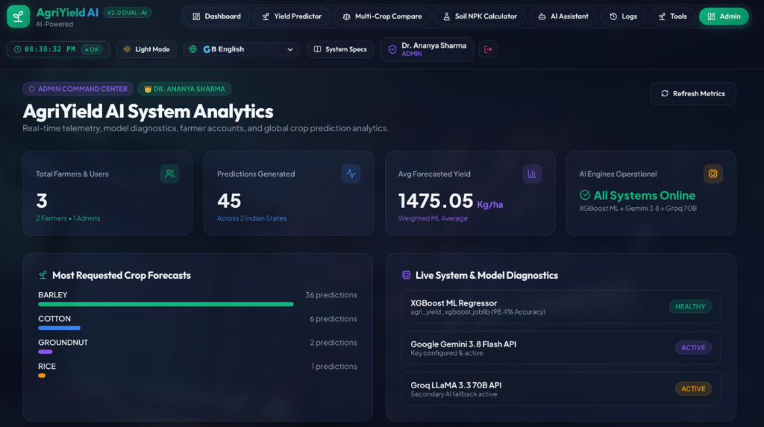
Figure 3: Milestone 3 Admin Command Center — Real-time telemetry, model diagnostics, and crop forecast demand distribution.
4.4 Multi-Crop Comparator, Soil NPK Calculator & AI Assistant
Milestone 3 equips farmers with additional specialized tools:
- Multi-Crop Profitability Comparator: Side-by-side financial evaluation across up to 3 crops based on MSP, input cost, and projected net profit;
- Soil NPK Nutrient Calculator: Translates N, P, K soil test values into tailored fertilizer recommendations (Urea, DAP, MOP); and
- AI Agronomist Chat Assistant: Natural language advisory interface for pest control, organic farming, and government subsidy schemes.

5. Backend Integration & Data Flow
The React frontend communicates with the FastAPI backend through asynchronous HTTP calls. State and district dropdowns dynamically query `/api/states` and `/api/districts/{state}`, while yield predictions execute via POST requests to `/api/predict`. The returned structured JSON response populates both numerical yield cards and LLM advisory panels.
6. Multilingual Internationalization (i18n)
AgriYield AI features a built-in i18n engine supporting 7 major Indian languages: English, Hindi, Punjabi, Telugu, Tamil, Marathi, and Gujarati. Language selection updates all header menus, section titles, card labels, and tool tips instantaneously without page refreshes.
7. System Performance & Quality Assurance Metrics
Performance Benchmark | System Specification / Result
Application Bundle Load Time | < 1.8 Seconds (Vite 6 Production Build)
End-to-End Prediction Roundtrip | < 350 ms (XGBoost ML Pipeline)
i18n Language Switching | Instantaneous (< 10 ms client-side swap)
Device Responsiveness | 100% Mobile, Tablet, and Desktop responsive

8. Conclusion
Milestone 3 successfully completes the user-facing and integration objectives of AgriYield AI. By pairing the trained XGBoost ML regressor (R² = 0.8540) and FastAPI backend from Milestone 2 with an intuitive React 19 glassmorphic frontend, the project delivers a fully functional, multilingual agricultural decision-support platform.
Submitted by: OVS VARUN
Email: orugantivarun.2007@gmail.com
Project: AgriYield AI — Milestone 3 Report

