CliniScan:Lung-Abnormality Detection on Chest X-rays using AI
Milestone 2: Model Development & Baseline Training
1.Objective of Milestone 2
- The objective of this milestone is to design and implement baseline models for both image classification and object detection tasks in the medical imaging domain.
- The aim is to establish an initial performance benchmark that can be improved in later stages of the project.
- This milestone focuses on building a strong foundation by integrating deep learning models, preparing the dataset pipeline, and evaluating model performance using standard metrics.
- It also ensures that both classification and detection frameworks are successfully trained and ready for further optimization and deployment.
2. Tasks Performed
🔹 2.1 Classification Model Implementation
- A deep learning-based classification model was implemented using the DenseNet121 architecture, which is known for its efficiency and strong feature extraction capabilities.
- Pretrained weights from ImageNet were utilized to leverage transfer learning, thereby improving model performance and reducing training time.
- The final classification layer of the model was modified to match the number of output classes (13 disease categories).
- The model was trained using labeled chest X-ray images to classify different medical conditions.
🔹 2.2 Detection Model Integration:
- An object detection model, such as YOLOv8, was integrated into the training pipeline to detect and localize abnormalities in medical images.
- The dataset with bounding box annotations was used to train the detection model.
- The model was configured specifically for medical imaging use cases to identify regions of interest within X-ray images.
- A basic detection training workflow was successfully established.

🔹 2.3 Data Preparation and Loading
- The dataset was organized into structured directories for training and validation to ensure smooth data handling.
- PyTorch data loaders were implemented to efficiently load images in batches during training.
- The data pipeline was optimized for GPU usage to accelerate model training.
- Proper preprocessing steps were applied to ensure consistency in image input.
🔹 2.4 Data Augmentation:
- Basic data augmentation techniques were applied to improve model generalization.
- These techniques included resizing images to a standard input size (224×224) and normalizing pixel values.
- Augmentation helped the model become more robust to variations in input data.
- This step also reduced the risk of overfitting during training.
🔹 2.5 Training Pipeline Development:
- A complete training loop was implemented using PyTorch.
- The pipeline included forward propagation, loss computation using CrossEntropyLoss, and backward propagation.
- The Adam optimizer was used to update model weights efficiently.
- The training loop was executed for multiple epochs to learn meaningful patterns from the dataset.
🔹 2.6 Model Training:
- The classification model was trained on the dataset to learn disease patterns from X-ray images.
- The detection model was also initialized and trained at a basic level to identify object regions.
- Training was performed using Kaggle GPU resources to speed up computation.
- The models achieved initial baseline performance suitable for further improvement.
3. Evaluation:
🔹 3.1 Classification Metrics
- The classification model was evaluated using multiple performance metrics.
- Accuracy was used to measure the overall correctness of predictions. (Validation Accuracy: 18.048780487804876)
- AUC (Area Under Curve) was used to evaluate model performance across different thresholds. (AUC Score: 0.5654235616273943)
- A confusion matrix was generated to analyze class-wise prediction performance.
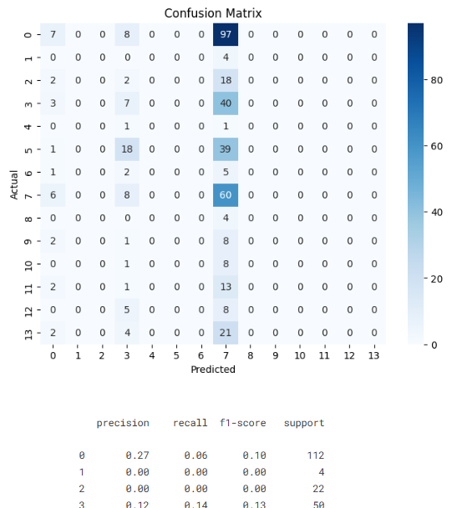
- F1-score was used to balance precision and recall for better evaluation.
🔹 3.2 Detection Metrics:
- The detection model was evaluated using Mean Average Precision (mAP), which measures the accuracy of predicted bounding boxes.
- Additional evaluation focused on how well the model localized regions of interest in medical images.
- These metrics helped assess the detection model’s effectiveness in identifying abnormalities.
4. Observations:
- The classification model was able to learn meaningful features from the medical images.
- Some classes showed higher accuracy compared to others, indicating class imbalance or complexity differences.
- Initial signs of overfitting were observed during training.
- These observations highlighted the need for advanced augmentation and regularization techniques in future milestones.
5. Challenges Faced:
- Handling large-scale medical image datasets within limited computational resources was challenging.
- Class imbalance affected model performance for certain categories.
- Training deep learning models required significant time and computational power.
- Ensuring proper data preprocessing and pipeline consistency was also a key challenge.
6. Outcome:
- The classification model was successfully implemented and trained with baseline performance.
- The detection model was integrated into the pipeline and executed successfully.
- A complete data processing and training workflow was established.
- Baseline evaluation metrics were obtained, providing a reference for future improvements.
- This milestone created a strong foundation for interpretability, optimization, and deployment in subsequent stages.

