CliniScan:Lung-Abnormality Detection on Chest X-rays using AI
Milestone 3: Model Optimization & Refinement
1.Objective of Milestone 3
- The objective of this milestone is to improve the performance, robustness, and reliability of the developed models using optimization techniques.
- It focuses on enhancing model accuracy through hyperparameter tuning, transfer learning, and advanced data augmentation.
- Additionally, this milestone aims to improve model interpretability by applying Grad-CAM for visual explanation of predictions.
- Overall, the goal is to make the model more accurate, generalizable, and explainable for real-world applications.
2. Tasks Performed
- Hyperparameter tuning was performed by adjusting parameters such as learning rate, batch size, and optimizer settings to improve model performance.
- Advanced data augmentation techniques were implemented using Albumentations, including flipping, rotation, brightness adjustment, and noise addition to improve generalization.
- Transfer learning was applied using pretrained models (DenseNet), where final layers were fine-tuned for the medical dataset.
- A comprehensive evaluation was conducted on the validation dataset using metrics like accuracy, AUC, F1-score, and mAP.
- Grad-CAM was implemented to visualize model attention by highlighting important regions in the input images.
- Detection results were refined by improving bounding box visualization for better interpretability.
3. Evaluation
- The optimized model showed measurable improvement over the baseline in terms of accuracy and other performance metrics.
- Grad-CAM visualizations confirmed that the model focuses on relevant regions in most cases.
- Both quantitative metrics and qualitative visual analysis were used to evaluate model performance.
- Strengths and weaknesses of the model were identified for further improvement.
4. Observations
- Data augmentation improved model robustness and reduced overfitting.
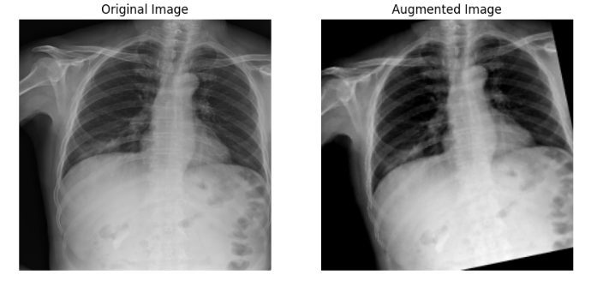
- Transfer learning helped achieve better performance with less training time.
- Grad-CAM provided clear insights into model decision-making.
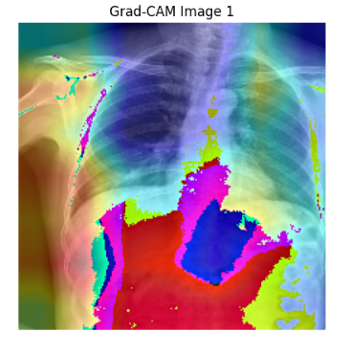
- Some classes still showed lower performance due to dataset imbalance.
5. Challenges Faced
- Hyperparameter tuning required multiple experiments and increased computation time.
- Implementing Grad-CAM involved handling gradients and hooks carefully.
- Visualization issues occurred due to tensor and numpy conversions.
6. Outcome
- Model performance was successfully improved compared to baseline.
- Advanced augmentation and transfer learning enhanced generalization.
- Grad-CAM improved model interpretability and transparency.
- The model is now more accurate, robust, and ready for deployment.

