MetroFlow
AI Platform for Metro Crowd Management and Scheduling
Milestone 2 Report
Scheduling System & AI Prediction

Prepared by: Ankita Jana
August 2026

Milestone 2 focuses on converting the Milestone 1 foundation into an operational platform with train scheduling, frequency adjustment, prediction workflows, operational monitoring, and analytics.

1. Milestone 2 Overview
Milestone 2 corresponds to Weeks 3 and 4 of the MetroFlow implementation plan. The project specification identifies this phase as the point where train scheduling workflows, frequency adjustment, real-time operational monitoring, crowd prediction, passenger-demand forecasting, and traffic analysis are brought into the working platform.

1.1 Objectives
- Implement train schedule management and station timing workflows.
- Provide an AI-assisted frequency adjustment workflow using station occupancy information.
- Add an operational dashboard for network status, train states, delays, and high-crowd stations.
- Expose crowd prediction results with predicted entries, exits, crowd level, timestamp, and confidence.
- Provide train scheduling and platform allocation recommendations based on predicted demand and current operating conditions.
- Centralize prediction outputs in an analytics and prediction center.

1.2 Milestone 2 Outcomes Demonstrated
Area | Demonstrated capability
Scheduling | Schedule listing, search/filter controls, station timing and schedule identifiers
Frequency | Input of station/current frequency and AI-based recommendation output
Operations | Live-style network status, train counts, maintenance, delays and high-crowd stations
Crowd Prediction | Station crowd level, predicted entries/exits and confidence display
Schedule Optimization | Passenger estimate, frequency recommendation, train/platform allocation and delay action
Analytics | Prediction counts and categorized prediction results from the application
The screens included in this report are evidence of the implemented application state. Displayed numbers are reported as shown by the interface at the time of capture and should be treated as application outputs rather than independent performance benchmarks.

2. System Implementation & Technology Foundation
Milestone 1 established the React/Vite frontend, Python backend, authentication foundation, PostgreSQL-oriented data layer, dataset preparation process, and EDA workflow. Milestone 2 builds the scheduling and AI-facing workflows on top of that foundation.

2.1 Application Layers
Layer | Role in Milestone 2
Frontend | Interactive operator-facing pages for schedules, frequency adjustment, operations, prediction and analytics
Backend/API | Serves application data and executes business/prediction workflows
Database | Stores structured operational and prediction records
AI/Analytics | Uses passenger/occupancy information to produce crowd, demand, frequency and schedule insights
Presentation | Converts model/service results into operational recommendations for users

2.2 Connection with Milestone 1 Data Work
The Milestone 1 report describes ticketing, ridership, train schedules, occupancy, sensor and GPS data as the principal data categories. It also describes cleaning, missing-value handling, time-based feature engineering and normalization before EDA and model training. Milestone 2 uses this prepared data context to support operational prediction and recommendation interfaces.

2.3 Key User Workflow
- Select or inspect a station, train or schedule.
- Review current operational or occupancy conditions.
- Request a prediction/recommendation.
- Receive a structured result such as crowd level, frequency, platform or departure recommendation.
- Use the recommendation as an operational decision-support input.
- Review aggregated prediction activity in Analytics.

3. Scheduling Management Module
The scheduling module provides an operational view of train schedules and station timings. The screen includes a live-data indicator, refresh control, schedule search, train filtering, status filtering and schedule cards.
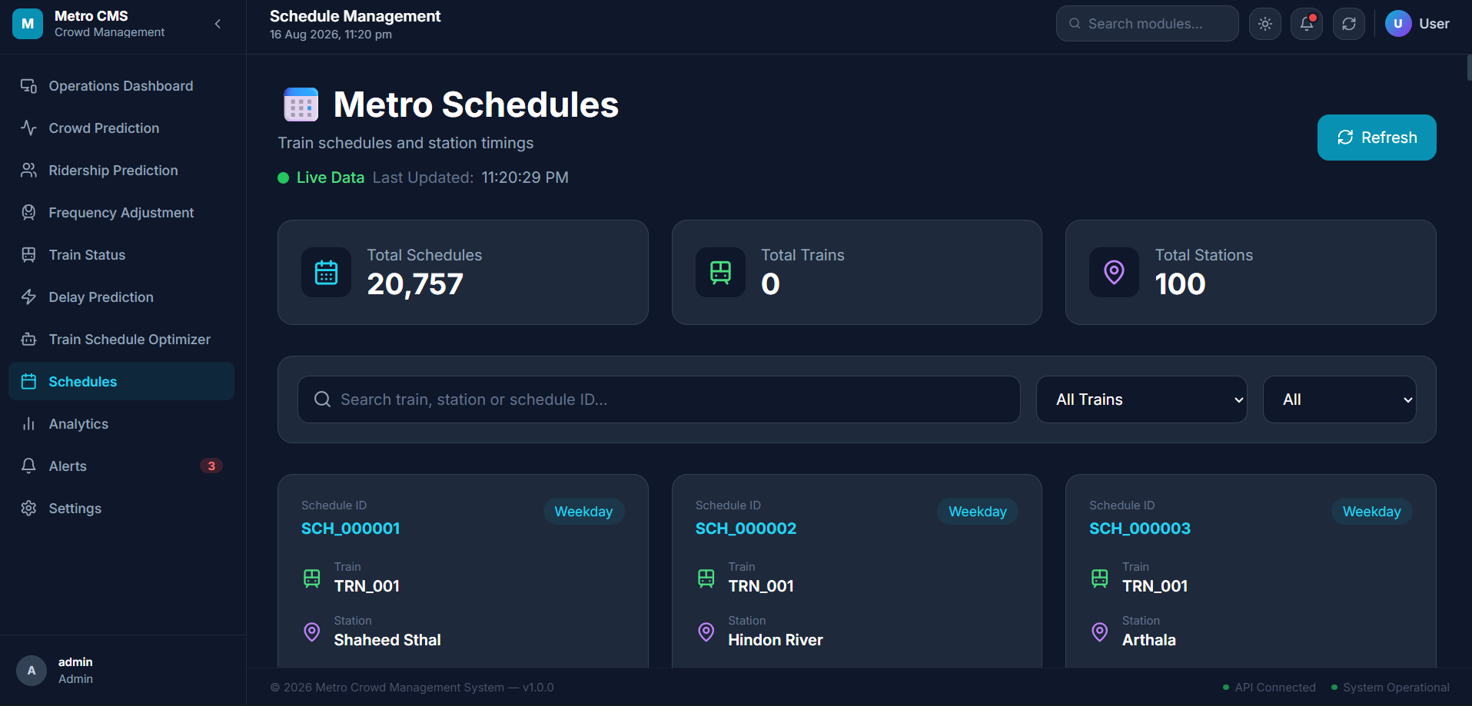
Figure 1. Metro Schedules screen showing schedule records, station information and search/filter controls.

3.1 Interface Evidence
- The interface reports 20,757 total schedules and 100 stations in the captured state.
- Schedule cards expose a Schedule ID, train identifier, station name and weekday classification.
- The search field supports lookup by train, station or schedule ID.
- Train and status filters support targeted schedule inspection.
- A refresh action is available for updating the displayed schedule data.

3.2 Functional Significance
This module operationalizes the Milestone 2 requirement for train schedule management. It provides the base schedule context required by frequency adjustment and schedule optimization workflows.

4. AI-Based Frequency Adjustment
Frequency adjustment is designed as a decision-support workflow. The operator selects a station and supplies the current train frequency in minutes; the system then returns an AI/ML-based recommendation using station occupancy information.
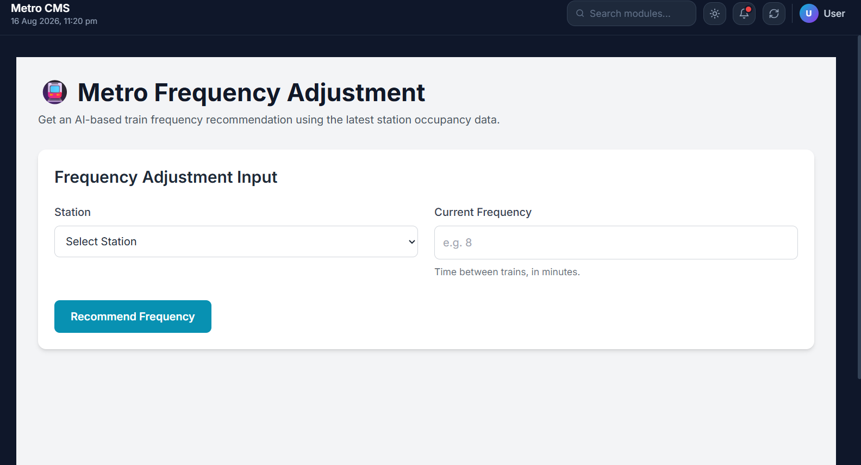
Figure 2. Frequency Adjustment input interface.

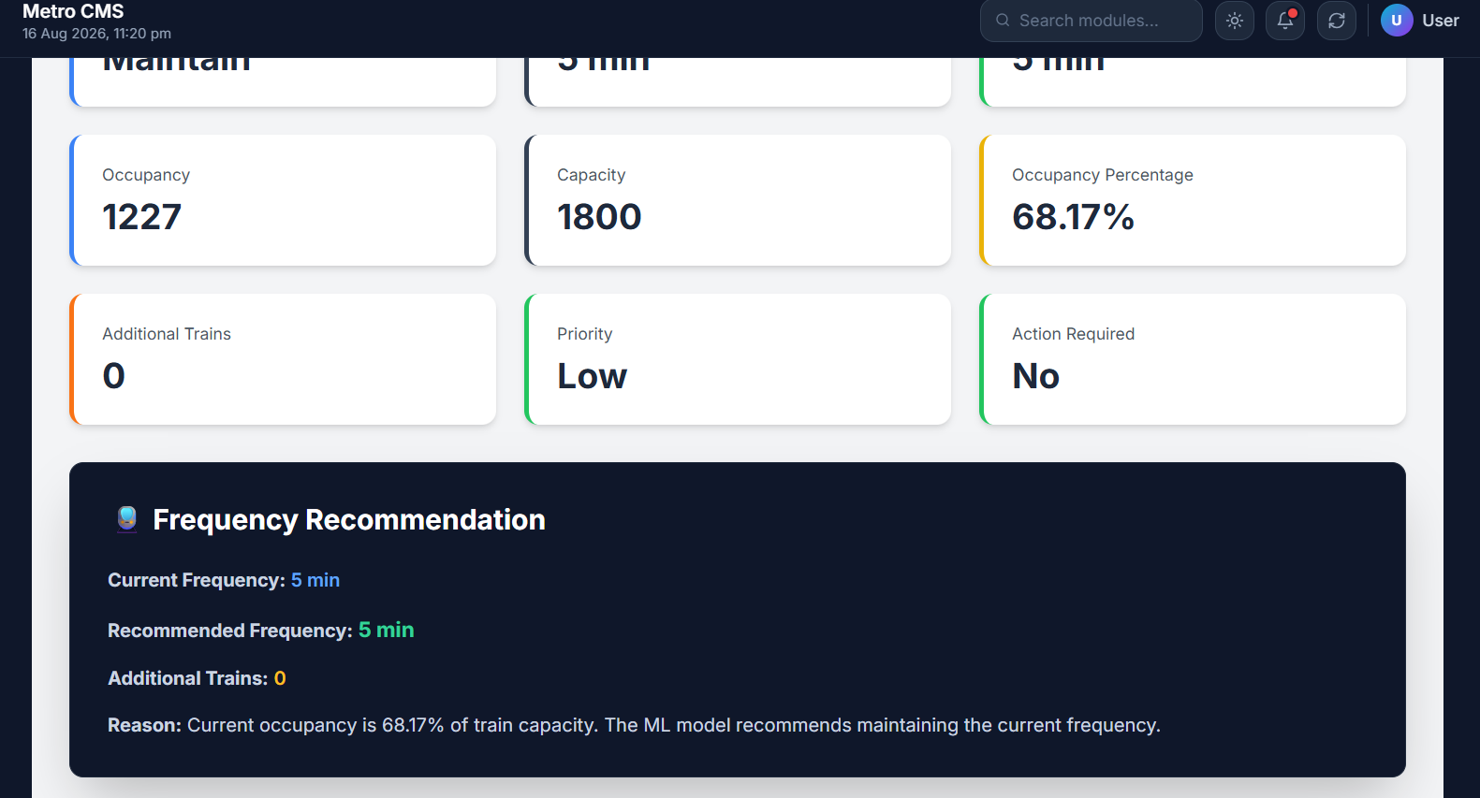
Figure 3. Frequency Recommendation result showing occupancy, capacity, priority and recommended frequency.

4.1 Demonstrated Result
In the captured result, occupancy is 1,227 against a capacity of 1,800, corresponding to 68.17% occupancy. The interface reports a current frequency of 5 minutes, a recommended frequency of 5 minutes, zero additional trains, low priority and no immediate action required. The displayed reason states that the ML model recommends maintaining the current frequency.

4.2 Decision Logic Presented to the Operator
- Current operating condition → occupancy/capacity assessment.
- Occupancy level → priority assessment.
- Recommendation → maintain or change the train interval.
- Additional-train requirement → operational resource indication.
- Reason text → human-readable explanation of the recommendation.

5. Real-Time Operations Monitoring
The Operations Dashboard provides a centralized control-center view of network status. It is intended to support the Milestone 2 requirement for real-time operational monitoring.
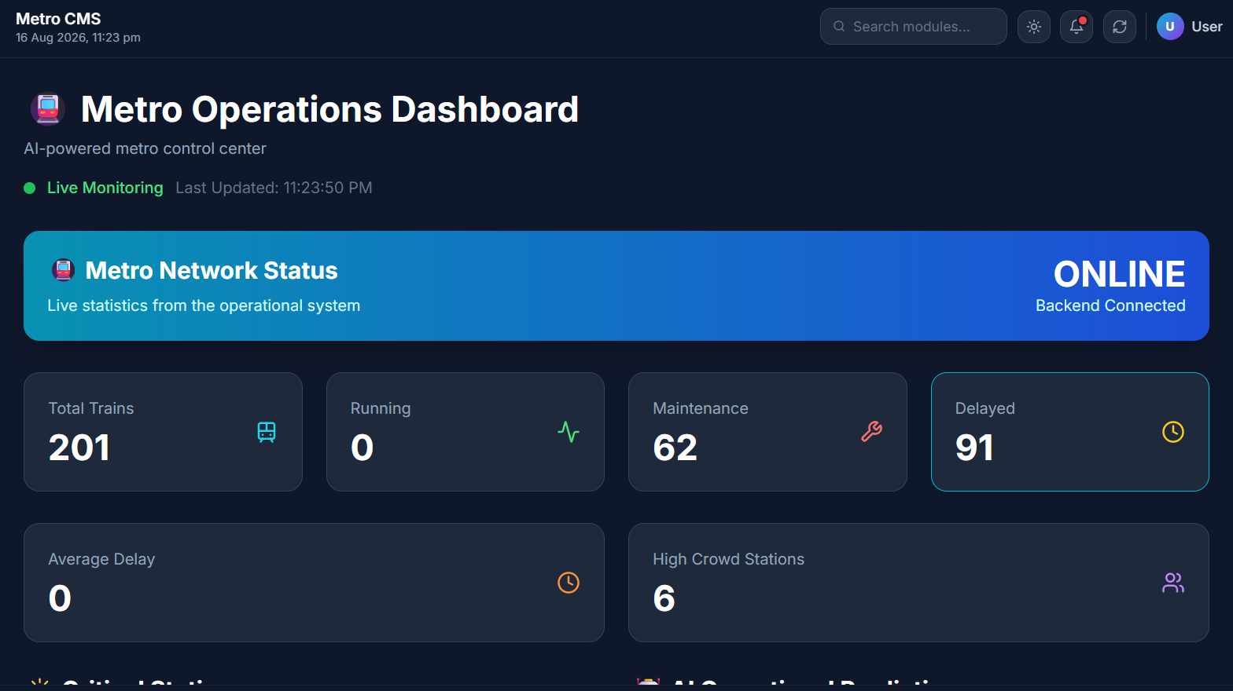
Figure 4. Metro Operations Dashboard showing network status and operational indicators.

5.1 Captured Operational Indicators
Indicator | Displayed value
Backend status | ONLINE / Backend Connected
Total trains | 201
Running | 0
Maintenance | 62
Delayed | 91
Average delay | 0
High-crowd stations | 6
These values demonstrate how operational information is surfaced to the user in a compact control-center view. Because the values are time-dependent application data, they should be validated against the underlying database/API before being used as formal operational KPIs.

5.2 Operational Value
- Provides a single view of network availability and operating condition.
- Highlights delayed and maintenance states for rapid attention.
- Surfaces high-crowd stations that can feed the prediction and scheduling workflows.
- Creates the operational context needed for schedule and frequency decisions.

6. Crowd Prediction Module
The crowd prediction workflow converts station-level passenger information into a structured prediction result. The result is designed to be directly interpretable by an operator.
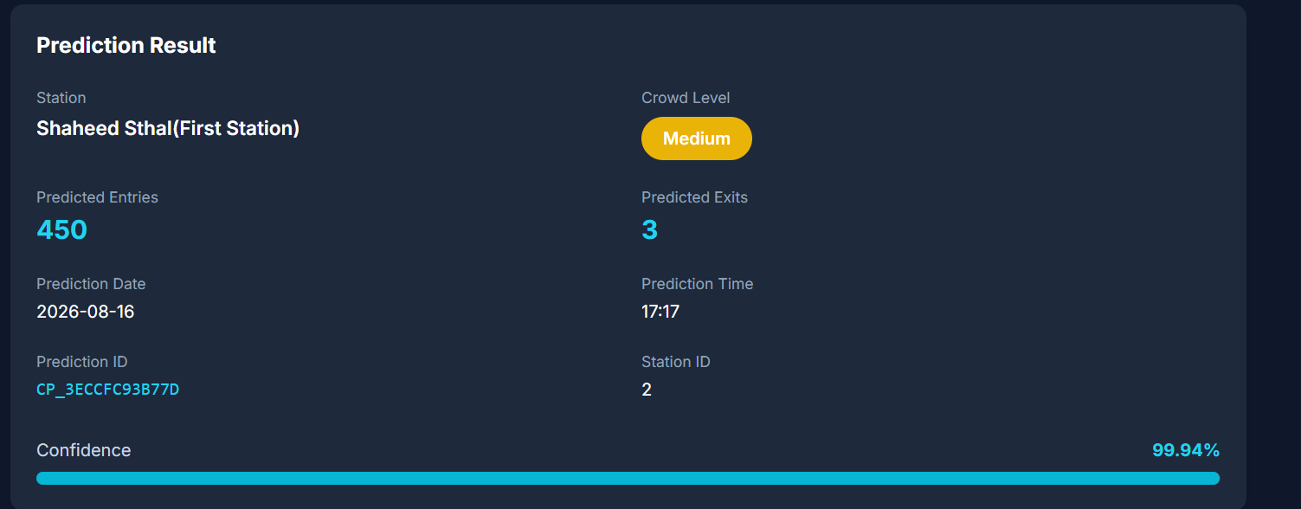
Figure 5. Crowd prediction result for Shaheed Sthal (First Station).

6.1 Prediction Output
Field | Captured result
Station | Shaheed Sthal (First Station)
Crowd level | Medium
Predicted entries | 450
Predicted exits | 3
Prediction date | 2026-08-16
Prediction time | 17:17
Station ID | 2
Prediction ID | CP_3ECCFC93B77D
Displayed confidence | 99.94%
The 99.94% figure is the confidence value displayed for this individual prediction result; it should not be interpreted as overall model accuracy. The screen also exposes the prediction identifier and timestamp, supporting traceability of generated results.

6.2 Relation to the EDA Foundation
Milestone 1 identified peak-hour demand, ridership trends, occupancy distributions and cross-dataset relationships as important analytical signals. Milestone 2 turns those analytical inputs into an operational crowd-level prediction interface.

7. Train Schedule Optimization & Platform Allocation
The schedule optimization interface combines predicted passenger demand with current frequency and platform information to produce an operational recommendation.
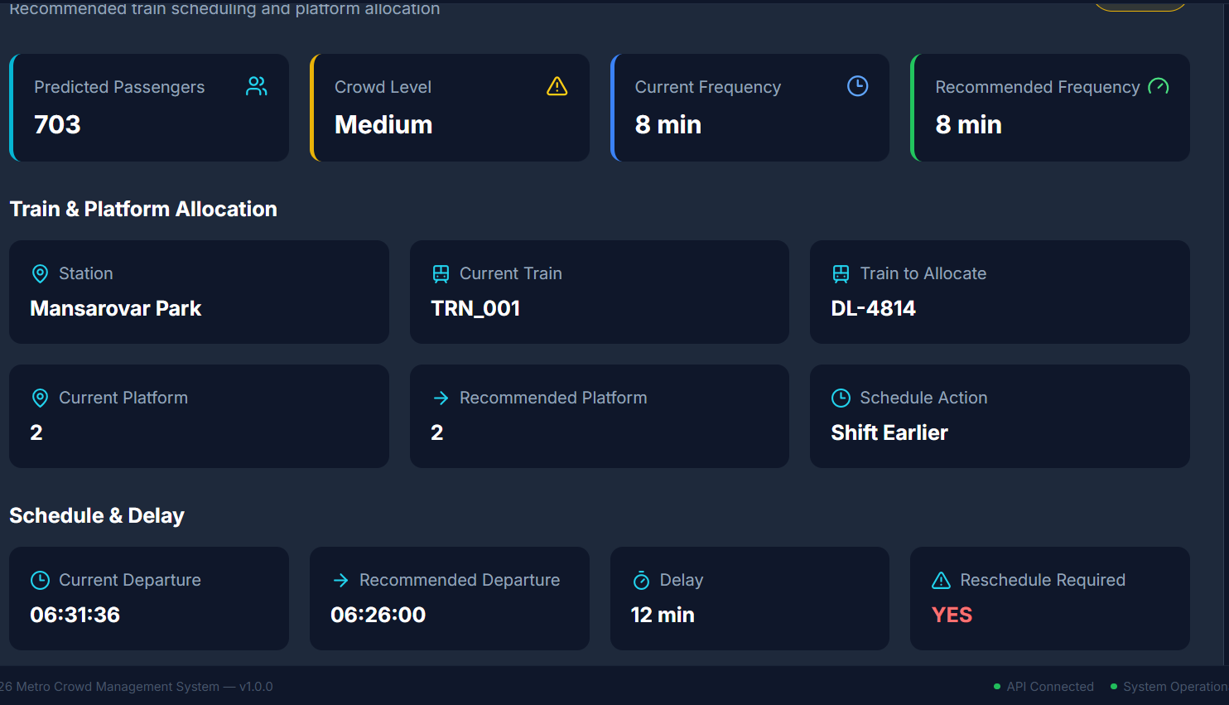
Figure 6. Train and platform allocation result with schedule and delay recommendation.

7.1 Captured Recommendation
Metric | Captured result
Predicted passengers | 703
Crowd level | Medium
Current frequency | 8 min
Recommended frequency | 8 min
Station | Mansarovar Park
Current train | TRN_001
Train to allocate | DL-4814
Current platform | 2
Recommended platform | 2
Schedule action | Shift Earlier
Current departure | 06:31:36
Recommended departure | 06:26:00
Delay | 12 min
Reschedule required | YES

7.2 Operational Interpretation
The result shows that the system can recommend an earlier departure while retaining the same platform and frequency. This demonstrates a more complete scheduling workflow than a simple timetable display: the interface combines demand, frequency, train allocation, platform assignment and delay handling.

8. Analytics & Prediction Center
The Analytics & Prediction Center aggregates prediction activity and provides a central entry point for crowd, ridership, frequency, delay and schedule results.
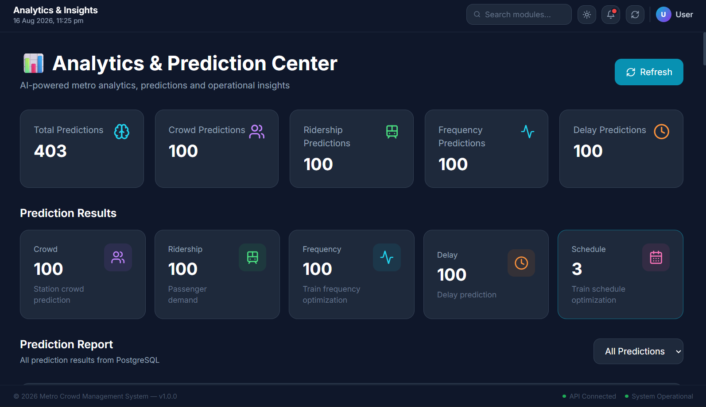
Figure 7. Analytics & Prediction Center with prediction summaries and categorized results.

8.1 Captured Analytics Summary
Category | Displayed count
Total predictions | 403
Crowd predictions | 100
Ridership predictions | 100
Frequency predictions | 100
Delay predictions | 100
Schedule results | 3

8.2 Role in the Platform
- Centralizes prediction activity from multiple operational modules.
- Separates prediction categories so users can inspect the type of analysis performed.
- Provides a foundation for future reporting, filtering, trend analysis and model monitoring.
- Connects individual prediction workflows with the broader operational analytics layer.

9. Testing, Validation & Milestone 2 Conclusion

9.1 Functional Validation Performed Through the Implemented Screens
Test area | Observed evidence
Schedule management | Schedule records, station/train identifiers and filters rendered successfully
Frequency adjustment | Input workflow and recommendation result rendered successfully
Operations monitoring | Network status and operational indicators displayed
Crowd prediction | Station prediction with entries, exits, level and confidence displayed
Schedule optimization | Train/platform allocation and departure recommendation displayed
Analytics | Prediction totals and categories displayed in a unified center

9.2 Data Consistency Checks for the Next Iteration
The captured screens show different operational aggregates in different modules—for example, the Schedules screen reports 0 total trains in its summary while the Operations Dashboard reports 201 total trains. This may reflect different datasets, filters, or endpoint definitions, but it should be reconciled before the figures are treated as a single source of truth. Similarly, average delay is displayed as 0 while a schedule optimization result reports a 12-minute delay. These values should be traced to their respective API/database fields and definitions.

9.3 Milestone 2 Conclusion
Milestone 2 extends the MetroFlow foundation into a functional scheduling and AI-assisted decision-support platform. The implemented interfaces demonstrate schedule management, frequency recommendation, operational monitoring, crowd prediction, schedule optimization, platform allocation and centralized analytics. The work aligns with the Milestone 2 plan described in the project specification: scheduling workflows, frequency adjustment, real-time operational monitoring, crowd prediction, passenger-demand forecasting and traffic analysis.

10. Next Steps Toward Milestone 3
- Strengthen alert and notification workflows for overcrowding and delay events.
- Add real-time schedule update and emergency communication capabilities.
- Expand analytics and reporting, including congestion heatmaps and operational trends.
- Validate model performance using formal evaluation metrics rather than single-screen confidence values.
- Reconcile cross-module aggregates so schedules, trains, delays and predictions use consistent definitions and data sources.
- Continue integration testing across frontend, backend, database and AI services.

End of Milestone 2 Report

