MetroFlow
AI Platform for Metro Crowd Management and Scheduling
Milestone 3 Report
Alerts, Notifications & Analytics

Prepared by: Ankita Jana
August 2026

Milestone 3 extends the scheduling and prediction foundation with alert management, user-facing alert visibility, operational monitoring and analytics/reporting workflows.

1. Milestone 3 Overview
According to the MetroFlow implementation plan, Milestone 3 covers Weeks 5 and 6 and focuses on alerts, notifications and analytics. The planned work includes notification and alert workflows, an emergency announcement system, real-time schedule updates, analytics and reporting dashboards, congestion heatmaps and operational insights.

1.1 Milestone 3 Objectives
- Implement real-time crowd-management alerts and incident notification workflows.
- Provide administrative controls for creating, reviewing and resolving alerts.
- Provide a separate user-facing interface so metro users can view relevant alerts.
- Integrate operational monitoring with train status, delay and crowd information.
- Provide analytics and prediction reporting for operational decision support.
- Support exportable analytics reports through PDF/JPG actions shown in the application.

1.2 Evidence Covered in This Report
Evidence | What it demonstrates
Admin Alerts page | Alert creation, severity/status summaries, filtering and resolve workflow
User Alerts page | End-user visibility of the same crowd/incident alert information
Analytics page | Prediction analytics records and export-report controls
Schedule page | Live schedule data, schedule totals and station/train timing records
Train Status page | Train-status visualization, delay overview, crowd monitoring and live train records
The screenshots are treated as evidence of the implemented interface state. Where a Milestone 3 requirement is not visible in the supplied screenshots, this report does not claim that it has been fully implemented.

2. Milestone 3 Functional Workflow
The Milestone 3 implementation introduces a two-sided alert workflow: an administrative control interface for managing incidents and a user-facing interface for consuming alerts. This separates operational authority from public/user visibility.

2.1 Admin-to-User Alert Flow
Step | Administrative side | User side
1. Detection/incident | Operational condition or incident is identified | —
2. Alert creation | Admin can use Create Alert | —
3. Classification | Severity/status are represented as Critical/High/Medium/Low and Resolved | User sees the resulting alert classification
4. Publication/visibility | Alert appears in alert management | User can see alert information
5. Resolution | Admin can resolve an active alert | Resolved state becomes visible to users

2.2 Why Two Interfaces Matter
The admin page is designed for operational control: it contains Create Alert, Refresh, severity filters and Resolve controls. The user page presents the alert information without exposing administrative controls. This creates a clear separation between incident management and incident consumption.

2.3 Milestone 3 Relationship to Previous Modules
- Train Status supplies operational context such as active/maintenance states and delay information.
- Crowd Monitoring supplies crowd-related conditions that can lead to alerts.
- Schedules supplies station and timing information useful for incident context.
- Analytics consolidates prediction information and provides a reporting surface.
- Alerts convert operational conditions into actionable notifications.

3. Admin Alert Management
The administrative Alerts interface is the control point for managing real-time crowd-management alerts and incident notifications. It provides summary counters, severity filters, alert cards, Refresh and Create Alert actions, and Resolve controls.
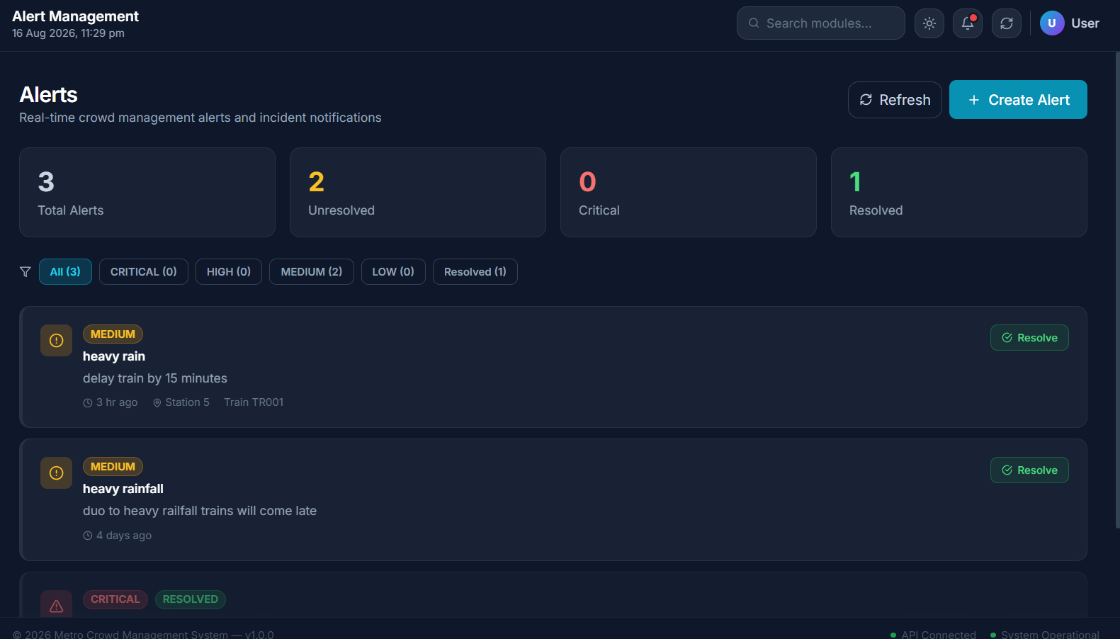
Figure 1. Administrative Alert Management page with alert summaries, filters, creation and resolution controls.

3.1 Captured Alert Summary
Metric | Displayed value
Total Alerts | 3
Unresolved | 2
Critical | 0
Resolved | 1
Medium | 2
High | 0
Low | 0

3.2 Alert Records Shown
- A Medium alert titled 'heavy rain' states that the train should be delayed by 15 minutes; it is associated with Station 5 and Train TR001.
- A Medium alert titled 'heavy rainfall' states that trains will arrive late.
- A third alert is shown with Critical and Resolved labels in the captured interface.

3.3 Administrative Capabilities
- Create Alert: allows an administrator to add an incident notification.
- Refresh: updates the alert list.
- Severity/status filters: All, Critical, High, Medium, Low and Resolved.
- Resolve: allows an unresolved alert to be marked as resolved.
- Summary counters: provide a quick view of current incident workload.

4. User-Facing Alert Visibility
The project contains a separate user-facing webpage where users can view alerts. This is an important part of the Milestone 3 communication workflow: administrators manage incidents, while users receive the resulting information.
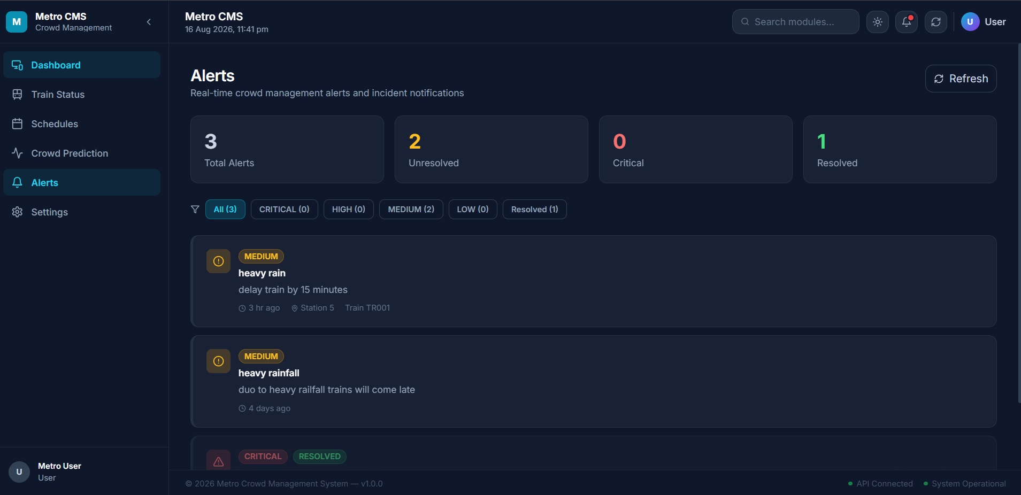
Figure 2. User-facing Metro CMS Alerts page showing alerts available to metro users.

4.1 User View Characteristics
- The navigation identifies the page as Alerts and describes it as real-time crowd-management alerts and incident notifications.
- The same alert information is presented in a user-oriented layout without the administrative Create Alert control.
- The interface still exposes severity/status information so users can understand the importance of an incident.
- The user page provides a communication endpoint between the MetroFlow operational system and passengers/users.

4.2 Admin vs User Access
Function | Admin interface | User interface
View alerts | Yes | Yes
Create alert | Yes | No evidence of this control
Resolve alert | Yes | No evidence of this control
Filter by severity/status | Yes | Not shown in supplied user screenshot
Receive incident information | Yes | Yes
The table intentionally distinguishes between visible evidence and assumptions. The supplied screenshots establish administrative creation/resolution controls and user alert visibility; they do not establish additional user permissions.

5. Analytics & Reporting
The Analytics & Insights page provides a reporting view of prediction records retrieved from PostgreSQL. It shows prediction rows with type, station, prediction level, confidence and status, and provides report export controls.
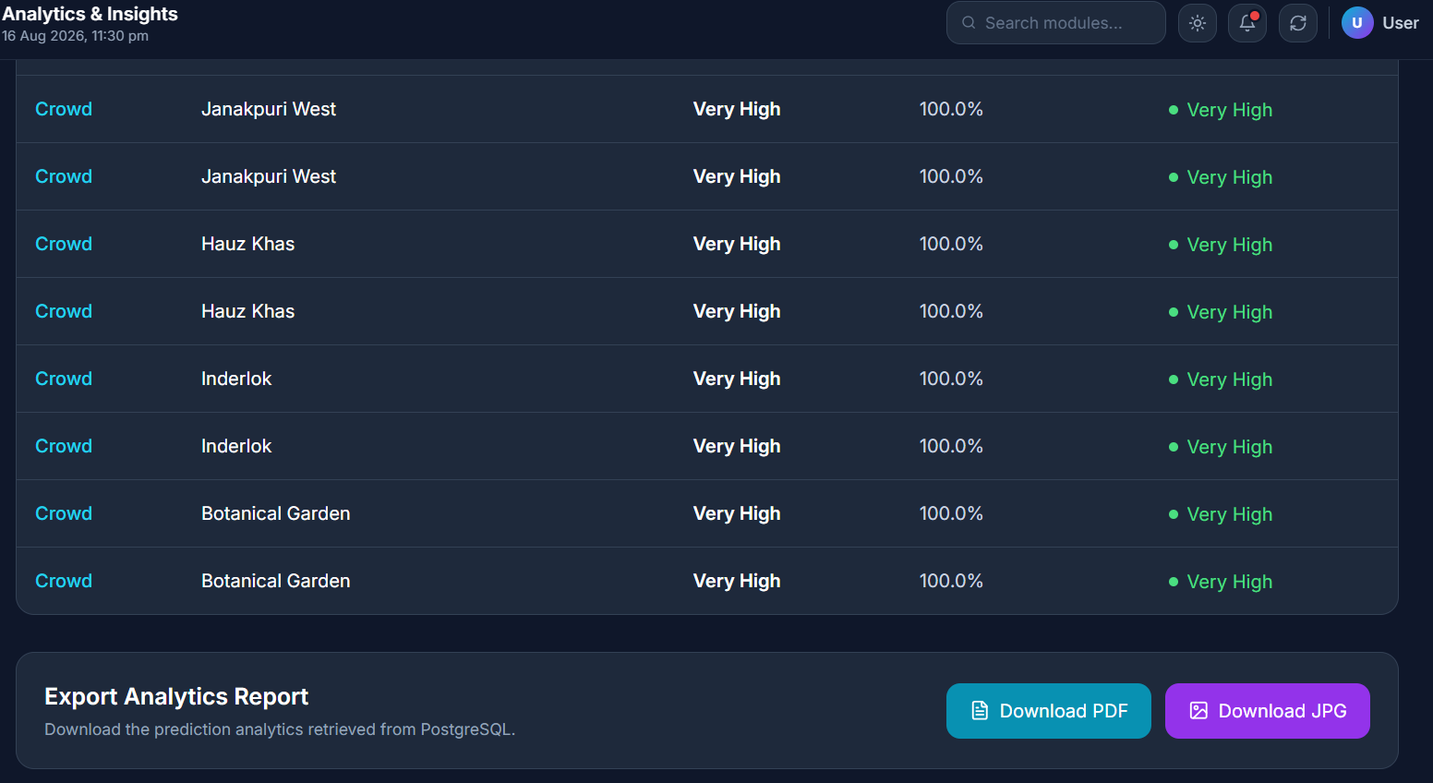
Figure 3. Analytics & Insights prediction records and export-report controls.

5.1 Analytics Records Visible in the Screenshot
- Prediction type: Crowd.
- Stations shown include Janakpuri West, Hauz Khas, Inderlok and Botanical Garden.
- The visible prediction level is Very High.
- The visible confidence value is 100.0%.
- The status indicator is Very High.

5.2 Export Functionality
The page contains an 'Export Analytics Report' section with Download PDF and Download JPG controls. This demonstrates that analytics results are intended to be exportable for reporting and operational review.

5.3 Interpretation
The analytics page provides a bridge between individual AI predictions and operational reporting. It can be used to review where high crowd predictions are occurring and to preserve or communicate the results through exported reports.

6. Real-Time Schedule and Train Monitoring
Milestone 3 also builds on the operational monitoring capabilities implemented earlier. The supplied Schedule Management and Train Status screens provide supporting context for alerts and analytics.
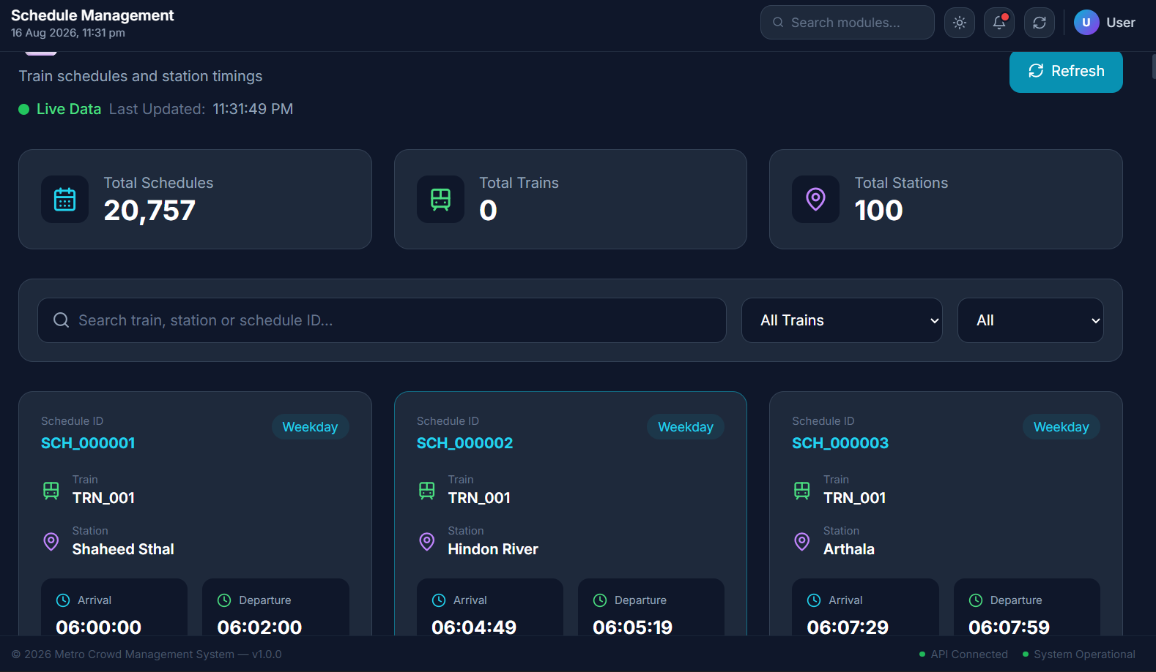
Figure 4. Schedule Management page showing live schedule data and station timing records.

6.1 Schedule Management Evidence
Indicator | Displayed value
Live data | Active
Total schedules | 20,757
Total trains | 0 in this module summary
Total stations | 100
Visible schedule IDs | SCH_000001, SCH_000002, SCH_000003
Visible stations | Shaheed Sthal, Hindon River, Arthala
The schedule records show arrival and departure times and provide the timing context needed when incidents such as delays or weather disruptions are communicated.
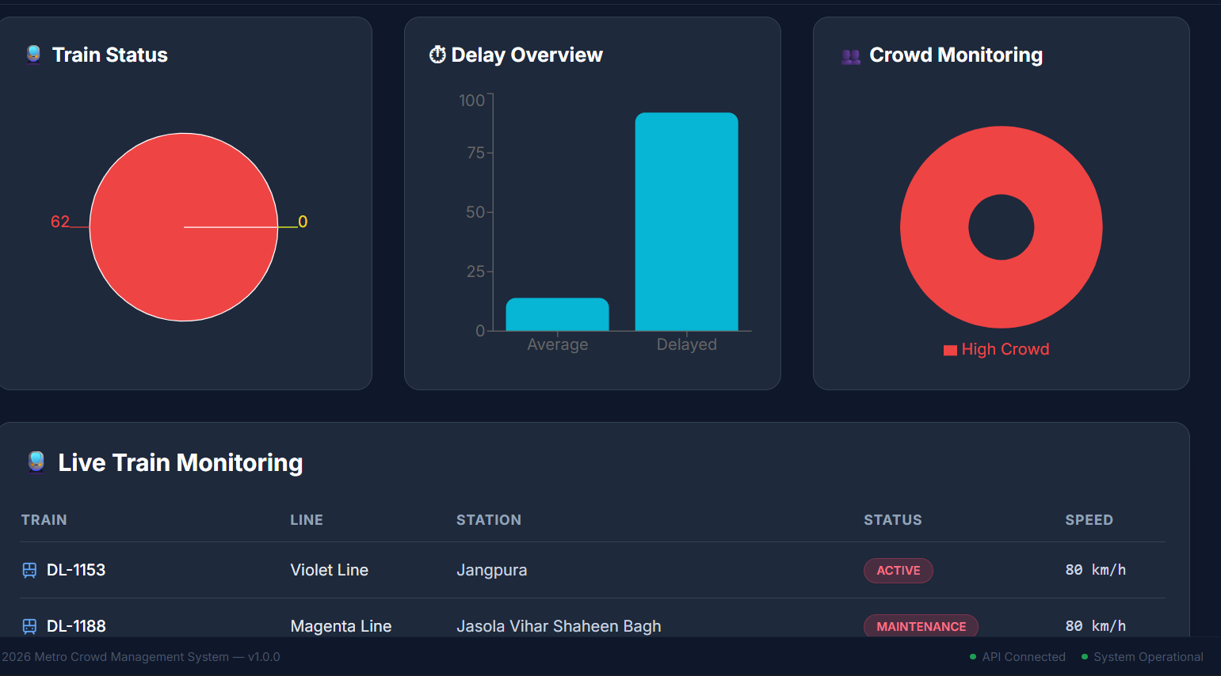
Figure 5. Train Status page with train-status, delay-overview, crowd-monitoring and live-monitoring panels.

6.2 Train Status and Delay Evidence
- Train Status is visualized separately from the delay overview.
- The Delay Overview panel compares Average and Delayed values.
- Crowd Monitoring highlights High Crowd.
- Live Train Monitoring lists train, line, station, status and speed.
- Visible examples include DL-1153 on the Violet Line at Jangpura with ACTIVE status and 80 km/h, and DL-1188 on the Magenta Line at Jasola Vihar Shaheen Bagh with MAINTENANCE status and 80 km/h.

7. Alert, Monitoring and Analytics Integration
The screenshots show how the Milestone 3 modules fit together as an operational communication loop. Train status, schedule information and crowd conditions provide context; alert management converts incidents into notifications; the user interface communicates those notifications; and analytics records provide a reporting layer.
Input/Condition | Operational Module | Communication/Insight
Train delay or maintenance | Train Status / Schedule | Alert can communicate disruption
High crowd condition | Crowd Monitoring / Analytics | Crowd alert and prediction insight
Weather disruption | Alert Management | Delay/incident notification
Prediction records | Analytics & Insights | Review and export reporting
Schedule timing | Schedule Management | Provides timing context for incidents

7.1 Functional Validation from Supplied Screenshots
Test area | Observed result
Admin alert management | Alert summaries, filters and Resolve controls are visible
Alert creation workflow | Create Alert control is visible on the admin page
User alert visibility | A separate user page displays alert records
Analytics | Prediction records and export controls are visible
Schedules | Live-data indicator, schedule totals and timing records are visible
Train monitoring | Train status, delay and crowd panels are visible

7.2 Important Validation Note
The screenshots demonstrate the frontend workflows and displayed application state. They do not by themselves prove backend latency, notification delivery guarantees, model accuracy, database consistency or real-world deployment performance. Those aspects require API-level and end-to-end testing.

8. Milestone 3 Conclusion & Next Steps
Milestone 3 extends MetroFlow from prediction and scheduling into operational communication and reporting. The supplied evidence demonstrates an administrative alert-management interface, a separate user-facing alert page, analytics and report-export functionality, and supporting schedule/train monitoring views.

8.1 Achievements Demonstrated
- Implemented an alert-management interface for administrators.
- Provided alert creation and resolution controls.
- Added severity and resolution categorization.
- Provided a separate user-facing alert-consumption interface.
- Integrated alert information with train, schedule and crowd-management context.
- Implemented an analytics view for crowd prediction records.
- Added PDF/JPG report export actions in the analytics interface.
- Provided schedule and train-status monitoring screens that support incident awareness.

8.2 Milestone 3 Requirements Not Directly Evidenced by the Supplied Images
- Emergency announcement workflow is not directly visible in the supplied screenshots.
- Real-time schedule update actions beyond refresh/display are not directly demonstrated.
- Congestion heatmap generation is not visible in the supplied screenshots.
- Actual push/SMS/email delivery is not directly demonstrated.
- Formal end-to-end alert latency and notification reliability measurements are not provided.

8.3 Recommended Next Steps
- Add and document emergency announcement controls and delivery status.
- Validate alert propagation from admin creation to the user page through the backend.
- Add automated tests for alert creation, filtering, resolution and user visibility.
- Add congestion heatmaps and trend-based operational reports if planned for the final milestone.
- Validate real-time updates with WebSocket/API integration tests.
- Measure alert delivery latency, API response time and database query performance.
- Continue toward Milestone 4 testing, deployment and final documentation.
End of Milestone 3 Report

