MetroFlow
AI Platform for Metro Crowd Management and Scheduling
Milestone 4 Report
AI Schedule Optimization & Final Decision Support

Prepared by: Ankita Jana
August 2026

Milestone 4 validates the integrated schedule-optimization decision layer through a live API request and a structured optimizer response.

1. Milestone 4 Overview
Milestone 4 represents the final decision-support and validation stage of the MetroFlow workflow documented across the previous milestones. Milestone 2 established prediction, scheduling, frequency adjustment and platform-allocation capabilities, while Milestone 3 extended the platform with alerts, user-facing communication, analytics and operational monitoring. The current evidence focuses on validating the integrated Train Schedule Optimizer API.

1.1 Purpose of Milestone 4
- Validate the integrated AI-assisted train schedule optimization endpoint.
- Combine passenger-demand prediction, crowd level, train frequency, platform assignment and delay information into one decision result.
- Support train allocation and rescheduling decisions for operational planning.
- Return an explicit schedule action, recommendation and human-readable reason.
- Verify that the optimizer is accessible through the backend API and returns a successful HTTP response.
- Provide a traceable API-level result suitable for final testing and presentation.

1.2 Connection with Previous Milestones
Milestone | Foundation carried forward
Milestone 1 | Full-stack setup, data preparation, EDA and backend/frontend foundation
Milestone 2 | Crowd/ridership prediction, frequency adjustment, train status and schedule optimization
Milestone 3 | Alerts, user-facing alert visibility, analytics/reporting and operational communication
Milestone 4 | Integrated optimization decision, API validation and final decision-support evidence
This report is deliberately grounded in the supplied API screenshot. Features not demonstrated by the screenshot are described as future validation or deployment work rather than as completed functionality.

2. Schedule Optimizer API
The supplied evidence shows a POST request to the MetroFlow schedule optimizer endpoint. The request is executed against the local FastAPI backend and returns HTTP 200, confirming that the endpoint processed the submitted input successfully.
API property | Captured value
HTTP method | POST
Endpoint | /api/v1/schedule-optimizer/optimize
Request URL | http://localhost:8000/api/v1/schedule-optimizer/optimize
Content type | application/json
Response code | 200 OK
Backend context | Localhost FastAPI service

2.1 Request Payload
Input field | Value
station_name | Rajiv Chowk
hour | 18
day | 16
month | 8
weekend | false

2.2 Interpretation of the Request
The optimizer receives a station and time-context representation. In the captured test, the station is Rajiv Chowk and the request represents hour 18 on day 16 of month 8, with weekend set to false. This gives the decision layer temporal and location context for generating an operational recommendation.

3. Optimizer Response
The response contains the major decision variables required by the MetroFlow train scheduling optimizer: train identity, current and recommended platform, schedule action, departure times, passenger demand, crowd level, frequency, train allocation, delay and rescheduling status.
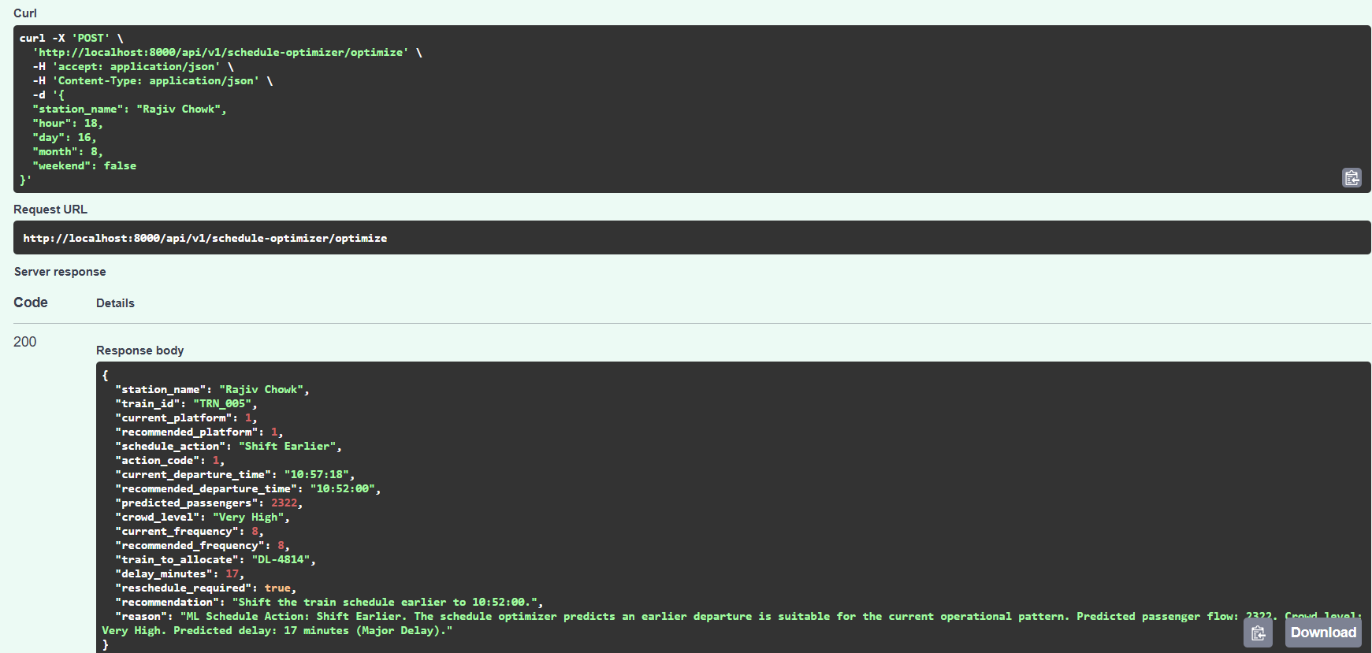
Figure 1. Successful Schedule Optimizer API request and response captured from the FastAPI documentation interface.

3.1 HTTP-Level Validation
Validation item | Observed result
Request accepted | Yes
Endpoint executed | Yes
HTTP status | 200
Structured JSON response | Yes
Station returned | Rajiv Chowk
Schedule action returned | Shift Earlier
Reschedule decision returned | true
The HTTP 200 status demonstrates successful endpoint execution for this test case. It does not by itself establish model accuracy, production reliability or real-world operational correctness; those require additional evaluation.

4. Detailed Decision Output
Output field | Captured value
station_name | Rajiv Chowk
train_id | TRN_005
current_platform | 1
recommended_platform | 1
schedule_action | Shift Earlier
action_code | 1
current_departure_time | 10:57:18
recommended_departure_time | 10:52:00
predicted_passengers | 2322
crowd_level | Very High
current_frequency | 8 min
recommended_frequency | 8 min
train_to_allocate | DL-4814
delay_minutes | 17
reschedule_required | true

4.1 Key Decision
For Rajiv Chowk, the optimizer recommends shifting the train schedule earlier. The current departure is 10:57:18, while the recommended departure is 10:52:00. The current and recommended platform both remain Platform 1, and the current and recommended frequency both remain 8 minutes.

4.2 Demand and Crowd Context
The optimizer reports 2,322 predicted passengers and a Very High crowd level. This provides the demand-side context behind the scheduling decision. The response also reports a 17-minute delay, which is classified in the explanation as a major delay.

5. AI Decision Logic Demonstrated by the Response
The captured response demonstrates a multi-factor decision-support workflow rather than a simple timetable lookup. The optimizer combines demand, crowd condition, frequency, platform state, train allocation and delay information before returning an operational action.
Decision factor | Captured value | Operational role
Predicted passengers | 2322 | Represents expected passenger flow
Crowd level | Very High | Indicates severe demand pressure
Current frequency | 8 min | Current train interval
Recommended frequency | 8 min | Optimizer keeps interval unchanged
Current platform | 1 | Existing platform assignment
Recommended platform | 1 | No platform change required
Delay | 17 min | Major operational disruption
Train to allocate | DL-4814 | Train selected for allocation
Schedule action | Shift Earlier | Primary scheduling decision
Reschedule required | true | Indicates timetable intervention

5.1 Decision Flow
- Receive station and time context.
- Estimate passenger demand and crowd level.
- Inspect current frequency and platform assignment.
- Account for predicted operational delay.
- Select/identify the train to allocate.
- Determine schedule action.
- Calculate a recommended departure time.
- Return a rescheduling flag, recommendation and reason.

6. Recommendation and Explainability

6.1 Recommendation Returned by the API
The response recommendation is: “Shift the train schedule earlier to 10:52:00.”

6.2 Reason Returned by the API
The reason explains that the ML schedule action is Shift Earlier and that an earlier departure is suitable for the current operational pattern. It explicitly references predicted passenger flow of 2,322, a Very High crowd level, and a predicted delay of 17 minutes described as a major delay.

6.3 Explainability Value
- The action is explicit rather than hidden inside an internal model score.
- The response includes the recommended departure time.
- The response identifies the demand and crowd context behind the action.
- The delay value explains why rescheduling is necessary.
- The reason field makes the recommendation easier for an operator to understand and review.

6.4 Relationship to Earlier Schedule Optimization
Milestone 2 already demonstrated schedule optimization and platform allocation as an operational recommendation layer. The present API evidence strengthens that workflow by showing the optimizer operating directly through the backend endpoint and returning a complete structured decision.

7. Functional Validation & Testing

7.1 Test Case
Test parameter | Value
Station | Rajiv Chowk
Hour | 18
Day | 16
Month | 8
Weekend | false
Expected behavior | Return schedule optimization recommendation
Observed HTTP result | 200 OK
Observed action | Shift Earlier
Observed rescheduling | true

7.2 Validation Checklist
Check | Result
Correct endpoint path | PASS
POST request accepted | PASS
JSON request processed | PASS
HTTP 200 response | PASS
Station returned correctly | PASS
Platform decision returned | PASS
Schedule action returned | PASS
Departure recommendation returned | PASS
Passenger prediction returned | PASS
Crowd level returned | PASS
Delay returned | PASS
Reschedule flag returned | PASS
Recommendation/reason returned | PASS

7.3 What This Test Does Not Prove
- It does not prove overall ML model accuracy.
- It does not prove that every station/time combination produces valid recommendations.
- It does not prove production-scale API performance.
- It does not prove real-world safety or operational suitability without domain validation.
- It does not prove notification delivery or deployment reliability.

8. Milestone 4 Conclusion & Final Integration Roadmap
The supplied evidence demonstrates a successful end-to-end API-level schedule optimization decision for Rajiv Chowk. The optimizer accepted a structured station/time request and returned HTTP 200 with train allocation, platform assignment, schedule action, departure recommendation, predicted passenger flow, crowd level, frequency, delay and rescheduling information.

8.1 Milestone 4 Achievement
- Validated the Train Schedule Optimizer endpoint through an actual POST request.
- Confirmed successful backend execution with HTTP 200.
- Demonstrated integrated schedule-action generation.
- Demonstrated platform assignment output.
- Demonstrated train allocation output.
- Demonstrated predicted passenger and crowd information inside the decision result.
- Demonstrated delay-aware rescheduling.
- Returned an explainable recommendation and reason.

8.2 Recommended Final Validation
- Run optimizer tests across multiple stations, peak/off-peak hours and weekday/weekend cases.
- Verify that platform assignments do not conflict with operational constraints.
- Validate train allocation against available train status and maintenance state.
- Compare predicted passenger values with evaluation data and report formal model metrics.
- Test delay and rescheduling behavior under different disruption levels.
- Measure API response time and reliability under repeated requests.
- Perform end-to-end integration testing across frontend, FastAPI backend, PostgreSQL and AI services.
- Prepare deployment and final demonstration documentation.

8.3 Final Statement
Milestone 4 demonstrates that MetroFlow has progressed from separate prediction and monitoring modules toward an integrated AI-assisted operational decision engine. The schedule optimizer now produces a concrete, traceable and explainable scheduling action from structured operational inputs.
End of Milestone 4 Report

