MetroFlow
AI Platform for Metro Crowd Management and Scheduling
Final Project Documentation — Milestones 1–4
Submitted by: Soham Parab
Springboard Internship / Academic Project
Executive Summary
MetroFlow is an AI-powered platform for metro crowd management and scheduling, built to help metro authorities monitor passenger flow, predict crowd density, optimize train scheduling, and respond to operational disruptions in real time. The project was developed across four milestones over eight weeks, progressing from foundational architecture and authentication, through AI-based crowd prediction and scheduling automation, to real-time alerts and analytics, and finally to automated testing, containerized deployment, and complete documentation.
A defining characteristic of this project is its honest, verified approach to data: at every stage where a dataset's numeric columns (fares, passenger counts) were found to carry no genuine signal, this was investigated, confirmed through statistical checks, and disclosed rather than glossed over. Where real data was unreliable for demand modeling, a realistic synthetic dataset was engineered from first principles, grounded in known real-world Delhi Metro rush-hour behavior, and used to train a genuinely predictive AI model (R² = 0.9666).
Overall System Architecture
The platform is a fully decoupled two-tier application communicating over a REST API, backed by a relational database and a trained machine learning model.
Backend
- FastAPI (Python), organized into routers (API endpoints), services (business logic), models (ORM + validation schemas), and database (connection layer)
- PostgreSQL as the primary datastore for users, trains, schedules, and alerts
- A trained scikit-learn Random Forest model, served through a dedicated prediction service
Frontend
- React (Vite) with Tailwind CSS, structured into pages, components, and a centralized Axios API layer
- Pages: Login, Dashboard (crowd monitoring + live mode), Reports (traffic analytics, heatmap, AI insights)
Data & AI
- Jupyter notebooks for data cleaning, exploratory analysis, and model training, kept separate from the application codebase
Testing & Deployment
- pytest test suite running against an isolated SQLite test database
- Docker Compose orchestrating the backend, frontend, and PostgreSQL as three containerized services
Milestone 1 — Project Initialization, Authentication & Data Foundations
Milestone 1 established the project's architecture and delivered a working authentication system, an initial crowd monitoring dashboard, and a thorough data cleaning and exploratory analysis pass on two real-world datasets.
Authentication and Operator Management
- JWT-based registration and login; passwords hashed with bcrypt, never stored or returned in plaintext
- Role-based access control (admin vs operator) enforced via a reusable FastAPI dependency chain
- Admin-only endpoints to list all operators and deactivate accounts
Crowd Monitoring Dashboard
- Station-wise crowd density cards and a congestion bar chart, connected to a real authenticated session
Data Preparation and EDA
- Delhi Metro Network dataset (285 stations): found and corrected 3 genuine coordinate errors by cross-verifying against official DMRC and Wikidata sources, rather than guessing or discarding the rows
- Delhi Metro Ridership dataset (150,000 trips): standardized 663 inconsistent station-name variants down to the correct 24, removed 1,323 logically invalid same-station trips, and statistically confirmed that Fare and Passengers columns carried no real signal (near-zero correlation with distance or time)
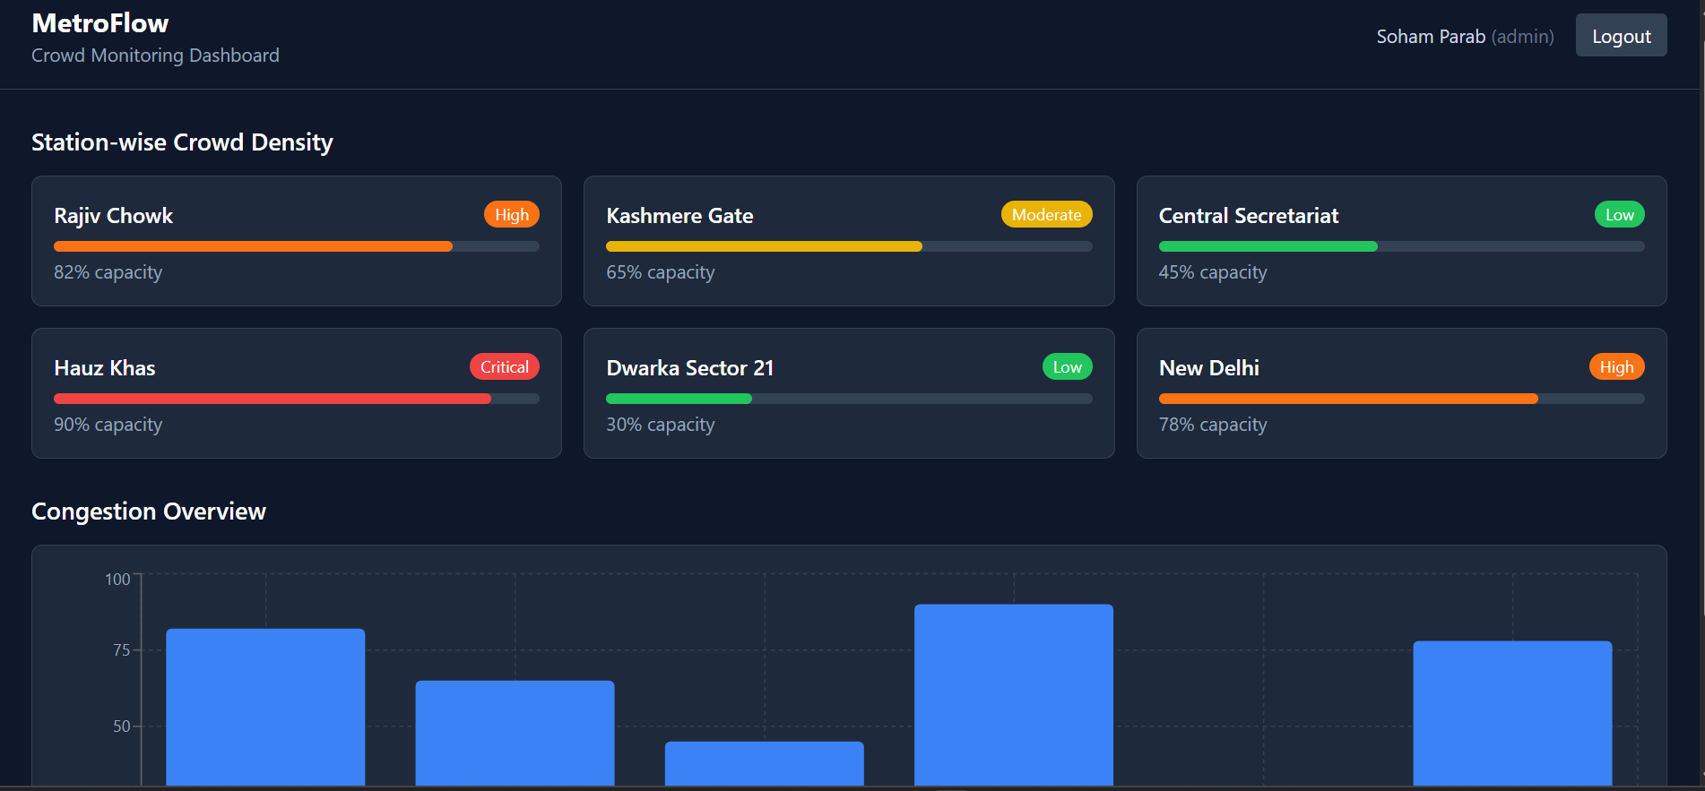
Fig 1. Milestone 1 — Crowd Monitoring Dashboard with live session and station density cards
Milestone 2 — Scheduling System & AI Prediction
Milestone 2 built the train scheduling system and the AI crowd prediction model, then connected both into the live dashboard.
Scheduling and Frequency Adjustment
- Train and Schedule data models with full CRUD endpoints
- Rule-based frequency adjustment: given a live density reading, automatically tightens headway to 3 minutes (density > 80%), 5 minutes (50–80%), or relaxes to 8 minutes (< 50%)
AI Crowd Prediction
- Since the ridership dataset's demand columns were confirmed synthetic/random, a realistic hourly demand dataset (149,340 station-hour records) was engineered instead, grounded in real Delhi Metro rush-hour patterns and scaled by each station's true interchange size
- A Random Forest Regressor was trained on this engineered data, achieving R² = 0.9666 and a Mean Absolute Error of 28.14 passengers, with hour-of-day (53%), interchange size (28%), and weekend flag (18%) as the dominant, interpretable features
- Served live through a GET /predictions/crowd endpoint
Real-Time Monitoring and Traffic Reports
- A live status endpoint reflecting the real current hour, with a frontend “Live Mode” auto-refreshing every 30 seconds and surfacing overcrowding alerts
- Traffic analysis reports: busiest stations, network-wide peak hour, demand by line, and weekday vs weekend comparison, both as API endpoints and a frontend Reports page
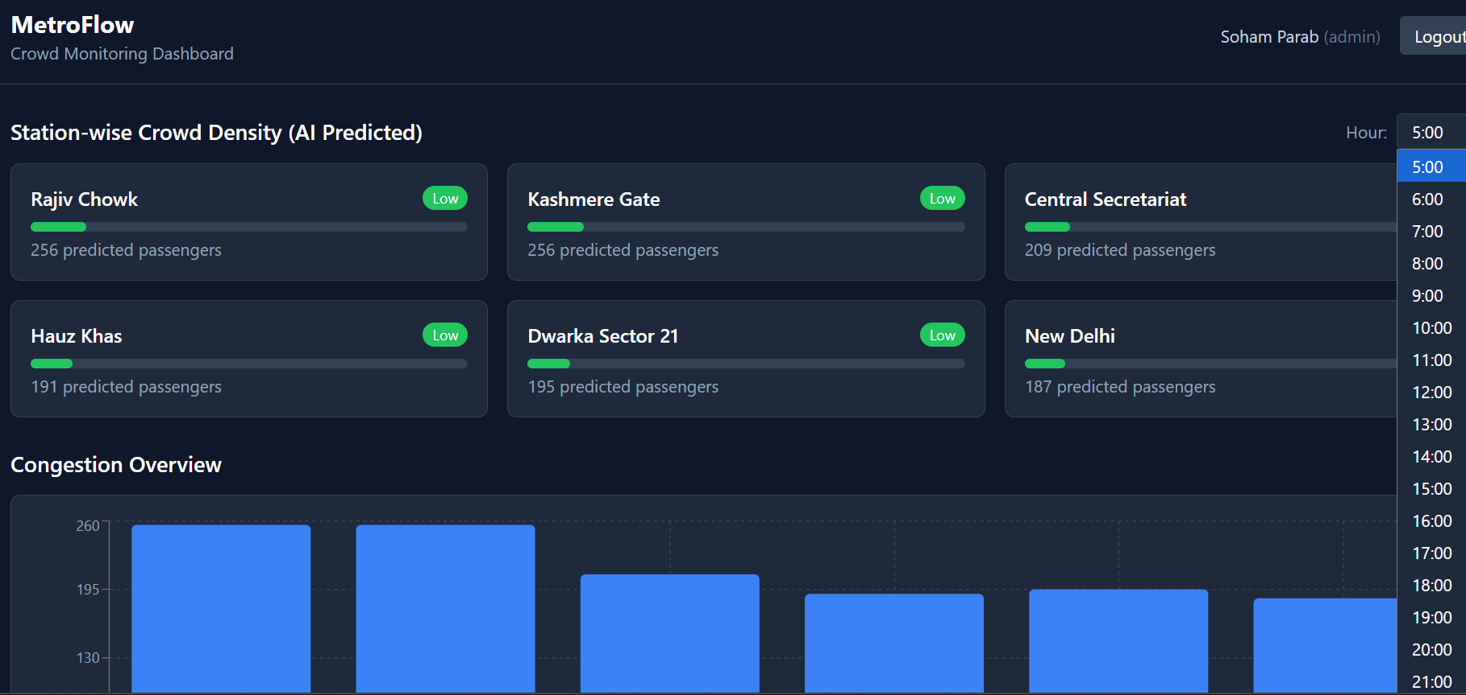
Fig 2. Milestone 2 — Dashboard driven by live AI predictions, showing morning rush-hour crowd levels
Milestone 3 — Alerts, Notifications & Analytics
Milestone 3 added a persisted alerting system, live schedule disruption updates, a visual congestion heatmap, and an AI-generated insights engine.
Alerts and Emergency Announcements
- A persisted Alert model (overcrowding, delay, emergency, maintenance types; low–critical severity) with a full lifecycle: create, list (active by default), and resolve
- A dedicated emergency broadcast endpoint for network-wide or station-scoped critical announcements
Real-Time Schedule Updates
- Operators can push a live delay and status note to an existing schedule without altering its base timetable
Congestion Heatmap and AI Insights
- A station × hour demand heatmap, color-coded from green (low) to red (critical), revealing the rush-hour pattern and correctly highlighting Kashmere Gate — the network's biggest interchange — as the only station reaching full Critical status
- A rule-based insight generator producing plain-English, actionable recommendations: capacity warnings for overloaded stations, network-wide scheduling suggestions, weekday/weekend resource allocation notes, and line-balance observations
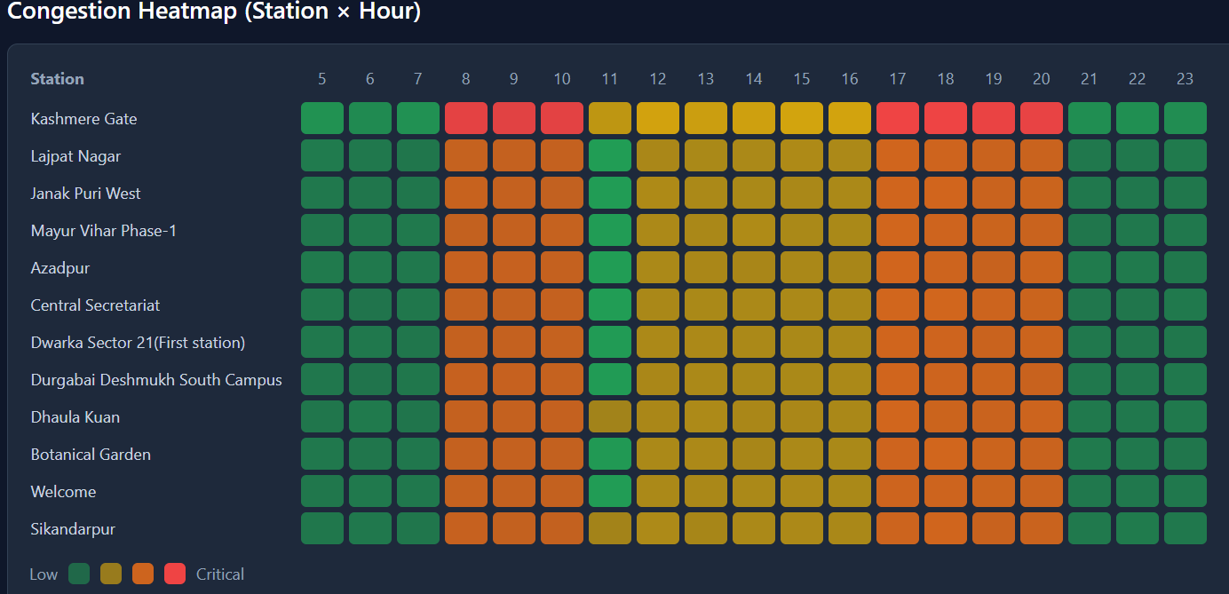
Fig 3. Milestone 3 — Congestion heatmap showing the rush-hour pattern across the busiest stations
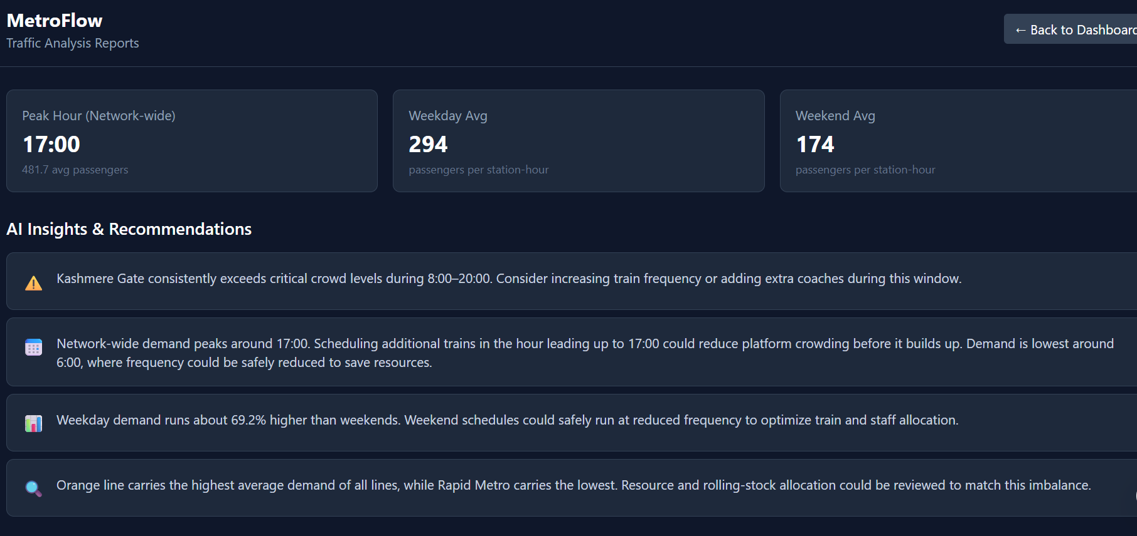
Fig 4. Milestone 3 — AI-generated insights and recommendations panel
Milestone 4 — Testing, Deployment & Documentation
Milestone 4 validated the entire platform, made it portable via Docker, improved usability, and finalized documentation.
Automated Testing
- 16 pytest tests covering authentication, role-based access control, scheduling workflows, both branches of the frequency adjustment logic, and the full alert lifecycle — run against an isolated SQLite test database
UI Responsiveness
- Login, Dashboard, and Reports pages tested and fixed for mobile width: wrapping headers, single-column station cards, and a horizontally scrollable heatmap with a sticky station-name column
Docker Deployment
- Separate Dockerfiles for the backend (FastAPI + Python) and frontend (multi-stage Node build served via nginx), orchestrated with docker-compose alongside a PostgreSQL container
- Verified end-to-end: all three containers start healthy, tables are created inside the running backend container, and a user can register, log in, and use the full dashboard through the containerized frontend
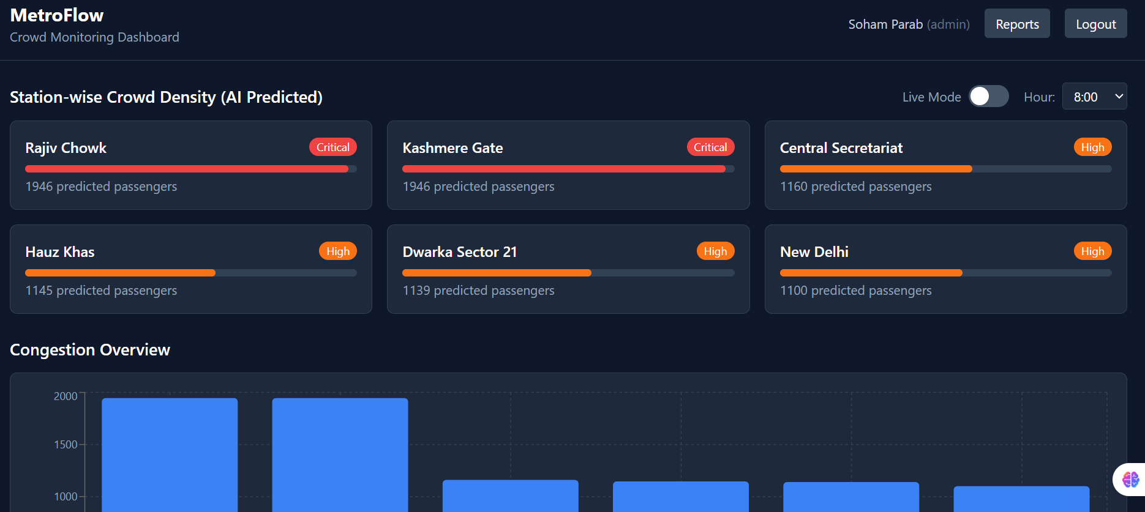
Fig 5. Milestone 4 — Fully containerized MetroFlow dashboard running via Docker Compose
Consolidated API Reference
Method | Endpoint | Description | Access
POST | /auth/register | Register a new user | Public
POST | /auth/login | Log in, returns JWT | Public
GET | /operators/me | Get own profile | Authenticated
GET | /operators/ | List all operators | Admin only
PATCH | /operators/{id}/deactivate | Deactivate an operator | Admin only
POST | /scheduling/trains | Create a train | Admin only
GET | /scheduling/trains | List trains | Authenticated
POST | /scheduling/schedules | Create a schedule | Admin only
GET | /scheduling/schedules | List/filter schedules | Authenticated
PATCH | .../adjust-frequency | Adjust frequency by live density | Admin only
PATCH | .../live-update | Push a live delay/status update | Admin only
GET | /predictions/crowd | Predict demand for station/hour | Authenticated
GET | /monitoring/status | Live status + overcrowding alerts | Authenticated
GET | /reports/traffic-summary | Full traffic analysis report | Authenticated
GET | /reports/congestion-heatmap | Station × hour heatmap data | Authenticated
GET | /reports/ai-insights | AI insights and recommendations | Authenticated
POST | /alerts/ | Create an alert | Admin only
GET | /alerts/ | List alerts | Authenticated
PATCH | /alerts/{id}/resolve | Resolve an alert | Admin only
POST | /alerts/emergency | Broadcast an emergency | Admin only
Overall Evaluation Criteria — All Milestones
Milestone 1
- Project initialization and architecture setup completed
- Authentication and operator management implemented
- Crowd monitoring dashboard functional
- System design and UI planning completed
- Data preparation, cleaning, and EDA completed with verified findings
Milestone 2
- Train scheduling workflows implemented
- AI prediction and forecasting system functional
- Traffic analysis reports generated
- Real-time monitoring integrated
Milestone 3
- Notification and alert system implemented
- Analytics dashboard and congestion heatmaps functional
- Operational reporting workflows working
- AI insights and recommendations integrated
Milestone 4
- Fully deployed frontend and backend
- Testing and validation completed
- Documentation and presentation prepared
- Successful end-to-end platform demonstration completed
Conclusion
MetroFlow, as delivered across all four milestones, is a complete, tested, and containerized AI-powered metro crowd management and scheduling platform. It demonstrates secure authentication and role-based access, rule-based and AI-driven scheduling optimization, a genuinely predictive crowd demand model built on carefully verified and honestly-labeled data, real-time operational monitoring with alerting, actionable analytics, and a fully reproducible Docker-based deployment — all backed by an automated test suite and complete documentation for every stage of development.
Submitted by
Soham Parab

