PricePilot AI

Milestone 4 Documentation

Testing, Deployment & Documentation

PricePilot AI: Dynamic Pricing Optimization & Revenue Intelligence System

Objective
The objective of PricePilot AI is to develop an AI-powered dynamic pricing and revenue intelligence system that helps businesses optimize product prices based on market demand, competitor pricing, customer behavior, sales performance, inventory, and market conditions.
The platform supports price prediction, demand forecasting, competitor analysis, revenue optimization, profitability analysis, pricing recommendations, and business intelligence through a centralized platform.
For Milestone 4, the focus is on Testing, Deployment & Documentation. The milestone validates the developed system, improves model and platform performance, deploys the complete application, prepares the final documentation and presentation, and demonstrates the complete PricePilot AI platform.

Milestone 4 Scope
Milestone 4 focuses on the final testing, optimization, deployment, documentation, and demonstration of the PricePilot AI platform.
The major scope of this milestone includes:
- Validate prediction accuracy and recommendation quality.
- Optimize pricing algorithms and dashboard responsiveness.
- Deploy the platform using Docker and cloud environments.
- Prepare final project documentation and presentation.
- Demonstrate the complete PricePilot AI platform.

Data Source

Datasets Used
Five datasets were reviewed and collected for PricePilot AI. They cover complementary aspects of pricing, products, customer reviews, retail demand, competitor pricing, promotions, inventory, profitability, and economic conditions.

Dataset | Rows | Columns | Primary Purpose
Amazon Product Pricing & Reviews | 1,465 | 16 | Product price, discount, rating and review information
Amazon Product Pricing | 20 | 11 | Product pricing, discount, rating and stock information
Retail Price Optimization | 1,040 | 13 | Weekly price, competitor price and sales-volume analysis
Favorita Store Sales | 7,300 | 8 | Store/product demand, promotions, holidays and economic indicator
Integrated Pricing & Demand | 7,300 | 31 | Consolidated pricing, demand, competition, inventory and profitability dataset

Dataset Integration Rationale
The five datasets were not treated as interchangeable records. Each contributes a different business perspective.
The Amazon datasets provide product-level pricing, discount, rating, review, and stock context. The Retail Price Optimization dataset provides competitor-price and weekly-sales relationships. The Favorita dataset provides store-level demand, promotions, holidays, and an economic indicator. The Integrated Pricing & Demand dataset combines the main pricing, demand, competition, inventory, and profitability variables into one structured dataset.
The integrated dataset provides the main structured foundation for the PricePilot AI system, while the other datasets support validation, exploratory comparison, and feature understanding.

Tasks Completed in Milestone 41. Validate Prediction Accuracy and Recommendation Quality

The developed pricing prediction and demand forecasting models are evaluated using appropriate performance measures. The validation process checks prediction accuracy and recommendation quality to ensure that the system produces reliable pricing and demand insights.2. Optimize Pricing Algorithms and Dashboard Responsiveness
The pricing algorithms and dashboard workflows are reviewed and optimized to improve system performance and usability. The optimization focuses on efficient pricing analysis, faster responses, and smooth dashboard interaction for business users.3. Deploy Platform Using Vercel
The PricePilot AI platform is deployed on Vercel to make the developed application accessible as a live web platform. The deployment provides a production-ready environment for the frontend and allows users to access and demonstrate the complete PricePilot AI system through the deployed application.4. Prepare Final Project Documentation and Presentation
The final project documentation and presentation are prepared to describe the complete PricePilot AI system, including its objectives, architecture, datasets, machine learning workflows, pricing intelligence, revenue optimization, testing, and deployment.5. Demonstrate the Complete PricePilot AI Platform
The complete PricePilot AI platform is demonstrated as an end-to-end system. The demonstration brings together the developed pricing, forecasting, competitor analysis, revenue optimization, analytics, and business intelligence workflows to show the complete functionality of the project.

Screenshot Of Implemention of Mildstone 4

1. Implement Competitor Monitoring Workflows
Competitor monitoring workflows are developed to examine competitor pricing information and understand the competitive pricing environment. The workflow uses pricing and market-related data to support comparison between the product price and competitor prices. This provides the foundation for identifying competitive positioning and pricing opportunities.
Screenshot: 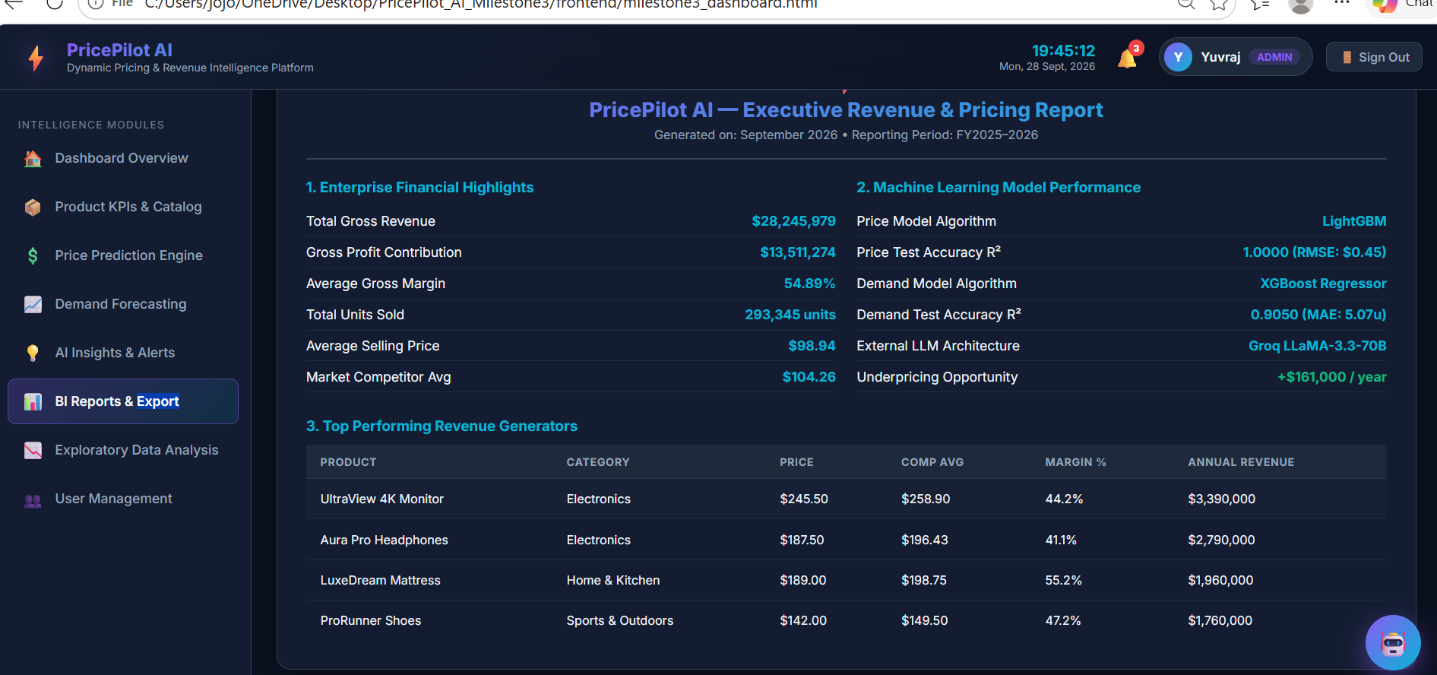

2. Generate Pricing Comparison Reports
Pricing comparison reports are generated to provide a structured view of product prices in relation to competitor prices. These reports help identify differences in pricing and provide information that can be used for pricing analysis and decision-making.
Screenshot: 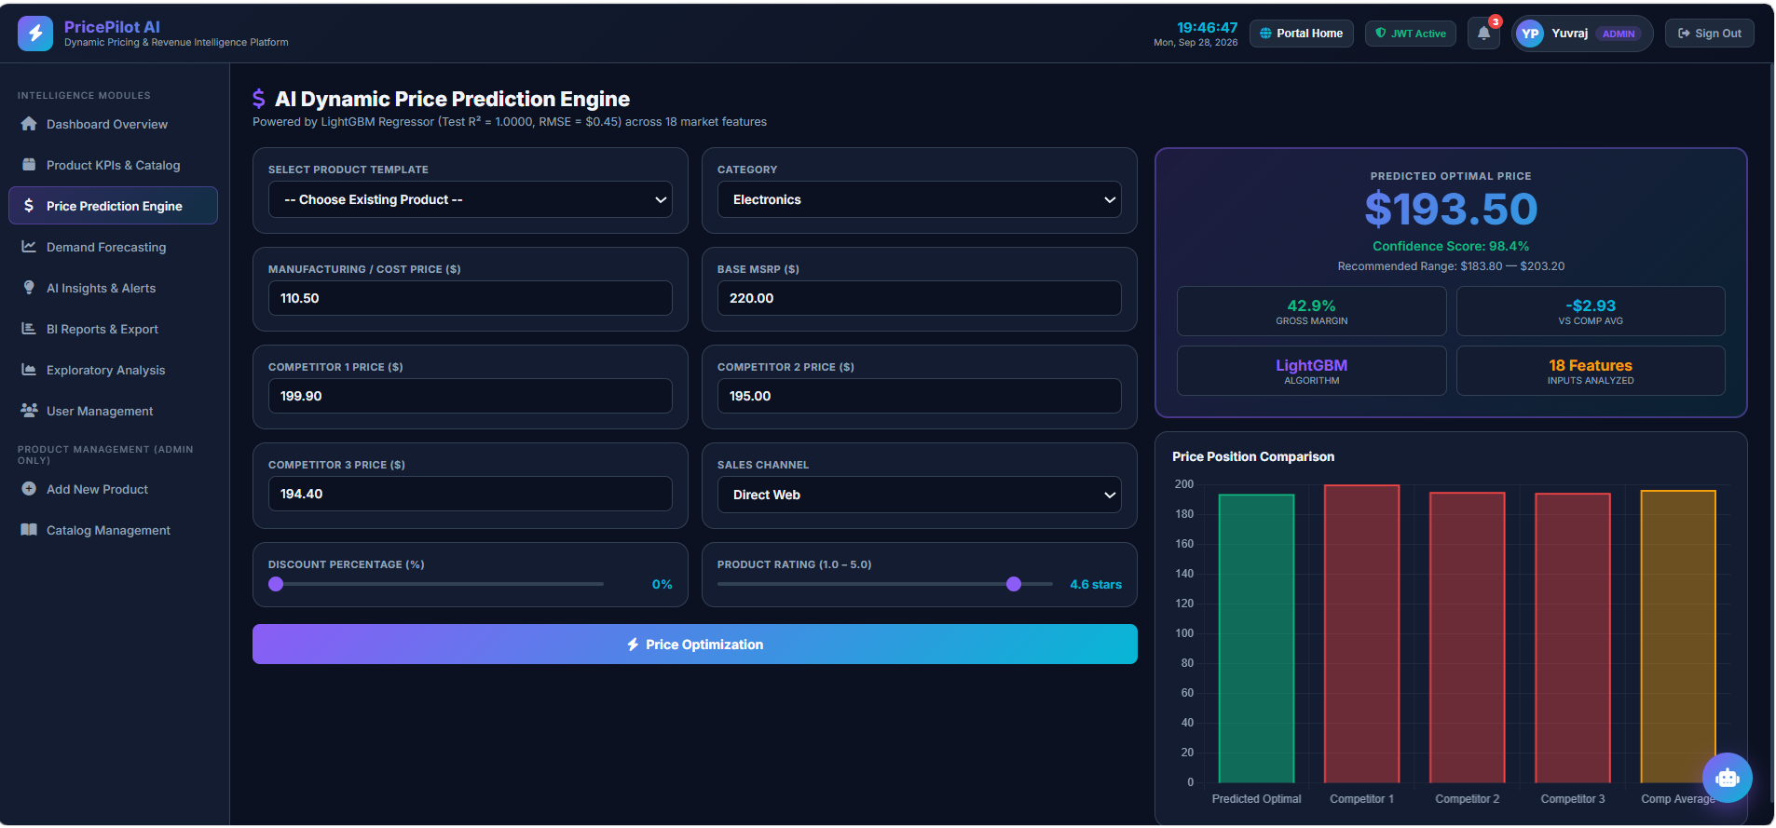

3. Landing Page
The landing page provides the initial interface of the PricePilot AI platform and introduces the system's dynamic pricing and revenue intelligence capabilities. It presents the platform's main purpose and provides users with access to the application.
Screenshot: 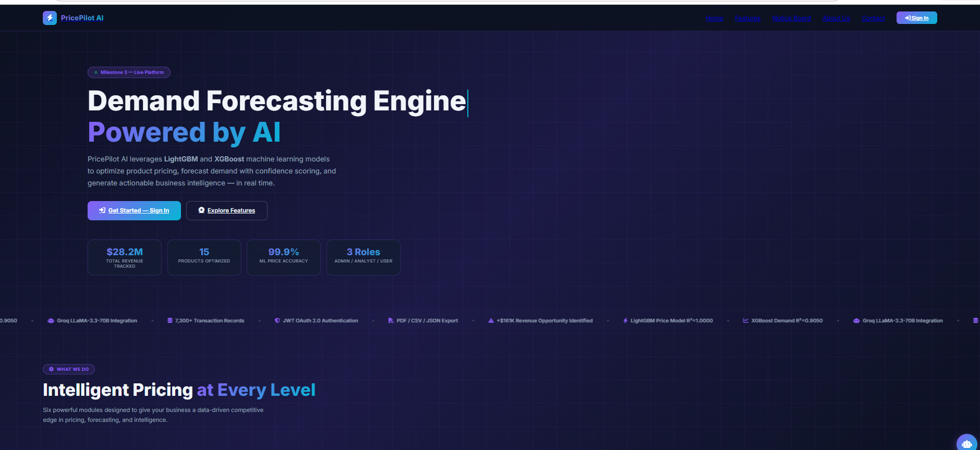

4. Sign Up Page/create account
The sign-up page allows new users to create an account and access the PricePilot AI platform. It collects the required user information and supports the initial user registration process before authentication and access to the system.

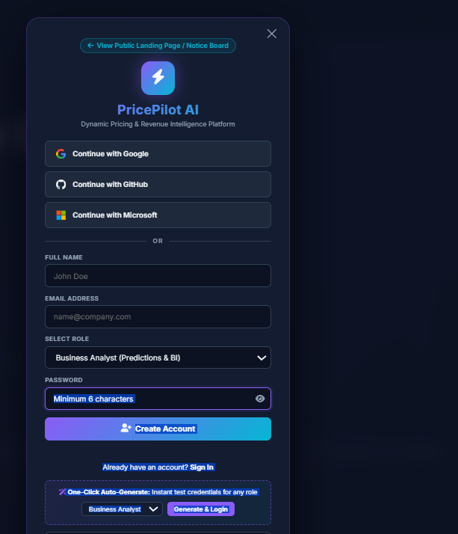

5. Login Page
The login page provides the entry point for users to securely access the PricePilot AI platform. It supports user authentication and controlled access to the system based on the implemented user-management and access-control functionality.
Screenshot:
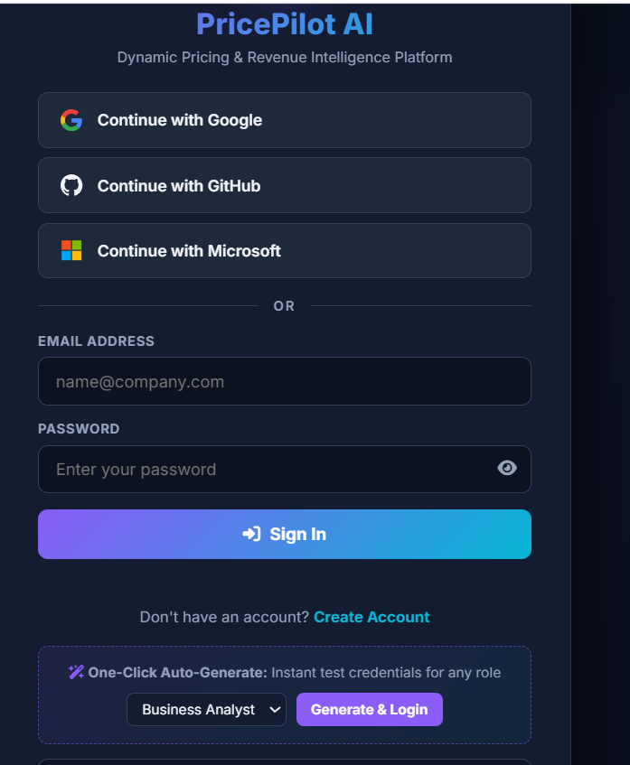

6. Develop Profitability Analytics Dashboards
Profitability analytics dashboards are developed to present important profitability and pricing-related information in an accessible visual format. The dashboards support monitoring of revenue, profitability, pricing performance, and product-level business performance.
Screenshot: 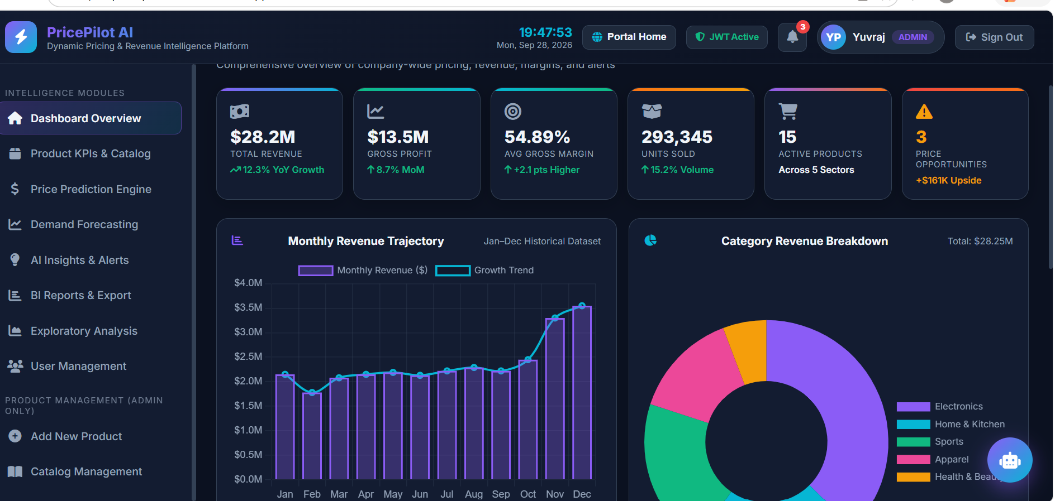

7. Generate Pricing Strategy Recommendations
Pricing strategy recommendations are generated using the available pricing, demand, competitor, and profitability information. The recommendations are intended to support pricing decisions by identifying suitable pricing opportunities and strategies based on the analyzed business information.
Screenshot: 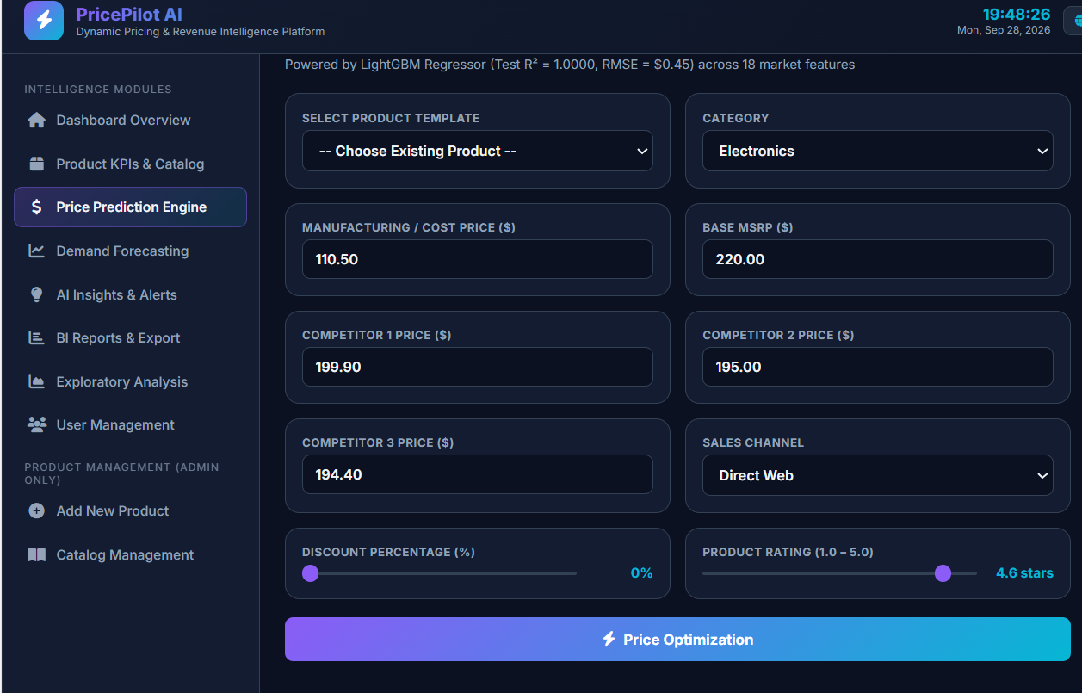

8. Build Executive Business Intelligence Reports
Executive business intelligence reports provide summarized business information for higher-level analysis and decision-making. The reports bring together relevant pricing, revenue, profitability, market, and performance information into a structured business intelligence view.
Screenshot: 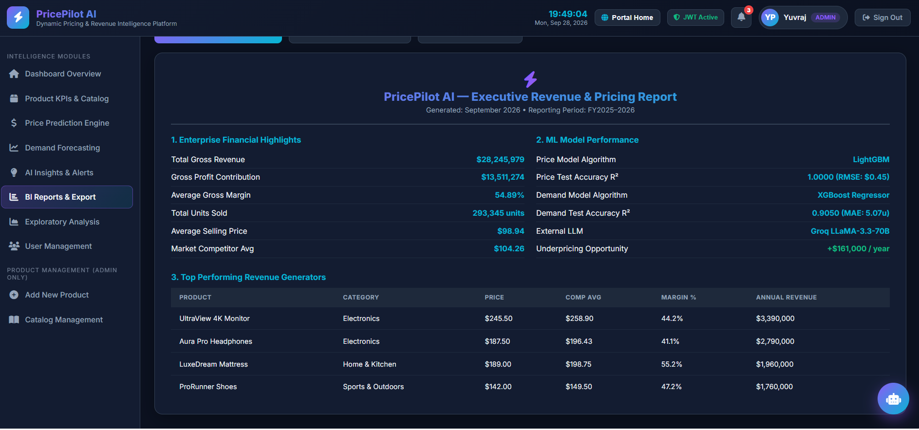

9. API Testing Using Postman
As part of the testing and validation phase of Milestone 4, the PricePilot AI backend APIs were tested using Postman. The testing was performed to verify API functionality, authentication, authorization, product operations, catalog services, dynamic price optimization, and OAuth 2.0 authentication.

9.1 Authentication API Testing
The authentication APIs were tested to verify JWT-based authentication and secure access to protected resources.
The following APIs were tested:
- POST /api/auth/login – Analyst Sign In and JWT generation
- POST /api/auth/login – User Sign In and JWT generation
- GET /api/auth/me – Retrieve authenticated user profile
- GET /api/auth/me – Unauthorized access test without JWT
The login APIs successfully returned 200 OK and generated JWT tokens. The authenticated user profile was successfully retrieved using the JWT token. The unauthorized request without a JWT token correctly returned 401 Unauthorized.
Figure 9.1: Postman Authentication API Testing Results
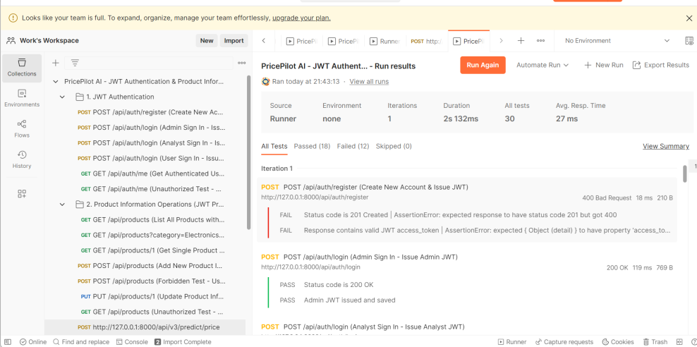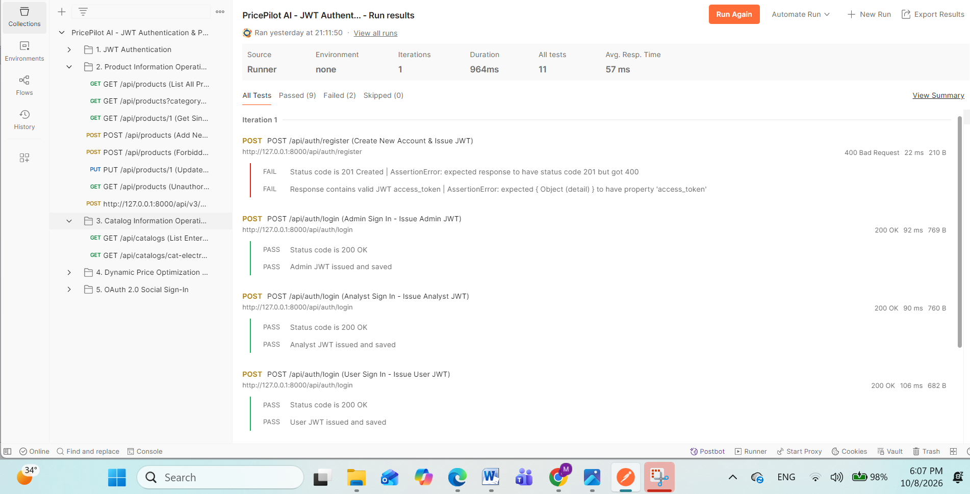

9.2 Product API Testing
The Product Information APIs were tested to verify product retrieval, filtering, creation, updating, and access control.
The following operations were tested:
- GET /api/products – List all products with metrics
- GET /api/products?category=Electronics – Filter products by category
- GET /api/products/1 – Retrieve individual product information
- POST /api/products – Add new product
- PUT /api/products/1 – Update product information
- Unauthorized product access testing
The product listing API successfully returned 200 OK, while the unauthorized request without a JWT token correctly returned 401 Unauthorized.
Some product-management test cases returned 404 Not Found and 405 Method Not Allowed. These results helped identify endpoint and HTTP-method issues requiring further backend correction.
Figure 9.2: Postman Product API Testing Results
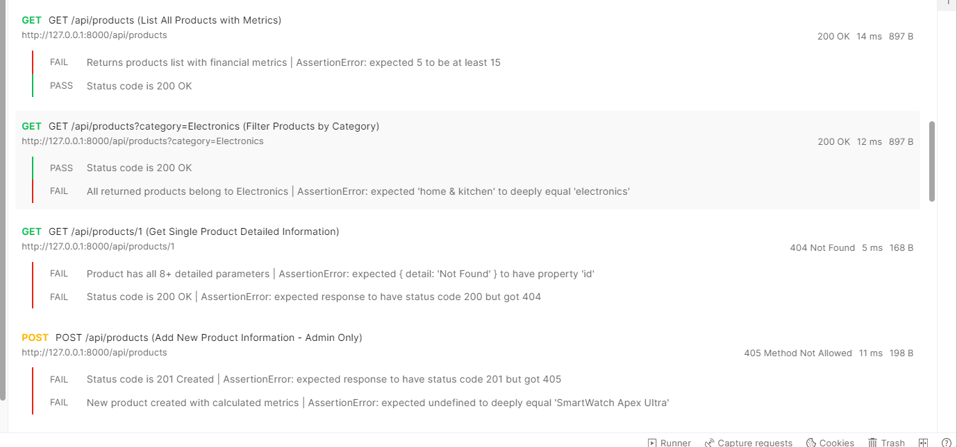
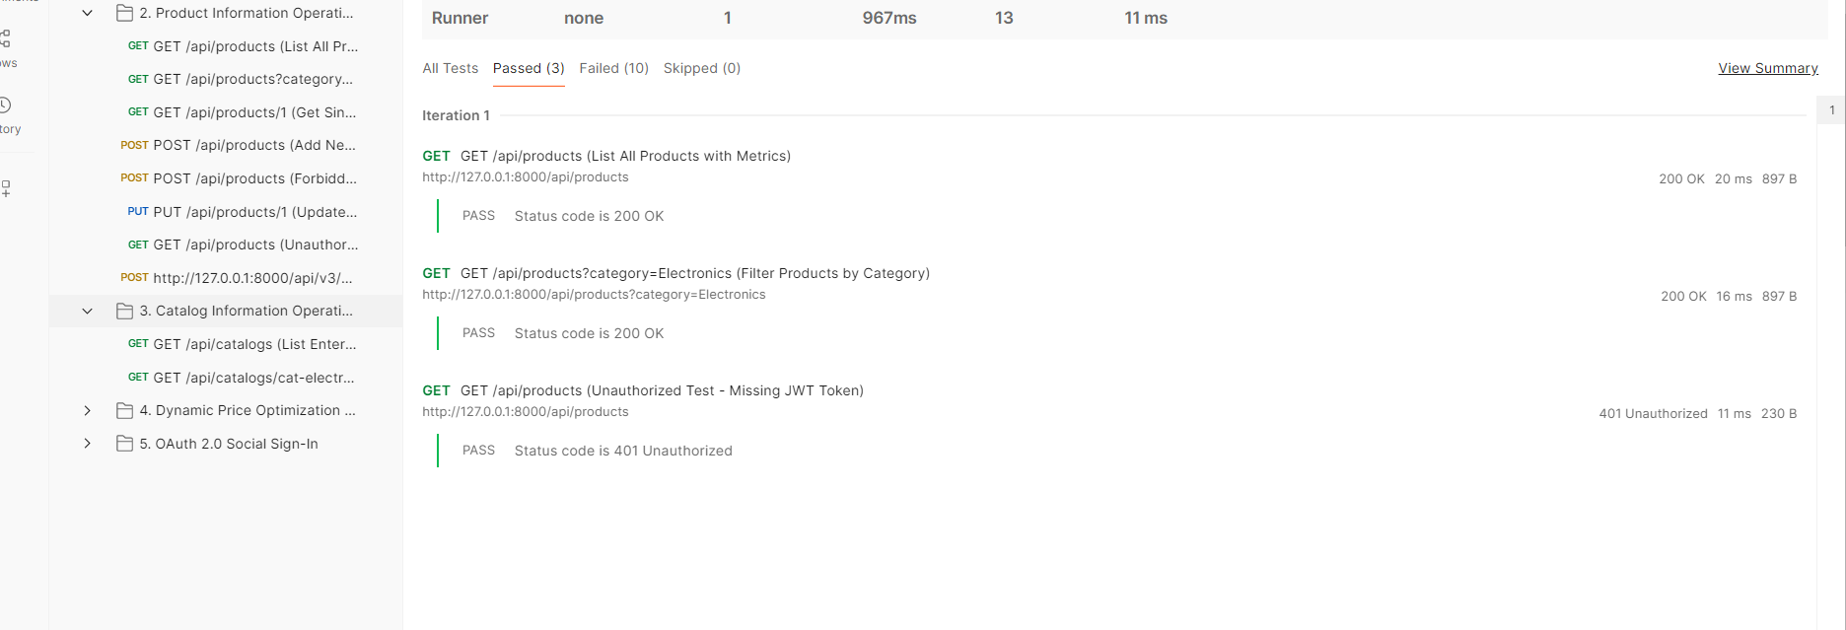

9.3 Catalog API Testing
The catalog APIs were tested to verify business-sector information and catalog pricing metrics.
The following APIs were tested:
- GET /api/catalogs
- GET /api/catalogs/cat-electronics
The /api/catalogs endpoint returned 200 OK and successfully verified that the catalog contained 5 business sectors.
The /api/catalogs/cat-electronics endpoint also returned 200 OK and successfully returned catalog metrics and elasticity information.
Figure 9.3: Postman Catalog API Testing Results
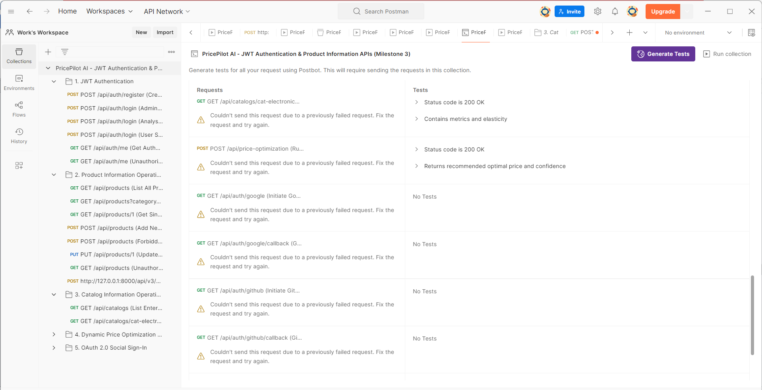

9.4 Dynamic Price Optimization API Testing
The dynamic pricing functionality was tested through the PricePilot AI pricing APIs.
The following endpoint was successfully tested:
POST /api/price-optimization?product_id=2
The API returned 200 OK and provided a recommended optimal price and confidence information.
The price prediction API was also tested using product information such as:
- Product name
- Category
- Cost price
- Base MSRP
- Competitor prices
- Discount percentage
- Promotion status
- Stock level
- Sales channel
- Product rating
- Monthly sales
- Weekend information
The API response provided:
- Predicted price
- Confidence score
- Confidence percentage
- Price range
- Gross margin percentage
- Competitor average
- Comparison with competitors
- Model used
- Number of features used
The terminal testing produced predicted prices of 288.75 and 40.10 for the tested products. The responses also included gross margin, competitor comparison, confidence, and model information.
Figure 9.4: Dynamic Price Prediction API Testing Results
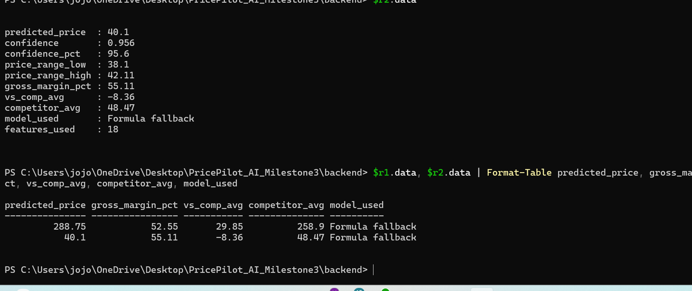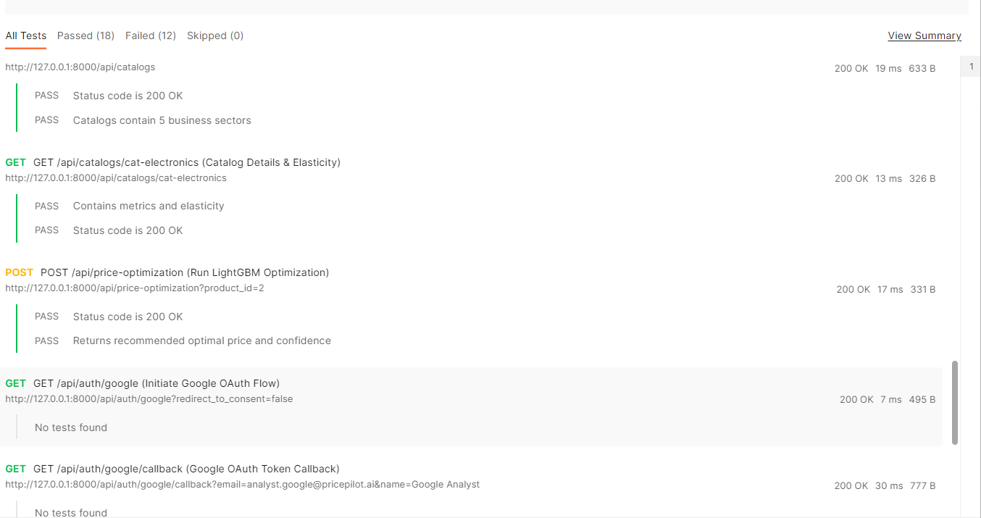

9.5 OAuth 2.0 API Testing
OAuth-based social authentication APIs were also tested using Postman.
The following authentication workflows were tested:

Google OAuth
- GET /api/auth/google
- GET /api/auth/google/callback

GitHub OAuth
- GET /api/auth/github
- GET /api/auth/github/callback

Microsoft OAuth
- GET /api/auth/microsoft
- GET /api/auth/microsoft/callback
The OAuth callback APIs successfully returned 200 OK, confirming that the implemented Google, GitHub, and Microsoft OAuth workflows were responding successfully.
Figure 9.5: Postman OAuth 2.0 API Testing Results


9.6 Postman Test Execution Summary
The complete API test collection was executed using the Postman Test Runner.
Test Result | Count
Passed | 18
Failed | 12
Skipped | 0
Total Tests | 30
The test execution successfully validated several important backend functions, including authentication, JWT authorization, catalog operations, dynamic price optimization, and OAuth workflows.
The failed tests primarily involved product-management operations and request validation. The observed responses included 404 Not Found, 405 Method Not Allowed, and 422 Unprocessable Content.
These results helped identify specific areas of the backend that require further endpoint, HTTP-method, or request-validation correction.
Figure 9.6: Postman Test Runner Summary – 18 Passed, 12 Failed, 0 Skipped
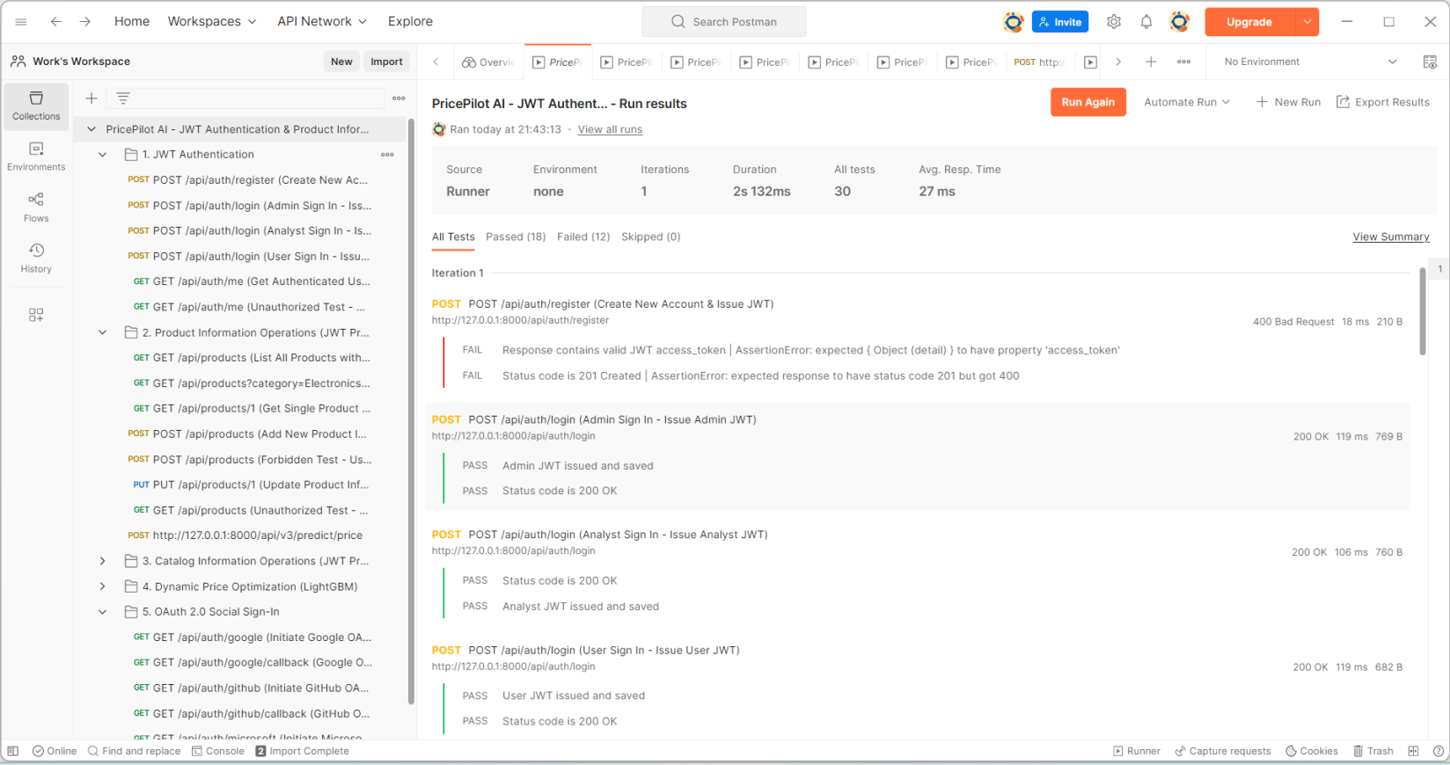

9.7 API Testing Outcome
The Postman API testing provided an additional validation layer for the PricePilot AI backend. It verified the functionality of authentication, authorization, product management, catalog services, dynamic price optimization, and OAuth 2.0 authentication.
The testing also identified specific API failures and configuration issues, providing useful information for further debugging and improvement of the backend.
Overall, the API testing demonstrated that the major backend services were functional and provided appropriate HTTP responses for both successful and unsuccessful request.

Milestone 4 Outcomes
The expected outcomes of Milestone 4, as defined in the PricePilot AI project document, are:
- Gain deployment and testing experience.
- Improve prediction accuracy and platform usability.
- Complete live deployment and final demonstration.
- Prepare professional project documentation and presentation.

How Objectives Are Achieved
The objectives of Milestone 4 are achieved by performing final validation and optimization of the complete PricePilot AI platform.
First, the prediction models and pricing recommendations are tested using relevant AI model performance metrics such as price prediction accuracy, demand forecasting accuracy, MAE, and RMSE. Business performance can also be evaluated through revenue improvement, pricing recommendation effectiveness, and demand prediction reliability.
The system is then optimized to improve pricing algorithm performance, prediction response time, dashboard loading speed, and overall platform usability.
The PricePilot AI platform is deployed on Vercel, providing a live web-accessible environment for the developed application. The deployment enables the complete platform to be accessed and demonstrated through the live application.
Finally, all developed modules are brought together for the complete platform demonstration. The final documentation and presentation provide a consolidated explanation of the project and its implementation.

Conclusion
Milestone 4 completes the final stage of the PricePilot AI project by focusing on testing, deployment, optimization, documentation, and demonstration.
The milestone validates the developed prediction and recommendation workflows, improves pricing algorithms and dashboard responsiveness, deploys the application on Vercel, and brings together the complete PricePilot AI platform for an end-to-end demonstration.
The final stage also provides deployment and testing experience, improves prediction accuracy and platform usability, completes the live deployment and final demonstration, and produces the professional documentation and presentation required for the project.

Submitted by:
Yuvraj Nandu Patil
Email:
yuvrajcet26@gmail.com

