PricePilot AI
Title: PricePilot AI: Dynamic Pricing Optimization & Revenue Intelligence System
Milestone-2 (Machine Learning, Price Intelligence, Backend & Database Implementation)

Project Objective

The objective of PricePilot AI is to build an AI-powered dynamic pricing and revenue intelligence platform that helps businesses make data-driven pricing decisions using demand patterns, product information, inventory conditions, competitor pricing, promotions, and historical sales data.
Following the successful completion of Milestone 1 (EDA part), Milestone 2 focused on transforming the prepared dataset and system architecture into an operational Machine Learning and backend intelligence layer.
The major objectives of Milestone 2 were:
- Develop demand prediction models
- Compare multiple Machine Learning algorithms
- Perform model evaluation and optimization
- Select the best-performing model
- Experiment with deep learning using LSTM
- Perform time-series feature experiments
- Build the backend API architecture
- Configure PostgreSQL database
- Implement database migrations using Alembic
- Implement authentication and authorization
- Implement product, inventory and competitor management APIs
- Implement pricing and recommendation APIs
- Integrate AI-powered endpoints
- Prepare the system for ML inference and pricing intelligence

The Milestone 2 implementation follows the project requirement of developing price prediction, demand forecasting, pricing recommendation and AI-powered pricing intelligence workflows.

Step 1: Machine Learning Environment Setup
The Machine Learning environment was configured using Python and the required data science and ML libraries.
Technologies Used
- Python
- Pandas
- NumPy
- Matplotlib
- Seaborn
- Scikit-learn
- XGBoost
- TensorFlow
- Keras
- Google Colab
- VS Code
The ML pipeline was developed separately from the application backend so that the trained model, preprocessing pipeline and inference layer can later be integrated into the FastAPI application.

Step 2: Dataset Preparation for Machine Learning
The cleaned dataset prepared during Milestone 1 was used for Machine Learning development.
The dataset contained:
- 76,000 records
- 25 engineered columns after preprocessing and feature engineering
- Historical sales information
- Product information
- Pricing information
- Competitor pricing
- Inventory information
- Promotion information
- Seasonal information
- Epidemic indicator
- Date-based features
The target variable selected for the main ML task was:
Target Variable: Demand
The reason for selecting Demand as the primary ML target was that demand prediction provides the foundation for pricing intelligence.
The system can first estimate expected demand and subsequently use that prediction within pricing and revenue optimization workflows.

Step 3: Feature Engineering
Additional features were created to improve the ability of the models to understand pricing, competitive and temporal patterns.
Date Features

df['Year'] = df['Date'].dt.year
df['Month'] = df['Date'].dt.month
df['Day'] = df['Date'].dt.day
A
Additional temporal features were created:
- Day of Week
- Quarter
- Week of Year
- Month Sin
- Month Cos
- Day of Week Sin
- Day of Week Cos
These features allow the model to capture periodic and seasonal patterns.

Competitive Pricing Features
A major feature for the PricePilot AI system was the difference between the company's price and competitor pricing.
df['Price Difference'] = (
df['Price'] - df['Competitor Pricing']
)
Additional competitive features included:
- Price Difference
- Relative Price Difference
- Relative Price Difference %
- Price Position
The Price Position feature helps identify whether the company's product is:
- Cheaper
- Similar
- More expensive
These features are particularly relevant to the project's competitive pricing intelligence requirements.

Step 4: Machine Learning Feature Selection
The final ML feature set contained 26 features.
Categorical Features
- Store ID
- Product ID
- Category
- Region
- Weather Condition
- Seasonality
- Price Position
Numerical Features
- Inventory Level
- Units Ordered
- Price
- Discount
- Promotion
- Competitor Pricing
- Epidemic
- Year
- Month
- Day
- Price Difference
- Relative Price Difference
- Day of Week
- Quarter
- Week of Year
- Month Sin
- Month Cos
- DayOfWeek Sin
- DayOfWeek Cos
Excluded Variables
The following variables were excluded from the main prediction features:
- Date
- Demand
- Units Sold
- Revenue
- Inventory Group
- Relative Price Difference %
Units Sold and Revenue were excluded because they represent outcomes associated with the observed demand/sales period and could introduce target leakage when used for forecasting.

Step 5: Preprocessing Pipeline
A Scikit-learn preprocessing pipeline was implemented.
Numerical Data
Numerical variables were standardized using:
StandardScaler()
Categorical Data
Categorical variables were converted using:
OneHotEncoder(
handle_unknown='ignore'
)
ColumnTransformer
The preprocessing process was combined using ColumnTransformer.
The resulting pipeline provides consistent transformations between:
- Training
- Validation
- Testing
- Future inference
This is important because the same preprocessing logic must be applied when the model is eventually called through the backend API.

Step 6: Chronological Train, Validation and Test Split
Since the project deals with historical business data, a chronological split was used instead of random splitting.
Dataset Split

Dataset | Records | Time Period
Training | 53,200 | 2022-01-01 → 2023-06-16
Validation | 11,400 | 2023-06-17 → 2023-10-08
Testing | 11,400 | 2023-10-09 → 2024-01-30

This prevents future observations from being randomly mixed into the training data.
The test dataset was kept as a held-out evaluation period.

Step 7: Machine Learning Models
Multiple regression models were evaluated to identify the most suitable model for demand prediction.
The following models were tested:
- Linear Regression
- Ridge Regression
- Lasso Regression
- Decision Tree Regressor
- Optimized Decision Tree
- Random Forest Regressor
- XGBoost Regressor
- LSTM Neural Network
This model progression allowed both simple linear models and advanced nonlinear models to be compared.

Step 8: Linear Regression
Linear Regression was implemented as the initial baseline model.
Validation Results
Metric | Result
MAE | 25.59
RMSE | 33.39
R² | 0.5201
MAPE | 31.48%
The model explained approximately 52.01% of the variance in demand.
The results showed that a simple linear relationship was not sufficient to capture all the complex relationships present in the dataset.
Therefore, nonlinear models were investigated.

Step 9: Ridge and Lasso Regression
Regularized linear models were evaluated to determine whether controlling model complexity could improve the baseline.
Ridge Regression
Metric | Result
MAE | 25.22
RMSE | 32.91
R² | 0.5337
MAPE | 30.73%
Lasso Regression
Metric | Result
MAE | 25.22
RMSE | 32.91
R² | 0.5337
MAPE | 30.73%
Both models provided a small improvement over standard Linear Regression.
However, the improvement was limited, indicating that regularization alone could not capture the nonlinear relationships in demand.

Step 10: Decision Tree Regression
A Decision Tree Regressor was implemented to capture nonlinear feature interactions.
Initial Validation Results
Metric | Result
MAE | 21.87
RMSE | 32.87
R² | 0.5350
MAPE | 23.92%
The initial model showed strong training performance but significant overfitting.
Therefore, tree parameters were optimized.
Optimized Decision Tree
Metric | Result
MAE | 21.46
RMSE | 29.91
R² | 0.6149
MAPE | 25.69%
The optimized tree reduced overfitting and improved generalization.

Step 11: Random Forest Regression
Random Forest was then evaluated as an ensemble tree-based model.
Validation Results
Metric | Result
MAE | 20.32
RMSE | 27.83
R² | 0.6666
MAPE | 25.18%
The Random Forest model substantially improved upon the linear and single-tree models.
A controlled GridSearchCV experiment was also performed to identify better hyperparameters.
The selected configuration included:
n_estimators = 200
max_depth = None
max_features = sqrt
min_samples_split = 2
min_samples_leaf = 1
Random Forest provided a strong baseline for nonlinear demand prediction, but XGBoost performed better.

Step 12: XGBoost Regression
XGBoost was selected as the primary advanced Machine Learning algorithm because the dataset contains complex nonlinear relationships between:
- Price
- Demand
- Competitor pricing
- Product
- Store
- Category
- Promotion
- Inventory
- Seasonality
XGBoost is capable of learning these nonlinear relationships and feature interactions.

Step 13: XGBoost Hyperparameter Optimization
Several controlled configurations were tested.
The best validation configuration was:
XGBRegressor(
n_estimators=500,
learning_rate=0.05,
max_depth=6,
subsample=0.8,
colsample_bytree=0.8,
objective="reg:squarederror",
random_state=42
)
Best Validation Performance
Metric | Result
MAE | 14.01
RMSE | 19.96
R² | 0.8285
MAPE | 17.45%
The model was selected using validation performance before final evaluation on the untouched test period.
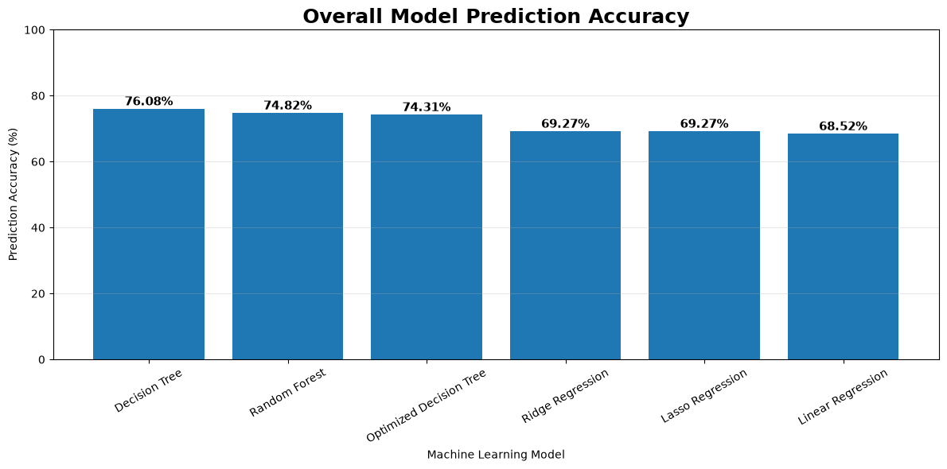

Step 14: Final XGBoost Model Evaluation
After model selection, the final XGBoost model was evaluated on the held-out test dataset.
Final Results
Dataset | MAE | RMSE | R² | MAPE
Training | 11.61 | 16.15 | 0.8809 | 16.19%
Validation | 14.01 | 19.96 | 0.8285 | 17.45%
Test | 12.43 | 17.24 | 0.8527 | 18.94%
The final model achieved:
R² = 0.8527
on the held-out test dataset.
This means that approximately 85.27% of the variance in the target demand was explained under the evaluation setup.
It should not be interpreted as 85.27% individual prediction accuracy.

Step 15: Model Comparison
The major model development results are summarized below.
Model | MAE | RMSE | R² | MAPE
Linear Regression | 25.59 | 33.39 | 0.5201 | 31.48%
Ridge Regression | 25.22 | 32.91 | 0.5337 | 30.73%
Lasso Regression | 25.22 | 32.91 | 0.5337 | 30.73%
Decision Tree | 21.87 | 32.87 | 0.5350 | 23.92%
Optimized Decision Tree | 21.46 | 29.91 | 0.6149 | 25.69%
Random Forest | 20.32 | 27.83 | 0.6666 | 25.18%
Original XGBoost | 16.23 | 22.69 | 0.7784 | 20.27%
Tuned XGBoost | 14.01 | 19.96 | 0.8285 | 17.45%
Final XGBoost Test | 12.43 | 17.24 | 0.8527 | 18.94%
The project documentation records XGBoost as the current best-performing model.

Step 16: LSTM Deep Learning Experiment
LSTM was evaluated because the project specification identifies LSTM as one of the recommended deep-learning approaches for demand forecasting.
Two LSTM experiments were performed.

Initial LSTM
The initial model used a 30-day sequence containing:
- Demand
- Price
- Discount
- Inventory Level
- Units Ordered
- Competitor Pricing
- Promotion
- Epidemic
- Month
- Day of Week
- Month Sin
- Month Cos
Results
Dataset | MAE | RMSE | R² | MAPE
Train | 29.78 | 38.61 | 0.3246 | 42.22%
Validation | 32.46 | 42.22 | 0.2328 | 39.99%
Test | 29.15 | 37.66 | 0.2969 | 44.69%

Step 17: Improved LSTM
A more advanced LSTM architecture was developed using:
- Full engineered feature set
- One-hot encoded features
- Store embeddings
- Product embeddings
- Bidirectional LSTM
- Layer Normalization
- Dropout
- Dense layers
- Huber Loss
- Adam optimizer
- Learning-rate reduction
- Early stopping
The sequence size was:
30 × 39
The model contained approximately:
98,185 trainable parameters
Results
Dataset | MAE | RMSE | R² | MAPE
Train | 28.91 | 38.10 | 0.3424 | 37.95%
Validation | 32.76 | 43.24 | 0.1951 | 37.67%
Test | 29.95 | 38.36 | 0.2705 | 47.25%
The tested LSTM architectures did not outperform XGBoost on the current dataset representation. The primary issue was predictive underperformance rather than severe overfitting.

Step 18: Lag and Rolling Feature Experiment
Additional time-series features were tested to determine whether historical demand information could improve the XGBoost model.
The following features were introduced:
- Demand Lag 1
- Demand Lag 7
- Demand Lag 14
- Demand Lag 30
- Rolling Mean 7
- Rolling Mean 14
- Rolling Mean 30
Shifted historical values were used to avoid directly exposing the current target to the model.
Validation Results
Metric | Result
MAE | 16.68
RMSE | 22.93
R² | 0.7761
MAPE | 21.40%
The experiment performed slightly worse than the selected XGBoost configuration and was therefore not adopted as the final model.

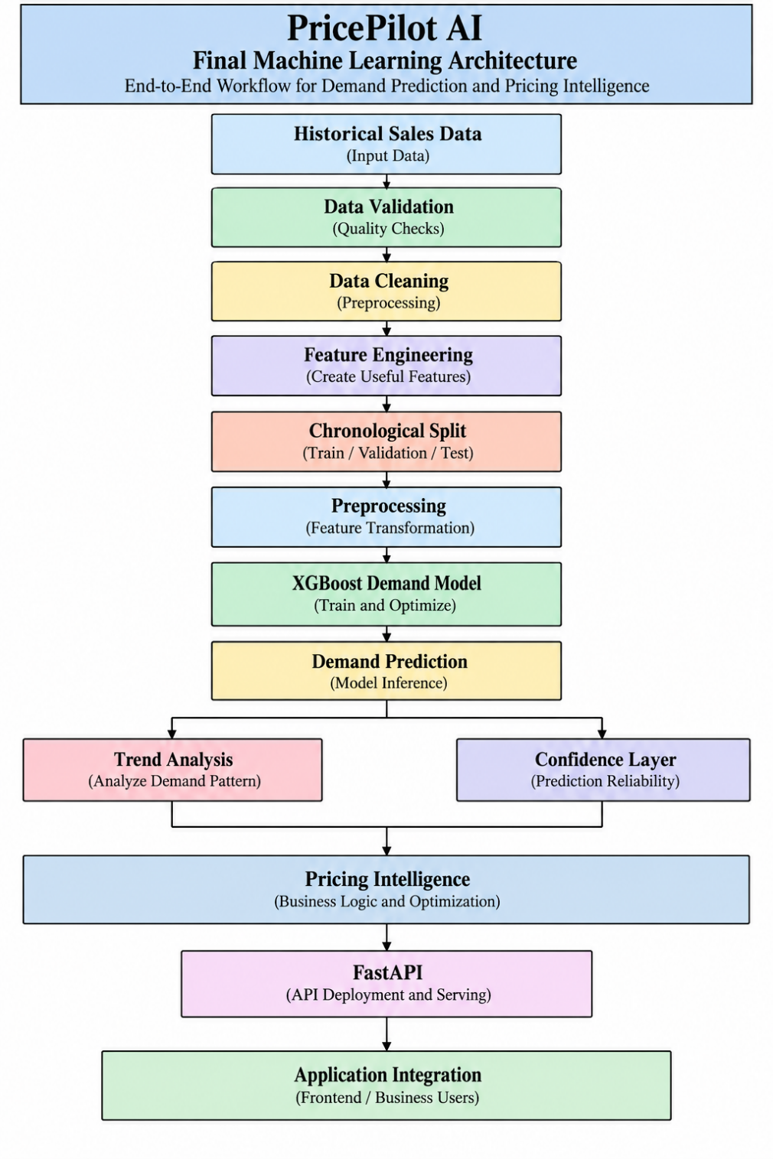

This follows the intended forecasting architecture defined for PricePilot AI.

Step 20: Backend Environment Setup
The backend was implemented using FastAPI.
The backend provides the application layer through which the frontend can communicate with:
- Authentication
- Users
- Organizations
- Products
- Categories
- Inventory
- Competitors
- Pricing
- Sales
- AI services

Step 21: PostgreSQL Database Setup
PostgreSQL was configured as the primary relational database for PricePilot AI.
The database is used to persist:
- User information
- Organizations
- Roles
- Products
- Categories
- Inventory
- Competitors
- Competitor products
- Competitor prices
- Pricing history
- Pricing recommendations
- Sales records
- Authentication information
The database architecture follows a normalized and multi-tenant design.

Step 23: Database Tables Implemented
The PricePilot AI database contains the major entities required for the application.
Authentication and Organization
- organizations
- roles
- users
- user_roles
- organization_members
- refresh_tokens
Product Management
- categories
- products
- product_variants
- inventory
Competitor Intelligence
- competitors
- competitor_products
- competitor_prices
Pricing Intelligence
- price_histories
- pricing_recommendations
Sales
- sales_records
These entities form the data foundation for the pricing intelligence system.
The broader architecture separates organizational data, product information, pricing, sales, inventory and competitor information into related entities.

Step 24: Database Relationship Architecture
The primary logical relationship is:
Organization
|
+---------- Users
|
+---------- Categories
|
+---------- Products
|
+------ Product Variants
|
+------ Inventory
|
+------ Price History
|
+------ Sales Records
|
+------ Pricing Recommendations
|
+------ Competitor Products
|
+------ Competitor Prices
This structure allows product-level business intelligence to be connected with pricing, inventory, sales and competitor information.
The project's ER design follows normalized relational principles and supports multi-user, multi-tenant operation.

Step 25: Authentication and Authorization
A secure authentication system was implemented using:
- Password hashing
- JWT authentication
- Access tokens
- Refresh tokens
- Token expiration
- Role-based authorization
- Organization-level authorization
Plaintext passwords and secrets are not intended to be stored in the database.
The architecture specification explicitly requires password hashing, JWT access tokens, refresh tokens, role-based authorization and organization-level authorization.

Step 26: Backend API Development
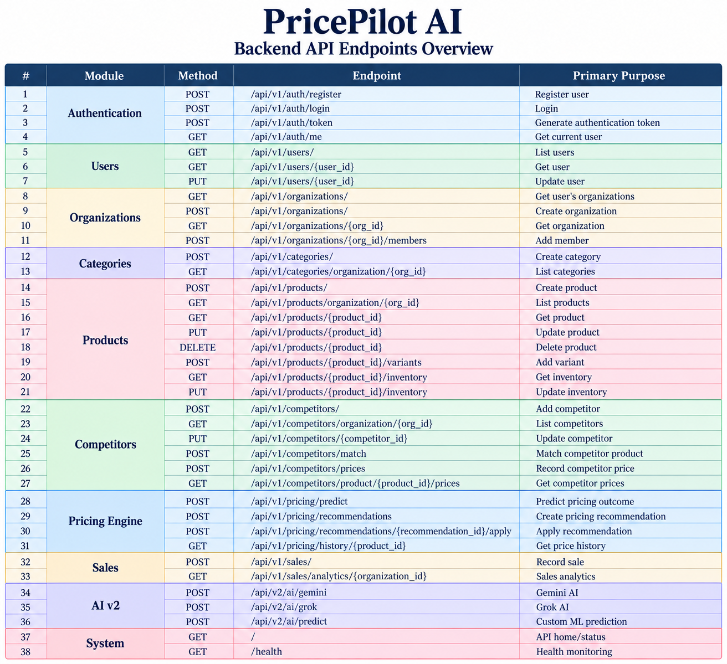

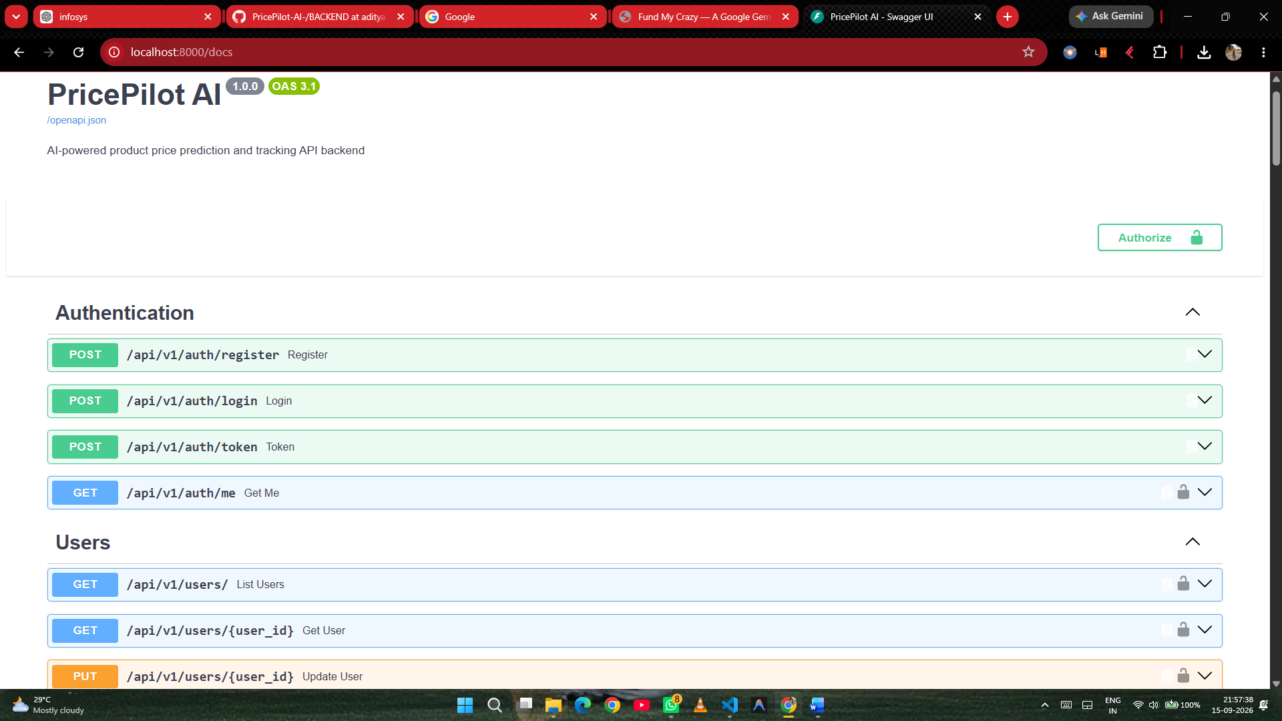
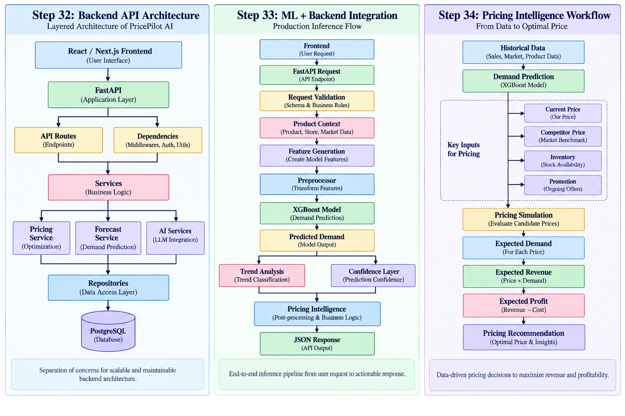

Step 35: Forecasting Horizons
The project specification defines three forecasting horizons.
Short-Term
- 7 days
- 14 days
- 30 days
Use cases:
- Inventory planning
- Daily pricing
- Promotion planning
Medium-Term
- 3 months
- 6 months
Use cases:
- Procurement
- Revenue forecasting
- Capacity planning
Long-Term
- 12 months
Use cases:
- Strategic planning
- Product expansion
- Annual forecasting
These horizons are defined in the PricePilot AI specification.
Important: the current XGBoost model has been rigorously evaluated on the available chronological holdout setup. It should not automatically be described as a validated 12-month forecasting model without separate long-horizon back testing.

Step 36: Demand Trend Classification
The intended forecasting system supports three demand trend categories:
- Increasing Demand
- Stable Demand
- Decreasing Demand
Trend classification can be derived from the slope and behavior of the forecast sequence.
This information can be displayed to business users alongside the numerical demand prediction.

Step 37: Forecast Confidence
The project specification defines a forecast confidence output between:
0% – 100%
Example:
Forecast Confidence = 88%
However, a confidence score should only be exposed as a formal calibrated confidence measure after implementing and validating an appropriate calibration method.
Therefore, confidence reporting is treated as part of the forecasting layer rather than incorrectly deriving it directly from the model's R².

Step 38: Model Overfitting Analysis
The final XGBoost model produced:
Training R² = 0.8809
Validation R² = 0.8285
Test R² = 0.8527
Training-to-validation difference:
0.8809 - 0.8285 = 0.0524
Training-to-test difference:
0.8809 - 0.8527 = 0.0282
The relatively small gaps indicate that the final model does not show severe overfitting under the current evaluation setup.

Step 39: Backend Database and ML Integration
The overall completed architecture can now be represented as:
PRICEPILOT AI
|
+---------------+---------------+
| | |
v v v
Frontend FastAPI ML Intelligence
| | |
| | v
| | XGBoost
| | |
| | Demand Prediction
| | |
| +---------------+
| |
| Pricing Intelligence
| |
+----------- Business Intelligence
|
v
PostgreSQL
The intended architecture connects PostgreSQL, the XGBoost intelligence layer and FastAPI, followed by forecasting, pricing and revenue engines and the frontend business intelligence layer.

Step 40: Technologies Used in Milestone 2
Machine Learning
- Python
- Pandas
- NumPy
- Scikit-learn
- XGBoost
- TensorFlow
- Keras
Backend
- Python
- FastAPI
- Pydantic
- SQLAlchemy
- JWT Authentication
Database
- PostgreSQL
- Alembic
Development
- VS Code
- Google Colab
- Git
- GitHub
- Postman / FastAPI Swagger
The project specification identifies FastAPI, PostgreSQL, Scikit-learn, XGBoost, Random Forest, TensorFlow, Pandas, NumPy and LSTM among the project's technology stack.

Challenges Faced
The following challenges were encountered during Milestone 2:
1. Model Selection
Different algorithms produced significantly different results. Linear models were easier to implement but could not capture the nonlinear structure of the dataset.
2. Overfitting
The initial Decision Tree and ensemble models required careful evaluation to ensure that high training performance was not simply caused by memorization.
3. Computational Cost
Hyperparameter optimization for ensemble models required careful control of:
- Number of estimators
- Tree depth
- Parallel workers
- Search space
4. LSTM Performance
The LSTM models required substantially more complexity but did not outperform the tuned XGBoost model.
5. Time-Series Feature Engineering
Lag and rolling features were tested using shifted historical values to avoid target leakage, but the experiment did not improve validation performance.
6. Backend–ML Integration
The ML pipeline must use exactly the same preprocessing and feature definitions during inference as during training.
7. Database Design
The backend required a structured relational design capable of supporting:
- Multiple organizations
- Multiple users
- Products
- Competitors
- Pricing
- Inventory
- Sales
- Recommendations

Database Schema

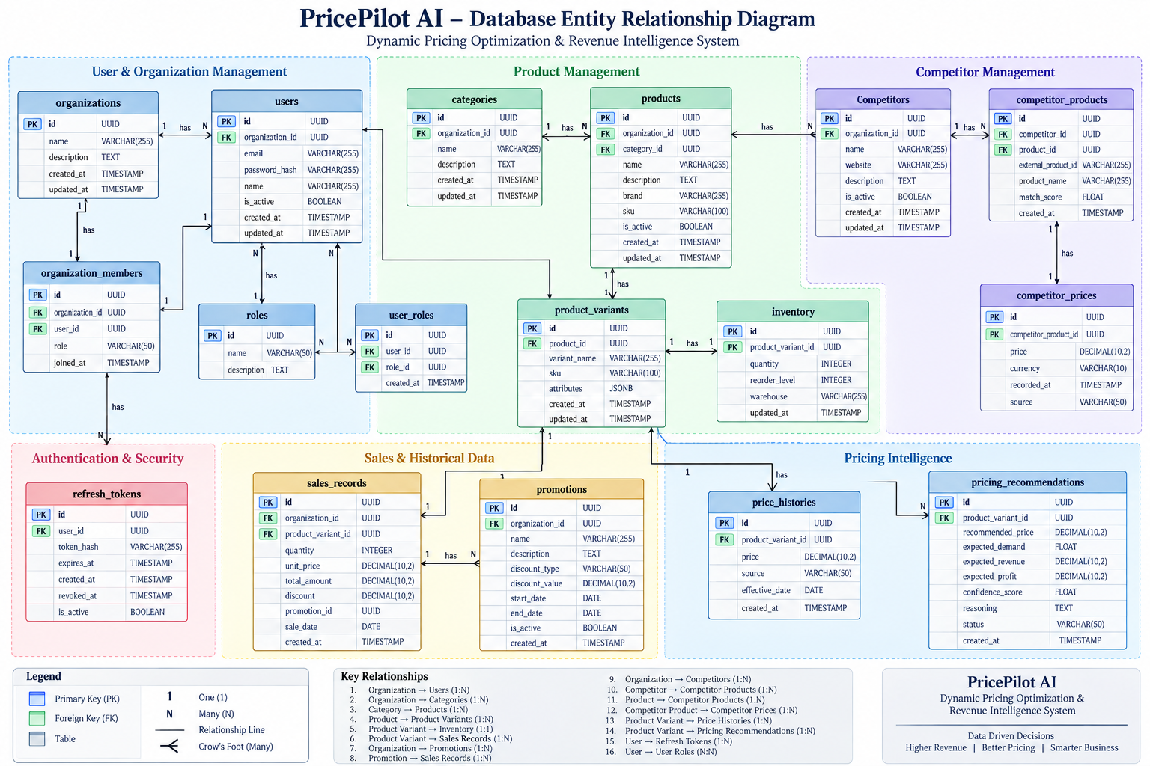

Conclusion
Milestone 2 successfully progressed PricePilot AI from an exploratory data analysis project into an integrated Machine Learning, backend and database system.
Multiple Machine Learning algorithms were implemented and evaluated, including Linear Regression, Ridge, Lasso, Decision Tree, Random Forest, XGBoost and LSTM.
Among the tested approaches, XGBoost demonstrated the strongest predictive performance, achieving an R² of 0.8527 on the held-out test dataset, making it the current primary demand prediction model for the project.
On the software engineering side, a FastAPI backend and PostgreSQL database were established with authentication, organization management, product management, inventory, competitor, pricing, sales and AI functionality.

Submitted By
Aditya Raj Pandey
PricePilot AI: Dynamic Pricing Optimization & Revenue Intelligence System

