PricePilot AI
Dynamic Pricing Optimization & Revenue Intelligence System
Project Documentation
Machine Learning Based Demand Forecasting and Price Optimization
Title
PricePilot AI: Dynamic Pricing Optimization & Revenue Intelligence System.
1. Introduction / Objective
PricePilot AI is a machine-learning based system designed to help an e-commerce/retail business understand product demand and set optimal selling prices. The project combines historical daily sales operations, competitor pricing, customer browsing/purchase activity, and product catalog information to build a demand-prediction model, and then uses that model to recommend the price for each product that maximizes expected profit.
The core objective of the project is twofold: (1) to accurately predict the number of units of a product that will be sold (units_sold) under a given set of price, competitor, and demand conditions, and (2) to use this prediction to search for the selling price that yields the highest expected profit for each product, generating actionable pricing recommendations (Increase Price / Decrease Price / Keep Price).
2. Problem Statement
Retail and e-commerce businesses frequently set prices manually or through simple discounting rules, without fully accounting for competitor pricing, seasonal demand, promotional events, and customer engagement signals (views, cart additions, purchases). This often results in under-priced or over-priced products, leading to lost revenue or lost sales. The problem addressed by PricePilot AI is: given historical operational, competitor, and customer-activity data, can a model reliably forecast product demand at a given price point, and can that forecast be used to systematically recommend a more profitable price?
3. Proposed Solution
PricePilot AI proposes a data-driven pipeline that: (1) integrates four separate data sources (daily operations, competitor prices, customer activity, and product catalog) into a single unified dataset, (2) engineers additional features that capture price competitiveness and customer engagement (price gap, price ratio, cart rate, buy rate), (3) trains and compares two regression models (Random Forest and XGBoost) to predict units_sold, (4) selects the best-performing model based on evaluation metrics, and (5) uses the trained model inside a price-search routine that evaluates a range of candidate prices for each product and selects the price that maximizes predicted profit, producing a final pricing-recommendation table.
4. System / Project Architecture
The system follows a linear data-to-decision pipeline, implemented end-to-end in a single Google Colab notebook. The architecture can be represented as follows:
Raw Data Sources
(Daily Operations, Competitor Prices, Customer Activity, Product Catalog)
↓
Data Cleaning
(Type conversion, duplicate removal, missing-value handling)
↓
Data Integration
(Pivoting customer activity, aggregating competitor prices, merging all sources)
↓
Feature Engineering
(Price gap, price ratio, cart rate, buy rate, profit, date parts, label encoding)
↓
Model Training
(Random Forest Regressor & XGBoost Regressor)
↓
Model Evaluation & Best Model Selection
(MAE, RMSE, R² comparison)
↓
Demand Prediction
(Predicted units_sold, revenue, profit on test data)
↓
Price Optimization Engine
(Searches candidate prices to maximize predicted profit)
↓
Pricing Recommendation Output
(Optimal price, expected demand/revenue/profit, action label)

5. Modules
The implementation is organized into the following functional modules within the notebook:
- Data Ingestion Module: Loads the four raw CSV files (competitor_prices.csv, customer_activity.csv, daily_operations.csv, product_catalog.csv) using pandas.
- Data Cleaning Module: Converts date columns to datetime, removes duplicate rows, and fills missing values in customer activity and competitor price fields.
- Exploratory Data Analysis Module: Generates distribution, relationship, trend, and correlation visualizations.
- Data Integration Module: Pivots customer activity into per-day/per-product engagement counts, aggregates competitor prices, and merges all four sources into one working dataset.
- Feature Engineering Module: Creates derived numerical features and label-encodes categorical columns.
- Model Training Module: Splits data chronologically and trains a Random Forest Regressor and an XGBoost Regressor.
- Model Evaluation Module: Computes MAE, RMSE and R² for both models and selects the best model.
- Prediction Module: Generates predicted demand, revenue and profit for the test set.
- Price Optimization Module: Implements a candidate-price search function (opt) that finds the profit-maximizing price per product and outputs final pricing recommendations.
6. Dataset Description
Four datasets were used, loaded directly as CSV files in the Colab environment:
Dataset | Variable | Shape (rows, cols) | Description
daily_operations.csv | do | 43,245 x 26 | Day-level, per-product sales operations: pricing, discounts, units sold, revenue, stock, channel, warehouse, holiday/festival/promotional flags, competitor summary prices, demand & economic indices.
competitor_prices.csv | cp | 18,848 x 5 | Date-wise competitor prices per product, including competitor name and stock availability.
customer_activity.csv | ca | 92,668 x 15 | Individual customer events (views, add-to-cart, purchase) with session, customer segment, device and channel information.
product_catalog.csv | pc | 69 x 13 | Static product-level attributes: category, subcategory, brand, cost price, base price, launch date, weight, rating, and number of reviews.

Key columns used from these datasets include:
- daily_operations: date, product_id, category, list_price, discount_pct, final_price, units_sold, revenue, channel, stock_available, restocked, stockout_flag, warehouse, competitor_avg_price, competitor_min_price, day_of_week, is_weekend, is_holiday, is_festival_season, is_promotional_event, market_demand_index, inflation_rate_pct, consumer_confidence_index.
- competitor_prices: date, product_id, competitor_name, competitor_price, in_stock.
- customer_activity: timestamp, product_id, event_type (view / add_to_cart / purchase), customer_segment, device, channel, price_shown, quantity, total_amount.
- product_catalog: product_id, product_name, category, subcategory, brand, cost_price, base_price, launch_date, weight_kg, rating, num_reviews, is_active.
- Target variable: units_sold, the number of units sold for a given product on a given day, used as a proxy for demand.
7. Data Preprocessing / Data Cleaning
7.1 Type Conversion and Duplicate Removal
do["date"] = pd.to_datetime(do["date"])
cp["date"] = pd.to_datetime(cp["date"])
ca["timestamp"] = pd.to_datetime(ca["timestamp"])
pc["launch_date"] = pd.to_datetime(pc["launch_date"])

do = do.drop_duplicates()
cp = cp.drop_duplicates()
ca = ca.drop_duplicates()
pc = pc.drop_duplicates()
7.2 Missing Value Handling
ca["quantity"] = ca["quantity"].fillna(0)
ca["total_amount"] = ca["total_amount"].fillna(0)

cp["competitor_price"] = cp["competitor_price"].fillna(
cp.groupby("product_id")["competitor_price"].transform("median")
)

do["competitor_avg_price"] = do["competitor_avg_price"].fillna(
do["competitor_avg_price"].median()
)
do["competitor_min_price"] = do["competitor_min_price"].fillna(
do["competitor_min_price"].median()
)
Missing values in the raw data were identified using df.isnull().sum() for each of the four datasets. The results were as follows:
Dataset | Column(s) with missing values | Missing count
daily_operations | holiday_name | 42,684
daily_operations | festival_name | 38,484
daily_operations | promotional_event_name | 39,905
customer_activity | order_id | 83,981
customer_activity | payment_method | 83,981
competitor_prices | none | 0
product_catalog | none | 0

The missing values in holiday_name, festival_name, promotional_event_name, order_id, and payment_method correspond to rows where the underlying event simply did not occur (e.g., a non-holiday day, or a browsing event with no completed order), rather than data-quality errors. The numeric fields actually used for modeling (competitor prices, customer quantity/amount) had their missing values explicitly filled using median/zero imputation as shown above; the remaining descriptive text columns were not required as model features.
8. Exploratory Data Analysis (EDA)
EDA was performed primarily on the daily_operations dataset to understand the sales, pricing, and demand behaviour of the business.
8.1 Units Sold Distribution
plt.figure(figsize=(7,4))
sns.histplot(do["units_sold"], kde=True)
plt.title("Units Sold Distribution")
plt.show()
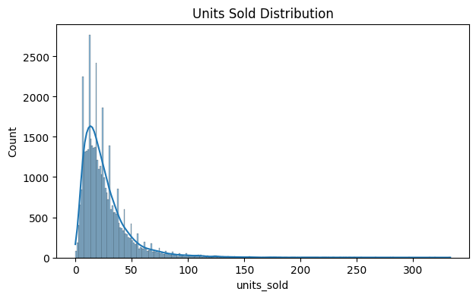
Observation: Units sold per product per day is heavily right-skewed — most sales transactions fall between roughly 10 and 50 units, with a long tail extending out to 300+ units, indicating occasional high-demand spikes for specific products or days.
8.2 Missing Value Summary
df.isnull().sum() was run on all four datasets (see Section 7.2) to confirm which fields required imputation before merging and modeling.
9. Data Visualization
9.1 Price vs Demand
plt.figure(figsize=(7,4))
sns.scatterplot(data=do, x="final_price", y="units_sold")
plt.title("Price vs Demand")
plt.show()
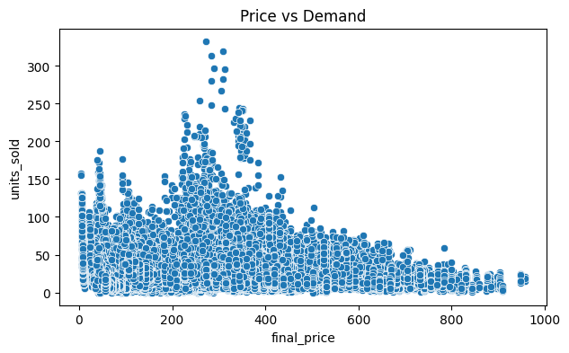
Observation: Demand is concentrated at lower to mid-range prices (roughly 200–400), where units sold peaks above 250 for some products, while very high-priced items (700+) consistently show low unit sales — an expected inverse price-demand relationship, though with considerable spread caused by category and product differences.
9.2 Sales Trend Over Time
x = do.groupby("date")["units_sold"].sum()
plt.figure(figsize=(10,4))
plt.plot(x)
plt.title("Sales Trend")
plt.xlabel("Date")
plt.ylabel("Units Sold")
plt.show()
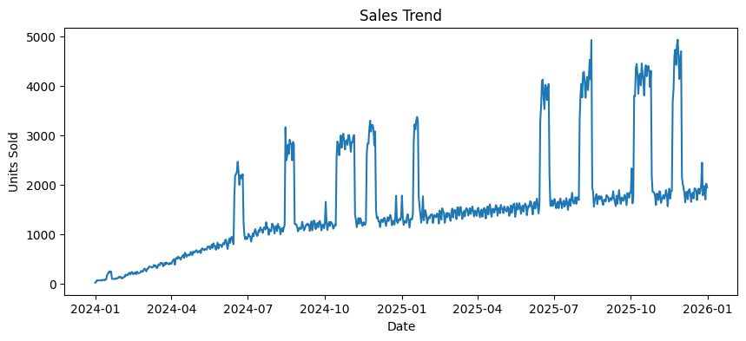
Observation: Total daily units sold shows a gradual upward trend from early 2024 through late 2025, along with several sharp, short-lived spikes (reaching close to 5,000 units) that recur periodically — consistent with festival or promotional-event driven demand surges captured by the is_festival_season and is_promotional_event flags.
9.3 Correlation Matrix
plt.figure(figsize=(10,6))
sns.heatmap(do.select_dtypes("number").corr(), annot=True, cmap="coolwarm")
plt.title("Correlation Matrix")
plt.show()
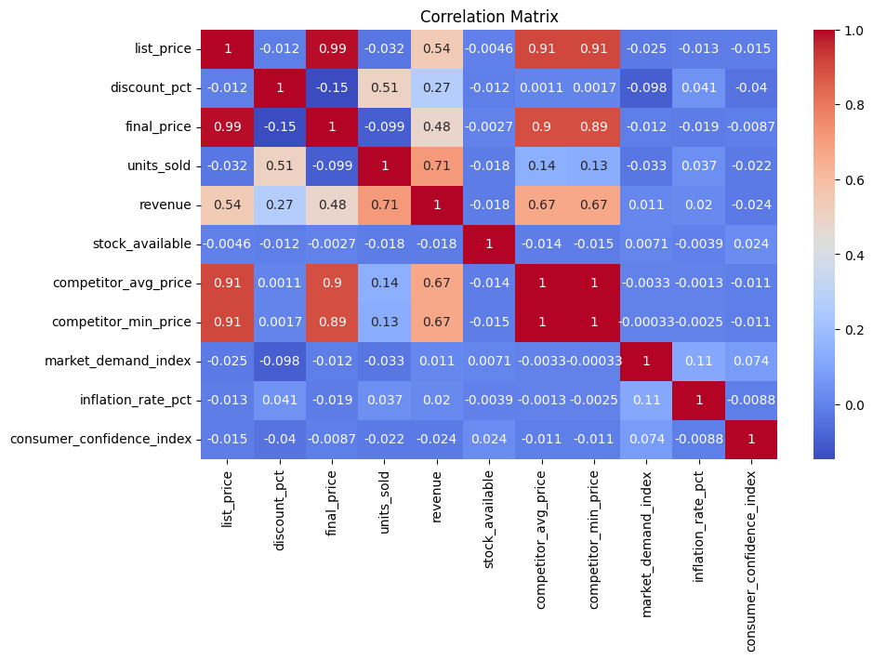
Observation: list_price and final_price are almost perfectly correlated (0.99), and both are strongly correlated with competitor_avg_price and competitor_min_price (~0.9), confirming that competitor pricing tracks closely with the business's own pricing. units_sold correlates moderately with revenue (0.71) and discount_pct (0.51), suggesting discounting has a meaningful positive relationship with volume sold, while its correlation with final_price alone is weak and slightly negative (-0.099), showing that price by itself is not a strong linear predictor of demand — supporting the use of a non-linear model.
10. Feature Engineering
10.1 Data Integration
Customer activity events were pivoted into per-day, per-product counts of views, carts, and purchases:
ca["date"] = pd.to_datetime(ca["timestamp"].dt.date)
cu = ca.pivot_table(
index=["date", "product_id"], columns="event_type",
values="event_id", aggfunc="count", fill_value=0
).reset_index()
cu = cu.rename(columns={"view":"views","add_to_cart":"carts","purchase":"purchases"})
Competitor prices were aggregated per day/product (mean, minimum, and average stock availability):
co = cp.groupby(["date","product_id"]).agg(
ca=("competitor_price","mean"),
cm=("competitor_price","min"),
ci=("in_stock","mean")
).reset_index()
All four sources were then merged (left joins) on product_id / date into a single working dataframe of shape (43,245, 44).
10.2 Derived Features
df["mo"] = df["date"].dt.month
df["dy"] = df["date"].dt.day
df["wk"] = df["date"].dt.isocalendar().week.astype(int)
df["pg"] = df["final_price"] - df["ca"]
df["pr"] = df["final_price"] / (df["ca"] + 1)
df["cr"] = df["carts"] / (df["views"] + 1)
df["br"] = df["purchases"] / (df["views"] + 1)
df["profit"] = (df["final_price"] - df["cost_price"]) * df["units_sold"]
- pg (price gap): own final price minus average competitor price — positive means priced above competitors.
- pr (price ratio): own final price relative to competitor average price.
- cr (cart rate): add-to-cart events relative to views — an engagement/interest signal.
- br (buy rate): purchase events relative to views — a conversion signal.
- profit: realized profit for the day, used later for validating optimization results.
10.3 Categorical Encoding
Six categorical columns were label-encoded using scikit-learn's LabelEncoder: category, subcategory, brand, channel, warehouse, and day_of_week.
cat = ["category","subcategory","brand","channel","warehouse","day_of_week"]
for c in cat:
le = LabelEncoder()
df[c] = le.fit_transform(df[c].astype(str))
10.4 Final Feature Set
The final model input consisted of 37 features (fs), combining pricing, competitor, engagement, catalog, calendar, and event-flag information:
- Pricing & discount: final_price, list_price, discount_pct, pg, pr
- Competitor: competitor_avg_price, competitor_min_price, ca, cm, ci
- Customer engagement: views, carts, purchases, cr, br
- Product catalog: rating, num_reviews, weight_kg, category, subcategory, brand
- Operational: stock_available, restocked, stockout_flag, channel, warehouse
- Calendar & events: mo, dy, wk, day_of_week, is_weekend, is_holiday, is_festival_season, is_promotional_event
- Macro / demand indices: market_demand_index, inflation_rate_pct, consumer_confidence_index
Any resulting infinite values (from ratio calculations) were replaced with NaN and filled with the column median before training.
11. Machine Learning Models
Two regression models were implemented to predict units_sold (demand):
- Random Forest Regressor: An ensemble of decision trees used as the baseline model. Configured with n_estimators=300, max_depth=20, min_samples_split=5. Its purpose is to provide a robust, low-variance baseline that captures non-linear relationships between price, competitor, engagement, and demand.
- XGBoost Regressor: A gradient-boosted tree model configured with n_estimators=500, max_depth=8, learning_rate=0.05, subsample=0.8, colsample_bytree=0.8. Its purpose is to improve on the Random Forest baseline through boosting, typically yielding lower error on structured/tabular data such as this.
rf = RandomForestRegressor(n_estimators=300, max_depth=20,
min_samples_split=5, random_state=42, n_jobs=-1)

xg = XGBRegressor(n_estimators=500, max_depth=8, learning_rate=0.05,
subsample=0.8, colsample_bytree=0.8,
objective="reg:squarederror", random_state=42, n_jobs=-1)
No other models (e.g., linear regression, LSTM, Prophet) were implemented in the notebook; the comparison is limited to these two tree-based regressors.
12. Model Training
To respect the time-ordered nature of sales data, the dataset was sorted chronologically by date and split 80/20 into training and test sets (not randomly shuffled), so the model is evaluated on the most recent, unseen time period.
df = df.sort_values("date").reset_index(drop=True)
n = int(len(df) * 0.8)
x1, x2 = X.iloc[:n], X.iloc[n:]
y1, y2 = y.iloc[:n], y.iloc[n:]
Split | Shape (rows x features)
Training set | 34,596 x 37
Test set | 8,649 x 37

Both the Random Forest and XGBoost models were trained (.fit()) on the identical training split (x1, y1) and evaluated on the same held-out test split (x2, y2).
13. Model Evaluation
Model performance was evaluated on the test set using three standard regression metrics: Mean Absolute Error (MAE), Root Mean Squared Error (RMSE), and R² (coefficient of determination).
Model | MAE | RMSE | R²
Random Forest | 6.479 | 10.035 | 0.8816
XGBoost | 5.816 | 8.762 | 0.9097

- Best Model: XGBoost was identified as the best-performing model, since it achieved a lower MAE (5.816 vs. 6.479), lower RMSE (8.762 vs. 10.035), and a higher R² (0.9097 vs. 0.8816) than the Random Forest model. XGBoost was therefore selected as the model used for all subsequent demand prediction and price-optimization steps.
13.1 Actual vs Predicted Demand
plt.plot(y2.values[:300], label="Actual")
plt.plot(bp[:300], label="Predicted")
plt.title("Actual vs Predicted Demand")
plt.show()
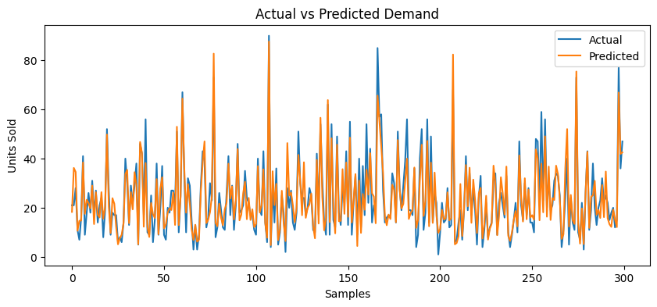
Observation: The predicted demand curve (XGBoost) closely tracks the actual units-sold curve across the first 300 test samples, correctly following most peaks and troughs, though it occasionally over-predicts sharp spikes — consistent with the reported R² of roughly 0.91.
13.2 Feature Importance
fi = pd.DataFrame({"feature": fs, "importance": bm.feature_importances_})
fi = fi.sort_values("importance", ascending=False).head(15)
sns.barplot(data=fi, x="importance", y="feature")
plt.title("Top Demand Factors")
plt.show()
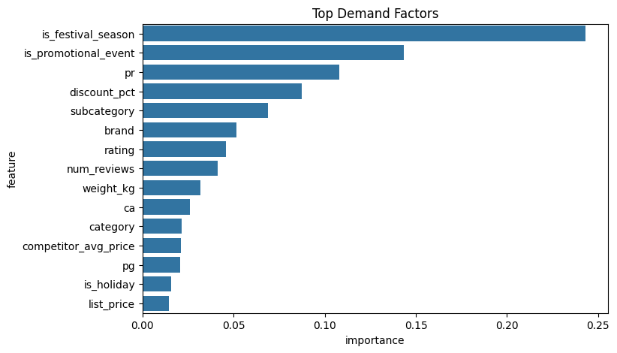
Observation: According to the best model (XGBoost), the strongest drivers of demand are is_festival_season (highest importance, ~0.24), followed by is_promotional_event (~0.14) and pr, the price ratio relative to competitors (~0.11). discount_pct, subcategory, and brand also contribute meaningfully, while calendar/operational features such as list_price and is_holiday have comparatively lower importance.
14. Prediction / Forecasting
Using the best model (XGBoost), demand was predicted for the entire test set, and predicted revenue and predicted profit were derived from the predicted demand:
pr = df.iloc[n:].copy()
pr["pred_demand"] = np.maximum(bp, 0)
pr["pred_revenue"] = pr["pred_demand"] * pr["final_price"]
pr["pred_profit"] = pr["pred_demand"] * (pr["final_price"] - pr["cost_price"])
A sample of the output (first rows of the test period) is shown below:
Product | Final Price | Pred. Demand | Pred. Revenue | Pred. Profit
Orbis Hotel Room - Deluxe Max | 227.68 | 18.32 | 4170.26 | 2114.07
Solace Hotel Room - Standard Pro | 37.36 | 36.22 | 1353.04 | 157.18
Lumen Face Serum Lite | 140.63 | 34.57 | 4861.48 | 308.36
Lumen Moisturizer Pro | 627.43 | 10.66 | 6688.27 | 3818.12
Vertex Perfume Pro | 405.31 | 14.83 | 6010.16 | 1860.69

Negative demand predictions (which can occur with regression models) were clipped to zero using np.maximum(bp, 0) before computing revenue and profit.
15. Price Optimization / Recommendation
A price-search function, opt(row), was implemented to find the profit-maximizing price for each product using the trained XGBoost model:
def opt(row):
cur, cost = row["final_price"], row["cost_price"]
ps = np.arange(max(cost * 1.05, cur * 0.8), cur * 1.2, 1)
z = pd.DataFrame([row] * len(ps))
z["final_price"] = ps
z["pg"] = z["final_price"] - z["ca"]
z["pr"] = z["final_price"] / (z["ca"] + 1)
d = np.maximum(bm.predict(z[fs]), 0)
pf = (ps - cost) * d
k = np.argmax(pf)
return ps[k], d[k], ps[k] * d[k], pf[k]
For each candidate price (ranging from 5% above cost, or 80% of the current price — whichever is higher — up to 120% of the current price), the model predicts expected demand, and the price with the highest predicted profit (price − cost) × demand is selected as the optimal_price.
This was applied to the most recent 500 records (df.tail(500)) to generate final pricing recommendations. Each product was labelled based on the percentage change between its current price and the optimal price:
rec["change_pct"] = (rec["optimal_price"] - rec["current_price"]) / rec["current_price"] * 100
rec["recommendation"] = np.where(rec["change_pct"] > 3, "Increase Price",
np.where(rec["change_pct"] < -3, "Decrease Price", "Keep Price"))
Sample pricing recommendations generated by the system:
Product | Current Price | Competitor Price | Optimal Price | Exp. Demand
Aether Moisturizer Max | 417.70 | 611.87 | 500.70 | 28.29
Orbis Sneakers Pro | 475.74 | 902.21 | 570.39 | 29.53
Zenith Cookware Set Pro | 60.38 | 101.88 | 71.88 | 38.07
Solace Vacation Package Pro | 37.65 | 51.66 | 45.12 | 7.93

In all sampled cases above, the optimizer recommends a price increase, as the products are priced well below competitor levels while the model still predicts healthy demand at the higher recommended price — indicating unrealized profit potential.
16. Results and Analysis
Comparing the two trained models on the same held-out (chronologically later) test set:
Model | MAE | RMSE | R² | Verdict
Random Forest | 6.479 | 10.035 | 0.8816 | Baseline
XGBoost | 5.816 | 8.762 | 0.9097 | Best Model

XGBoost reduced RMSE by roughly 13% relative to Random Forest and explained approximately 91% of the variance in daily units sold (R² = 0.9097), compared to 88% for Random Forest. Feature importance analysis showed that seasonal and promotional context (is_festival_season, is_promotional_event) and relative pricing (pr, discount_pct) are the dominant drivers of demand, more influential than absolute price alone — which is consistent with the weak direct correlation observed between final_price and units_sold in the EDA stage. The price-optimization step built on this model was able to generate concrete, product-level pricing actions (Increase / Decrease / Keep) with quantified expected demand, revenue, and profit for each recommendation.
17. Project Workflow
The end-to-end workflow implemented in the notebook proceeded in the following order:
- 1. Install and import required libraries (pandas, numpy, matplotlib, seaborn, scikit-learn, xgboost).
- 2. Load the four raw CSV datasets and inspect their shapes.
- 3. Clean the data — convert date columns, remove duplicates, impute missing values.
- 4. Perform exploratory data analysis — distribution, price-vs-demand, sales trend, and correlation plots.
- 5. Engineer customer-activity and competitor-price aggregates, then merge all sources into one dataset.
- 6. Engineer derived features (price gap, price ratio, cart rate, buy rate, profit) and label-encode categorical columns.
- 7. Split the data chronologically into train (80%) and test (20%) sets.
- 8. Train a Random Forest Regressor and an XGBoost Regressor on the training set.
- 9. Evaluate both models on the test set (MAE, RMSE, R²) and select the best model.
- 10. Generate demand, revenue, and profit predictions on the test set using the best model.
- 11. Run the price-optimization routine to find the profit-maximizing price for recent products.
- 12. Produce the final pricing-recommendation table (Increase / Decrease / Keep Price).
18. Week-wise / Milestone-wise Implementation
A formal week-wise or milestone-wise breakdown was not documented within the provided Colab notebook — the implementation is presented as a single continuous notebook covering the full pipeline. Based on the logical order in which the work was carried out, the implementation can be grouped into the following broad phases:
- Phase 1 – Data Preparation: Library setup, data loading, cleaning, and missing-value treatment across all four datasets.
- Phase 2 – Exploratory Analysis: Distribution, relationship, trend, and correlation visualizations.
- Phase 3 – Feature Engineering: Dataset merging, derived feature creation, and categorical encoding.
- Phase 4 – Model Building & Evaluation: Train/test split, training of Random Forest and XGBoost, metric comparison, and best-model selection.
- Phase 5 – Prediction & Optimization: Demand/revenue/profit prediction and the price-optimization / recommendation engine.
19. Expected / Achieved Outcomes
- Four raw datasets were successfully cleaned, integrated, and transformed into a single 43,245-row modeling dataset.
- Two regression models (Random Forest, XGBoost) were trained and objectively compared using MAE, RMSE, and R².
- XGBoost was identified as the best-performing model, achieving an R² of 0.9097 on unseen (chronologically later) data.
- The key drivers of product demand were identified via feature importance analysis (festival season, promotional events, relative pricing, discount).
- A working price-optimization routine was built that searches candidate prices per product and recommends the profit-maximizing price.
- A final, actionable pricing-recommendation table (Increase Price / Decrease Price / Keep Price) with expected demand, revenue, and profit was produced for recent products.
20. Performance Metrics
The following metrics were used to evaluate the demand-prediction models, all computed on the chronologically held-out test set (8,649 rows):
- MAE (Mean Absolute Error): Average absolute difference between actual and predicted units sold. Lower is better. XGBoost: 5.816 units; Random Forest: 6.479 units.
- RMSE (Root Mean Squared Error): Penalizes larger errors more heavily than MAE. Lower is better. XGBoost: 8.762 units; Random Forest: 10.035 units.
- R² (Coefficient of Determination): Proportion of variance in units_sold explained by the model. Higher is better (max 1.0). XGBoost: 0.9097; Random Forest: 0.8816.
21. Deployment / Implementation Details
The project was developed and executed entirely within a Google Colab notebook (PricePilot AI.ipynb), using Python with pandas, numpy, matplotlib, seaborn, scikit-learn, and xgboost. All data loading, cleaning, feature engineering, model training, evaluation, and price optimization steps were run interactively within this single notebook environment.
No deployment pipeline, web application, API, or user interface was implemented as part of the provided Colab notebook — this information is not available in the current implementation and is therefore not claimed here. The Technology Stack recommended for a future production deployment of PricePilot AI is presented on the final page of this document.

22. Best Technology Stack for PricePilot AI
Frontend
- JavaScript
- React.js
- Tailwind CSS
Backend
- Python
- FastAPI
Database
- PostgreSQL
AI / Machine Learning
- Scikit-learn
- XGBoost
- TensorFlow
Data Processing
- Pandas
- NumPy
Forecasting
- Prophet
- LSTM
Visualization
- Recharts
Authentication
- JWT
Deployment
- Docker
- AWS

