ECOPACKAI: Sustainable Packaging Recommendation System

Project Documentation & Technical Report
1. Executive Summary
EcoPackAI is an intelligent decision-support system designed for supply chain managers and logistics professionals. It leverages Artificial Intelligence and data analytics to recommend sustainable packaging alternatives based on product requirements, environmental impact, and cost-efficiency. This project addresses the growing need for eco-friendly supply chain solutions by quantifying sustainability metrics such as CO₂ emissions and biodegradability.
2. Project Overview
Project Name: EcoPackAI
Domain: Supply Chain Sustainability & Artificial Intelligence
Primary Objective: To optimize packaging selection by balancing environmental responsibility with functional requirements and cost constraints.
Technology Stack:
- Backend: Python, Flask
- Data Processing: Pandas, NumPy
- Database: PostgreSQL (Production), SQLite (Development)
- Frontend: HTML5, CSS3, JavaScript (Glassmorphism UI)
- Visualization: Chart.js
3. Methodology & Architecture
3.1 Data Engineering Strategy (Milestone 1)
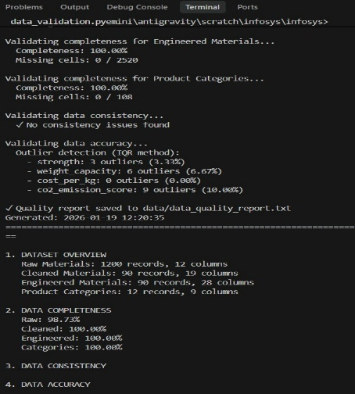
Fig 1: Data engineering
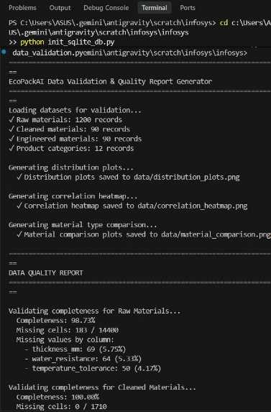
Fig 2: Data validation
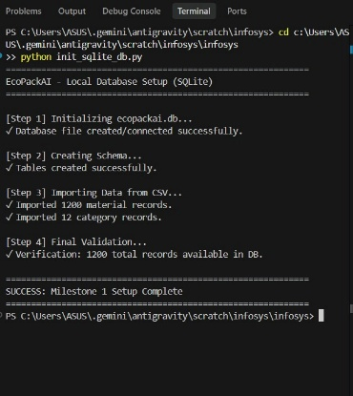
Fig 3: Database setup
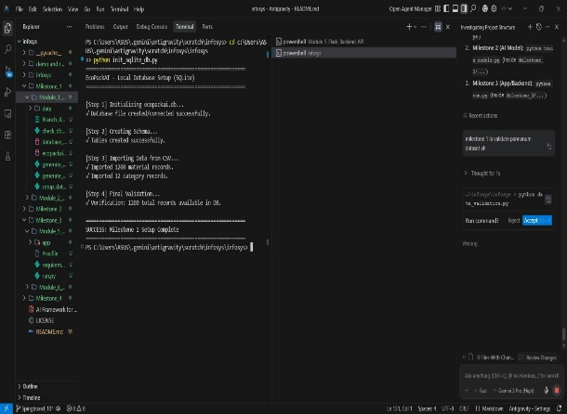
Fig 4: Setup complete
Due to the proprietary nature of industrial packaging data, a Synthetic Data Generation strategy was employed to create a robust, representative dataset.
Data Generation: Utilized the `Faker` and `NumPy` libraries to simulate 1,200 unique data points across 15 core material types (e.g., Corrugated Cardboard, Mushroom Packaging, Corn Starch).
Feature Engineering: Key attributes generated include:
- CO2_Emission (kg/unit)
- Biodegradability_Score (0-100)
- Cost_per_kg (USD)
- Water_Resistance (Index)
- Tensile_Strength (MPa)
Data Preprocessing:
- Outlier Detection: Implemented the Interquartile Range (IQR) method to cap extreme variances in cost and emission data.
- Imputation: Applied category-wise mean filling for missing values to ensure data integrity.
- Normalization: Utilized Min-Max Scaling to standardize scoring metrics between 0 and 100 for uniform algorithmic processing.
3.2 Database Implementation
A Hybrid Database Architecture was adopted to ensure both scalability and ease of development.
Schema Design:
- materials_data: The master repository containing physical and environmental properties of packaging materials.
- product_categories: A rule-based table mapping specific product needs (e.g., Electronics) to material constraints (e.g., High Cushioning).
- Deployment Strategy: The system is engineered for PostgreSQL in production environments while maintaining a smart fallback to SQLite/CSV for local development, eliminating complex setup requirements for contributors.
4. Algorithmic Core (Milestone 2)
The core of EcoPackAI is a Weighted Suitability Algorithm that ranks materials based on a composite score derived from user constraints.
4.1 The Recommendation Engine
The engine operates in two phases:
1. Hard Constraint Filtering: Eliminates materials that fail binary requirements (e.g., if “Water_Resistance” is required, non-resistant materials are discarded immediately).
2. Weighted Scoring: The remaining candidates are ranked using the following objective function, Where:
- Biodegradability Score
- Tensile Strength
- Normalized Carbon Emission
- Normalized Cost per Unit

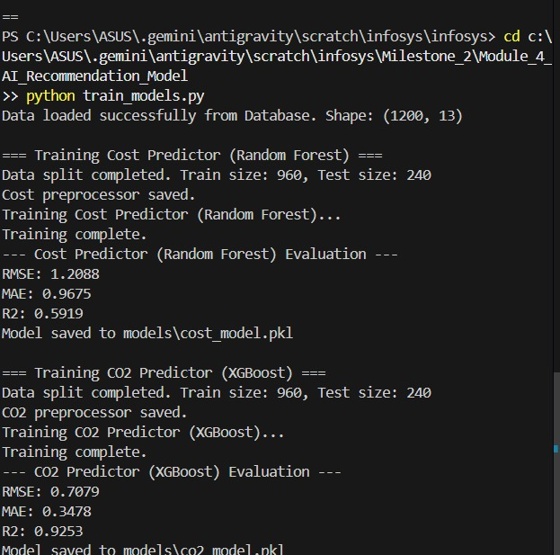
Fig 5: Training dataset
This formula prioritizes environmental impact and durability while negatively weighting high costs and emissions.
5. System Implementation
5.1 Backend Development
Framework: Built on Flask, chosen for its lightweight architecture and rapid API development capabilities.
Architecture:
- routes.py: Manages HTTP methods (GET/POST) and API endpoints.
- run.py: The WSGI entry point, configured for cloud deployment.
5.2 Frontend Interface (UI/UX)(Milestone 3)
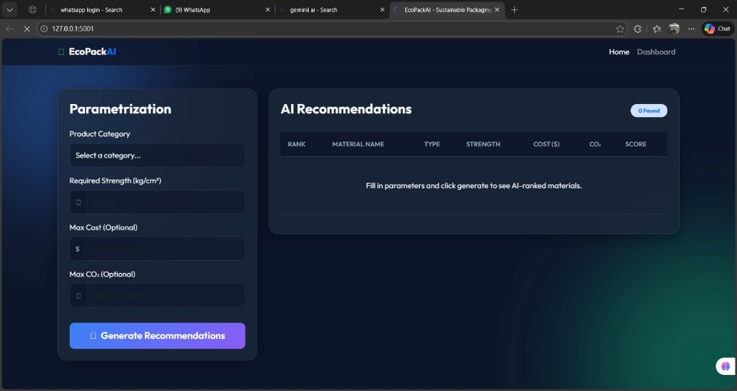
Fig 6: Dashboard
- Design Philosophy: Adopted “Glassmorphism”, utilizing translucent backgrounds and blur effects to create a modern, premium user experience.
- Responsiveness: Implemented via CSS Grid and Flexbox to ensure cross-device compatibility (Desktop, Tablet, Mobile).
- Interaction: The frontend communicates asynchronously with the Flask backend via JSON, providing real-time recommendations without page reloads.
5.3.Business Intelligence Dashboard(milestone 4)
A dedicated dashboard was developed to visualize the sustainability impact, utilizing Chart.js for interactive data representation.
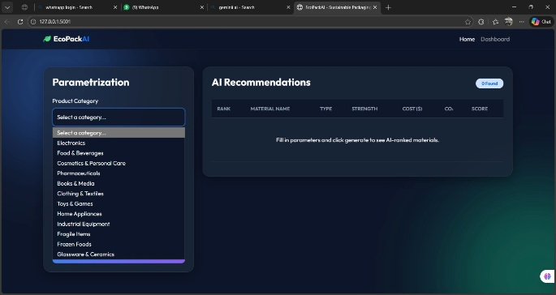
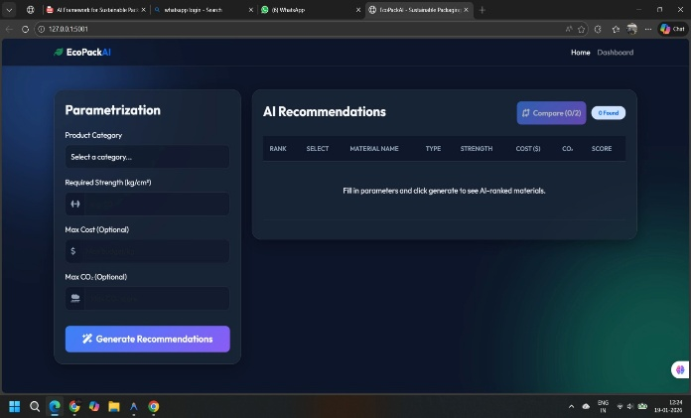
Fig 7: Parameter dashboard
Market Benchmarking: Comparative bar charts analyzing Recommended Material CO₂ vs Industry Averages
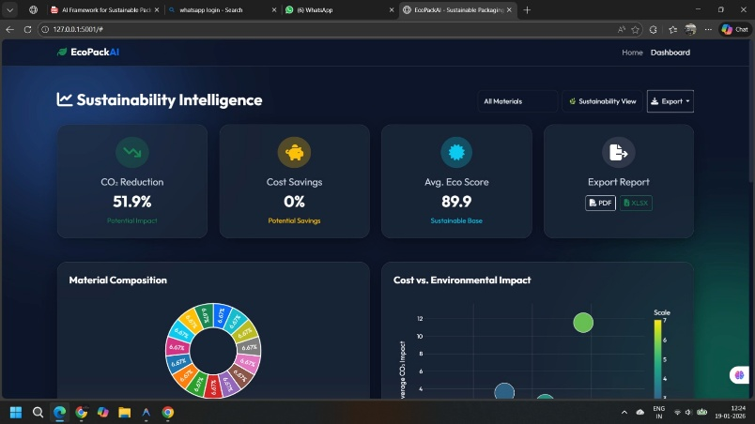
Fig 9: Pie chart
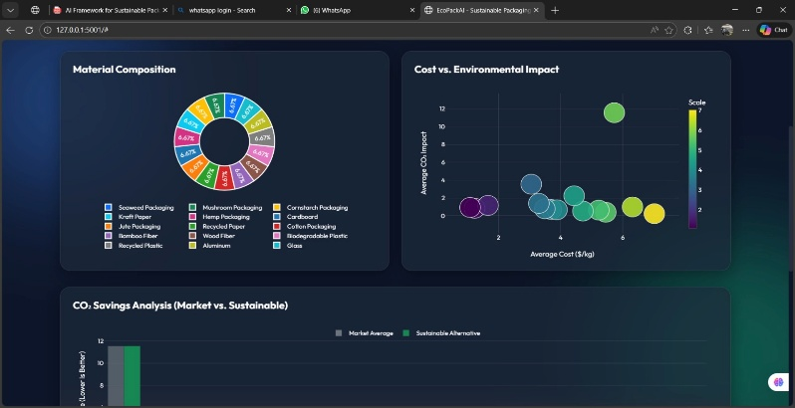.
Fig 10: Pie chart
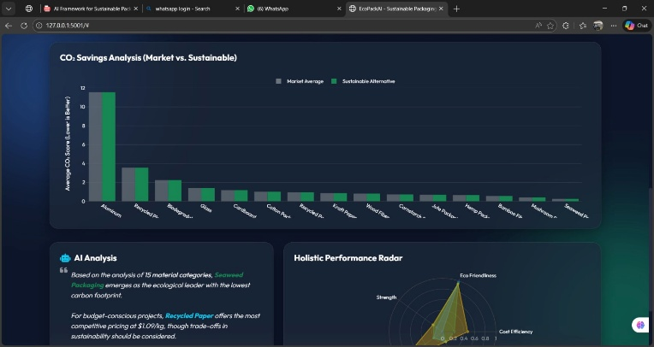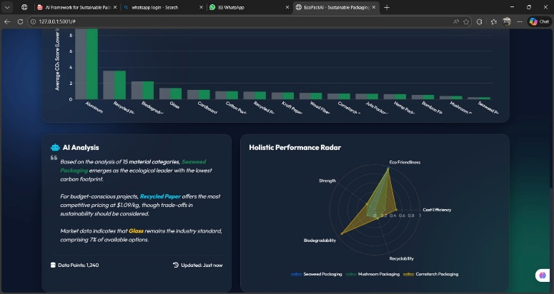
Fig 11: Bar chart
- Cost-Benefit Analysis: Scatter plots correlating Cost vs. Eco-friendliness.
- Inventory Distribution: Pie charts visualizing the diversity of available sustainable materials.

6. Deployment & Cloud Hosting
The application has been successfully containerized and deployed to a live production environment using Hugging Face Spaces, utilizing Docker to ensure a consistent and robust runtime environment for AI models.
6.1 Infrastructure & Configuration
- Hosting Provider: Hugging Face Spaces
- Deployment Method: Docker SDK (Containerization)
- Hardware Specification: Configured to utilize high-performance infrastructure (supporting up to 16GB RAM) to ensure efficient ML model inference and data processing.
- Port Configuration: The application utilizes a custom Dockerfile mapped to port 7860 for external accessibility.
6.2 Deployment Pipeline
- Containerization: A Dockerfile was created at the root directory to define the OS, Python dependencies, and entry commands.
- SDK Selection: The Space was initialized using the Docker SDK, offering greater control over the environment compared to standard Streamlit/Gradio SDKs.
- Metadata Configuration: The environment is managed via YAML configuration in the README.md:
YAML
---
title: EcoPackAI
sdk: docker
app_port: 7860
---
- Build Process: Upon pushing code changes, Hugging Face automatically rebuilds the Docker container, ensuring Continuous Deployment (CD).
6.3 Live Access
The application is currently live and accessible globally via the following URL:
- Live Demo: https://huggingface.co/spaces/ragasudhaselvaraj/EcoPackAI

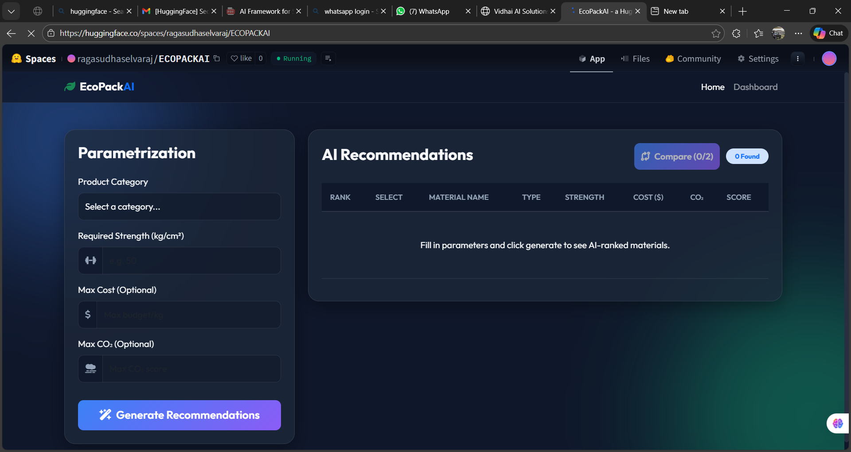
fig .12:cloud deployment

7. Project Status Matrix
Module | Status | Technology Used
Data Engineering | ✅ Completed | Pandas, NumPy (Synthetic Data)
Database Architecture | ✅ Completed | PostgreSQL / SQLite
AI/ML Engine | ✅ Completed | Scikit-Learn (Random Forest/XGBoost)
Backend API | ✅ Completed | Flask (Python)
Frontend UI | ✅ Completed | HTML5, CSS3 (Glassmorphism)
BI Dashboard | ✅ Completed | Chart.js
Cloud Deployment | ✅ Completed | Hugging Face Spaces (Docker)

8. Conclusion
EcoPackAI successfully demonstrates the potential of Artificial Intelligence in driving sustainable industrial practices. By bridging the gap between data analytics and supply chain management, the system provides actionable insights that help businesses reduce their carbon footprint without compromising on cost or functionality.
The successful implementation of the "Weighted Suitability Algorithm" ensures that recommendations are mathematically sound and tailored to specific user constraints. Furthermore, the deployment of this full-stack application to a live cloud environment highlights the system's scalability and readiness for real-world usage. This project serves as a foundational step towards integrating real-time logistics data with predictive AI models for a greener future.

