EcoPackAI – AI-Powered Sustainable Packaging Recommendation System

Abstract
EcoPackAI is an end-to-end AI-powered decision support system designed to recommend sustainable packaging materials by intelligently balancing environmental impact, material performance, and cost efficiency. The system integrates structured data collection, advanced feature engineering, machine learning models, backend APIs, frontend visualization, business intelligence dashboards, and cloud deployment. This technical document provides a comprehensive and consolidated explanation of all project modules, covering the complete development lifecycle from data acquisition to deployment and evaluation.

Introduction

Background
The rapid growth of e-commerce, manufacturing, and consumer goods industries has significantly increased the demand for packaging materials. Conventional packaging solutions often prioritize cost and strength while neglecting environmental sustainability. This has led to increased carbon emissions, waste accumulation, and ecological imbalance.
Sustainable packaging has emerged as a critical requirement due to stricter environmental regulations, corporate sustainability goals, and rising consumer awareness. However, selecting an optimal eco-friendly material is complex, as it requires balancing multiple conflicting factors such as strength, weight capacity, recyclability, biodegradability, cost, and CO₂ emissions.
Problem Statement
Existing packaging selection methods are largely manual, experience-based, and lack quantitative evaluation. Organizations face challenges in:
- Comparing multiple eco-friendly materials objectively
- Estimating environmental impact accurately
- Balancing sustainability with cost efficiency
- Making data-driven packaging decisions

Proposed Solution
EcoPackAI addresses these challenges by leveraging artificial intelligence and data analytics to recommend optimal packaging materials based on product requirements. The system evaluates materials using machine learning predictions, sustainability metrics, and real-world constraints to provide intelligent, explainable recommendations.

Objectives
- To build a structured eco-friendly material database
- To preprocess and engineer sustainability-driven features
- To develop AI models for cost and CO₂ impact prediction
- To rank and recommend optimal packaging materials
- To design an interactive frontend interface
- To deploy the system on a cloud platform
- To generate technical documentation and sustainability reports

Data Collection and Management

Data Sources
Eco-friendly packaging material data was collected from publicly available datasets, sustainability research articles, industry websites, and open data platforms. Product-related data was synthetically generated to simulate real-world packaging requirements.

Material Dataset Description
The material dataset includes key physical, environmental, and functional attributes such as:
- Material type
- Structural strength
- Weight capacity
- Biodegradability score
- CO₂ emission score
- Recyclability percentage
- Compostability indicator
- Water resistance level
These attributes are essential for evaluating both material performance and environmental sustainability.

Product Dataset Description
The product dataset contains information required to evaluate packaging suitability, including:
- Product category
- Product weight
- Product dimensions (width, height)

Database Design
A PostgreSQL relational database was designed to store and manage the datasets efficiently. Separate tables were created for material data and product data to maintain normalization, reduce redundancy, and support scalable querying.

Data Integration and Validation
CSV and Excel datasets were imported into PostgreSQL using Python and Pandas. Schema validation checks ensured:
- Presence of required columns
- Correct data types
- Valid numerical ranges
- Consistent categorical values
This process resulted in a clean, structured, and reliable database ready for further processing.

Data Cleaning and Feature Engineering

Data Cleaning
Raw datasets often contain missing values, inconsistencies, and outliers. To address these issues:
- Outliers were removed using the Interquartile Range (IQR) method
- Numerical missing values were filled using mean imputation
- Categorical missing values were filled using the most frequent category

Normalization
Numerical features such as weight capacity, biodegradability, CO₂ emission, and recyclability were normalized using Min–Max scaling to ensure uniform contribution during modeling.

Encoding Categorical Variables
Categorical attributes were transformed into numerical representations:
- Ordered encoding for strength and water resistance
- Binary encoding for compostable property
- One-hot encoding for material type

Feature Engineering
Several derived features were created to enhance model performance and interpretability:
CO₂ Impact Index – Quantifies environmental impact by combining CO₂ emissions and biodegradability.
Cost Efficiency Index – Measures economic feasibility using recyclability and weight capacity.
Material Suitability Score – Aggregates strength, water resistance, compostability, and cost efficiency into a single metric.
These engineered features form the foundation for intelligent prediction and ranking.

Machine Learning Dataset Preparation

Feature Selection
Relevant features influencing sustainability and cost were selected to avoid noise and overfitting.

Target Variable Definition
Two independent targets were defined:
- Cost Efficiency Index
- CO₂ Impact Index
This separation enables multi-objective optimization.

Train–Test Split
The dataset was split into 80% training data and 20% testing data with a fixed random state to ensure reproducibility.

Baseline Models
Linear Regression models were implemented as baseline predictors to validate data readiness and establish reference performance.

AI-Based Recommendation Model

Model Selection
Advanced regression models were selected to improve prediction accuracy:
- Random Forest Regressor for cost prediction
- XGBoost Regressor for CO₂ impact prediction
Model Training and Evaluation
Models were trained using engineered features and evaluated using RMSE, MAE, and R² metrics. The results demonstrated strong predictive capability, particularly for CO₂ impact estimation.

Material Ranking Logic
Predicted cost and CO₂ values were normalized and combined using equal weighting to compute a final ranking score. Materials with lower combined scores were ranked higher.
This ranking mechanism enables objective and data-driven material selection.
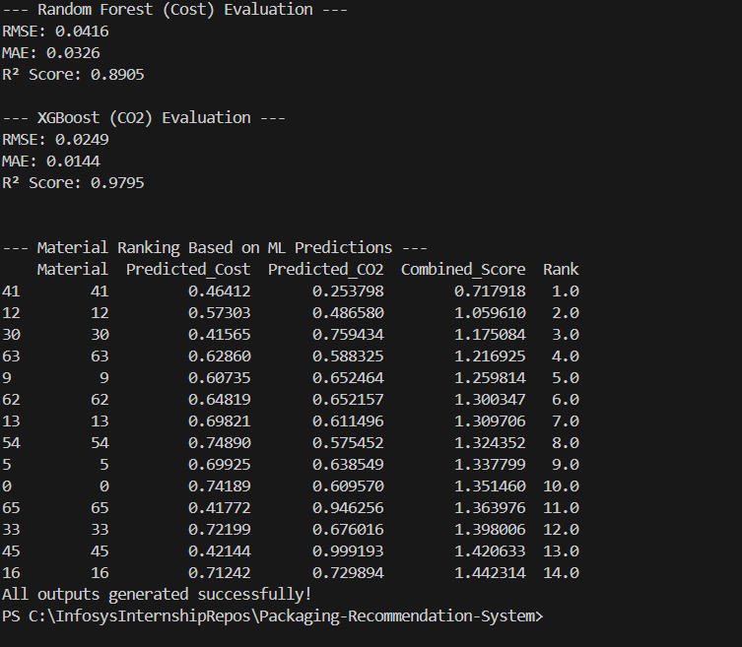

Flask Backend API Development

Backend Role
The Flask backend serves as the system’s core intelligence layer, integrating machine learning models, database access, and business logic.

API Architecture
The backend follows a layered architecture consisting of:
- API Layer
- Business Logic Layer
- Machine Learning Layer
- Database Layer

Recommendation Logic
The backend evaluates real-world constraints such as product weight and fragility. Penalties are applied when material capacity or strength is insufficient, ensuring realistic recommendations.

API Endpoints
- /recommend – Returns top-ranked packaging materials
- /environment-score – Evaluates sustainability metrics
All responses are returned in structured JSON format.

Frontend User Interface Development

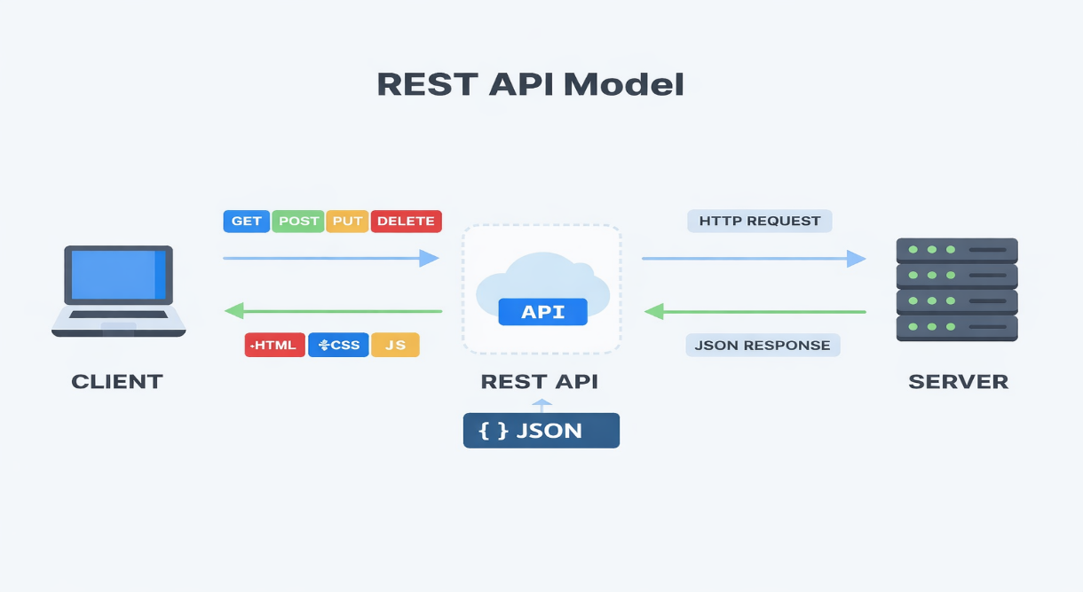

UI Design
The frontend was developed using HTML, CSS, Bootstrap, and JavaScript to ensure responsiveness and usability.
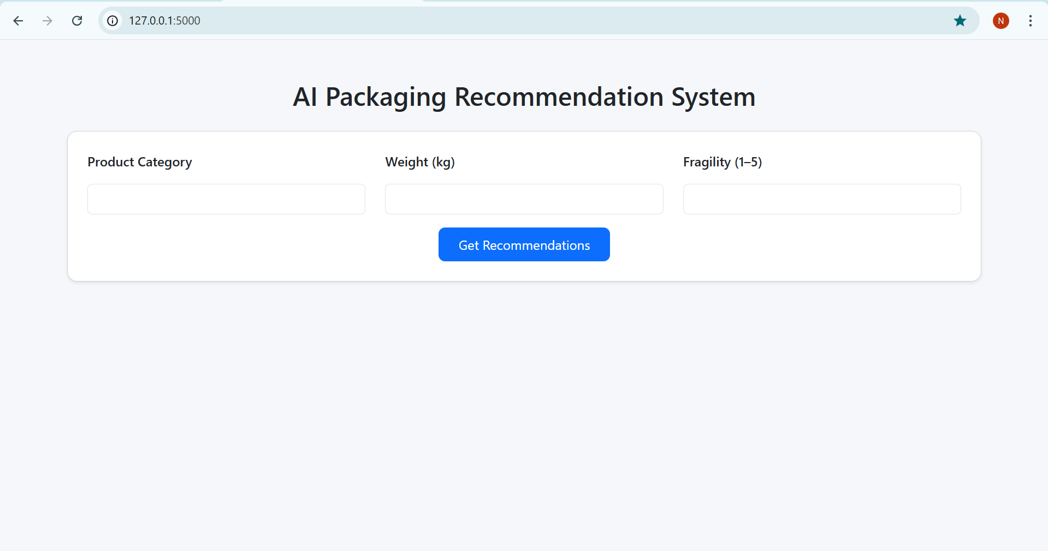

User Interaction Flow
Users provide product details, submit requests, and view AI-generated recommendations and sustainability scores in real time.
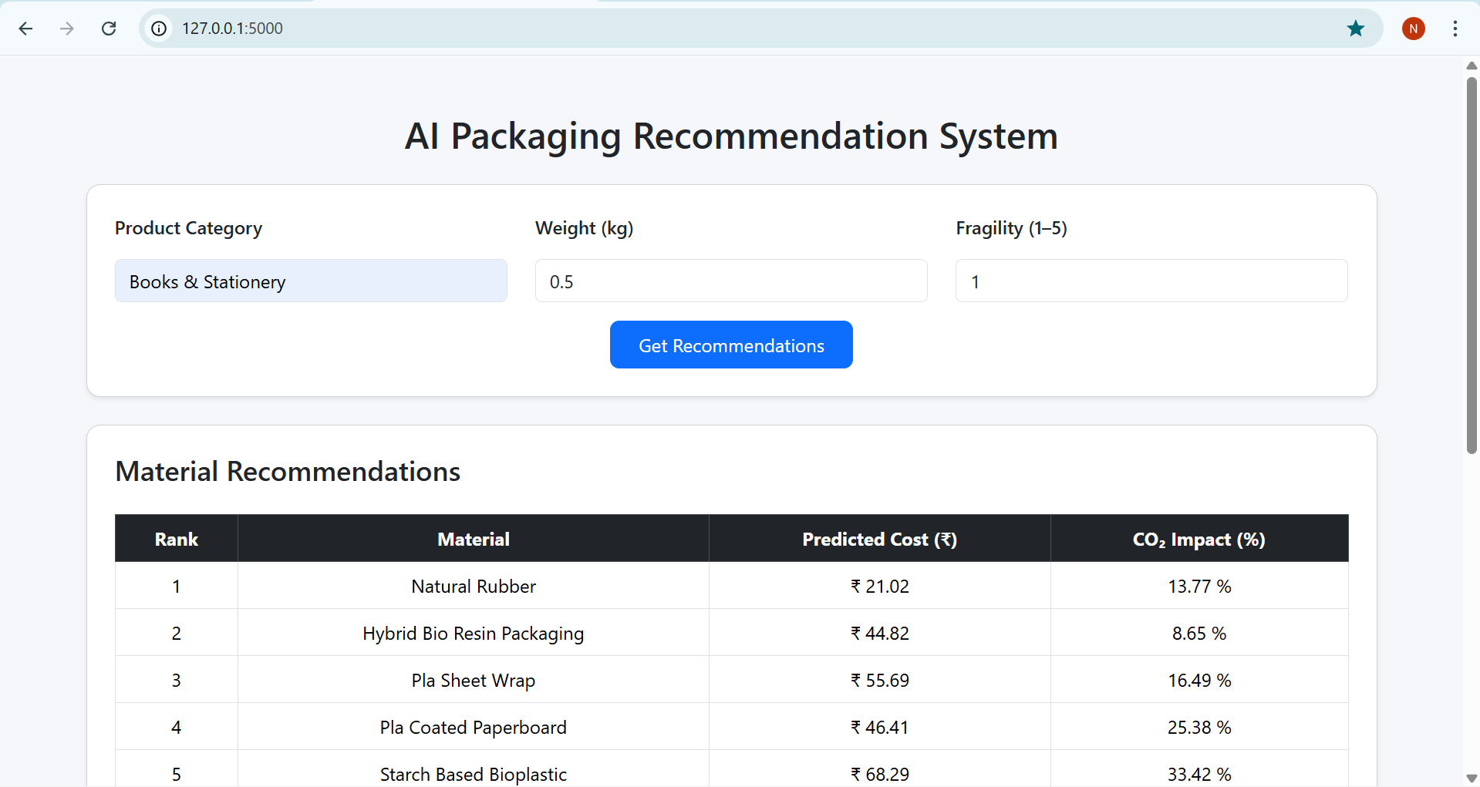
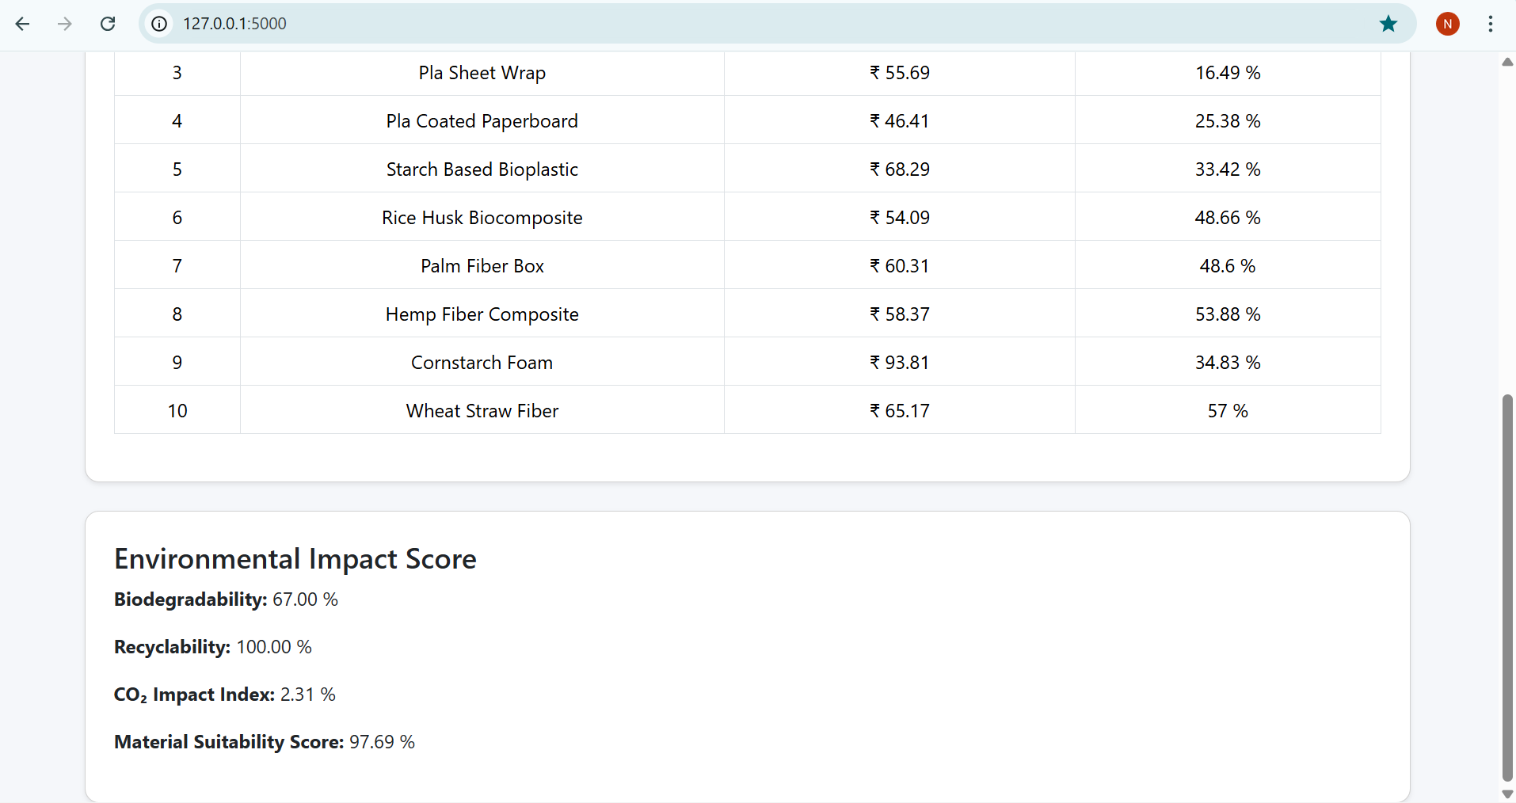

API Integration
The frontend communicates with backend APIs using the Fetch API and dynamically updates content without page reloads.

Business Intelligence Dashboard and Reporting

BI Objectives
The BI dashboard transforms AI outputs into actionable insights by visualizing cost savings, CO₂ reduction, and sustainability performance.
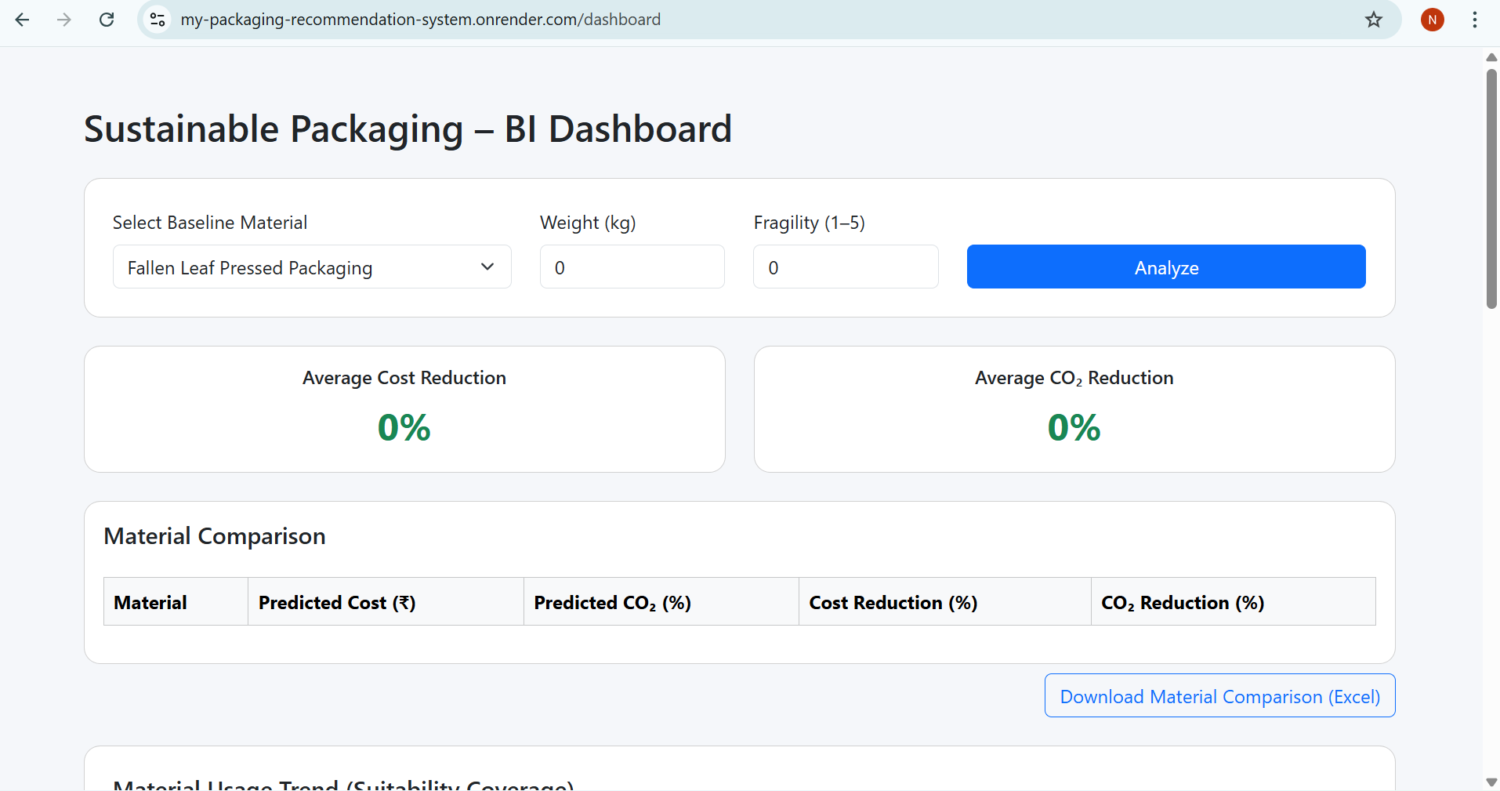

KPIs and Metrics
Key indicators include:
- Cost reduction percentage
- CO₂ reduction percentage
- Performance score
- Sustainability score
- 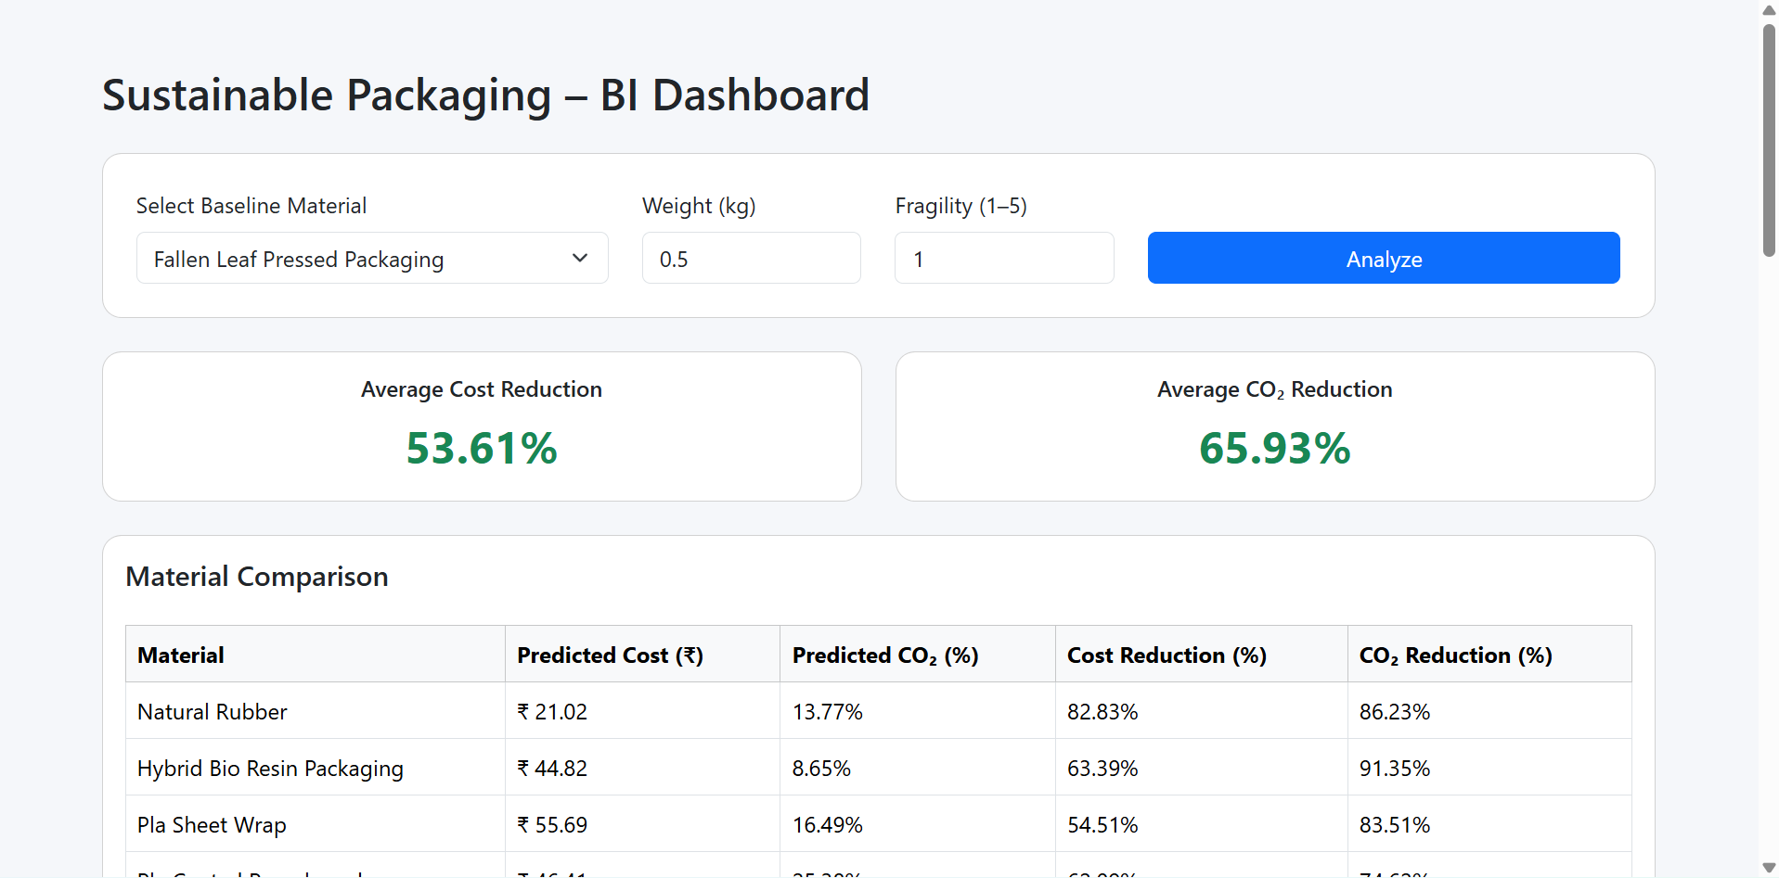
- 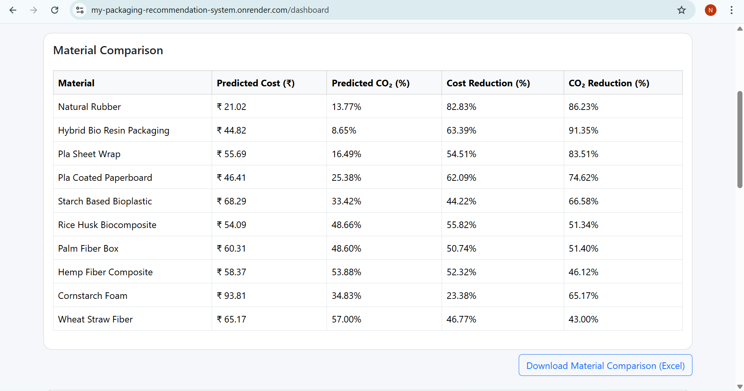

Reporting
The system supports Excel-based sustainability report exports for compliance, auditing, and management decision-making.
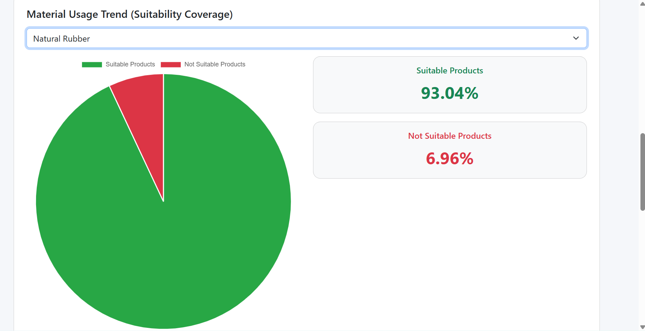
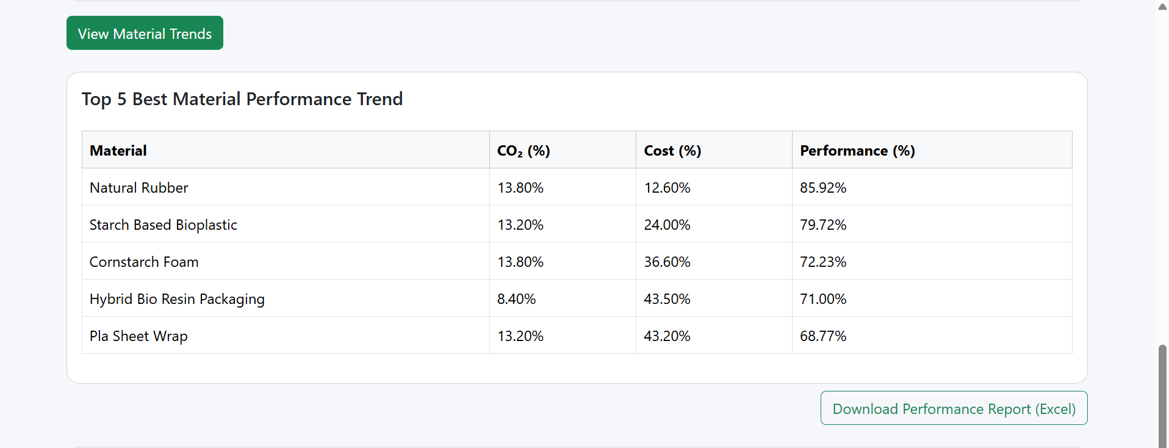
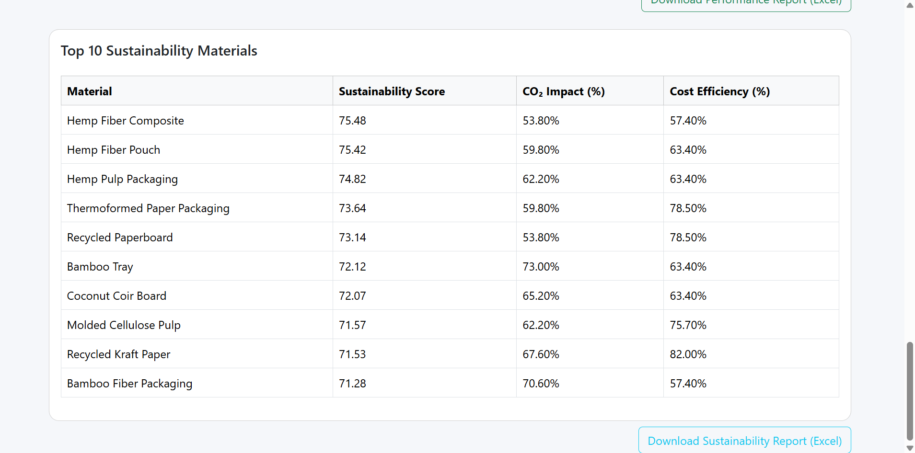

Deployment and Documentation

Cloud Deployment
The complete application was deployed on the Render cloud platform. Flask was configured as a web service and connected to a cloud-hosted PostgreSQL database using environment variables.

Documentation
Comprehensive technical documentation and a README file were prepared, detailing setup, usage, architecture, and deployment steps.

Project Deliverables
- Live deployed application
Link: https://my-packaging-recommendation-system.onrender.com/
- GitHub repository
- Project report
- Video demonstration
Link: https://drive.google.com/file/d/18Ijd5YpUXgIBRVOi_AXpxgBhLOady-lM/view?usp=drive_link

System Architecture and Workflow

Overall System Architecture
EcoPackAI follows a modular, layered, and scalable architecture that integrates data engineering, machine learning, web technologies, and cloud infrastructure. The system is divided into the following major layers:
- Data Layer: PostgreSQL database storing eco-friendly material data and product attributes
- Processing Layer: Data preprocessing, feature engineering, and sustainability score computation
- AI Layer: Machine learning models for cost and CO₂ impact prediction
- Backend Layer: Flask-based REST APIs handling business logic and model inference
- Frontend Layer: Web-based user interface for user interaction and visualization
- BI & Reporting Layer: KPI computation, dashboards, and sustainability report generation
- Deployment Layer: Cloud hosting and environment configuration using Render
This layered design ensures loose coupling, maintainability, and ease of future expansion.

End-to-End Workflow
- User enters product details such as weight and fragility through the frontend
- Frontend sends input data to Flask backend APIs
- Backend fetches relevant material data from PostgreSQL
- Business logic applies capacity and strength constraints
- Machine learning models predict cost and CO₂ impact
- Sustainability metrics and ranking scores are calculated
- Results are returned to the frontend as JSON
- Frontend dynamically displays recommendations and scores
- BI layer aggregates insights and enables report export

Algorithms and Mathematical Models

Outlier Detection (IQR Method)
Outliers were removed using the Interquartile Range method:
IQR = Q3 − Q1
Lower Bound = Q1 − 1.5 × IQR
Upper Bound = Q3 + 1.5 × IQR
Values outside this range were treated as outliers and removed.

Feature Normalization (Min–Max Scaling)
Normalized Value = (x − min(x)) / (max(x) − min(x))
This ensures all numerical features lie between 0 and 1.

CO₂ Impact Index
CO₂ Impact Index = (1 − CO₂ Emission) × 0.6 + (Biodegradability Score) × 0.4
Lower values indicate lower environmental impact.

Cost Efficiency Index
Cost Efficiency Index = (Recyclability × 0.7) + (1 − Weight Capacity) × 0.3
Higher values indicate better economic feasibility.

Material Suitability Score
Material Suitability Score = 0.3 × Strength + 0.2 × Water Resistance + 0.1 × Compostable + 0.4 × Cost Efficiency
This score represents the overall applicability of a material.

Machine Learning Algorithms Description

Random Forest Regressor
Random Forest is an ensemble learning algorithm that builds multiple decision trees and averages their predictions. It reduces overfitting and captures non-linear relationships effectively. In EcoPackAI, it is used to predict packaging cost due to its robustness and stability.

XGBoost Regressor
XGBoost is a gradient boosting algorithm known for high performance and accuracy. It incrementally improves predictions by correcting previous errors. In this project, XGBoost is used for CO₂ impact prediction due to its superior handling of complex feature interactions.
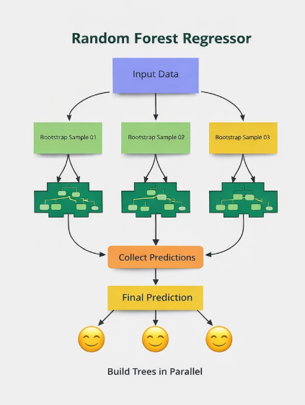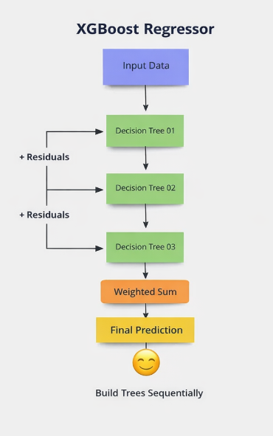

Security, Validation, and Reliability
- Input validation is performed at both frontend and backend levels
- SQLAlchemy prevents SQL injection attacks
- Environment variables secure database credentials
- Error handling ensures graceful system failure
- Modular architecture improves reliability and debugging

Testing and Evaluation

Model Evaluation
Models were evaluated using RMSE, MAE, and R² score to assess prediction accuracy.

System Testing
- API endpoints were tested using POST requests
- Frontend-backend integration was validated
- Database connectivity was verified in cloud deployment

Limitations of the System
- Dataset size is limited to publicly available data
- Cost predictions are relative, not absolute market prices
- Environmental scores depend on assumed weights
- Real-time industrial constraints are simplified

Applications of the System
- Sustainable packaging selection for industries
- Decision support for supply chain optimization
- Environmental impact assessment
- Educational and research use cases

Conclusion
EcoPackAI successfully demonstrates the practical application of artificial intelligence in sustainable decision-making. By integrating data engineering, machine learning, business logic, and cloud deployment, the system provides accurate, explainable, and scalable packaging recommendations. The project highlights how AI can drive environmentally responsible choices without compromising economic feasibility.

Future Scope
- Integration of real-time market pricing data
- Support for additional material properties
- Advanced deep learning models
- Role-based user authentication
- Enterprise-scale deployment with CI/CD pipelines

References
- Kaggle – Sustainable Packaging Materials Dataset
- European Bioplastics – Sustainability Resources
- Research articles on eco-friendly packaging materials
- Render Cloud Platform Documentation

