EcoPackAI – AI-Powered Sustainable Packaging Recommendation System

Module 5

Business Intelligence (BI) Dashboard & Sustainability Reporting

Introduction
With increasing environmental concerns and rising packaging costs, industries require data-driven decision systems to evaluate sustainable alternatives.
This project focuses on building a Business Intelligence (BI) dashboard that converts AI-based material recommendations into actionable sustainability insights.
The dashboard evaluates materials based on:
- CO₂ emission reduction
- Cost savings
- Material suitability & performance
- Usage trends
It also supports exportable sustainability reports for compliance, auditing, and management decisions.

Objectives of the BI Dashboard
The main objectives are:
- Visualize AI-generated recommendations using BI techniques
- Quantify environmental and economic benefits
- Enable baseline vs recommended material comparison
- Provide exportable sustainability reports
- Support decision-making using charts and KPIs

Architecture Overview

System Components
Component | Description
Frontend | HTML, CSS, Bootstrap, Chart.js
Backend | Flask REST APIs
AI Engine | Material recommendation logic
Database | PostgreSQL
BI Layer | KPI calculations, trends, charts
Export Engine | Excel report generation

Data Flow Architecture
User Input (Weight, Fragility, Baseline)
↓
Flask API (/api/material-comparison)
↓
AI Recommendation Engine
↓
Metric Computation (Cost, CO₂, Performance)
↓
BI Dashboard Visualization
↓
Excel Sustainability Report Export

Key BI Metrics and Calculations

CO₂ Reduction Percentage
CO₂ reduction measures the environmental benefit of switching from a baseline material to AI-recommended materials.
Formula:
CO₂ Reduction (%) = ((Baseline CO₂ − Target CO₂) / Baseline CO₂) × 100
Calculated per material and averaged to generate KPI.

Cost Reduction Percentage
Cost reduction quantifies financial savings achieved through material optimization.
Formula:
Cost Reduction (%) = ((Baseline Cost − Target Cost) / Baseline Cost) × 100
Used to rank materials and display financial KPIs.
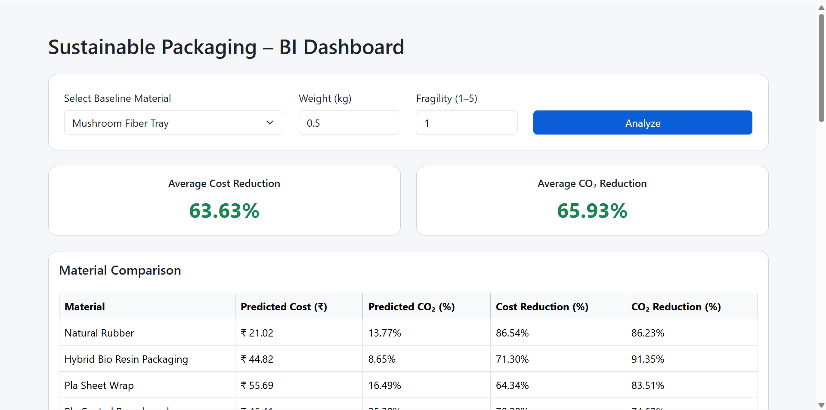
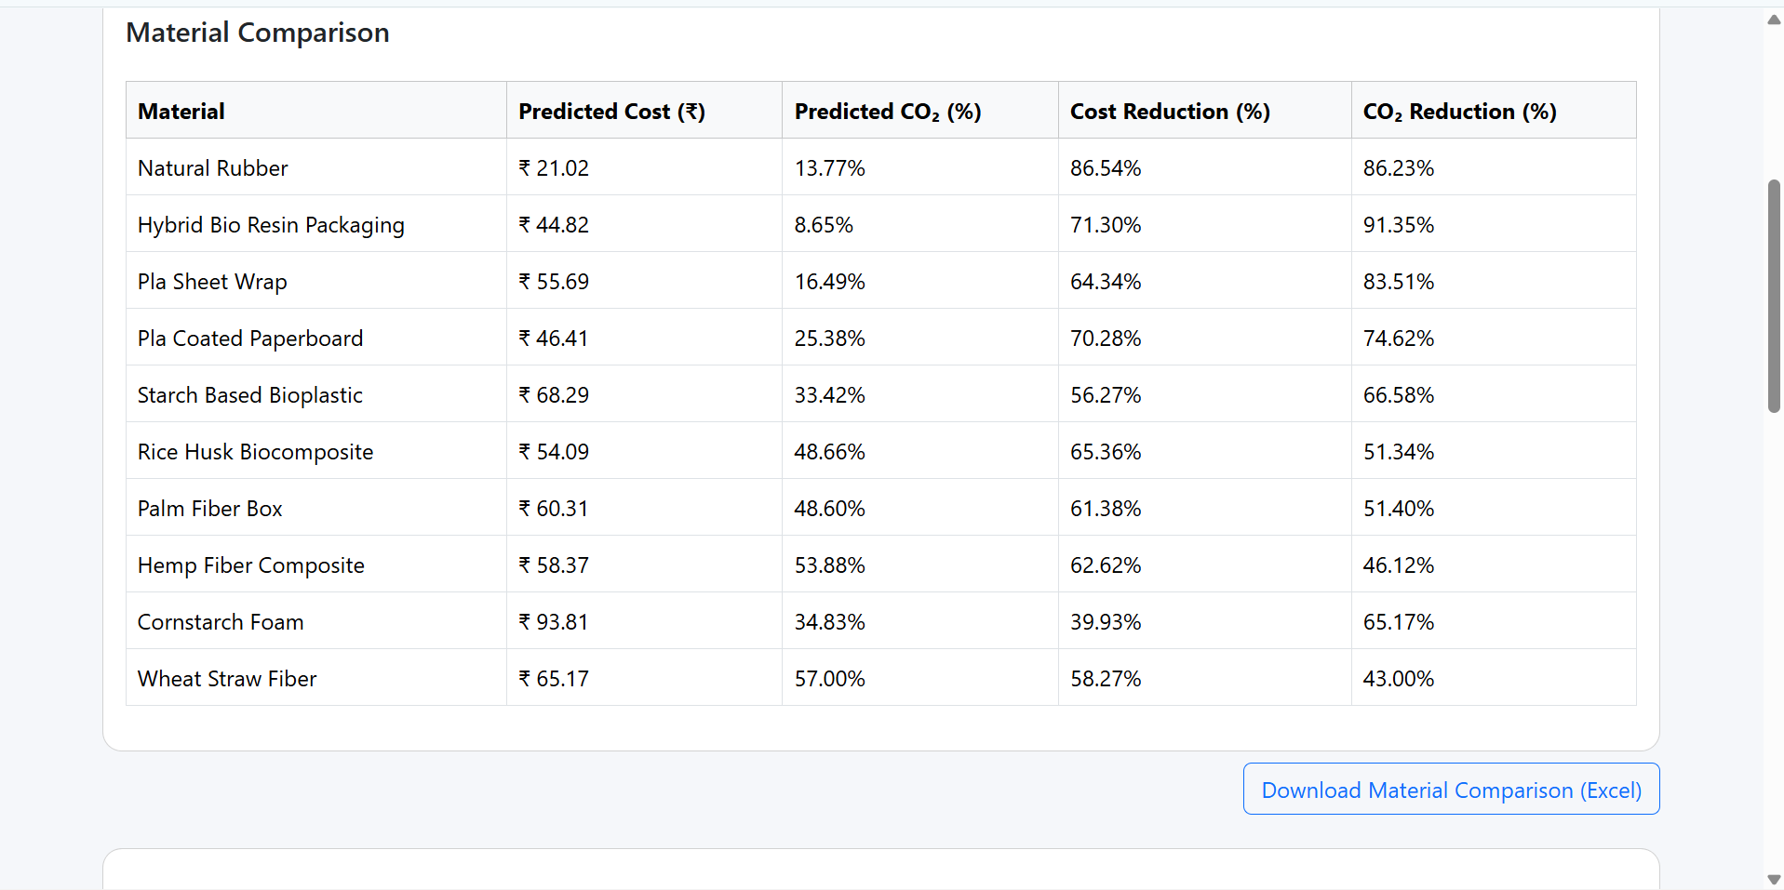

Material Performance Score
A composite performance score (0–100%) is calculated using actual cost and actual CO₂ impact.
Logic:
- Lower cost → higher score
- Lower CO₂ → higher score
- Normalized against maximum observed values
Used for ranking materials and performance trend analysis.

Sustainability Score
The sustainability score (0–100) evaluates overall environmental and economic suitability of a material.
Computation:
Sustainability Score =
(Biodegradability × 25) +
(Recyclability × 20) +
((1 − CO₂ Impact Index) × 25) +
(Cost Efficiency Index × 20) +
(Material Suitability × 10)
This is used to identify top sustainable materials.

Dashboard Functional Modules

Baseline Material Comparison
Evaluates AI-recommended materials versus a user-selected baseline.
Inputs: Baseline material, product weight, fragility level
Outputs: Average cost reduction, average CO₂ reduction, material-wise comparison table
API: POST /api/material-comparison

Material Comparison Table
Provides detailed metrics per material:
Column | Description
Material | Recommended material name
Predicted Cost | Estimated cost (₹)
Predicted CO₂ | Estimated CO₂ impact (%)
Cost Reduction | % saving vs baseline
CO₂ Reduction | % emission reduction

KPI Cards
Displays two KPIs:
- Average Cost Reduction
- Average CO₂ Reduction
Summarizes the overall benefit of AI recommendations.

Material Usage Trend (Suitability Coverage)
Shows how suitable a material is across different product conditions.
Visualization: Pie chart
Metrics: Suitable product percentage, Not suitable product percentage
API: POST /api/material-performance

Top Material Performance Trend
Displays Top 5 best-performing materials based on the performance score.
Metrics: Actual CO₂ (%), Actual cost (₹), Performance score (%)
API: GET /api/material-performance-trend

Top Sustainability Materials
Displays Top 5 materials with highest sustainability score, including CO₂ impact and cost efficiency.
API: GET /api/sustainability-report
Frontend displays the table and allows Excel export via POST /api/export/sustainability-report/excel.

Data Visualization Technologies
Visualization | Tool
Pie charts | Chart.js
KPI cards | Bootstrap
Ranking tables | HTML tables
Server-side charts | matplotlib
Charts ensure easy interpretation of complex data.
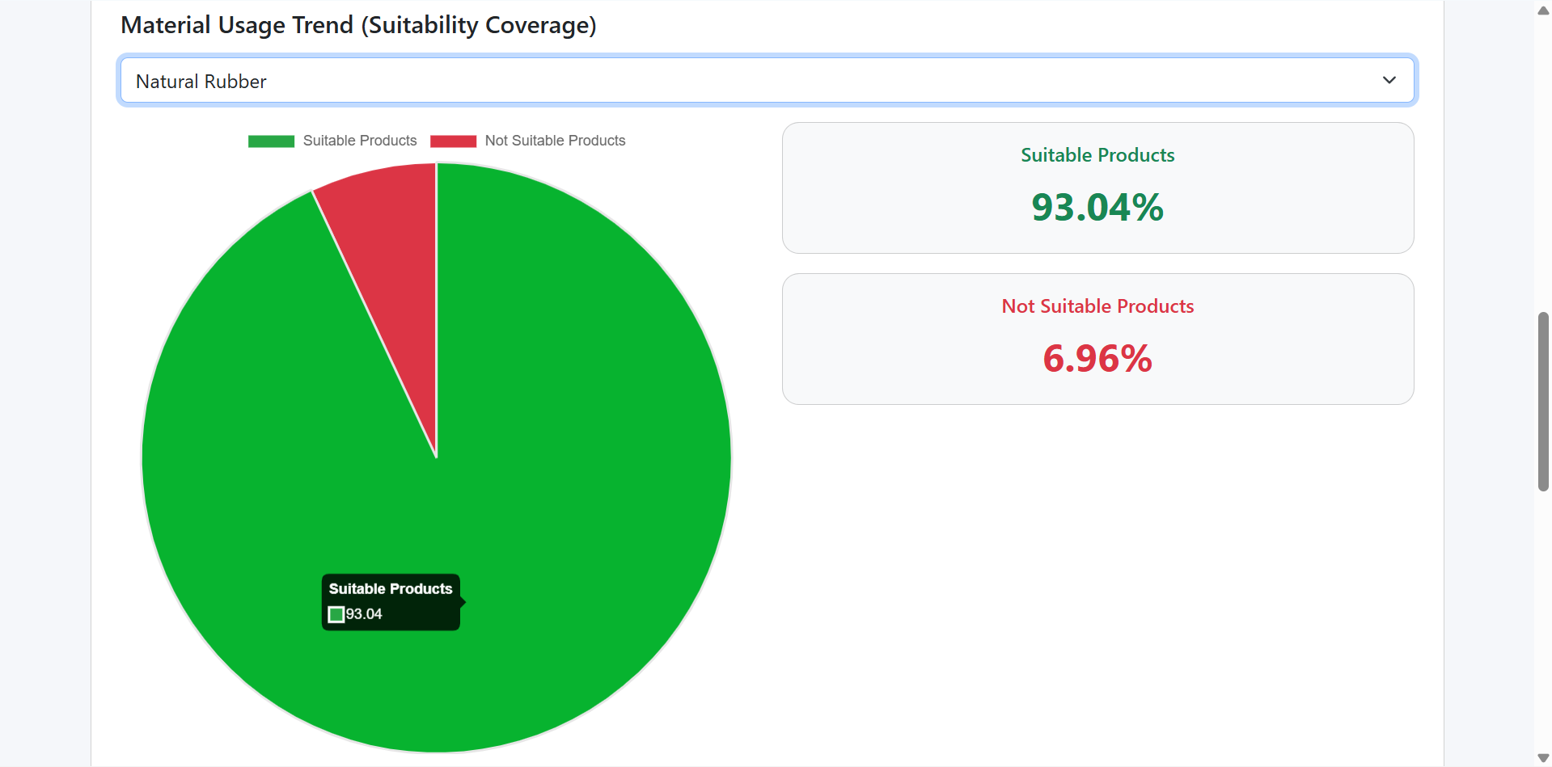

Sustainability Report Export

Material Comparison Report (Excel)
Content:
- Material name
- Predicted cost
- Predicted CO₂
- Cost reduction %
- CO₂ reduction %
API: POST /api/export/material-comparison/excel

Material Performance Report (Excel)
Content:
- Material name
- Cost efficiency
- CO₂ efficiency
- Overall performance score
API: POST /api/export/material-performance/excel

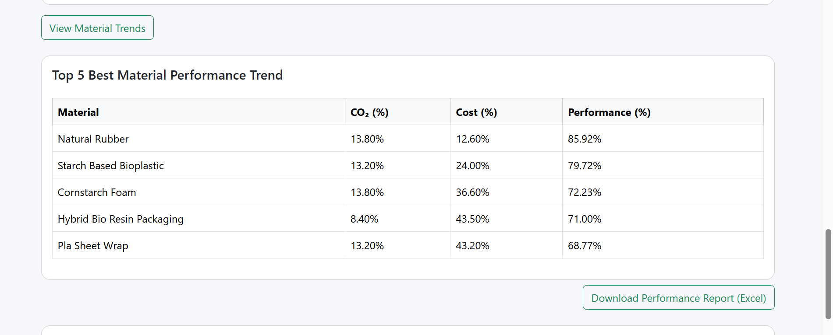

Sustainability Report (Excel)
Content:
- Material name
- Sustainability score
- CO₂ impact (%)
- Cost efficiency (%)
API: POST /api/export/sustainability-report/excel
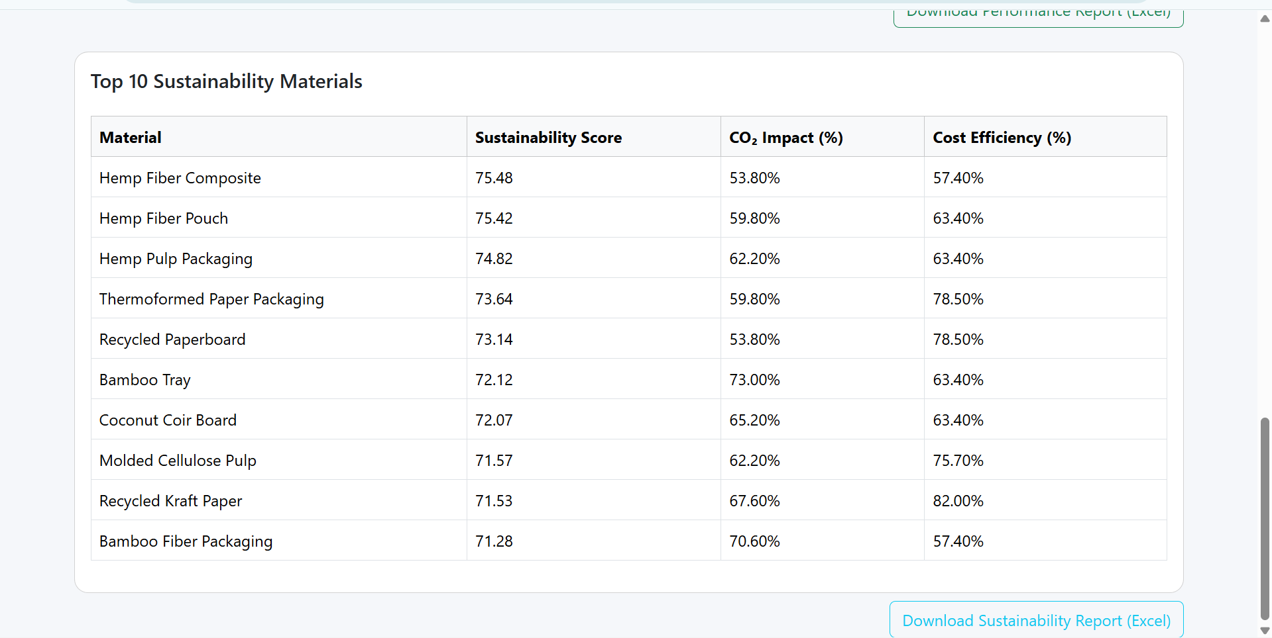

Mapping to Previous Modules
Module 5: Flask Backend API
- Designed REST APIs
- Implemented AI material recommendation logic
- Computed environmental and cost metrics
- Connected Flask with PostgreSQL
- Ensured structured JSON responses
Module 6: Frontend UI Development
- Developed responsive UI using Bootstrap
- Implemented input forms
- Displayed AI recommendations dynamically
- Integrated BI tables and KPIs
- Connected frontend to backend APIs

Evaluation Outcomes
- AI-driven sustainable decision support
- Clear visualization of cost & CO₂ savings
- End-to-end system integration
- Exportable sustainability documentation
- Industry-aligned BI dashboard

Conclusion
The module successfully transforms AI recommendations into meaningful business intelligence insights.
By combining analytics, visualization, and reporting, the system enables organizations to make data-backed sustainable packaging decisions.
The dashboard provides easy-to-understand KPIs, tables, trends, and downloadable reports, demonstrating real-world applicability.

