EDUVISION_DV
Higher Education Performance Dashboard
Final Project Documentation
Prepared by
Palle Chandana
Python • Excel • Tableau • GitHub
Final dashboard evidence: University Overview • Research Analytics • Student Analytics • Country Comparison

1. Project Overview
EduVision_DV is a higher-education analytics project that integrates university ranking, research, student and country-level education information into a unified analytical workflow. The final solution is implemented through four Tableau dashboards.

Project Goal
Transform fragmented higher-education data into a clean, defensible and reproducible analytical model that supports university comparison, research analysis, student analysis and country benchmarking.

Stakeholders
- Students
- Academic researchers
- University administrators
- Policymakers
- Education consultants

2. Project Objectives
- Collect and inspect approved datasets.
- Clean and standardize university and country information.
- Create consistent University_ID and Country_ID fields.
- Handle duplicates and missing values without fabricating analytical values.
- Build a common data model.
- Engineer six core KPIs.
- Develop four interactive Tableau dashboards.
- Validate KPI calculations, ranking order, data quality and dashboard interactions.

3. Dataset Sources
Source | Primary use | Key analytical areas
QS World University Rankings | University ranking and reputation | Global ranking; academic reputation
Times Higher Education (THE) | University performance and research | Research and performance analysis
World University Rankings (WUR) | Research and student indicators | Research; student/faculty; international indicators
World Bank Education Data | Country-level education indicators | Country comparison; education benchmarking
Each source serves a different analytical purpose. Approved source data is kept separate from cleaned and analytical outputs.

4. Cleaning Methodology
- Inspect raw files, columns, data types, missing values and duplicate records.
- Standardize university and country names.
- Convert ranking and score fields to appropriate numeric types.
- Remove duplicate records where the same record is repeated.
- Create consistent identifiers for universities and countries.
- Retain legitimate missing analytical values as NULL.
- Validate the cleaned structure before KPI engineering and Tableau development.

Missing-Value Policy
Missing values are treated as unavailable information, not as zero. This prevents missing research or student indicators from being interpreted as poor performance.

5. Matching Methodology
- Standardize university names before matching.
- Standardize country names for country-level analysis.
- Use University_ID as the common university-level key.
- Use Country_ID as the common country-level key.
- Retain Year where the source is time-dependent.
- Do not use aggressive fuzzy matching simply to increase a match percentage.

6. Data Dictionary — Key Analytical Fields
Field | Role | Meaning | Used in
university_id | Identifier | Unique standardized university identifier | University analyses
university_name | Dimension | University display name | University, Research, Student
country | Dimension | University country | All dashboards
country_id | Identifier | Standardized country identifier | Country Comparison
year | Time field | Reference year | Analytical model
kpi1_global_ranking_rank | KPI | Global ranking position | University Overview; Country Comparison
kpi2_research_impact_score | KPI | Research impact measure | Research Analytics
kpi3_faculty_student_ratio | Ratio | Students per faculty/staff member | Student Analytics
kpi4_international_student_pct | Percentage | Share of international students | Student Analytics
kpi5_academic_reputation_score | Score | Academic reputation measure | University Overview; Country Comparison
kpi6_research_productivity_index | Composite KPI | Research productivity measure | Research; Country Comparison

7. KPI Definitions & Formulas

Global Ranking Score
QS 2025 rank passed through directly; missing values remain NULL.

Research Impact Score
Mean of available THE Research Quality and WUR Research Score values; missing source values are not treated as zero.

Faculty-to-Student Ratio
WUR measure preferred, with configured THE fallback where applicable.

International Student Percentage
WUR measure preferred, with configured THE fallback where applicable.

Academic Reputation Score
QS 2025 Academic Reputation Score passed through directly.

Research Productivity Index
0.40 × WUR Research Score + 0.30 × THE Research Environment + 0.30 × THE Research Quality; available weights are re-normalized when components are missing.
The Research Productivity Index weighting above describes the implemented project formula; it is not presented as an externally standardized industry formula.

8. Data Model
The analytical model separates dimensions from fact tables to avoid unnecessary many-to-many joins.
- dim_university — university master/dimension information.
- dim_country — country dimension information.
- fact_university_performance — university performance/ranking measures.
- fact_research — research-related measures.
- fact_student — student and faculty-related measures.
- fact_country_education — country/year education indicators.
- KPI_Table — final KPI measures used for dashboard analysis.
dim_university
│
├── fact_university_performance
├── fact_research
└── fact_student
dim_country
│
└── fact_country_education

9. Dashboard Architecture
Dashboard 1 — University Overview — Global ranking, academic reputation, global university distribution, reputation vs research impact and KPI comparison.
Dashboard 2 — Research Analytics — Research impact, research productivity, impact vs productivity and country research impact.
Dashboard 3 — Student Analytics — International student percentage, faculty-to-student ratio, student diversity and country-level international student percentage.
Dashboard 4 — Country Comparison — Average global ranking, academic reputation, research productivity and international student percentage.

10. Final Dashboard Outputs
The following figures are the final Tableau dashboard outputs supplied for this documentation.
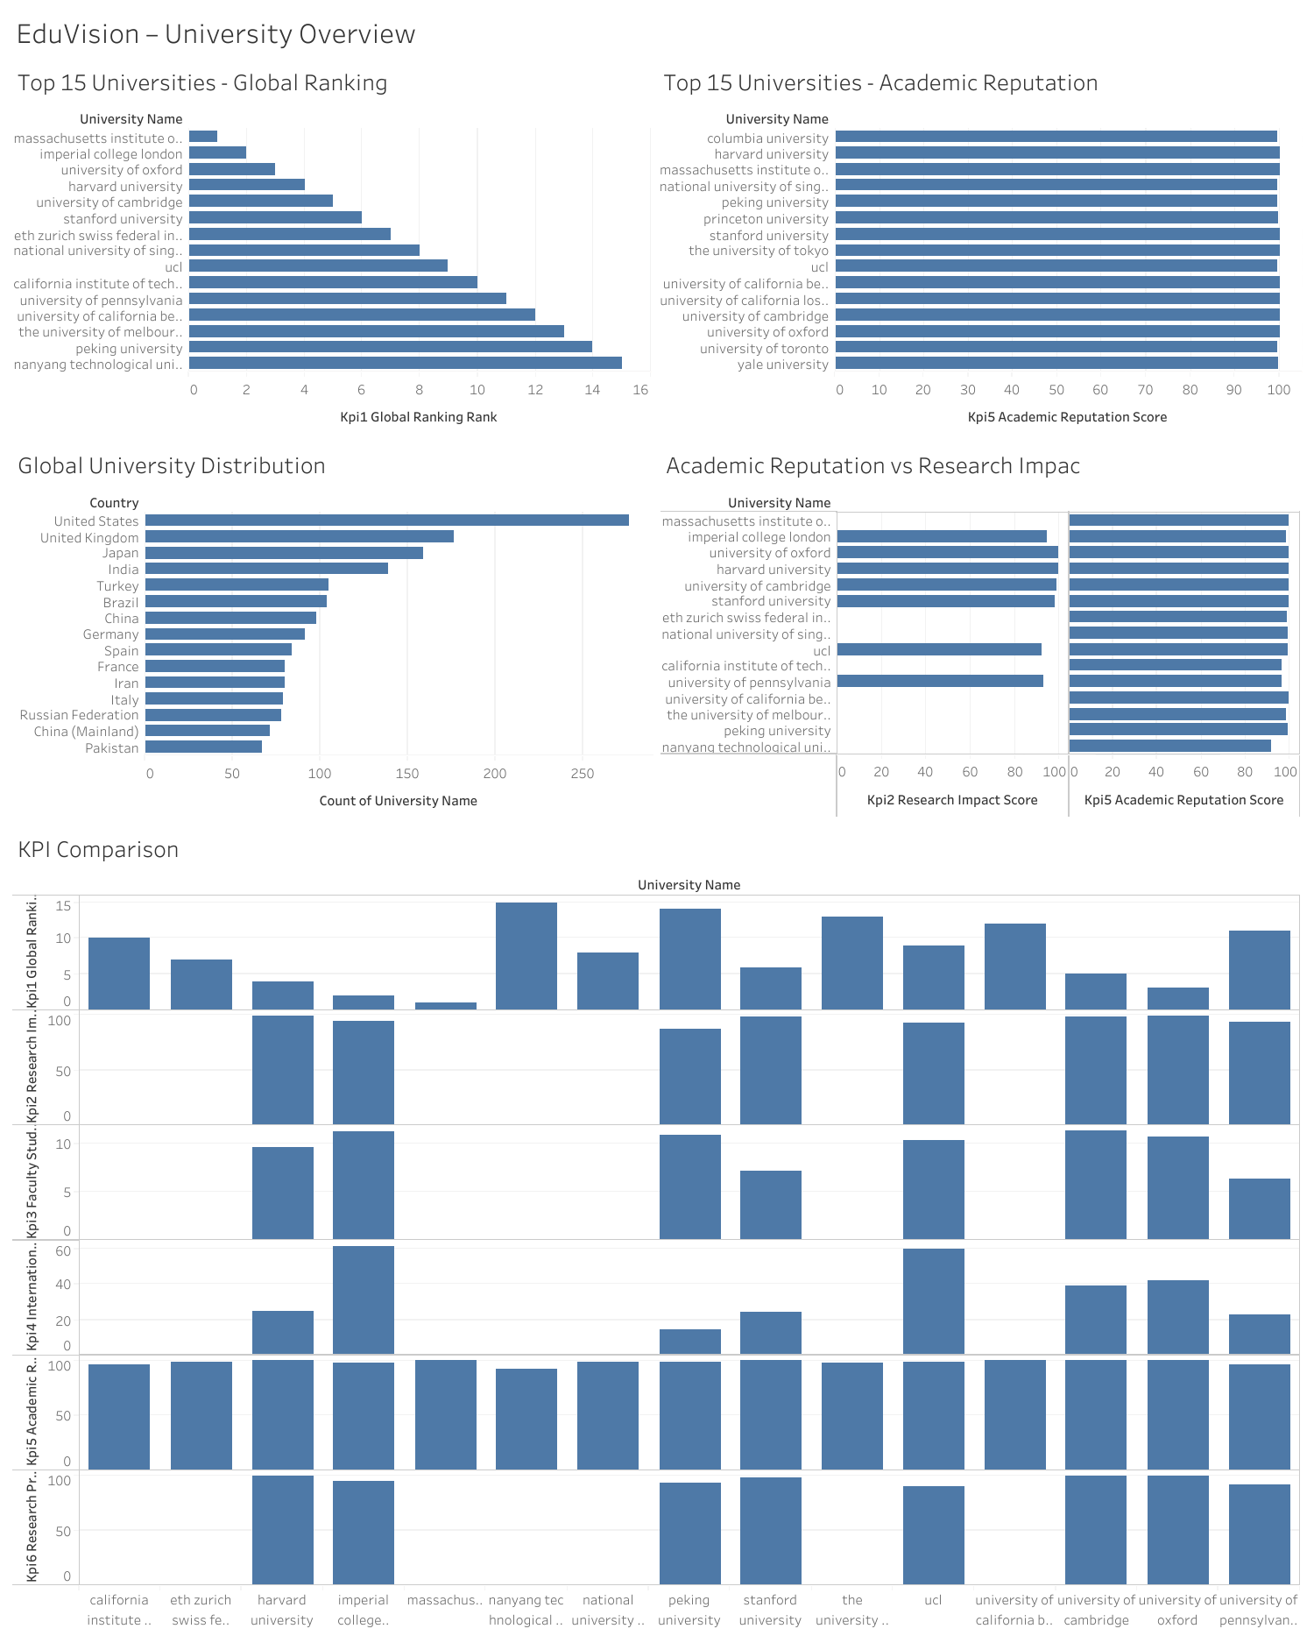
Figure: EduVision — University Overview

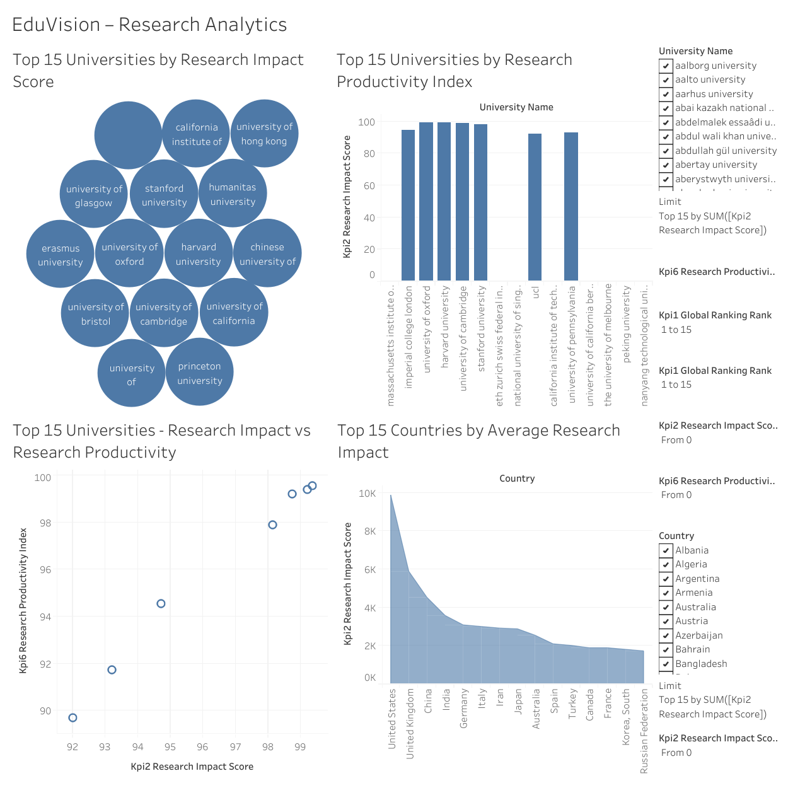
Figure: EduVision — Research Analytics

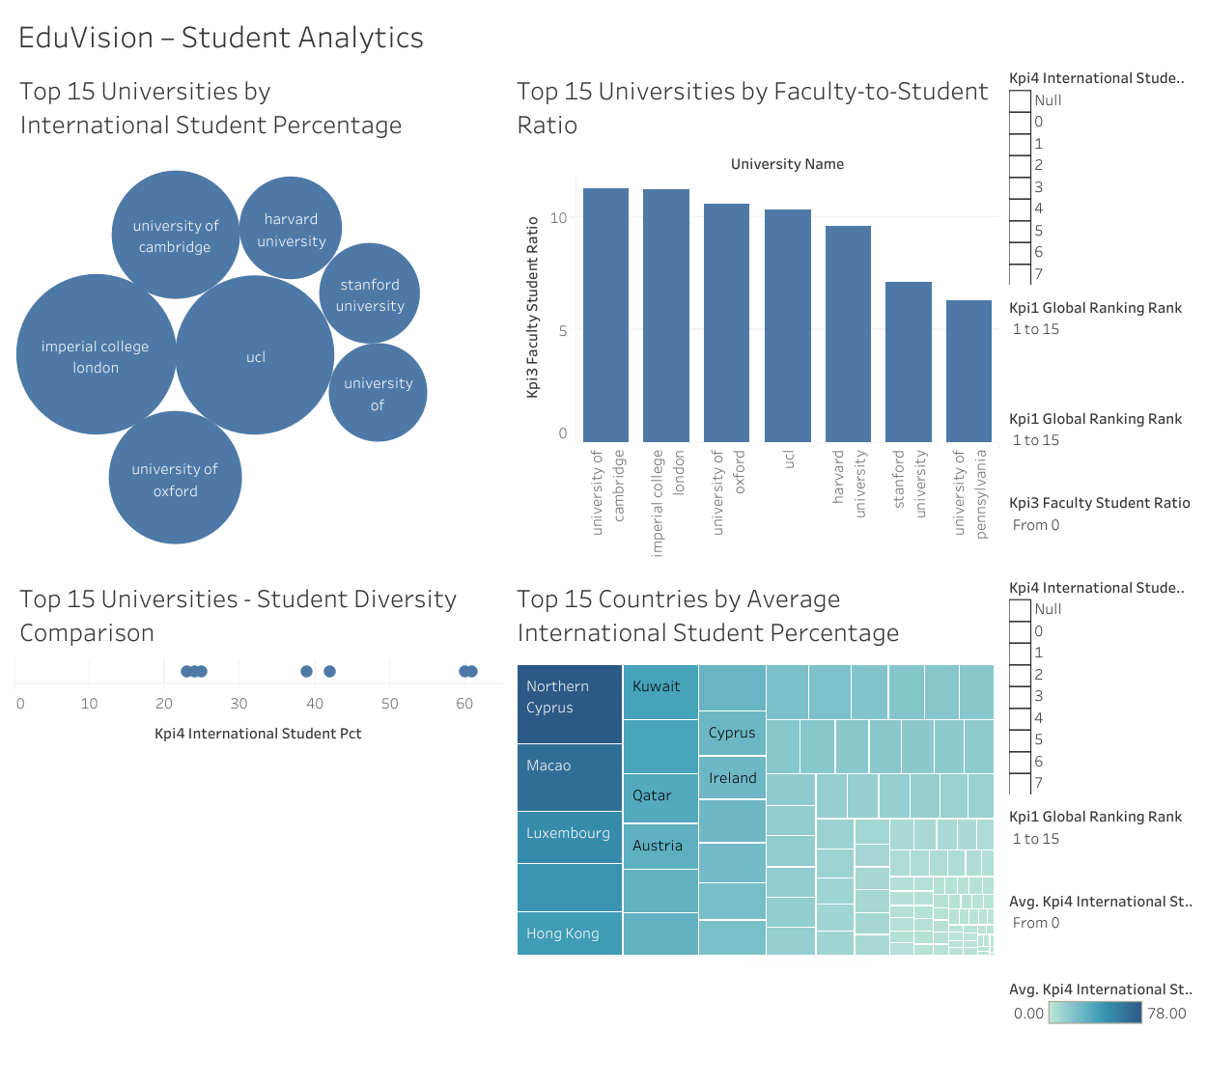
Figure: EduVision — Student Analytics

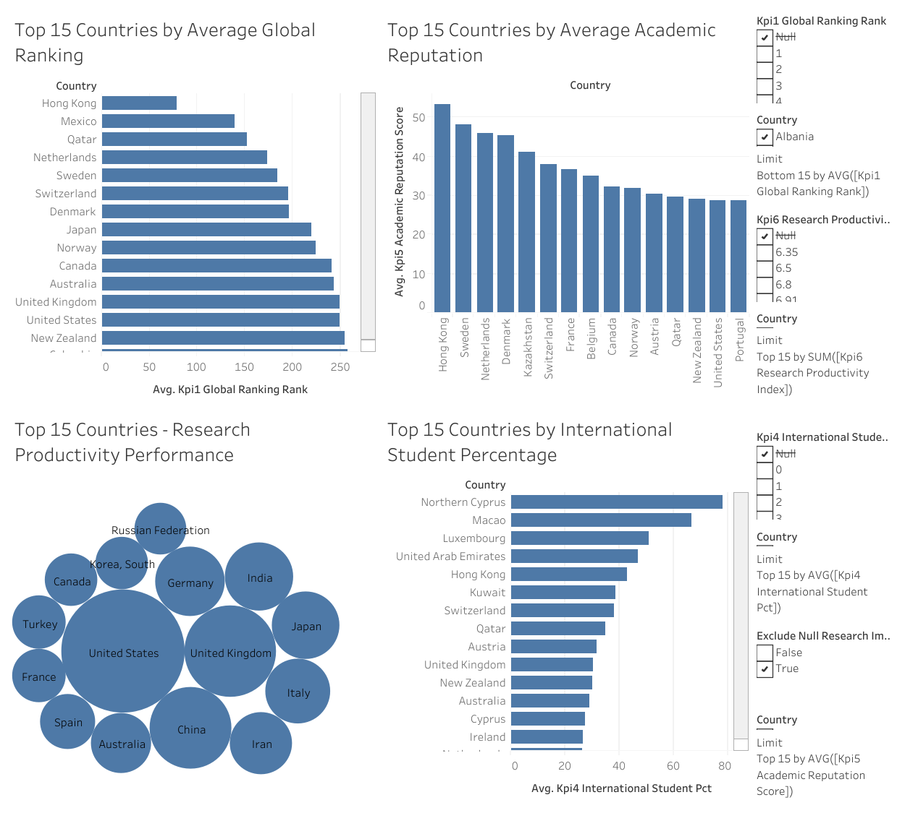
Figure: EduVision — Country Comparison

11. Dashboard Output Interpretation

University Overview
Provides a consolidated view of top university global ranking, academic reputation, global university distribution, reputation versus research impact and six-KPI comparison.

Research Analytics
Compares university research impact and research productivity and provides a country-level research impact view. The scatter plot shows records where both KPI values are available.

Student Analytics
Compares international student percentage, faculty-to-student ratio, student diversity and country-level international student percentage.

Country Comparison
Benchmarks countries using average global ranking, academic reputation, research productivity performance and international student percentage.

12. Dashboard Interaction & Usability
- University Overview supports selection-based exploration of university performance.
- Student Analytics supports relevant university and student-indicator comparisons.
- Country Comparison supports country-level selection and benchmarking.
- Research Analytics supports research exploration where required KPI values are available.
- Tooltips and ranking filters provide additional context.
- Not every chart is intended to cross-filter every other chart; interactions are scoped to logically related analyses.

13. Validation, Testing & QA

KPI Validation
- Global Ranking
- Research Impact
- Faculty-to-Student Ratio
- International Student Percentage
- Academic Reputation
- Research Productivity

Ranking Validation
- Top-15 ranking order checked.
- Displayed ranking values checked against analytical KPI fields.

Dashboard Testing
- University Overview interaction tested.
- Student Analytics interaction tested.
- Country Comparison interaction tested.
- Research Analytics interaction tested with a partial limitation where underlying research productivity data is unavailable.
- Navigation, chart readability and layout reviewed.

14. Limitations
- Source datasets have different coverage and reporting structures.
- Some universities do not have complete values for every KPI.
- Research Productivity Index is unavailable for some records because required underlying components are missing.
- Country-level indicators may have different year availability.
- Dashboard results are constrained by source coverage and quality.
- Missing KPI values are retained as NULL rather than estimated or replaced with zero.

15. Final Project Deliverables
- Raw datasets
- Cleaned datasets
- Final analytical data model
- KPI dataset
- Python data-processing notebooks/scripts
- EduVision_DV Tableau workbook
- Four major Tableau dashboards
- KPI validation worksheet
- Ranking calculation verification worksheet
- QA checklist
- Dashboard testing report
- Final project documentation
- GitHub repository

16. Conclusion & Future Scope
EduVision_DV demonstrates an end-to-end higher-education analytics workflow: source-data collection, cleaning, matching, KPI engineering, data modeling, Tableau visualization and validation. The final dashboards provide a unified view of university performance, research analytics, student indicators and country-level comparisons.

Future Scope
- Add newer approved ranking and education datasets.
- Extend historical trend analysis.
- Add advanced institutional and country benchmarking.
- Explore predictive analytics.
- Automate periodic data refresh and validation.

17. Documentation Basis
This document uses the EduVision project specification, available project documentation, and the four final Tableau dashboard screenshots supplied for the final documentation. The assignment requires documentation covering dataset sources, data dictionary, cleaning methodology, matching methodology, KPI definitions and formulas, data model, dashboard architecture and limitations.

