AUTOMATED LEGAL ARGUMENTS TRANSCRIPTION AND TRANSLATION

1.Introduction
The legal domain generates a vast amount of spoken content in the form of court proceedings, legal arguments, hearings, and discussions. Traditionally, this information is documented manually, which is a time-consuming and error-prone process. Moreover, legal systems often operate in multilingual environments, creating an additional challenge of translating legal content accurately while preserving its original meaning and context.
Automated Legal Arguments Transcription and Translation leverages advancements in Speech Recognition and Natural Language Processing (NLP) to convert legal audio recordings into accurate textual transcripts and translate them into required languages. The system aims to improve efficiency, accessibility, and reliability of legal documentation by reducing manual effort, enabling easy retrieval of legal information, and supporting multilingual legal communication.

2.Problem Statement
Legal proceedings and arguments are primarily conducted in spoken form, resulting in large volumes of audio data that are difficult to store, search, and analyze efficiently. Manual transcription of legal audio is time-consuming, costly, and prone to human errors, especially due to complex legal terminology, speaker variations, and background noise in courtroom environments.
Additionally, legal content often needs to be accessed in multiple languages to serve diverse stakeholders such as lawyers, judges, clients, and researchers. The lack of an automated and accurate system for both transcription and translation leads to delays, limited accessibility, and inefficiencies in legal workflows. Therefore, there is a need for a reliable solution that can automatically transcribe and translate legal arguments while preserving their legal meaning and context.

3. Objectives of the Project
The primary objective of this project is to develop an automated system that accurately transcribes legal audio recordings, including court proceedings and legal arguments, into structured textual form. By leveraging speech recognition techniques, the system aims to reduce the dependency on manual transcription and minimize errors caused by complex legal terminology and lengthy discussions.
Another key objective is to translate the transcribed legal content into required languages while preserving its original legal meaning and context. This ensures that legal information becomes more accessible to a wider audience, including lawyers, judges, clients, and legal researchers, thereby improving efficiency and communication within the legal system.

4. Scope of the Project
The scope of this project includes the automated transcription of legal audio recordings such as court hearings, legal arguments, and judicial discussions. The system focuses on converting spoken legal content into accurate and readable text while handling domain-specific legal terminology and formal language used in legal proceedings.
Additionally, the project covers the translation of transcribed legal text into one or more required languages to support multilingual legal environments. The system is intended to assist legal professionals, researchers, and students by improving accessibility, documentation efficiency, and information retrieval. Future enhancements may extend the system to support real-time transcription, multiple speakers, and advanced legal text analysis.

5. System Architecture
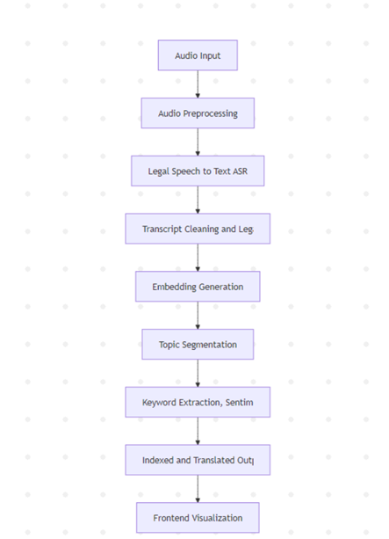
The system follows a modular pipeline to process legal audio recordings efficiently. First, audio input from court proceedings is preprocessed to remove noise and normalize volume. The cleaned audio is then transcribed into text using Automatic Speech Recognition (ASR) models. The transcribed text is processed to handle legal terminology and improve readability, after which it is translated into the required language. Finally, the output is stored in a structured format and displayed through a user-friendly interface, with optional analysis for quality and keyword highlights. This architecture ensures accurate, efficient, and accessible legal documentation.

6. Module Description
6.1 Audio Preprocessing Module
The audio preprocessing module is the foundation of the system, responsible for preparing raw recordings for accurate transcription. Courtroom audio often contains background noise, overlapping speech, low volume, and inconsistent pacing, which can negatively impact transcription accuracy. This module applies noise reduction algorithms, removes silent sections, normalizes audio levels, and filters out irrelevant sounds to produce a clean, high-quality audio signal. By standardizing the input, it ensures that the transcription module receives audio that is optimized for speech recognition, ultimately reducing errors and improving the fidelity of the text. Effective preprocessing is especially critical in legal contexts where precise wording and subtle nuances in speech can have significant implications.

6.2 Transcription Module
The transcription module converts the preprocessed audio into text using advanced Automatic Speech Recognition (ASR) models, generating accurate, time-stamped transcripts for each segment. Legal arguments are often complex, with specialized terminology, multiple speakers, and formal language structures. This module is designed to handle these challenges, capturing every spoken word with high precision. It also manages variations in accent, speech speed, and overlapping dialogues, ensuring that the resulting transcript is a faithful representation of the original proceedings. The transcription output serves as the backbone for all subsequent modules, and its accuracy directly affects translation quality, keyword extraction, and topic segmentation.

6.3 Topic Segmentation Module
Once transcription is complete, the topic segmentation module analyzes the text to identify natural boundaries between different arguments, discussions, or cases. Legal proceedings can be long and intricate, with multiple topics addressed in a single session. By segmenting the transcript into logical sections, this module enhances readability and makes it easier for users to locate specific arguments or points of interest. It uses lexical analysis and pattern recognition techniques to detect shifts in topics, enabling structured presentation and improving overall navigation. Segmentation also facilitates downstream processes, such as keyword extraction and sentiment analysis, by providing contextually coherent units of text for analysis.

6.4 Keyword Extraction Module
The keyword extraction module identifies critical terms and phrases that summarize each segment, helping users quickly understand the essence of legal discussions. It applies Natural Language Processing techniques, including semantic analysis and frequency-based weighting, to extract terms that are both representative and legally relevant. These keywords serve multiple purposes: they enable rapid content scanning, improve searchability within transcripts, and allow for efficient indexing and reference. By highlighting key points, this module reduces the time legal professionals spend navigating lengthy audio recordings, while ensuring that important legal concepts are not overlooked.

6.5 Sentiment and Quality Evaluation Module
This module is responsible for assessing both the accuracy and reliability of the transcribed and translated text. It evaluates transcription clarity, translation fidelity, and overall readability, identifying any inconsistencies or errors that could compromise legal integrity. Additionally, it can analyze the tone or sentiment of arguments when required, providing insights into the attitude or stance of speakers in certain contexts. This quality evaluation ensures that the final output is trustworthy and usable for legal documentation, research, and decision-making. High-quality assessment is crucial because even small errors in legal text can have significant consequences.
6.6 Frontend Visualization Module
The frontend visualization module presents the processed data in an organized, interactive interface. Users can view the full transcript, translated text, segmented topics, and extracted keywords, all in a searchable and navigable format. Interactive features, such as timestamp-based audio navigation, keyword highlighting, and segment filtering, allow legal professionals to access relevant information efficiently without listening to entire recordings. By providing a user-friendly interface, this module bridges the gap between raw legal data and actionable insights, making the system practical and effective for daily use in courts, law firms, and research institutions.
Overall, the coordinated operation of these modules ensures that the system delivers a complete solution for legal transcription and translation. By automating labor-intensive processes, preserving legal accuracy, and improving accessibility, the system supports lawyers, judges, and researchers in managing complex legal information more efficiently. Its modular architecture also allows for future enhancements, including real-time transcription, speaker diarization, and advanced legal analytics, ensuring that it remains a scalable and adaptable solution for evolving legal workflows.

7. Usage of the System
The Automated Legal Arguments Transcription and Translation system provides a comprehensive framework for processing legal audio recordings, generating accurate transcripts, translating content, and presenting results in an organized and accessible manner. It is designed to be user-friendly, scalable, and compatible with standard computing environments.

7.1 System Requirements
To run the system effectively, the following requirements should be met:
- Operating System: Windows, Linux, or macOS
- Python Version: 3.9 or higher
- RAM: Minimum 8GB, 16GB recommended for faster processing
- Storage: Approximately 2–3 GB for models and dependencies
- CPU: Multi-core processor recommended
- Additional Software: Node.js for frontend visualization (optional)

7.2 Project Setup and Installation
- Clone the Repository
git clone https://github.com/your-username/legal-transcription-translation.git
cd legal-transcription-translation
- Create a Virtual Environment
Creating a virtual environment ensures that all Python dependencies are isolated and do not conflict with the system Python.
python -m venv venv
source venv/bin/activate # On Windows: venv\Scripts\activate

7.3 Environment Configuration
A .env file is required for configuring environment-specific variables, such as database paths, API keys, or model directories. Create a .env file in the root directory using the provided example:
cp.env.exanple.env
Ensure that all paths correspond to your local setup before running the system.

7.4 Running the Backend Pipeline
The backend pipeline handles the complete processing workflow, from audio preprocessing to transcription, translation, and storage. It can be executed using the pipeline controller:
python main.py
Processing Steps:
- Audio Preprocessing – Cleans the uploaded legal audio files for optimal transcription.
- Transcription – Converts audio to text with timestamps using ASR models.
- Topic Segmentation – Divides the transcript into logical sections for easier navigation.
- Keyword Extraction – Identifies key legal terms and phrases in each segment.
- Sentiment and Quality Evaluation – Ensures transcription and translation accuracy.
- Storage – Saves processed outputs in structured directories for further access.

7.5 Output Generation
The generated outputs are stored in structured directories:
• Transcripts → Inference/transcripts/
• Segments → Inference/segments/
• Keywords → Included inside segment JSON files
• Quality Metrics → Word Error Rate (WER), Character Error Rate (CER), semantic similarity
7.6 Frontend Visualization
To visualize results using the frontend interface:
cd automated legal arguments
npm install
start The application can be accessed at:
http://localhost:3000
7.7 User Interface Preview
Figure -7.1: UI Landing Page of the Automated Medical Podcast Transcription and Topic Segmentation System
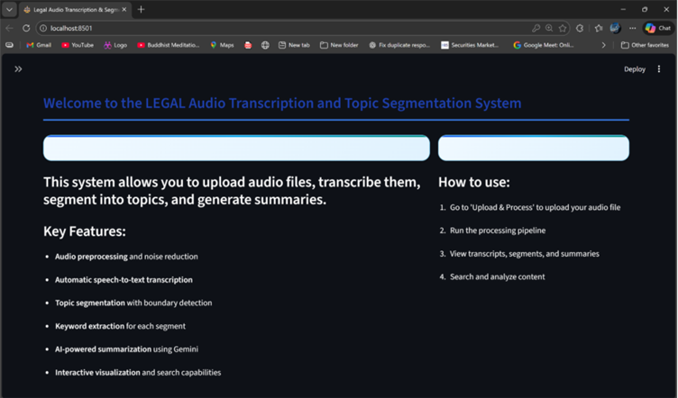
7.8 Testing and Validation
The system’s backend modules are rigorously validated using Pytest, ensuring the correctness and reliability of all processing components. Running the following command executes the test suite:
pytest -v
These tests cover key functionalities, including topic segmentation, keyword extraction, sentiment analysis, and overall quality evaluation of transcriptions and translations. Validation ensures that the system produces accurate, consistent, and trustworthy outputs, which is critical for handling legal content where precision is essential.

7.9 Notes on Usage
- All audio files are processed offline and are not permanently stored to maintain privacy.
- Large inference outputs, such as model weights and intermediate processing files, are excluded from version control to optimize repository size.
- The system is intended strictly for educational and analytical purposes and should not be used for official legal proceedings without proper verification.

8. Technology Stack
The proposed system is implemented using a layered technology stack to ensure efficient audio processing, advanced natural language analysis, and interactive visualization. The stack consists of the following layers:
- Frontend Layer: Built with React.js, HTML, CSS, and JavaScript to provide a responsive and interactive user interface. Data visualization is implemented using Chart.js, Plotly, and Matplotlib, allowing users to navigate transcripts, segments, and keywords easily. Communication with the backend is handled through REST APIs.
- API Layer: Implemented using Flask, this layer manages requests, orchestrates backend processing, and facilitates data exchange between frontend and backend components.
- Backend Processing Layer: Developed using Python 3.9+, this layer handles audio preprocessing, transcription, and intermediate data generation. Whisper or Faster-Whisper models are used for accurate speech-to-text conversion, while Librosa, PyDub, and FFmpeg manage audio cleaning, normalization, and processing tasks.
- NLP and Machine Learning Layer: Responsible for advanced text analysis, this layer performs topic segmentation, keyword extraction, and sentiment analysis using HuggingFace Transformers, Sentence Transformers, NLTK, SpaCy, KeyBERT, YAKE, and RAKE.
- Storage Layer: Manages structured and semi-structured data using JSON and CSV formats. Optional support for SQLite and FAISS allows persistent storage and similarity search, enabling efficient retrieval of transcribed and analyzed legal content.

9. Project Structure
9.1 Backend Structure
The backend consists of several Python modules, each performing a specific function in the processing pipeline:transcription.py – Converts legal audio into text and generates precise timestamps for each segment.
- segmentation.py – Detects topic boundaries and divides transcripts into logically coherent sections.
- evaluation_summary.py – Computes transcription accuracy metrics, such as Word Error Rate (WER), Character Error Rate (CER), and semantic similarity between reference and generated transcripts.
- sentiment_analysis.py – Evaluates the tone and sentiment of legal arguments when required.
- keyword_extraction.py – Identifies and counts key legal terms or phrases for indexing and quick reference.
- logger.py – Tracks pipeline execution, logs errors, and maintains a record of processing for debugging and monitoring purposes.
This modular design ensures that each component of the backend is focused, maintainable, and can be independently tested.

9.2 API Layer
The API layer is implemented using Flask, which handles incoming requests from the frontend and manages communication with the backend processing pipeline. The backend pipeline controller coordinates audio preprocessing, transcription, segmentation, keyword extraction, sentiment evaluation, and storage, and sends the processed results to the frontend via RESTful APIs. This separation of concerns ensures that the system is scalable and that the frontend can access processed data efficiently.

9.3 Frontend Structure
The frontend provides an interactive dashboard for legal professionals to access and analyze processed transcripts. Users can navigate by timestamps, explore topic-based segments, search for keywords, and view quality metrics. The interface also allows viewing translations alongside the original transcripts, making it easier to analyze multilingual content. Data visualization libraries such as Chart.js and Plotly are used to present summaries, segment distributions, and keyword frequencies in an intuitive manner.

9.4 Data and Output Folders
The system maintains separate directories for:
- Clean reference transcripts
- Generated transcripts
- Processed outputs such as JSON, CSV, or evaluation reports
This organization ensures that all outputs are clearly structured, easy to retrieve, and properly versioned, while keeping raw and processed data separate for privacy and reproducibility.

10. Milestone-wise Implementation
The project was implemented in sequential phases:
- Audio Preprocessing and Transcription – Raw legal audio was cleaned and converted to text.
- Topic Segmentation and Keyword Extraction – Transcripts were divided into sections and key terms were extracted.
- Sentiment and Quality Evaluation – Transcribed and translated content was analyzed for accuracy and tone.
- Frontend Integration and Visualization – Dashboards were built for easy navigation and exploration of processed content.
- Documentation and Finalization – The complete system was documented, tested, and prepared for submission.

11. Data and Privacy Considerations
All audio files are processed temporarily and are not permanently stored to ensure confidentiality. Environment variables are used to securely manage API keys and sensitive configurations. No personal user data or identifying information is retained, ensuring compliance with privacy standards.

12. Challenges Faced
Key challenges included:
- Handling legal terminology accurately during transcription and translation.
- Managing poor audio quality, background noise, and overlapping speech.
- Tuning topic segmentation to accurately reflect shifts in arguments.
- Ensuring consistent and context-aware sentiment analysis for nuanced legal discussions.

13. Limitations
- The system supports only recorded audio files and does not handle real-time transcription.
- Accuracy may vary depending on audio clarity, background noise, and speaker accents.
- The system does not provide legal advice or analysis; it is intended strictly for transcription and translation purposes.

14. Troubleshooting
- Low transcription accuracy can be addressed by enhancing audio quality or adjusting ASR parameters.
- Topic segmentation issues may require fine-tuning similarity thresholds or segmentation logic.
- All errors and warnings are logged through the logger module, facilitating efficient debugging.

15. Future Scope
Potential future enhancements include:
- Legal Named Entity Recognition to identify case names, statutes, and important legal entities.
- Speaker Diarization to distinguish between multiple speakers in hearings.
- Multilingual transcription support for broader accessibility.
- Semantic search to enable retrieval of relevant sections from large transcripts.
- Automated summarization of topics for quick review of proceedings.

16. Intended Users
The system is designed for:
- Lawyers and legal practitioners
- Judges and court staff
- Legal researchers and students
- Multilingual legal teams requiring translated transcripts

17. License
This project is licensed under the MIT License, allowing free use, modification, and distribution with proper attribution.

18. References
- OpenAI Whisper Documentation
- HuggingFace Transformers Documentation
- Sentence Transformers Research Papers
- Librosa Audio Processing Library Documentation
- Research studies on ASR, NLP, and topic segmentation in legal contexts

