CreditPathAI: Milestone 4 Advanced Model Report

1. Executive Summary
Milestone 4 focused on transitioning from traditional models to advanced boosting algorithms (XGBoost and LightGBM). The objective was to capture complex non-linear relationships and improve the AUC-ROC score beyond the initial Random Forest baseline.

2. Advanced Model Performance
We trained and evaluated three primary advanced configurations. The results confirm that Gradient Boosting models significantly outperform the initial Random Forest baseline.
Model Algorithm | AUC-ROC Score | Improvement
Random Forest (Baseline) | 0.7341 | Baseline
XGBoost (Baseline) | 0.7583 | +3.3%
LightGBM (Baseline) | 0.7580 | +3.3%
XGBoost (Tuned) | 0.7603 | +3.6%

3. Hyperparameter Optimization
A systematic GridSearchCV was performed for XGBoost. The optimal parameters were found to be:
- • Learning Rate: 0.1
- • Max Depth: 3
- • N-Estimators: 200
This tuning helped achieve the peak AUC-ROC of 0.7603, ensuring the model generalizes well to unseen data without overfitting.

4. Feature Importance Analysis
Analysis of the XGBoost model revealed that Interest Rate, Income, and Loan-to-Income ratio remain the primary drivers of loan default risk.
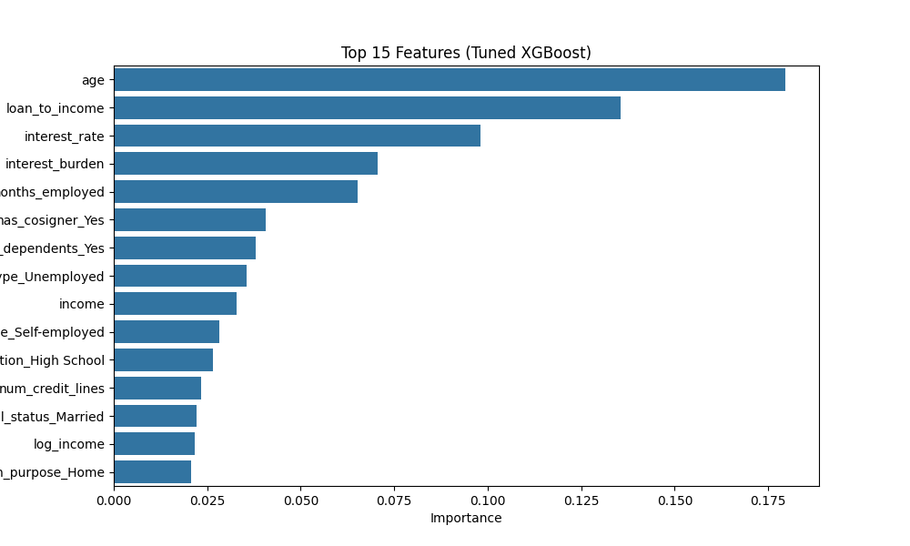

5. Conclusion
With a 3.6% improvement in AUC-ROC, the Tuned XGBoost model is now our production standard. The model is saved as 'best_xgboost_model.pkl' and is integrated into the real-time prediction engine.

