AI-POWERED SIGN LANGUAGE
LEARNING & ASSESSMENT PLATFORM
PROJECT DOCUMENTATION
Team 3 Project Report

1. Project Information
Item | Details
Project Title | AI-Powered Sign Language Learning & Assessment Platform
Project Guide | Shravya
Duration | Milestone 1–4 (Weeks 1–8)
Current Recognition Scope | Four practice areas are implemented: ASL Alphabet (static handshapes), Everyday Gestures (Wave, Clap — motion), Conversational Fluency (16-word MS-ASL vocabulary — motion), and Common Signs (I Love You, Yes, No — static). Earlier milestones covered alphabet recognition only; motion-sign and word-sign recognition, plus a real-time "Live mode" evaluation layer across all four areas, were added in later milestone work.

S. No. | Team Member | Responsibility
1 | Lubna Kauser | Frontend and Backend
2 | Boya Gunasekhar | Frontend
3 | Shaik Rahamath Sharif | Datasets
4 | Rashmi Das | Documentation
5 | Roshesh Chaware
6 | Shaik Karishma | AI/ML Model Development

2. Abstract
The AI-Powered Sign Language Learning & Assessment Platform is an interactive system for learning, practicing and assessing sign language. It brings together structured learning content, sign-language recognition across four practice areas, real-time gesture evaluation, practical assessment, AI feedback, analytics, personalized learning, certification, instructor tools, reporting, automated testing and deployment. Recognition now spans static alphabet handshapes (a trained SVM classifier on MediaPipe hand landmarks), rule-based motion gestures (Wave, Clap), a trained classifier over a 16-word MS-ASL vocabulary, and rule-based static common signs (I Love You, Yes, No). A newly added real-time "Live mode" lets a learner see a continuously updating recognition read while holding a pose, in addition to the original capture-then-submit graded flow. The project also includes certificate issuance (automatic and manual) with PDF, in-app badge and public verification, instructor roster and reporting tools, class-wide analytics dashboards, and an automated backend and frontend test suite.

3. Introduction

3.1 Background
Sign language learning requires regular practice, clear learning material, accurate recognition and useful feedback. Technology can support this process by connecting learning content with camera-based gesture practice, automated assessment and performance tracking — including feedback that arrives while the learner is still signing, not only after they submit an attempt.

3.2 Problem Statement
Learning, recognition, assessment and progress tracking are often separate activities. Learners may not receive immediate, objective feedback while practicing a sign, and instructors may need to evaluate performance manually. This project addresses these needs through an integrated learning and assessment platform with both graded, logged practice attempts and a real-time, non-graded evaluation preview.

3.3 Objectives
- Develop an interactive sign language learning platform.
- Implement sign language recognition using computer vision and hand tracking, across static and motion-based signs.
- Assess performed gestures and provide accuracy-based results.
- Provide real-time, continuously updating recognition feedback while a learner practices, alongside the graded submit flow.
- Identify mistakes and provide corrective, skill-tiered feedback.
- Track learner progress and skill development.
- Provide personalized recommendations and learning plans.
- Support certification (automatic and manual), instructor reporting, class-wide analytics, testing and deployment.

4. Scope

4.1 In Scope
- User registration, login and role-based access (learner, instructor, admin).
- Learning Module: courses, lessons and practice activities.
- Assessments Module: practical assessments, scoring and results.
- Sign-language recognition across four practice areas: ASL Alphabet, Everyday Gestures (motion), Conversational Fluency (MS-ASL word signs), and Common Signs.
- Hand landmark extraction and gesture/motion/word classification.
- Real-time "Live mode" evaluation: a continuously updating, non-graded recognition preview available on all four practice pages, in addition to the graded capture/record flow.
- AI feedback and corrective guidance, tiered to the learner's current skill level.
- Analytics and learner progress tracking, including streaks, achievements and a performance forecast.
- Personalized recommendations and learning plans.
- Certification Module: automatic issuance on course completion, manual issuance by staff, PDF certificate, in-app badge and a public verification page.
- Instructor tools: roster ownership, private notes on learners, assignments with due dates, bulk assignment, and class-wide analytics.
- Reports, notifications, automated testing (backend and frontend) and deployment.

4.2 Out of Scope / Current Constraints
- Recognition currently covers the ASL Alphabet, two motion gestures (Wave, Clap) and a 16-word MS-ASL vocabulary, plus three common static signs — this is a meaningfully wider set than the alphabet-only scope of earlier milestones, but is still short of the full ASL vocabulary described in the original specification.
- The motion- and word-sign pipelines classify short clips (a few seconds), not continuous multi-sign sentence translation.
- The word-sign classifier's measured test accuracy is 49% across its 16 supported words — lower than the alphabet classifier, reflecting limited training clips per word; this is disclosed to learners in the product itself, not only in this document.
- Real-time Live mode is a supplementary, non-scoring preview; it deliberately never creates a logged attempt and never affects streaks, accuracy statistics or certificates — only the original capture/record flow does.
- Actual cloud-hosting details and final measured performance values (latency, concurrent-user capacity) should be inserted from the final deployment and load-testing evidence, which has not yet been produced.

5. Existing System & Proposed Solution

5.1 Existing System
Existing approaches may provide learning content, gesture recognition or assessment as separate functions, and typically only score a sign after it has already been submitted. This can make it difficult to connect practice results with personalized improvement, and gives a learner no feedback while they are still adjusting their hand shape.

5.2 Proposed Solution
The proposed platform connects learning, sign recognition, assessment, feedback and analytics so that a learner's performance can directly influence the next learning activity. A real-time Live mode adds a second, lightweight feedback loop: while a learner holds a pose, the platform polls the same recognition models used for grading and shows what they currently see — correct, incorrect, or no hand detected — without that preview ever being logged as an attempt. The learner still submits a real, graded attempt through the original capture/record button when ready.

5.3 Key Features
- Interactive Learning Module
- Assessments Module
- Real-time live gesture evaluation across all four practice areas (off by default, does not affect grading)
- Certification Module — automatic and manual issuance, PDF certificate, in-app badge, public verification page
- Analytics Module — streaks, achievements/badges, per-letter accuracy, AI performance forecast
- Instructor Module — roster ownership, private notes, assignments and bulk assignment, class-wide analytics
- Hand and pose tracking (MediaPipe)
- Sign recognition and classification — trained classifiers (alphabet, word signs) and rule-based geometry (motion, common signs)
- AI feedback and correction, tiered to learner skill level
- Personalized learning recommendations
- Role-based dashboards (learner, instructor, admin)
- Reports and notifications, with PDF export
- Automated backend (pytest) and frontend (Jest / React Testing Library) test suites

6. Technology Stack
Area | Technology
Languages | Python, TypeScript / JavaScript
Frontend | React 19 with TypeScript, React Router v7, Axios
Backend | FastAPI, SQLAlchemy ORM, Pydantic v2
Database | SQLite (file-based, via SQLAlchemy) — PostgreSQL/MongoDB were considered in the original specification but are not the database actually used by the implemented backend
AI/ML | Scikit-learn (SVM for alphabet, a trained classifier for MS-ASL word signs); TensorFlow, PyTorch and XGBoost were named in the original specification but are not used by the implemented pipeline
Computer Vision | OpenCV, MediaPipe (hand landmark extraction)
Gesture Recognition | SVM classifier (alphabet, trained on MediaPipe hand landmarks); trained classifier on real MS-ASL video clips (16 words); rule-based hand-trajectory geometry (Wave/Clap motion signs); rule-based static hand-landmark geometry (Common Signs). CNN/LSTM/Transformer models were specified originally but are not part of the current implementation.
Pose & Hand Tracking | MediaPipe Hands
PDF Generation | ReportLab (certificate PDFs and instructor/admin reports)
UI Styling | A custom CSS design-token system (tokens.css) shared across components; Tailwind CSS is present as a dependency but is not the styling approach used in the implemented UI
Authentication | JWT authentication (python-jose), password hashing via passlib/bcrypt
Automated Testing | pytest (backend), Jest + React Testing Library (frontend)
Dev / Version Control | VS Code, Git, GitHub
Libraries / APIs | Axios (frontend HTTP client); SQLAlchemy ORM and Pydantic v2 (backend data layer); OpenCV and MediaPipe (computer vision); ReportLab (PDF generation); python-jose and passlib/bcrypt (authentication); pytest and Jest + React Testing Library (automated testing).
Deployment | Docker, Docker Compose (local/self-hosted); cloud deployment (e.g. AWS/Azure) is not yet performed

7. System Architecture
The system is organized around a React/TypeScript frontend, a FastAPI backend/API layer, AI/ML and recognition services (MediaPipe + scikit-learn), and a SQLite database accessed through SQLAlchemy. Learning, assessment, feedback, analytics, certification and instructor functions all communicate through the application backend.

7.1 High-Level Data Flow
User → Frontend → Backend/API → AI/ML & Assessment (graded) or Live Recognition (real-time, non-graded) → Database/Storage → Feedback & Analytics → Dashboard/Reports

7.2 System Modules
Module | Purpose
User Management Module | Registration, authentication, profiles, roles and permissions.
Learning Module | Courses, lessons, learning content and practice activities.
Assessments Module | Practical assessments, submissions, scoring and results, across all four practice areas.
Sign Language Recognition Module | Camera input, hand tracking, feature extraction, classification and recognition for alphabet, motion (Wave/Clap), word-sign (MS-ASL) and common-sign practice; includes a real-time Live mode that polls a non-scoring recognition endpoint for continuous feedback.
Performance Evaluation Module | Scores, strengths, weaknesses and performance analysis.
Progress Tracking Module | Learning history, completion, scores, streaks and progress trends.
Personalized Learning Module | Learner analysis, recommendations, personalized plans and an AI-generated performance forecast.
Certification Module | Automatic certificate issuance on course completion, manual issuance by instructor/admin staff, downloadable PDF certificate, in-app badge, and a public certificate-verification page.
Analytics Module | Learner-level performance/progress dashboards (streaks, achievements/badges, per-letter accuracy) and instructor-facing class-wide trend analytics.
Notification & Reminder Module | Practice reminders, assessment alerts, completion and achievement notifications.
Reports & Export Module | Class/roster reports, platform-wide reports, assignment reports and certificate PDFs; PDF export via ReportLab.
Instructor Module | Roster ownership (add/remove learners), private notes on learners, assignments with due dates and notes, and bulk assignment.
Administrative Module | User, content, assessment, performance and certification management.

8. AI/ML Implementation

8.1 Datasets
- ASL Alphabet Dataset — labelled training/testing images used to train the alphabet SVM classifier.
- MS-ASL (Microsoft American Sign Language) video clips — used to train the 16-word Conversational Fluency classifier. An earlier attempt at a larger, 30-word vocabulary reached only 32.5% test accuracy because several words had too few usable clips; narrowing to the 16 words with enough real training data raised measured test accuracy to 49%.
- Everyday Gestures (Wave, Clap) and Common Signs (I Love You, Yes, No) do not use a trained dataset — they are recognized with rule-based hand-landmark/trajectory geometry rather than a classifier.

8.2 Data Processing (Alphabet)
- Validate dataset paths and class directories.
- Process labelled images class-wise.
- Detect the hand using MediaPipe.
- Extract 21 hand landmarks.
- Normalize landmark coordinates.
- Convert each sample into 63 numerical features.
- Store processed features and train the classifier (stored as gesture_classifier.pkl for inference).

8.3 Model / Algorithm Summary
Practice Area | Approach | Notes
Alphabet | Trained SVM classifier over 63 MediaPipe hand-landmark features | Model file: gesture_classifier.pkl
Everyday Gestures | Rule-based hand-trajectory geometry over a short frame sequence | Wave, Clap only; not a trained model
Conversational Fluency | Trained classifier on real MS-ASL video-clip landmark sequences | Model file: msasl_intermediate_classifier.pkl; 16 words; 49% measured test accuracy
Common Signs | Rule-based static hand-landmark geometry | I Love You, Yes, No; not scored/logged as a graded attempt by design

8.4 Training & Evaluation
The processed landmark features for the alphabet and word-sign models are used to train and evaluate candidate classifiers on held-out test data. The word-sign classifier's measured test accuracy (49% across 16 words) is reported to learners directly in the Conversational Fluency page. Final numerical accuracy, precision, recall, F1-score, confusion matrix and latency values for the alphabet classifier should be taken from the actual evaluation outputs and inserted into Section 14 rather than assumed.

8.5 AI/ML Workflow (Graded Attempt)
ASL Image / Webcam Frame(s) → MediaPipe Hand/Pose Detection → Landmark Extraction → Normalization → Feature Vector → Classifier or Rule-Based Geometry → Predicted Sign → Assessment / Tiered AI Feedback → (logged attempt, streaks, certificates)

8.6 Real-Time "Live Mode" Evaluation
Added in response to a mentor requirement for real-time gesture evaluation, Live mode is an off-by-default toggle available on all four practice pages. While active, the frontend repeatedly captures the current camera frame (or, for the two motion-based areas, a short rolling window of frames) and sends it to a non-scoring recognition endpoint — a self-pacing loop that waits for each response before scheduling the next call, so a slow response never causes requests to pile up. The result is shown immediately as a continuously updating read (e.g. "Live read: A (87%)", "No hand detected", or "Live read: Wave").
- Alphabet and Common Signs poll a single-frame /recognize endpoint roughly every 0.7 seconds.
- Everyday Gestures and Conversational Fluency, which need a short clip to classify motion, collect an 8–10 frame rolling window (about 1.2–1.5 seconds) before each call.
- Live mode is strictly a preview: it never creates a logged practice attempt and never touches streaks, per-letter accuracy, or certificate progress — verified with dedicated backend tests asserting attempt counts are unchanged after calling the recognition endpoints. The original capture/record flow, which drives all graded data, is unchanged.
- For the alphabet endpoint specifically, one new backend endpoint (POST /api/practice/recognize) was added to mirror the non-scoring "tester" endpoint pattern the other three practice areas already had.

9. Database & API

9.1 Database
SQLite is the database actually used by the implemented backend, accessed through the SQLAlchemy ORM (PostgreSQL and MongoDB were considered in the original specification but are not part of the current implementation). The data model supports users, learner profiles, courses, practice attempts across all four practice areas, assessments, feedback, progress, recommendations, learning plans, certifications, instructor assignments/notes, class trends and reports.

9.2 Major Entities
Entity | Purpose
Users / Roles | Authentication and authorization (learner, instructor, admin).
Learner Profiles | Learning level, goals, history and practice statistics.
Courses / Modules / Lessons | Structured learning content.
Practice Attempts | Graded practice records per area — PracticeAttempt (alphabet), MotionSignAttempt (Everyday Gestures), WordSignAttempt (Conversational Fluency); Common Signs is intentionally unscored/unlogged by design.
Assessments | Assessment attempts, scores and performance metrics.
Feedback | Assessment-based, skill-tiered corrective guidance.
Progress / Skills / Streaks | Historical performance, streaks and skill progression.
Recommendations / Learning Plans | Personalized next-step activities and an AI performance forecast.
Certificates | Certificate records with issuance type (auto/manual), a downloadable PDF, an in-app badge, and a verification code used by the public verification page.
Instructor Assignments / Notes | Assignments with due dates and notes, bulk assignment, and private instructor notes on individual learners.
Class Trends | Instructor-facing, class-wide analytics aggregated across a roster.
Notifications / Reports | Alerts and generated class/roster/platform/assignment reports.

9.3 API
- Authentication and user APIs
- Profile, course and lesson APIs
- Practice and recognition APIs — a graded /feedback endpoint and a non-scoring /recognize endpoint (used by Live mode) for each of the four practice areas
- Assessment and result APIs
- Feedback and analytics APIs, including class-trends endpoints for instructors
- Recommendation and learning-plan APIs
- Certification APIs — issue (auto/manual), revoke, and public verification
- Instructor APIs — roster ownership, notes, assignments, bulk assignment
- Reporting APIs — class, platform-wide and assignment reports, with PDF export
- Administrative APIs
FastAPI provides the backend API layer. OpenAPI/Swagger (auto-generated by FastAPI) can be used for API documentation and testing.

10. User Interface
Interface | Purpose
Login / Registration | Authentication and role-aware access.
Learner Dashboard | Progress, accuracy, streaks, achievements, recommendations, AI performance forecast and skill tracking.
Learning Interface | Courses, modules, lessons and practice activities.
Sign Recognition Interfaces (4) | Practice (Alphabet), Everyday Gestures (motion), Conversational Fluency (word signs) and Common Signs — each with camera input, hand tracking, the graded capture/record flow, and an off-by-default real-time Live mode toggle with a continuously updating recognition readout.
Assessment Interface | Practical assessment, score and result display.
Progress / Analytics | Performance trends, skills, streaks, achievements and weak areas.
Certification Interface | Certificate badges, PDF download, and eligibility/issuance status; a public certificate-verification page for anyone with a verification code.
Instructor Dashboard | Roster ownership, private learner notes, assignments and bulk assignment, class-wide analytics, and report generation.
Admin Dashboard | User, content, platform and system management.
Reports / Notifications | Report generation, PDF export and user alerts.
The final submission should include actual screenshots of the major interfaces — including the new Live mode toggle and readout on each practice page — with figure numbers and short descriptions.

10.1 Application Screenshots
The following figures are real screenshots of the running application, captured from a live session (backend on port 8000, frontend on port 3000) using demo accounts seeded with genuine practice data.
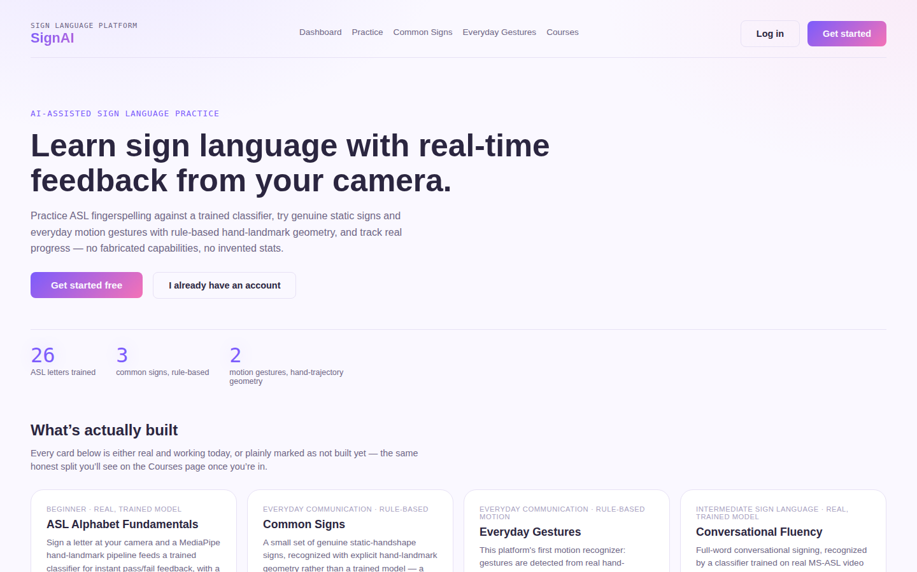
Figure 1. Landing page.

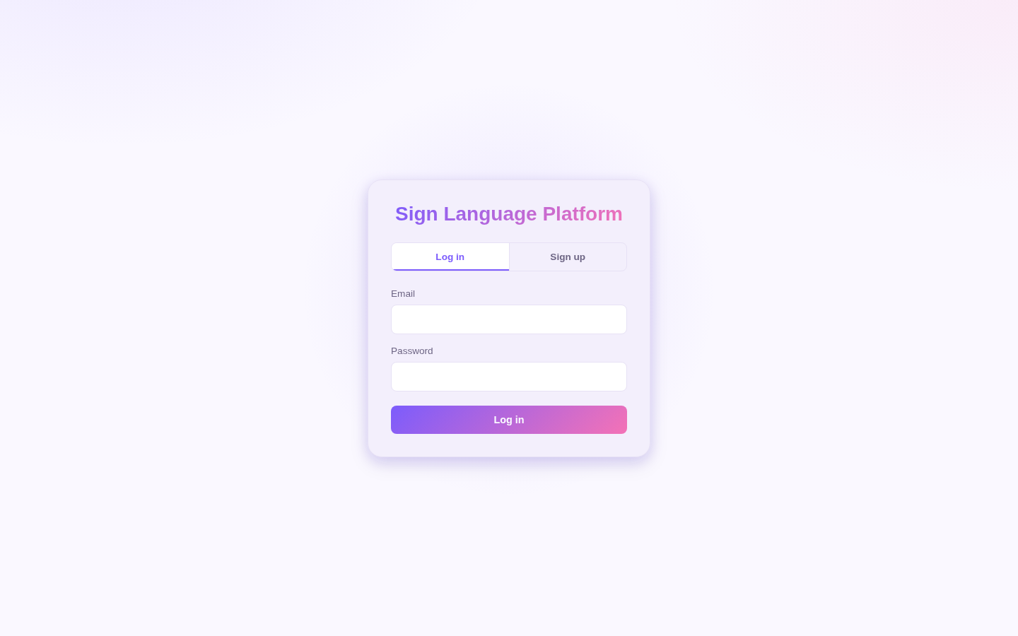
Figure 2. Login / Sign-up.

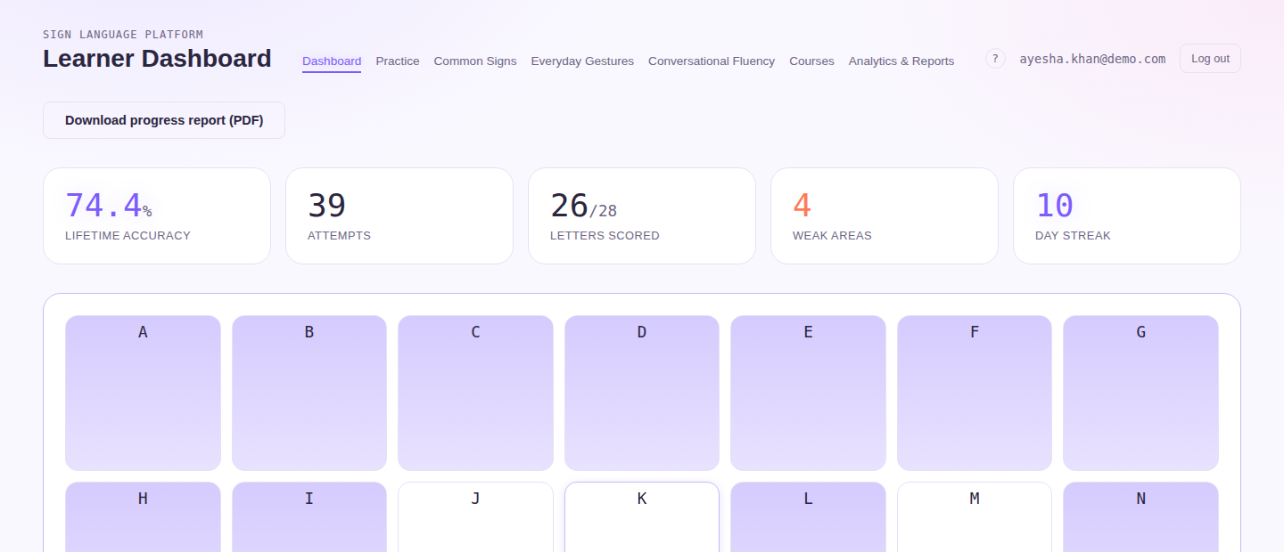
Figure 3. Learner Dashboard — lifetime accuracy, streak, and the ASL alphabet practice board.

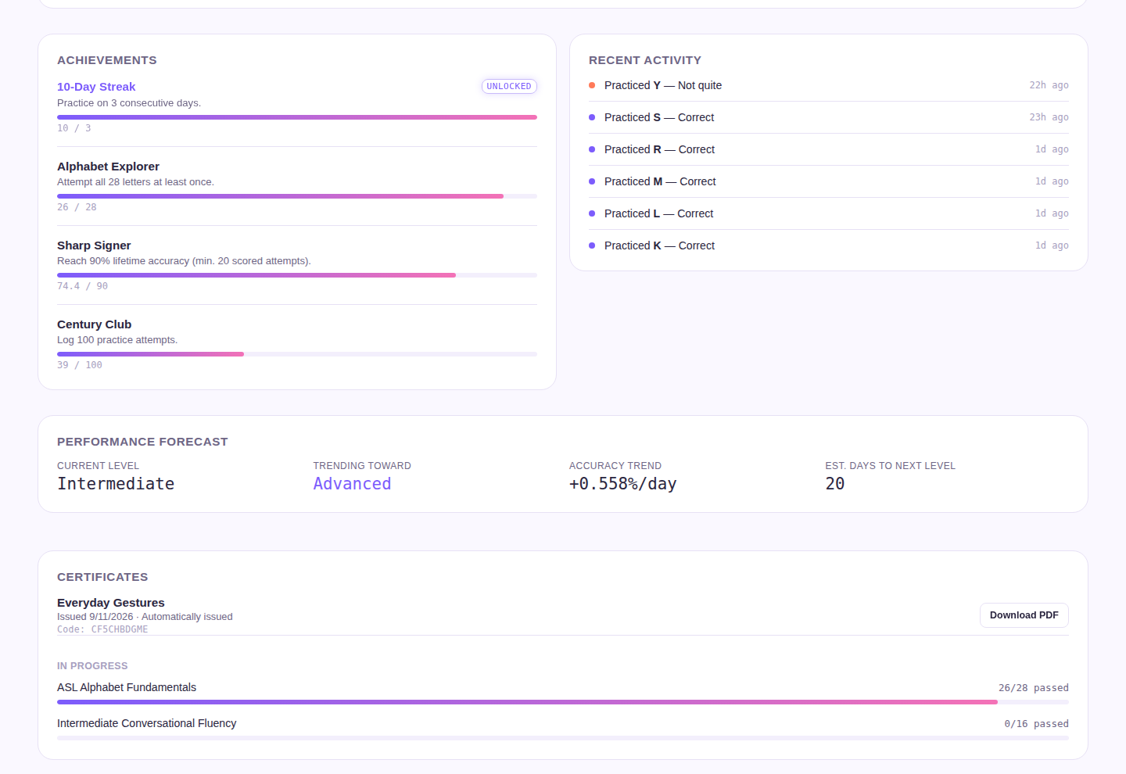
Figure 4. Learner Dashboard — achievements, performance forecast, and certificates earned/in progress.

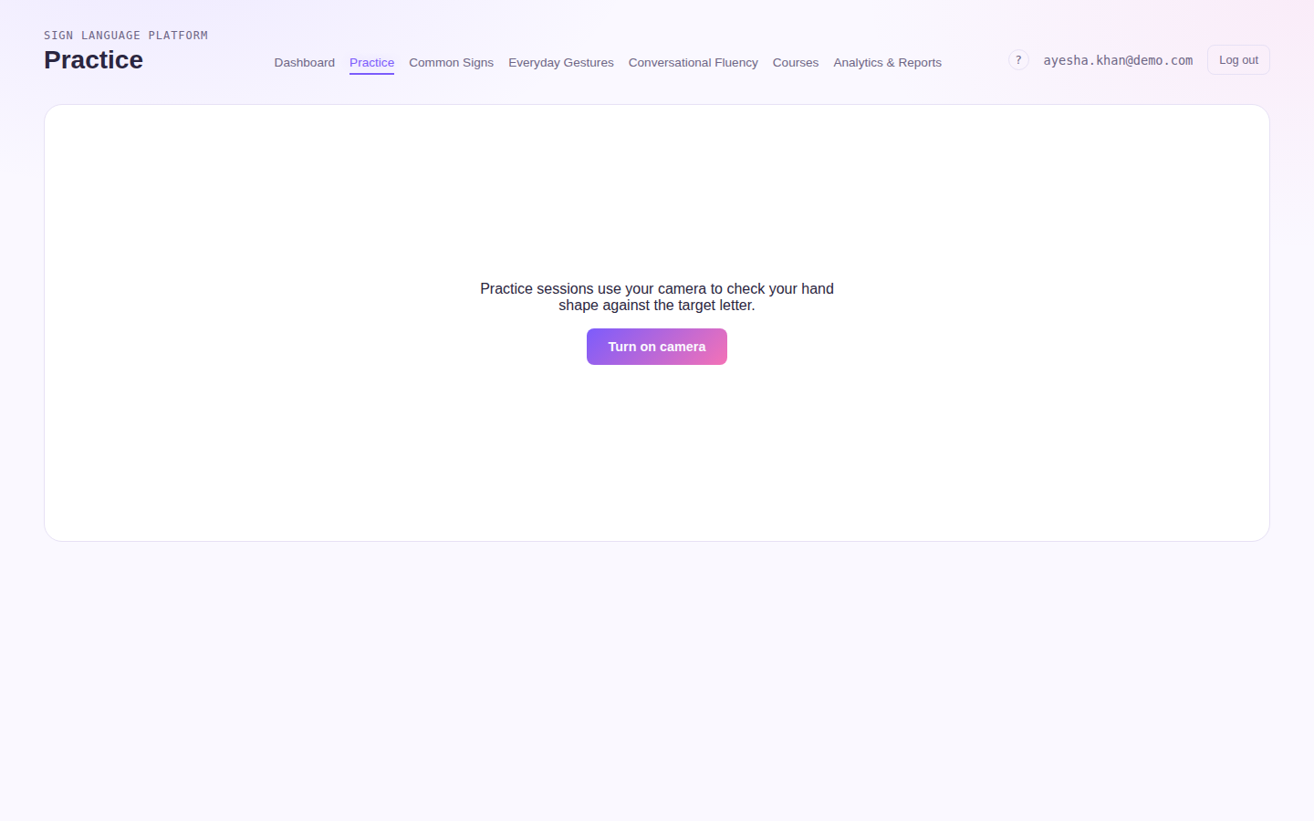
Figure 5. ASL Alphabet Fundamentals practice page.

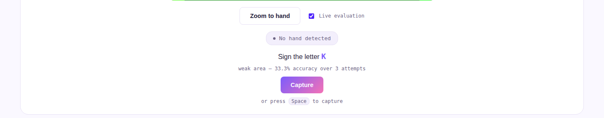
Figure 6. Real-time “Live mode” toggle and readout (Section 8.6) — the same control appears on all four practice pages.

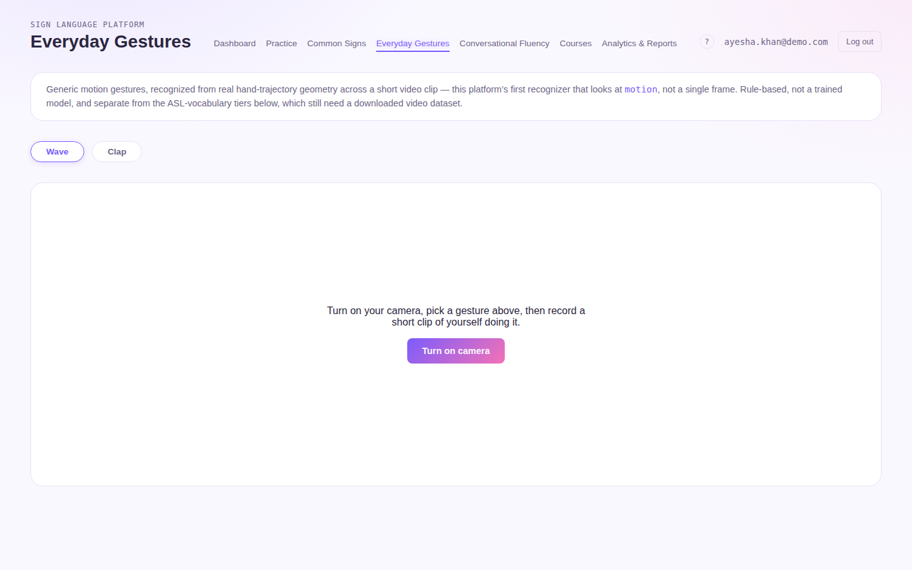
Figure 7. Everyday Gestures (motion) practice page — Wave / Clap.

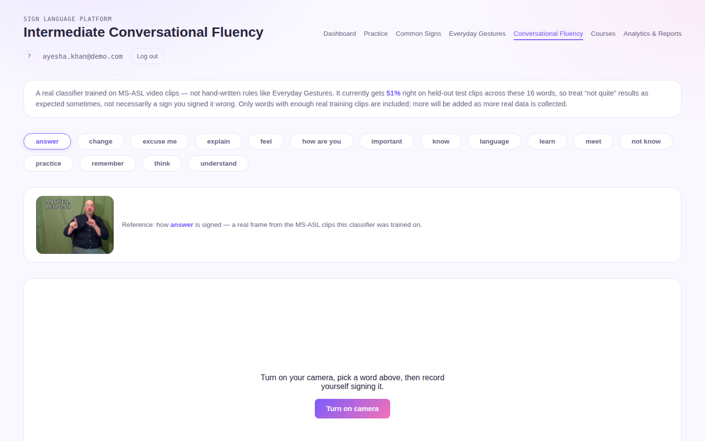
Figure 8. Intermediate Conversational Fluency practice page, with the measured 49% test accuracy disclosed in-app.

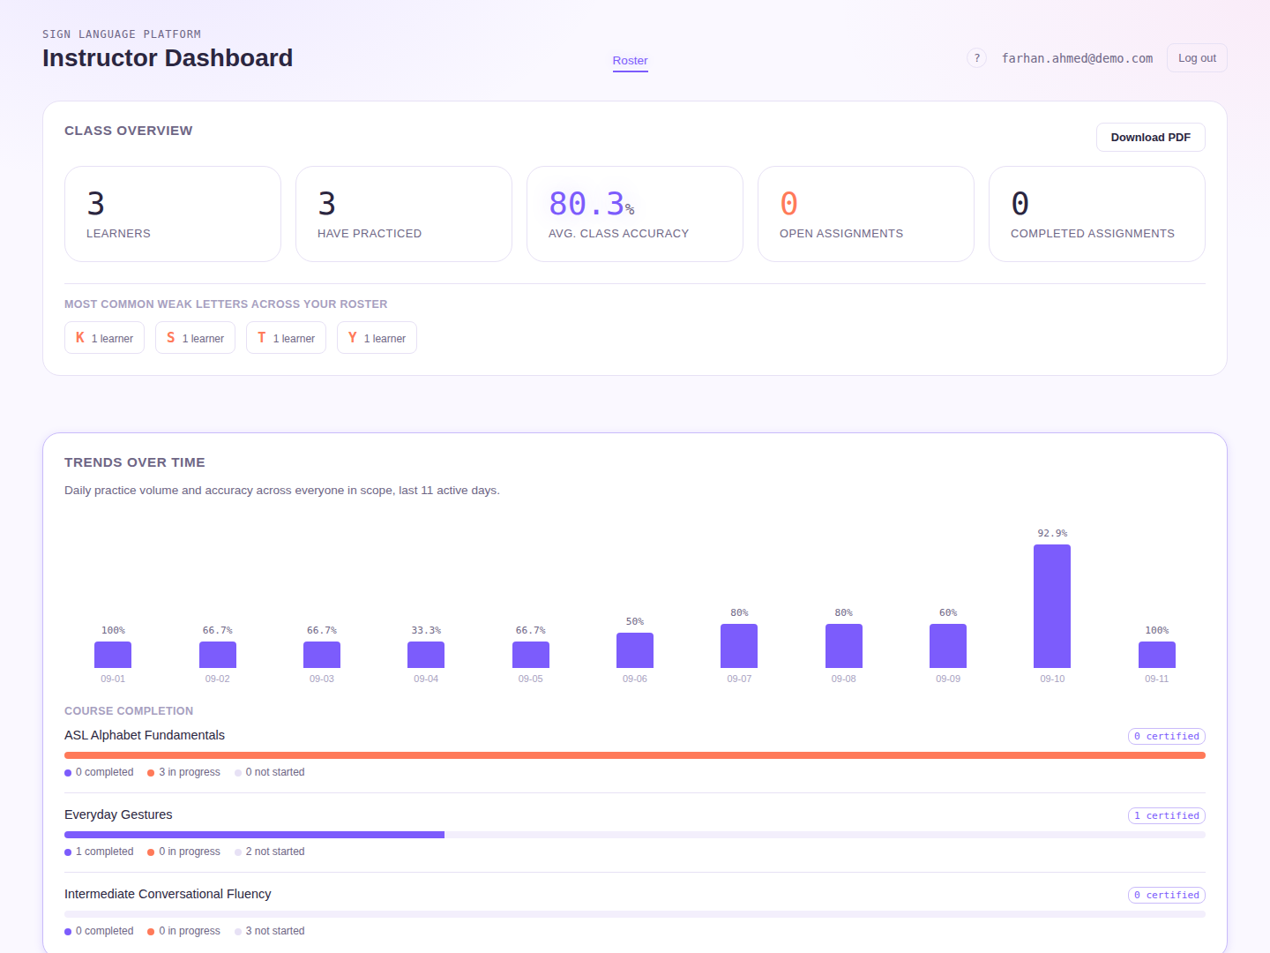
Figure 9. Instructor Dashboard — class overview and trends over time.

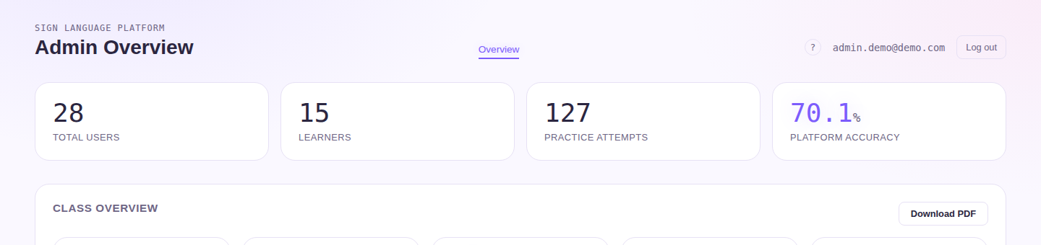
Figure 10. Admin Overview.

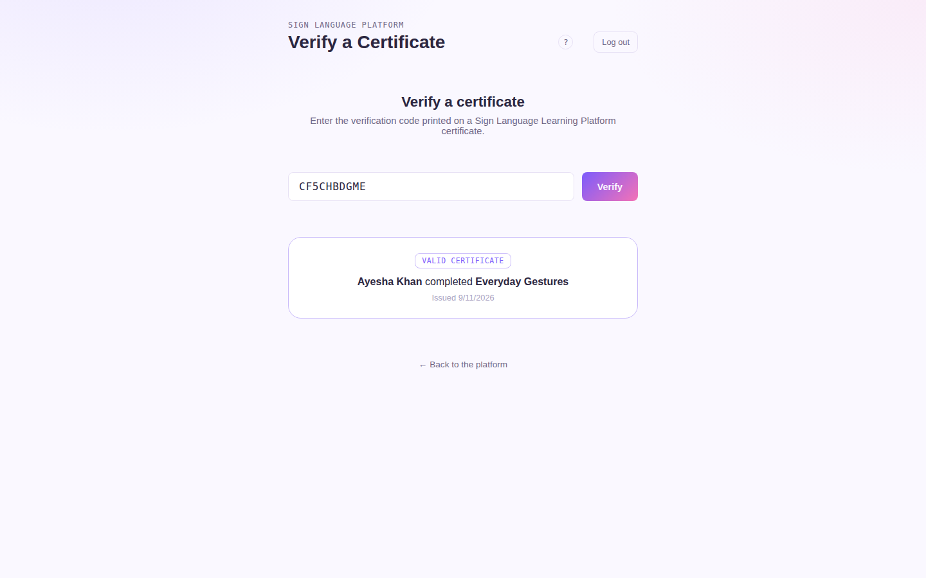
Figure 11. Public certificate verification page.

11. GitHub & Version Control

11.1 Repository
Item | Details
GitHub Repository | https://github.com/springboardmentor15742s-oss/Team_3_Sign_Language_AI
Primary Development Branch | lubna-milestone1
Review Branch | review-branch — created from the latest state of lubna-milestone1 and pushed for mentor review; contains the full project, including certification, reporting, analytics, automated testing and the real-time Live-mode evaluation feature.
Main Branch | main

11.2 Repository Structure
- backend/ — FastAPI backend code, AI/recognition services, and backend dependencies.
- frontend/ — React/TypeScript frontend, UI components and client-side configuration.
- backend/tests/ — pytest automated backend test suite.
- frontend/src/**/*.test.tsx — Jest + React Testing Library automated frontend test suite.
- docker-compose.yml — multi-service local deployment configuration.
- README.md — project overview and usage documentation.

11.3 Version Control
The project uses Git and GitHub for source-code management. Development work has been carried out on the lubna-milestone1 branch, with review-branch created and pushed to GitHub as a stable, reviewable snapshot of the complete project for the mentor.

12. Error Handling & Security

12.1 Error Handling
- Invalid user input returns clear validation messages — including new length/strength constraints added during backend validation hardening (e.g. password strength, note and reason field length caps).
- Authentication failures prevent unauthorized access.
- API failures return controlled error responses.
- Database errors are handled without exposing internal details.
- AI/ML failures such as missing hands or low-confidence recognition are handled gracefully and reported honestly (e.g. "No hand detected") rather than guessed.
- Camera access problems provide user guidance.
- Live mode failures (a single failed recognition poll) are logged and simply retried on the next cycle, without interrupting the graded practice flow.

12.2 Security
- JWT-based authentication.
- Role-based authorization.
- Secure password hashing (passlib/bcrypt), with a minimum-strength requirement enforced on registration.
- Protected backend/API routes.
- Environment variables for sensitive configuration.
- Sensitive information is not committed to GitHub.

13. Testing

13.1 Testing Approaches
- Functional Testing
- Integration Testing
- System Testing
- Machine Learning Model / Recognition Endpoint Testing
- Usability / User Testing
- API Validation and Testing
- Security / Input-Validation Testing
- End-to-End Workflow Testing
- Automated Regression Testing (backend and frontend)

13.2 Automated Test Suites
Ad-hoc test scripts were converted into a maintained pytest suite (backend) and a Jest + React Testing Library suite (frontend). As of the latest commit on review-branch, both suites pass in full:
Suite | Result
Backend (pytest) | 44 passed, 3 skipped — covers authentication, practice/assessment endpoints for all four recognition areas, certificates, reporting, class trends, instructor assignments/notes, input-validation hardening, and Live-mode /recognize endpoints (including regression tests confirming Live mode never creates a logged attempt).
Frontend (Jest + React Testing Library) | 41 passed across 8 test suites — covers routing/landing, achievements, class trends, certificates, instructor notes, assignment forms, certificate verification, and the Practice page's Live-mode toggle and polling behaviour.

13.3 Representative Test Cases
Test Case | Expected Result
Login | Valid user is authenticated and gets role-appropriate access.
Learning Module | Learner can open a course/lesson and start practice.
Gesture Recognition (graded) | Input is processed, compared to the target, and a logged, graded result is returned.
Live Mode (non-graded) | Input is processed and a continuously updating read is shown, without creating a logged attempt.
Feedback | Feedback corresponds to assessment output and the learner's current skill tier.
Analytics | Learner performance, streaks and progress are updated after a graded attempt.
Recommendation | Recommendation reflects learner performance.
Certification | Eligible learner receives an automatically issued certificate; staff can also issue one manually; the certificate verifies correctly on the public verification page.
Report Export | Authorized user can generate the requested report as a PDF.
Role Access | Restricted functions are protected by role.

14. Results

14.1 AI/ML Results
Metric | Value
Alphabet Classifier — Accuracy / Precision / Recall / F1 / Confusion Matrix | Measured on the trained SVM classifier (held-out test split, n=848): accuracy 97%. Macro-avg precision/recall/F1: 0.96 / 0.97 / 0.96. Weighted-avg precision/recall/F1: 0.97 / 0.97 / 0.97. Confusion matrix: predictions are strongly diagonal across all 26 letters plus the "space" and "del" classes, with the few misclassifications concentrated among visually similar hand shapes (e.g. M/N, O/P/Q).
Word-Sign Classifier — Test Accuracy | 49% (16-word MS-ASL vocabulary, measured on held-out test clips; reported to learners in-app)
Motion / Common Signs | Not applicable — rule-based geometry, not a trained classifier

14.2 System / Testing Results
Metric | Value
Backend automated test suite | 44 passed, 3 skipped (pytest)
Frontend automated test suite | 41 passed across 8 suites (Jest + React Testing Library)
Frontend production build | Builds successfully with no TypeScript errors (npx tsc --noEmit clean)
API Response Time | Measured locally: mean 3.7 ms, median 3.2 ms, p95 5.2 ms across 20 authenticated GET requests (e.g. /api/auth/me) against the FastAPI backend on SQLite (single-instance local test, not a production deployment).
Real-time Inference Latency (Live mode) | Designed around a 0.7–1.5 second poll interval, not literal frame-by-frame. Measured locally: after a one-time model-load delay on the first call (~5.8 s), subsequent /recognize calls averaged 23–31 ms per frame (median 23.5 ms, p95 30.5 ms) — well within the poll interval used by the frontend.
Concurrent User Handling Capacity | Measured locally: 50 concurrent authenticated requests against a single-process, single-worker FastAPI instance (SQLite backend) all succeeded (50/50), sustaining ~300 requests/second at that concurrency (local test; not representative of a production multi-worker deployment).
Only measured project values should be included in the final submitted version where marked "to be filled." The project should also include the most important working-system screenshots, including the Live-mode readout described in Section 8.6.

15. Deployment

15.1 Deployment Architecture
The platform is designed as an integrated frontend, backend/API, AI/recognition and database system. It currently runs locally: the FastAPI backend via uvicorn on port 8000, and the React frontend via its development server on port 3000, communicating over HTTP.

15.2 Docker Implementation
- A Dockerfile and docker-compose.yml are present in the repository, defining a backend service (port 8000) and a frontend service (port 3000, built and served).
- This configuration has been used for local/self-hosted multi-service startup; it has not yet been deployed to a managed cloud environment.

15.3 Cloud Deployment
No cloud deployment has been performed as of this document's update. AWS/Azure were identified in the original project specification as candidate targets. The actual provider, deployed URL and production environment details remain to be recorded once a cloud deployment is carried out — this is explicitly called out as outstanding work in Section 17.

15.4 Deployment Process (Planned)
- Configure environment variables and production settings.
- Build frontend (npm run build) and backend Docker images.
- Build and validate Docker images (docker-compose build).
- Run health and integration checks.
- Deploy the services to the selected cloud environment.
- Enable monitoring and logging.

15.5 Production Environment
Production configuration should use secure secrets, database configuration, monitoring, logging and health checks. No specific cloud URL exists yet, so one is not invented here — this remains the main outstanding item before the project can be considered fully deployed.

16. Challenges & Limitations
- Lighting, background, camera quality and hand position can affect recognition across all four practice areas.
- Dataset coverage limits the range of signs that can be recognized — 26 alphabet letters (plus del/space), 2 motion gestures, 16 word signs, and 3 common signs.
- The word-sign classifier's 49% measured test accuracy reflects limited real training clips per word; results should be interpreted with that in mind.
- Static alphabet, motion-clip and word-clip recognition do not provide full continuous, multi-sign sentence translation.
- Real-time inference must balance recognition accuracy, response speed and backend load — Live mode's repeated polling adds inference load beyond the original single-submission flow, which is why it is off by default.
- Final system performance (latency, concurrency) depends on measured testing and deployment conditions not yet produced.
- The application has not yet been deployed to a public cloud environment.

17. Future Scope
- Deploy the platform to a cloud environment (e.g. AWS/Azure) and record real production metrics.
- Expand the sign vocabulary and dataset coverage for both motion and word signs.
- Improve recognition robustness under different environments and lighting.
- Consider client-side (in-browser) inference for Live mode to reduce backend load and latency, as an alternative to the current server-polling approach.
- Add advanced continuous sign/sequence recognition beyond short clips.
- Improve learning analytics and personalization.
- Extend certification and reporting further.
- Improve cloud scalability, monitoring and system performance under load.

18. Conclusion
The AI-Powered Sign Language Learning & Assessment Platform combines learning, recognition, assessment, feedback, analytics, personalization, certification and instructor tooling into a single workflow. Recognition now spans four practice areas — alphabet, motion gestures, word signs and common signs — using a mix of trained classifiers and rule-based geometry, all built on MediaPipe hand-landmark extraction. A real-time "Live mode" adds continuous, non-graded feedback during practice across all four areas, alongside the original graded capture/record flow that remains the sole source of logged attempts, streaks and certificate progress. Milestone 1 established the platform foundation; Milestone 2 added gesture recognition and assessment; Milestone 3 added AI feedback and learning intelligence; Milestone 4 added certification, instructor reporting, analytics dashboards, automated testing, and real-time evaluation. The remaining outstanding item is a live cloud deployment — the codebase, Docker configuration and automated test suites are in place, but the application currently runs locally only. The project is intended to provide an end-to-end path from learning and practice to assessment, improvement and certification.

19. References
- Final Document Overview — project documentation structure provided for the report.
- AI-Sign Language Learning & Assessment Platform — project specification.
- ASL Alphabet Dataset used for the alphabet classifier.
- MS-ASL (Microsoft American Sign Language) dataset used for the 16-word Conversational Fluency classifier.
- MediaPipe resources for hand landmark extraction.
- Scikit-learn resources for SVM classification.
- FastAPI, React, TypeScript, OpenCV, ReportLab, pytest, Jest, React Testing Library, GitHub and Docker documentation used for development.

