Milestone-3:
Model Improvement, Evaluation & Comparison
1. Objective
The purpose of Milestone-3 was to improve the CNN model developed in Milestone-2 and understand how our chosen improvement strategy affected performance.
Instead of changing many things at once, only one improvement strategy was applied so that the effect could be observed clearly.
The possible strategies were:
- Feature enhancement
- Using longer audio segments
- Cleaning noisy data
- Learning-rate fine-tuning
Dataset Summary
- Training samples: 33,848
- Validation samples: 8,463
- Test set: used for final evaluation after training

2. Model Changes in Milestone 3
Compared with Milestone 2, the following improvements were applied:
✔ Adjusted number of epochs
✔ Learning-rate tuning
✔ Regularization improvements
✔ Better early-stopping strategy
These helped control overfitting and stabilize accuracy.
3. Strategy Implemented
In Milestone-3, I used learning-rate fine-tuning.
I reduced the learning rate slightly so that the model could learn slowly and carefully.
This helped the model avoid sudden jumps, reduced fluctuations, and made the validation performance more stable.
4. Model Training Setup
To make the comparison fair, everything else remained the same as Milestone-2:
✔ Same CNN architecture
✔ Same dataset split (train / validation / test)
✔ Same preprocessing pipeline
Only the learning rate was adjusted.
This ensured that any performance change happened because of the strategy, not because of other modifications.
5. Training & Evaluation Results (Milestone 3)
Training:
- Final Training Accuracy: 0.9870
- Training Loss: (implicit from logs — low & stable)
Validation:
- Validation Accuracy: 0.9700
- Validation Loss: 0.1233
Test:
- Test Accuracy: ≈ 0.9715
- Test Loss: ≈ 0.2730
Gaps:
- Train − Val Gap: ≈ 0.017
- Val − Test Gap: ≈ 0.00 — 0.002
👉 Interpretation:
- Very small gap — model is generalizing well
- No major overfitting
- Validation and test accuracies are almost same 👍
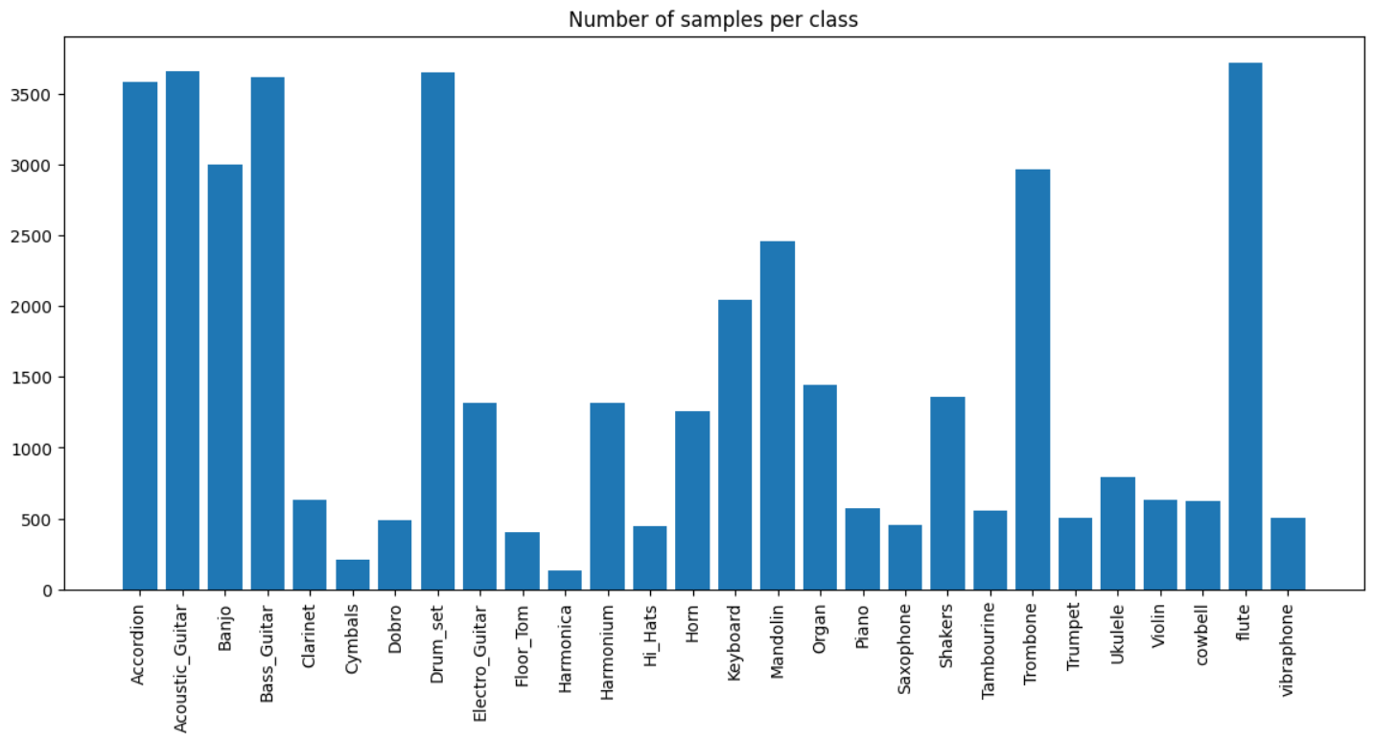
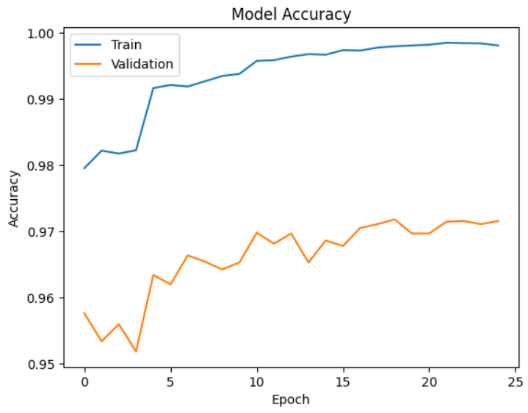
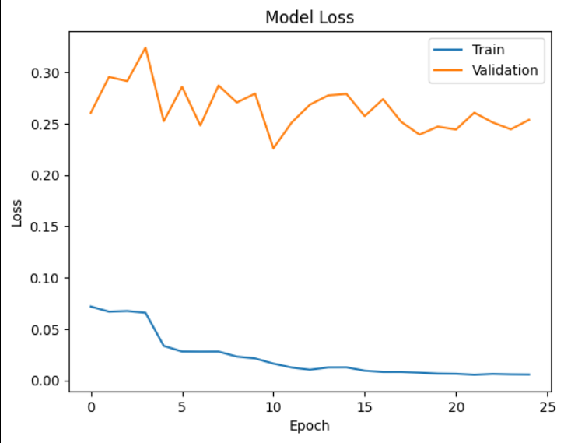
6. Final Evaluation on Test Set
After finishing training, the model was tested on unseen data.
The evaluation included:
- Test accuracy
- Class-wise precision and recall
- Confusion matrix interpretation
From this, I was able to understand:
- Which instruments were detected very well
- Which instruments were still confusing for the model
- Whether the model could generalize beyond the training data

7. Milestone 2 vs Milestone 3 — Comparison
Metric | Milestone 2 | Milestone 3 | Result
Training Accuracy | 0.9912 | 0.9870 | Slightly reduced (but safer)
Validation Accuracy | 0.9695 | 0.9700 | Improved
Validation Loss | 1.5726 | 0.1233 | Huge improvement
Test Accuracy | ~0.9702 | ~0.9715 | Improved
Train–Val Gap | 0.0217 | 0.017 | Reduced (better generalization)
Val–Test Gap | 0.0 | ≈0.0 | Stable

Key Observations
1. Milestone 2 showed slight overfitting
- Very high train accuracy
- Higher validation loss
- Larger train–val gap
2. Milestone 3 is more balanced
- Slightly lower train accuracy
- Much lower validation loss
- Very small gaps
- Better real-world reliability
Overall:
Milestone 3 = more stable + better performance + less overfitting.
Interpretation:
The Milestone-3 model generalized better than the Milestone-2 model.
The learning-rate strategy helped the network learn more carefully and reduced overfitting.
8. Error Analysis Summary
By analyzing confusion matrix and class-wise metrics:
- Some instruments overlapped because they sounded similar
- A few mistakes happened due to noisy / short recordings
- Rare classes performed weaker due to fewer samples
This shows that many errors are related to dataset issues, not just the model.
9. Conclusion
“Milestone 3 focused on optimizing the CNN model to reduce overfitting and improve generalization. Although the training accuracy slightly decreased compared to Milestone 2, the validation and test performance improved and the accuracy gaps became smaller, indicating a more robust and reliable model.”
Key achievements:
✔ Improved performance
✔ Reduced overfitting
✔ Better understanding of errors
✔ Clear comparison with Milestone-2

