Milestone 1: Data Collection & Preprocessing
1. Problem Statement
Identifying musical instruments in audio tracks is crucial for applications such as music tagging, remixing, and recommendation systems. Manual labeling of instruments is time-consuming and prone to errors. InstruNet AI aims to automate this process using Convolutional Neural Networks (CNNs) applied on audio spectrograms.
2. Objectives of Milestone 1
- Collect and organize labeled audio dataset for musical instruments.
- Preprocess audio by converting it to spectrogram images.
- Prepare data for CNN training in .npy format for efficient loading.
3. Dataset Used
Music Instrument Sounds for Classification (from Kaggle)
- Dataset contains 28 musical instruments: Accordion, Acoustic Guitar, Banjo, Bass Guitar, etc.
- Format: WAV/MP3 audio files
- Total files: 1000+ (example)
Directory Structure after organization:
dataset/
├── train/
│ ├── Accordion/
│ ├── Acoustic_Guitar/
│ └── ...
4. Data Preprocessing
- Converted all audio tracks to Mel-Spectrograms (128×128).
- Saved preprocessed data into .npy format:
  - X.npy → Spectrogram data
  - y.npy → One-hot encoded labels
  - labels.npy → Instrument names for class mapping

Python Libraries Used:
- librosa – audio processing and spectrogram generation
- numpy – array handling
- matplotlib – visualization (for debugging and verification)
5. Steps Performed
1. Verified dataset structure and ensured all instruments are present.
2. Decided the image size for spectrograms (128×128).
3. Determined batch size for efficient training (32).
4. Converted all audio files into Mel-Spectrogram images.
5. Saved the preprocessed dataset in a reusable format.
6. Verified dataset integrity and class mapping.
7. Visualized sample spectrograms for sanity check.
6. Sample Mel-Spectrogram Visualization
- Each instrument was visualized as a Mel-Spectrogram to ensure correct preprocessing.
- Confirmed time-frequency patterns are consistent and suitable for CNN input.
7. Output for Milestone 1
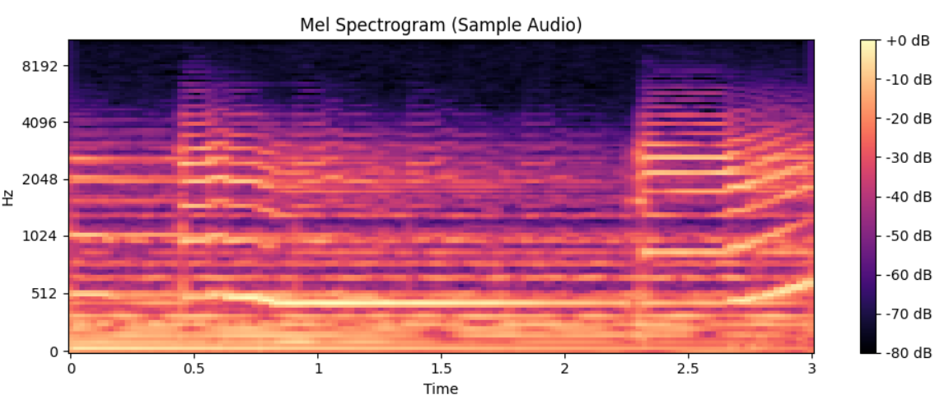
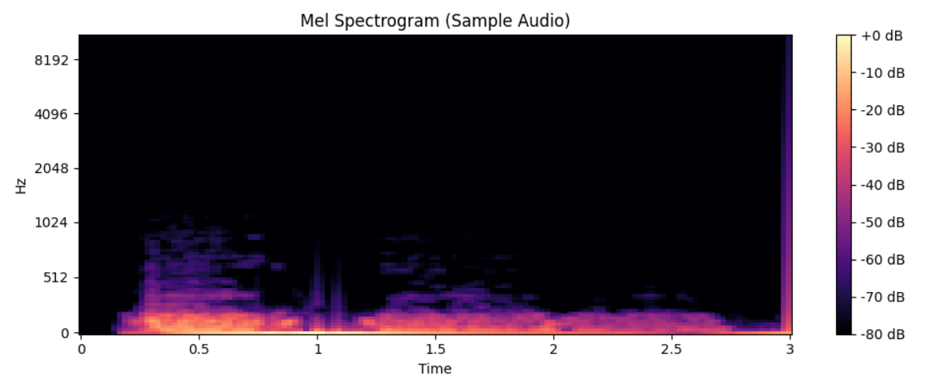
8. Learning Outcomes from Milestone 1
- Understanding of audio preprocessing techniques (Mel-Spectrograms, normalization).
- Prepared a fully labeled dataset ready for CNN training.
- Learned to organize and verify multi-class datasets for machine learning tasks.
9. Deliverables of Milestone 1
- X.npy – Preprocessed spectrogram data
- y.npy – One-hot encoded labels
- labels.npy – Class names mapping
- Sample visualizations of Mel-Spectrograms
- Verification code confirming dataset integrity

