Milestone 2: CNN Model Development
1. Objective
The goal of Milestone 2 is to develop a Convolutional Neural Network (CNN) that can classify musical instruments from audio spectrograms. This involves:
- Designing an effective CNN architecture for multi-class classification.
- Training the model using preprocessed spectrogram data.
- Evaluating the model’s performance and identifying areas for improvement.
2. Dataset Overview
In this milestone, we used previously prepared files:
- X.npy – Spectrogram images (features)
- y.npy – Encoded class labels
- labels.npy – Mapping of label indices to instrument names
The dataset was split into:
- Training set
- Validation set
This ensured that model performance could be evaluated on unseen data.
3. CNN Model for Instrument Classification Architecture Design
The CNN model was designed with the following considerations:
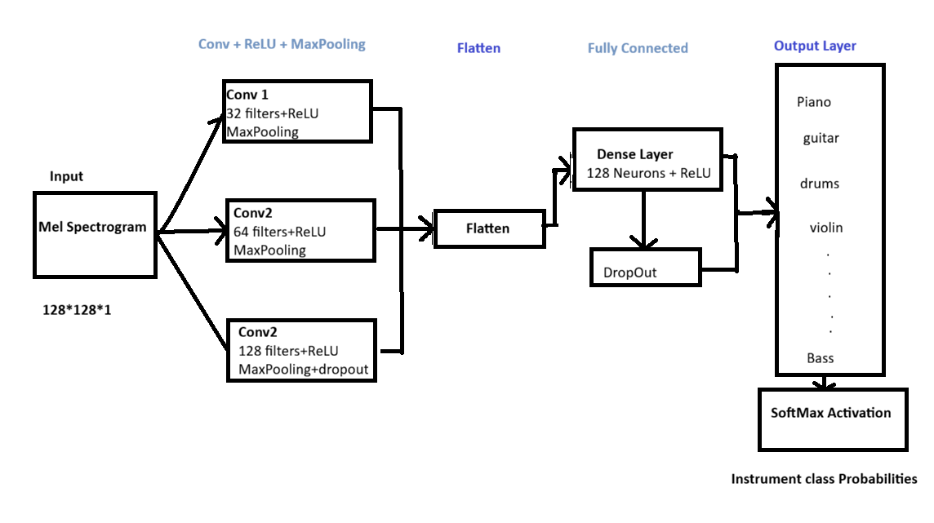
- Input Layer: Accepts spectrogram images of size 128×128 pixels with three channels.
- Convolutional Layers: Extract feature maps to identify patterns in frequency and time.
- Pooling Layers: Reduce dimensionality and retain important features.
- Fully Connected Layer: Integrates extracted features for classification.
- Output Layer: Produces probabilities for each of the 28 instrument classes using a softmax activation function.
Design Goals:
- Capture time-frequency patterns characteristic of each instrument.
- Maintain model simplicity to avoid overfitting on the available dataset.
- Ensure compatibility with the preprocessed dataset (.npy files).
3. Training Configuration
- Dataset Split: 80% training, 20% validation.
- Batch Size: 32, chosen for efficient memory usage and stable gradient updates.
- Loss Function: Categorical cross-entropy, suitable for multi-class classification.
- Optimizer: Adam optimizer with an adjusted learning rate of 0.0005 to improve convergence.
- Number of Epochs: 20, allowing sufficient training while preventing overfitting.
Observations during training:
- Training accuracy rapidly increased in the first few epochs.
- Validation accuracy closely followed training accuracy, indicating good generalization.
4. Model Performance
Final Metrics:
- Training Accuracy: 99.29%
- Validation Accuracy: 96.90%
Interpretation:
- The gap between training and validation accuracy is small (~2–3%), indicating that the model generalizes well.
- High training and validation accuracy show that the model is neither underfitting nor overfitting.
5. Evaluation & Analysis
- Confusion Matrix: Generated to visualize correct and incorrect predictions across all 28 instruments.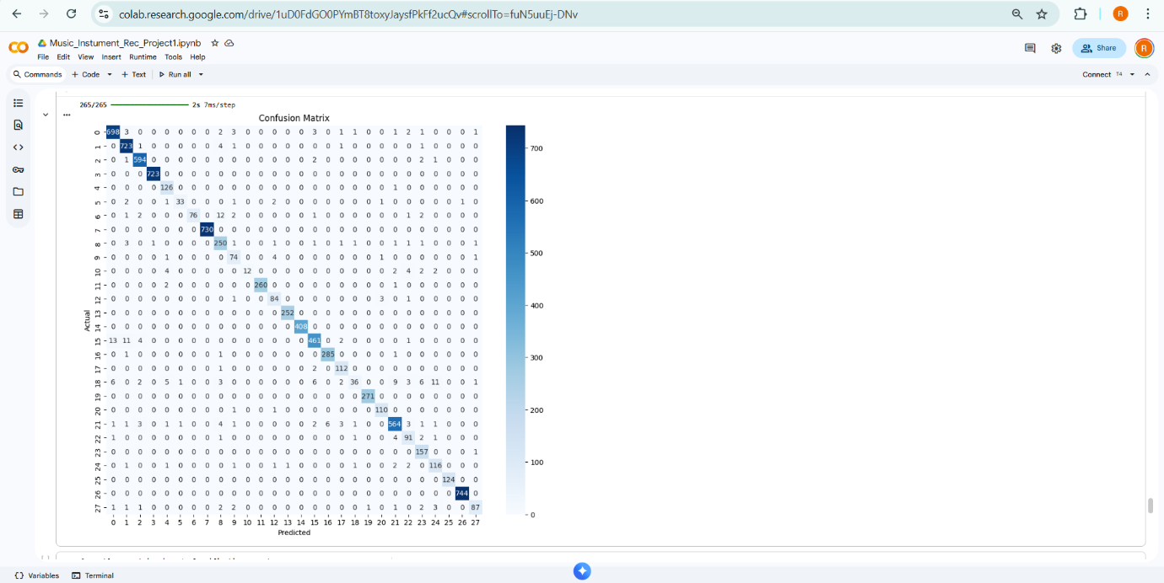
- Class-wise Metrics: Precision, recall, and F1-score calculated for each instrument, confirming consistent performance.
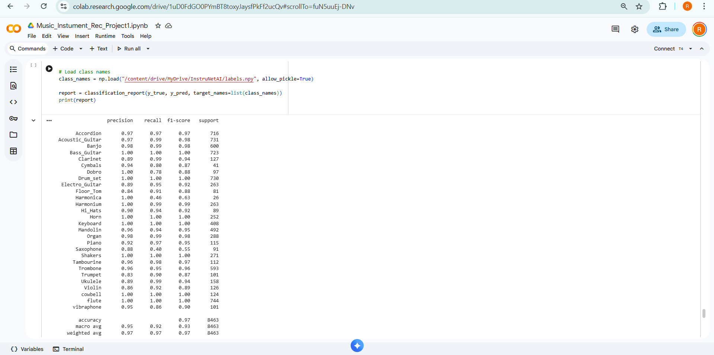
- Error Analysis: Misclassified samples examined; most errors occur among instruments with similar timbre (e.g., acoustic guitar vs. electric guitar).
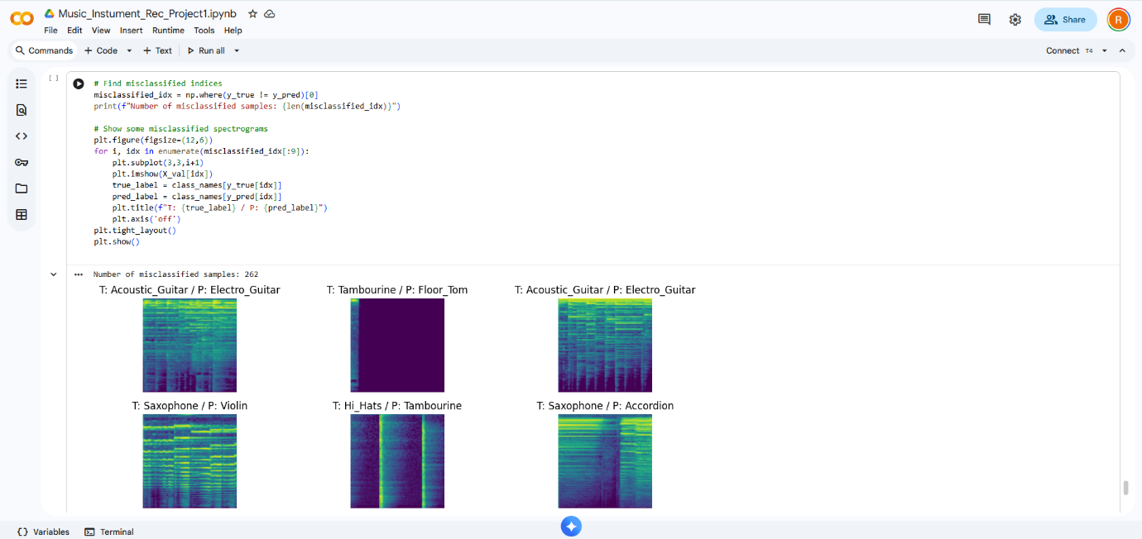
- Overfitting Check: Minimal signs of overfitting; training and validation curves are closely aligned.
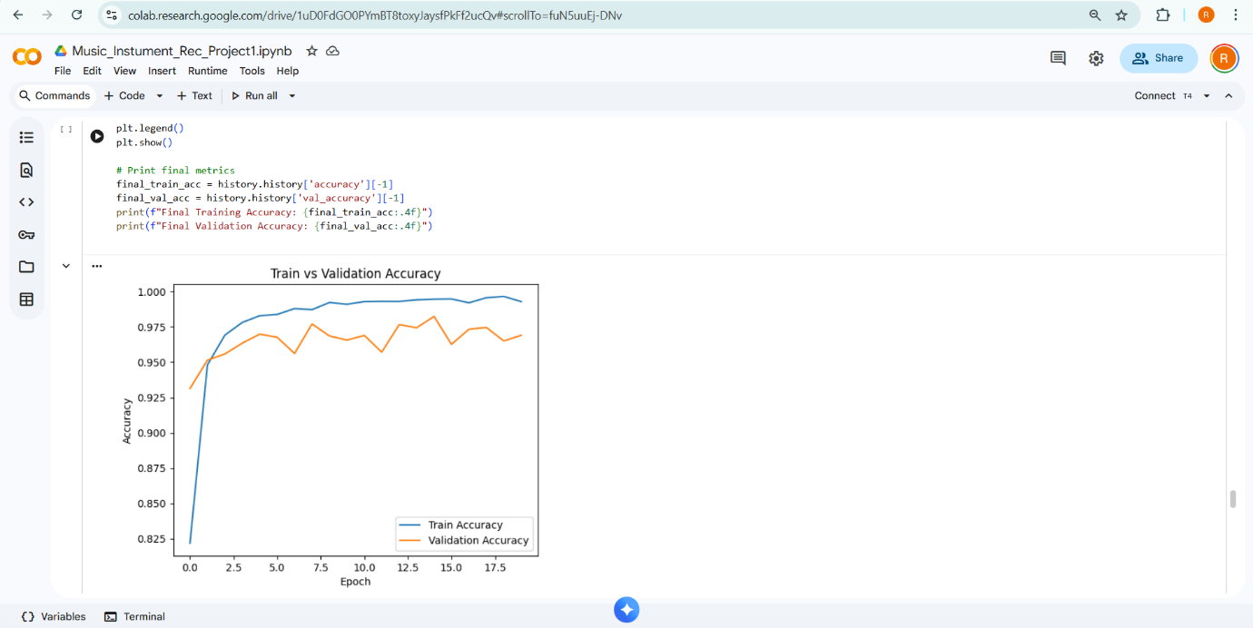

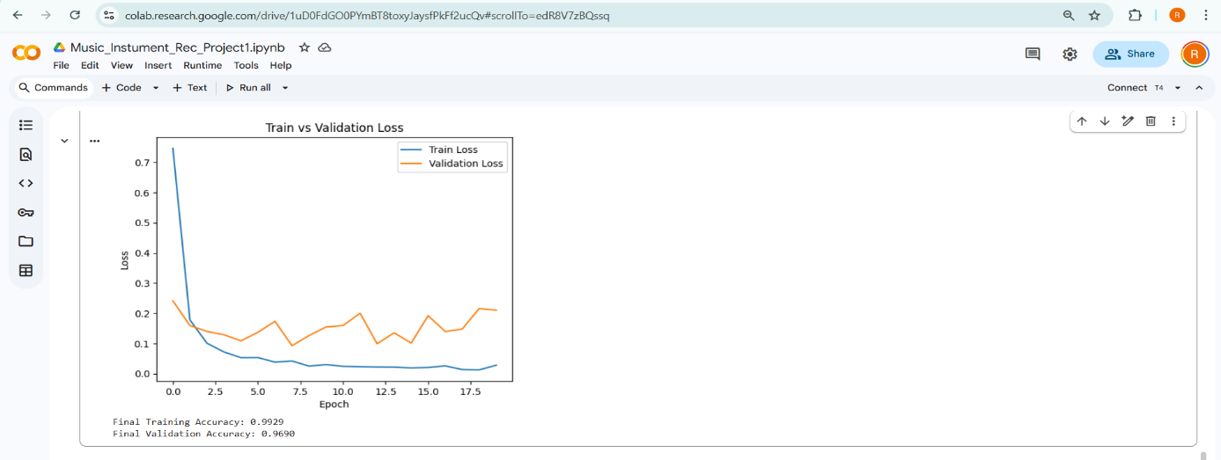
6. Learning Outcomes
- Gained practical experience in designing and training CNNs for audio classification.
- Learned to interpret training metrics, confusion matrices, and class-wise performance metrics.
- Understood techniques for handling multi-class datasets and ensuring generalization.
- Developed skills to fine-tune hyperparameters, including learning rate adjustments for optimal performance.
7. Deliverables
- Trained CNN model capable of classifying 28 instruments from spectrogram images.
- Validation results including final accuracy, loss curves, and confusion matrix.
- Analysis of misclassifications and per-class performance metrics.
- Ready-to-use model for integration with subsequent Milestone 3: Model Evaluation & Visualization.
Summary
In this milestone, we selected the best-performing CNN model based on validation accuracy and stability. The final model achieved 99.29% training accuracy and 96.90% validation accuracy, showing strong generalization with only a small accuracy gap. Evaluation using the confusion matrix and classification report demonstrated that most classes performed well, with a few misclassifications mainly between acoustically similar instruments. The accuracy and loss curves confirmed that the model is not overfitting and learns effectively. This model is finalized for deployment and further testing.

