WebScanPro:Web Application Security Testing Tool

Goal:
The primary goal of WebScanPro is to develop an automated web application security testing tool that can identify common vulnerabilities in web applications with minimal manual effort.The tool should simulate attack techniques, analyze the security posture of the target application, and generate clear, actionable reports for developers and security analysts.Build a tool that automatically scans a web app, finds security weaknesses like SQL Injection and XSS, and tells the developer how to fix them.
Outcomes:
- Detection of At Least 4 Major Vulnerability Types
- Automatic Report Generation
- Fully Functional Security Scanner
- Target Metadata Extraction
- Documentation
Week-1:
Project Initialization and setup
- Docker installation:
Why docker- WebScanPro uses vulnerable apps like DVWA and Juice Shop inside containers. Docker makes running those targets reproducible and easy
- Download Docker Desktop for Windows from the official Docker Desktop page
- Run the installer .exe and follow prompts. If prompted, enable WSL 2 and virtualization features (the installer can do this for you
- After installation, start Docker Desktop from the Start Menu. Open Settings → Resources → WSL Integration and enable integration with your chosen WSL distributions (e.g., Ubuntu).
Requirements:
If using Windows, hardware virtualization / VT-x must be enabled in BIOS/UEFI for Docker Desktop / WSL2 to work. If Docker fails to start with a virtualization error, enable virtualization in firmware (Novo button / BIOS settings on Lenovo).
GitHub Setup:

Create a New Repository
- Click the + icon (top-right of GitHub).
- Select New Repository.
- Fill in:
  - Repository name: WebScanPro
  - Description: Automated Web Application Security Testing Tool
  - Visibility: Public or Private
- DO NOT check “Add README” (we will push it manually).
- Click Create Repository.

Initialize Git Locally and adding project
Open your terminal / VS Code terminal:
cd WebScanPro # go to your project folder
git init # initialize git
git add .
git commit -m "Initial project structure setup"
git remote add origin https://github.com/<your-username>/WebScanPro.git
git branch -M main
git push -u origin main
git push

Setup DVWA using Docker

Step 1: Run DVWA container
docker run --rm -it -p 80:80 vulnerables/web-dvwa

Step 2: Open browser
http://localhost/

Step 3: Set DVWA security level
- Login: admin / password
- Go to: DVWA Security
- Set: Low (for testing)

Setup Juice Shop using Docker

Step 1: Run Juice Shop container
docker run -d -p 3000:3000 bkimminich/juice-shop

Step 2: Open browser
http://localhost:3000/
Juice Shop loads automatically and is ready to test.

Tech Stack Selected
Core Language: Python 3.9+
Libraries:
- requests – HTTP requests
- beautifulsoup4 – HTML parsing
- selenium – dynamic page analysis
- lxml – fast parsing engine
- jinja2 – report templating
- pdfkit / weasyprint – generate PDFs
- pytest (optional) – testing
Tools / Platforms:
- Docker – to run DVWA, Juice Shop, bWAPP
- Git – version control
- VS Code / PyCharm – development environment

Work Flow:
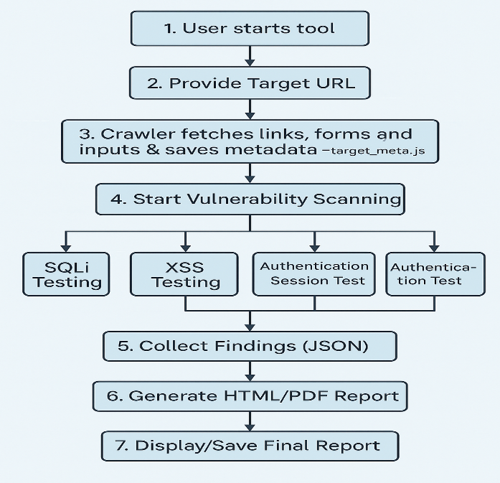
Week-2:
Use tools like BeautifulSoup or Selenium to extract interactive elements.
1.To install required packages:
# activate your venv first (.venv\Scripts\Activate on Windows)
pip install requests beautifulsoup4 lxml
pip install selenium webdriver-manager
2. Use BeautifulSoup for static HTML: fast and minimal
It helps extract links, forms, inputs, buttons, selects, and elements with data
Develop a crawler to discover web pages, links, and input fields.

1.Crawler code — webscanpro/crawler.py

2.run in VS Code
- Save file at: webscanpro/crawler.py.
- Ensure your virtualenv is active and you have dependencies: .venv\Scripts\Activate
3. Output format
A JSON file is generated.
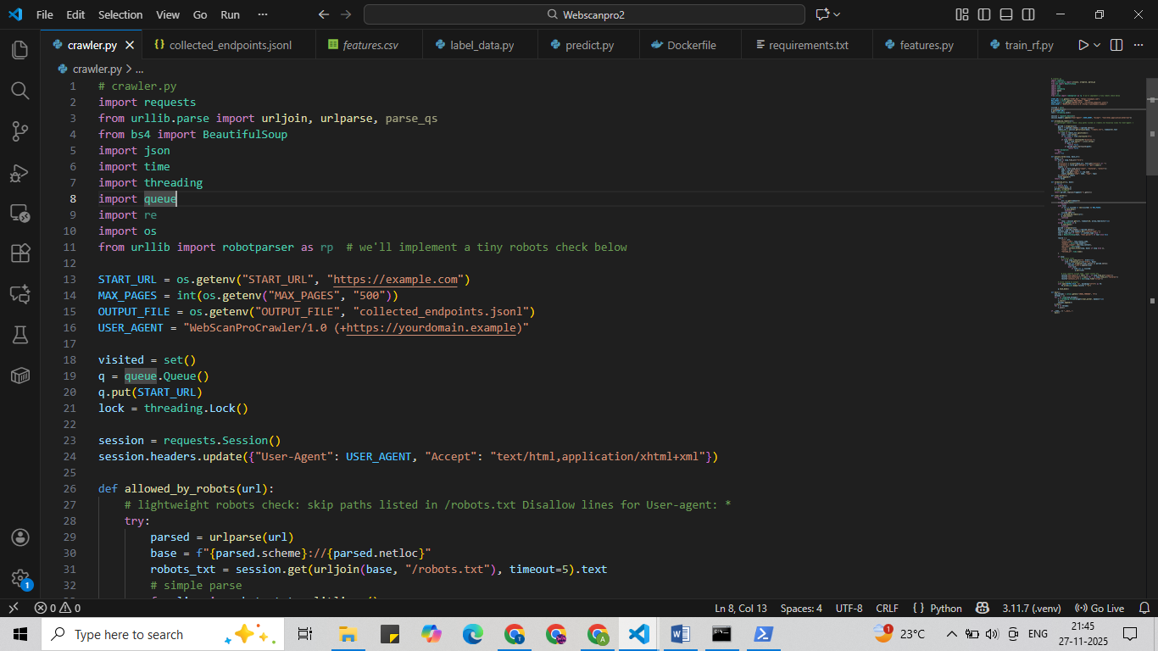
The JSON file created here is collected_endpoints.json.
How to run:
Run this in terminal - python crawler.py
To check run - Get-Content .\data\collected_endpoints.jsonl -Tail 20 (it show last 20 lines)
Save and structure target metadata for testing modules.
- defines a clear data model for target metadata,
- supports adding/updating/deleting/listing targets,
- persists metadata to both SQLite (primary) and JSON (export),
- includes CLI helpers, validation, and example usage.

WEEK-3
Structure of project this week
webscanpro/
├─ crawler.py
├─ features.py
├─ train_rf.py
├─ requirements.txt
├─ Dockerfile
├─ docker-compose.yml
├─ data/ # output will be written here
└─ models/
Dockerfile:
How to run - docker build -t webscanpro-crawler .
Output it shows - Successfully built <image_id>
Successfully tagged webscanpro-crawler:latest
Then
Run - docker run --rm -e START_URL="https://owasp.org/www-project-juice- shop/" -e MAX_PAGES=150 -v "${PWD}\data:/data" webscanpro-crawler
output- webscanpro/data/collected_endpoints.jsonl
Inside the Dockerfile
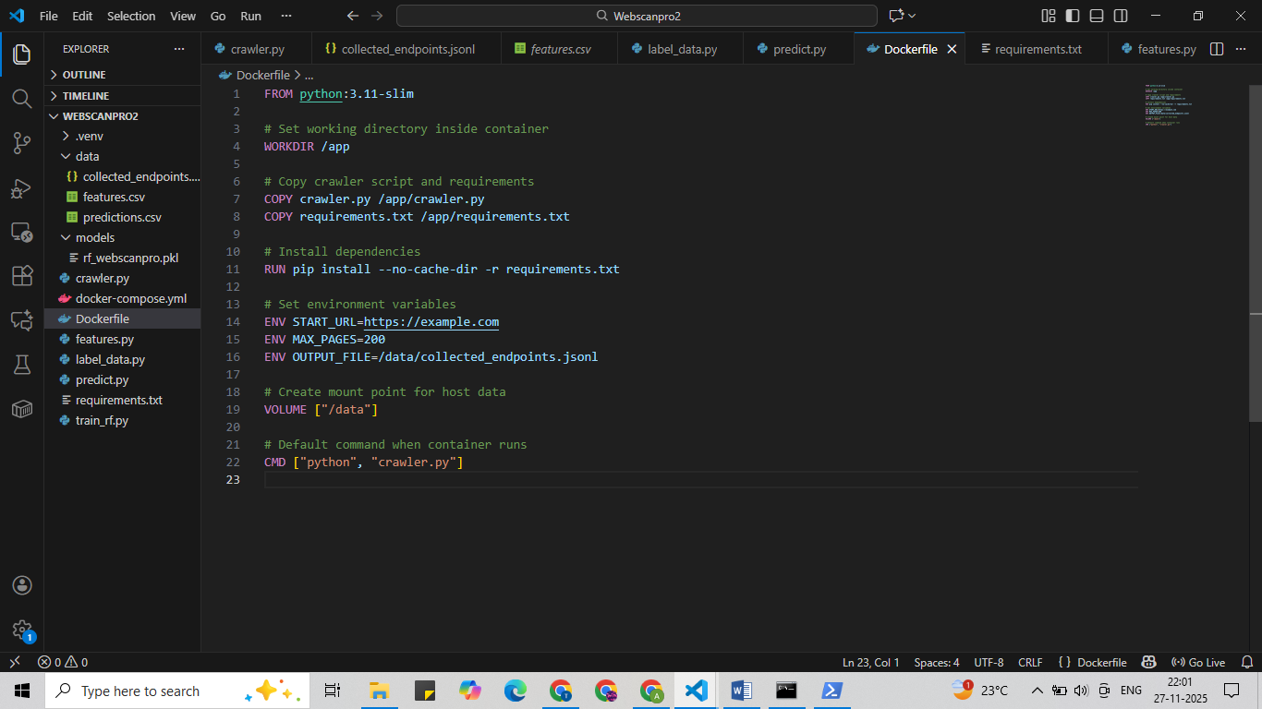
To check the code:open json file there we must see
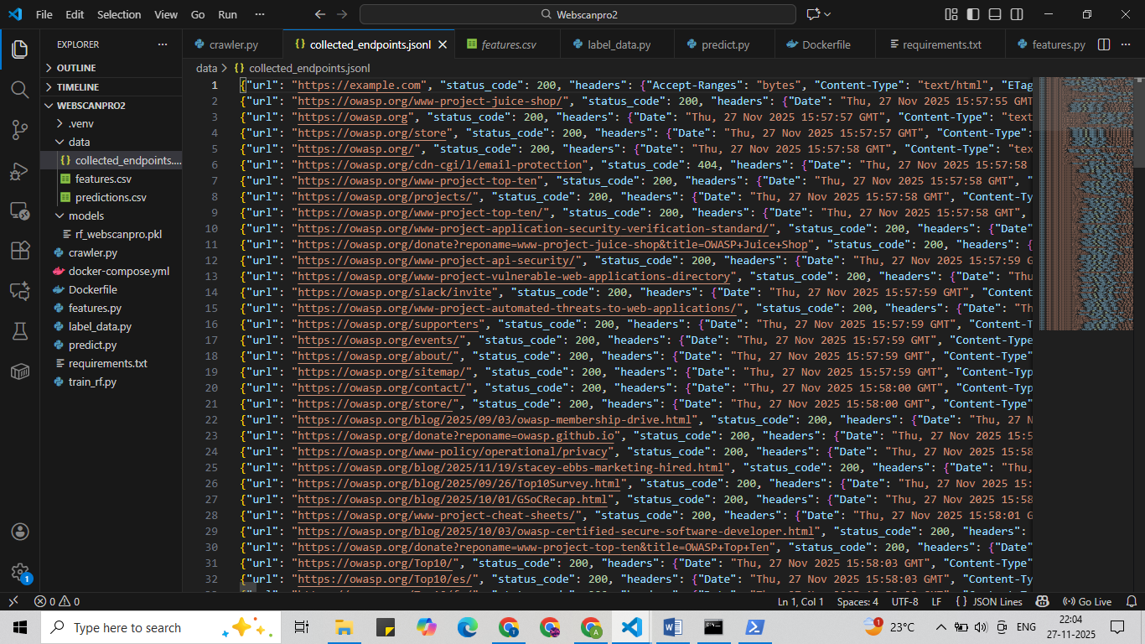
features.py
To run this code: python features.py
This will create data/features.csv
To check - Get-Content .\data\features.csv | Select-Object -First 5
Below is the code of features.py and features.csv

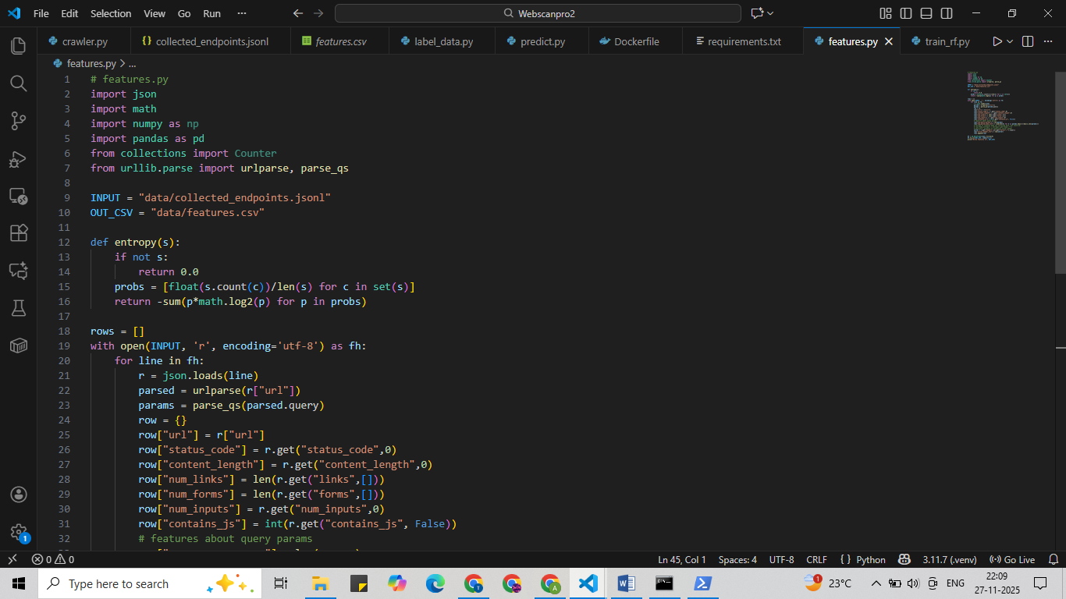
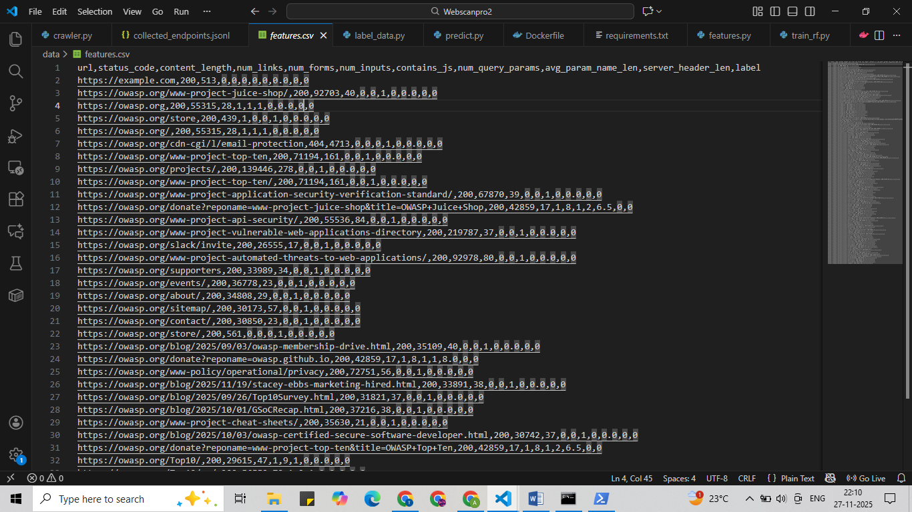
label_data.py
This is to train the machine to detect actual vulnerable endpoints and give correct labels.
Code:
import pandas as pd
df = pd.read_csv("data/features.csv")
df["label"] = 0 # Testing only
df.to_csv("data/features.csv", index=False)
print("Label column added ✔")
To run- python label_data.py

After adding label.
train_rf.py
Used to train the machine
To run this code – python train_rf.py
Output
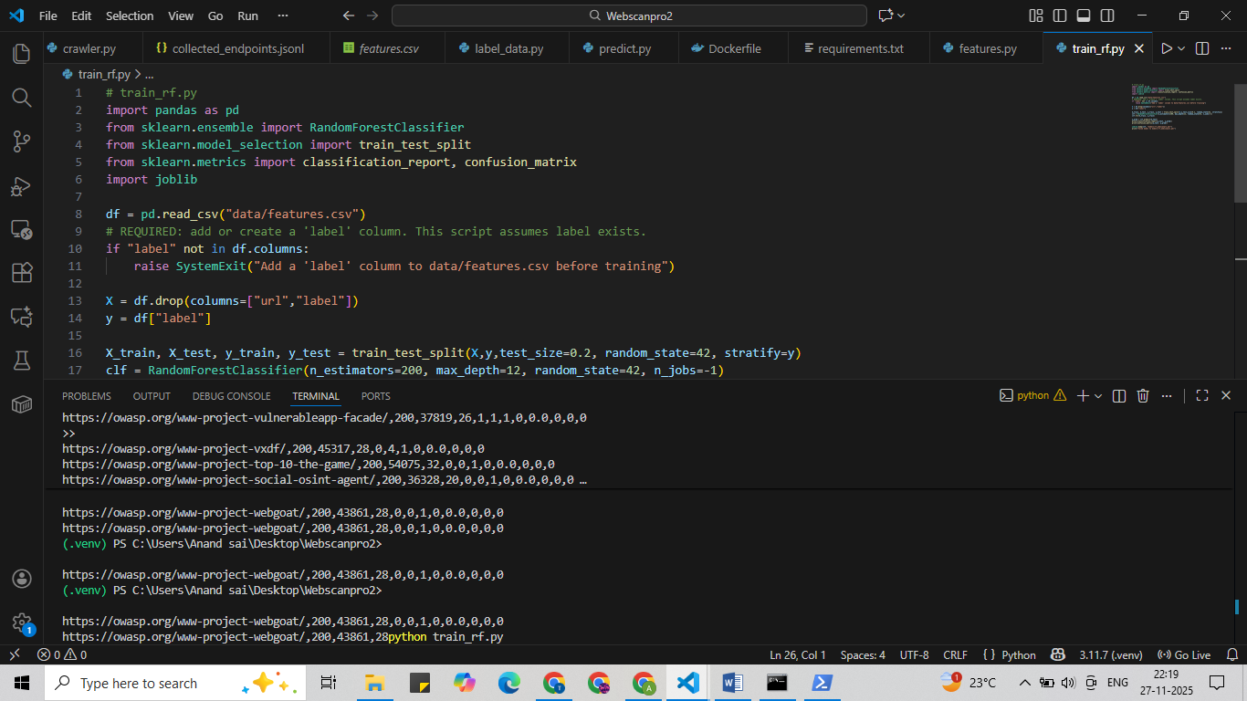
Then will to actually predict the data create predict.py
predict.py
To predict the data we require data/features.csv, models/rf_webscanpro.pkl, features.csv
Run – python predict.py
To view predictions - Get-Content .\data\predictions.csv -Tail 10
Else can be seen in predictions.csv
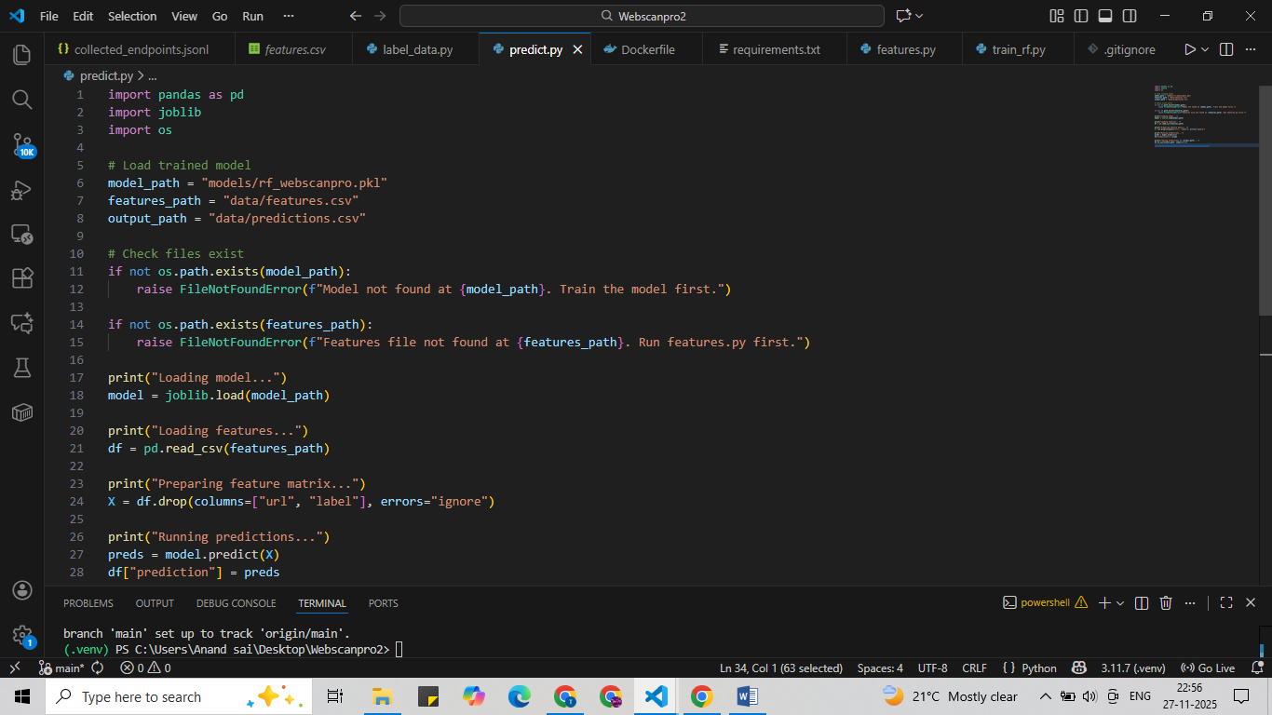
WEEK-4:
XSS DETECTION
What is XSS:
XSS (Cross-Site Scripting) detection involves using various techniques to identify vulnerabilities that allow attackers to inject malicious scripts into trusted websites.
To Detect those type of vulnerabilities.
Create a file xss_detector.py.It is used to detect the xss vulnerability in the given url.By giving a xss score as an output.
What is XSS score:
Here the output resembles xss score.The range of xss score will be 0-1.If the
Xss-score = 0 then there is no xss vulnerability in the given url.
Xss-score=1 then there is xss vulnerability in the given url.
CODE and OUTPUT
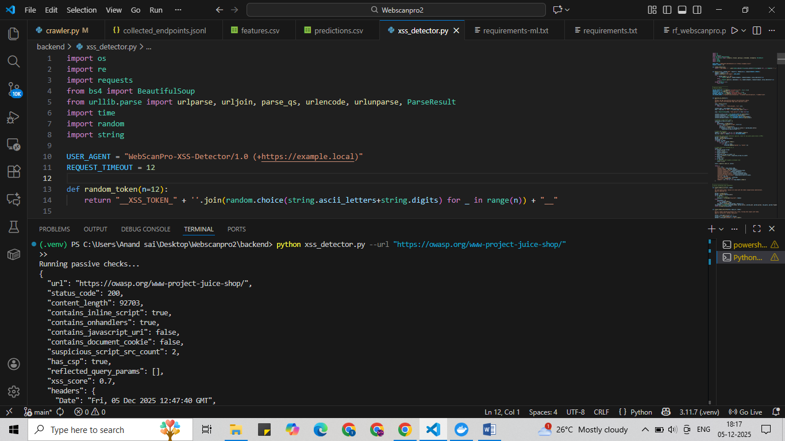
Here when the code is executed by giving juice shop website as input.The xss_score is 0.7.Therefore,it consists of xss vulnerabilities in juice shop website.
Backend:
Create a folder backend and place the xss_detector.py and sqli_detector in it with the requirements.txt.now create a file app.py here with the help of xss_detector and sqli_detector we run the backend to it.
app.py
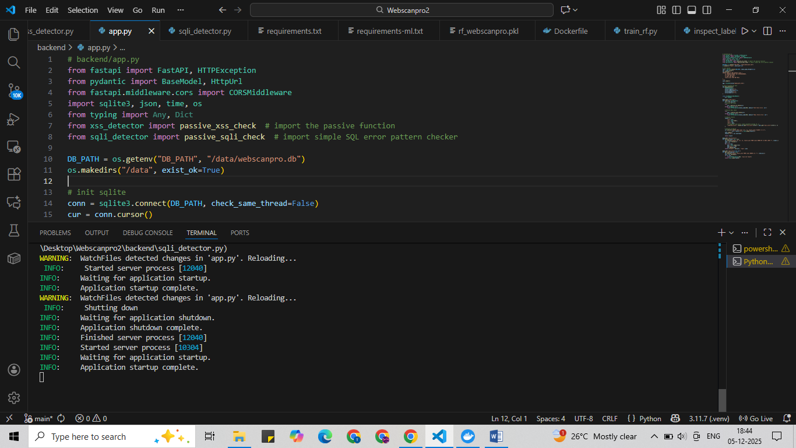
To run this code - uvicorn app:app --reload --host 0.0.0.0 --port 8000.
Week-5
Authentication and Session Testing.

1. Weak or Default Credential Testing

Objective:To identify accounts that can be accessed using commonly used weak passwords or factory default credentials.

Methodology

Compiled a list of weak credentials (e.g., admin/admin, root/password, guest/123456).
- Attempted logins against the authentication endpoint.
- Checked whether the system enforces:
  - Minimum password length
  - Special characters or complexity requirements
  - Account lockout after repeated failed attempts

2. Brute-Force Attack Simulation

Objective:To evaluate how the application responds to repeated automated login attempts.

Methodology

Automated rapid login attempts using a predefined list of usernames and passwords.
- Observed application behavior:
  - Is the IP temporarily blocked?
  - Does the system show CAPTCHA or similar mechanisms?
  - Does the user receive too many failed login alerts?

3. Insecure Cookie and Session Fixation Testing

Objective:To detect insecure cookie attributes and test whether session identifiers can be predicted, reused, or fixed.

Methodology

Inspected cookies for:
  - HttpOnly
  - Secure
  - SameSite restrictions
  - Cookie expiration time
- Attempted to set a user’s session ID manually (session fixation).
- Monitored whether sessions are invalidated on:
  - Logout
  - Password change
  - User role changes

4. Session Hijacking Simulation

Objective:To test whether an attacker can steal or reuse a valid session.

Methodology

Captured session cookies during authenticated sessions.
- Attempted to reuse them from a different client/environment.
- Tested for:
  - IP binding
  - User-Agent binding
  - Session timeout rules

5. Logging, Monitoring, and Security Best Practices

Objective:To ensure all authentication-related activities are properly logged and monitored.

Logging Activities Performed

Recorded login attempts (successful & failed).
- Logged brute-force and unusual login patterns.
- Logged cookie inspection results.
- Logged all session manipulation attempts.
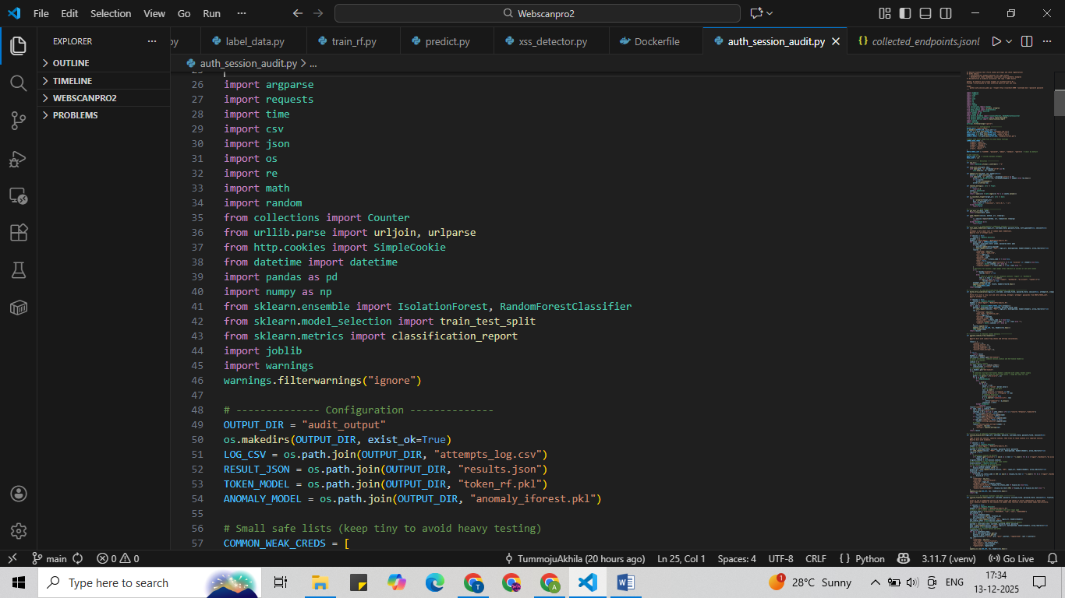
Week-6:
Access Control vulnerabilities occur when an application does not properly enforce restrictions on what authenticated or unauthenticated users are allowed to do.
Insecure Direct Object Reference (IDOR) is a common access control flaw where attackers manipulate object identifiers (such as user IDs, order IDs, or file IDs) to access unauthorized data.

Horizontal Privilege Escalation
Definition:
Occurs when a user accesses resources belonging to another user with the same privilege level.
Testing Methodology:
- Login as a normal user (User A).
- Capture requests accessing user-specific data.
- Modify object identifiers (e.g., user_id=101 → user_id=102).
- Replay the request.
- Observe if data of another user is accessible.

Vertical Privilege Escalation
Definition:
Occurs when a low-privileged user gains access to higher-privileged (admin) functionality.
Testing Methodology:
- Login as a normal user.
- Attempt to access admin or restricted endpoints directly.
- Modify role-related parameters or headers if present.
- Analyze server response.

IDOR (Insecure Direct Object Reference) Testing
IDOR occurs when the application uses direct references to internal objects without proper authorization checks.

Testing Steps
- Identify parameters such as:
- user_id
- account_id
- order_id
- file_id
- Modify the identifier value.
- Send the modified request.
- Observe the response behavior.

Suggested Access Control Techniques

Role-Based Access Control (RBAC)
Description:
Permissions are assigned based on user roles such as Admin, User, and Guest.
Advantages:
- Easy to manage
- Scalable
- Suitable for enterprise systems
Best Practices:
- Enforce role checks on server-side
- Avoid role validation on client-side
- Use middleware for authorization

Attribute-Based Access Control (ABAC)
Description:
Access decisions are based on attributes like user role, resource ownership, time, and location.
Advantages:
- Fine-grained access control
- Dynamic and flexible
- Suitable for modern web applications
Example Attributes:
- User role
- Resource owner ID
- Request time
- IP address
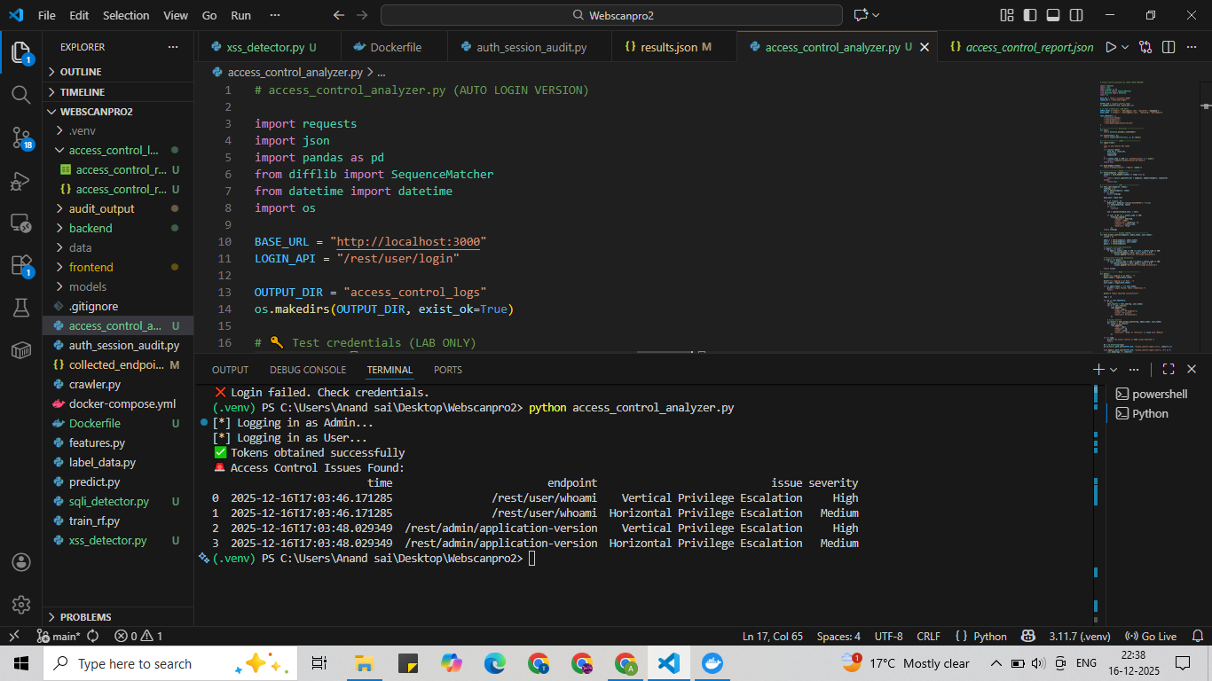
In the juiceshop will be registering user and admin role those will be scanned and checks for the issue severity.
To run – python access_control_analyzer.py
Output will be stored in the form access_control_logs
Week-7
Security Report Generation
The report generator receives normalized scan results from the following modules:
- Cross-Site Scripting (XSS) Scanner
- SQL Injection Scanner
- Authentication & Session Audit Module
- Access Control Analyzer
Each scanner produces findings that are normalized into a common structure before report generation.

Report Compilation Process

Scan results are collected from all vulnerability scanners
- Results are normalized into a unified data format
- Severity levels are extracted or defaulted safely
- Mitigation guidance is mapped to each vulnerability type
- All findings are compiled into a single report structure

Report Summary Section

The generated report includes a summary section that provides a quick overview of scan results:

Total number of vulnerabilities detected
- Count of High severity issues
- Count of Medium severity issues
- Count of Low severity issues

HTML Report Generation

The system generates a styled HTML security report that includes:

Target application details
- Scan timestamp
- Severity-based summary
- Detailed vulnerability table
- Color-coded severity indicators (Red – High, Yellow – Medium, Green – Low).
In the backend folder create a app.py python file for report generation taking files in scanner folder as input.
app.py
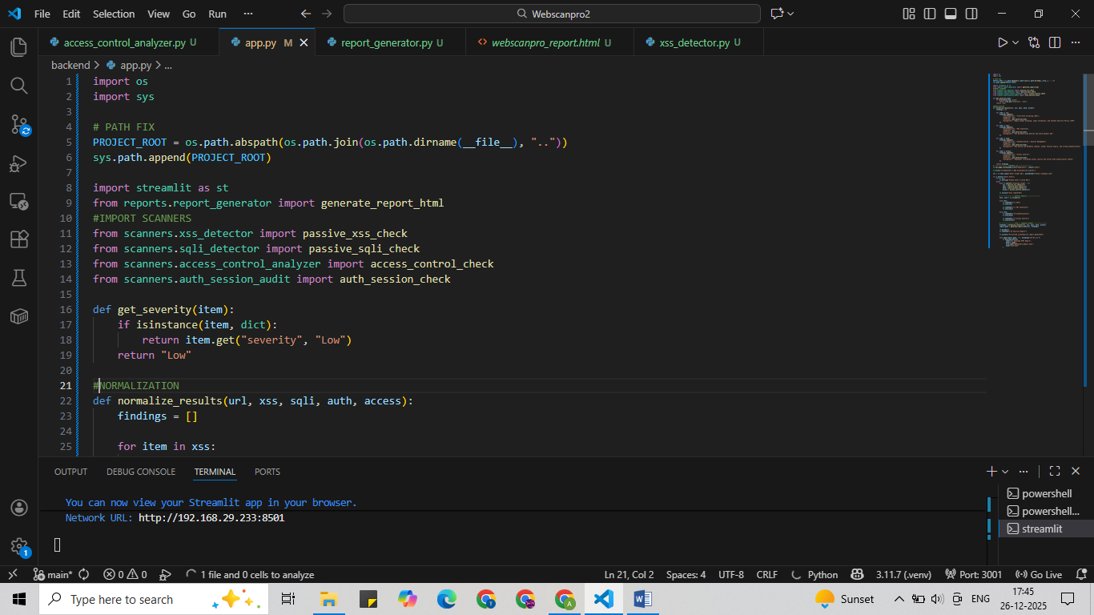
By running streamlit run backend/app.py
It redirects to http://localhost:8501/
Final Output: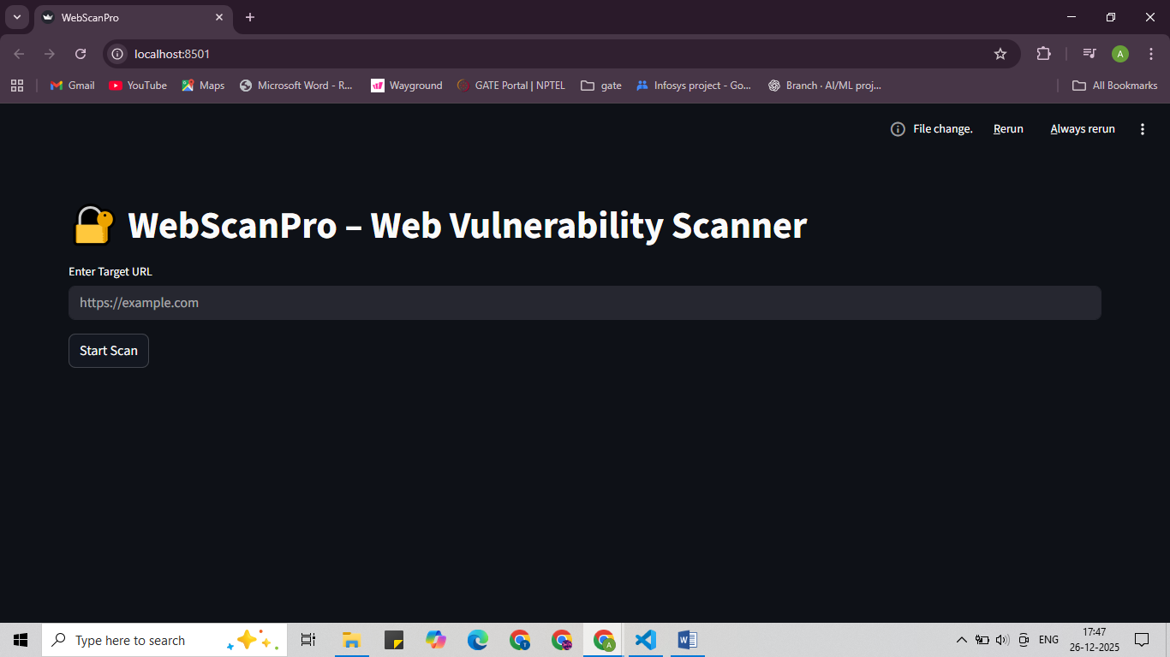
When a url is given as input and we scan the url it gives results like
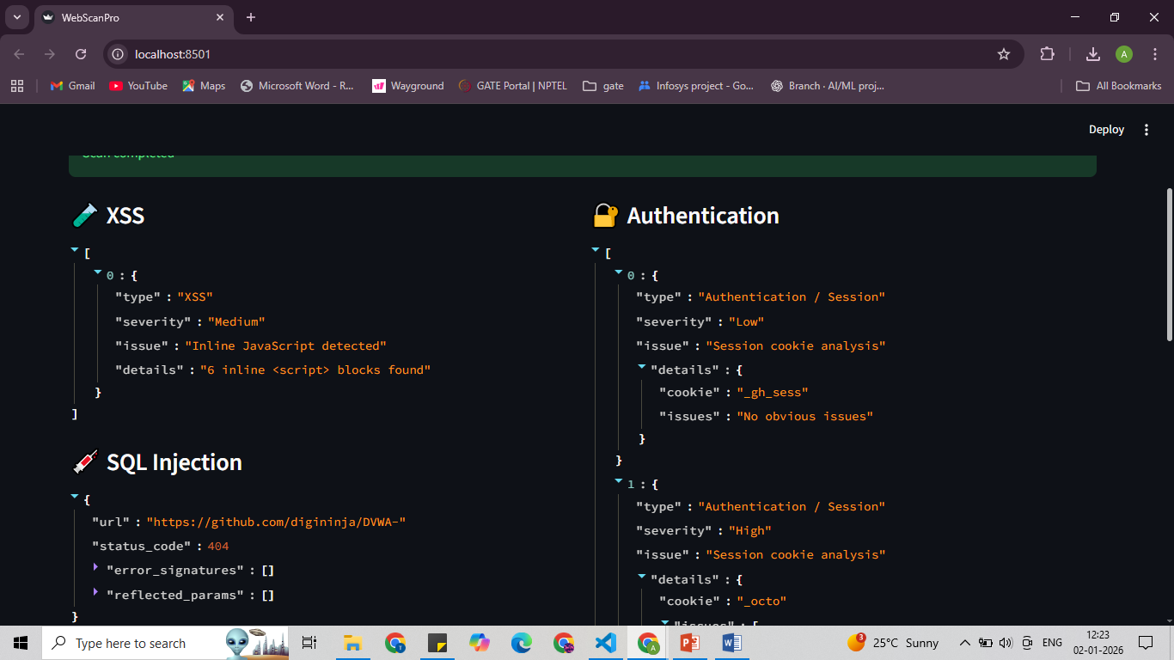we have an option to download the report.
The report 