BUILDTRACK
Construction Project Management & Site Monitoring Platform
MILESTONE 3 DOCUMENTATION
Modules 5–7: Material Inventory, Workforce Management & Procurement Management

Document Item | Details
Project | BuildTrack – Construction Project Management & Site Monitoring Platform
Milestone | Milestone 3 Documentation
Modules Covered | Modules 5–7: Material Inventory, Workforce Management & Procurement Management
Technology Evidence | Angular frontend; Python FastAPI backend; SQLAlchemy/database layer
Document Type | Technical Project / Internship Documentation
Evidence Basis | Current BuildTrack project source and reference milestone specification
Version | 1.0

1. Milestone Overview
Milestone 3 documents the material/inventory, workforce and procurement areas of BuildTrack. The source project contains a Material Inventory placeholder screen, a detailed Workforce Management workspace, and a detailed Procurement Management workspace. The reference specification identifies material procurement, inventory monitoring, material requests, material allocation, stock management, workforce operations and procurement operations as the intended scope. Only functionality evidenced in the current project is described as implemented.
Module | Purpose | Main Implemented / Observed Areas
Module 5 – Material Inventory | Provide a material/inventory area for construction materials. | Current source contains an Admin Material Inventory placeholder page; full inventory workflows are not evidenced in the current source.
Module 6 – Workforce Management | Manage construction workers, attendance, allocation, shifts and payroll. | Dashboard, Worker Registration, Attendance Tracking, Workforce Allocation, Shift Scheduling, Payroll Monitoring, Workforce Categories and Workforce Reports.
Module 7 – Procurement Management | Manage procurement requests, vendors/suppliers, purchase orders and invoices. | Dashboard, Procurement Requests, Purchase Orders, Invoice Tracking, Vendor Management, Supplier Management, Procurement Categories and Procurement Reports.

3. Milestone Objectives
- Provide a dedicated Material Inventory entry point while clearly recording any incomplete inventory functionality.
- Provide workforce visibility through worker registration, attendance, allocation, shift scheduling, categories, payroll and reports.
- Provide procurement workflows for requests, vendors, suppliers, purchase orders, invoices, categories and reports.
- Present construction operations through structured Angular pages, forms, tables, search fields and dashboard summaries.
- Maintain a clear distinction between implemented frontend UI and backend persistence that requires verification.

2. System Architecture Used in This Milestone
BuildTrack uses an Angular frontend with route-based page components and a Python FastAPI backend. The project also contains a SQLAlchemy/database layer. The documentation distinguishes visible frontend interfaces from backend persistence so that a page is not automatically treated as proof of a live API/database workflow.
Layer | Observed Implementation
Frontend | Angular project structure with standalone components, templates, forms, tables and dashboard-style interfaces.
Routing | Dedicated routes/pages exist for Material Inventory, Workforce Management, Procurement Management, Notifications, Dashboard & Analytics, Reports and Budget Management.
Backend | Python FastAPI application with multiple routers and database-session integration.
Database | SQLAlchemy engine/session configuration and ORM/database layer are present.
Authorization | authGuard and roleGuard are defined; protected module routes should be described according to the actual route configuration.

4. Module 5 – Material Inventory

4.1 Objective
The Material Inventory module is intended to support material procurement, inventory monitoring, material requests, material allocation and stock management. In the current BuildTrack source inspected for this documentation, the Admin Material Inventory area contains a Material Inventory page, but the available implementation is only a placeholder. Therefore, the full reference feature set is not claimed as implemented.

4.2 Current BuildTrack Implementation Status
Area | Observed Status
Material Inventory page | A dedicated Admin Material Inventory page exists in the Angular source.
Inventory functionality | The current page is a placeholder rather than a demonstrated end-to-end inventory workflow.
Material Procurement | Not specified as implemented in the inspected current source.
Inventory Monitoring | Not specified as implemented in the inspected current source.
Material Requests | Not specified as implemented in the inspected current source.
Material Allocation | Not specified as implemented in the inspected current source.
Stock Management | Not specified as implemented in the inspected current source.
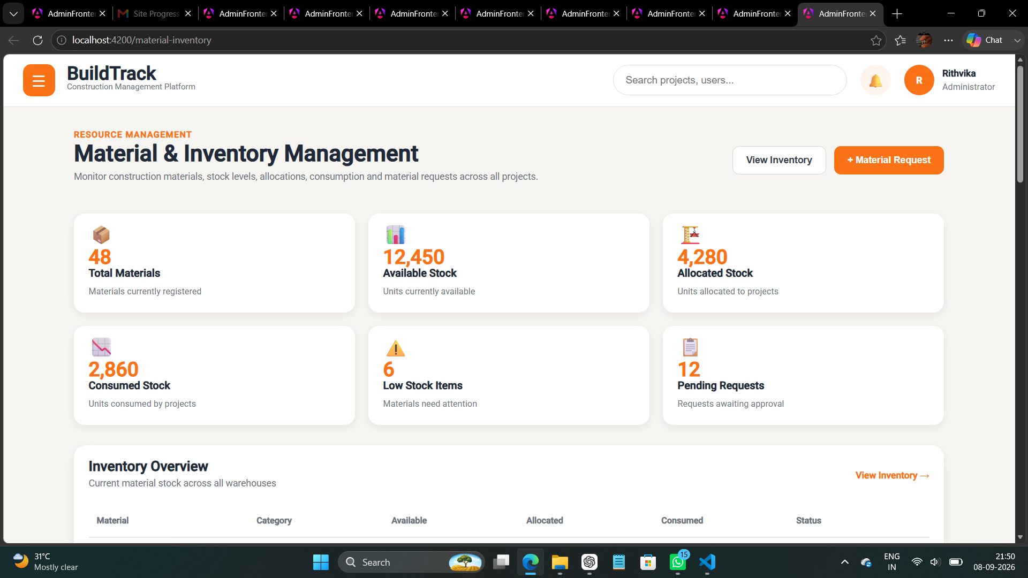

Figure 1: BuildTrack – Material Inventory Page

Screenshot note: capture the actual Material Inventory screen from the latest running version. Do not label placeholder content as a completed inventory workflow.

4.3 Inventory Management
The Inventory Management page allows users to monitor and manage materials available for construction projects.
It provides information about material names, categories, quantities and current stock levels.
This helps ensure that required materials are available for ongoing project activities.
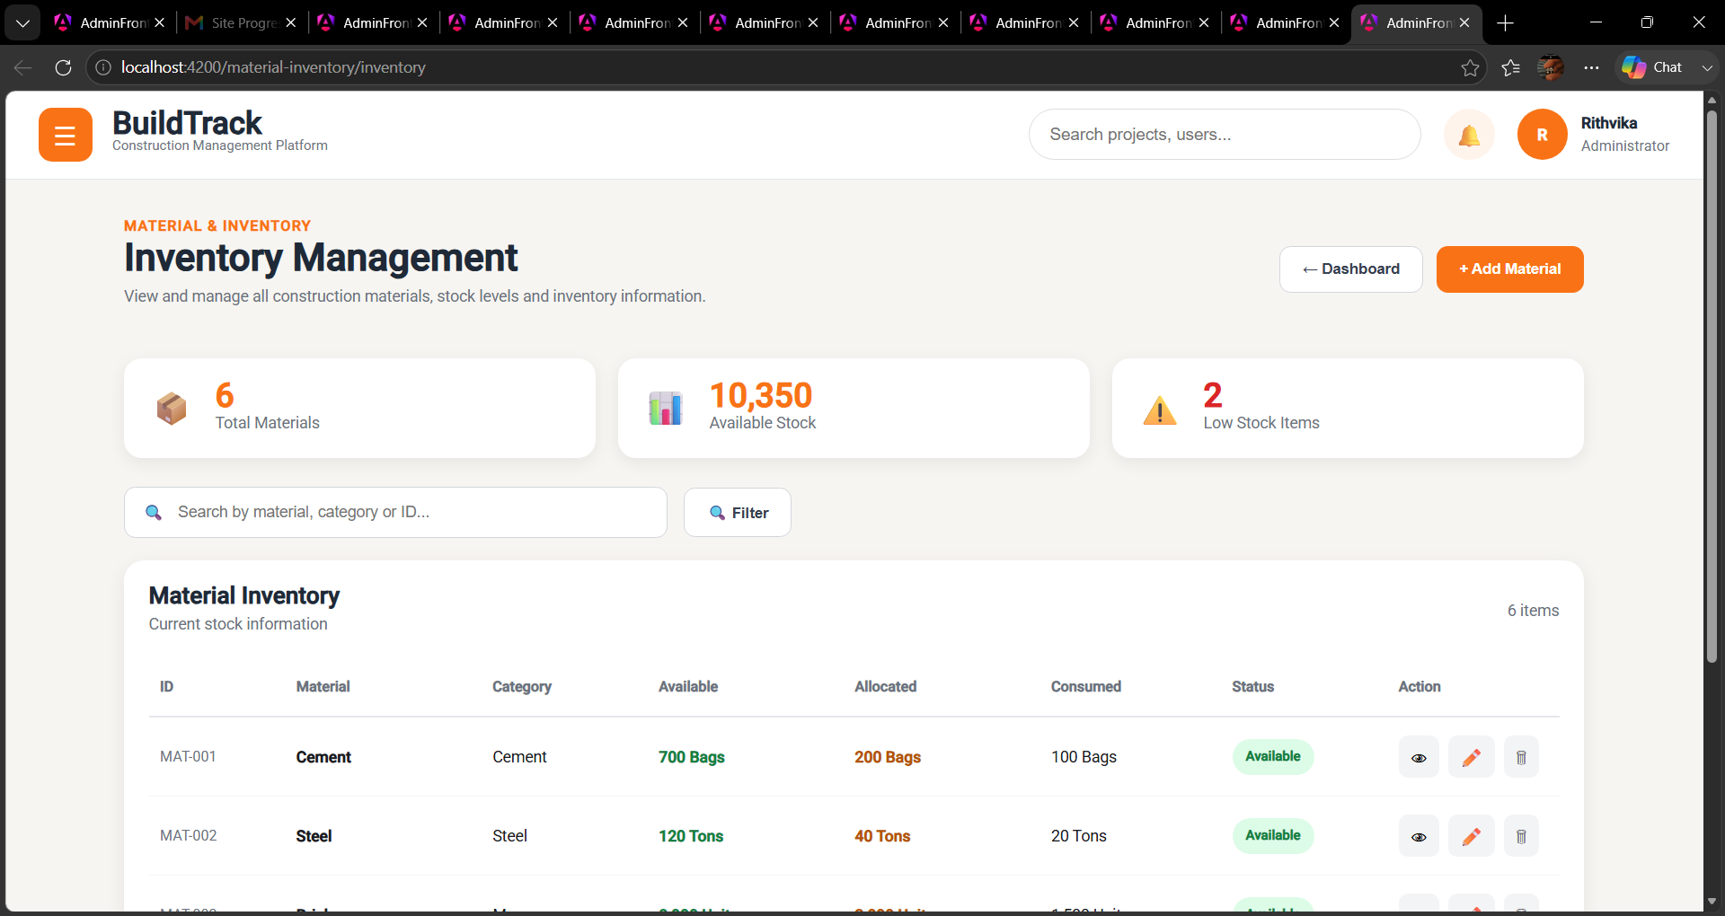
Figure 2: BuildTrack – Inventory Management Page
4.4 Material Request
The Material Request page allows users to view and monitor requests raised for construction materials.
It provides information about requested materials, quantities, projects and request status.
This helps track material requirements and supports timely procurement and allocation.
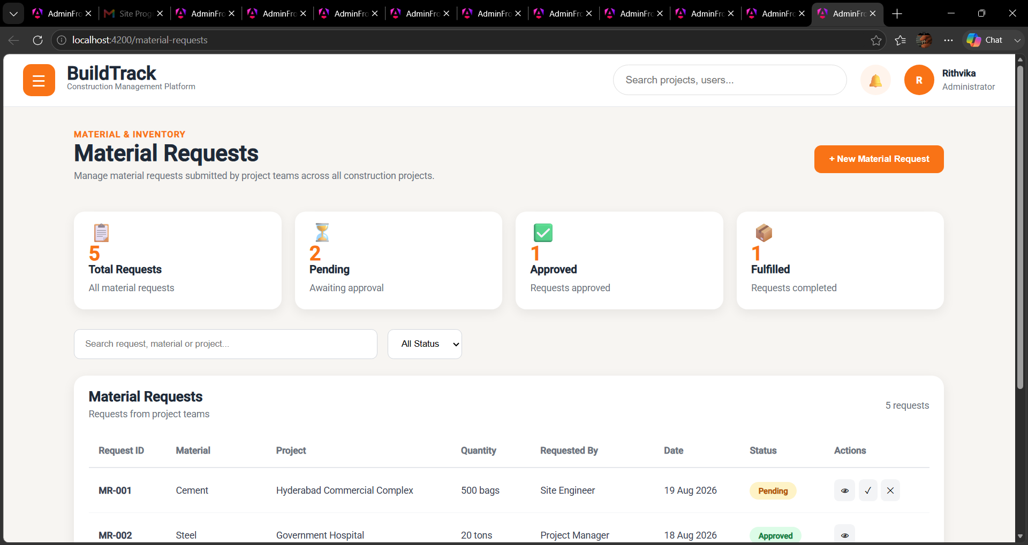
Figure 3: BuildTrack – Material request Page

4.5 New Material Request
The New Material Request page allows users to create a request for required construction materials.
The user can provide details such as the material, required quantity, project and request information.
After submission, the request can be reviewed and processed for further material procurement.

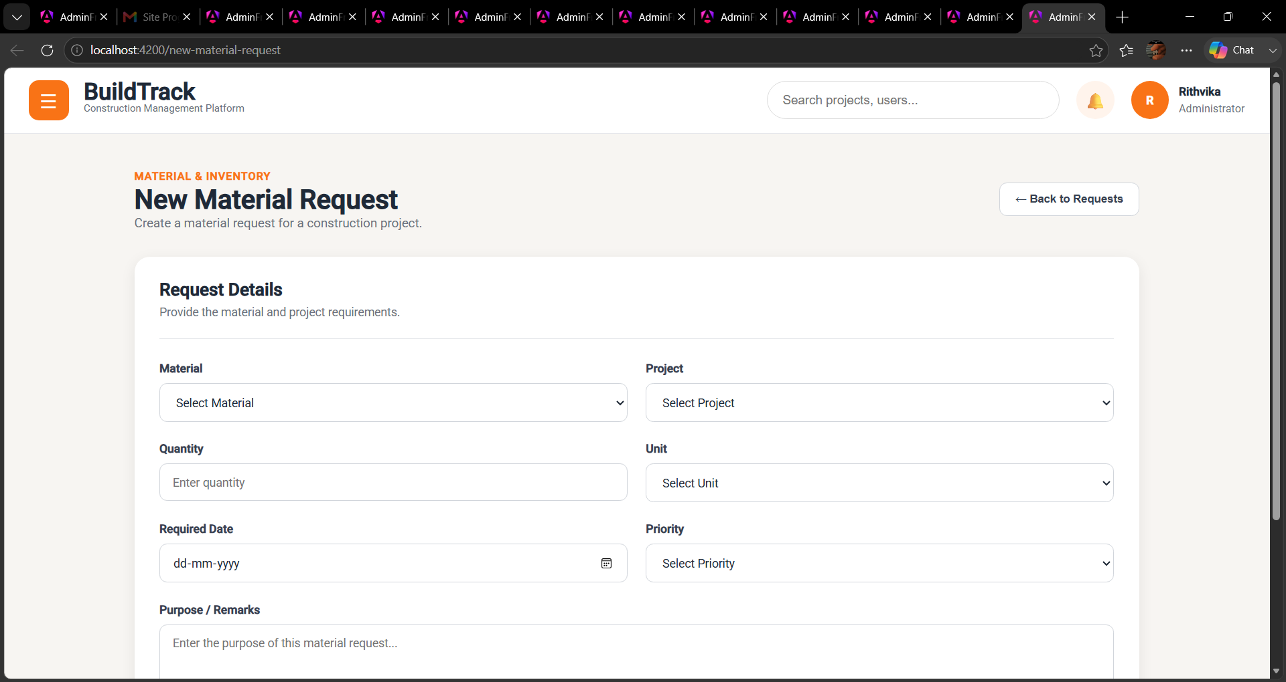

Figure 4: BuildTrack – New Material request Page

4.6 Low Stock
The Low Stock page helps users identify materials whose available quantity has reached a low stock level.
It provides information about materials that may require replenishment.
This helps prevent material shortages and supports continuous construction activities.
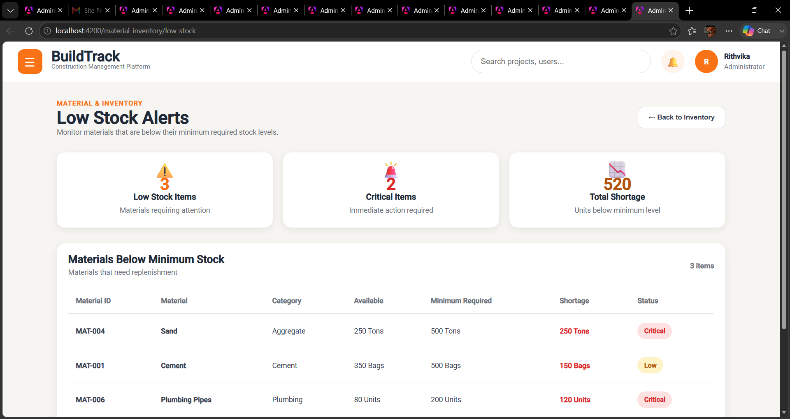
Figure 5: BuildTrack – Low stock Page
4.7 Material Allocation
The Material Allocation page allows users to allocate available materials to specific projects or construction activities.It provides information about the material, allocated quantity and associated project or work requirement.This helps ensure that materials are distributed according to project requirements.
Figure 6: BuildTrack – Material allocation Page
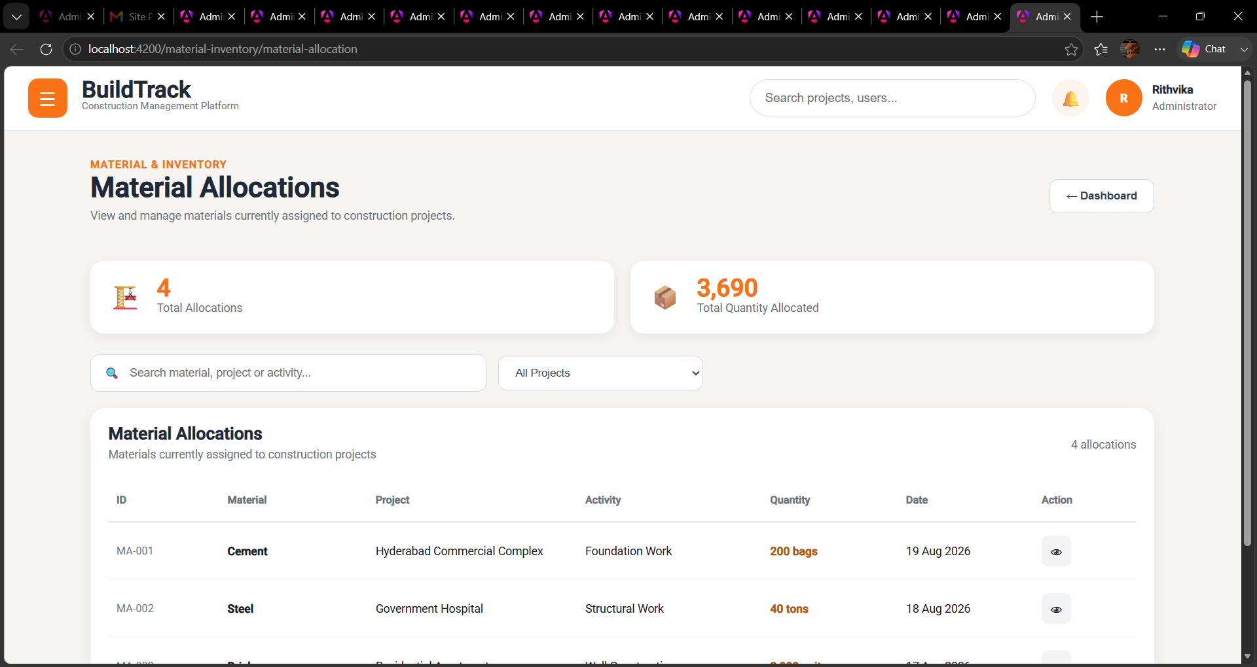

4.8 Stock Movements

The Stock Movements page allows users to monitor changes in material stock levels.
It provides information about material movements such as stock additions, issues and other inventory changes.
This helps maintain visibility of material flow and supports accurate inventory monitoring.

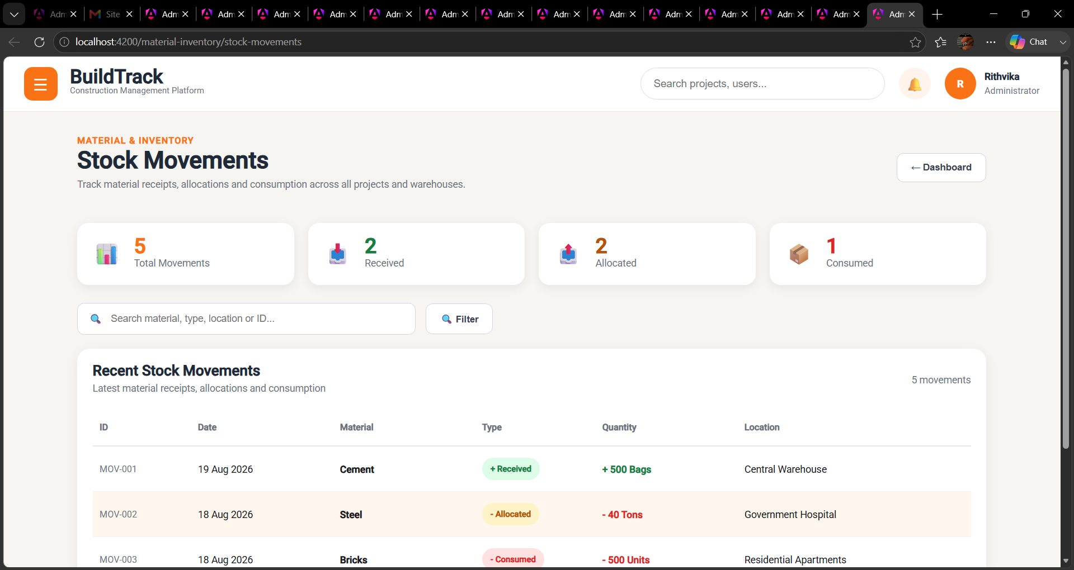

Figure 7: BuildTrack – Stock movements Page

Module Outcome
The Material Inventory module is represented by a dedicated frontend entry point, but the inspected implementation does not provide sufficient evidence to claim the complete inventory feature set. The module should be marked as partial/pending until its actual workflows and persistence are demonstrated.

5. Module 6 – Workforce Management

5.1 Objective
The Workforce Management module provides a structured workspace for registering workers, monitoring attendance, allocating workforce to projects, scheduling shifts, managing workforce categories, monitoring payroll and generating workforce reports.

5.2 Workforce Dashboard
Purpose: Provide a consolidated workforce overview.
How it works in BuildTrack: The dashboard displays total workers, present workers, absent workers, workers on leave, active assignments, active shifts, pending payroll and an attendance percentage. It also includes workforce categories, attendance overview and project-wise workforce sections.
Role/User: Workforce Management user
Expected output: A summarized workforce status and project-wise workforce view.
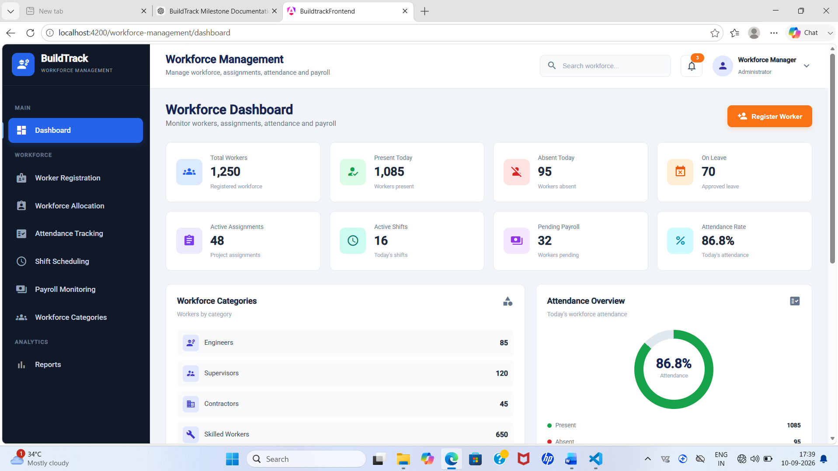

Figure 2: BuildTrack – Workforce Dashboard

5.3 Worker Registration
Purpose: Register and maintain worker information.
How it works in BuildTrack: The page provides worker registration fields such as Worker ID, worker name, contact information and skill/work type. It also provides active/leave/inactive summary information, a registered-worker table, search, and a bulk workforce-file upload area.
Role/User: Workforce Management user
Expected output: Worker records can be entered/reviewed through the registration interface.
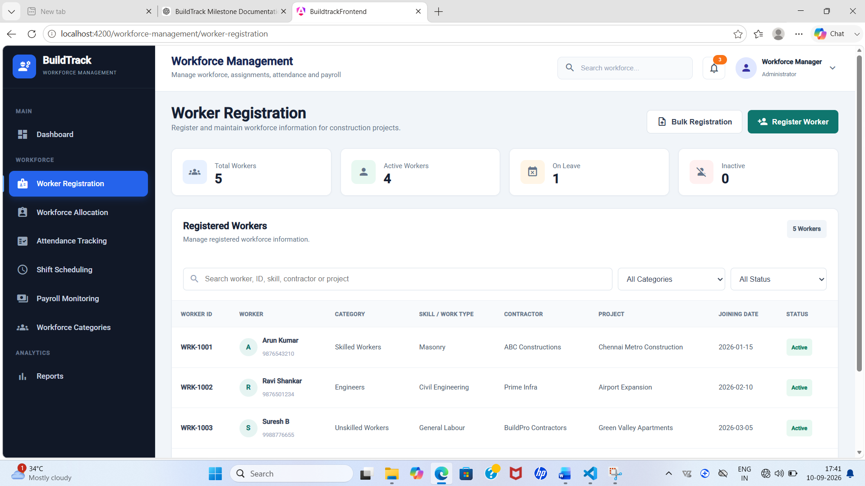
Figure 3: BuildTrack – Worker Registration

5.4 Attendance Tracking
Purpose: Monitor workforce attendance records.
How it works in BuildTrack: The page summarizes total workers, present, absent and late counts and provides an Attendance Records table with Attendance ID, Worker, Project, Date, Shift, Check In, Check Out and Status.
Role/User: Workforce Management user
Expected output: Attendance status and attendance records are presented for monitoring.
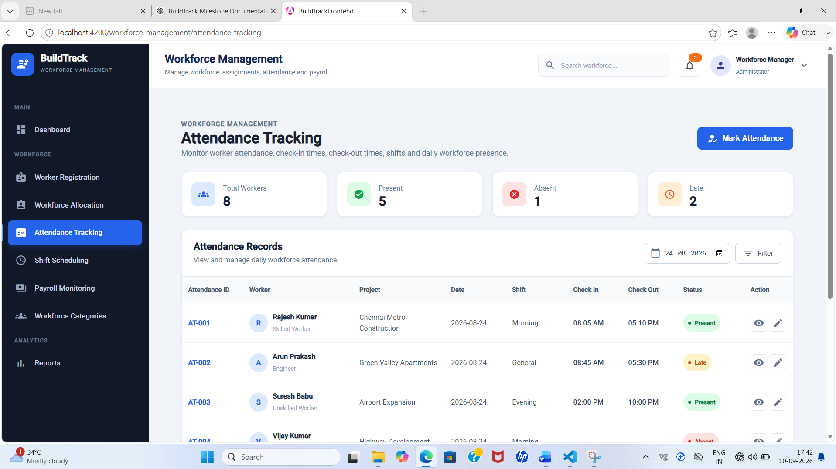

Figure 4: BuildTrack – Attendance Tracking

5.5 Workforce Allocation

Purpose: Assign workers to construction projects and work areas.
How it works in BuildTrack: The page provides allocation summary values and a New Workforce Allocation area. The current allocation table includes Allocation ID, Worker, Category, Project, Work Area, Contractor, Shift, Start Date, End Date and Status.
Role/User: Workforce Management user
Expected output: Workforce allocation information is available for project-level monitoring.
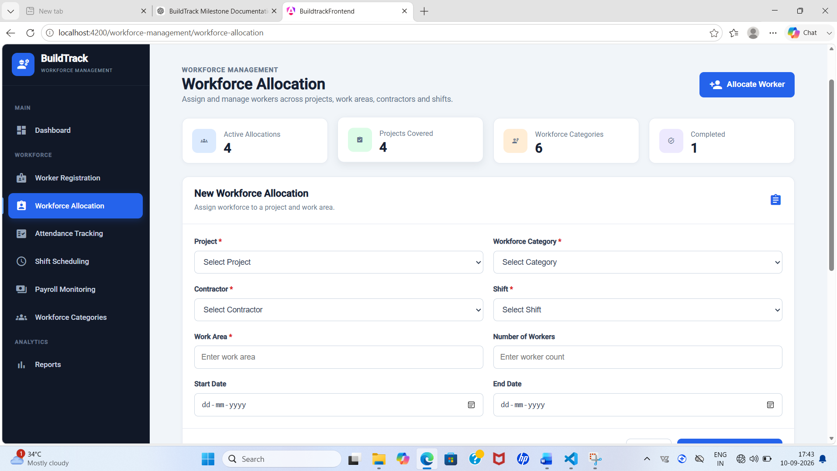

Figure 5: BuildTrack – Workforce Allocation

5.6 Shift Scheduling

Purpose: Plan and monitor workforce shifts.
How it works in BuildTrack: The page summarizes total schedules, morning shifts, active shifts and night shifts. A Create New Shift Schedule area and a Current Shift Schedules table are provided with project, category, work area, shift, date, workers, supervisor, timing and status.
Role/User: Workforce Management user
Expected output: Scheduled workforce shifts can be reviewed through the page.


Figure 6: BuildTrack – Shift Scheduling

5.7 Payroll Monitoring

Purpose: Monitor workforce payroll information.
How it works in BuildTrack: The page displays total payroll, processed payroll, pending payroll and worker count. The Payroll Monitoring table includes Payroll ID, Worker, Project, Category, Pay Period, Basic Pay, Overtime, Deductions, Net Pay and Status.
Role/User: Workforce Management user
Expected output: Payroll processing and monitoring information is presented.
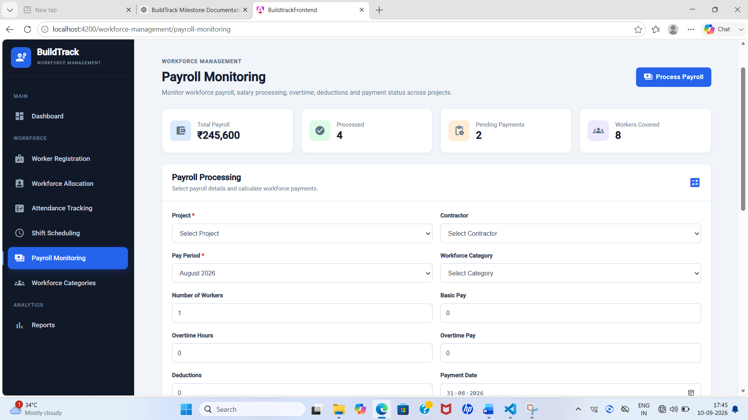

Figure 7: BuildTrack – Payroll Monitoring

5.8 Workforce Categories

Purpose: Organize workers by workforce category.
How it works in BuildTrack: The page provides category summary values and a Workforce Category Setup/List area for managing category-related information.
Role/User: Workforce Management user
Expected output: Workforce categories can be organized and reviewed.
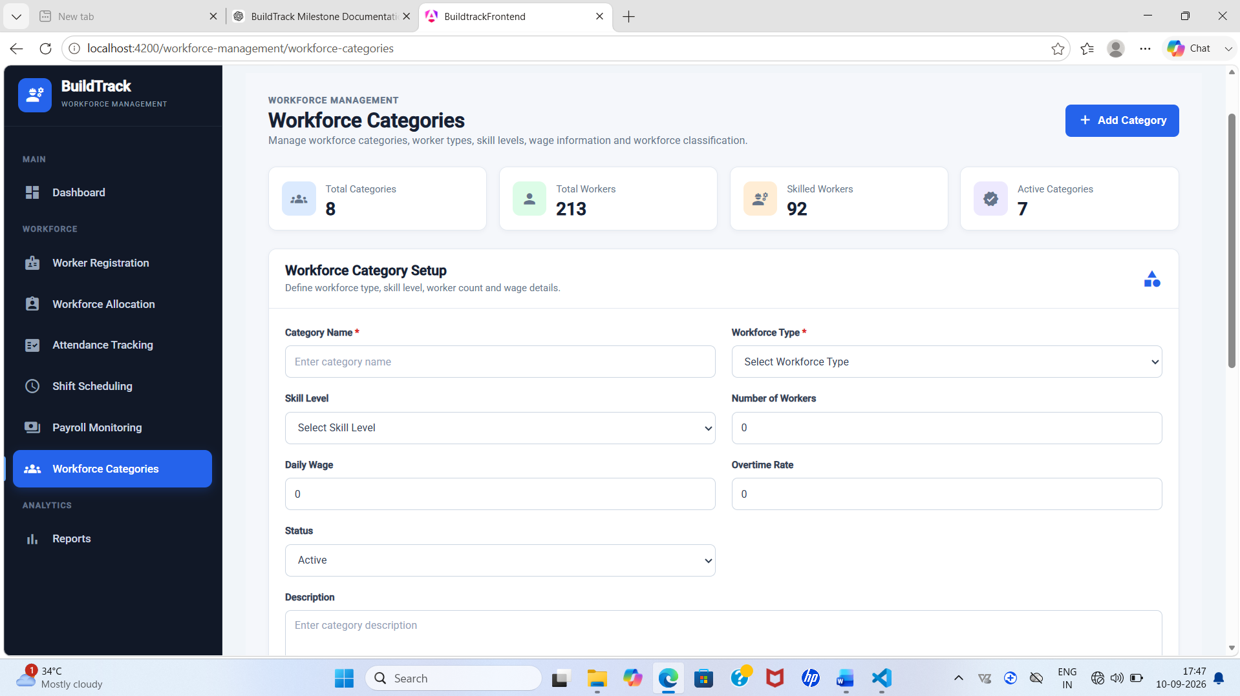

Figure 8: BuildTrack – Workforce Categories

5.9 Workforce Reports

Purpose: Provide workforce-focused reporting.
How it works in BuildTrack: The Workforce Reports page contains a Report Generator and Workforce Report Overview area for presenting workforce reporting information.
Role/User: Workforce Management user
Expected output: Workforce reporting information can be accessed.
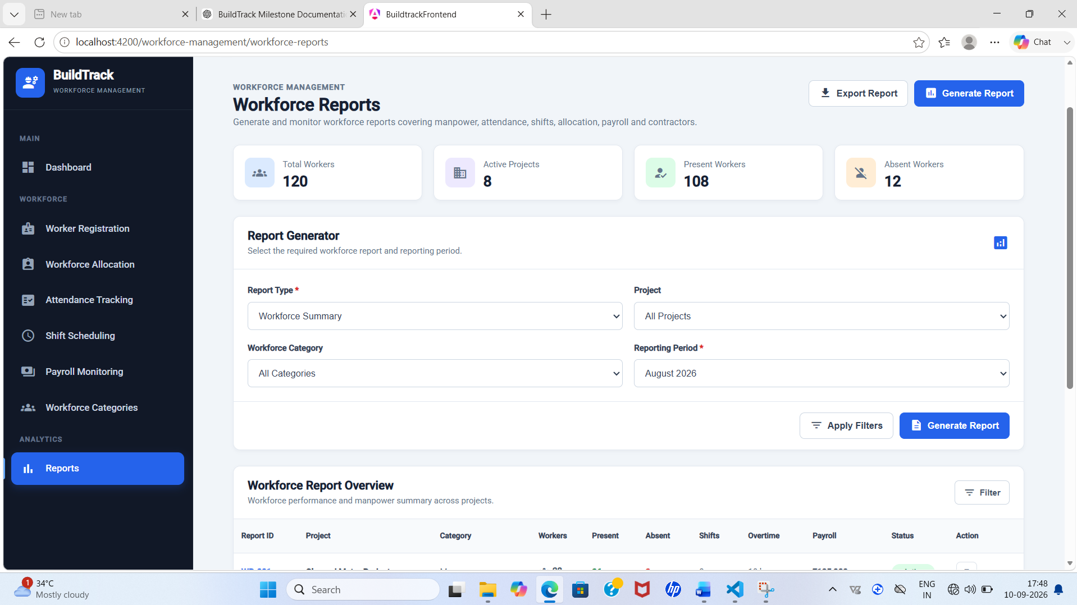
Figure 9: BuildTrack – Workforce Reports

End-to-End Workflow
Step | User Action | System Response | Result
1 | Open Workforce Dashboard | Dashboard loads workforce summary indicators and project-wise workforce information. | Overall workforce status is available.
2 | Register or review workers | Worker Registration displays worker fields, status summaries and the registered-worker table. | Worker information can be maintained/reviewed.
3 | Review attendance | Attendance Tracking displays attendance counts and detailed attendance records. | Attendance status is available for monitoring.
4 | Allocate workforce | Workforce Allocation presents worker/project/work-area/shift allocation information. | Workforce assignments can be reviewed.
5 | Schedule shifts | Shift Scheduling displays schedule summaries and current shift schedules. | Shift planning information is available.
6 | Review payroll | Payroll Monitoring presents payroll totals and payroll records. | Payroll status can be monitored.

Module Outcome
The Workforce Management module provides dedicated frontend interfaces covering the main operational areas of workforce registration, attendance, allocation, shift scheduling, categories, payroll and reporting.

6. Module 7 – Procurement Management

6.1 Objective
The Procurement Management module provides a structured procurement workspace for managing procurement requests, vendors, suppliers, purchase orders, invoices, procurement categories and procurement reports.

6.2 Procurement Dashboard
Purpose: Provide a centralized procurement overview.
How it works in BuildTrack: The page presents a Procurement Dashboard with summary information and procurement navigation.
Role/User: Procurement Management user
Expected output: High-level procurement information is presented.
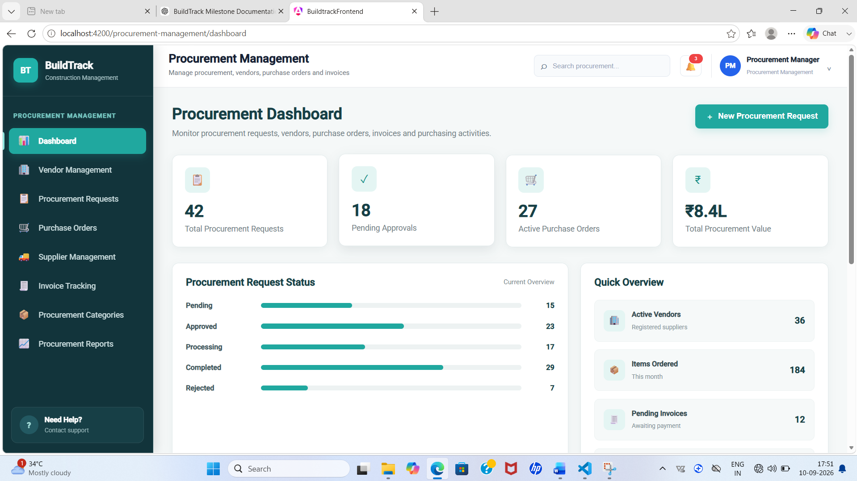
Figure 10: BuildTrack – Procurement Dashboard

6.3 Procurement Requests
Purpose: Create, search and review procurement requests.
How it works in BuildTrack: The page includes a searchable request table with Request ID, Project, Requested By, Item/Material, Category, Quantity, Required Date, Priority, Request Date and Status. A Request Details area captures project, requester, item/material, quantity, required date, priority, purpose/requirement and remarks.
Role/User: Procurement Management user
Expected output: Procurement requests can be entered and reviewed through the interface.
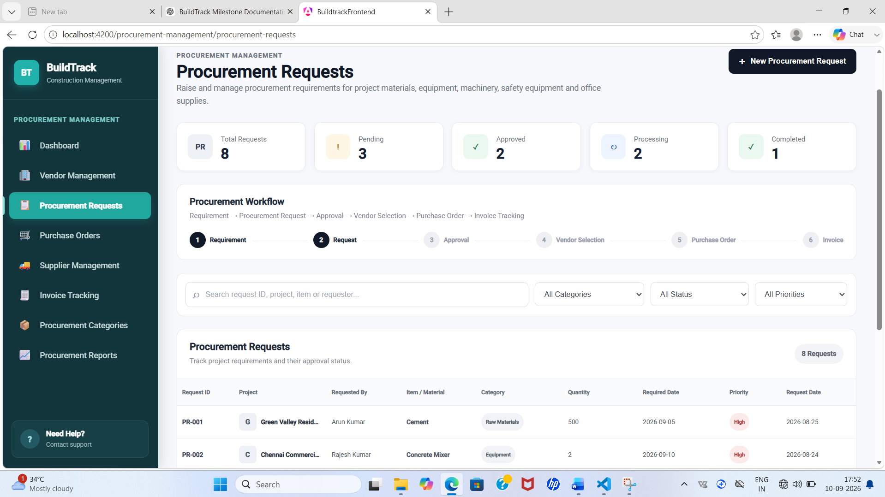
Figure 11: BuildTrack – Procurement Requests

6.4 Purchase Orders
Purpose: Create and monitor purchase orders.
How it works in BuildTrack: The page provides search and a purchase-order table with PO ID, Vendor, Project, Request ID, Item, Category, Order Date, Delivery Date, Quantity, Total Amount and Status. The form includes request, item and quantity/amount-related fields.
Role/User: Procurement Management user
Expected output: Purchase-order information can be reviewed and entered.
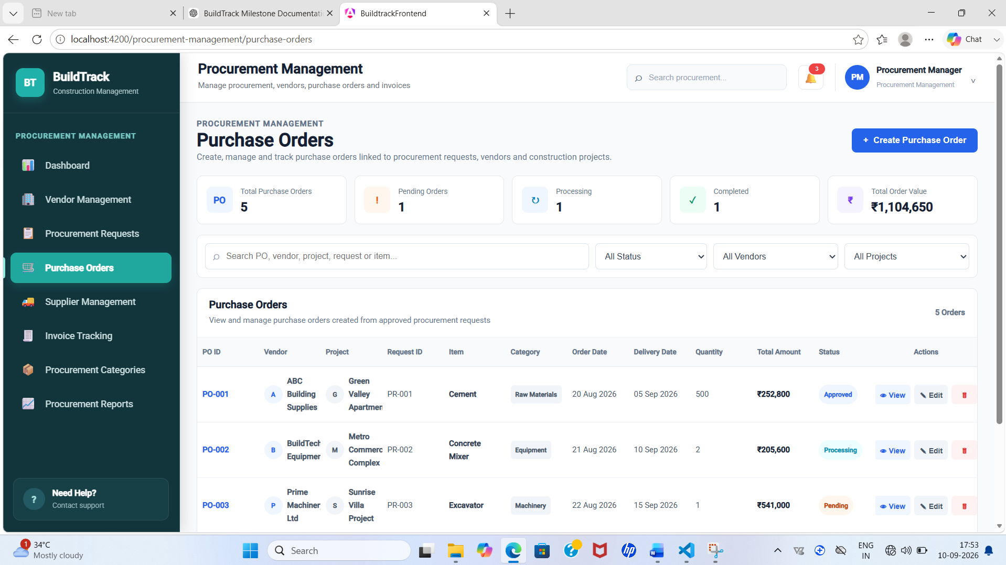

Figure 12: BuildTrack – Purchase Orders

6.5 Invoice Tracking

Purpose: Track vendor/supplier invoices and payment status.
How it works in BuildTrack: The page provides search by invoice, vendor, PO or project and an Invoice Records table containing Invoice ID, Invoice Number, Vendor/Supplier, Purchase Order, Project, Invoice Date, Due Date, Amount, Payment Status and Invoice Status. An Add Invoice form is available.
Role/User: Procurement Management user
Expected output: Invoice information and payment status can be monitored.
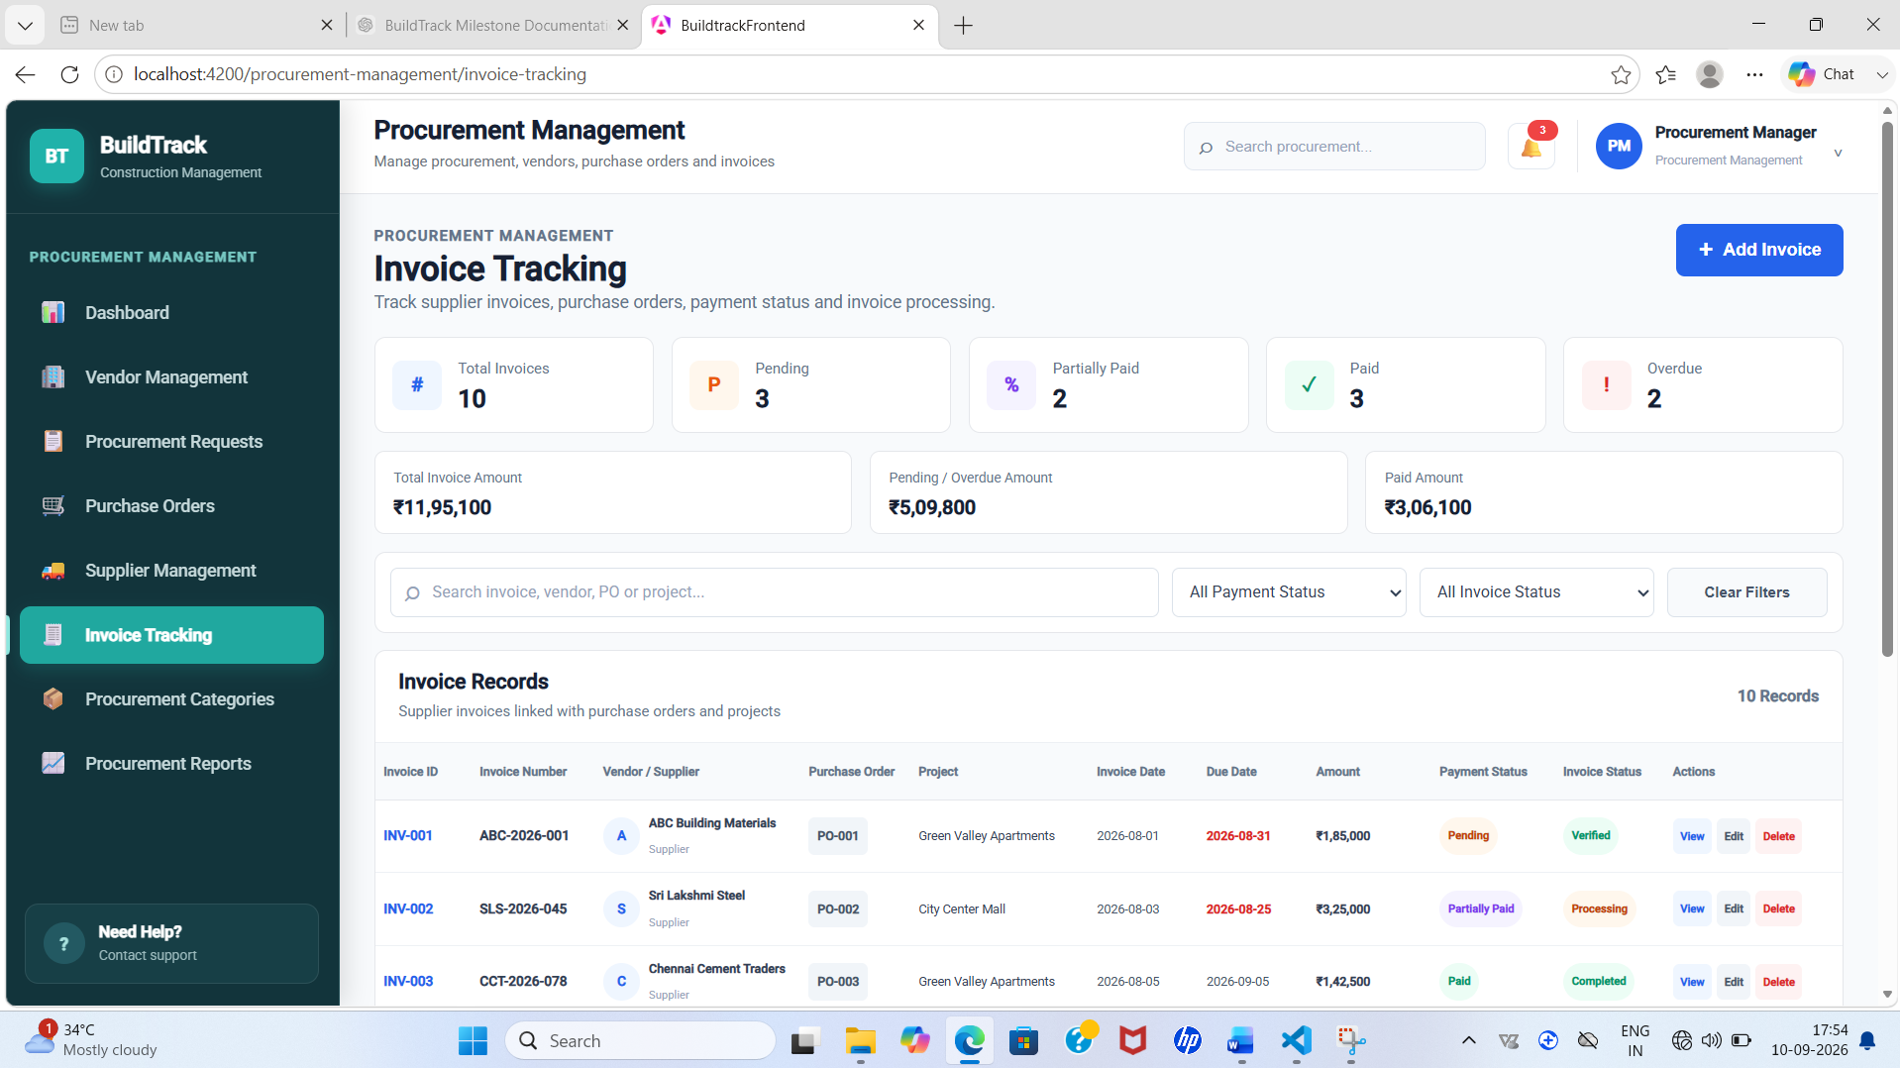

Figure 13: BuildTrack – Invoice Tracking

6.6 Vendor Management

Purpose: Maintain registered vendor information.
How it works in BuildTrack: The Vendor Management page provides search, a Registered Vendors table and Vendor Details. The form includes vendor name, contact person, contact number, email, category, products/services, status and address.
Role/User: Procurement Management user
Expected output: Vendor information can be reviewed and entered.
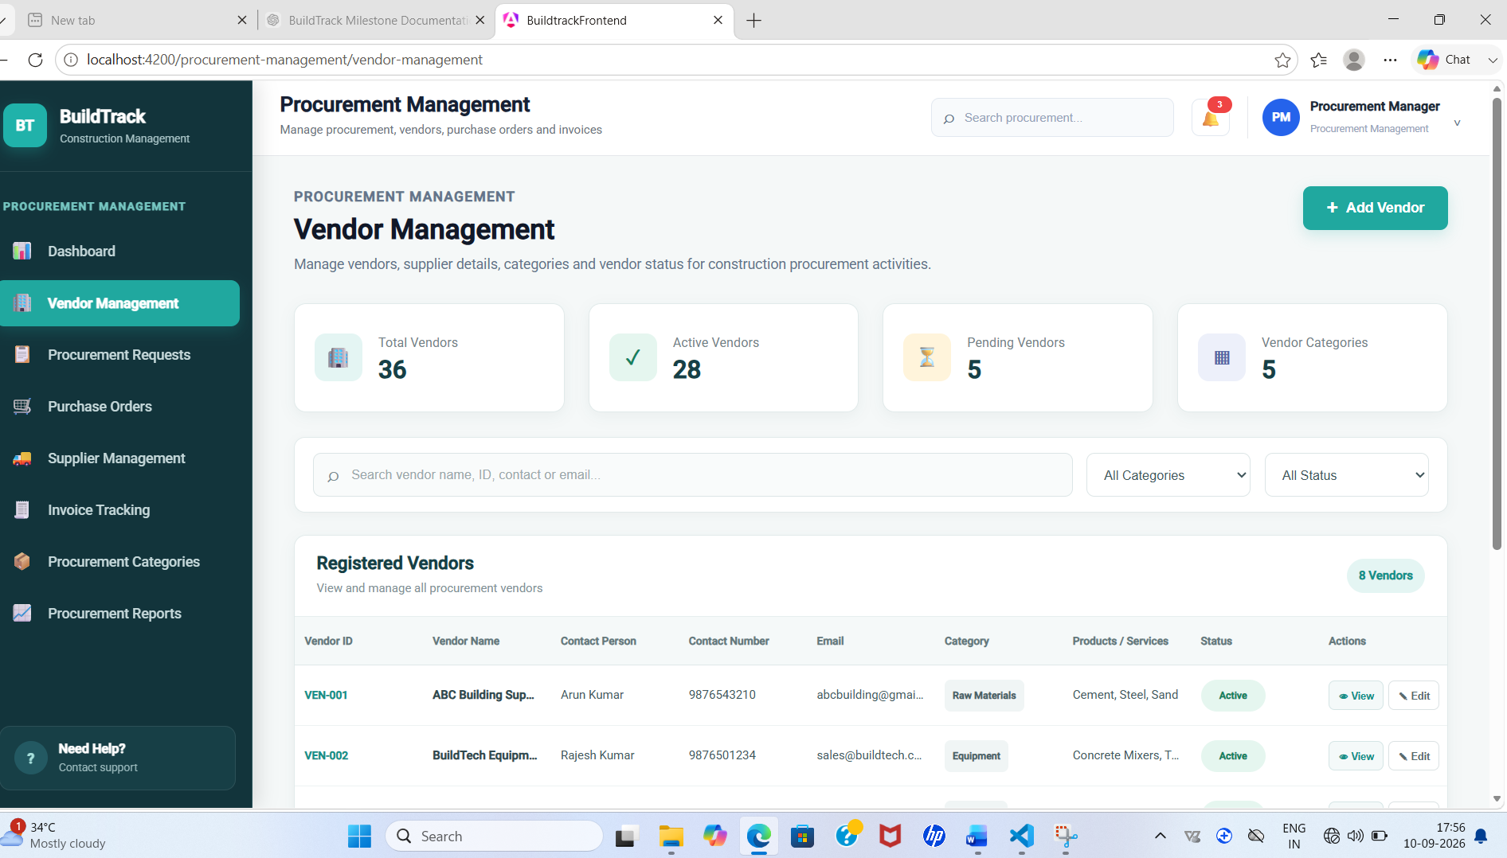

Figure 14: BuildTrack – Vendor Management

6.7 Supplier Management

Purpose: Maintain supplier information relevant to procurement.
How it works in BuildTrack: The Supplier Management page includes search and a Supplier Directory with supplier ID, supplier, contact, category, material/service, projects, rating and status. Supplier details include name, company, contact, phone, email, category, material/service, rating, projects supplied, address and notes.
Role/User: Procurement Management user
Expected output: Supplier information can be reviewed and managed through the UI.
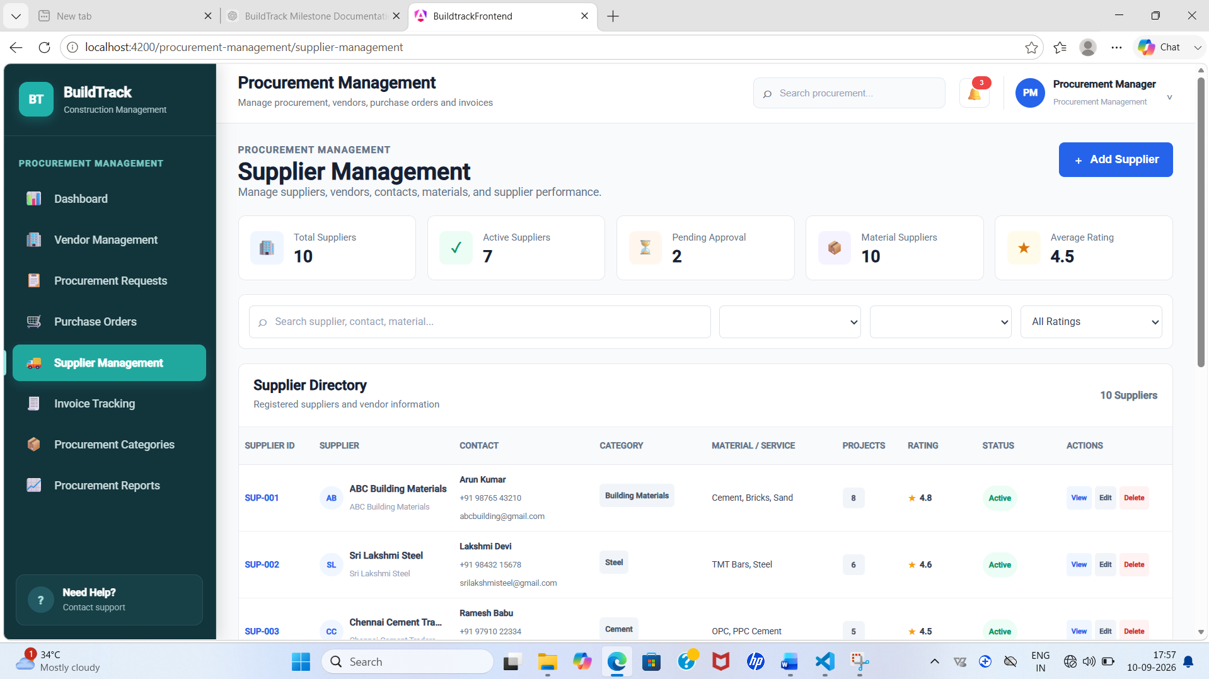

Figure 15: BuildTrack – Supplier Management

6.8 Procurement Categories

Purpose: Organize procurement information by category.
How it works in BuildTrack: The Procurement Categories page provides a category-management interface for procurement classification.
Role/User: Procurement Management user
Expected output: Procurement category information is presented.
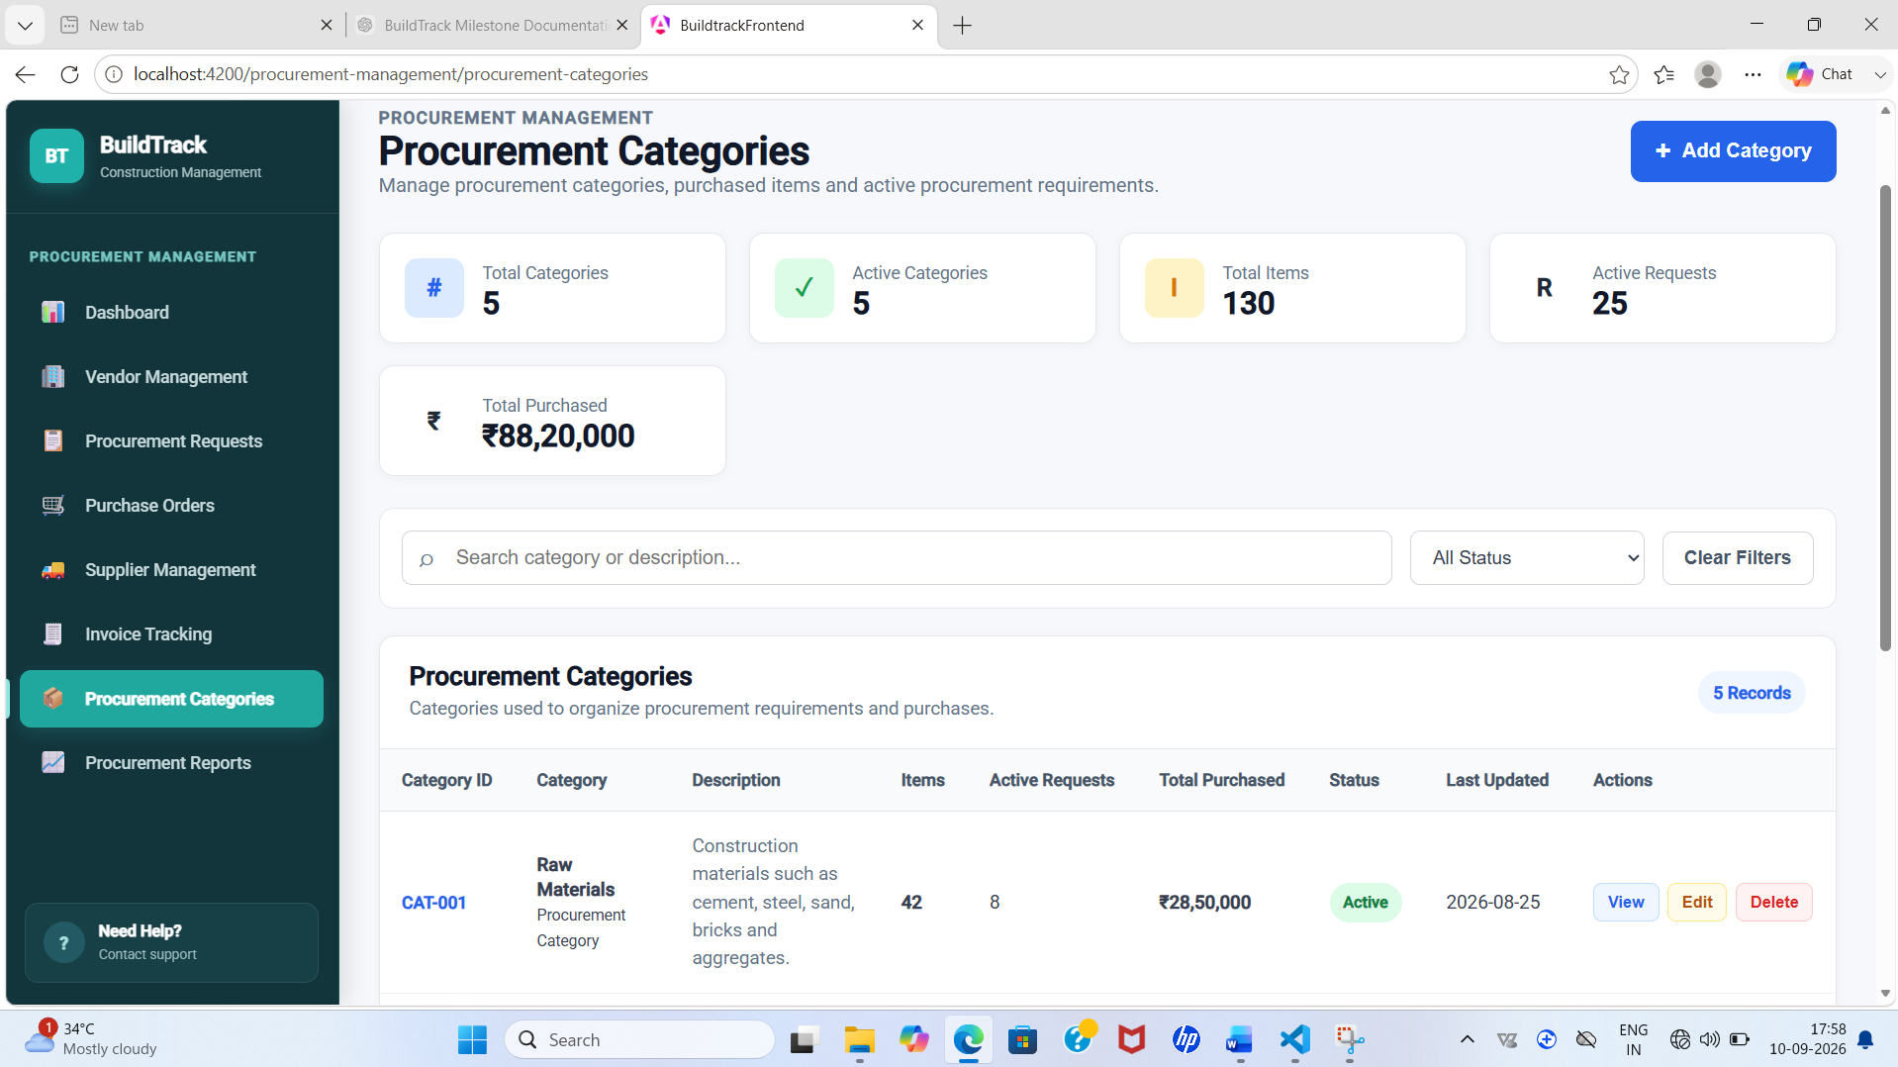

Figure 16: BuildTrack – Procurement Categories

6.9 Procurement Reports

Purpose: Provide procurement reporting information.
How it works in BuildTrack: The Procurement Reports page provides a dedicated procurement-reporting interface.
Role/User: Procurement Management user
Expected output: Procurement reporting information can be accessed.
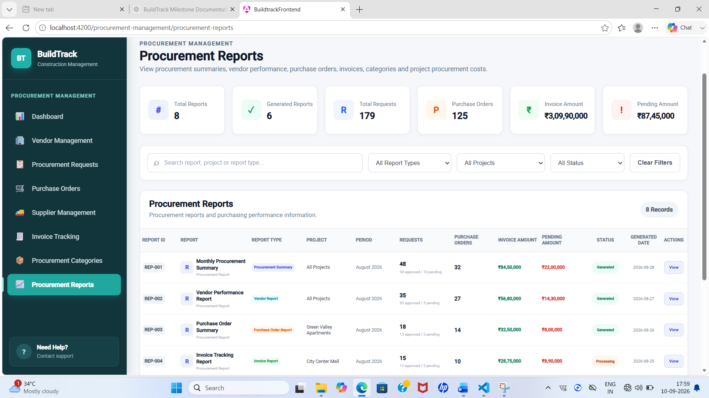
Figure 17: BuildTrack – Procurement Reports

End-to-End Workflow
Step | User Action | System Response | Result
1 | Open Procurement Dashboard | Procurement overview is displayed. | Central procurement workspace is available.
2 | Create/review a procurement request | Request form/table captures project, requester, item, quantity, dates, priority and status. | Procurement requirement is recorded/reviewed.
3 | Review vendors/suppliers | Vendor and Supplier Management pages provide searchable directories and detail forms. | Supplier source information is available.
4 | Create/review purchase order | Purchase Orders displays order, vendor, project, item, quantity, amount and status. | Purchase-order information is available.
5 | Track invoice | Invoice Tracking displays invoice, PO, project, amount and payment/status fields. | Invoice and payment status can be monitored.
6 | Open Procurement Reports | Procurement reporting interface is displayed. | Procurement information can be reviewed in report form.

Module Outcome
The Procurement Management module provides dedicated interfaces for procurement requests, vendors, suppliers, purchase orders, invoice tracking, categories and reporting.

7. Role-wise Functionality
Role / User Area | Milestone 3 Capabilities Evidenced
Material Inventory | Dedicated Admin Material Inventory page exists; complete inventory operations are not claimed because the inspected page is a placeholder.
Workforce Management User | Dashboard, worker registration, attendance tracking, workforce allocation, shift scheduling, payroll monitoring, workforce categories and workforce reports.
Procurement Management User | Dashboard, procurement requests, purchase orders, invoice tracking, vendor management, supplier management, procurement categories and procurement reports.
Other Roles | No additional Milestone 3 capability is claimed without direct evidence from the current source.

8. End-to-End Milestone 3 Workflow
Input | Processing / Action | System View | Output
Material inventory requirement | Open Material Inventory area | Material Inventory page | Inventory entry point; complete workflow pending.
Worker information | Register/review worker | Worker Registration | Worker information available for workforce operations.
Attendance information | Review attendance records | Attendance Tracking | Attendance status and records.
Project workforce requirement | Allocate workers and schedule shifts | Workforce Allocation / Shift Scheduling | Workforce assignment and shift information.
Payroll information | Review payroll records and status | Payroll Monitoring | Payroll monitoring view.
Procurement requirement | Create/review request | Procurement Requests | Procurement requirement information.
Vendor/supplier information | Review or enter source details | Vendor / Supplier Management | Procurement source information.
Purchase requirement | Create/review purchase order | Purchase Orders | PO information and status.
Invoice information | Record/review invoice | Invoice Tracking | Invoice and payment-status information.

Screenshots and Evidence Checklist
Use screenshots from the latest running BuildTrack application. Insert each screenshot immediately after the related feature description, keeping image width, caption style and figure numbering consistent.
- Figure 1 – Material Inventory Page
- Figure 2 – Workforce Dashboard
- Figure 3 – Worker Registration
- Figure 4 – Attendance Tracking
- Figure 5 – Workforce Allocation
- Figure 6 – Shift Scheduling
- Figure 7 – Payroll Monitoring
- Figure 8 – Workforce Categories
- Figure 9 – Workforce Reports
- Figure 10 – Procurement Dashboard
- Figure 11 – Procurement Requests
- Figure 12 – Purchase Orders
- Figure 13 – Invoice Tracking
- Figure 14 – Vendor Management
- Figure 15 – Supplier Management
- Figure 16 – Procurement Categories
- Figure 17 – Procurement Reports

Technical Implementation Summary
Area | Implementation Evidence
Frontend Framework | Angular project structure with standalone components and route-based pages.
UI | Angular templates, forms, data binding, tables, search fields, dashboard summaries and management interfaces.
Routing | Dedicated pages exist for workforce-management and procurement-management areas; Material Inventory is represented by an Admin Material Inventory page.
Backend | Python FastAPI application with routers and database session integration.
Database | SQLAlchemy engine/session configuration and ORM/database layer.
Integration Note | Frontend screens are not treated as proof of live database persistence unless the corresponding API/persistence is demonstrated.

Limitations / Pending Work
- The current Material Inventory page is a placeholder; the reference features of material procurement, inventory monitoring, material requests, material allocation and stock management are not claimed as fully implemented.
- Some Workforce and Procurement screens contain frontend forms/data structures; exact backend persistence should be verified feature by feature.
- The existence of a route or screen alone is not treated as proof of complete API/database integration.
- Final screenshots should be taken from the latest running BuildTrack version.
- Any remaining integration, validation or persistence work should be recorded as pending rather than presented as fully operational.

Milestone Completion Summary
Item | Status / Evidence
Milestone | Milestone 3
Modules Covered | Module 5 – Material Inventory; Module 6 – Workforce Management; Module 7 – Procurement Management
Material Inventory | Dedicated page present; full inventory workflow pending/not sufficiently evidenced.
Workforce Management | Dashboard, registration, attendance, allocation, shifts, payroll, categories and reports present.
Procurement Management | Dashboard, requests, purchase orders, invoice tracking, vendor/supplier management, categories and reports present.
Screenshots | Recommended screenshot positions are provided throughout the document.
Technical Foundation | Angular frontend, FastAPI backend and SQLAlchemy/database layer are evidenced in the project.
Overall Status | Frontend functionality is documented according to source evidence; backend persistence and end-to-end integration require verification where not demonstrated.

9. Conclusion
Milestone 3 extends BuildTrack into workforce and procurement operations while documenting the current state of material inventory functionality. The Workforce Management module provides structured interfaces for worker registration, attendance, allocation, shifts, payroll, categories and reports. The Procurement Management module provides request, vendor, supplier, purchase-order, invoice, category and reporting interfaces. The Material Inventory area is documented conservatively as a partial/placeholder implementation so that the submission reflects the actual project source.

