BUILDTRACK
Construction Project Management & Site Monitoring Platform
MILESTONE 4 DOCUMENTATION
Modules 8–11: Notifications, Dashboard & Analytics, Reports & Documentation, Budget & Cost Management

Document Item | Details
Project | BuildTrack – Construction Project Management & Site Monitoring Platform
Milestone | Milestone 4 Documentation
Modules Covered | Modules 8–11: Notifications, Dashboard & Analytics, Reports & Documentation, Budget & Cost Management
Technology Evidence | Angular frontend; Python FastAPI backend; SQLAlchemy/database layer
Document Type | Technical Project / Internship Documentation
Evidence Basis | Current BuildTrack project source and reference milestone specification
Version | 1.0

1. Milestone Overview
Milestone 4 documents the communication, monitoring, reporting and financial-management areas of BuildTrack. The current project source contains dedicated notification pages, Project Manager and Administrator dashboard/analytics pages, a reporting workspace with multiple report types, and a Budget & Cost Management workspace with budget planning, cost estimation, expense management, budget monitoring, dashboard and financial summary pages.
Module | Purpose | Main Implemented / Observed Areas
Module 8 – Notifications | Provide notification viewing, detail and management capabilities. | Notifications page, Notification Details, Notification Management, Notification Settings and Notification Activity.
Module 9 – Dashboard & Analytics | Provide consolidated project and administrative monitoring. | Project Manager Dashboard and Administrator Dashboard with project, financial, workforce, equipment, milestone and system-overview information.
Module 10 – Reports & Documentation | Provide centralized project and operational reporting. | Reports Dashboard, Project Progress Report, Resource Utilization Report, Workforce Report, Procurement Report, Budget Report and Report Preview.
Module 11 – Budget & Cost Management | Plan, estimate, monitor and review project finances. | Budget Dashboard, Budget Planning, Cost Estimation, Expense Management, Budget Monitoring and Financial Summary.

3. Milestone Objectives
- Provide a centralized notification interface for viewing and managing system notifications.
- Provide role-oriented dashboards for Project Manager and Administrator monitoring.
- Provide project, resource, workforce, procurement and budget reporting interfaces.
- Support budget planning, cost estimation, actual expense recording, budget monitoring and financial summaries.
- Present information using structured dashboards, tables, filters, summaries and report-preview interfaces.
- Clearly distinguish frontend implementation from backend persistence or external-service integration that has not been demonstrated.

2. System Architecture Used in This Milestone
BuildTrack uses an Angular frontend with route-based page components and a Python FastAPI backend. The project also contains a SQLAlchemy/database layer. The documentation distinguishes visible frontend interfaces from backend persistence so that a page is not automatically treated as proof of a live API/database workflow.
Layer | Observed Implementation
Frontend | Angular project structure with standalone components, templates, forms, tables and dashboard-style interfaces.
Routing | Dedicated routes/pages exist for Material Inventory, Workforce Management, Procurement Management, Notifications, Dashboard & Analytics, Reports and Budget Management.
Backend | Python FastAPI application with multiple routers and database-session integration.
Database | SQLAlchemy engine/session configuration and ORM/database layer are present.
Authorization | authGuard and roleGuard are defined; protected module routes should be described according to the actual route configuration.

4. Module 8 – Notification System

4.1 Objective
The Notification System provides a centralized interface for viewing notification activity, opening notification details and managing notification-related settings.

4.2 Notifications Page
Purpose: View notification information and notification activity.
How it works in BuildTrack: The Notifications page provides a notification listing/activity area and handles the no-notification state when records are unavailable.
Role/User: Notification-enabled application user / role-specific workspace.
Expected output: Notification information can be reviewed.
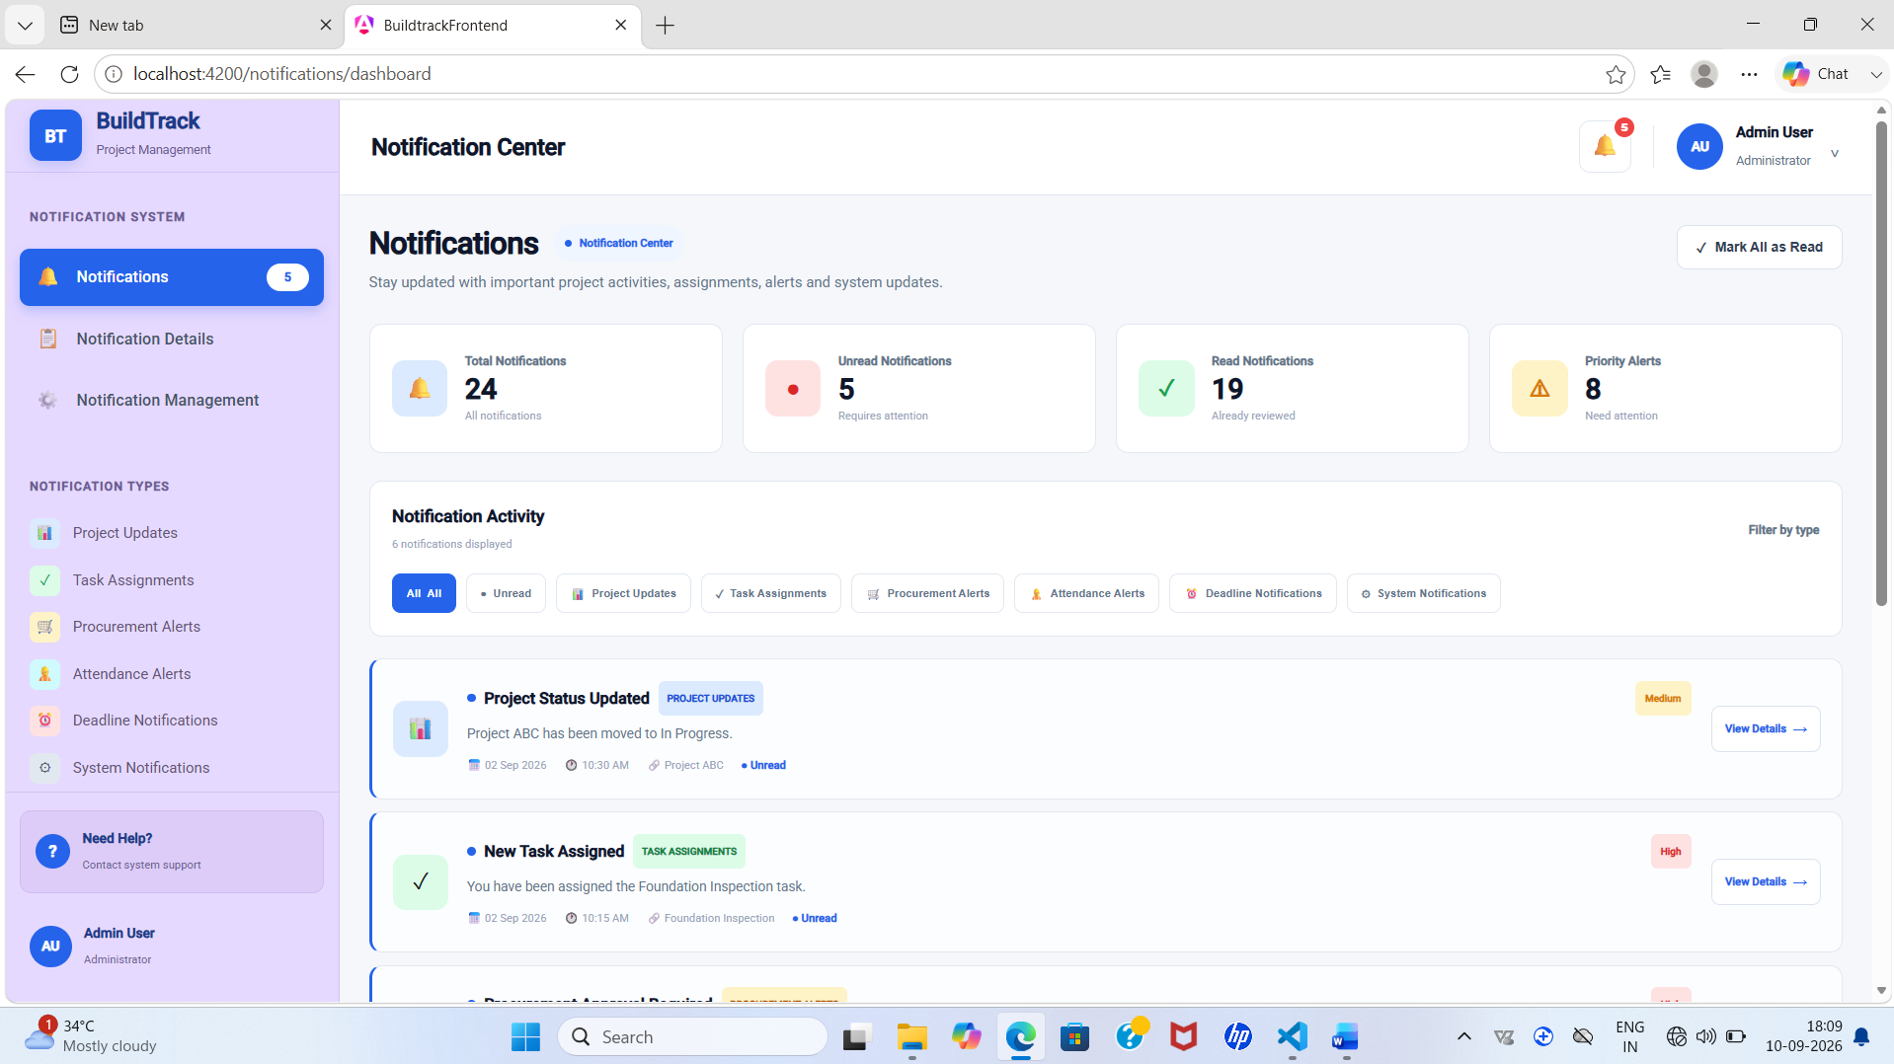
Figure 4: BuildTrack – Notifications Page

4.3 Notification Details
Purpose: Inspect a selected notification in more detail.
How it works in BuildTrack: The Notification Details page presents the notification title, message/description, notification information and related information.
Role/User: Notification-enabled application user / role-specific workspace.
Expected output: Detailed notification context is displayed.
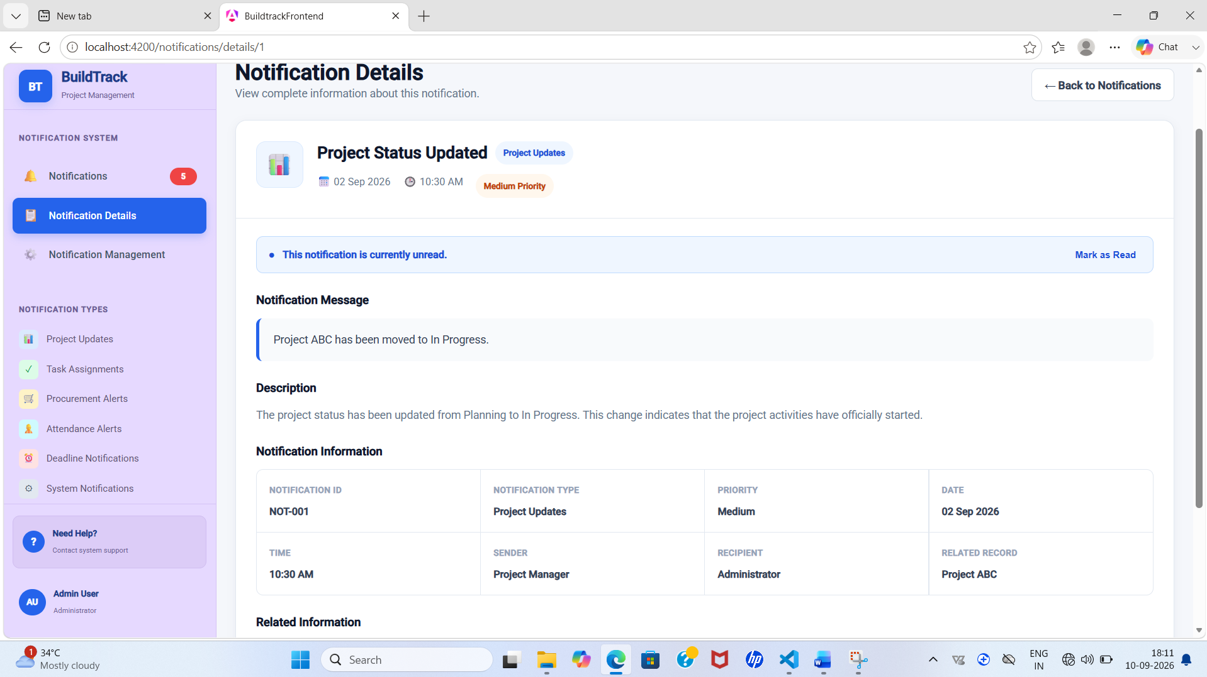
Figure 4: BuildTrack – Notification Details

4.4 Notification Management
Purpose: Manage notification activity and settings.
How it works in BuildTrack: The Notification Management page contains Notification Settings and Notification Activity sections for notification-related administration.
Role/User: Notification-enabled application user / role-specific workspace.
Expected output: Notification-management information is available.
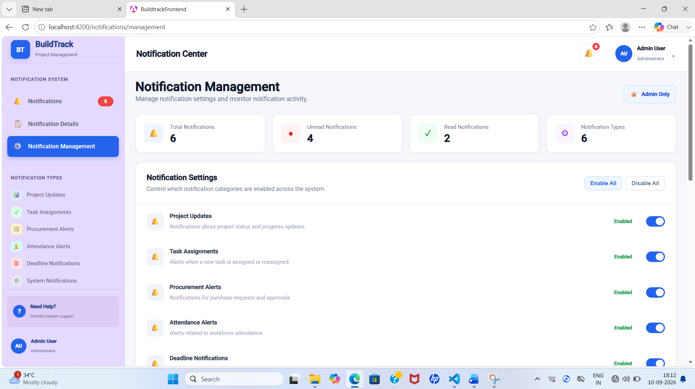

Figure 4: BuildTrack – Notification Management

4.5 Notification Dropdown

Purpose: Provide a compact notification access point.
How it works in BuildTrack: A Notifications dropdown component provides a condensed notification interaction area.
Role/User: Notification-enabled application user / role-specific workspace.
Expected output: Notifications can be accessed from a compact UI element.
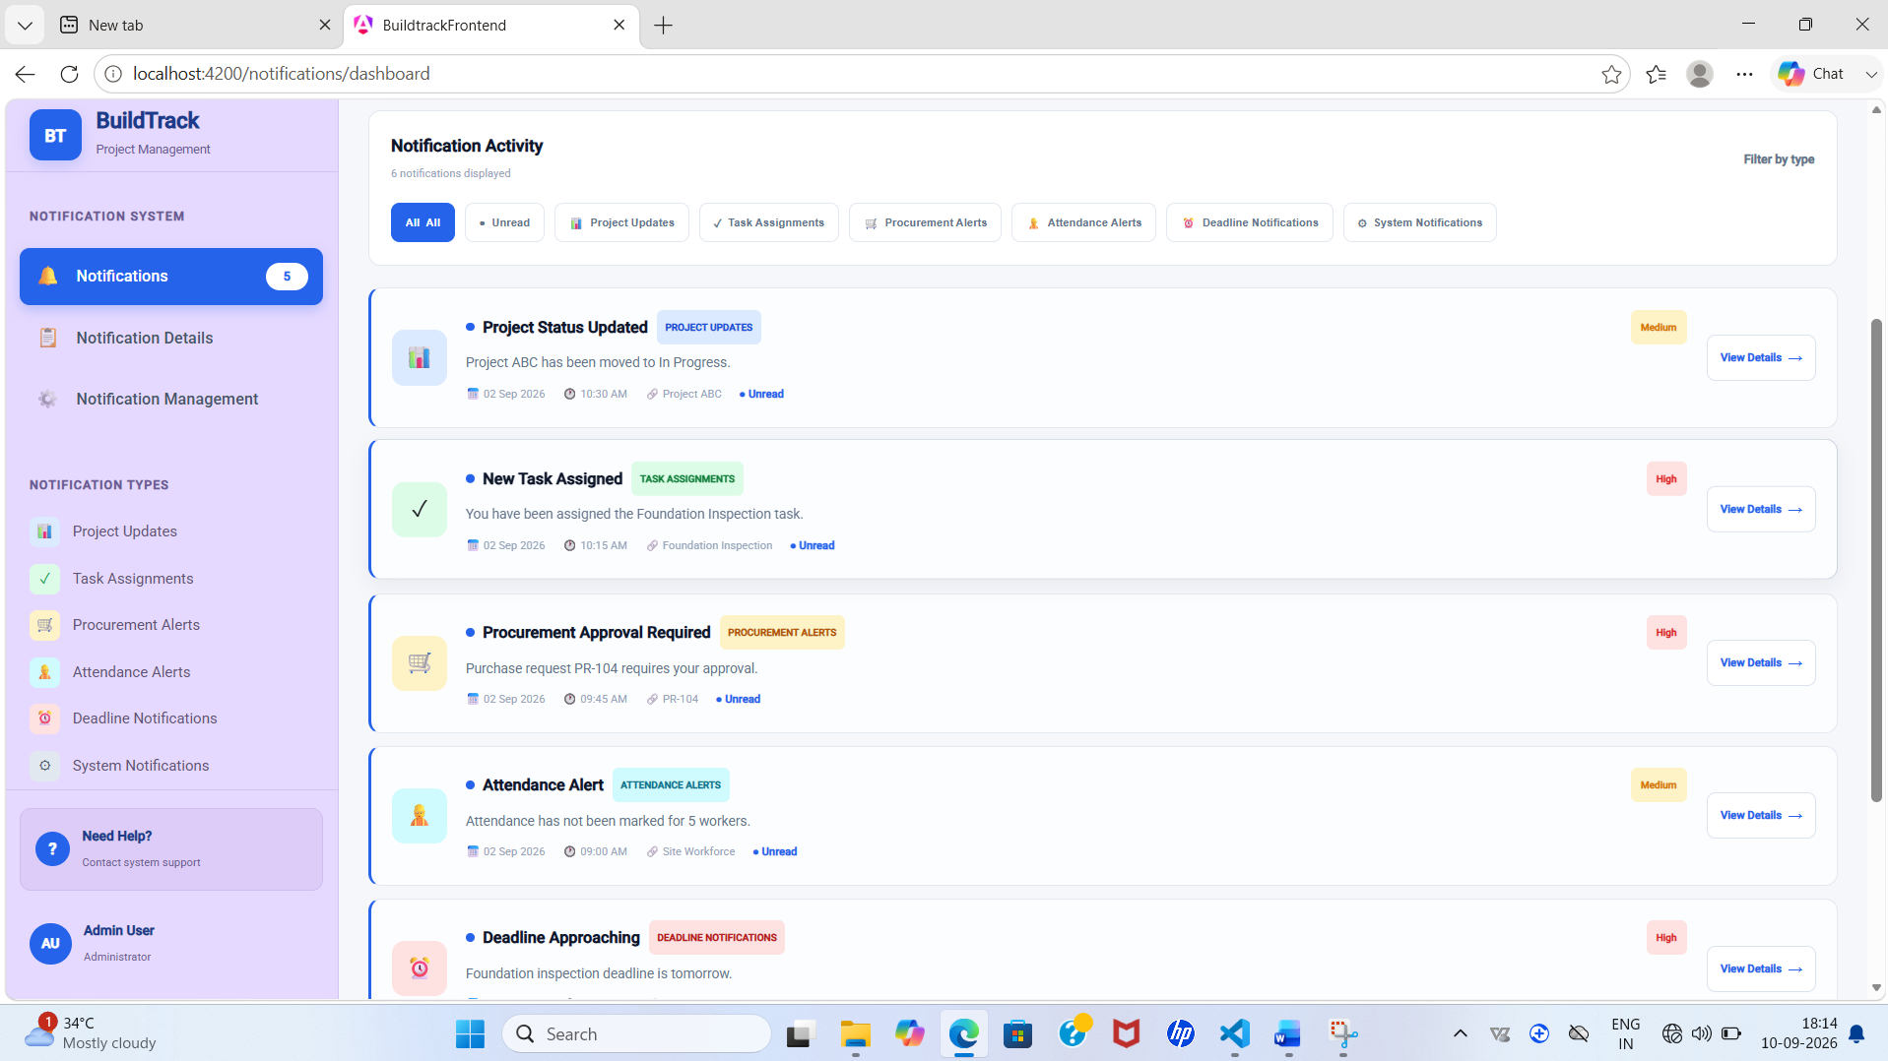
Figure 4: BuildTrack – Notification Dropdown

End-to-End Workflow
Step | User Action | System Response | Result
1 | Open Notifications | Notification activity/list is displayed. | Available notifications can be reviewed.
2 | Select a notification | Notification Details displays title, message, description and related information. | Notification context is available.
3 | Open Notification Management | Settings and activity sections are displayed. | Notification-management information is available.

Module Outcome
The Notification System contains dedicated pages for notification viewing, details and management, providing a structured communication interface within BuildTrack.

5. Module 9 – Dashboard & Analytics

5.1 Objective
The Dashboard & Analytics module provides role-oriented monitoring dashboards. The current source contains dedicated Project Manager and Administrator dashboard components.

5.2 Project Manager Dashboard
Purpose: Provide consolidated project monitoring for the Project Manager.
How it works in BuildTrack: The dashboard includes project selection and displays project completion, budget utilization, workforce overview, equipment/resource utilization, milestone status and recent procurement information.
Role/User: Project Manager
Expected output: A consolidated project monitoring view.
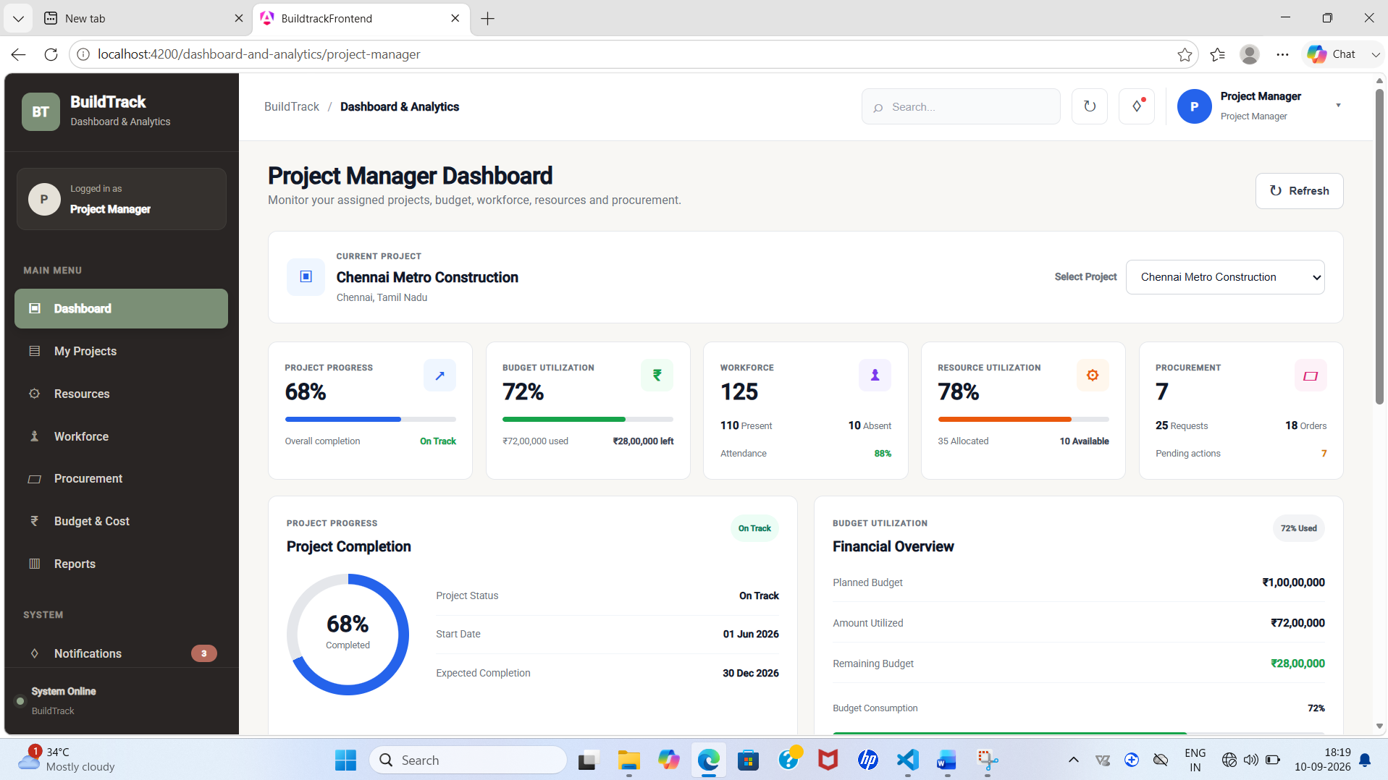
Figure: BuildTrack – Project Manager Dashboa

5.3 Administrator Dashboard
Purpose: Provide system-level administrative monitoring.
How it works in BuildTrack: The dashboard displays total users, active projects, today's activities and total reports, along with Users by Role, System Overview and Project Status Overview sections.
Role/User: Administrator
Expected output: A high-level administrative/system overview.
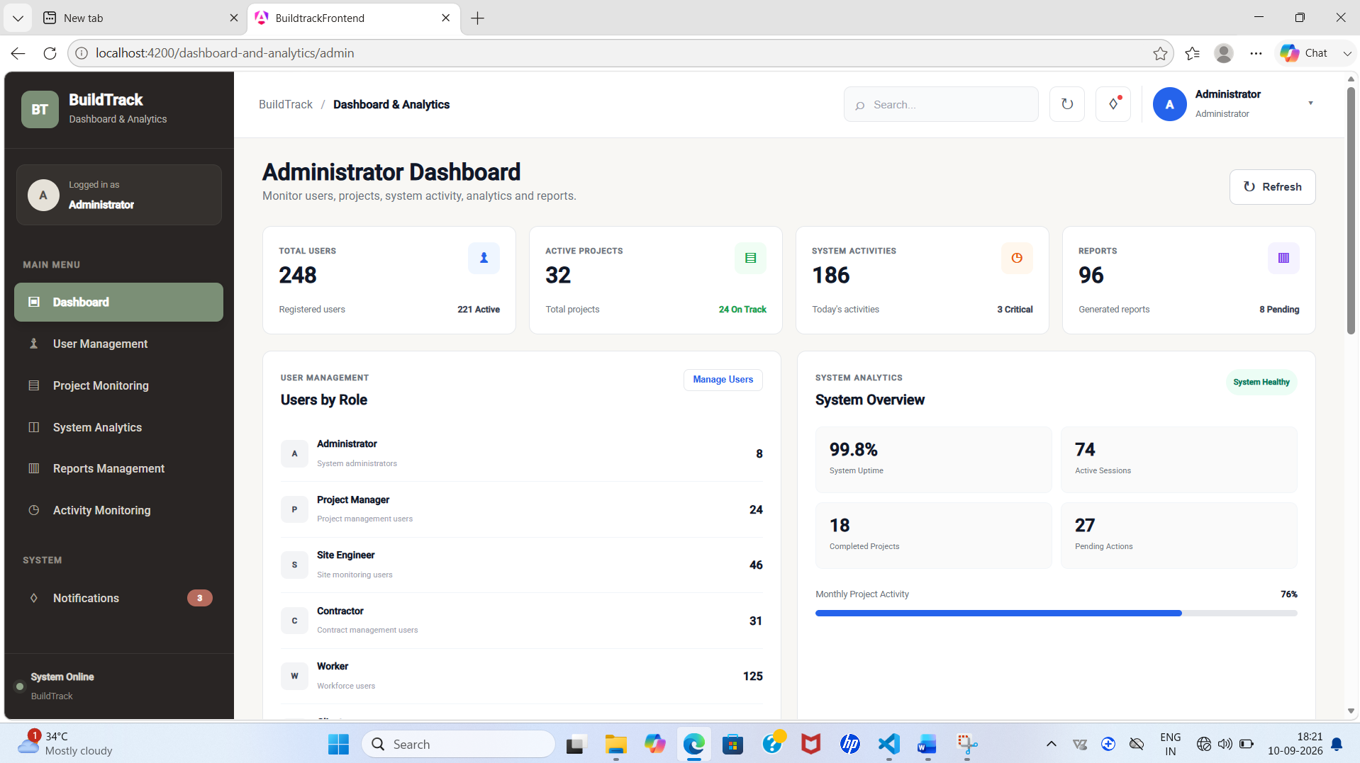
Figure: BuildTrack – Administrator Dashboard

End-to-End Workflow
Step | User Action | System Response | Result
1 | Project Manager selects a project | Dashboard loads the selected project's monitoring values. | Project-specific monitoring view.
2 | Review completion and finance | Project Completion and Financial Overview sections are displayed. | Progress and financial status can be reviewed.
3 | Review workforce and equipment | Workforce Overview and Equipment Overview are displayed. | Operational resource status is visible.
4 | Review milestones/procurement | Milestone Status and Recent Procurement sections are displayed. | Key project activities can be monitored.
5 | Administrator opens dashboard | User, project, activity and report summaries are displayed. | System-level administrative overview.

Module Outcome
The Dashboard & Analytics module provides dedicated role-oriented monitoring screens for Project Managers and Administrators.

6. Module 10 – Reports & Documentation

6.1 Objective
The Reports & Documentation module provides a centralized report dashboard and dedicated report pages for project progress, resource utilization, workforce, procurement and budget information, together with a report-preview page.

6.2 Reports Dashboard
Purpose: Centralize access to report categories.
How it works in BuildTrack: The dashboard provides report filters, report categories for Project Progress, Resource Utilization, Workforce, Procurement and Budget, a Project Summary Report option, and a Recent Reports table.
Role/User: Reporting user
Expected output: Centralized report navigation.
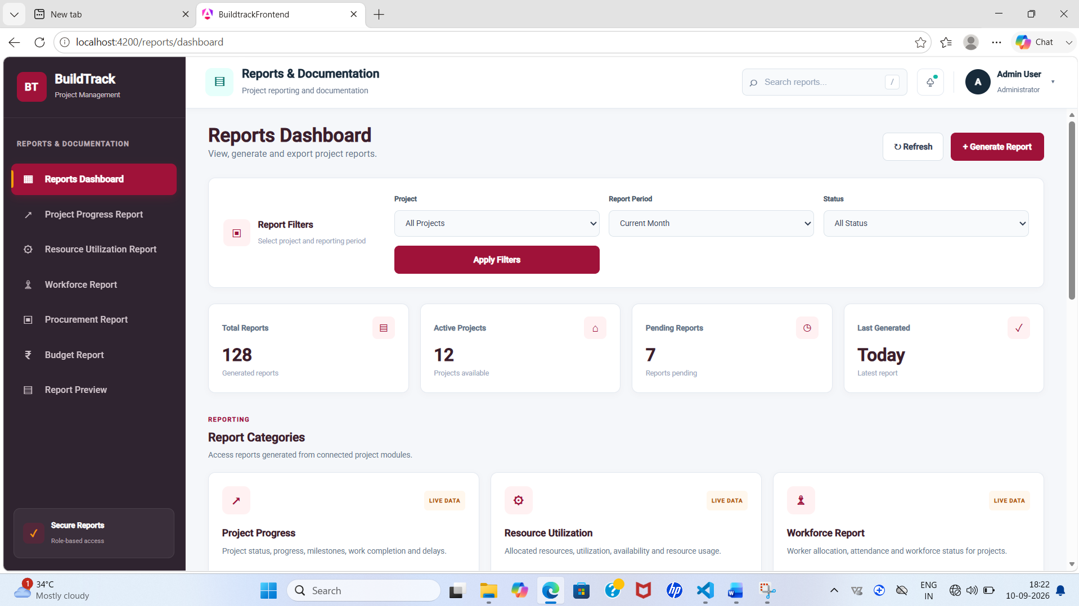
Figure 8: BuildTrack – Reports Dashboard

6.3 Project Progress Report
Purpose: Present project progress information.
How it works in BuildTrack: The page includes report filters and sections for project information, milestone progress, work completion analysis and project delays.
Role/User: Reporting user
Expected output: Project progress report view.
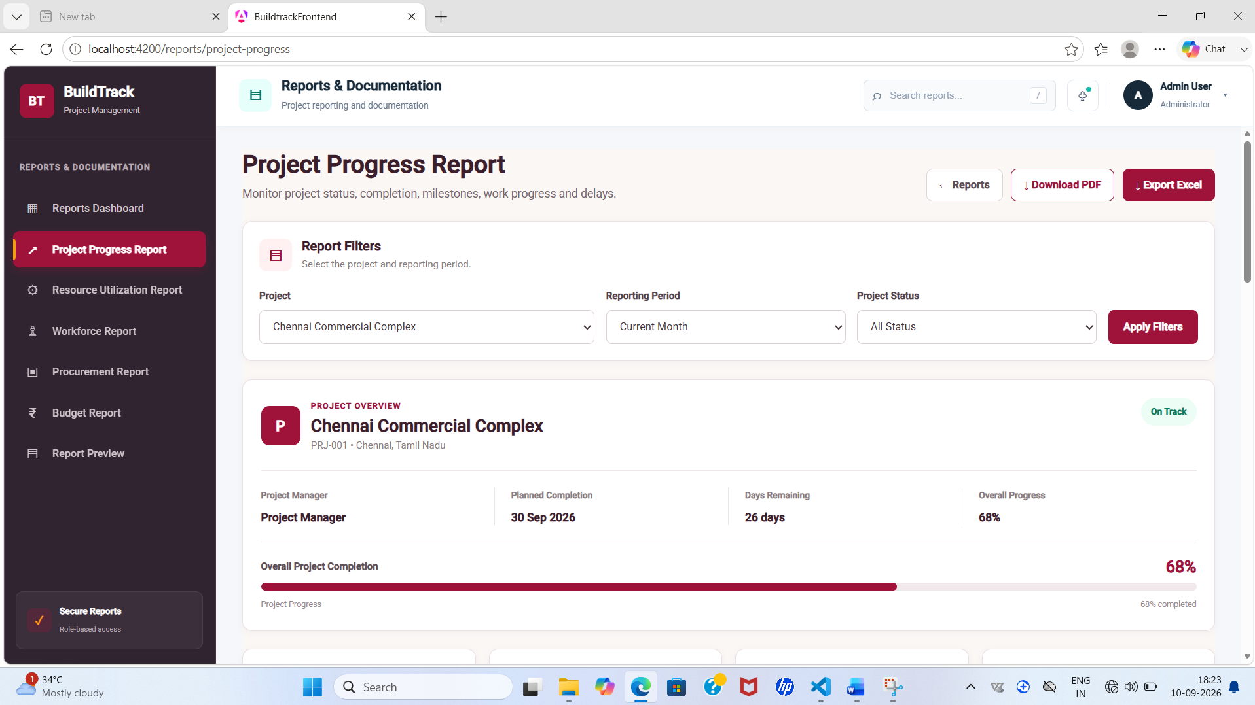

Figure 9: BuildTrack – Project Progress Report

6.4 Resource Utilization Report

Purpose: Present resource/equipment utilization information.
How it works in BuildTrack: A dedicated Resource Utilization Report page provides report filters and resource utilization reporting content.
Role/User: Reporting user
Expected output: Resource utilization report view.
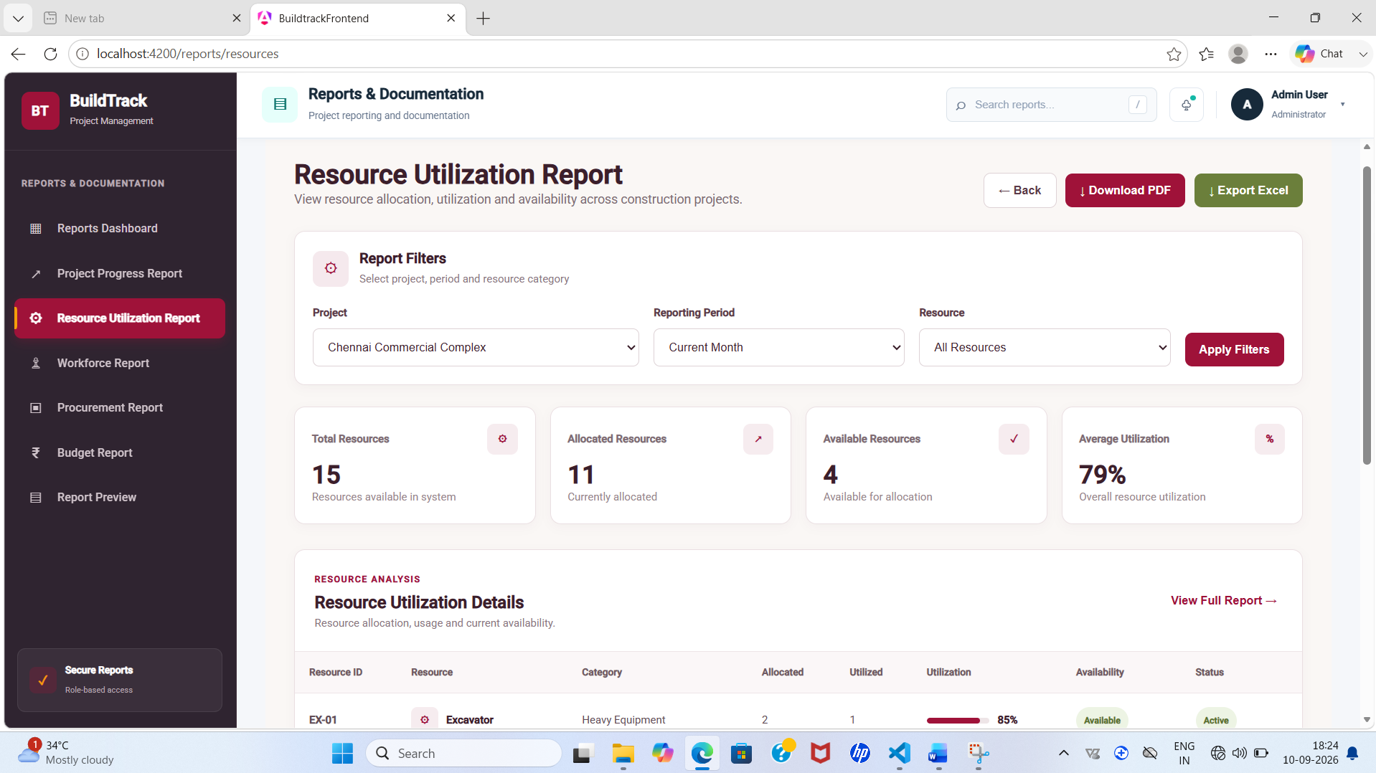

Figure 10: BuildTrack – Resource Utilization Report

6.5 Workforce Report

Purpose: Present workforce-related reporting information.
How it works in BuildTrack: The page provides report filters, Workforce Details and Workforce Insight sections.
Role/User: Reporting user
Expected output: Workforce report view.
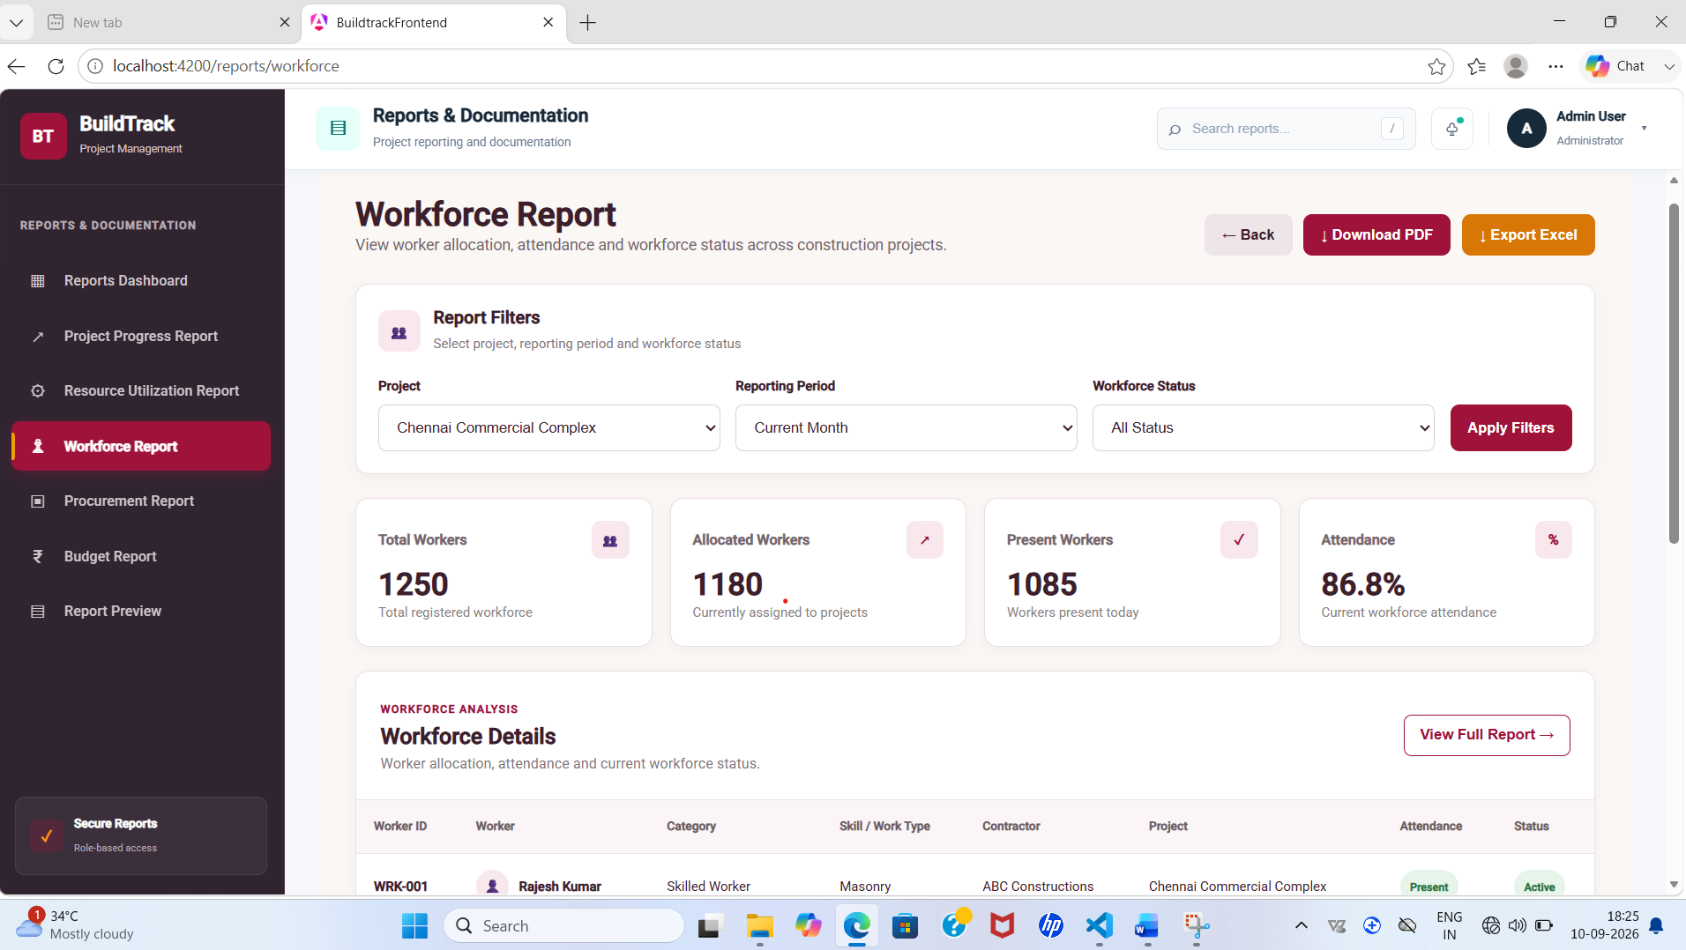

Figure 11: BuildTrack – Workforce Report

6.6 Procurement Report

Purpose: Present procurement reporting information.
How it works in BuildTrack: The page provides report filters, Procurement Details and Procurement Insight sections.
Role/User: Reporting user
Expected output: Procurement report view.
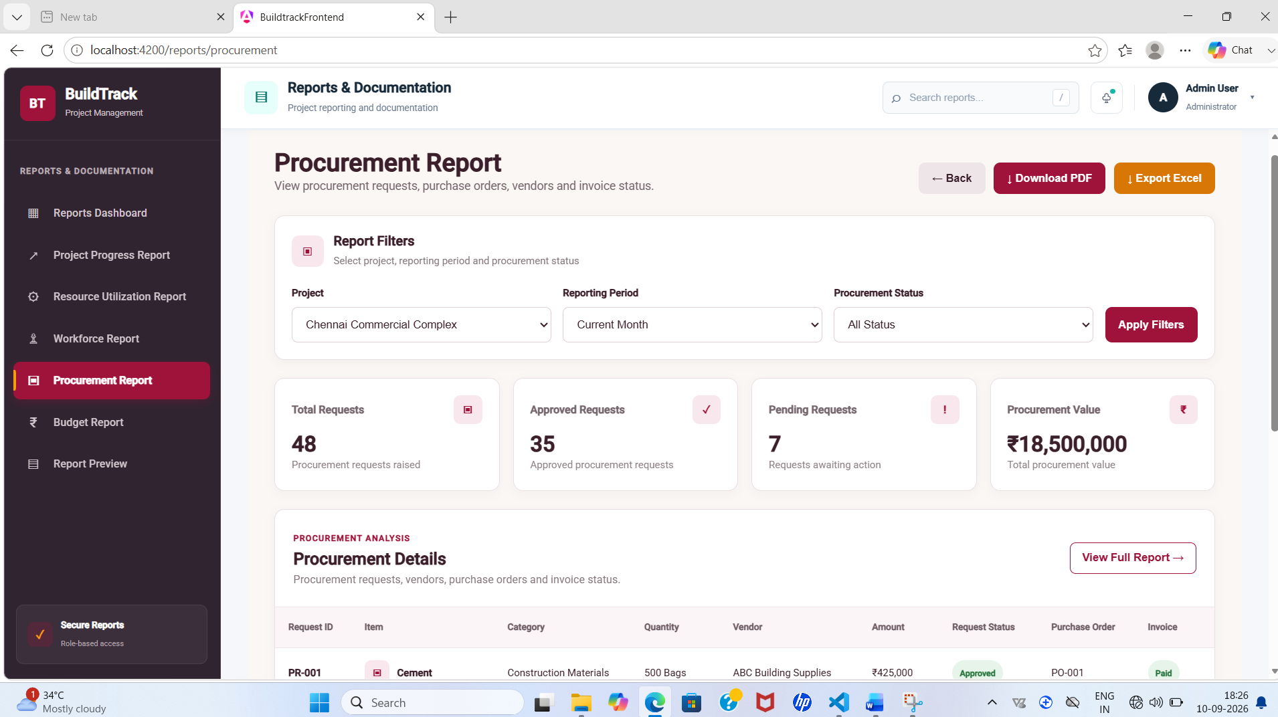

Figure 12: BuildTrack – Procurement Report

6.7 Budget Report

Purpose: Present project budget reporting information.
How it works in BuildTrack: The page provides report filters, Budget Details and Budget Insight sections.
Role/User: Reporting user
Expected output: Budget report view.
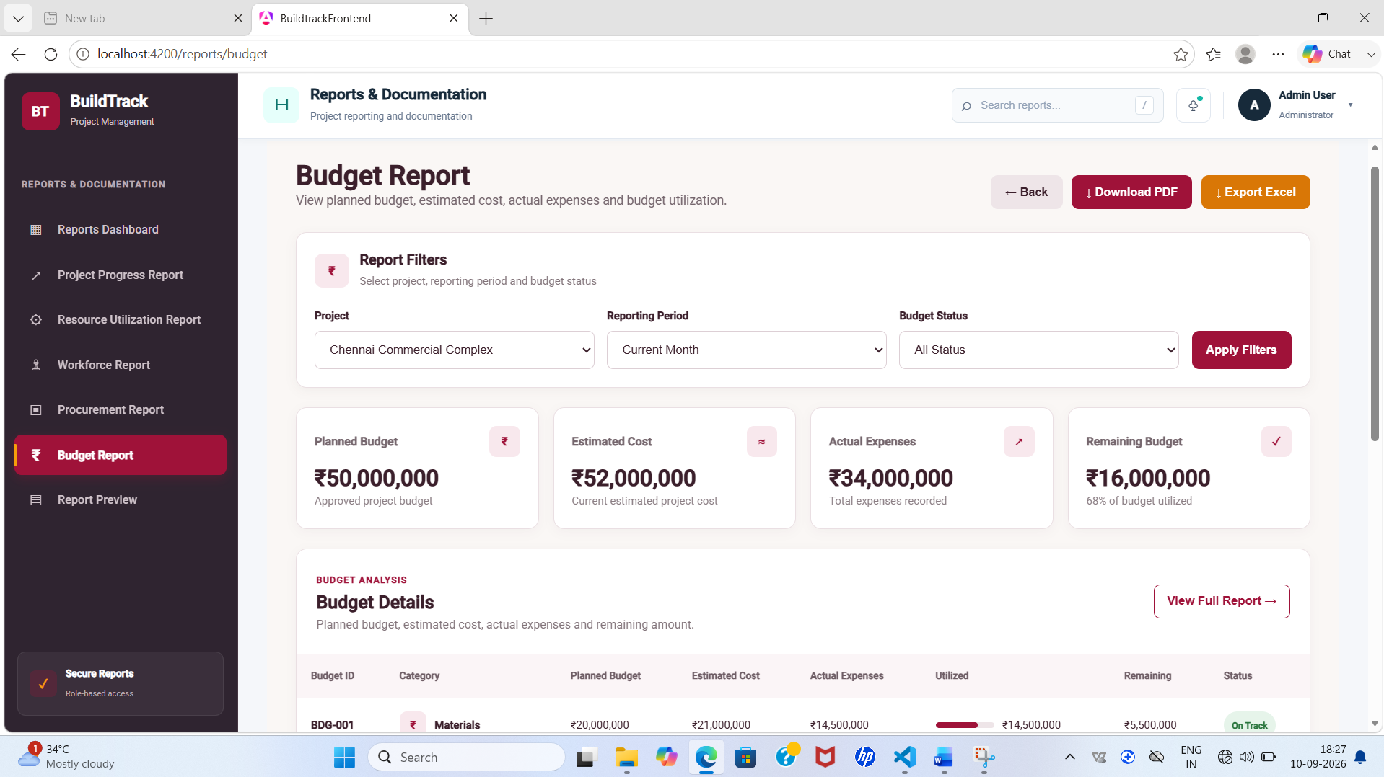

Figure 13: BuildTrack – Budget Report

6.8 Report Preview

Purpose: Provide a formatted preview of a selected report.
How it works in BuildTrack: The preview page presents the report title, BuildTrack heading, Project Summary, Project Milestones and Report Notes.
Role/User: Reporting user
Expected output: Report preview for review.
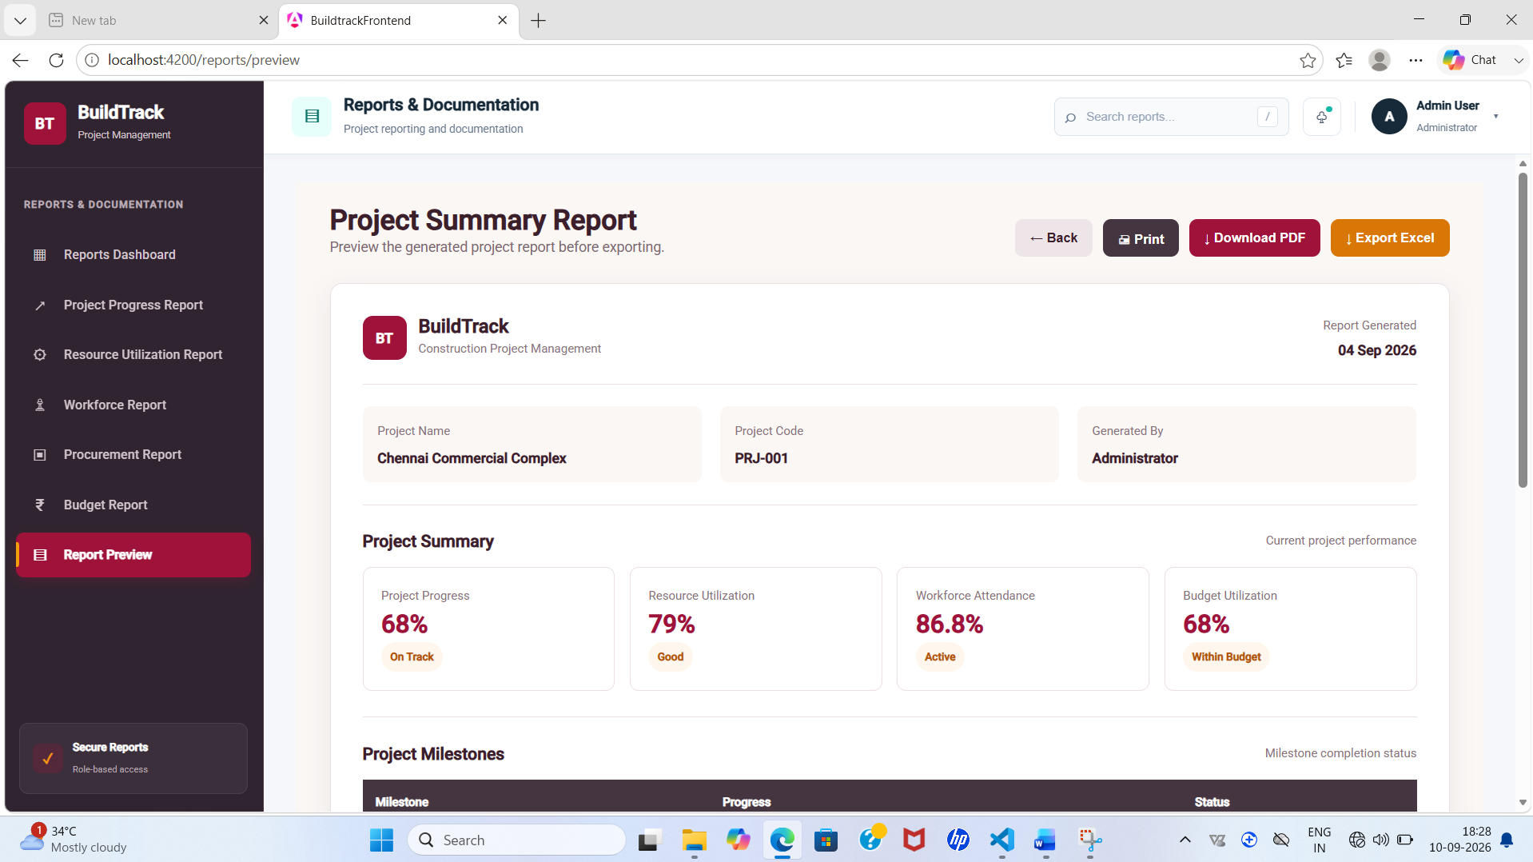
Figure 14: BuildTrack – Report Preview

End-to-End Workflow
Step | User Action | System Response | Result
1 | Open Reports Dashboard | Report categories and recent reports are displayed. | Central report workspace.
2 | Select report type | The corresponding report page opens with filters and report sections. | Report-specific information is displayed.
3 | Apply filters/review report | The selected report's details/insights are displayed. | Filtered report information.
4 | Open Report Preview | Formatted project summary, milestones and notes are shown. | Previewable report representation.

Module Outcome
The Reports & Documentation module provides a centralized report dashboard and dedicated report views for major BuildTrack operational areas.

7. Module 11 – Budget & Cost Management

7.1 Objective
The Budget & Cost Management module provides interfaces for project budget planning, cost estimation, expense recording, budget monitoring, financial summaries and dashboard-level financial analysis.

7.2 Budget Dashboard
Purpose: Provide a consolidated financial overview.
How it works in BuildTrack: The dashboard displays Total Budget, Estimated Cost, Amount Spent and Remaining Budget. It also contains Budget Utilization, Project Financial Status and Category-wise Cost Analysis with Budget, Estimated, Actual Spent, Remaining and Utilization columns.
Role/User: Budget/Project user
Expected output: Project financial overview.
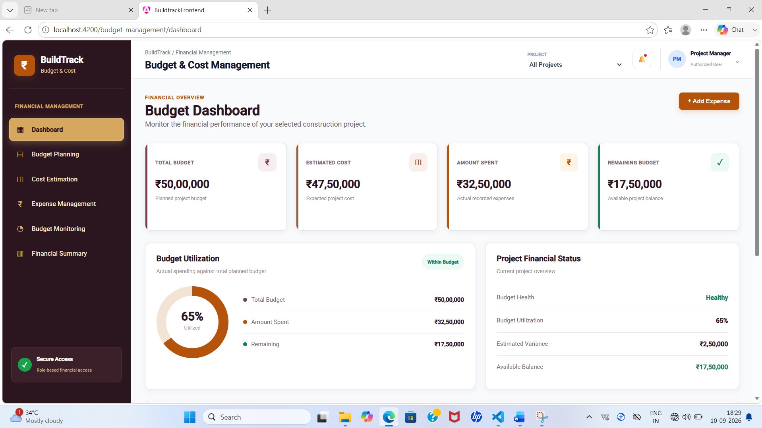
Figure 15: BuildTrack – Budget Dashboard

7.3 Budget Planning
Purpose: Plan and allocate project budgets.
How it works in BuildTrack: The page provides Project Selection, project total budget, Budget Allocation and a category-wise allocation table with Cost Category, Description, Allocated Amount, Allocation % and Action.
Role/User: Budget/Project user
Expected output: Planned budget allocation information.
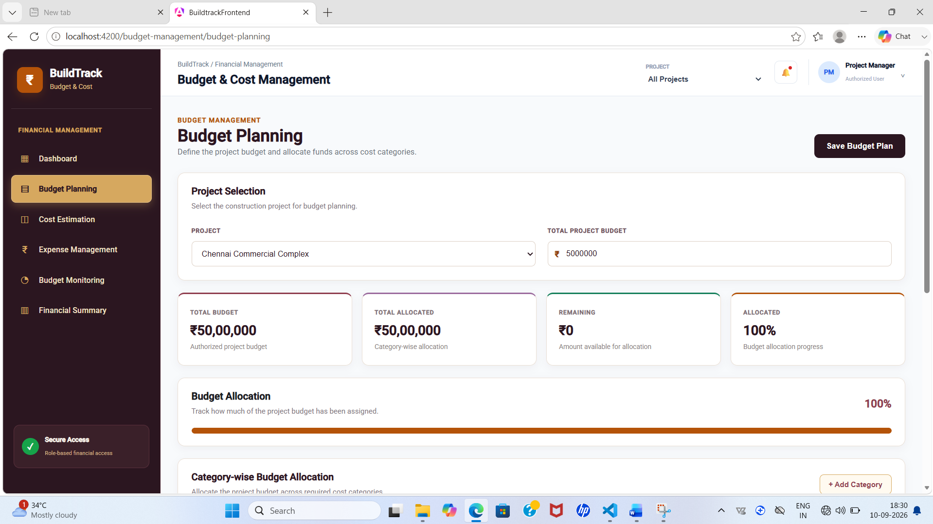

Figure 16: BuildTrack – Budget Planning

7.4 Cost Estimation

Purpose: Compare estimated and actual project costs.
How it works in BuildTrack: The page provides project selection and an Estimated vs Actual Cost area. Activity-wise Cost Estimation contains Activity, Cost Category, Estimated Cost, Actual Cost, Variance and Utilization.
Role/User: Budget/Project user
Expected output: Cost estimation and variance view.
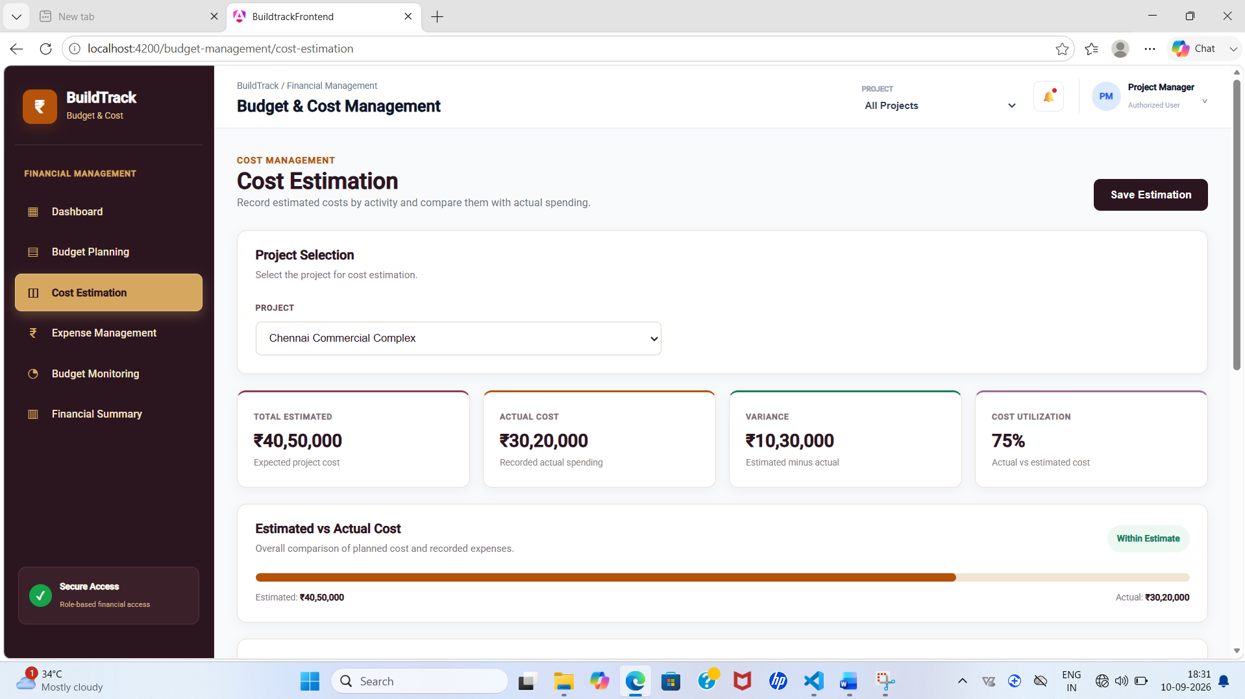

Figure 17: BuildTrack – Cost Estimation

7.5 Expense Management

Purpose: Record and review actual expenses.
How it works in BuildTrack: The page provides project selection, Record Actual Expense fields including expense date, description, cost category and amount, plus an Actual Expense Records table containing Expense ID, Date, Description, Cost Category, Amount and Source Module.
Role/User: Budget/Project user
Expected output: Recorded expense information.
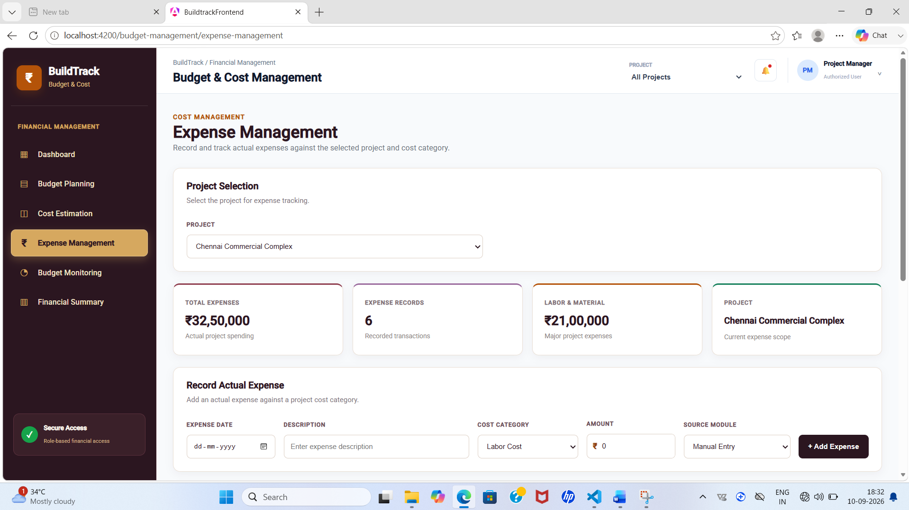

Figure 18: BuildTrack – Expense Management

7.6 Budget Monitoring

Purpose: Monitor planned, estimated and actual spending.
How it works in BuildTrack: The page provides project selection, Budget Utilization, Budget Status and Category-wise Budget Monitoring with Planned, Estimated, Actual Spent, Remaining and Utilization values.
Role/User: Budget/Project user
Expected output: Budget monitoring view.
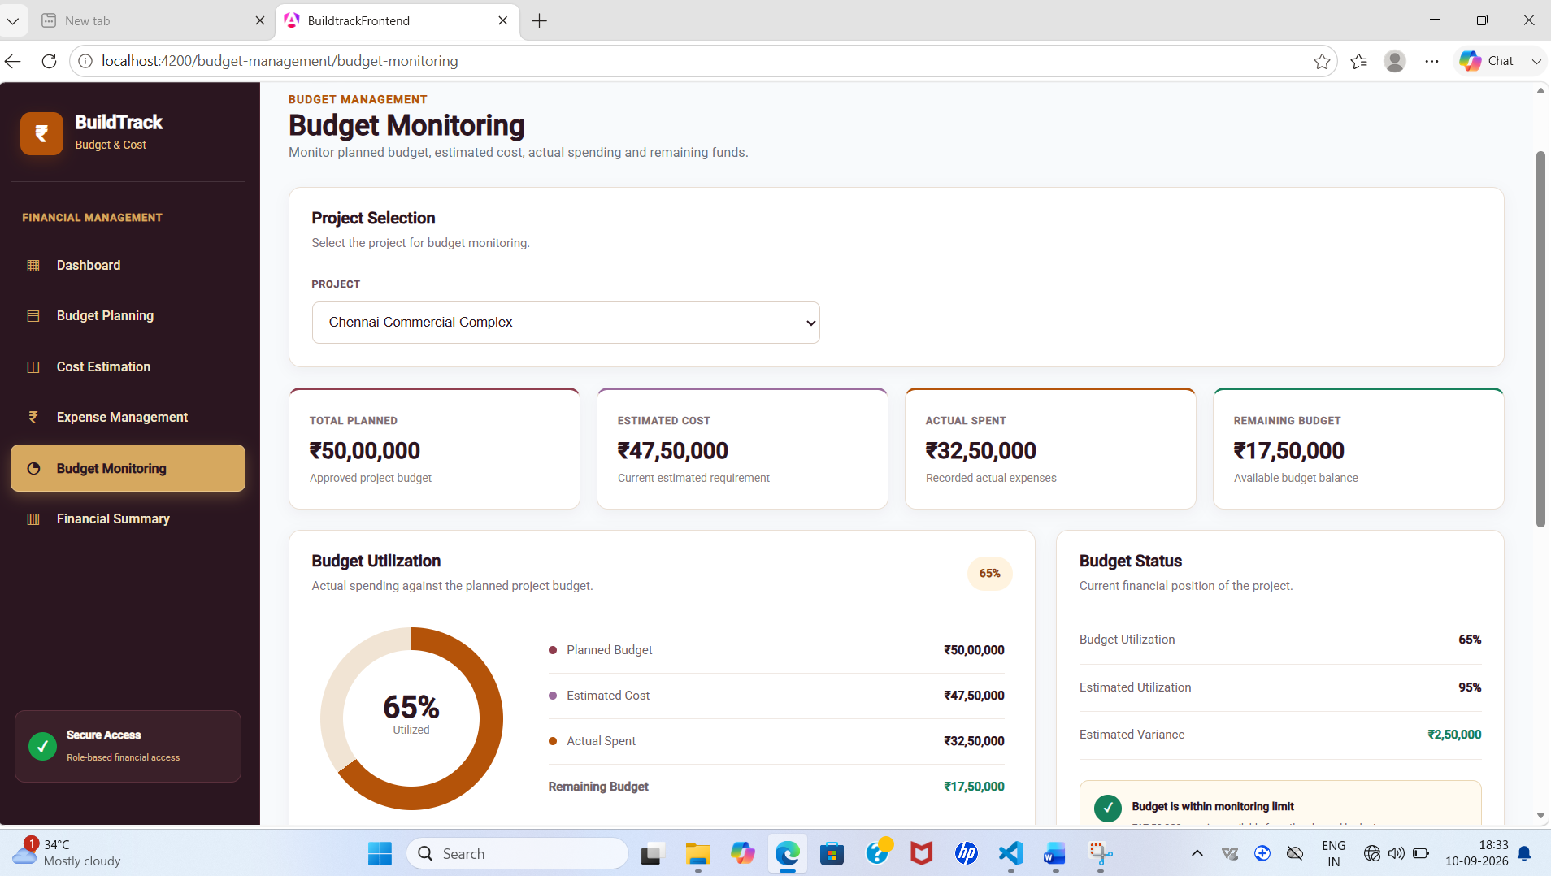

Figure 19: BuildTrack – Budget Monitoring

7.7 Financial Summary

Purpose: Provide a consolidated financial summary.
How it works in BuildTrack: The page includes Project and Reporting Period selection and a financial summary table with Cost Category, Planned, Estimated, Actual Spent, Remaining, Utilization and Variance.
Role/User: Budget/Project user
Expected output: Financial summary view.
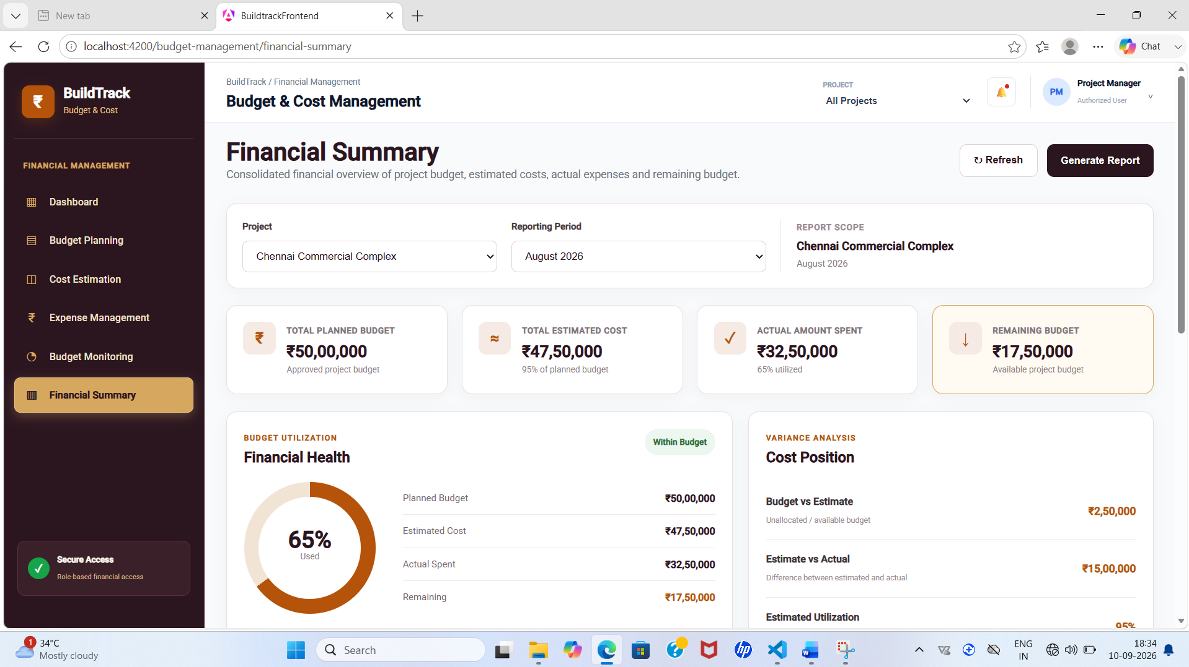
Figure 20: BuildTrack – Financial Summary

End-to-End Workflow
Step | User Action | System Response | Result
1 | Select project in Budget Planning | Project budget and category allocation fields are displayed. | Budget planning information is prepared.
2 | Estimate project/activity costs | Estimated and actual cost fields are displayed by activity/category. | Cost variance and utilization can be reviewed.
3 | Record actual expense | Expense details are captured in the expense-management interface. | Actual expense record is prepared.
4 | Monitor budget | Budget Monitoring compares planned, estimated, actual spent, remaining and utilization. | Current budget position can be reviewed.
5 | Review financial summary/dashboard | Financial summary and dashboard present consolidated financial indicators. | Overall project financial status is available.

Module Outcome
The Budget & Cost Management module provides dedicated interfaces for planning, estimating, recording expenses, monitoring budget utilization and reviewing financial summaries.

8. Role-wise Functionality
Role / User Area | Milestone 4 Capabilities Evidenced
Project Manager | Project Manager Dashboard with project completion, budget utilization, workforce, equipment/resource utilization, milestone status and recent procurement information; access to reporting and project financial views where routed.
Administrator | Administrator Dashboard with users, active projects, today's activities, total reports, user-role overview and project/system status overview.
Notification User | Notification viewing, notification details and notification-management interfaces.
Reporting User | Reports Dashboard, project progress, resource utilization, workforce, procurement, budget and report-preview pages.
Budget/Project User | Budget Dashboard, Budget Planning, Cost Estimation, Expense Management, Budget Monitoring and Financial Summary.

9. End-to-End Milestone 4 Workflow
Input | Processing / Action | System View | Output
Notification event/information | Open notification list/details/management | Notifications module | Notification information and related details.
Project monitoring data | Select/review project dashboard | Project Manager Dashboard | Progress, financial, workforce, equipment, milestone and procurement overview.
Administrative system data | Open admin dashboard | Administrator Dashboard | User/project/activity/report overview.
Report requirement | Select report category and filters | Reports Dashboard and dedicated report pages | Project/resource/workforce/procurement/budget report view.
Project budget | Plan allocation and estimate costs | Budget Planning / Cost Estimation | Planned and estimated cost information.
Actual expense | Record expense and review records | Expense Management | Actual expense information.
Budget status | Compare planned, estimated, actual and remaining | Budget Monitoring / Financial Summary | Budget utilization and variance view.

Screenshots and Evidence Checklist
Use screenshots from the latest running BuildTrack application. Insert each screenshot immediately after the related feature description, keeping image width, caption style and figure numbering consistent.
- Figure 1 – Notifications Page
- Figure 2 – Notification Details
- Figure 3 – Notification Management
- Figure 4 – Notification Dropdown
- Figure 5 – Project Manager Dashboard
- Figure 6 – Administrator Dashboard
- Figure 7 – Reports Dashboard
- Figure 8 – Project Progress Report
- Figure 9 – Resource Utilization Report
- Figure 10 – Workforce Report
- Figure 11 – Procurement Report
- Figure 12 – Budget Report
- Figure 13 – Report Preview
- Figure 14 – Budget Dashboard
- Figure 15 – Budget Planning
- Figure 16 – Cost Estimation
- Figure 17 – Expense Management
- Figure 18 – Budget Monitoring
- Figure 19 – Financial Summary

Technical Implementation Summary
Area | Implementation Evidence
Frontend Framework | Angular project structure with standalone components and route-based pages.
UI | Angular templates, forms, data binding, dashboard summaries, filters, tables and report/financial views.
Routing | Dedicated routes/pages exist for notifications, dashboard-and-analytics, reports and budget-management areas.
Backend | Python FastAPI application with multiple routers and database session integration.
Database | SQLAlchemy engine/session configuration and ORM/database layer.
Integration Note | The presence of dashboard/report/budget pages is not treated as proof of live database persistence unless the corresponding integration is demonstrated.

Limitations / Pending Work
- Some dashboard, report and budget values may be frontend data structures; they should not be described as live database values unless integration is demonstrated in the running application.
- The reference specification mentions external notification services and deployment/testing technologies, but this document does not claim those services unless directly evidenced by the current project source.
- Report export formats such as PDF/Excel should be claimed only when the current running implementation demonstrates the export action.
- The existence of a route or screen alone is not treated as proof of complete API/database integration.
- Final screenshots should be taken from the latest running BuildTrack version and should match the submitted source.

Milestone Completion Summary
Item | Status / Evidence
Milestone | Milestone 4
Modules Covered | Module 8 – Notifications; Module 9 – Dashboard & Analytics; Module 10 – Reports & Documentation; Module 11 – Budget & Cost Management
Notifications | Notification page, details, management/settings/activity and dropdown components present.
Dashboard & Analytics | Project Manager and Administrator dashboard components present.
Reports & Documentation | Reports Dashboard plus project progress, resource utilization, workforce, procurement, budget and report-preview pages present.
Budget & Cost Management | Budget Dashboard, Budget Planning, Cost Estimation, Expense Management, Budget Monitoring and Financial Summary pages present.
Screenshots | Recommended screenshot positions are provided throughout the document.
Technical Foundation | Angular frontend, FastAPI backend and SQLAlchemy/database layer are evidenced in the project.
Overall Status | Dedicated frontend pages and workflows are documented; backend persistence and external integrations require verification where not demonstrated.

10. Conclusion
Milestone 4 completes the documented operational areas around notifications, role-oriented dashboards, reporting and budget/cost management. The notification pages provide structured communication views; the dashboard components provide consolidated project and administrative monitoring; the reporting module organizes project, resource, workforce, procurement and budget reports; and the budget module provides planning, estimation, expense, monitoring and financial-summary interfaces. The documentation intentionally separates visible UI implementation from integration claims that require additional evidence.

