Milestone 1 Comprehensive Project Report: Objectives, Dataset Analysis, System Architecture and UI Wireframes
Internship: | Infosys Springboard Virtual Internship 7.0
Project Track: | Healthcare AI & Medical Image Analysis
Project Title: | Artery Segmentation and Stenosis Detection Using Advanced Deep Learning Techniques
Application Name: | StenoVision
Milestone: | Milestone 1 (Weeks 1 & 2) — Project Definition, Modality Selection, Dataset Setup, Architecture & UI Wireframes
Prepared by / Date: | Individual Project Report | October 2026
PART I: Project Objectives, Clinical Workflow & Dataset Selection Analysis
1. Project Objectives and End-to-End Workflow
1.1 Clinical Background and Problem Statement
Coronary Artery Disease (CAD) is a major cause of morbidity and mortality worldwide. It occurs when atherosclerotic plaque accumulates inside the coronary arteries, resulting in arterial lumen narrowing, known as stenosis. This narrowing can restrict blood flow to the heart muscle and lead to conditions such as angina and acute myocardial infarction.
In clinical practice, interventional cardiologists use X-ray Coronary Angiography (XCA) to assess coronary artery stenosis and make decisions regarding revascularization procedures, such as Percutaneous Coronary Intervention (PCI) with stent placement or Coronary Artery Bypass Grafting (CABG).
Through my project research, I identified several challenges associated with manual angiographic interpretation:
- Inter- and Intra-Observer Variability: Visual estimation of stenosis severity may vary between clinicians, affecting the consistency of assessments.
- Visual Clutter and Overlapping Vessels: Two-dimensional angiographic images may contain overlapping vessels, bones, diaphragmatic structures and catheters, making vessel identification more difficult.
- Time-Critical Workload: Manual frame-by-frame analysis can be time-consuming, particularly when rapid clinical assessment is required.
These challenges motivated me to explore deep learning techniques for automated coronary artery segmentation and stenosis detection.

1.2 Core Project Objectives
My primary objective is to research, design and develop an AI-powered medical image analysis decision-support system that can assist in coronary artery assessment.
The specific objectives are:
- Automate Artery Segmentation: I aim to extract coronary artery structures at the pixel level from angiographic images while minimizing background interference.
- Classify Anatomical Vascular Branches: I intend to identify and classify coronary artery branches, including the Left Anterior Descending artery (LAD), Right Coronary Artery (RCA) and Left Circumflex artery (LCx), according to the anatomical categories available in the dataset.
- Detect and Localize Stenosis: I aim to identify stenotic regions and determine their spatial locations within angiographic images.
- Assess Narrowing Severity: I plan to investigate methods for estimating the percentage of luminal narrowing and categorizing stenosis severity into appropriate clinical categories, subject to the availability of suitable ground-truth labels and validated measurement criteria.
- Develop an Explainable Interface: I intend to present segmentation overlays, detection results and quantitative measurements through an understandable interface that supports clinical review.
1.3 End-to-End System Architecture and Workflow
I have defined a modular workflow that connects image preprocessing, artery segmentation, vessel analysis, stenosis detection and result visualization.
Stage 1: Image Ingestion and Preprocessing — I will validate the input images, normalize pixel intensities to the range [0, 1] and investigate Contrast Limited Adaptive Histogram Equalization (CLAHE) to improve the visibility of coronary vessels.
Stage 2: Artery Segmentation (Milestone 2) — I will investigate deep learning architectures such as U-Net and Attention U-Net to generate vessel segmentation masks. Depending on the task, I will explore binary segmentation and multi-class anatomical segmentation.
Stage 3: Vessel Centerline and Diameter Analysis — I plan to investigate morphological skeletonization and centerline extraction to trace segmented vessels. Where image resolution and calibration permit, I will examine methods for estimating reference vessel diameter and minimum luminal diameter.
Stage 4: Stenosis Detection and Localization (Milestone 3) — I will explore suitable object detection or instance segmentation models to localize stenotic regions using the available annotations. I will also evaluate whether the dataset supports reliable severity estimation.
Stage 5: Dashboard and Automated Reporting (Milestone 4) — I aim to integrate the trained models into a user interface that displays input images, segmentation overlays and detection results. I will investigate automated report generation and result logging as part of the final system.
2. Selection of Medical Imaging Modality
2.1 Comparative Analysis of Vascular Imaging Modalities
During my research, I compared four imaging modalities relevant to vascular analysis.
Attribute | X-Ray Coronary Angiography (XCA) | Coronary CT Angiography (CCTA) | CT Pulmonary Angiography (CTPA) | Magnetic Resonance Angiography (MRA)
Image type | 2D dynamic projections | 3D volumetric images | 3D volumetric images | 2D/3D or flow-based imaging
Primary application | Coronary artery assessment and catheter-based intervention | Non-invasive coronary artery assessment | Pulmonary embolism assessment | Vascular assessment without ionizing radiation
Target vessels | Coronary arteries | Coronary arteries | Pulmonary arteries | Various vascular structures
Relevant imaging features | Contrast-filled vessel lumen and narrowing | Coronary anatomy and plaque-related features | Pulmonary arterial filling defects | Vascular anatomy and blood-flow-related features
Computational requirements | Generally lower for individual 2D frames | Higher for volumetric processing | Higher for volumetric processing | Depends on acquisition and reconstruction
Suitability for my project | Directly aligned with coronary artery segmentation and stenosis localization | Relevant to coronary anatomy but requires a different processing workflow | Focuses on pulmonary rather than coronary arteries | Relevant to vascular imaging but less directly aligned with the selected dataset

2.2 Justification for Modality Selection
Selected modality: 2D X-Ray Coronary Angiography (XCA).
I selected XCA because it aligns directly with my project objectives and the ARCADE dataset:
- Clinical Relevance: XCA is widely used to visualize coronary artery lumens and assess stenosis during catheter-based procedures.
- Alignment with Project Objectives: The images provide the coronary artery structures needed for vessel segmentation and the visual information required to investigate stenosis localization.
- Computational Feasibility: Processing individual 2D images is generally less computationally demanding than processing large 3D imaging volumes.
- Dataset Compatibility: The ARCADE dataset provides XCA images with annotations for both coronary artery segmentation and stenosis-related tasks.
3. Dataset Selection and Comparative Evaluation
3.1 Evaluation of Candidate Datasets
I evaluated three candidate datasets available in my project workspace:
- ARCADE: A coronary angiography dataset designed for coronary artery segmentation and stenosis-related analysis.
- PARSE 2022: A CT Pulmonary Angiography dataset focused on pulmonary artery segmentation.
- ImageCAS: A Coronary CT Angiography dataset focused on coronary artery segmentation.
Evaluation criterion | ARCADE | PARSE 2022 | ImageCAS
Primary modality | 2D XCA | 3D CTPA | 3D CCTA
Vascular target | Coronary arteries | Pulmonary arteries | Coronary arteries
Segmentation annotations | Anatomical coronary artery classes | Pulmonary vessel masks | 3D coronary vessel masks
Stenosis annotations | Available in the stenosis subset | Not identified in the project report | Not identified in the project report
Annotation format | COCO JSON | 3D NIfTI masks | 3D image and mask data
Computational requirements | Comparatively manageable for 2D images | Higher for 3D processing | Higher for 3D processing
Suitability for my project | High | Limited alignment with coronary targets | Relevant to segmentation but less directly aligned with the selected XCA workflow

3.2 Why I Selected the ARCADE Dataset
After comparing the available datasets against my project requirements, I selected the ARCADE dataset as the primary dataset for further development.
- Supports Both Segmentation and Stenosis Detection: My project requires two major capabilities: artery segmentation and stenosis detection. ARCADE provides a syntax subset for anatomical coronary artery segmentation and a stenosis subset for lesion detection and segmentation. The other candidate datasets only provide vessel segmentation annotations without stenosis lesion labels.
- Provides Anatomical Class Information: ARCADE includes 25 anatomical coronary artery categories associated with the AHA/SYNTAX anatomical classification framework. This allows me to investigate branch-level segmentation instead of treating the entire coronary tree as a single undifferentiated structure.
- Includes Expert-Annotated Data: The project report identifies ARCADE as a dataset with annotations prepared and reviewed by certified interventional cardiologists using CVAT. These annotations provide reliable reference labels for model training and evaluation.
- Supports Evaluation Across Imaging Equipment: The dataset documentation describes images acquired using Philips Azurion 3 and Siemens Artis Zee angiographic systems across patients aged 19 to 90. This provides an opportunity to evaluate model robustness across multi-vendor equipment.
- Uses the COCO Annotation Format: ARCADE annotations use the standard COCO JSON structure, which includes image information, category identifiers, bounding boxes, segmentation polygons and annotation attributes. I can use these annotations with PyTorch-based vision pipelines.
- Supports Research-Oriented Data Handling: The dataset is fully de-identified and intended for research use, conforming strictly to ethical patient data guidelines.
4. Dataset Structure and Annotation Analysis
4.1 Dataset Directory Structure
I examined the dataset organization documented in my project workspace. The ARCADE dataset is divided into two main subsets: stenosis and syntax.
datasets/data/
├── stenosis/
│ ├── train/
│ │ ├── annotations/train.json
│ │ └── images/
│ ├── val/
│ │ ├── annotations/val.json
│ │ └── images/
│ └── test/
│ ├── annotations/test.json
│ └── images/
│
└── syntax/
├── train/
│ ├── annotations/train.json
│ └── images/
├── val/
│ ├── annotations/val.json
│ └── images/
└── test/
├── annotations/test.json
└── images/

4.2 Dataset Statistics
Subset | Split | Number of images | Annotation instances
Stenosis | Training | 1,000 | 1,625
Stenosis | Validation | 200 | 406
Stenosis | Testing | 300 | 386
Stenosis subtotal | All splits | 1,500 | 2,417
Syntax | Training | 1,000 | 4,976
Syntax | Validation | 200 | 1,168
Syntax | Testing | 300 | 1,672
Syntax subtotal | All splits | 1,500 | 7,816
Combined total | Both subsets | 3,000 | 10,233

The images are 512 × 512-pixel, 8-bit grayscale PNG images. I verified these statistics directly using automated inspection scripts.
4.3 Annotation Format and Anatomical Categories
The COCO annotation structure comprises Images, Annotations (bounding boxes, polygon coordinates, areas), and Categories.
For the stenosis subset, Category 26 represents arterial stenosis lesions with spatial bounding boxes and polygon boundaries.
For the syntax subset, Categories 1–25 correspond to the standardized AHA/SYNTAX 16-segment coronary tree:
- Right Coronary Artery (RCA) and its branches (Segments 1–4, 16a–16c).
- Left Main Coronary Artery (LMCA) (Segment 5).
- Left Anterior Descending artery (LAD) and diagonal branches (Segments 6–10a).
- Left Circumflex artery (LCx) and obtuse marginal branches (Segments 11–15, 12b, 14b).
5. Input Preprocessing and Technical Readiness
- Pixel Intensity Normalization: Convert 8-bit intensities [0, 255] to normalized floating-point range [0, 1].
- Contrast Enhancement: Apply CLAHE to amplify fine distal coronary vessels against soft tissue background.
- Polygon-to-Mask Conversion: Convert vector polygon annotations into 2D raster masks for binary/multi-class segmentation.
- Data Augmentation: Evaluate affine rotations, horizontal flips, and minor blurring while verifying anatomical validity.
- Data Validation: Verify image-annotation integrity and enforce strict split separation to prevent data leakage.
PART II: Progress Report: System Architecture and UI Wireframe Design
Project Title: | Artery Segmentation and Stenosis Detection Using Advanced Deep Learning Techniques
Application Name: | StenoVision
Milestone: | 1 — Project Initialization, Dataset and Core Setup

1. Work Overview
After joining the project team, I worked on designing the system architecture and preparing the initial user interface wireframes for StenoVision. The objective was to establish the application's overall structure, define the major system components and their interactions, and plan the user interface for medical image analysis and case management.
The work focused on developing a high-level architecture, identifying the responsibilities of the system layers, and creating low-fidelity wireframes to guide subsequent frontend development.
2. System Architecture Design
I worked on the high-level system architecture to illustrate the major components of the proposed application and their interactions.
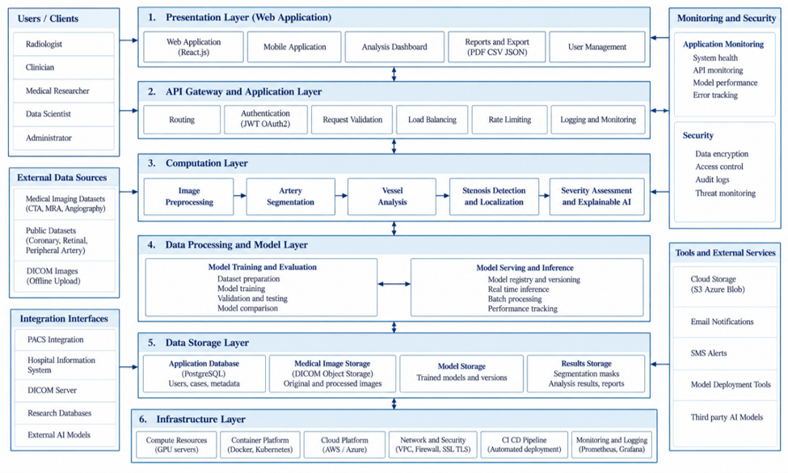
Figure 1: High-Level System Architecture Diagram for StenoVision
The architecture is organized into six core functional layers.
2.1 Presentation Layer
This layer provides the user-facing interface for interacting with the system. Its main components include:
- Web application developed using React.js.
- Case management interface.
- Medical image upload portal.
- Interactive analysis dashboard.
- Report generation and export in PDF, CSV, and JSON formats.
- User management interface.
2.2 API and Application Layer
This layer manages communication between the frontend and backend services. Its responsibilities include:
- Request routing.
- User authentication using JWT and OAuth2.
- Request validation.
- Load balancing.
- Rate limiting.
- Logging and audit tracking.
2.3 Computation Layer
This layer contains the core image-processing and analytical components responsible for artery segmentation and stenosis analysis.
Its main components include:
- Image Preprocessing Service: Prepares medical images for analysis through validation, normalization, and other applicable preprocessing operations.
- Artery Segmentation Service: Identifies artery structures using deep learning architectures such as U-Net and Attention U-Net.
- Vessel Structure and Centerline Analysis: Supports vessel structure extraction, centerline identification, and diameter estimation.
- Stenosis Detection and Localization Service: Identifies suspected stenotic regions and determines their locations.
- Severity Assessment Service: Estimates the degree of arterial narrowing and classifies stenosis severity when supported by the available data and validation criteria.
- Explainable AI Visualization: Provides interpretable visual outputs using techniques such as Grad-CAM and attention maps.
2.4 Data Processing and Model Layer
This layer supports model development, evaluation, deployment, and inference. Its components include:
- Model training pipeline.
- Model evaluation and validation metrics.
- Model version management and model registry.
- Inference engine using a suitable model-serving approach, such as TorchServe or FastAPI.
- Report generation service.
2.5 Data Storage Layer
This layer stores the information required for application operations and AI analysis. It includes:
- Relational Database: PostgreSQL for user accounts, case records, and analysis metadata.
- Medical Image Storage: Storage for original medical images, including supported PNG or DICOM files.
- Model Storage: Storage for trained model weights and associated model versions.
- Processed Results Storage: Storage for segmentation masks, stenosis predictions, and analysis outputs.
- Logs and Audit Data: Records required for application monitoring, traceability, and auditing.

2.6 Infrastructure Layer
This layer provides the computing and deployment environment required to operate the system. Its components include:
- CPU and GPU compute resources.
- Containerization using Docker and, where required, Kubernetes.
- Cloud hosting through platforms such as AWS or Azure.
- Network security, including virtual private clouds, firewalls, and TLS encryption.
- Infrastructure monitoring using tools such as Prometheus and Grafana.
The design also identifies supporting requirements for security, monitoring, external data sources, and system integrations. The proposed architecture provides a reference for implementation and integration activities planned in subsequent milestones.
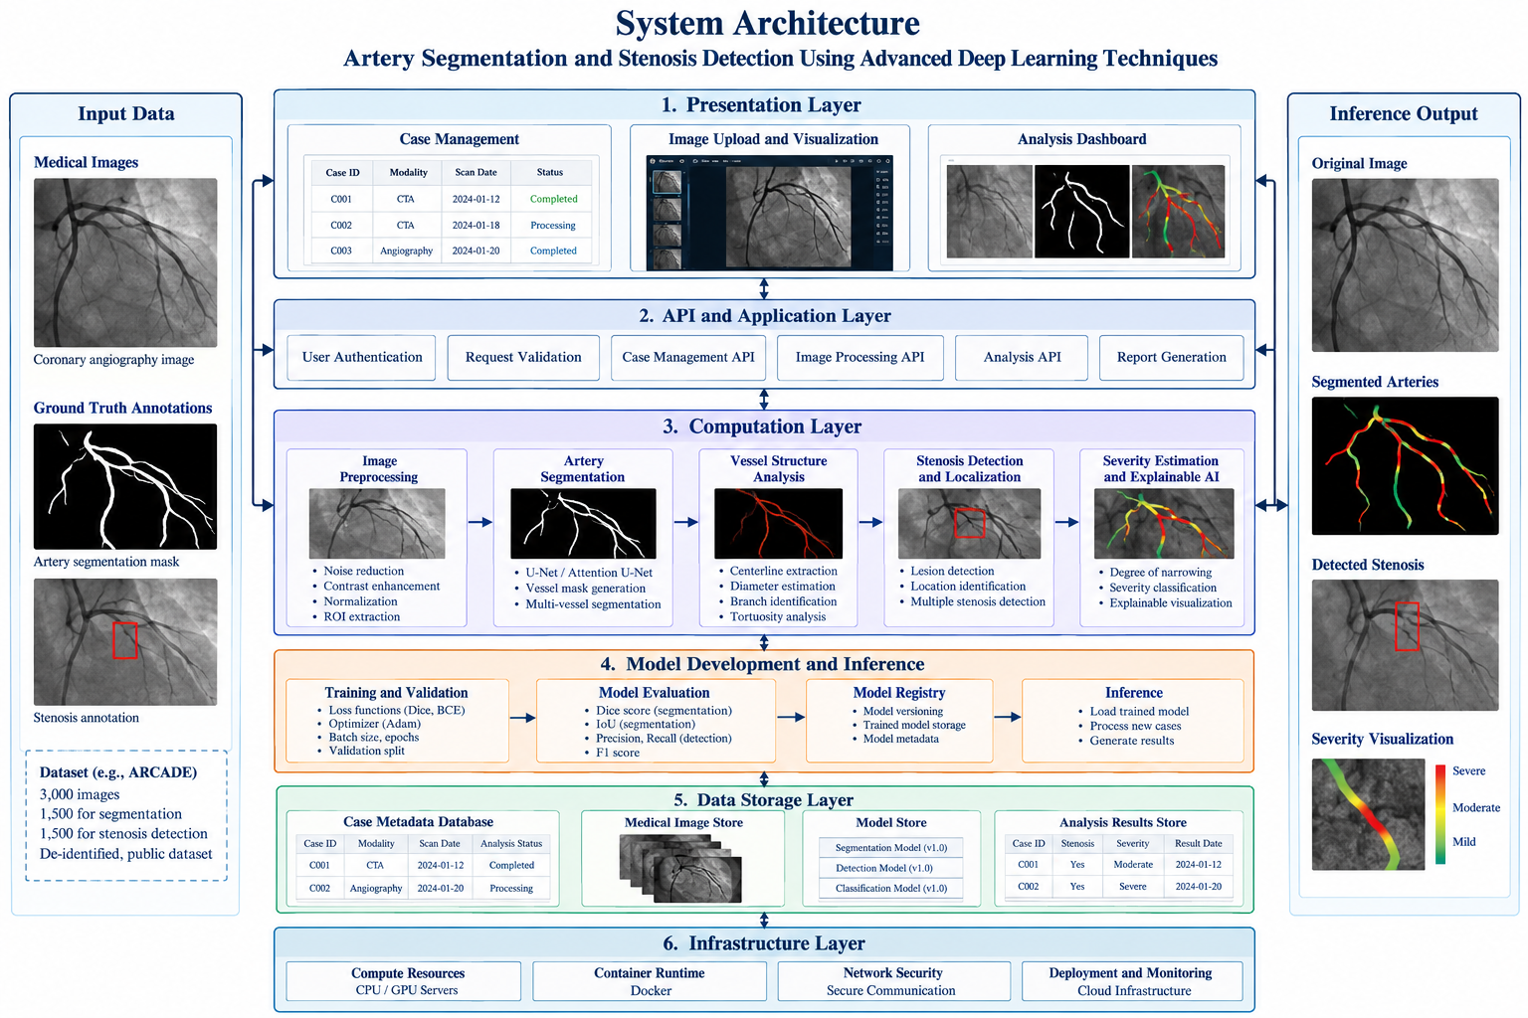
Figure 2: Detailed System Architecture
The detailed architecture illustrates the relationships between the system layers, supporting services, data storage components, and external interfaces.
2.7 Data Flow
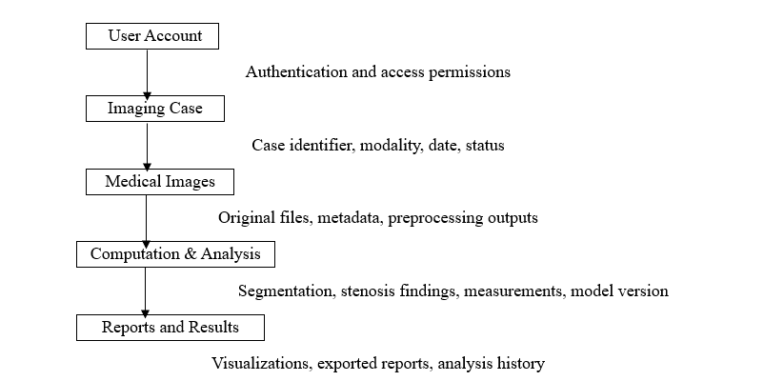
Figure 3: System Data Flow

The proposed system follows this sequence:
- Medical Image Input: The user selects an existing case or creates a new case and uploads a supported medical image.
- Image Validation and Preprocessing: The application validates the uploaded file and prepares the image for analysis.
- Artery Segmentation: The segmentation model identifies artery structures and generates a segmentation mask.
- Vessel Structure Analysis: The system analyzes the segmented vessel structures and estimates relevant geometric measurements where feasible.
- Stenosis Detection and Localization: The detection module identifies suspected stenotic regions and localizes them within the image.
- Severity Assessment: The system estimates the degree of narrowing and assigns a severity category according to the implemented methodology.
- Visualization and Explainability: The original image, segmentation masks, detected regions, and model explanations are presented to the user.
- Results and Reporting: Analysis results are stored and made available through the dashboard and reporting interface.
The system is intended to support medical image analysis and research. Its outputs should be interpreted as AI-assisted results rather than standalone clinical diagnoses.
3. UI Wireframe Design
I worked on creating low-fidelity user interface wireframes in Figma to define the application's navigation, page layouts, and user workflow.
The wireframes establish a consistent visual structure for case management, medical image upload, AI analysis, results review, and administrative operations.
3.1 UI Wireframe Screens
The planned wireframes cover nine dedicated application screens.
Screen No. | Screen Name | Functional Layout and Workflow
1 | Login | User authentication, credential entry, role-based access, and password recovery.
2 | Dashboard | Overview of analyzed cases, recent case activity, stenosis findings, quick image-upload access, and system status.
3 | Case Management | Searchable and filterable case registry displaying case identifiers, imaging modality, scan date, processing status, and available actions.
4 | Upload Medical Image | Image upload area, case metadata form, supported file validation, image preview, and upload controls.
5 | Analysis Configuration | Selection of available analysis models and configuration of artery segmentation, centerline extraction, stenosis detection, and severity assessment tasks.
6 | Analysis Results | Interactive multi-canvas viewer with vessel mask overlay, centerline skeleton, detected stenosis bounding box, and Grad-CAM heatmap.
7 | Case Details | In-depth case record with zoom controls, quantitative vessel measurement table (Reference Diameter, Min Luminal Diameter, % Narrowing), and SYNTAX branch tag.
8 | Reports | Diagnostic report generator, findings summary, radiologist sign-off notes, and one-click PDF/CSV export.
9 | User Management | Administrator portal for user accounts, role permissions, and security audit logs.

The login and user management screens support the proposed authentication and access-control workflow. The analysis screens provide a structured interface for reviewing model outputs and related measurements.
3.2 UI Design Approach
The wireframes use the following design principles:
- Consistent header and sidebar navigation.
- Grayscale styling for a clean, low-fidelity interface.
- Structured page layouts and clearly grouped controls.
- Consistent navigation and interaction patterns across screens.
- Clear separation between case information, image-processing operations, and analysis results.
These designs serve as visual references for frontend development and help establish the initial user experience before detailed implementation.
Figma Design Link: UI Wireframes
Live demo Link: Presentation

3.3 UI Wireframe Visual Designs
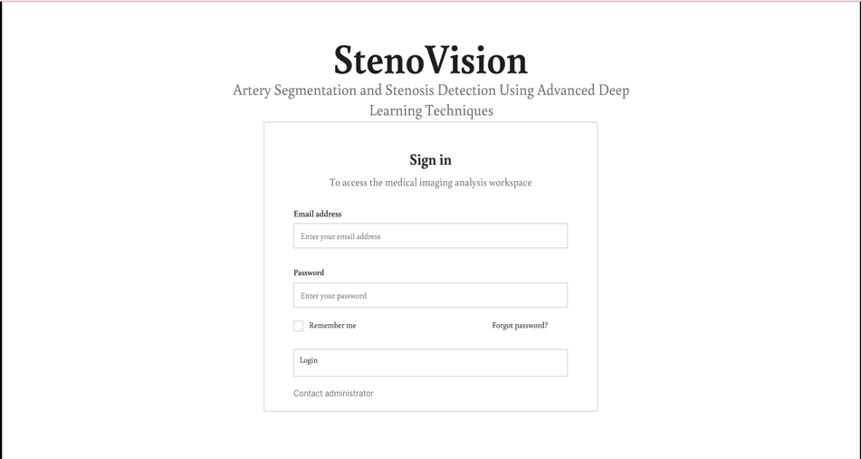
Figure 4: Registration and Authentication Interface Design
This figure presents the proposed authentication interface for accessing the StenoVision application.
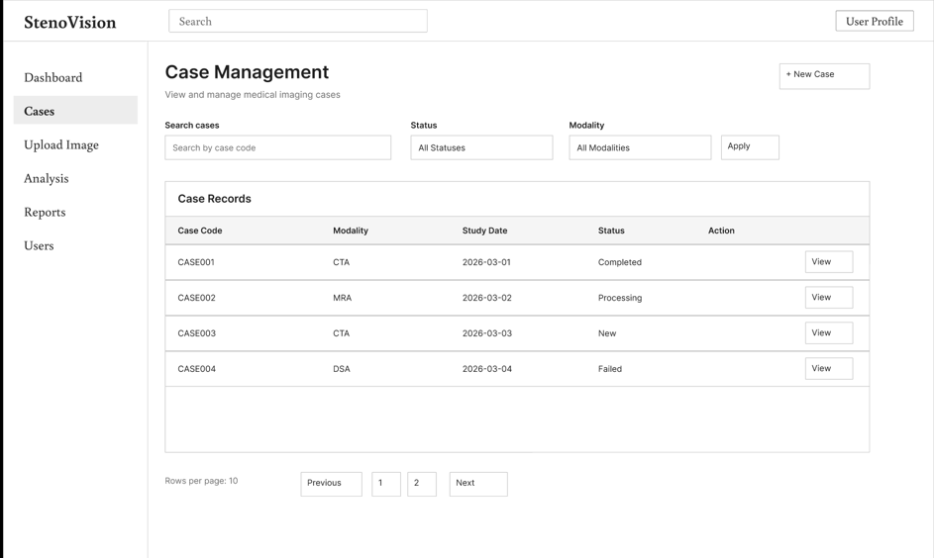
Figure 5: Dashboard and Case Management Interface Designs
This figure illustrates the dashboard layout and the interface for viewing, searching, and managing imaging cases.
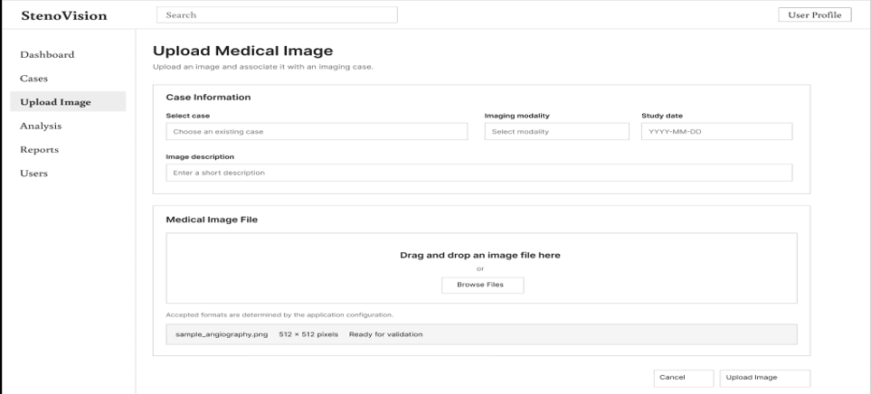
Figure 6: Medical Image Upload and Analysis Configuration Interface Designs
This figure presents the medical image upload workflow, case metadata fields, image selection controls, and analysis configuration interface.
Anwesha Singh worked on the design of Screens 6, 7, 8, and 9, covering Analysis Results, Case Details, Reports, and User Management, respectively.
4. Deliverables
The work completed for this design activity produced the following deliverables:
- High-level system architecture diagram.
- Detailed system architecture identifying the six core functional layers.
- Description of the major components and their responsibilities.
- Proposed end-to-end system data flow.
- Low-fidelity UI wireframes for nine application screens.
- Initial design references for frontend development and system integration.
5. Next Steps
The next activities include:
- Reviewing the proposed architecture with the project team and mentor.
- Refining component interfaces according to implementation requirements.
- Reviewing and finalizing the UI wireframes.
- Supporting frontend development by translating the wireframes into functional screens.
- Coordinating with the backend team on authentication, case management, and image-upload interfaces.
- Aligning the image-processing workflow with the selected dataset and available annotations.
6. Status Summary
I contributed to the initial system design of StenoVision by working on the system architecture and UI wireframes. The architecture defines the major system layers, their responsibilities, and the flow of medical image data through the proposed analysis pipeline.
The UI wireframes establish the initial navigation structure and layouts for nine application screens. Together, these design deliverables provide a foundation for the subsequent frontend implementation, backend integration, and AI analysis development planned for the remaining project milestones.
7. Milestone 1 Overall Conclusion
During Milestone 1 of my Infosys Springboard Virtual Internship, I completed the foundational research, dataset preparation, system architecture, and UI wireframing for the project, Artery Segmentation and Stenosis Detection Using Advanced Deep Learning Techniques (StenoVision).
After being added to the project team, I actively worked on designing the system architecture and preparing the initial UI wireframes. In this effort, the development of the last four wireframe screens (Screens 6, 7, 8, and 9, covering Analysis Results, Case Details, Reports, and User Management) was completed in collaboration with and with the assistance of teammate Anwesha Singh.
- Modality Confirmed: 2D X-Ray Coronary Angiography (XCA) was established as the primary modality due to its gold-standard clinical role in catheterization suites and computational tractability.
- Dataset Finalized: ARCADE was selected as the optimal dataset because it provides dual ground truth for both vessel segmentation (SYNTAX 25 classes) and stenosis detection (2,417 plaque annotations), cross-validated by cardiologists in standard COCO JSON format.
- Architecture Established: A scalable 6-tier microservices architecture was defined, connecting data ingestion, deep learning inference, and PostgreSQL storage.
- UI Wireframes Planned: Nine comprehensive low-fidelity wireframe screens were planned in Figma to establish the complete physician clinical workflow.
This comprehensive progress report establishes a complete structural, clinical, and data foundation. The project is fully primed to commence Milestone 2 with combination of our team’s work.

