Milestone 2 – Segmentation Performance Report
Project: Artery Segmentation and Stenosis Detection
Basis: analysis of the CSV and JSON result files supplied in artery_model_code.zip. This report distinguishes model-to-model agreement from ground-truth segmentation accuracy.

1. Executive summary
The supplied results include 200 paired segmentation masks for prediction-agreement analysis and per-image vessel-diameter summaries for both U-Net and Attention U-Net (200 images per model). The two models show a mean prediction-agreement Dice of 0.8309 and mean agreement IoU of 0.7182. These are agreement measurements between model predictions, not measures of accuracy against expert annotations.

2. Prediction agreement
Number of paired masks: 200.
Mean agreement Dice: 0.8309.
Mean agreement IoU: 0.7182.
Interpretation: the scores quantify spatial overlap between the two models' predicted masks. A high agreement does not establish that either prediction is anatomically correct.
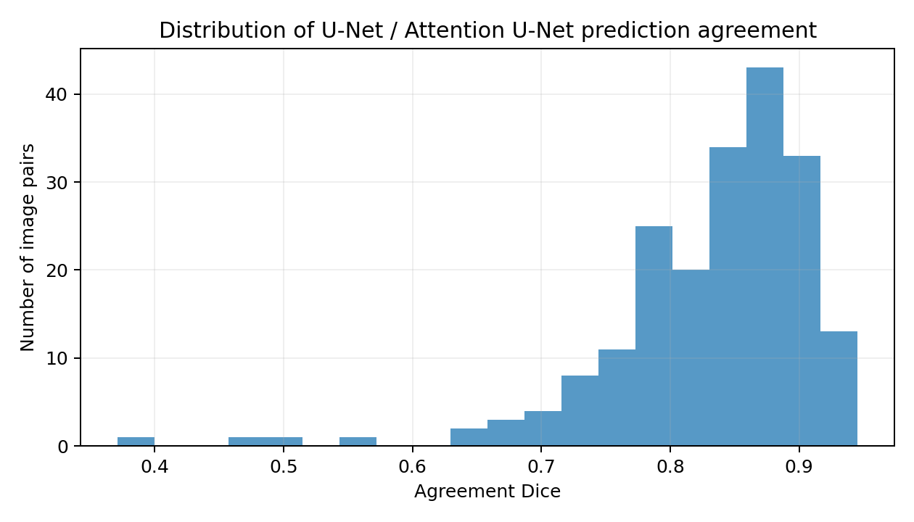

3. Vessel-diameter summary
The diameter_measurements.csv file contains 400 image-level records: 200 for U-Net and 200 for Attention U-Net. The following statistics are calculated from those per-image records. 'Mean of per-image mean' gives each image equal weight; it is not a pooled mean over every centerline point.
Measure | U-Net | Attention U-Net | Unit
Images | 200 | 200 | count
Total centerline points measured | 162047 | 148104 | points
Mean of per-image mean diameter | 9.52 | 10.90 | px
Median of per-image median diameter | 8.79 | 10.20 | px
Mean of per-image 90th percentile | 14.81 | 16.30 | px
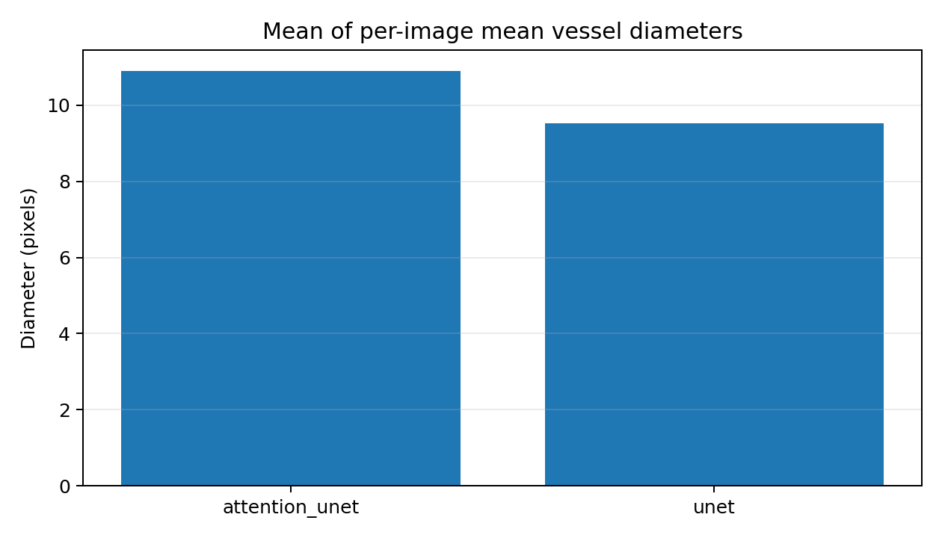
The supplied diameter CSV reports pixel measurements. Physical units such as millimetres should not be reported unless a valid image calibration factor is available.

4. Files and outputs represented
The supplied archive includes prediction_agreement.csv, prediction_agreement_summary.json, diameter_measurements.csv, diameter_profile.csv, and diameter_summary.csv. The current report uses prediction_agreement.csv and diameter_measurements.csv for the summary tables and figures.

5. Limitations and validation required
- The supplied agreement summary explicitly states that no ground-truth masks were used for the prediction-agreement calculation.
- Ground-truth Dice, IoU, precision, recall, specificity, and boundary-distance metrics cannot be calculated from the supplied agreement CSV alone.
- The archive does not establish that the diameter estimates have been validated against independently annotated vessel diameters.
- Diameter values are in pixels; conversion to millimetres requires image-specific spatial calibration.
- The two models' agreement should not be used by itself to decide which model is more accurate.

6. Conclusion
The supplied outputs support an initial comparison of U-Net and Attention U-Net prediction agreement and vessel-diameter characteristics over 200 images per model. Attention U-Net has a higher mean of per-image mean diameter in these outputs, but this is a descriptive difference, not evidence of better segmentation. Completion of a true segmentation performance evaluation requires the matching ground-truth masks and a verified image-to-mask mapping.

