

PROJECT REPORT

SKINSENSE AI:
Skin Intelligence & Personalized Skincare Planner

By: Virja Surve

Under the guidance of: Arti Ochani

Table of Content
- Introduction
- Problem Statement
- Objectives
- Proposed Methodology
- Hardware and Software requirements
- Source code
- Result(Screenshots)
- Future Scope
Conclusion
1. Introduction
SkinSense AI – Skin Intelligence & Personalized Skincare Planner is an AI-powered skincare assistance web application designed to help users understand their skin condition and receive personalized skincare recommendations.
Traditional skincare routines often involve trial and error, as users may not know their skin type, specific concerns, suitable ingredients, or the potential risks associated with certain products. SkinSense AI aims to make this process more structured by collecting information about the user's skin, lifestyle, allergies, sleep, hydration, and environmental exposure.
The system processes the collected information using predefined scoring logic and machine learning-based recommendation models to generate personalized skincare guidance. It also provides a skin health score, ingredient recommendations, suitable skincare products, and suggestions for maintaining a consistent skincare routine.
The application is developed using React.js for the frontend, FastAPI for backend services, PostgreSQL for database management, and Python-based machine learning components.
SkinSense AI is intended to provide preliminary skincare guidance and educational recommendations. It does not replace professional dermatological diagnosis or medical treatment.
2. Problem Statement
Choosing suitable skincare products and maintaining an effective skincare routine can be difficult because every individual has different skin types, concerns, allergies, and lifestyle habits.
Many existing skincare approaches rely on generalized recommendations that may not adequately consider individual requirements. Users may also struggle to understand skincare ingredients, track changes in their skin condition, or identify products that suit their needs.
Therefore, there is a need for an intelligent skincare assistance system that collects individual skin-related information, evaluates relevant factors, and provides personalized skincare recommendations through a user-friendly web application.
Problem statement: To design and develop an AI-based skincare assistance system that analyzes user-provided skin and lifestyle information, calculates a skin health score, and recommends suitable skincare ingredients, products, and routines while considering relevant safety constraints.
3. Objectives
The main objectives of SkinSense AI are:
- To develop a user-friendly web application for personalized skincare assistance.
- To collect information about skin type, skin concerns, allergies, lifestyle, sleep, hydration, and environmental exposure.
- To calculate an overall skin health score based on selected skin and lifestyle parameters.
- To implement machine learning models for skincare routine generation and personalized recommendations.
- To recommend skincare ingredients and products according to user preferences and suitability.
- To incorporate basic safety rules for allergies, sensitive skin, age restrictions, and ingredient combinations.
- To store and manage user profiles and assessment information using a PostgreSQL database.
- To provide role-based access for users, dermatologists, consultants, and administrators.
- To create a scalable foundation for future skincare progress tracking and advanced personalization.
4. Proposed Methodology
SkinSense AI follows a modular development approach consisting of frontend development, backend processing, database management, machine learning, and recommendation generation.
- User Registration and Login
Authentication and role-based access

- Skin Assessment
Skin type, concerns, allergies, lifestyle, sleep, hydration and environment

- Backend Processing
FastAPI receives and validates assessment data

- Skin Scoring and ML Models
Score calculation, routine generation and product recommendation

- Safety and Suitability Checks
Ingredient compatibility, allergies and relevant restrictions

- Personalized Results Dashboard
Skin health score, skincare routine and recommendations
4.1 Frontend Development
The frontend is developed using React.js and CSS. It provides an interactive interface through which users can register, log in, complete the skin assessment, and view personalized results.
4.2 Backend Development
The backend is developed using FastAPI in Python. It handles API requests, validates input, coordinates scoring and recommendation engines, and communicates with the database.
4.3 Database Management
PostgreSQL stores application data such as user accounts, skin profiles, skin health scores, progress entries, and consultation-related records, according to the implemented database schema.
4.4 Skin Health Score Calculation
The system calculates a skin health score using multiple factors. The current planned weighting is:
Parameter | Weight
Skin condition | 35%
Lifestyle | 20%
Sleep | 15%
Hydration | 10%
Additional baseline component | 20%
Total | 100%
4.5 Machine Learning and Recommendation System
The machine learning components are developed in Python. They support skincare routine generation and product recommendation.
- Routine generation: Uses trained classification models to predict suitable routine slots based on assessment features.
- Product recommendation: Uses a trained regression model to estimate product relevance or suitability, depending on the implemented target.
- Ingredient recommendation: Uses ingredient information and matching logic to identify potentially relevant skincare ingredients.
- Safety checks: Applies rules for known allergies, sensitive skin, age-related restrictions, and potentially unsuitable ingredient combinations.
4.6 Result Generation
After processing the assessment, the application displays the calculated skin health score and relevant skincare guidance on the results dashboard. If enabled and functioning, the application can also display product recommendations, ingredient matching information, and progress records.
5. Hardware and Software Requirements
Hardware Requirements
- Processor: Intel Core i3 or equivalent and above.
- RAM: Minimum 8 GB or more recommended.
- Storage: At least 2 GB of free space for development tools and project files.
- Display: Standard desktop or laptop display.
- Internet: Required for accessing Supabase and other online services.

Software Requirements
- Windows 10/11: Used as the operating system for project development and execution.
- Visual Studio Code: Used to write, edit, and manage the project source code.
- React.js: Used to develop the interactive frontend and user interface.
- JavaScript, HTML, and CSS: Used to structure, design, and implement the frontend interface.
- Node.js and npm: Used to run the frontend development environment and manage project dependencies.
- Python: Used for backend development and machine learning implementation.
- FastAPI: Used to develop backend APIs and handle communication between the frontend and backend.
- PostgreSQL 18: Used to store and manage user profiles, skin assessment data, health scores, and other application records.
- SQLAlchemy: Used to interact with the PostgreSQL database through Python.
- Scikit-learn: Used to train and implement machine learning models for skincare routine generation and personalized recommendations.
- Vite: Used as the frontend development server and build tool for the React application.
- Git and GitHub: Used for version control and source code management, if configured in the project
6. Results
The application is designed to:
- Collect and process user skin assessment information.
- Calculate an overall skin health score.
- Generate personalized skincare routine suggestions.
- Provide ingredient and product recommendations based on available information.
- Store user information and assessment results in the database.
- Support role-based access according to the configured user roles.
Homepage
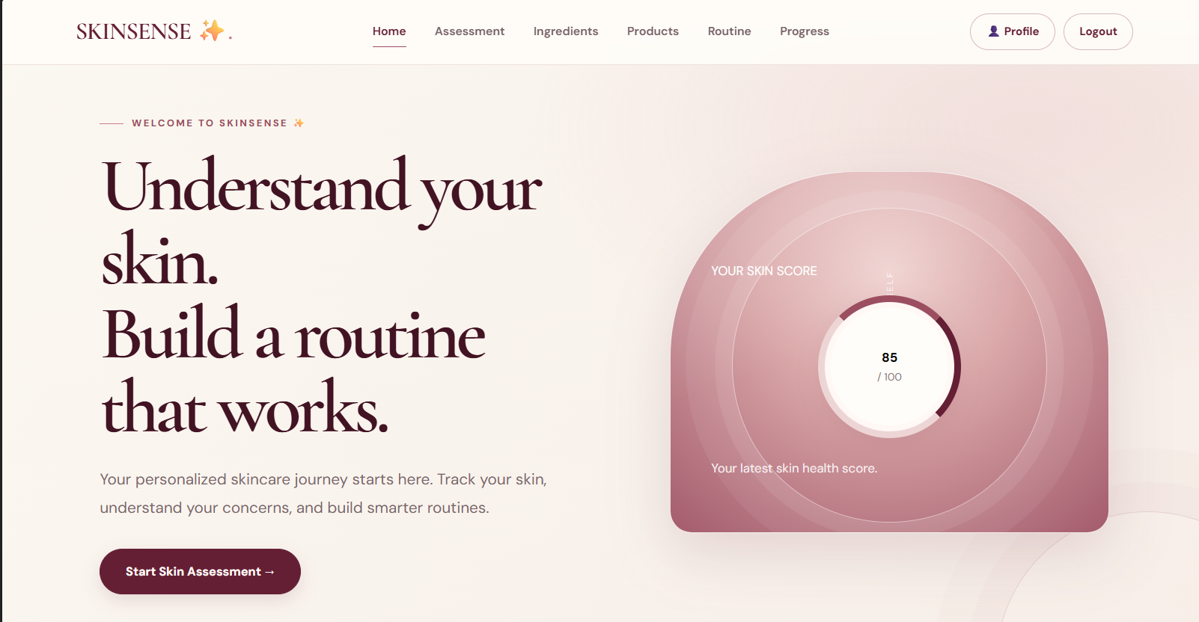
Assesment
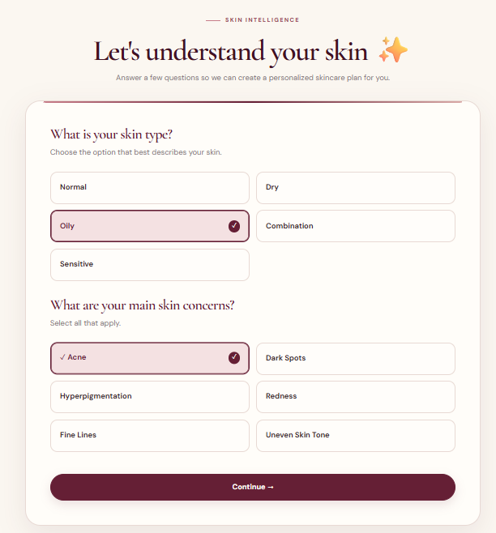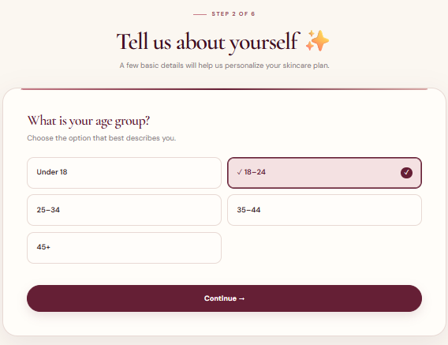
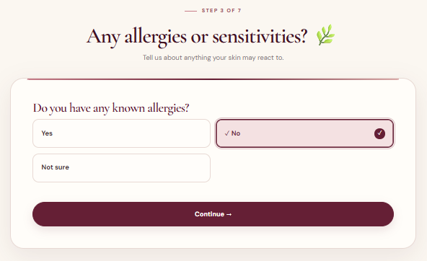
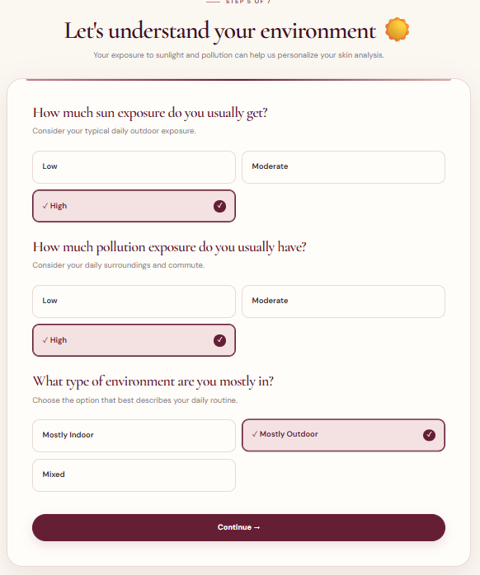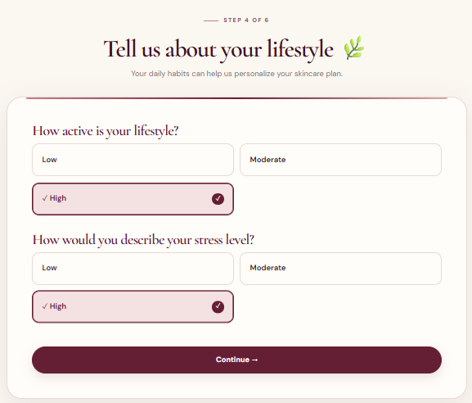

Score
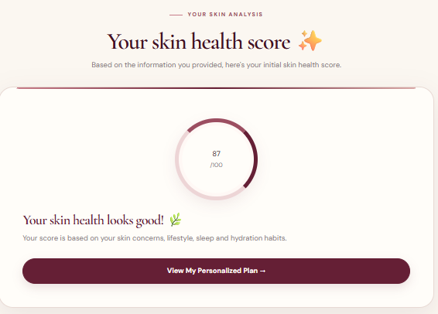
Ingredient recommendation
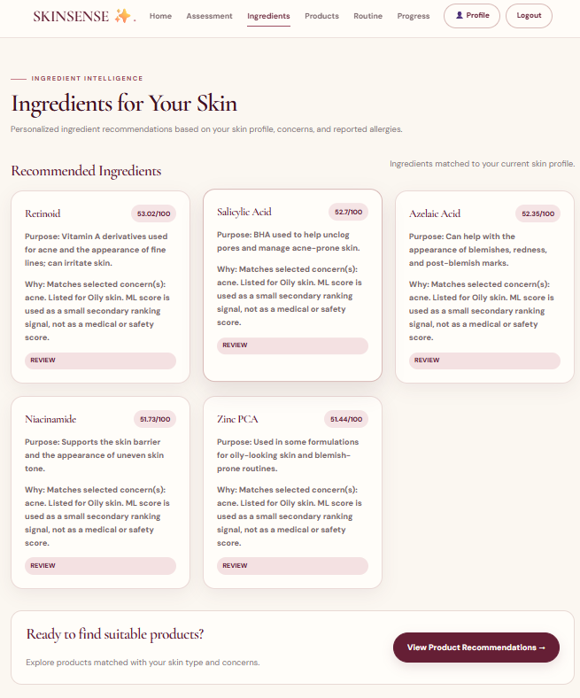
Product Recommendation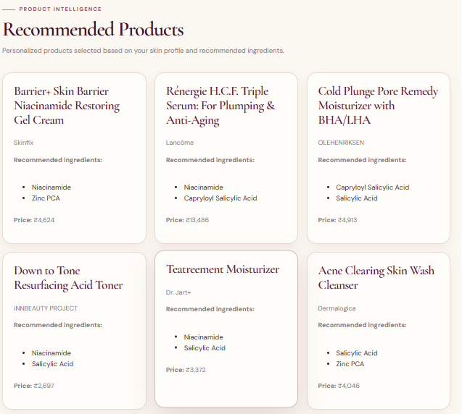
Routine generator
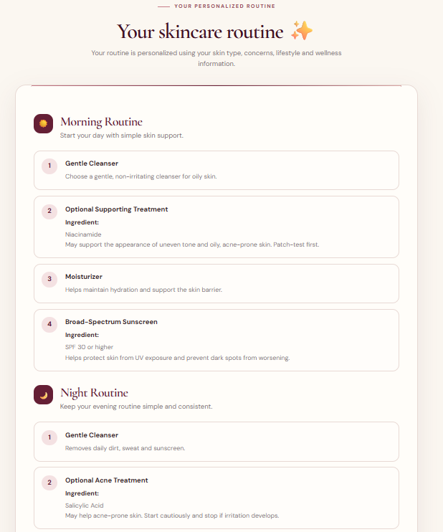
Progress tracker
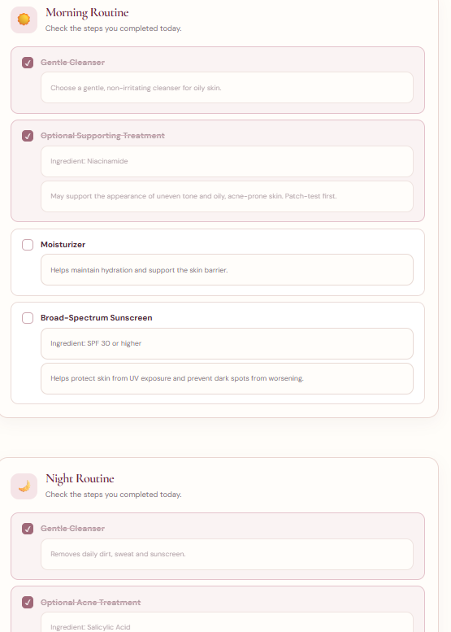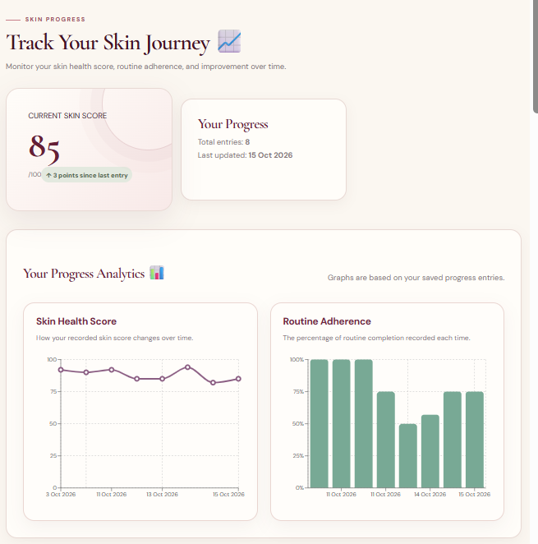
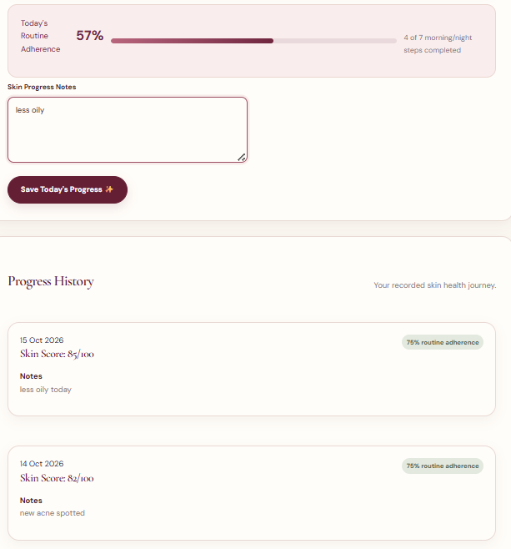
Admin Dashboard
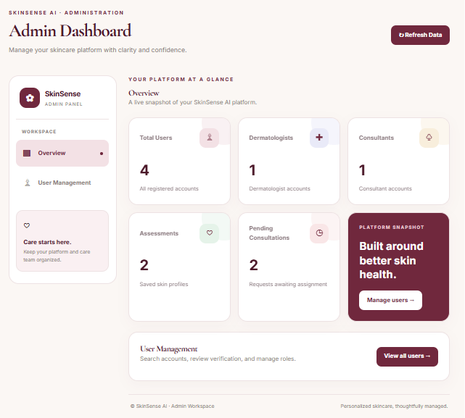

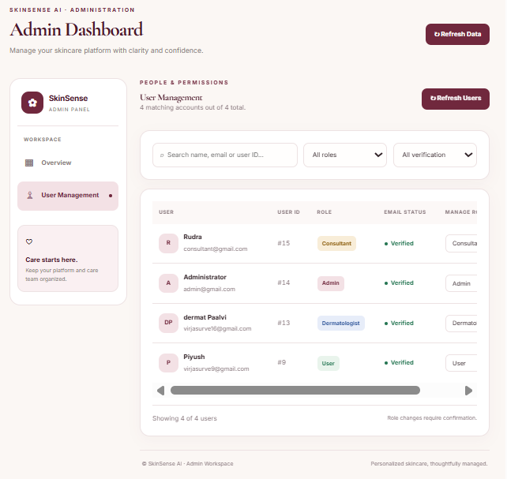

Dermatologist Dashboard
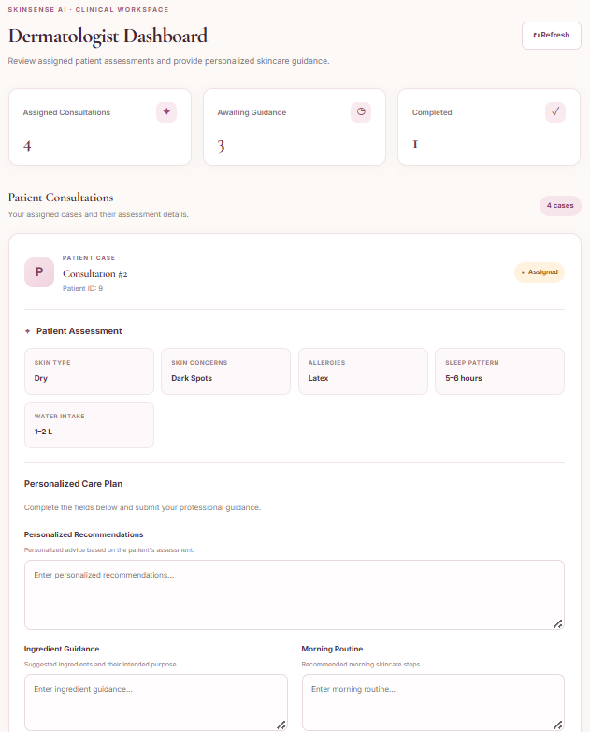

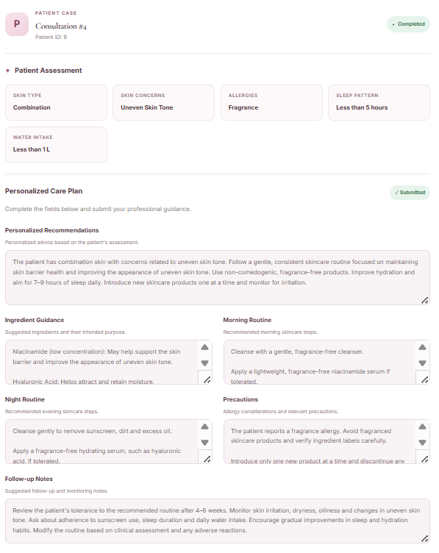

Consultant Dashboard
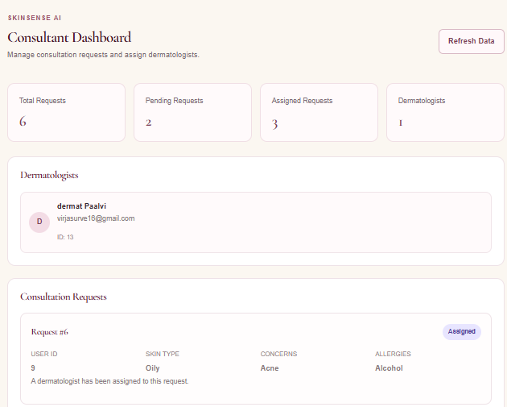
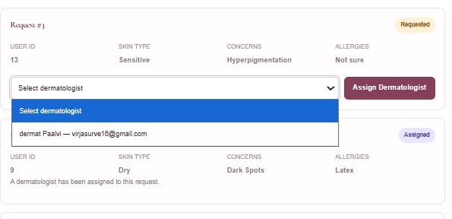
7. Future Scope
SkinSense AI can be extended with additional features to improve personalization, usability, and reliability.
- AI-based skin image analysis: Integrate a properly trained computer vision model to analyze uploaded skin images, with appropriate validation and privacy safeguards.
- Advanced personalization: Improve recommendations using user feedback, product preferences, and historical assessment data.
- Progress tracking: Add functional charts to visualize changes in assessment scores over time.
- Dermatologist consultation: Introduce appointment scheduling and secure communication with qualified dermatologists.
- Product database expansion: Add verified ingredient lists, product details, and updated product information.
- Mobile application: Develop an Android or iOS version of the application.
- Multilingual support: Provide recommendations and navigation in additional languages.
- Cloud deployment: Deploy the frontend, backend, database, and ML models to secure cloud infrastructure.
- Model evaluation: Evaluate prediction quality using suitable test datasets and documented metrics.
- Privacy and security improvements: Strengthen authentication, access control, data protection, and user consent mechanisms.
8. Conclusion
SkinSense AI – Skin Intelligence & Personalized Skincare Planner is a web-based application designed to make skincare guidance more personalized and accessible. It combines a React-based user interface, a FastAPI backend, PostgreSQL database management, machine learning components, and rule-based safety checks.
The system aims to help users organize their skin assessment information, understand their skin health score, and explore skincare ingredients, products, and routines that may suit their individual needs.
The project also demonstrates the practical application of full-stack development, database integration, machine learning, and personalized recommendation systems in the skincare domain.
Further development and systematic testing can improve the reliability of its recommendations, strengthen its safety mechanisms, and support additional features such as progress tracking and dermatologist consultation.

