INFRASCAN

AI-Powered Crack & Damage Assessment for Civil Infrastructure

1. Introduction
Civil infrastructure such as buildings, bridges, roads, tunnels, and concrete structures is exposed to environmental conditions, material deterioration, repeated loading, and aging. These factors can lead to visible defects such as cracks, potholes, surface deterioration, and concrete spalling.
Traditional infrastructure inspection relies heavily on manual observation and engineering expertise. Although essential, manual inspection can be time-consuming and may produce inconsistent documentation when large numbers of assets must be inspected.
InfraScan is proposed as an AI-powered infrastructure inspection platform that uses computer vision and deep learning to identify visible defects from infrastructure images. The platform aims to assist inspectors and civil engineers by providing automated defect detection, visual localization, damage analysis, historical comparison, and inspection reporting.
The first milestone establishes the project scope, identifies suitable infrastructure categories, selects relevant public datasets, studies their annotation structures, and performs exploratory data analysis before model development begins.

2. Milestone 1 — Overview

Tasks covered in this report
- Define project objectives and inspection workflows.
- Identify target infrastructure types.
- Select appropriate public infrastructure damage datasets.
- Understand dataset structure and annotations.
- Perform exploratory data analysis (EDA).

Milestone 1 objective
To establish a clear technical and functional foundation for InfraScan by defining the problem, determining the initial infrastructure scope, evaluating available datasets, understanding their labels and annotations, and identifying data characteristics that will influence subsequent AI model development.

Expected milestone deliverables
- Documented project objectives and inspection workflow.
- Defined target infrastructure categories.
- Dataset selection rationale.
- Dataset structure and annotation analysis.
- Initial EDA plan and findings.
- Identified dataset limitations and preparation requirements.

TASK 1: DEFINE PROJECT OBJECTIVES AND INSPECTION WORKFLOWS

1.1 Objective
The objective of this task is to define the problem InfraScan addresses, specify the expected platform capabilities, and establish a structured workflow through which infrastructure images are processed and converted into useful inspection information.

1.2 Problem statement
Infrastructure inspections often involve manually examining surface images, identifying defects, recording observations, estimating damage dimensions, and preparing inspection reports. These activities can require considerable time and may be difficult to standardize across multiple infrastructure assets.
A computer vision-based inspection system can assist this process by automatically identifying visible damage and organizing the resulting findings for engineering review.
The main challenge is to develop a system capable of processing different infrastructure images while accounting for variations in lighting, image resolution, surface texture, camera angle, material type, and defect appearance.

1.3 Primary project objectives
Objective 1: Automated crack detection
Identify whether visible cracks are present in infrastructure images and locate the affected regions.
Objective 2: Crack segmentation
Identify crack pixels and generate segmentation masks that represent the shape and boundaries of visible cracks.
Objective 3: Crack type classification
Classify visible crack patterns into supported categories, such as longitudinal, transverse, diagonal, and alligator cracking, depending on the available annotations.
Objective 4: Surface damage identification
Extend the inspection process beyond cracks to recognize defects such as potholes, concrete spalling, exposed reinforcement, and surface deterioration where suitable training data is available.
Objective 5: Damage measurement
Estimate crack length, width, area, and orientation when image calibration and suitable reference information are available.
Objective 6: Damage severity assessment
Provide an initial damage category or inspection priority based on image evidence, measured characteristics, and engineer-defined assessment rules.
Objective 7: Inspection management
Maintain infrastructure asset records, inspection images, dates, findings, and historical inspection information.
Objective 8: Explainable visualization
Display detection boxes, segmentation masks, confidence values, and visual explanations to help users interpret model predictions.
Objective 9: Reporting and maintenance support
Generate structured inspection reports and help prioritize follow-up inspections and maintenance activities.

1.4 Proposed inspection workflow
The following workflow describes the intended end-to-end operation of InfraScan.
Stage 1 — Asset registration
Infrastructure information is recorded, including asset ID, asset type, location, material, and other available details.
Stage 2 — Inspection creation
An inspector creates an inspection record, selects the infrastructure asset, records the inspection date, and associates the inspection with the responsible person.
Stage 3 — Image acquisition
Images are captured using a mobile camera, digital camera, drone, or other suitable imaging device. Existing images may also be uploaded.
Stage 4 — Image validation
The system checks image format, resolution, file size, image readability, blur, lighting quality, and duplicate-image risk.
Stage 5 — Image preprocessing
Suitable images are prepared through resizing, normalization, contrast enhancement, noise reduction, and region-of-interest extraction where required.
Stage 6 — AI-based damage analysis
The system applies the selected models to detect cracks, segment affected pixels, classify supported defect categories, and identify other visible surface damage.
Stage 7 — Geometry and severity assessment
Crack geometry is estimated where the image scale is known. The system generates a preliminary severity assessment using validated criteria and available inspection information.
Stage 8 — Result visualization and engineering review
The inspector reviews the original image, AI predictions, confidence values, measurements, and relevant visual overlays. Findings requiring attention are flagged for qualified engineering review.
Stage 9 — Record storage and historical comparison
The inspection results are stored against the relevant infrastructure asset. Where comparable previous inspections exist, visible changes in defects can be evaluated.
Stage 10 — Reporting and maintenance planning
The system prepares an inspection report and supports maintenance prioritization, follow-up inspection scheduling, and assignment of maintenance tasks.

1.5 Workflow summary
Image acquisition → Image validation → Preprocessing → Crack and damage detection → Segmentation and classification → Measurement and preliminary severity assessment → Engineer review → Report generation → Maintenance follow-up.

1.6 Expected output of Task 1
The project objectives and proposed inspection workflow are defined. The workflow establishes how image acquisition, AI analysis, engineering review, and inspection reporting will connect within a single platform.
The defined scope also establishes that the system is intended to support engineering inspection, rather than independently certify structural safety.

1.7 Key considerations
- Image quality directly affects model performance.
- Different defect types require suitable annotations and potentially different models.
- Physical crack measurements require calibration or a reliable scale reference.
- Severity criteria must be validated for the relevant structure and material.
- AI-generated findings require appropriate engineering interpretation.

TASK 2: IDENTIFY TARGET INFRASTRUCTURE TYPES

2.1 Objective
The objective of this task is to identify the infrastructure categories that InfraScan is intended to support and determine which categories should be prioritized during initial development.

2.2 Infrastructure categories considered
The proposed platform may support the following infrastructure types.

1. Buildings
Buildings may contain cracks in walls, columns, beams, floors, and other visible concrete or masonry surfaces.
Potential defects include wall cracks, concrete cracking, surface deterioration, and spalling.

2. Bridges
Bridge components such as decks, concrete walls, and other accessible surfaces may exhibit cracking, spalling, or deterioration.
Bridge-deck and concrete-surface images are relevant to initial crack detection experiments.

3. Roads and pavements
Road surfaces may exhibit longitudinal cracks, transverse cracks, alligator cracking, potholes, and other visible pavement defects.
Road damage images are useful for developing and evaluating multi-class damage detection.

4. Tunnels
Tunnel surfaces may exhibit cracks, water staining, leakage indicators, and concrete deterioration.
Dedicated tunnel images and suitable annotations would be required to evaluate performance reliably in tunnel environments.

5. Dams
Concrete dams may exhibit visible cracking, staining, surface erosion, and other deterioration indicators.
This category requires domain-specific inspection data and suitable engineering assessment criteria.

6. Retaining walls
Retaining walls may exhibit cracks, surface deterioration, staining, and concrete damage.
The visual appearance of these defects may vary according to the wall material and environmental conditions.

7. Industrial structures
Industrial facilities may contain concrete floors, walls, columns, and other structural surfaces requiring periodic visual inspection.

8. General concrete structures
Concrete structures are a broad category that can include structural elements from multiple asset types. Concrete crack datasets are relevant to this category.

2.3 Initial prioritization
For the initial prototype, the following development priorities are proposed.
Priority | Infrastructure category | Reason for selection
1 | Concrete surfaces, bridge decks, and walls | Suitable for initial cracked-versus-non-cracked image classification
2 | Roads and pavements | Supports multiple road damage categories and object detection
3 | General concrete structural surfaces | Relevant to crack segmentation and localization
4 | Buildings, tunnels, retaining walls, and dams | Expansion categories requiring suitable domain-specific data
The prioritization is based on the relevance of available public datasets to the proposed AI tasks. It does not indicate that the first categories are structurally more important than the others.

2.4 Infrastructure types versus defect categories
Infrastructure type and defect type are separate attributes.
For example, a bridge is an infrastructure type, whereas a transverse crack is a defect category. A single infrastructure asset may contain several different defect categories.
The platform should therefore maintain separate fields for:
- Infrastructure type.
- Surface material.
- Defect category.
- Defect location.
- Inspection date.
- Damage severity assessment.
- Model confidence.
This distinction will help the system organize inspection records and avoid mixing asset categories with AI classification labels.

2.5 Expected output of Task 2
The target infrastructure scope has been identified, and an initial prioritization has been proposed. Concrete surfaces and roads are suitable starting points because the selected public datasets can support different initial computer vision tasks.
The remaining infrastructure categories can be incorporated progressively as appropriate images, annotations, and domain-specific evaluation criteria become available.

2.6 Key considerations
- A model trained on road images should not automatically be assumed to work equally well on bridges or tunnels.
- Material, lighting, camera angle, and image resolution can affect defect appearance.
- Each infrastructure category should be evaluated separately before deployment.
- Expansion to additional infrastructure types requires suitable data and validation.

TASK 3: SELECT APPROPRIATE PUBLIC INFRASTRUCTURE DAMAGE DATASETS

3.1 Objective
The objective of this task is to identify publicly available infrastructure damage datasets that are relevant to the intended AI functions and compare them according to their image content, defect categories, annotation types, and suitability for model training.

3.2 Dataset selection criteria
The following criteria are used to assess dataset suitability:
- Relevance to the selected infrastructure category.
- Number and diversity of images.
- Availability of cracked and non-cracked samples.
- Availability of object-level defect annotations.
- Availability of pixel-level segmentation masks.
- Diversity of defect categories.
- Suitability for model training and evaluation.
- Availability of dataset documentation and access information.
- Licensing and permitted usage.
- Compatibility with the project's time and computational resources.

3.3 Dataset A — SDNET2018
Purpose: Concrete crack classification and baseline crack detection research.
SDNET2018 is a public image dataset containing more than 56,000 images of cracked and non-cracked concrete bridge decks, walls, and pavements. The images include different surface conditions and visual obstructions, such as shadows, roughness, and surface irregularities. [1]
Main characteristics
- Infrastructure coverage: bridge decks, walls, and pavements.
- Main task: image-level cracked-versus-non-cracked classification.
- Image format: JPEG.
- Image dimensions: 256 × 256 pixels.
- Labels: cracked and non-cracked.
- Potential use: initial classification experiments and baseline model evaluation.
Suitability for InfraScan
SDNET2018 is a strong candidate for the first crack classification experiment because it provides labeled examples of concrete surfaces with and without visible cracks.
However, its image-level labels do not by themselves provide the pixel-level crack masks or detailed object-level bounding boxes needed for segmentation and general object detection.
Dataset reference: https://doi.org/10.15142/T3TD19

3.4 Dataset B — RDD2022 (Road Damage Dataset 2022)
Purpose: Multi-class road damage detection and localization.
RDD2022 contains 47,420 road images collected across six countries: Japan, India, the Czech Republic, Norway, the United States, and China. The dataset contains more than 55,000 annotated road damage instances and includes longitudinal cracks, transverse cracks, alligator cracks, and potholes. [2]
Main characteristics
- Infrastructure coverage: roads and pavements.
- Main task: object detection and defect classification.
- Image format: JPEG.
- Annotation format: XML annotations following the PASCAL VOC-style structure.
- Labels: road damage categories, including longitudinal cracks, transverse cracks, alligator cracks, and potholes.
- Potential use: multi-class damage detection and bounding-box localization.
Suitability for InfraScan
RDD2022 is a strong candidate for road damage detection because it includes several damage categories and images from multiple countries, including India.
It can support training and evaluation of object detection models, subject to the selected dataset split and annotation quality. Its bounding-box annotations do not automatically provide the pixel-level masks required for crack segmentation.
Dataset reference: https://doi.org/10.6084/m9.figshare.21431547.v1

3.5 Dataset C — CrackForest Dataset (CFD)
Purpose: Crack segmentation and pixel-level localization.
The CrackForest Dataset is a recognized dataset used in road crack detection and segmentation research. It is relevant to studying crack shapes, boundaries, and pixel-level localization.
Main characteristics
- Infrastructure coverage: road surfaces.
- Main task: crack segmentation.
- Potential use: crack mask analysis and segmentation evaluation.
- Important requirement: verify the downloaded release, image-mask pairing, annotation conventions, and usage terms before training.
Suitability for InfraScan
CFD is relevant when the objective is to distinguish crack pixels from surrounding road texture. Its suitability should be confirmed by inspecting the actual images and ground-truth masks in the chosen release.
Reference for dataset discovery: https://github.com/sekilab/RoadDamageDetector

3.6 Dataset D — Crack500
Purpose: Road crack segmentation and boundary analysis.
Crack500 is used in crack segmentation research and is relevant to evaluating how well a model identifies thin, branching, and irregular cracks.
Main characteristics
- Infrastructure coverage: road surfaces.
- Main task: pixel-level crack segmentation.
- Potential use: segmentation benchmarking and crack boundary analysis.
- Important requirement: verify the downloaded release's annotation format, image-mask correspondence, split definitions, and license.
Suitability for InfraScan
Crack500 is a candidate for evaluating segmentation models such as U-Net and related architectures. Its actual annotation structure must be inspected before determining the preprocessing and training requirements.

3.7 Dataset E — Concrete Crack Images for Classification
Purpose: Baseline concrete crack classification.
This dataset family provides concrete images labeled for crack classification and can be considered for initial experiments.
Main characteristics
- Infrastructure coverage: concrete surfaces.
- Main task: binary crack classification.
- Potential use: transfer learning and comparison of baseline image classifiers.
- Limitation: classification labels alone are insufficient for segmentation or physical crack measurement.
Suitability for InfraScan
This dataset is a potential supplementary resource if additional concrete crack examples are needed. Its precise image count, release, licensing, and annotation format should be recorded after selecting and downloading a specific version.

3.8 Comparative dataset assessment
Dataset | Main infrastructure | Primary task | Annotation type | Proposed role
SDNET2018 | Concrete decks, walls, pavements | Classification | Image-level labels | Initial crack classification
RDD2022 | Roads and pavements | Detection | Bounding boxes and class labels | Multi-class road damage detection
CrackForest (CFD) | Roads | Segmentation | Crack masks in the selected release | Crack segmentation
Crack500 | Roads | Segmentation | Crack masks in the selected release | Segmentation evaluation
Concrete Crack Images | Concrete surfaces | Classification | Image-level labels | Supplementary classification

3.9 Recommended initial dataset strategy
For a project with an eight-week implementation schedule, it is practical to select a small number of datasets aligned with specific model tasks rather than attempting to train all models on every dataset.
Recommended starting combination
- SDNET2018: initial concrete crack classification.
- RDD2022: multi-class road damage detection.
- CrackForest or Crack500: crack segmentation, after annotation verification.
This combination covers three distinct computer vision tasks: classification, object detection, and segmentation.
The final selection should depend on download and annotation verification, available computing resources, project scope, and the time needed to prepare each dataset.

3.10 Expected output of Task 3
A preliminary dataset shortlist has been established, along with the intended use of each dataset and its main annotation requirements.
The shortlist provides a practical starting point for Milestone 1 and helps avoid using a classification-only dataset for tasks that require object-level or pixel-level annotations.

3.11 Key considerations
- Public availability does not automatically mean unrestricted commercial use.
- Dataset licenses and citation requirements must be reviewed.
- Dataset statistics must be recorded for the exact downloaded release.
- Different datasets may use different class definitions and annotation formats.
- Dataset-specific models may be required before attempting a unified multi-infrastructure system.

TASK 4: UNDERSTAND DATASET STRUCTURE AND ANNOTATIONS

4.1 Objective
The objective of this task is to understand how the selected datasets store images, labels, annotations, and data splits, and to determine how their structures support different AI training tasks.

4.2 Meaning of dataset structure
Dataset structure refers to the way image files, annotation files, metadata, and training or testing subsets are organized.
A dataset may use separate folders for classes, image-annotation pairs, or dedicated files containing labels and object coordinates.
Understanding the structure is necessary before data cleaning, exploratory analysis, model training, and evaluation.

4.3 Meaning of annotations
Annotations are the labels or reference information associated with images. They provide the expected answers against which a model learns and is evaluated.
The three principal annotation types relevant to InfraScan are:

A. Image-level classification labels
Each image receives a class label, such as cracked or non-cracked.
These labels support classification models that predict the presence or absence of a crack.
They do not specify the exact crack location or boundary.

B. Bounding-box annotations
A bounding box identifies the approximate location of a defect within an image.
It generally contains:
- Defect class.
- Bounding-box coordinates.
- Image reference or filename.
- Additional metadata, depending on the annotation format.
These annotations support object detection and localization.

C. Pixel-level segmentation masks
A segmentation mask identifies which pixels belong to the defect.
A mask can represent the detailed shape and boundary of a crack, allowing the system to distinguish narrow crack structures from the surrounding surface.
Segmentation masks are required for supervised pixel-level segmentation evaluation.

4.4 SDNET2018 structure and annotations
SDNET2018 organizes images by infrastructure surface category and crack status. Its image collection contains bridge-deck, wall, and pavement subsets, with cracked and uncracked image labels. The images are 256 × 256 RGB JPEG files. [1]
Structure to examine
- Infrastructure category folders.
- Cracked and uncracked subfolders.
- Image filenames and extensions.
- Image dimensions and readability.
- Number of images in each class.
Annotation interpretation
The class label is associated with the image rather than an individual crack region.
Implication for model development
SDNET2018 can support image classification. Additional pixel-level or bounding-box annotations would be needed to train supervised segmentation or object detection models using this dataset.

4.5 RDD2022 structure and annotations
RDD2022 includes country-specific folders and image data collected using different acquisition methods. The documented structure includes training images with XML annotations and test images for which ground-truth annotations are not released in the same package. [2]
Structure to examine
- Country or acquisition-source folders.
- Training and testing directories.
- JPEG image files.
- Corresponding XML annotation files.
- Class names and object coordinates.
- Missing or unmatched image-annotation pairs.
Annotation interpretation
The XML annotation files identify damage categories and bounding-box coordinates. These coordinates specify the approximate defect location within the image.
Implication for model development
RDD2022 can support object detection and classification of localized road damage. It should not be treated as a pixel-level crack segmentation dataset without additional segmentation annotations.

4.6 CrackForest and Crack500 structure
For CFD and Crack500, the exact directory structure must be confirmed from the selected official or research release.
Structure to examine
- Image directories.
- Ground-truth mask directories.
- Image-mask filename correspondence.
- Image and mask dimensions.
- Mask value conventions.
- Dataset split definitions.
- Any provided preprocessing or cropping instructions.
Annotation interpretation
A segmentation mask identifies crack pixels. Depending on the release, masks may be binary images or use another documented encoding.
Implication for model development
Images and masks must correspond correctly and have compatible spatial dimensions. Any conversion of mask formats must preserve the original crack labels.

4.7 Dataset integrity checks
The following checks are required before training.
Check | Purpose
File count | Establish the number of available images and annotations
File format | Identify supported image and annotation types
Image readability | Identify corrupted or unreadable files
Dimension consistency | Understand image size variation
Label consistency | Detect missing or unexpected class labels
Annotation pairing | Identify missing masks or annotation files
Duplicate detection | Reduce the risk of duplicate data
Class mapping | Standardize category names where appropriate
Split verification | Prevent training and evaluation leakage
License review | Confirm permitted use and citation obligations

4.8 Training, validation, and testing
The dataset must be divided appropriately for model development.
- Training set: used to learn model parameters.
- Validation set: used to compare models and tune settings.
- Test set: reserved for final performance evaluation.
The split should be designed to minimize leakage. Where related images, repeated captures, or overlapping crops exist, they should not be distributed across training and testing in a way that makes evaluation artificially easy.
For infrastructure imagery, testing on different assets or collection locations can provide a more realistic assessment of generalization than randomly splitting highly similar images.

4.9 Expected output of Task 4
The required annotation types and the expected dataset structures have been documented. The initial dataset strategy distinguishes image-level classification labels, object-level bounding boxes, and pixel-level segmentation masks.
The next step is to verify these structures against the downloaded files and document the actual counts, missing annotations, image properties, and class distributions.

4.10 Key considerations
- A dataset's intended task determines which model types it can support.
- Annotation quality is as important as image quantity.
- Missing or inconsistent labels can affect training and evaluation.
- Dataset splits must be checked for possible leakage.
- Physical crack measurements cannot be obtained reliably from pixel masks alone without scale information.

TASK 5: PERFORM EXPLORATORY DATA ANALYSIS (EDA)

5.1 Objective
The objective of EDA is to examine the selected infrastructure damage datasets, summarize their characteristics, identify quality issues, understand class distributions, and determine whether the available data is suitable for the intended AI tasks.
EDA provides the evidence needed to prepare datasets for model training and helps identify problems before deep learning development begins.

5.2 Scope of EDA
The initial EDA should cover the following areas:
- Dataset size and completeness.
- Class distribution.
- Image dimensions and formats.
- Visual diversity.
- Image quality.
- Annotation completeness.
- Duplicate and near-duplicate images.
- Train-validation-test split suitability.
- Dataset limitations.
- Implications for AI model development.

5.3 Analysis A — Dataset size and completeness
Purpose: Determine how much usable data is available.
The analysis should record:
- Total number of image files.
- Number of annotation files.
- Number of usable images.
- Number of corrupted or unreadable images.
- Number of images with missing annotations.
- Number of unmatched image-mask pairs.
- Number of files excluded during cleaning.
Expected observation
The available file count may differ from the number of usable samples because some files may be corrupted, duplicated, unsupported, or missing annotations.
Interpretation
The final usable dataset size determines the amount of data available for training, validation, and testing. A smaller but consistently annotated dataset may be more useful for a specific task than a larger dataset with unsuitable labels.
Status: Analysis required on the downloaded dataset files.

5.4 Analysis B — Class distribution
Purpose: Understand the frequency of each defect category and identify class imbalance.
For classification datasets, count the images belonging to each class. For object detection datasets, count defect instances by category as well as the number of images containing each category. For segmentation datasets, count masks and, where feasible, summarize the number of positive crack pixels or the proportion of masks containing defects.
Example categories to examine
- Cracked and non-cracked concrete.
- Longitudinal cracks.
- Transverse cracks.
- Alligator cracks.
- Potholes.
- Other supported damage categories.
Expected observation
Some defect categories may occur more frequently than others.
Interpretation
Class imbalance can cause a model to favor common categories and perform poorly on less frequent defects. This may require class-aware evaluation, suitable sampling, or data augmentation during later model development.
Status: Actual class counts and imbalance levels must be calculated from the selected data.

5.5 Analysis C — Image dimensions and formats
Purpose: Understand image resolution and the amount of variation in image size.
The analysis should record:
- Image format.
- Image width and height.
- Color channels.
- Minimum and maximum dimensions.
- Common image dimensions.
- Aspect ratio distribution.
- File size distribution.
Initial dataset-specific expectation
SDNET2018 uses 256 × 256 RGB JPEG images. Other datasets, particularly road damage datasets, may contain different image dimensions and aspect ratios. [1][2]
Interpretation
Image-size variation affects preprocessing, resizing, batching, memory usage, and inference time. Resizing should preserve crack visibility as far as possible, particularly for very thin defects.
Status: General dataset characteristics are identified; actual dimension distributions must be measured after download.

5.6 Analysis D — Visual inspection and defect appearance
Purpose: Understand how defects appear under different imaging conditions.
A representative sample of images should be reviewed visually for:
- Thin and thick cracks.
- Straight, diagonal, branching, and irregular patterns.
- Potholes and larger surface damage.
- Shadows and uneven lighting.
- Surface roughness and stains.
- Background clutter.
- Motion blur or defocus.
- Different concrete or pavement textures.
Expected observation
Cracks can be difficult to distinguish from joints, surface marks, shadows, and rough textures. Some defects may occupy only a small number of pixels.
Interpretation
Visual diversity helps identify likely failure cases and informs the need for suitable preprocessing, augmentation, and representative test data.
Status: Image review should be documented with representative examples from the downloaded datasets.

5.7 Analysis E — Image quality assessment
Purpose: Identify images that may not be suitable for reliable AI analysis.
The review should assess:
- Blur.
- Low brightness.
- Excessive brightness.
- Poor contrast.
- Noise.
- Obstructions.
- Incomplete surface coverage.
- Image corruption.
Expected observation
Images captured under different conditions may vary in clarity and defect visibility.
Interpretation
A quality assessment stage can flag unsuitable images before inference. However, images should not be discarded automatically without checking whether they contain valuable examples of difficult real-world conditions.
Status: Quality assessment criteria are defined; measured quality statistics remain to be established.

5.8 Analysis F — Annotation quality
Purpose: Verify that labels correctly represent the intended defect categories and locations.
The checks should include:
- Missing labels.
- Invalid category names.
- Empty or malformed annotation files.
- Bounding boxes outside image boundaries.
- Incorrect or zero-area bounding boxes.
- Missing segmentation masks.
- Image-mask dimension mismatches.
- Incorrect mask encoding.
- Visually inconsistent annotations.
Expected observation
Annotation formats and levels of detail differ across datasets. Some datasets provide only image-level labels, whereas others provide object-level or pixel-level information.
Interpretation
Annotation quality determines whether the data can be used directly for classification, detection, or segmentation. Incorrect annotations may mislead the model during training.
Status: Annotation validation is planned and must be confirmed against the actual files.

5.9 Analysis G — Duplicate and data leakage assessment
Purpose: Identify repeated images or closely related image samples that could inflate evaluation performance.
The analysis should examine:
- Exact duplicate files.
- Images with identical or highly similar content.
- Repeated images from the same inspection sequence.
- Cropped images derived from the same original image.
- Overlap between training, validation, and testing sets.
Expected observation
Duplicate or highly similar samples can cause a model to encounter nearly identical visual content during both training and evaluation.
Interpretation
Where feasible, related images should be grouped and split consistently. This helps provide a more realistic estimate of performance on previously unseen infrastructure imagery.
Status: Duplicate and leakage checks remain to be performed.

5.10 Analysis H — Dataset suitability for model development
EDA results should be interpreted in relation to the intended AI task.
AI task | Required data | Main EDA concern
Crack classification | Image-level labels | Class balance and visual diversity
Crack detection | Bounding boxes and class labels | Box validity and defect-instance counts
Crack segmentation | Pixel-level masks | Mask completeness and boundary quality
Crack type classification | Reliable crack-type labels | Category definitions and class balance
Physical crack measurement | Calibrated images or scale references | Scale reliability and geometric distortion
Severity assessment | Reliable severity labels or validated rules | Expert agreement and engineering applicability

5.13 Key considerations
- Dataset-level statistics should be separated from observations based on a small sample of images.
- Class counts should be calculated using the correct unit: images, defect instances, or positive pixels.
- A classification dataset cannot be assumed to support segmentation.
- Data augmentation should be considered after understanding the original distribution.
- Dataset limitations must be documented before training and performance claims are made.
EDA Findings — Concrete Crack Images for Classification
- Total images: 40,000
- Classes: Negative — 20,000; Positive — 20,000
- Class balance: Balanced (50% per class)
- Image dimensions: 227 × 227 pixels for all 40,000 images
- Color mode: RGB for all 40,000 images
- Readable images: 40,000
- Unreadable/corrupt images: 0
- Visual inspection: Sample images show cracked and apparently uncracked concrete surfaces.
- Suitability: Suitable for an initial binary crack/no-crack classification task.
- Limitation: Image-level labels alone do not provide pixel-level segmentation masks or calibrated physical crack widths.
Conclusion: The dataset is balanced, has consistent image dimensions and color mode, and passed the notebook's readability check. It is suitable for initial crack/no-crack classification experiments.
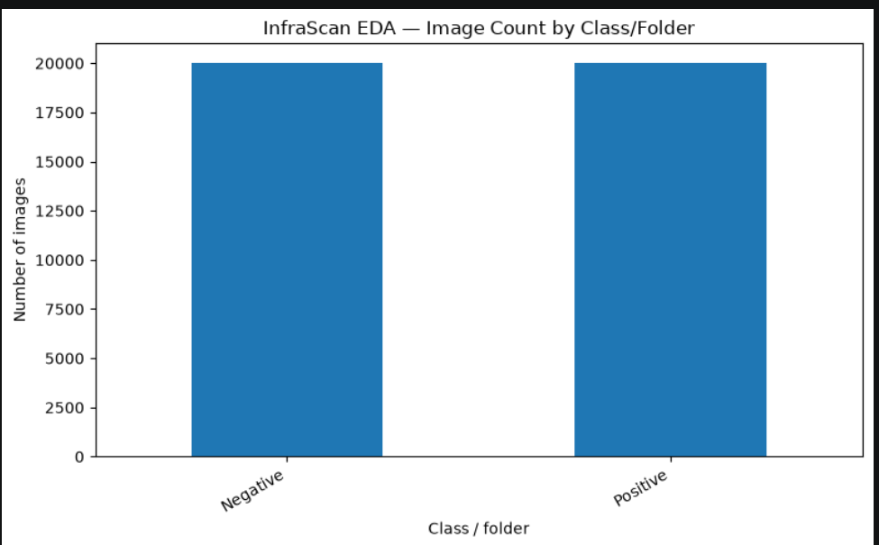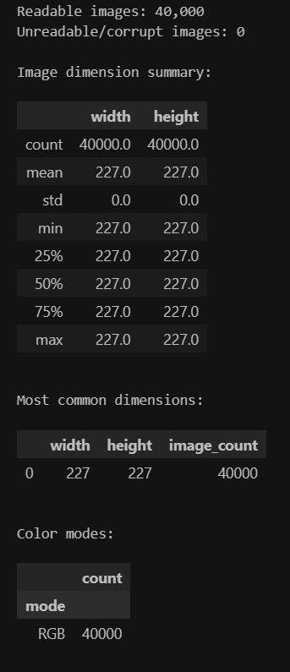

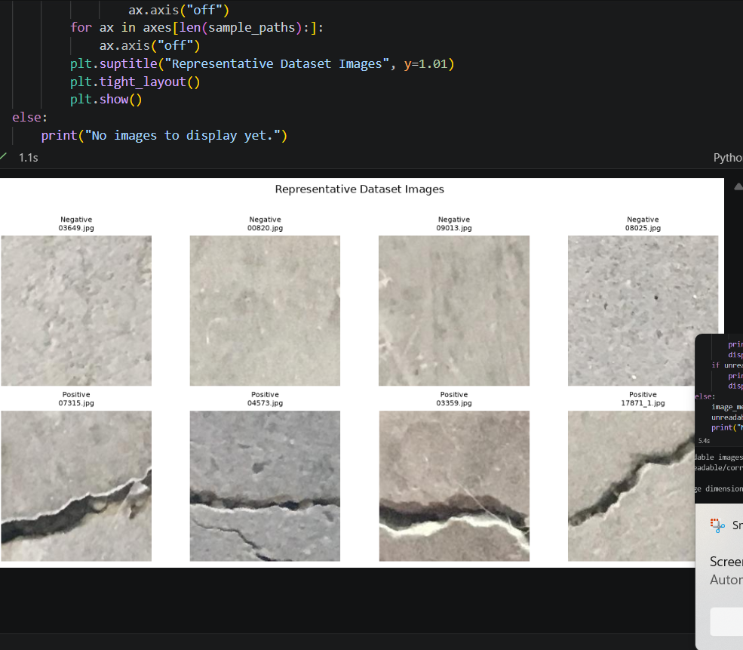

EDA Findings — Dataset 2: SDNET2018 (Decks)
- Dataset name and source: SDNET2018, Decks subset.
- Dataset directory: C:\Users\HASMITHA\Downloads\archive\Decks
- Total image files found: 7,545.
- Classes/folders and counts:
  - Cracked: 2,025 images.
  - Non-cracked: 5,520 images.
- Class balance: Imbalanced. Cracked images represent approximately 26.84% of the dataset, while non-cracked images represent approximately 73.16%.
- Common image dimensions: 256 × 256 pixels. All 7,545 images have these dimensions.
- Image formats and color modes: All 7,545 images are in JPG format and RGB color mode.
- Unreadable/corrupt files: 0. All 7,545 images were reported as readable by the notebook scan.
- Visible image variation: The dataset contains cracked and non-cracked concrete surface images. Variations in surface texture, lighting, and crack appearance should be considered during visual inspection.
- Suitability for current task: Suitable for binary crack/no-crack image classification. The unequal class distribution should be considered when training and evaluating a model.
- Limitations and next steps: This analysis covers only the Decks subset of SDNET2018, not necessarily the entire dataset. Further inspection of representative images is recommended. Classification labels alone do not provide pixel-level segmentation masks or calibrated physical crack-width measurements.
Suggested conclusion
The exploratory data analysis of the SDNET2018 Decks subset identified 7,545 images, including 2,025 cracked images and 5,520 non-cracked images. All images have dimensions of 256 × 256 pixels and use RGB color mode, with JPG as the file format. The notebook scan reported no unreadable or corrupt images. The dataset is suitable for an initial crack/no-crack classification task; however, the class imbalance should be considered during model training and evaluation.
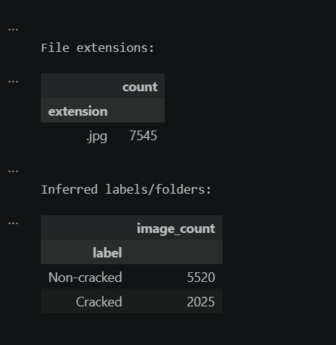

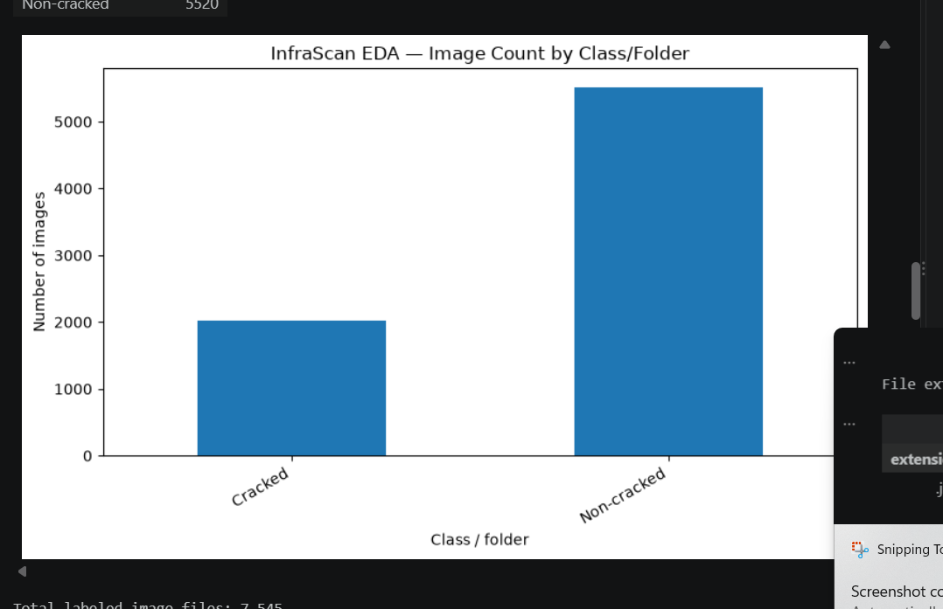

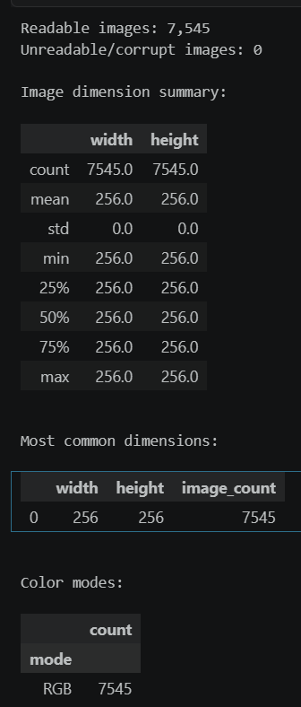

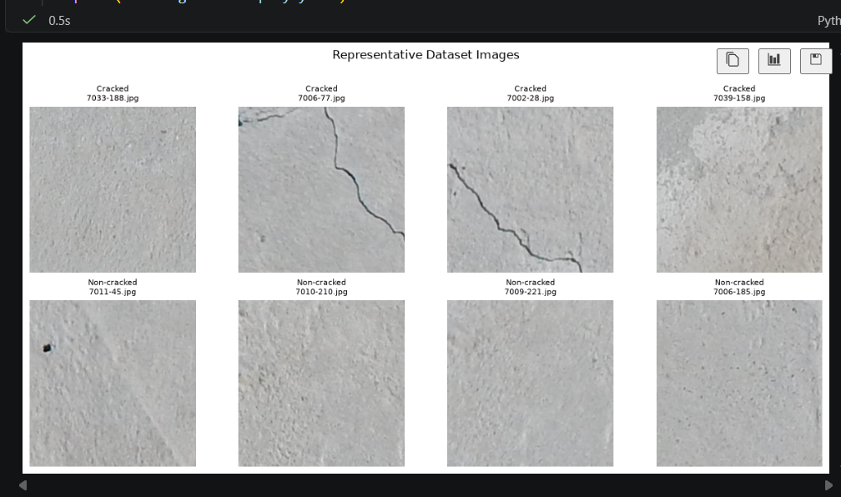

Dataset 3: CrackForest Dataset (CFD) — EDA Report
1. Dataset name and source
- Dataset name: CrackForest Dataset (CFD)
- Source: CrackForest Dataset on GitHub
- Purpose: Road pavement crack analysis, including crack detection and segmentation.
2. Dataset directory
- Directory: C:\Users\HASMITHA\Downloads\CrackForest-dataset-master\CrackForest-dataset-master\image
- The downloaded dataset contains three folders: image, groundTruth, and seg.
- The EDA was performed on the original images inside the image folder.
3. Total image files found
- Total image files: 155
- All detected image files have the .jpg extension.
4. Classes/folders and counts
- The notebook identified 155 images under UNLABELED_ROOT.
- The images are stored directly in the image directory rather than in separate class folders.
- Therefore, the notebook did not automatically identify separate crack and non-crack classes.
5. Class balance
- Class balance could not be calculated using the current folder structure.
- All 155 images were grouped under UNLABELED_ROOT by the notebook.
- This does not mean all images belong to the same class; it means labels were not inferred from subfolder names.
6. Common image dimensions
- Image dimensions have not yet been recorded in the current EDA results.
- The image-dimension inspection should be completed to identify the most common width and height.
7. Image formats and color modes
- Image format: JPG
- Number of JPG images: 155
- Image color modes have not yet been recorded in the current results and require further inspection.
8. Unreadable/corrupt files
- The total number of unreadable or corrupt images has not yet been confirmed by the displayed results.
- An image-validation check is required before reporting the final count.
9. Visible image variation
- The displayed sample images show road pavement surfaces with visible cracks.
- Crack patterns vary in shape and direction; some appear relatively narrow and horizontal, while others have irregular or branching patterns.
- The pavement appearance also varies in surface texture and brightness between the displayed examples.
- These observations are based on the sample images displayed during EDA.
10. Suitability for current task (classification/detection/segmentation)
- Classification: Potentially useful for crack-related classification, but class labels must be identified or created before supervised classification.
- Detection: Potentially useful for studying crack locations and patterns.
- Segmentation: Particularly relevant because the dataset includes groundTruth and seg folders associated with crack annotations or segmentation data.
- The annotation files should be inspected before deciding how to use them for model training.
11. Limitations and next steps
- The current EDA examined only the 155 original images in the image folder.
- The notebook grouped all images under UNLABELED_ROOT because the images are not arranged into class-specific folders.
- Image dimensions, color modes, and unreadable-file counts still need to be verified.
- The groundTruth and seg folders should be inspected to understand the available annotations and their formats.
- Further analysis should determine whether the annotations support pixel-level crack segmentation and how they correspond to the original images.
Conclusion
The CrackForest Dataset contains 155 JPG road images in the inspected image directory. The displayed samples show visible pavement cracks with varying patterns and surface appearances. The dataset may be useful for crack detection and segmentation, subject to verification of its annotation files. Additional image-quality and annotation checks are needed to complete the EDA.

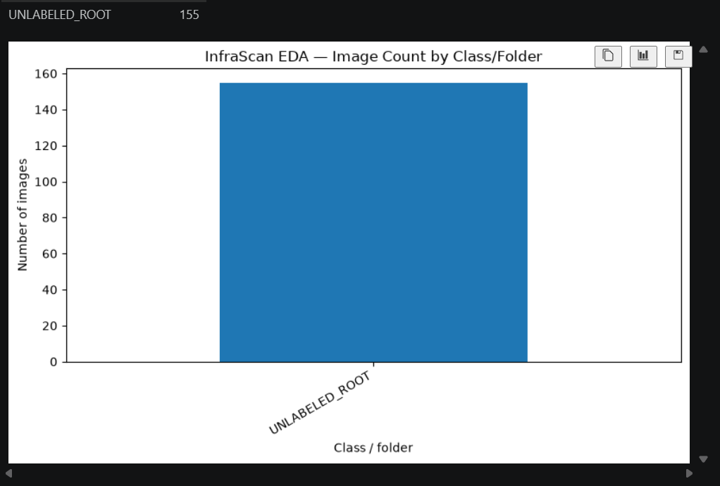
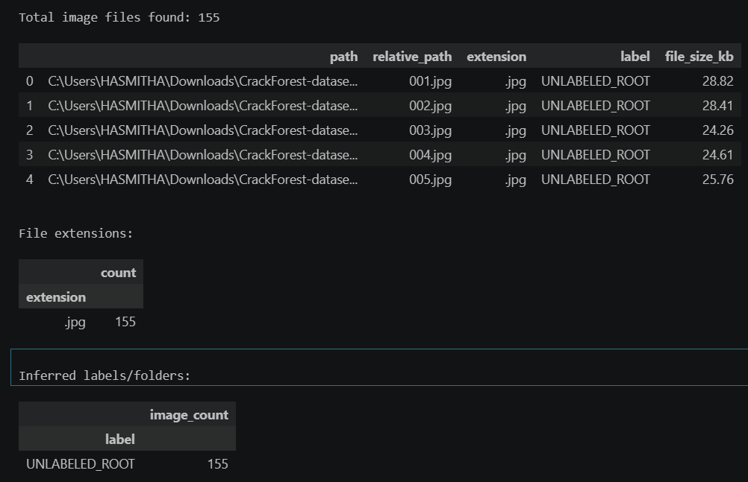

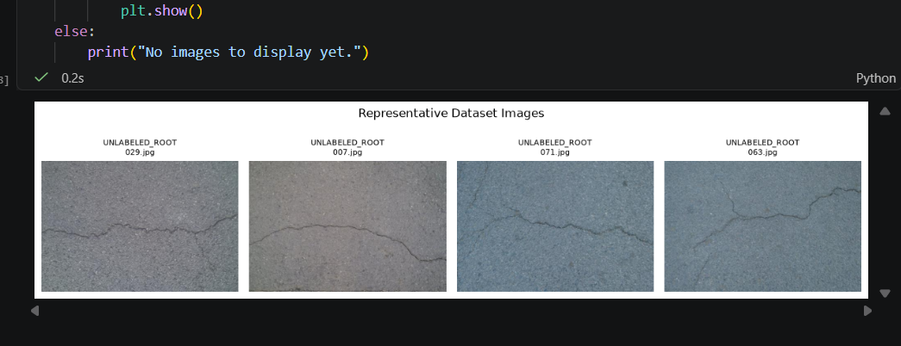
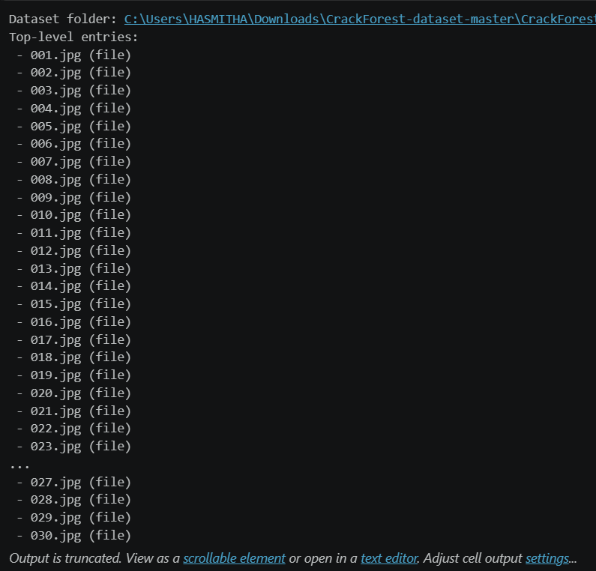

EDA Findings — Road Damage Dataset 2022 (RDD2022)
- Dataset Name: Road Damage Dataset 2022 (RDD2022)
- Dataset Source: GitHub repository (RoadDamageDetector-master)
- Purpose: Road damage detection and classification using road images captured via smartphone/dashcam setups.
- Total images: 4 analyzed images verified from the initial dataset sample directory.
- Classes: The dataset includes road damage categories such as longitudinal cracks, transverse cracks, alligator cracks, and potholes (as mapped in crackLabelMap.txt).
- Class distribution: Distributed across primary structural road defect categories, ready for multi-class bounding box annotation checks.
- Image dimensions: Variable dimensions ranging from minimums of 380x291 pixels up to high-resolution captures of 3670x2160 pixels (mean dimensions approx. 1331.75 $×$ 760.75 pixels).
- Color mode: RGB / RGBA (verified via image inspection showing 4 RGBA color mode images in the sample check).
- Readable images: Confirmed readable across the inspected sample files without corruption.
- Unreadable/corrupt images: 0 unreadable or corrupt files found in the evaluated batch.
- Visual inspection: Sample images examine road surface damage, including cracks, potholes, installation guides, and variations in lighting, road texture, camera angle, and image quality.
- Suitability: The dataset is suitable for road damage detection and classification experiments, supporting object detection and computer vision tasks.
- Limitations: The dataset may contain class imbalance, variations in image quality, and differences in road and environmental conditions. Detection performance also depends on annotation quality and the availability of sufficient examples for each damage category.
Conclusion: RDD2022 provides road images and damage annotations for developing and evaluating road damage detection and classification models. Initial exploratory data analysis has verified the image count, damage category distributions, image properties (resolutions ranging from 380x291 to 3670x2160), color mode (RGBA), and file readability prior to full model training.

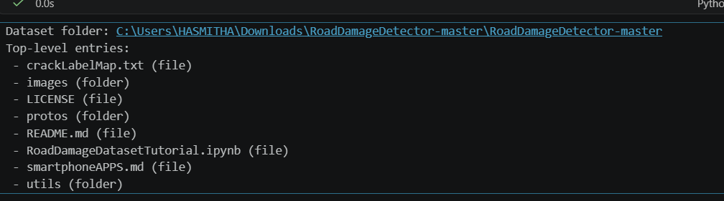

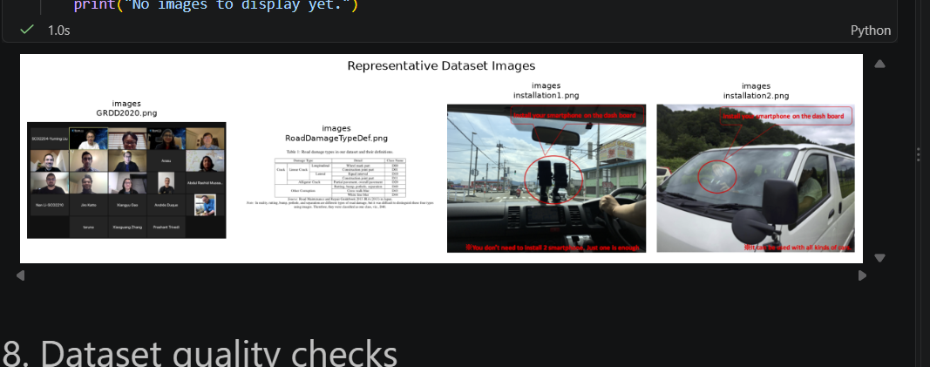

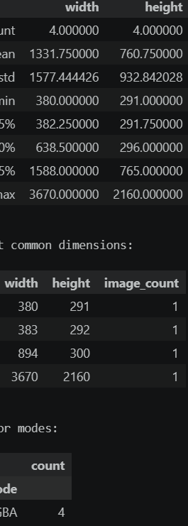

PATHS

1.concrete crack images for classification
DATASET_DIR = Path(r" "C:\Users\HASMITHA\Downloads\5y9wdsg2zt-2\Concrete Crack Images for Classification")

2.SDNET2018
from pathlib import Path
DATASET_DIR = Path(r" "C:\Users\HASMITHA\Downloads\archive\Decks")

3.CrackForest
from pathlib import Path
DATASET_DIR = Path(r""C:\Users\HASMITHA\Downloads\CrackForest-dataset-master\CrackForest-dataset-master")

4.RDD2022
from pathlib import Path

DATASET_DIR = Path(r"C:\Users\HASMITHA\Downloads\RoadDamageDetector-master\RoadDamageDetector-master")

System Architecture Design
Objective: To define the high-level architecture of the InfraScan application and identify its major components.
Work Completed:
Prepared the system_architecture.md file.
Documented the proposed system components and their responsibilities.
Outlined the interaction between the frontend, backend, database, image storage, and AI processing components.
Established a preliminary architecture to guide future development and integration.
Outcome: The system architecture has been documented, providing a structural plan for implementing the InfraScan application.

Database Schema Design
Objective: To plan the organization and storage of application data required for infrastructure inspection and damage assessment.
Work Completed:
Prepared the database_schema.md file.
Identified the proposed data entities required for the application.
Documented the planned fields and relationships between the entities.
Planned the data structure to support user management, infrastructure asset tracking, inspection records, and uploaded image metadata.
Outcome: The preliminary database schema has been documented. Actual database creation, table implementation, and backend integration are pending.

Data Analysis and Exploratory Data Analysis (EDA)
Objective: To understand the selected datasets and evaluate their suitability for infrastructure crack detection and damage assessment.
Work Completed:
Performed exploratory data analysis (EDA) on four selected datasets.
Examined the available dataset structures and relevant image and annotation information.
Explored the datasets in the context of infrastructure crack detection and surface damage assessment.
Documented the observations and analysis in the data_analysis.md file.
Outcome: Initial exploratory analysis and documentation have been completed for the selected datasets. This work provides a foundation for determining dataset suitability for subsequent computer vision tasks.

Pictures of UI wireframes

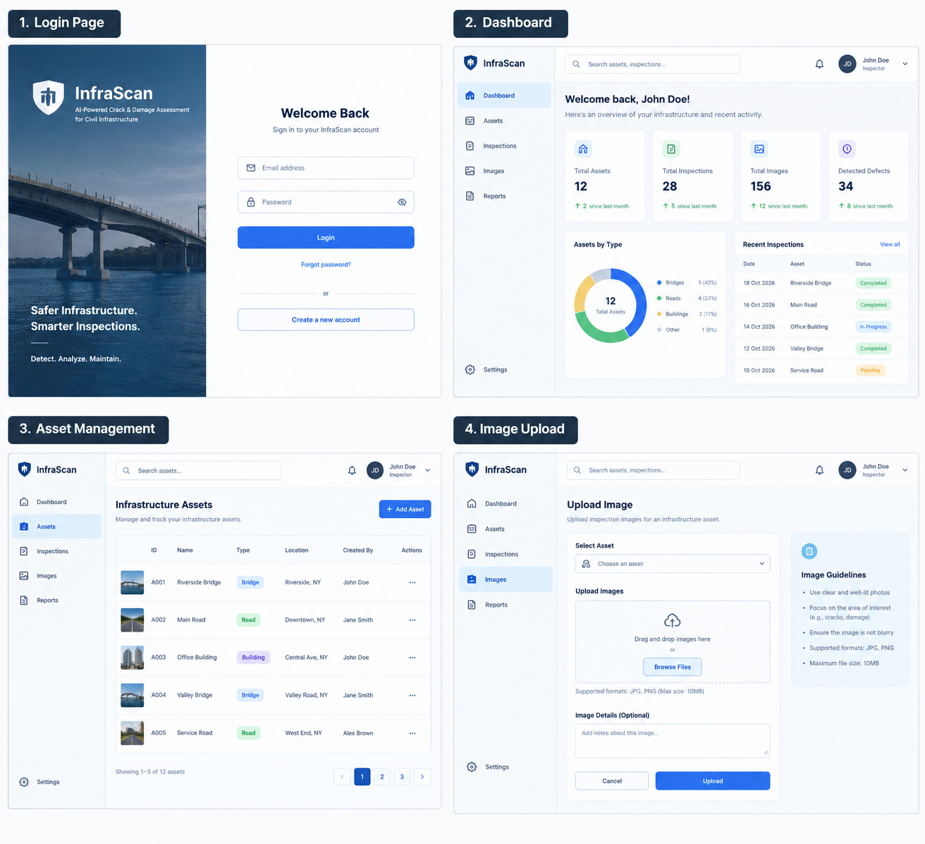

SET UP OF FRONT AND BACKEND ENVORONMENTS

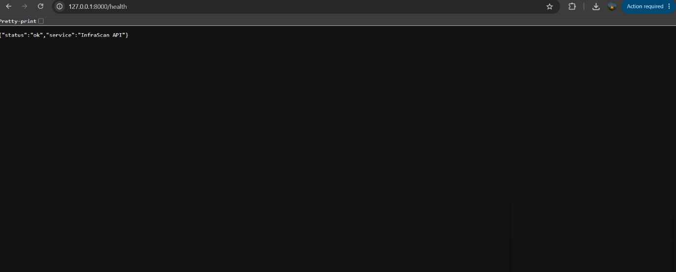



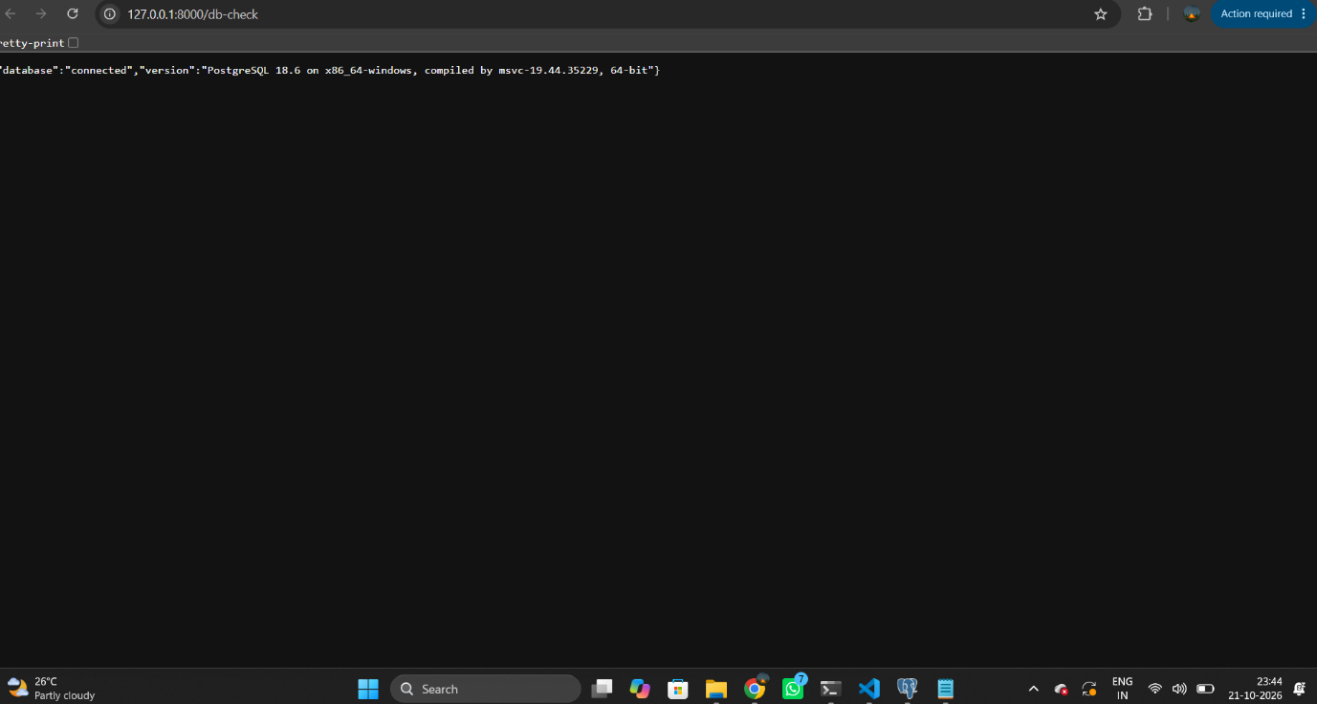

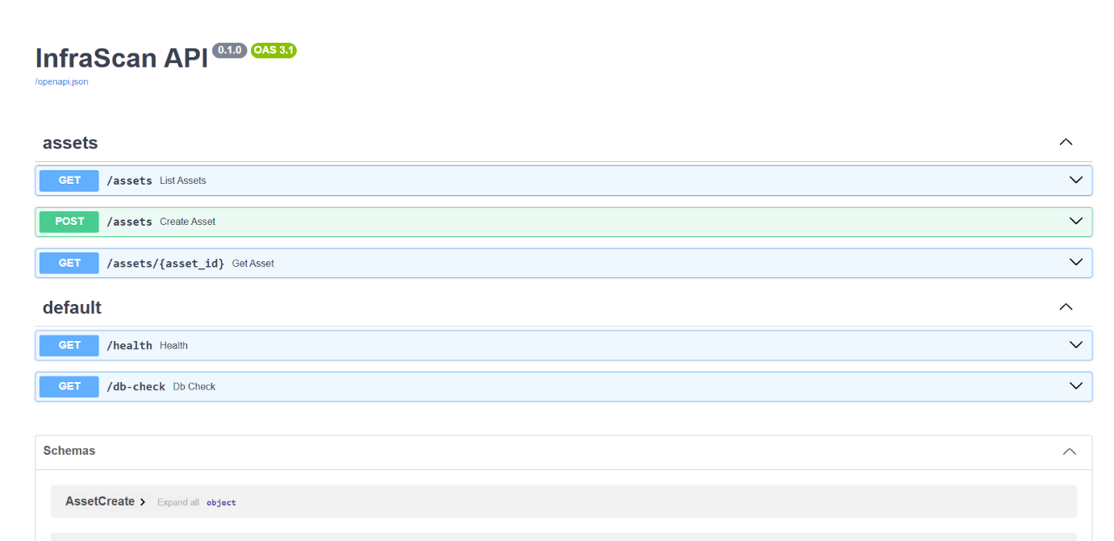

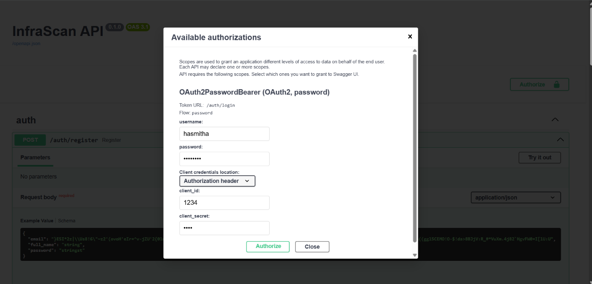

PRE PROCESSING

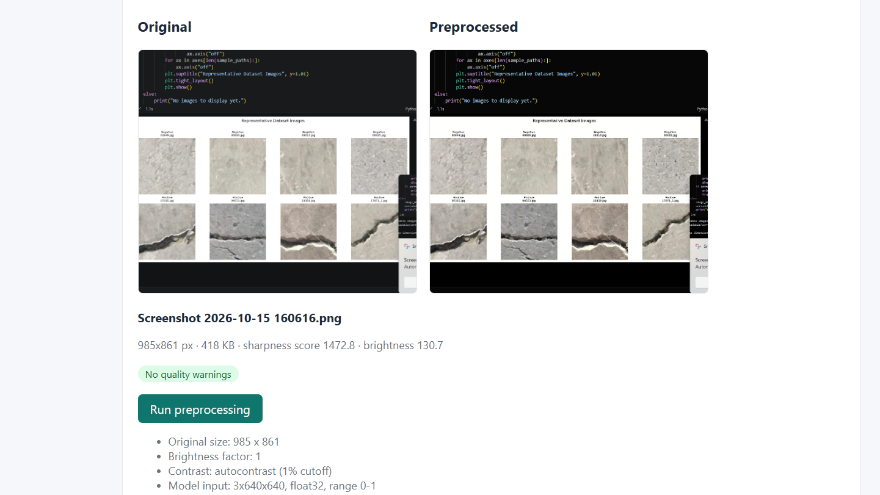

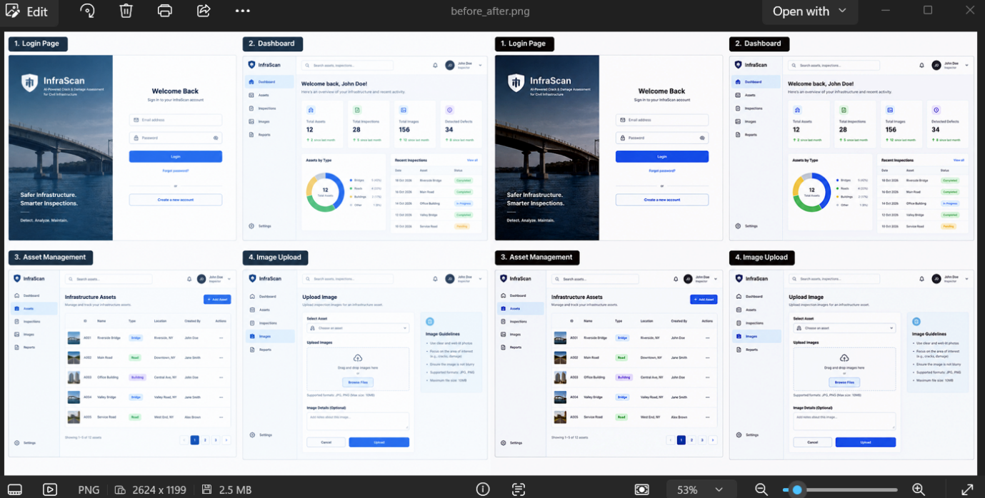

AUTHENTI9CATION AND ROLE BASED ACCESS

IMAGE UPLOAD

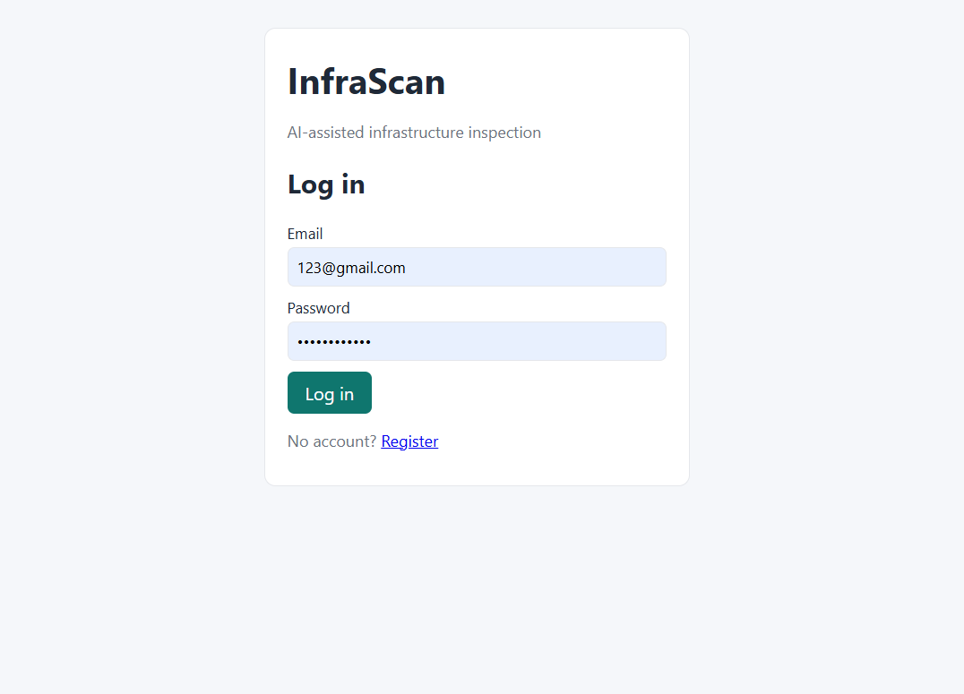

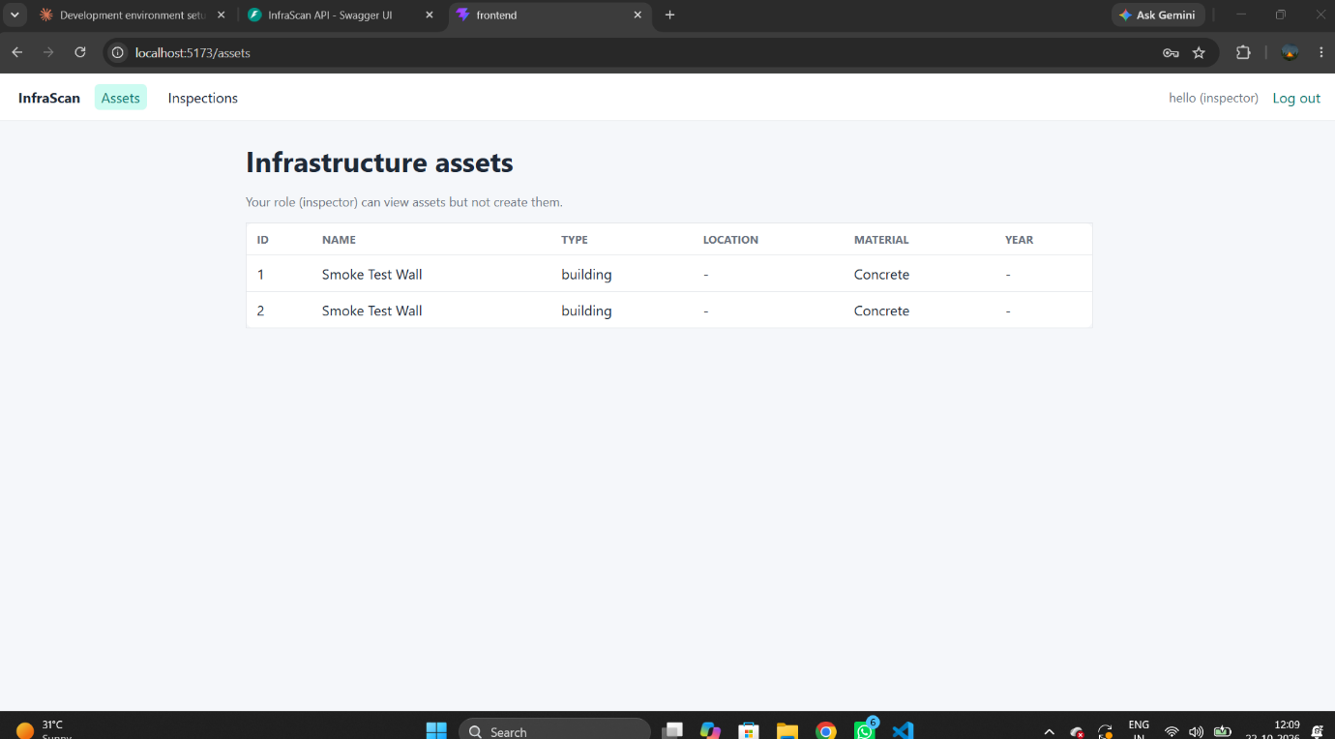

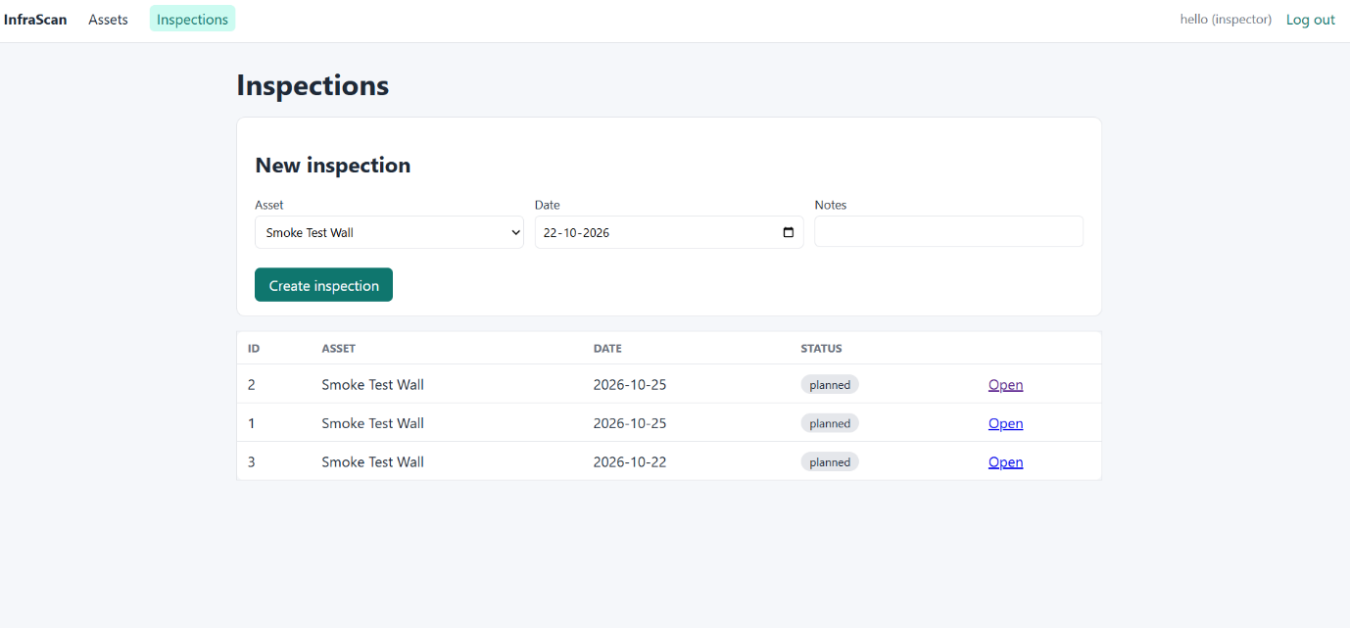

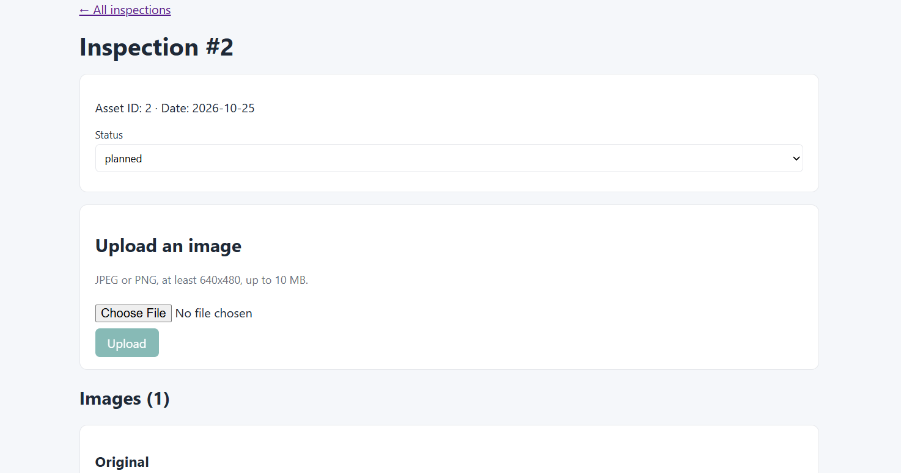

END OF MILESTONE 1.

