AI-Powered Crack & Damage Assessment for Civil Infrastructure

1. PROJECT OVERVIEW
1.1 Introduction to InfraScan
InfraScan is a proposed AI-powered civil infrastructure inspection and damage assessment platform. It is intended to automatically detect, segment, classify, and evaluate visible structural cracks and surface damage from images of buildings, bridges, roads, tunnels, and other civil infrastructure. The platform will use computer vision, image processing, and deep learning techniques to support inspection activities. It is intended to assist qualified professionals and not to replace them.
The platform will let users upload or capture images of structural surfaces, identify visible defects, analyze damage characteristics, estimate damage severity, and generate inspection reports. Beyond single-image analysis, InfraScan is designed to organize inspection records, compare inspections over time, and support maintenance planning.
1.2 Background: Manual Infrastructure Inspection
Civil infrastructure such as buildings, bridges, roads, tunnels, and dams is exposed to loading, weather, material ageing, and environmental effects. Visible signs of deterioration, such as cracks, spalling, corrosion, and water staining, are usually the first indicators that an asset needs closer attention.
Inspection of these visible defects is commonly carried out manually. Inspectors examine surfaces, photograph defects, and record observations in notes or reports. This approach has several practical challenges:
- Subjectivity: Different inspectors may describe or judge the same defect differently.
- Difficulty identifying fine defects: Hairline cracks and early-stage surface damage can be hard to see, especially on textured, stained, or poorly lit surfaces.
- Time and effort: Examining large surfaces, or areas that are difficult to reach, can be slow and demanding.
- Inconsistent documentation: Observations recorded in different formats make later review and comparison difficult.
- Difficulty tracking change: Without organized records, it is hard to judge whether a defect has grown over time.
1.3 Why an AI-Powered Inspection Platform Is Useful
An AI-powered platform can provide a consistent and repeatable first-level analysis of inspection images. Automated analysis can highlight regions of interest, record defect characteristics in a standard format, and organize results so that engineers can focus their attention on the findings that matter most. The platform is intended as a decision-support tool: it helps inspectors and engineers work more systematically, while final judgments remain with qualified professionals.
1.4 Role of Computer Vision, Image Processing, and Deep Learning
InfraScan will combine the following techniques:
- Image processing will prepare images for analysis through operations such as resizing, normalization, noise reduction, and contrast enhancement. It will also support quality checks such as detecting blurred or poorly lit images.
- Object detection will locate visible defects in an image and mark them with bounding boxes and confidence scores.
- Semantic segmentation will identify crack regions at pixel level, producing crack masks that outline the exact shape of a crack.
- Image classification will assign detected cracks to categories based on their visible characteristics, such as longitudinal, transverse, or alligator cracking, where suitable labeled data is available.
- Deep learning models, including convolutional neural networks (CNNs) and Transformer-based models, will form the basis of these detection, segmentation, and classification capabilities.
- Explainable AI visualizations will show which image regions influenced a prediction, helping engineers judge how much to rely on it.
1.5 Intended Users
The platform is intended for:
- Civil engineers, who review defects, measurements, and severity estimates.
- Infrastructure inspectors, who capture or upload images and conduct field inspections.
- Maintenance engineers, who plan and carry out repair and follow-up work.
- Infrastructure managers and authorities, who monitor asset condition and prioritize maintenance across multiple structures.
1.6 Expected Benefits
- Improved inspection efficiency through automated first-level analysis of images.
- Consistent damage documentation in a standard, structured format.
- Historical tracking of inspections for each infrastructure asset.
- Comparison of inspections to identify visible changes over time.
- Support for maintenance planning through severity-based prioritization.
- Organized inspection reports that can be reviewed, shared, and archive

2. PROBLEM STATEMENT
The inspection of civil infrastructure depends largely on visual examination and manual documentation. The following difficulties motivate the development of InfraScan.
2.1 Difficulties of Manual Inspection
Manual inspection depends on the experience, attention, and judgment of individual inspectors. Large surfaces, elevated or confined locations, and structures with limited access make inspection time-consuming. Fine cracks and early-stage damage can be overlooked, particularly under poor lighting, shadows, stains, or complex surface textures. Judgments about the same defect may also vary from one inspector to another.
2.2 Need for Accurate Documentation of Visible Defects
Useful inspection records must describe what defect was observed, where it is located, how large it appears, and when it was recorded. Notes and loosely organized photographs often lack this structure. There is a need for a systematic way to link images, defect locations, descriptions, and measurements to a specific infrastructure asset and inspection.
2.3 Challenges in Monitoring Damage over Time
Deciding whether a crack or damaged area is stable or progressing requires comparison with earlier observations. Without organized historical records, comparable image viewpoints, and consistent documentation, such comparison is difficult and often relies on memory or scattered files. Reliable comparison also requires images captured from similar viewpoints and, for physical measurements, a known scale.
2.4 Need for Organized Reports and Maintenance Prioritization
Infrastructure managers often oversee many assets and must decide which require attention first. This requires inspection findings to be summarized in clear reports and linked to a structured way of prioritizing maintenance. Where findings are not consistently organized, planning of repairs and follow-up inspections becomes harder.

2.5 Problem Addressed by InfraScan
InfraScan aims to address these needs by providing an image-based platform that helps detect and document visible cracks and surface damage, organize inspection records, track changes across inspections, generate structured reports, and support maintenance prioritization, always subject to review by qualified engineers.

3. PROJECT OBJECTIVES
The primary aim of InfraScan is to build an AI-assisted inspection and damage assessment platform that supports engineers throughout the inspection process, from image capture to maintenance follow-up. The specific objectives are described below.
Objective 1: Automated Detection of Visible Cracks and Surface Defects
The system will analyse infrastructure images to automatically identify the presence of visible cracks and other surface defects, such as spalling and corrosion. Each detection will be accompanied by a confidence score. This reduces the effort of examining every image manually and helps ensure that visible defects are less likely to be overlooked.
Objective 2: Crack Localization, Segmentation, and Classification
The system will locate detected cracks using bounding boxes, identify crack pixels through segmentation to produce crack masks, and classify cracks by visible characteristics such as longitudinal, transverse, diagonal, or alligator patterns. Crack categories will be adapted to the infrastructure material and to the availability of labelled data. These outputs provide a precise visual record of where cracks are and what form they take.
Objective 3: Estimation of Crack Length, Width, and Area
Where image calibration supports reliable measurements, the system will estimate crack length, width, and area from segmentation results. Calibration will rely on a known reference scale or object in the image. Where reliable calibration is not available, measurements will be reported in pixels and not as physical dimensions, so that the system does not make inaccurate claims.
Objective 4: Preliminary Damage Severity Assessment
The system will provide a preliminary severity category, such as No Visible Damage, Minor, Moderate, Severe, or Critical / Requires Urgent Engineering Review. This estimate will consider factors such as crack dimensions, density, damage type, and material. The thresholds used must be validated against applicable engineering standards, and the output remains a preliminary estimate for engineer review.
Objective 5: Automated Generation of Inspection Reports
The system will generate structured inspection reports containing inspection and infrastructure details, original images, detected defects, measurements, severity assessment, confidence values, maintenance priority, and engineer review status. This supports consistent documentation and reduces the manual effort of preparing reports.
Objective 6: Historical Inspection Comparison and Damage Progression Tracking
The system will store inspection records for each asset and allow current and previous inspections to be compared. Indicators such as increased crack length or width, increased damage area, new cracks, or additional visible defects will be examined. Reliable comparison requires comparable image viewpoints, calibrated scale, and suitable image registration.
Objective 7: Maintenance Prioritization and Follow-Up Inspection Support
The system will help classify the priority of maintenance, from routine monitoring to urgent engineering review, using factors such as severity, infrastructure type, asset importance, inspection history, and damage progression. It will also support follow-up inspection scheduling, so that findings lead to appropriate action.
Objective 8: Visual Explanations of AI Predictions
The system will provide explainable AI visualizations, such as Grad-CAM heatmaps, attention maps, and detection and segmentation overlays. These show which image regions influenced a prediction and help engineers judge whether an AI result is reasonable and trustworthy.
Objective 9: Support for Engineers in Inspection and Maintenance Decisions
Overall, the system is intended to support, not replace, engineering judgment. By providing organized findings, measurements, visual evidence, and priority indications, it helps engineers make better-informed inspection and maintenance decisions. Important findings will always require review by qualified engineers.

4. INSPECTION WORKFLOW DEFINITION
This section describes the proposed end-to-end inspection workflow for InfraScan. The workflow defines how an infrastructure asset moves from registration through inspection, analysis, review, and long-term monitoring. It is a proposed design, and all stages may be implemented progressively during development.
4.1 Workflow Steps
Step 1: Infrastructure Registration
- Purpose: To create a formal record of each infrastructure asset so that all inspections can be linked to it.
- Input: Asset details such as infrastructure ID, name, type, location, construction year, material type, responsible department, inspection frequency, and maintenance history.
- Output: A registered infrastructure asset record.
Step 2: Inspection Planning and Assignment
- Purpose: To schedule an inspection for a registered asset and assign it to a responsible inspector.
- Input: The registered asset record, the planned inspection date, and the selected inspector.
- Output: An inspection record with an assigned inspector and a recorded inspection date.
Step 3: Infrastructure Image Capture or Upload
- Purpose: To obtain images of the structural surfaces under inspection.
- Input: Images captured by smartphone cameras, digital cameras, or drones, or existing images from inspection repositories.
- Output: Images associated with the specific asset and inspection, ready for validation.

Step 4: Image Quality Validation
- Purpose: To ensure that only images suitable for analysis are processed, since poor images reduce the reliability of results.
- Input: Uploaded images.
- Output: Accepted images, or rejected or flagged images with reasons such as unsupported format, low resolution, blur, low light, incompleteness, or duplication.
Step 5: Image Preprocessing
- Purpose: To prepare validated images for AI analysis.
- Input: Quality-validated images.
- Output: Processed images (for example resized, normalized, and enhanced) ready for model input.
Step 6: AI-Based Crack Detection and Localization
- Purpose: To identify whether cracks are present and where they are located.
- Input: Pre-processed images.
- Output: Bounding boxes marking crack locations, with confidence scores.
Step 7: Crack Segmentation and Classification
- Purpose: To obtain the exact shape of each crack and categorize it by visible type.
- Input: Pre-processed images and detected crack regions.
- Output: Pixel-level crack masks and crack type labels with classification confidence.
Step 8: Surface Damage Identification
- Purpose: To identify visible defects other than cracks, such as spalling, corrosion, exposed reinforcement, potholes, and water staining.
- Input: Pre-processed images.
- Output: Localized and categorized surface damage regions.
Step 9: Crack Measurement and Preliminary Severity Assessment
- Purpose: To quantify crack properties and assign a preliminary severity category.
- Input: Crack masks, damage detections, and scale reference information where available.
- Output: Crack length, width, area, and density (in physical units if calibrated, or in pixels otherwise), with a preliminary severity category and associated confidence.
Step 10: Engineer Review and Verification
- Purpose: To ensure that AI outputs are checked by a qualified person before being relied upon.
- Input: AI results with visual overlays and explainability visualizations.
- Output: Verified, corrected, or rejected findings, and a recorded review status.
Step 11: Maintenance Prioritization
- Purpose: To decide which findings need attention first.
- Input: Reviewed findings, severity, infrastructure type, asset importance, inspection history, and damage progression.
- Output: A maintenance priority category, from routine monitoring to urgent engineering review.
Step 12: Inspection Report Generation
- Purpose: To document the inspection in a structured and shareable form.
- Input: Inspection details, images, verified findings, measurements, severity, and priority.
- Output: A structured inspection report that can be exported in formats such as PDF, CSV, Excel, or JSON.

Step 13: Historical Monitoring and Follow-Up Inspection
- Purpose: To track the condition of an asset over time and schedule further inspections where needed.
- Input: Current and previous inspection records and images.
- Output: Comparison of inspections, indications of damage progression, and follow-up inspection recommendations.

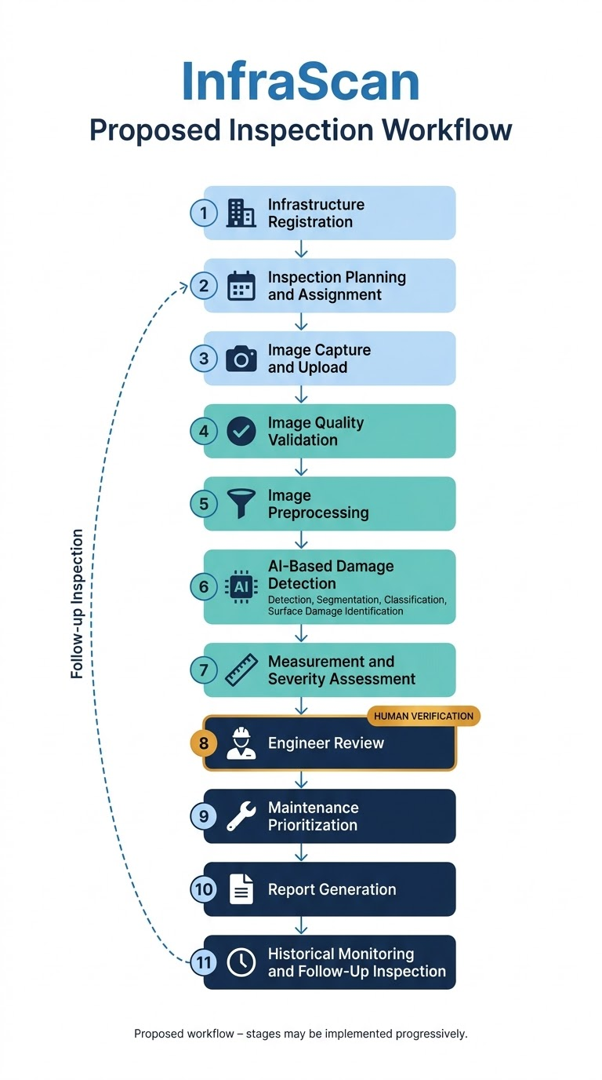

5. IDENTIFICATION OF TARGET INFRASTRUCTURE TYPES
5.1 Importance of Identifying Target Infrastructure Types
Different types of infrastructure differ in construction materials, structural function, exposure conditions, and typical defects. Cracks on a road surface, for example, differ in appearance and significance from cracks in a concrete dam or a building wall. Identifying the target infrastructure types at the start of the project is therefore important because it:
- Helps select suitable inspection methods and image capture approaches.
- Helps define relevant defect categories for each type.
- Guides the design of infrastructure records and inspection planning.
- Helps set realistic expectations about what can be detected from images.
InfraScan targets the following eight infrastructure types. In every case, the defects described are visible surface indications that may be assessed from images. Not every defect can be reliably detected from images alone, and findings require engineering verification.
5.2 Buildings
- Description and examples: Residential, commercial, institutional, and public buildings, including walls, columns, beams, slabs, ceilings, and facades.
- Common visible defects: Wall and plaster cracks (vertical, horizontal, diagonal), hairline cracks, concrete spalling, water seepage or staining, surface corrosion of exposed metal, and exposed reinforcement.
- What InfraScan aims to detect or document: Visible cracks and surface damage on building surfaces, with their location, type, approximate dimensions where calibration permits, and preliminary severity.
- Potential benefit of monitoring: Early documentation of visible deterioration supports timely maintenance and helps in recording the condition of buildings over time.
5.3 Bridges
- Description and examples: Road, rail, and pedestrian bridges, including decks, girders, piers, abutments, and bearings.
- Common visible defects: Cracks in concrete members, spalling, exposed or corroded reinforcement, surface corrosion on steel elements, water leakage or staining, and surface deterioration.
- What InfraScan aims to detect or document: Visible cracks and surface defects on accessible bridge surfaces from images (including drone images where used), with consistent records of location and severity.
- Potential benefit of monitoring: Regular monitoring helps track visible deterioration and supports planning of detailed engineering inspection and maintenance.
5.4 Roads
- Description and examples: Highways, urban roads, and pavements, including asphalt and concrete surfaces.
- Common visible defects: Longitudinal and transverse cracks, alligator (map) cracking, potholes, surface deformation, and material erosion or surface deterioration.
- What InfraScan aims to detect or document: Pavement cracks and visible surface damage, including multiple defect categories in a single image, with location mapping where location data are available.
- Potential benefit of monitoring: Monitoring Road surface condition supports maintenance prioritization and helps identify areas where damage is concentrated.
5.5 Tunnels
- Description and examples: Road, rail, and utility tunnels, including lining surfaces, walls, and crowns.
- Common visible defects: Lining cracks, spalling, water leakage and staining, surface deterioration, and exposed reinforcement.
- What InfraScan aims to detect or document: Visible cracks and surface damage on accessible tunnel lining images, noting that image quality in tunnels may be affected by low light and limited access.
- Potential benefit of monitoring: Image-based documentation can support routine condition tracking in locations that are difficult or time-consuming to inspect.
5.6 Dams
- Description and examples: Concrete and masonry dams, including exposed faces, crests, spillways, and galleries.
- Common visible defects: Surface cracks, seepage or leakage marks, surface erosion, spalling, and surface deterioration.
- What InfraScan aims to detect or document: Visible cracks and surface defects on accessible faces, with records that can be reviewed by specialist engineers.
- Potential benefit of monitoring: Consistent historical records of visible surface condition can support specialist engineers in tracking changes over time. Assessment of dam safety requires specialized engineering evaluation beyond image analysis.
5.7 Concrete Structures
- Description and examples: General reinforced and plain concrete elements, such as slabs, columns, walls, pavements, and precast components.
- Common visible defects: Cracks of various types, hairline cracks, spalling, exposed reinforcement, corrosion staining, and surface deterioration.
- What InfraScan aims to detect or document: Crack presence, localization, segmentation, and type, together with other visible concrete surface damage.
- Potential benefit of monitoring: Concrete surfaces are well suited to image-based crack analysis, and consistent monitoring helps document defect development.
5.8 Retaining Walls
- Description and examples: Structures that hold back soil or other materials, built from concrete, masonry, or stone.
- Common visible defects: Cracks (vertical, horizontal, or diagonal), surface deformation or bulging, water seepage or staining, spalling, and surface erosion.
- What InfraScan aims to detect or document: Visible cracks, visible deformation indicators, and moisture-related staining on wall faces. Visible deformation noted from images is only an indication and requires engineering verification.
- Potential benefit of monitoring: Regular documentation helps identify visible changes in wall condition and supports decisions on follow-up inspection.
5.9 Industrial Structures
- Description and examples: Factory buildings, storage structures, chimneys, tanks, supports, and plant foundations made of concrete or steel.
- Common visible defects: Surface cracks, spalling, corrosion, exposed reinforcement, surface deterioration, and staining.
- What InfraScan aims to detect or document: Visible cracks and corrosion-related surface damage on accessible structural surfaces, with documentation suitable for maintenance planning.
- Potential benefit of monitoring: Monitoring helps document the condition of industrial assets exposed to demanding operating environments and supports planned maintenance.

6. Review of Public Datasets
6.1 Introduction
Public infrastructure damage datasets are important for developing and testing automated damage assessment systems. They provide images of concrete surfaces, roads, cracks, and other visible defects. These images can be used to train and evaluate computer vision models for infrastructure inspection.
For the InfraScan project, five public datasets were reviewed: Concrete Crack Images for Classification, CrackForest Dataset (CFD), SDNET2018, Crack500, and Road Damage Dataset 2022 (RDD2022).
The datasets were compared based on their infrastructure type, defect categories, annotation format, image count, storage requirements, ease of preprocessing, and suitability for beginners. RDD2022 was included as the main road damage dataset, while smaller datasets were considered for learning and testing the initial image processing pipeline.
6.2 Review of Selected Public Datasets
6.2.1 Concrete Crack Images for Classification
Dataset source: https://data.mendeley.com/datasets/
This dataset contains approximately 40,000 images of concrete surfaces, divided equally into cracked and non-cracked categories.
- Infrastructure type: Concrete surfaces.
- Defect category: Cracks.
- Annotation type: Image-level class labels.
- Main application: Binary image classification.
- Advantages: Balanced classes, simple folder structure, and a straightforward starting point for beginners.
- Limitations: The classification version does not provide bounding boxes or pixel-level crack masks.
Relevance to InfraScan: This dataset is suitable for learning image loading, preprocessing, and basic crack classification before moving to more complex detection tasks.
6.2.2 CrackForest Dataset (CFD)
Dataset source: https://github.com/cuilimeng/CrackForest-dataset
CrackForest is a road surface dataset designed for studying visible road cracks. The local dataset examined during EDA contained 155 readable JPEG images.
- Infrastructure type: Roads and pavements.
- Defect category: Road cracks.
- Annotation type: Crack annotations may include pixel-level masks in the complete release; their availability in the local copy must be verified.
- Main application: Road crack analysis and segmentation.
- Advantages: Small image collection, manageable for initial experiments, and focused on road crack patterns.
- Limitations: The local copy contains relatively few images, which limits its use as the only training dataset. The annotation files were not identified during the initial EDA.
Relevance to InfraScan: CrackForest is a practical, low-volume dataset for understanding road images and testing image preprocessing. Its annotation structure must be checked before using it for supervised segmentation.
6.2.3 SDNET2018
Dataset source: https://digitalcommons.usu.edu/all_datasets/48
SDNET2018 contains approximately 56,092 images of cracked and uncracked concrete surfaces from bridge decks, walls, and pavements.
- Infrastructure type: Bridge decks, walls, and pavements.
- Defect category: Concrete cracks.
- Annotation type: Image-level class labels organized into folders.
- Main application: Concrete crack classification.
- Advantages: Covers different concrete surface types and has a uniform image resolution in the local EDA results.
- Limitations: It is larger than a small beginner dataset and requires the folder labels to be mapped correctly.
Relevance to InfraScan: SDNET2018 can be used in a later classification experiment to test the model on a wider range of concrete surfaces.
6.2.4 Crack500
Dataset source: https://www.kaggle.com/datasets/pauldavid22/crack50020220509t090436z001
Crack500 is a road crack dataset that contains original images and, in common releases, pixel-level crack annotations. The local copy examined during EDA contained 8,860 readable image files.
- Infrastructure type: Roads and pavements.
- Defect category: Cracks.
- Annotation type: Pixel-level segmentation masks in releases that include the corresponding annotations.
- Main application: Crack segmentation.
- Advantages: Useful for learning crack shape, boundaries, and location.
- Limitations: The local copy contains multiple file formats and image dimensions. The EDA classified 500 files as possible masks, but these relationships still need verification.
Relevance to InfraScan: Crack500 is a useful future dataset for developing segmentation capabilities after the basic preprocessing and annotation-handling pipeline is ready.
6.2.5 RDD2022 — Road Damage Dataset 2022
Dataset source: https://www.kaggle.com/datasets/aliabdelmenam/rdd-2022

RDD2022 is a road damage dataset containing road images from multiple regions and damage categories. It is intended for road damage detection and classification.
- Infrastructure type: Roads.
- Defect categories: Longitudinal cracks, transverse cracks, alligator cracks, and potholes.
- Annotation type: Object-level damage labels and bounding boxes in the annotated dataset.
- Main application: Road damage detection and classification.
- Advantages: Covers multiple damage categories and supports locating defects within road images.
- Limitations: The complete dataset may require considerable storage and preprocessing. The annotation files in the downloaded copy must be located and verified before supervised training.
Relevance to InfraScan: RDD2022 is the compulsory primary dataset because it aligns directly with the project's goal of identifying and locating different types of road damage. It will form the main road damage detection component once its annotation files and training splits have been confirmed.
6.3 Comparison of the Five Datasets
Dataset | Images in reviewed copy / reported size | Main task | Annotation type | Beginner suitability
Concrete Crack Images | 40,000 | Crack classification | Image-level labels | Very high
CrackForest (CFD) | 155 locally detected | Road crack analysis | Masks need verification in local copy | High for initial experiments
SDNET2018 | 56,092 | Concrete crack classification | Image-level labels | Moderate to high
Crack500 | 8,860 files in local copy | Crack segmentation | Possible masks; mapping needs verification | Moderate
RDD2022 | 35,700 locally detected | Multi-class road damage detection | Bounding-box annotations expected; local format needs verification | Moderate

7. EDA Findings
7.1 Objective
Exploratory Data Analysis (EDA) was performed to understand the downloaded datasets before model development. The analysis examined image counts, file formats, readability, image dimensions, colour modes, folder structures, and preliminary class or annotation information.
The findings help identify dataset suitability, possible preprocessing requirements, and issues that must be resolved before model training.
7.2 EDA Summary Table
Dataset | Total files/images detected | File formats and colour modes | Image dimensions | Main EDA findings
Concrete Crack Images | 40,000 images | JPEG; RGB | Standardized dataset images; see local inventory for exact dimensions | 20,000 cracked and 20,000 non-cracked images; balanced 50:50 distribution
CrackForest (CFD) | 155 images | JPEG; RGB | 153 images at 480 × 320; 2 at 320 × 480 | All detected images readable; no possible mask files identified by the initial filename and folder checks
SDNET2018 | 56,092 images | JPEG; RGB | 256 × 256 | All detected images readable; six image-containing folders; folder counts are uneven
Crack500 | 8,860 files | PNG and JPEG; RGB, binary, and grayscale modes | Most common: 640 × 360 | All detected files readable; 8,360 provisionally identified as road images and 500 as possible masks
RDD2022 | 35,700 images | JPEG; RGB | Multiple resolutions; most common: 600 × 600 | All detected images readable; variable image sizes; no XML annotation files detected in the scanned directory

9. System Architecture Design
9.1 Introduction
The system architecture defines how the different components of InfraScan communicate with one another. It describes the interaction between the user interface, backend server, database, image storage, image preprocessing pipeline, and AI model.
InfraScan is designed as a web-based application that allows users to manage infrastructure assets, upload inspection images, analyze visible damage, and review assessment results. The system will use a modular architecture so that new damage categories and AI models can be added in the future.
9.2 Proposed Technology Stack
Component | Proposed technology | Purpose
Frontend | React.js with Vite | Provides the user interface and dashboard
Backend | Python with FastAPI | Handles requests, authentication, image uploads, and assessment operations
Database | PostgreSQL | Stores user details, infrastructure assets, image metadata, and assessment results
Image storage | Local file storage during development | Stores uploaded inspection images
Image processing | Python, Pillow, NumPy | Validates, resizes, and prepares images for analysis
AI model | TensorFlow/Keras or a suitable object detection framework | Identifies and classifies visible damage
Development tools | Visual Studio Code and Git | Supports coding, testing, and version control
The technologies listed above are the proposed implementation stack. They can be adjusted depending on development requirements and the available hardware.

9.3 System Architecture Diagram
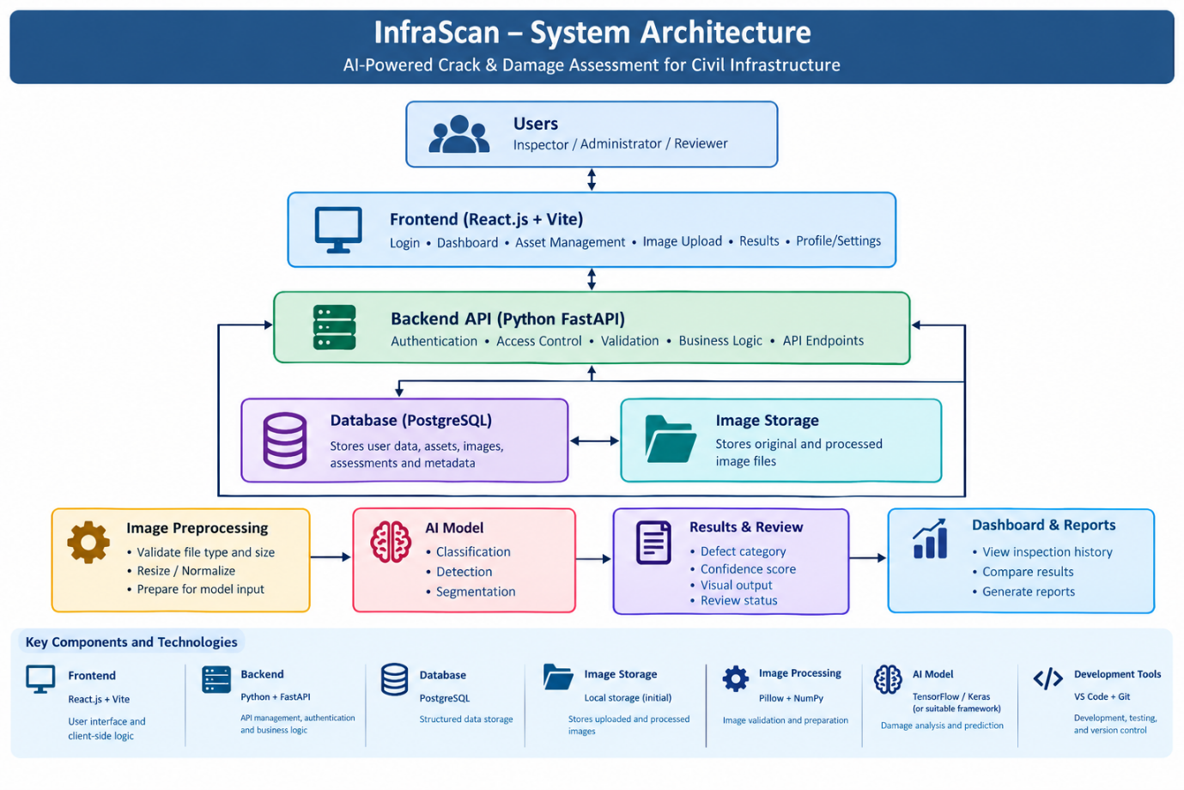
Figure 9.1: Proposed system architecture of InfraScan.
9.4 Working of the System
The system follows the workflow described below.
- User login: The user logs in using registered credentials. The backend verifies the credentials and checks the user's role and permissions.
- Infrastructure asset management: The user creates or selects an infrastructure asset, such as a road section, bridge, or concrete structure.
- Image upload: The user uploads an inspection image and links it to the selected asset.
- Image validation: The backend checks the file type, size, and readability before accepting the image.
- Image preprocessing: The image is resized and normalized according to the AI model's input requirements.
- AI-based assessment: The processed image is passed to the selected AI model to identify visible damage and generate predictions.
- Result storage: The assessment results, including defect category and confidence score, are stored in the database.
- Human review: An authorized reviewer examines the prediction and records the review status or additional notes.
- Dashboard and reports: The user views the uploaded images, assessment results, asset details, and review history.
9.5 Security and Reliability Considerations
- Passwords must be stored as secure password hashes rather than plain text.
- Role-based access control must restrict sensitive operations to authorized users.
- Uploaded files must be validated to reduce the risk of unsafe file uploads.
- Database credentials and secret keys must be stored securely.
- Errors during image processing or model inference must be recorded and communicated clearly.
- The original inspection image should be preserved so that the AI result can be checked later.
- AI predictions should assist inspection and must not independently certify that a structure is safe.
9.6 Conclusion
The proposed architecture separates the frontend, backend, database, image storage, and AI processing components. This structure makes the application easier to maintain and test. It also allows the AI model to be updated independently as the project progresses from basic image classification to road damage detection.

10. Database Design
10.1 Introduction
The database schema defines how InfraScan stores and organizes its information. The database must maintain user accounts, infrastructure asset details, uploaded inspection images, and the corresponding damage assessment results.
PostgreSQL is proposed as the relational database because it supports structured data, primary keys, foreign keys, and relationships between tables.
The initial database design contains four main tables: Users, Infrastructure_Assets, Uploaded_Images, and Damage_Assessments.
10.3 Entity Relationship Diagram (ER Diagram)
USERS
PK user_id
name, email, password_hash, role
1 user creates many assets
INFRASTRUCTURE_ASSETS
PK asset_id
FK created_by → Users.user_id
asset_name, asset_type, location
1 asset has many images
UPLOADED_IMAGES
PK image_id
FK asset_id → Infrastructure_Assets.asset_id
FK uploaded_by → Users.user_id
file_path, uploaded_at, status
1 image can have multiple assessments
DAMAGE_ASSESSMENTS
PK assessment_id
FK image_id → Uploaded_Images.image_id
defect_category, confidence, severity
review_status, model_version, notes
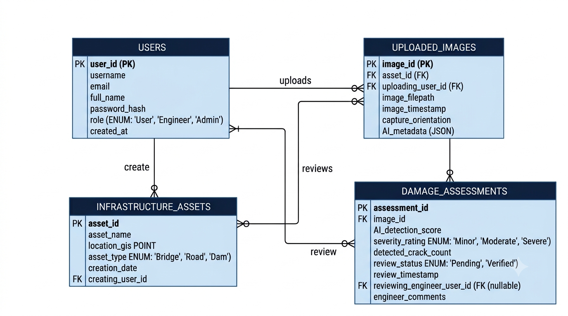
Figure 10.1: Proposed entity relationship diagram for the InfraScan database.
10.4 Relationships Between Tables
- Users and Infrastructure_Assets: One user can register multiple infrastructure assets. The created_by field identifies the user who registered each asset.
- Infrastructure_Assets and Uploaded_Images: One asset can have multiple inspection images. Each image belongs to one asset.
- Users and Uploaded_Images: One user can upload multiple images. The uploaded_by field records the uploader.
- Uploaded_Images and Damage_Assessments: One image can have multiple assessment records, allowing the system to preserve results from different model versions or repeated assessments.
10.5 Database Design Considerations
- Primary keys uniquely identify records in each table.
- Foreign keys maintain relationships between related records.
- The email field must be unique to prevent duplicate user accounts.
- Passwords must be stored as hashes, never as plain text.
- Image files should be stored outside the database, with their paths recorded in Uploaded_Images.
- Confidence values should be stored within the valid range of 0 to 1 when that is the model's output format.
- Deleting assets or images should follow a defined retention policy to avoid accidentally losing inspection records.
- Database queries should be parameterized to reduce SQL injection risks.
10.6 Conclusion
The proposed schema provides a structured way to manage users, infrastructure assets, inspection images, and AI assessment results. Primary and foreign keys help maintain data consistency, while the assessment table supports tracking model outputs and human review. The schema can be expanded later to include detailed defect locations, report generation, audit logs, and model performance records.

11. UI Wireframe Design
11.1 Introduction
User interface (UI) wireframes represent the basic layout and arrangement of the application's screens before detailed visual styling and implementation.
The InfraScan interface is planned to be simple and easy to navigate. Users should be able to log in, register infrastructure assets, upload inspection images, view AI assessment results, and review previously processed images.
The proposed interface contains six main screens: Login, Dashboard, Asset Management, Image Upload, Assessment Results, and Profile/Settings.
11.2 UI WIREFRAME
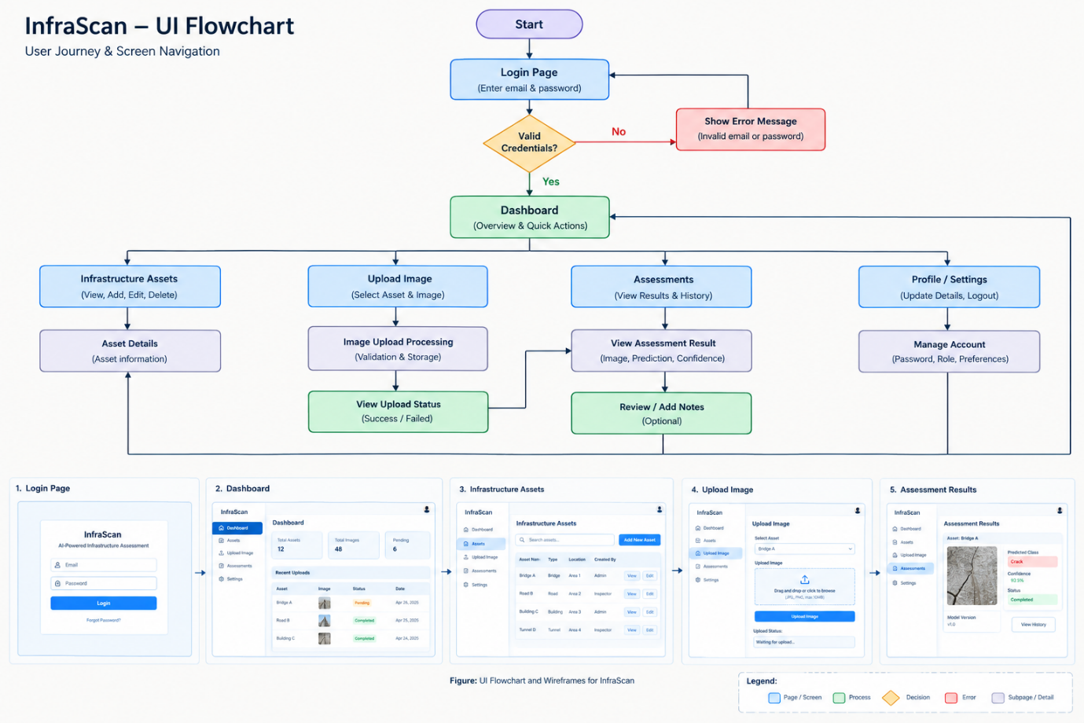

11.3 Conclusion
The proposed wireframes cover the main interactions required for InfraScan, from authentication and asset registration to image upload and damage assessment. They establish the layout and navigation before frontend development begins. The wireframes can later be converted into React components and connected to the FastAPI backend and PostgreSQL database.
Overall conclusion: The proposed system architecture, database schema, and UI wireframes define the initial technical foundation of InfraScan. Together, they establish how users interact with the application, how inspection information is stored, and how images move through the AI assessment workflow. These designs can be refined as the implementation and dataset preparation progress.

