InfraScan Milestone One Complete Report
  - Project analysis and core implementation
Hardik Saraf
21 October 2026
This report covers all 14 tasks in Milestone 1 of the supplied InfraScan project brief. It combines project planning, exploratory analysis of all five recommended dataset sources, architecture and database design, seven UI wireframes, and a working local prototype for login, asset records, image upload and initial preprocessing.

Milestone outcome
The prototype provides a React interface and a FastAPI backend. It supports role and assignment checks, asset registration and history, inspector uploads, retained original images and versioned preprocessing outputs. Automated tests verify the core workflows and rejected requests. The accompanying source package includes the built frontend, source code, dependency locks and reproducible checks.

Implementation scope
The executed development setup uses SQLite through SQLAlchemy and private local file storage. PostgreSQL connection support is included, while the 17-table PostgreSQL schema remains the broader system design. The local prototype implements eight runtime tables for this milestone. Model training, damage inference, engineer approval, maintenance execution and production deployment belong to later milestones.
The EDA records source-release problems, including duplicates and unresolved labels. These findings remain visible for review before model training. No trained-model accuracy or structural safety assessment is claimed.

Milestone One Task Coverage
Task | Completed output and verification | Section
1 | Objectives and inspection workflow with failure loops | 01
2 | Infrastructure types and user responsibilities | 02
3 | Five suitable dataset sources and clickable links | 03
4 | File structures and annotation interpretation | 04
5 | Executed EDA for all five dataset sources | 05
6 | Defect taxonomy and measured class distribution | 06
7 | Architecture and API responsibilities | 07
8 | 17-table database design and integrity rules | 08
9 | Seven UI wireframes and interaction states | 09
10 | React build and running FastAPI development environment | 10
11 | Login, logout, five roles and object access checks | 11
12 | Asset registration, editing, archiving and inspections | 12
13 | Validated private image upload and duplicate handling | 13
14 | Orientation, RGB, resize, normalization and saved outputs | 14

Sections 10 to 14 describe actual local implementation and its test evidence. Section 15 provides the final acceptance checks. Source-code paths are relative to the supplied project ZIP.

01 Project objectives and inspection workflow
The purpose is to make visible-defect inspections easier to record, review and follow up. AI provides evidence for a qualified reviewer; it does not approve the structural safety of an asset.
Objective | Observable outcome
Create an asset history | Every inspection, image, finding and report belongs to one asset.
Identify visible damage | Show a crack presence result, location or mask only when the selected model supports that task.
Maintain traceable evidence | Retain the original image, processing version, model version and reviewer decision.
Support maintenance planning | Engineer-confirmed findings can lead to assigned repair or follow-up tasks.
Avoid unsupported measurements | Display pixels unless verified image calibration supports physical units.

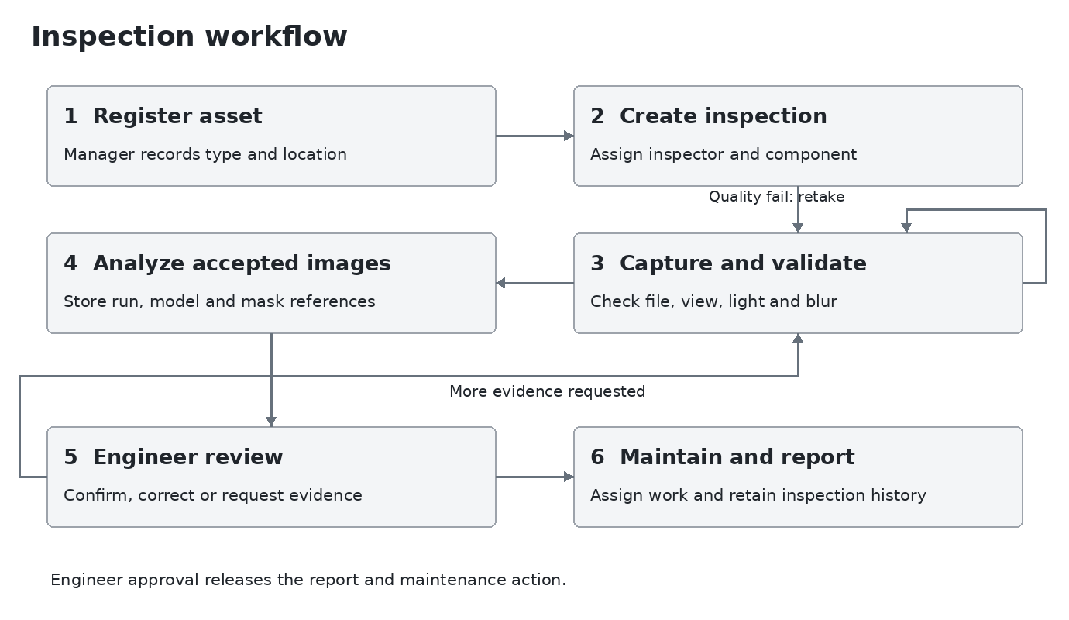
Figure 1 Proposed inspection workflow with a retake loop and an engineer review gate
Inspection states are Draft, Assigned, Capturing, Processing, Review required, Approved and Closed. Image or analysis failures stay at image/job level, so one failed image does not erase the inspection. An engineer may return the record to Capturing when more evidence is needed.

02 Target infrastructure and user responsibilities
Infrastructure | Initial decision | Inspection focus
Buildings | Initial scope | Visible concrete wall, slab, column and beam surfaces; record the exact component.
Bridges | Initial scope for concrete surfaces | Decks, parapets and exposed concrete surfaces; specialist inspection remains necessary.
Roads | Initial scope | Concrete pavement cracks and labelled asphalt road damage, including potholes where supported.
Tunnels | Later expansion | Lining cracks, staining and leakage require tunnel-specific image validation.
Dams and retaining walls | Later expansion | Visible surfaces only; specialist data and review criteria required.
Industrial and other concrete structures | Later expansion | Record assets first; enable AI only for validated material and defect combinations.

Concrete is recorded as a material, rather than creating a duplicate asset type for every concrete building or bridge. The type Other concrete structure is available when a more specific asset category does not fit.

Roles and access decisions
Role | Allowed responsibilities
Infrastructure Inspector | View assigned inspections, capture images, add surface notes and submit evidence.
Civil Engineer | Review assigned findings, correct labels, confirm severity and priority, and approve inspection results.
Maintenance Engineer | View assigned work orders, add repair notes, attach evidence and request follow-up.
Infrastructure Manager | Manage department assets, schedule and assign inspections, monitor reviewed results and assign work.
Administrator | Manage accounts, roles, model registration and audit access. Technical administration alone does not grant engineering approval.

The service checks both the user role and access to the specific asset or assignment. Hiding a button in the interface is not an authorization check. A user may hold more than one approved role, recorded in user_roles.

03 Dataset selection and suitability
Use separate data pipelines for classification, detection and segmentation. Combining them into one folder would lose the meaning of the labels and produce misleading evaluation results. All five datasets recommended in the brief were considered. [1]
Dataset | Label type and purpose | Selection decision
CrackForest Dataset | Paired road images and MATLAB ground truth; suitable for pixel-level segmentation research. [2] | Selected for the executed initial audit and segmentation preparation. Research use only.
SDNET2018 | Concrete image-level crack and non-crack labels across decks, walls and pavement. [3,4] | Selected for the concrete classification stage. Complete 56,092-image release decoded and audited; duplicate and conflicting-label cases recorded.
Concrete Crack Images for Classification | Positive and Negative image folders; 40,000 RGB patches of 227 by 227 pixels. [5] | All 40,000 files audited. Keep as a separate baseline; review exact duplicates before splitting.
RDD2022 | Road images with Pascal VOC XML boxes in the labelled training release. [6,7] | Complete Figshare archive audited across all country partitions, with image and box checks.
Crack500 | Road crack segmentation benchmark distributed through the authors project. [8] | All 3,368 released crop pairs audited, plus 250 full-image reference pairs. Review parent-ID split overlaps.

Practical dataset policy
- Preserve each original release and its licence. Keep derived masks, splits and preprocessing versions separately.
- CrackForest is available for non-commercial research. The classification dataset at Mendeley lists CC BY 4.0. Confirm release-specific terms before any commercial reuse. [2,5]
- The full RDD2022 Figshare release was downloaded successfully and its publisher MD5 verified. Country, object, image and annotation counts are measured from the complete archive. [6,9]
- Spalling, corrosion, exposed reinforcement, leakage and severity labels are not established by these selected annotations. They require additional labelled data.
All five dataset sources now have executed EDA. Crack500 coverage is the complete released crop benchmark plus validation/test full-image references; these representations are counted separately.

04 Dataset structure and annotations
Dataset | Expected organization | How labels are used
CrackForest actual checkout | image/*.jpg; groundTruth/*.mat; seg/*.seg; an additional image.rar archive exists. | Match image and MATLAB file stems. Read groundTruth.Segmentation and groundTruth.Boundaries. Do not count the archive as a new labelled sample.
SDNET2018 audited release | D/CD and D/UD; W/CW and W/UW; P/CP and P/UP. C means crack and U means non-crack. | Create image-level binary labels and preserve surface group and source image identity. There are no ready-made crack masks.
Concrete classification audited release | Positive and Negative folders. | Map Positive to crack present and Negative to crack absent. Image-level labels cannot identify the crack location.
RDD2022 audited release | Seven country/acquisition ZIP partitions. train/images and train/annotations/xmls; test/images has no paired labels. [6,9] | Read each object name and xmin, ymin, xmax, ymax. One image may have multiple objects/classes. Official test images do not provide local ground truth.
Crack500 audited crop release | traincrop, valcrop and testcrop JPG/PNG pairs; train.txt, val.txt and test.txt. Additional valdata and testdata full images. [8] | Crop stems match JPG images to PNG masks. Full references use _mask.png. Decoded masks are boolean, and crop counts are not original photo counts.

Annotation contract for model inputs
Store dataset_id, release/version, source_image_id, image_path, annotation_path, annotation_type, original width and height, label map version and split. Every derived tile also stores its parent image and coordinate transform.
For classification, the target is one image label. For detection, the target is a list of class and bounding-box records. For segmentation, the target is a mask aligned with the image and a valid-pixel mask for regions whose meaning is confirmed.

CrackForest region IDs need care
The file audit found raw Segmentation IDs 1, 2, 3 and 4. In the inspected examples, ID 2 follows the visible crack and ID 1 covers the main background. IDs 3 and 4 occur in 22 image pairs and are region identifiers, not verified crack subtypes. This EDA retains them as unresolved instead of merging all values above 1 into a crack class.
Before training, review those 22 overlays and confirm the mapping. Until then, exclude unresolved pixels from the loss and reported segmentation metrics. The crack-area values in this report refer specifically to ID 2, not a finalized training label map.

05 Executed exploratory data analysis
The audit was run on the public CrackForest repository checkout. The script reads each image fully, matches stems to MATLAB files, checks dimensions, counts raw mask values, hashes JPG bytes, and calculates brightness and a simple Laplacian texture/blur proxy. [2]
Check | Measured result
JPG files in image folder | 155
MATLAB annotation files | 118
Matched and readable pairs | 118
Images without matching MAT files | 37; listed in summary.json
Annotation files without images | 0
Corrupt files or dimension mismatches in matched set | 0
Exact duplicate JPGs in matched set | 0 extra copies by SHA-256 byte hash
Matched image size and mode | All 118 are 480 by 320 pixels, RGB
Additional packed file | image.rar; not extracted or double-counted

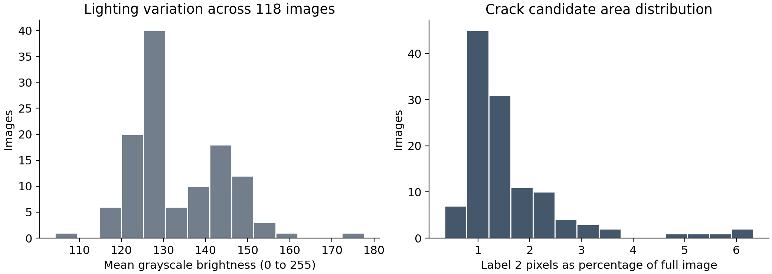
Figure 2 Measured brightness variation and ID 2 area across the 118 matched pairs
Mean grayscale brightness ranges from 104.25 to 177.60 on a 0 to 255 scale; the median is 128.51. ID 2 covers a median 1.314% of an image, ranging from 0.352% to 6.331%.
Brightness and Laplacian variance are descriptive signals, not validated quality pass/fail rules. Texture also changes Laplacian variance. Calibrate quality thresholds on real inspection photos and check them against human review.
Reproduction: run analysis/eda.py with --data pointing to a CrackForest checkout and --out to a results folder. Repository commit: ed57c2d96754e6c7d105805cd29aeeb3a799f267

05 Exploratory analysis of image and mask pairs
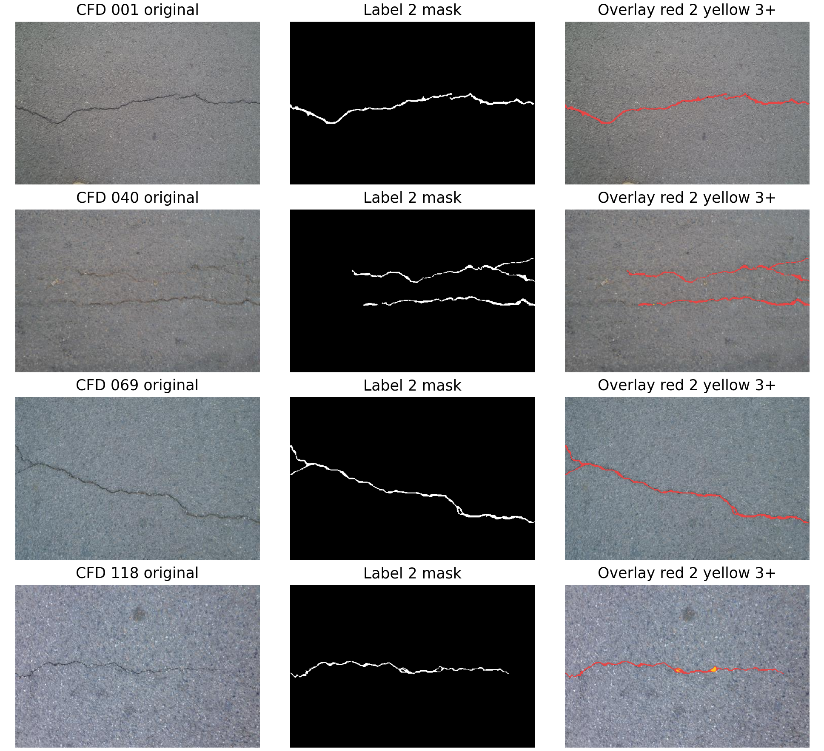
Figure 3 Actual CrackForest samples 001, 040, 069 and 118 with original images, ID 2 masks and overlays
Red marks region ID 2; yellow marks unresolved IDs 3 and above. The examples show thin, branching and textured crack regions. IDs are retained for review and are not interpreted as damage severity or physical width.
Ground-truth overlays are annotation examples, not AI predictions. Dataset attribution: Cui and collaborators, CrackForest Dataset; non-commercial research use. [2]

05 SDNET2018 image audit
The complete USU release was downloaded, its publisher MD5 was verified, and all 56,092 image files were decoded. Classification labels were read from the original C and U folders, while the deck, wall and pavement categories were retained. The counts below are measured from the files, rather than copied from the article. [3,4]
Surface | Crack images | Non crack images | Total
Deck | 2,025 | 11,595 | 13,620
Wall | 3,851 | 14,287 | 18,138
Pavement | 2,608 | 21,726 | 24,334
Total | 8,484 | 47,608 | 56,092

File check | Measured result
Readable images | 56,092 of 56,092; no decode errors
Dimensions and mode | All 256 by 256 pixels, RGB
Byte identical duplicate copies | 13 extra files in 13 groups
Conflicting class assignments | 2 duplicate groups have opposite class labels
Filename inferred source groups | 230 across deck, wall and pavement

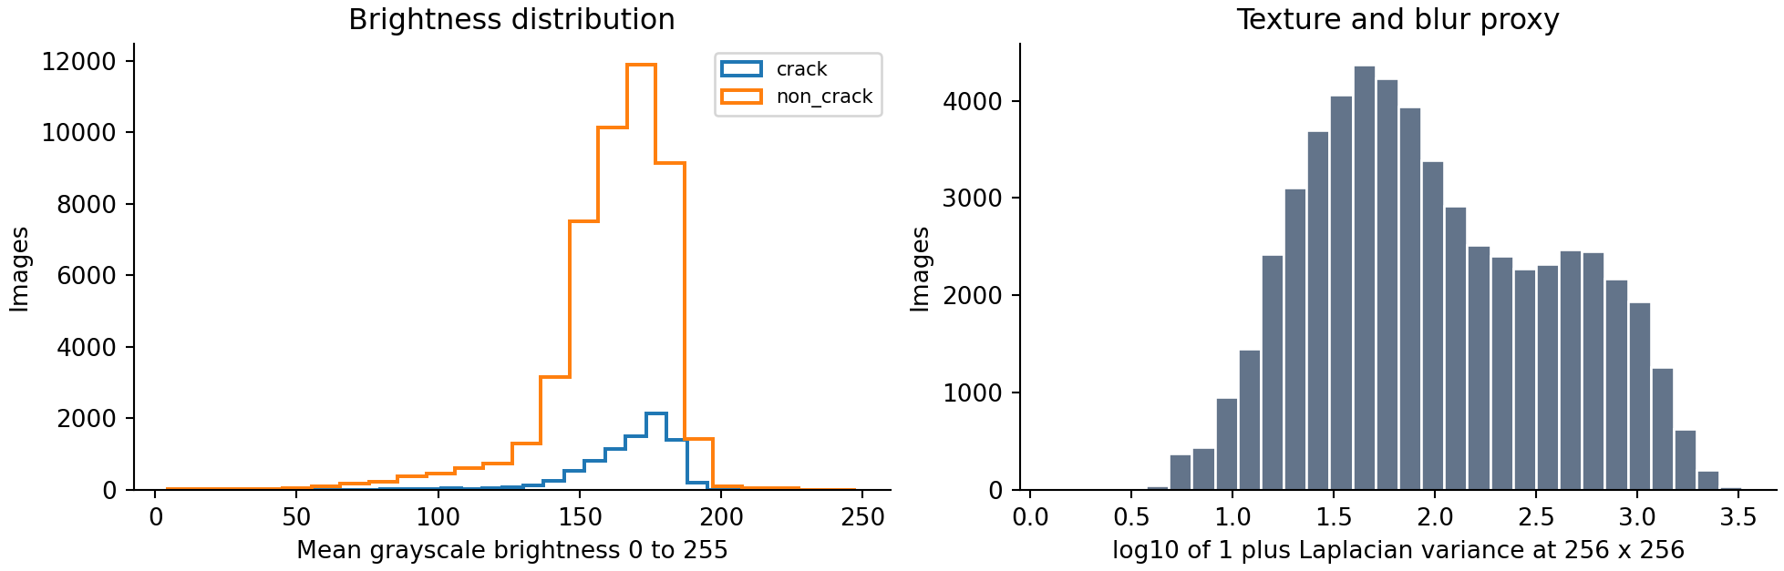
Figure 4 Actual SDNET2018 brightness and texture distributions
Brightness ranges from 4.55 to 247.80; the median is 166.56. The wide range includes very dark and very bright patches. The grayscale range is 0 to 255; brightness alone does not determine whether an image is usable.
Each image was read fully. The blur/texture proxy in the new audits is measured after resizing grayscale images to 256 by 256. It is descriptive, not a validated rejection threshold.

05 SDNET2018 duplicate and label review
Two pairs are byte-identical but occur in opposing class folders. The same pixels must not be used as independent evidence for both crack and non-crack classes. These are measured conflicts in the release; no replacement label is assigned automatically.
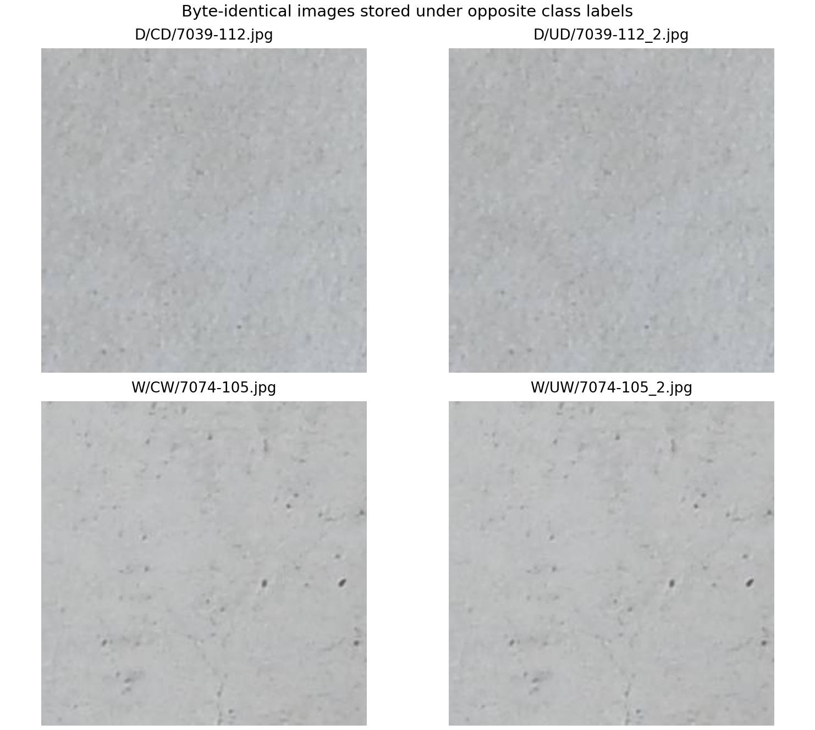
Figure 5 Identical SDNET2018 images stored under opposite class labels
Conflict | Original file paths
Deck pair | D/CD/7039-112.jpg and D/UD/7039-112_2.jpg
Wall pair | W/CW/7074-105.jpg and W/UW/7074-105_2.jpg

Quarantine these four files until a reviewer confirms their labels. For the remaining duplicate groups, keep a canonical copy or force every identical copy into the same split. Preserve a record of which files were removed or relabelled.
The filename prefix before the patch suffix identifies 230 source-image groups. Split by surface and source group before augmentation or tiling; also join any groups connected by exact duplicates. A random patch split can mix views from the same source image across training and test sets.
The evidence bundle lists all 13 duplicate groups, every per-image hash and the 230 group sizes. Representative images from all six surface/class combinations are also included.

05 Concrete classification image audit
The original Mendeley Version 2 RAR file was downloaded through the publisher API. Its SHA-256 matches the publisher metadata. All 40,000 images were extracted and decoded. Labels were taken from the Positive and Negative folders. [5]
Class | Original files | Duplicate copies | Unique byte contents
Crack Positive | 20,000 | 316 | 19,684
Non crack Negative | 20,000 | 1,282 | 18,718
Total | 40,000 | 1,598 | 38,402

File check | Measured result
Readable images | 40,000 of 40,000; no decode errors
Dimensions and mode | All 227 by 227 pixels, RGB
Duplicate groups | 1,519 groups; 1,598 files beyond the first copy
Decoded pixel duplicates | 1,598 extra copies; same excess count as byte hashes
Opposing labels within duplicate groups | 0
Source photograph mapping | Not verified from the class-folder filenames

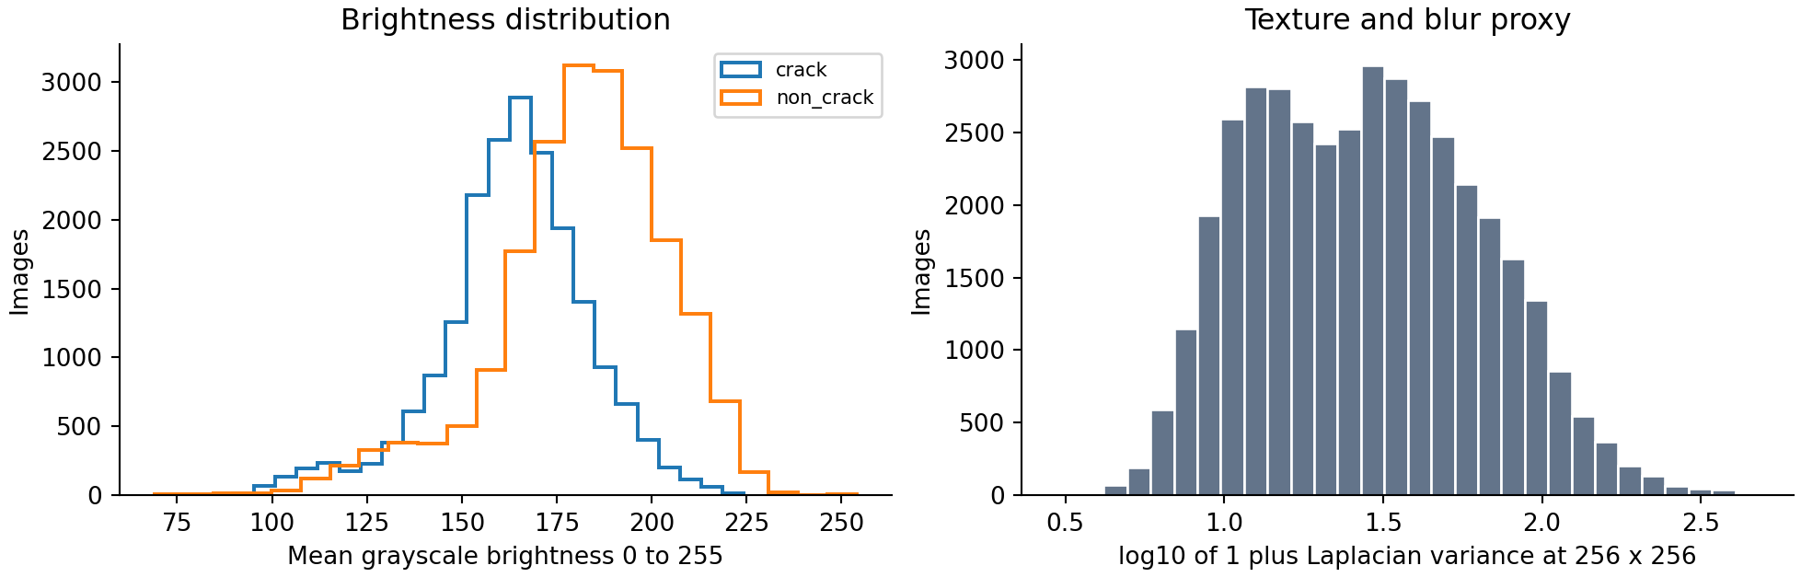
Figure 6 Measured quality distributions in the concrete classification release
Brightness ranges from 69.10 to 253.97; the median is 173.25. Both class balance and duplicate frequency must be checked: the original release is evenly balanced, while unique byte contents are not exactly balanced.

05 Concrete classification examples and preparation
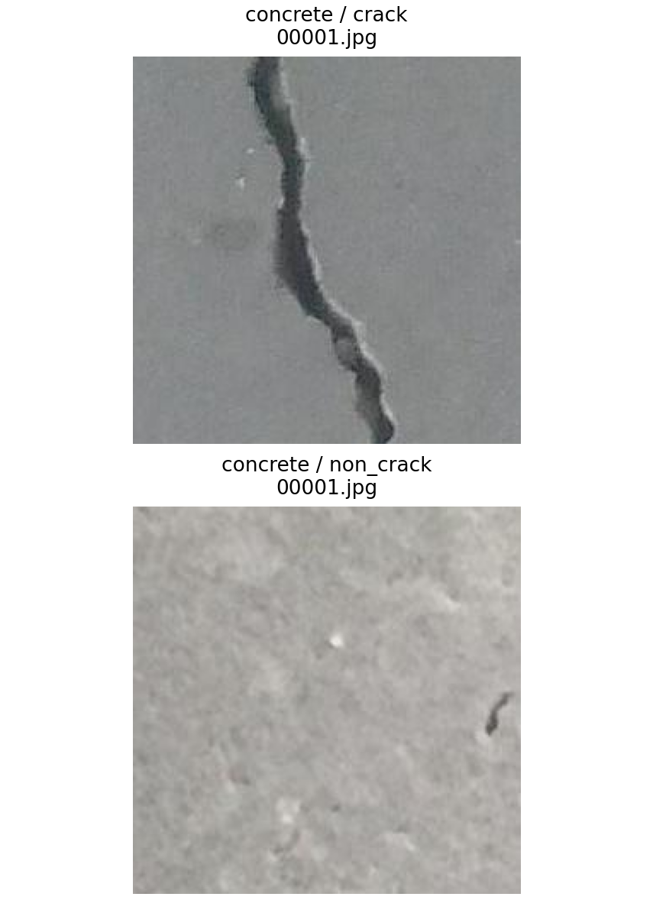
Figure 7 Actual Positive and Negative examples from the downloaded Mendeley release
The folder label records crack presence for the whole patch. It does not provide crack boxes, segmentation masks, physical scale, crack subtype or damage severity. Do not infer these additional labels from the filename or the visual examples.
Before training, remove redundant exact copies within a class or keep each hash group in one partition. Retain an original-to-canonical mapping so the 40,000 release files remain traceable to the 38,402 unique byte contents. Do not count repeated copies as separate test evidence.
The source description refers to 458 high-resolution photographs, but the class folders do not establish a verified parent-photo mapping for each patch. Exact deduplication is therefore necessary but not a complete scene-leakage check. Review near duplicates and source-photo grouping before making a generalization claim.
No files were silently deleted during this EDA. The original counts and proposed unique-file counts are both reported, and duplicate_files.csv contains the affected paths.

05 Crack500 crop and mask audit
The author-linked pavement dataset package contains the released Crack500 crop benchmark and full-image validation/test references. The full crop benchmark was audited, together with the 50 validation and 200 test reference image/mask pairs. These references overlap the underlying scenes and are not added to the crop total as independent training examples. [8]
Released partition | Images | Masks | Inferred parent IDs
Training crops | 1,896 | 1,896 | 250
Validation crops | 348 | 348 | 50
Test crops | 1,124 | 1,124 | 148
Crop total | 3,368 | 3,368 | Not a count of original photographs
Full image references | 250 | 250 | 50 validation and 200 test

All 3,368 crop pairs and all 250 full-reference pairs decode successfully, with matching image/mask dimensions. Every crop listed in train.txt, val.txt and test.txt is present, and no unlisted crop or orphan mask was found. The source PNG masks decode in Pillow mode 1, with False as background and True as crack; they must not be tested against the numeric value 255 without conversion.
Measured crop mask distribution | Pixels | Share
Background | 735,013,253 | 93.984%
Crack | 47,049,883 | 6.016%
Total | 782,063,136 | 100%

There are no empty crop masks and no exact duplicate crop images. Five inferred parent IDs are shared between train and test; one is shared between validation and test. These filename-level overlaps require review against the source images before the supplied split is called leakage-free. The original lists are preserved in the evidence bundle.
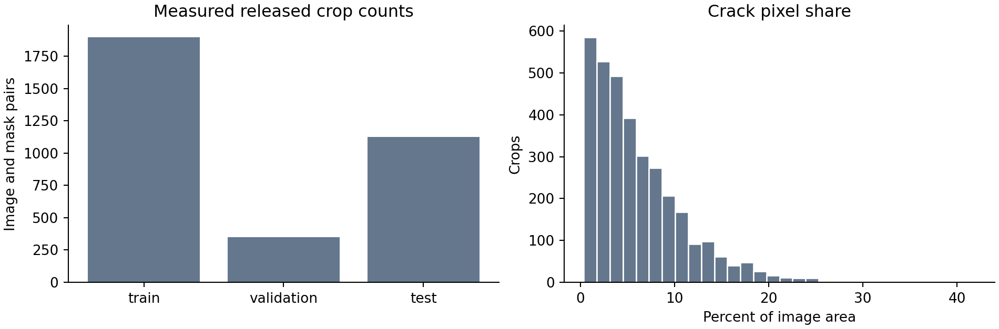
Figure 8 Measured Crack500 split counts and crack-area distribution

05 Crack500 examples and mask interpretation
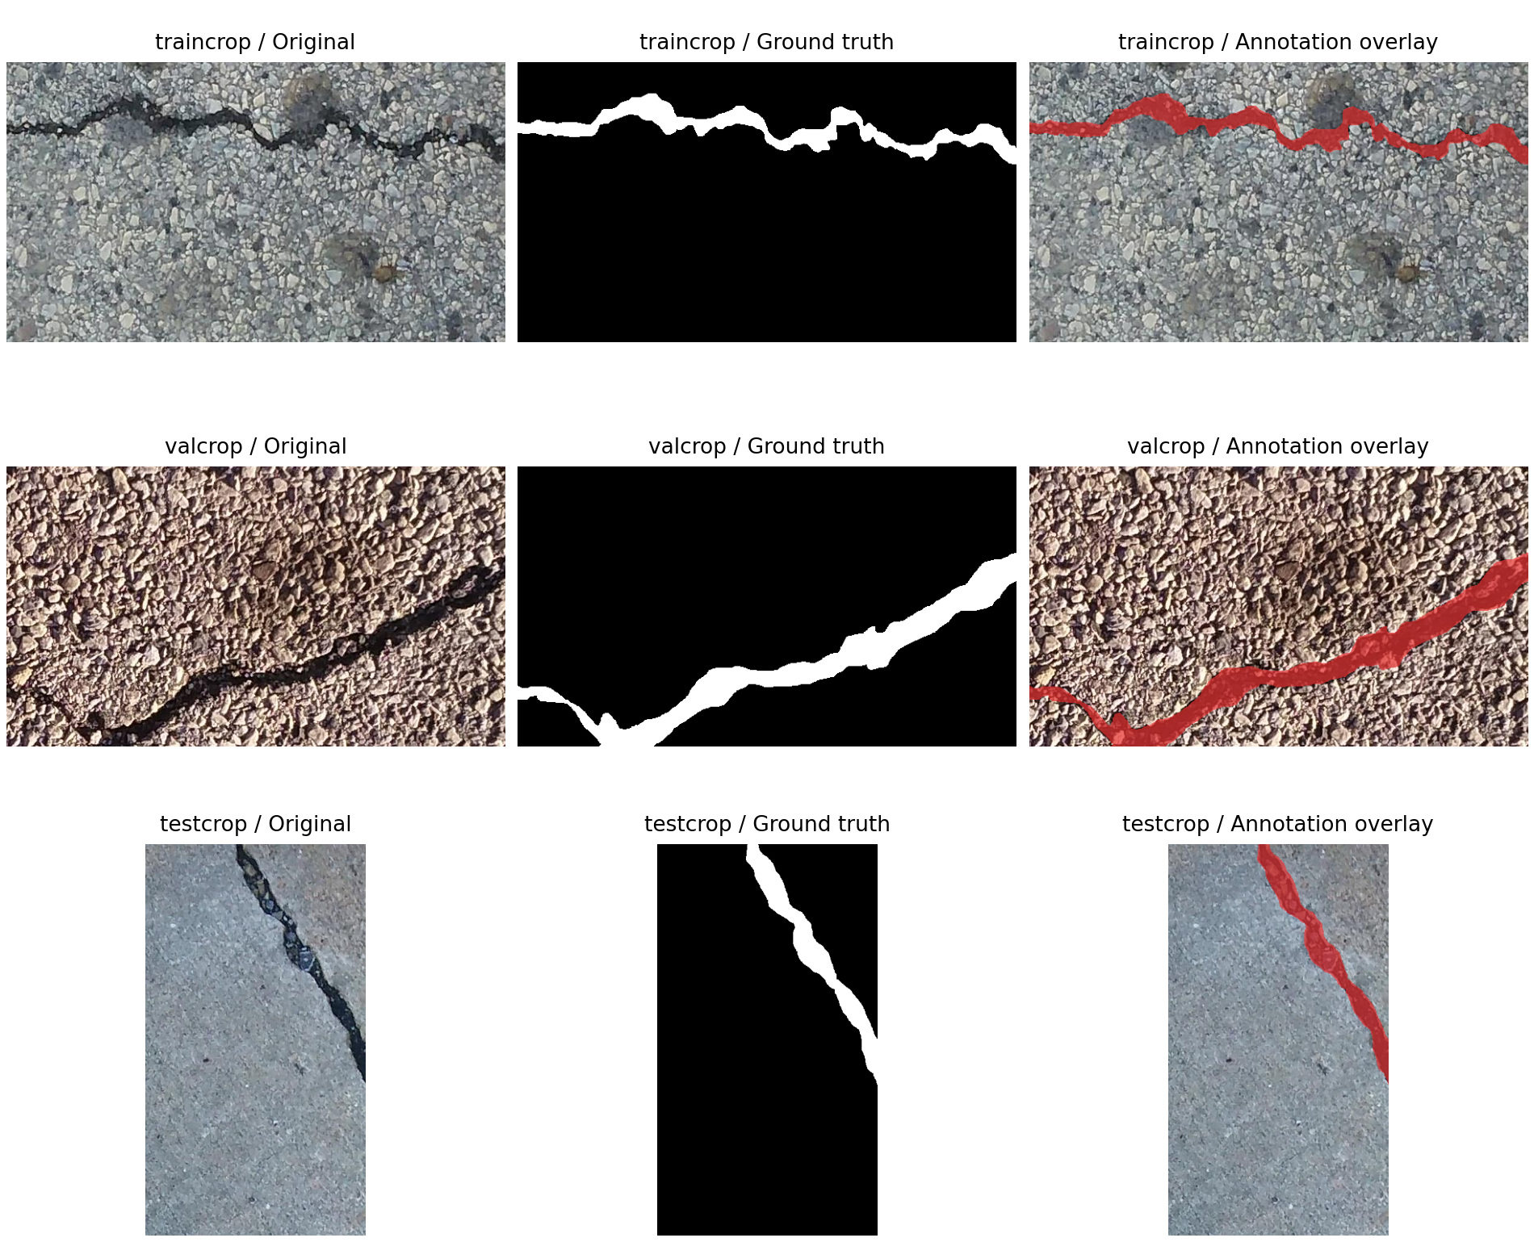
Figure 9 Actual Crack500 crop examples with supplied masks and annotation overlays
The median foreground share is 4.815% of crop area, with a range of 0.355% to 41.948%. The global foreground share is 6.016%; this pooled pixel percentage differs from the median per-image percentage.
Use boolean foreground masks for segmentation. Resize masks with nearest-neighbour interpolation and apply the same crop/flip transform to the paired image. Keep the original release lists for benchmark comparison, and disclose the inferred parent overlaps when reporting performance. A separate parent-group split can be evaluated for deployment testing.
Measured crop dimensions are 640 by 360 pixels for 3,183 pairs, 360 by 640 for 112 pairs, and 648 by 484 for 73 pairs.
The crop data do not supply physical pixel scale, engineer-confirmed severity or road crack-subtype labels. Overlays in this report show supplied annotations; they are not predictions from a trained model. The released crop benchmark is distinguished from the 500-original-image description of Crack500.

05 RDD2022 complete release audit
The complete Figshare Version 1 archive was downloaded and its MD5 matched the publisher record. All seven release partitions were inspected: China Drone, China MotorBike, Czech, India, Japan, Norway and United States. China has two acquisition partitions, so these represent six countries. [6,7,9]
Partition | Images | Train | Test | XML | Target objects
China Drone | 2,401 | 2,401 | 0 | 2,401 | 3,068
China MotorBike | 2,477 | 1,977 | 500 | 1,977 | 4,650
Czech | 3,538 | 2,829 | 709 | 2,829 | 1,745
India | 9,665 | 7,706 | 1,959 | 7,706 | 6,831
Japan | 13,133 | 10,506 | 2,627 | 10,506 | 16,470
Norway | 10,201 | 8,161 | 2,040 | 8,161 | 11,229
United States | 6,005 | 4,805 | 1,200 | 4,805 | 11,014
Total | 47,420 | 38,385 | 9,035 | 38,385 | 55,007

Four project classes in the measured annotations
Class | Object instances | Images containing class | Share of target objects
D00 longitudinal | 26,016 | 13,548 | 47.30%
D10 transverse | 11,830 | 7,709 | 21.51%
D20 alligator | 10,617 | 8,412 | 19.30%
D40 pothole | 6,544 | 3,674 | 11.90%

The release contains 65,712 annotated objects in total; 55,007 belong to the four project classes. Other raw labels are preserved in object_audit.csv and counted separately. An image can contain several classes, so per-class image counts must not be summed to obtain the number of unique images.
All 47,420 images were decoded; 0 image decode errors and 0 annotation parse errors were recorded. 9,035 images have no paired XML, and 11,724 paired XML files contain zero objects. Missing official test annotations are not evidence that a surface has no damage.

05 RDD2022 annotation quality and examples
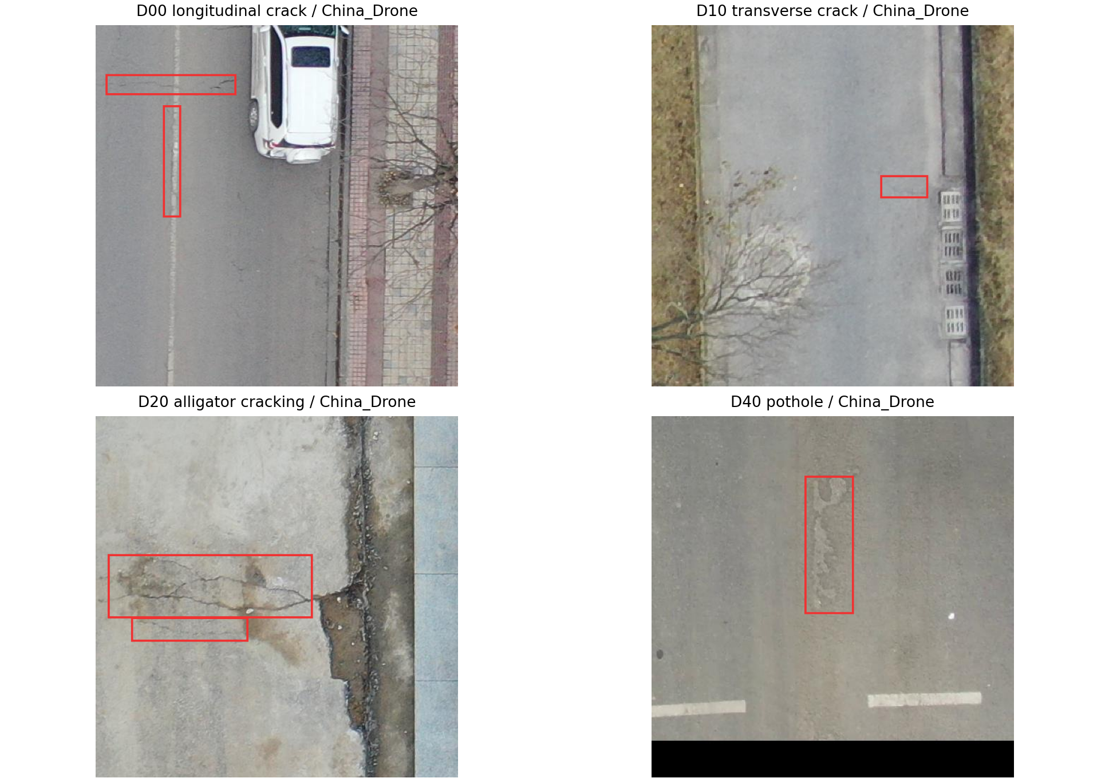
Figure 10 Actual RDD2022 images with supplied target-class boxes
Annotation or duplication check | Measured result
Boxes outside actual image bounds or with invalid ordering | 1
XML width or height differs from decoded image | 0
Repeated identical class and box inside one XML | 1
XML files without a matched decoded image | 0
Extra byte-identical image copies | 2
Exact duplicate groups spanning train and test | 1
Unmapped raw code D0w0 requiring review | 1

A valid geometric box check requires finite coordinates with 0 <= xmin < xmax <= image width and 0 <= ymin < ymax <= image height. The area fraction uses coordinate differences; it is a normalized bounding-box footprint, not a segmentation area or physical damage size.
The code D0w0 is retained exactly as found in one India annotation and requires label review. The totals describe raw annotations; the invalid target box is not silently removed. Keep the four project class codes unchanged. Exclude unsupported object categories from project training through an explicit label map rather than relabelling them. Review invalid boxes and metadata mismatches against the source image. Use a held-out part of labelled training data for local evaluation; the official test folder does not supply local ground truth.

06 Defect categories and class distribution
Source and counting unit | Category | Count | Share
CrackForest measured pixels | Region ID 1 main background | 17,710,362 | 97.713%
CrackForest measured pixels | Region ID 2 crack candidate | 292,885 | 1.616%
CrackForest measured pixels | Region ID 3 unresolved | 120,201 | 0.663%
CrackForest measured pixels | Region ID 4 unresolved | 1,352 | 0.007%
CrackForest measured pixels | Total | 18,124,800 | 100%
SDNET2018 measured images | Crack | 8,484 | 15.13%
SDNET2018 measured images | Non-crack | 47,608 | 84.87%
Concrete classification measured images | Positive / Negative | 20,000 / 20,000 | 50% / 50%

In the audited CrackForest set, all 118 matched images contain ID 2 pixels. It therefore does not provide a balanced crack/no-crack image classification test. Pixel frequency and image frequency answer different questions and must not be added together.

Supported defect catalogue
Task | Labels | Scope rule
Concrete classification | Crack / Non-crack | Presence only; no automatic subtype or severity label.
CrackForest segmentation | Crack / Background after mapping review | Pixel localization; IDs 3 and 4 remain unresolved until reviewed.
RDD2022 road detection [6,7] | D00 longitudinal, D10 transverse, D20 alligator cracking, D40 pothole | Four-class project label map; measured raw labels and target counts are retained separately.
Future infrastructure damage | Spalling, corrosion, exposed reinforcement, staining and other defects | Disabled until a suitable annotation source and evaluation set exist.

No visible damage is an inspection outcome, not a detector object class. Confidence describes a model output; it is not a severity score. The five severity categories in the brief require engineer-approved criteria and separate validation. [1]

06 Data preparation and evaluation decisions

Address imbalance without changing the evidence
The independently measured SDNET2018 counts imply roughly 5.61 non-crack images per crack image. Predicting only non-crack would produce 84.87% accuracy while finding no cracks. Use recall, precision, F1, balanced accuracy and a confusion matrix rather than headline accuracy alone. These are calculations from the audited file counts, not trained model results.
For segmentation, the measured ID 2 area is small relative to background. Evaluate Dice and IoU on confirmed crack labels, report crack recall, and inspect thin structures visually. Class weighting or Dice plus binary cross-entropy can be explored during training; these are planned choices, not executed experiments.

Provisional CrackForest split
Partition | Images | Rule
Training | 82 | Only this partition may receive random augmentation.
Validation | 18 | Use for model and threshold selection.
Test | 18 | Keep untouched until final evaluation.

The supplied split manifest uses a deterministic shuffle with NumPy seed 42. It is a preparation file, not a leakage-validated benchmark split. Review near duplicates and shared scenes first; move similar captures into the same partition. Regenerate the manifest if new scene groups are identified.

Preprocessing design
- Retain original images. Apply orientation correction and store the transform used for every derived image.
- For image resizing, preserve aspect ratio and retain the inverse transform. Resize masks with nearest-neighbour interpolation, never smooth their labels.
- Apply the same geometric transform to each image and mask. Split source images before generating tiles; keep all tiles from one parent together.
- Exclude 37 unmatched images from supervised segmentation. They are not automatic negative examples.
- Treat unresolved region IDs as ignored pixels until the label map is reviewed. Keep masks and boundary annotations as separate targets.

Cleaning and evaluation checks
Before training, review the SDNET conflicting labels, deduplicate the two classification datasets, check Crack500 parent-ID overlaps, and review RDD invalid boxes and metadata mismatches. Keep object-instance, image and pixel counts separate. The audits and original release files are retained without silent cleaning.

07 Proposed system architecture
The design follows the brief stack: React for the interface, FastAPI for APIs, PostgreSQL for structured records and private object storage for images. A worker handles longer image-processing jobs so metadata requests do not wait for inference. [1] The Milestone 1 implementation uses a synchronous initial preprocessing endpoint and SQLite for local development. The queue, PostgreSQL deployment and model worker remain the target architecture for later stages.
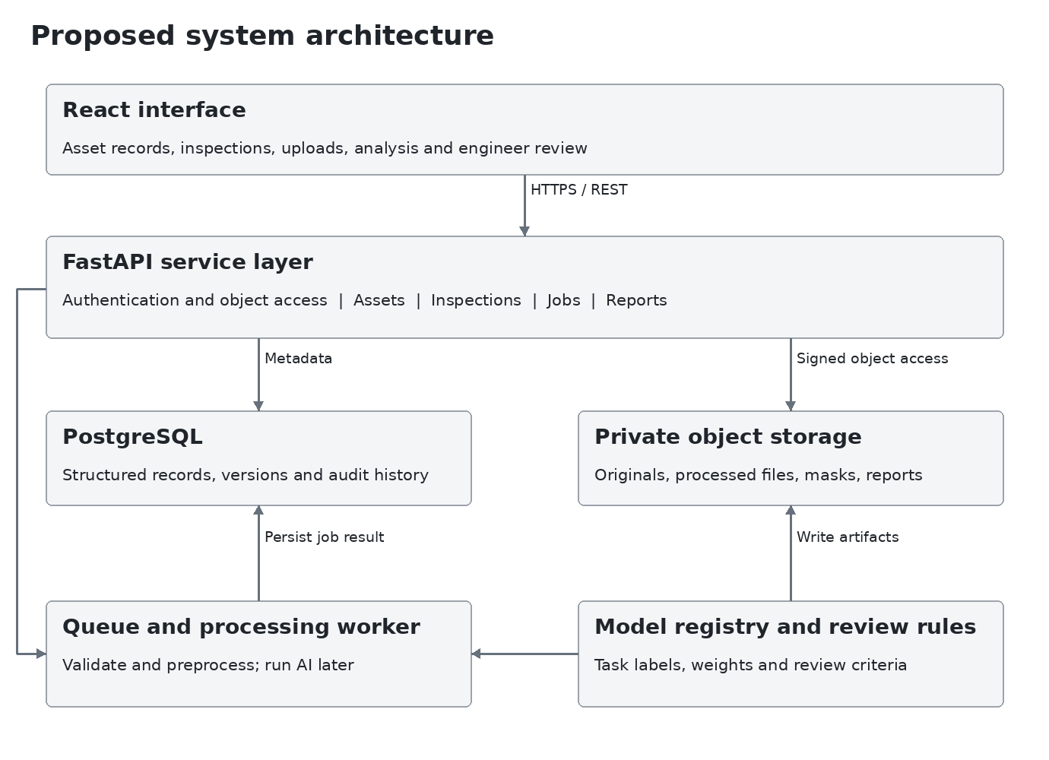
Figure 11 Proposed service boundaries and storage flow
Component | Design responsibility
Frontend | Display authorized assets and workflows; show upload, processing and review states.
API service | Validate requests, enforce permissions and create inspection and job records.
Queue and worker | Run quality checks, preserve preprocessing versions, load compatible models, and persist outputs or a clear failure reason.
Database and storage | Keep relationships and history in PostgreSQL; keep file bytes in private storage with short-lived authorized access.

Start with one FastAPI application with separate modules and a worker. Redis-backed queuing and PostGIS can be added when required; neither is necessary to draw wireframes or complete the design. Training runs stay outside ordinary web requests.

07 API contract and processing states
Method and route | Purpose | Required access
POST /auth/login | Authenticate and establish a session | Active account
GET or POST /assets | List accessible assets or create one | Scoped reader / Manager
POST /assets/{id}/inspections | Create an inspection and assignment | Manager with asset access
GET /inspections/{id} | Return inspection and permitted evidence | Assigned or authorized user
POST /inspections/{id}/images | Upload evidence and create image record | Assigned Inspector
POST /images/{id}/quality-checks | Queue quality review | Assigned Inspector
POST /images/{id}/analysis-runs | Queue a compatible model run | Authorized Inspector or Civil Engineer
GET /analysis-runs/{id} | Return job state and available results | Authorized inspection reader
POST /findings/{id}/reviews | Append an engineer decision | Civil Engineer
POST /reviews/{id}/maintenance-tasks | Create work from an accepted review | Manager
POST /inspections/{id}/reports | Generate a versioned report snapshot | Authorized report creator

Upload and inference sequence
The API validates file type and size, confirms inspection access, stores the original privately and records a checksum. A worker checks quality. Only stored and accepted images may enter analysis. POST analysis returns HTTP 202 with a job ID; the UI reads job status until it succeeds or fails. [Design]
Job states are Queued, Running, Succeeded and Failed. Retrying creates a traceable new run or reuses an idempotency key for the same request. Never replace an earlier successful result silently. A failed image remains visible with Retry or Replace actions.

Errors the interface must explain
Use 401 for an expired session, 403 for denied access, 413 for an oversized file, 415 for an unsupported format and 422 for invalid fields or incompatible input. Failed jobs return a stored reason. Error messages must not reveal another user's asset or private storage path.
Every result includes the image ID, original dimensions, model version, label map, preprocessing version and prediction type. Segmentation masks and boxes must map back to the original image coordinate system.

08 Database relationships
Use a relational schema to keep one asset connected to many inspections, images and findings. Store image and model files as object keys rather than database blobs. The companion schema.sql defines 17 tables, keys, checks and indexes.
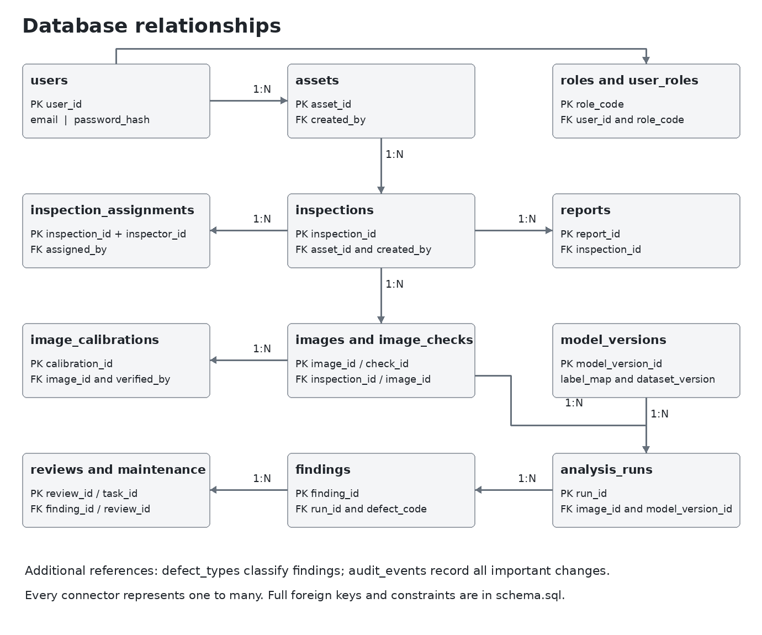
Figure 12 Condensed relationship diagram for the proposed PostgreSQL design
One inspection may be assigned to several inspectors through inspection_assignments. One image may have several analysis runs, and each run may produce several findings. Each finding may receive multiple review entries so corrections remain traceable.
Reports store an immutable snapshot of the selected runs, findings and reviews. Model versions store the task and label map, preventing a road detector output from being treated as a concrete severity classification.
The diagram groups closely related tables to keep it readable. Exact individual foreign keys, including calibration and reviewer references, are defined in schema.sql.

08 Data dictionary for core records
Table and key | Important fields | Purpose and relationship
roles  PK role_code | role_name | Five approved roles from the project brief.
users  PK user_id | full_name, email, password_hash or oauth_subject, is_active | Case-insensitive unique email; only password hashes are retained.
user_roles  PK user_id and role_code | FK user_id, role_code | Supports multiple authorized roles per account.
assets  PK asset_id | asset_code, name, asset_type, material_type, location, latitude, longitude, construction_year, department, inspection interval | Unique asset code. Coordinates may be absent, but must be supplied as a pair when recorded.
inspections  PK inspection_id | FK asset_id, created_by; scheduled_at, inspected_at, component_label, status, notes | Separates the permanent asset from a visit or inspection event.
inspection_assignments  Composite primary key | FK inspection_id, inspector_id, assigned_by; assigned_at | Connects inspectors to an inspection without overwriting the asset owner.
images  PK image_id | FK inspection_id, uploaded_by; object_key, MIME type, dimensions, checksum, viewpoint, upload and quality status | One record per original image. A repeated checksum within the same inspection is rejected as an exact duplicate upload.
image_checks  PK check_id | FK image_id; check_name, measured value, threshold, result, reason, pipeline version | Retains quality evidence and which rules produced it.
image_calibrations  PK calibration_id | FK image_id, verified_by; reference_length_mm, reference_length_px, uncertainty, method | Connects a reviewed scale reference to the exact image used for measurement.

Common field choices
Use generated bigint identifiers, timestamps with time zone, explicit status values and foreign keys. Store scheduled and captured times separately from upload time. Store unknown construction year, location coordinates or calibration as NULL, rather than inserting a guessed value.
The first deployment assumes one organization with department-scoped assets. If multiple organizations share a deployment, introduce organization identifiers and database isolation before importing any cross-organization data.

08 Results schema and integrity rules
Table and key | Important fields and relationship
model_versions  PK model_version_id | Unique name plus version; task, artifact key, dataset version, label map and evaluation metadata.
analysis_runs  PK run_id | FK image_id and model_version_id; preprocessing version, parameters, job status, timestamps, error, idempotency key and output key.
defect_types  PK defect_code | Human-readable name, dataset and supported task. Initial labels remain disabled until a validated model is available.
findings  PK finding_id | FK run_id and image_id, defect_code, optional calibration; confidence, box or mask, pixel measurements, optional calibrated millimetres and severity rule version.
reviews  PK review_id | FK finding_id and reviewer_id; decision, corrected defect, severity, priority, required note and review time.
maintenance_tasks  PK task_id | FK review_id, assigned_to, assigned_by; due date, status, resolution notes and completion time.
reports  PK report_id | FK inspection_id, generated_by, approved_by; version, format, status, object key and JSON snapshot.
audit_events  PK event_id | Actor, action, entity, details and event time; append-only access policy in the service/deployment.

Integrity rules
- A composite foreign key ties each finding to its run and that run's image. The calibration reference must belong to the same image.
- Physical dimensions require a calibration record. Service checks must also validate viewpoint and perspective assumptions; a scale reference alone does not remove every measurement error.
- Confidence is between 0 and 1. A severity proposal requires a rule version. An approved report requires an approver; a completed work order requires resolution notes and a completion time.
- Only authorized civil engineers submit reviews. Work orders require a confirmed or corrected review; a rejected finding cannot automatically create repair work.
- Use indexes on asset inspection history, image inspection links, image analysis history and audit entity history. Archive assets instead of deleting their evidence chain.
The SQL is a schema design deliverable. It has not been applied to a running PostgreSQL service. Role checks, box bounds and workflow transition checks are explicitly assigned to application transactions.

09 WF01 Sign in
Primary user All users
Email and password fields, recovery link and organization login entry. The role is loaded from the authenticated account; users cannot grant themselves a role on this screen.
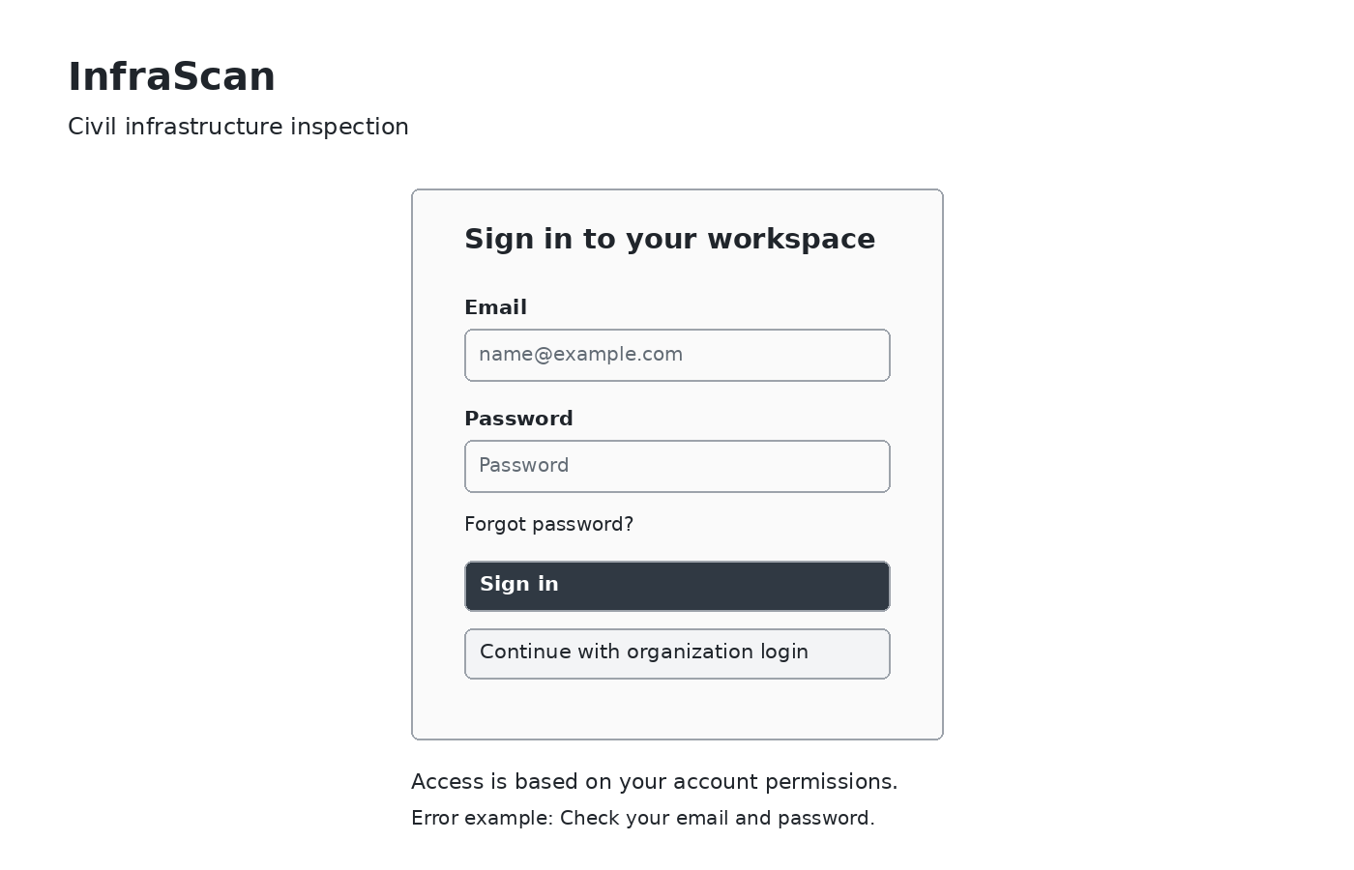
Figure 13 Low fidelity layout with illustrative records
Element or state | Expected behavior
Sign in | Validate credentials; load the permitted workspace.
Invalid credentials or expired session | Show a plain error and retain the email; do not reveal whether an account exists.
Organization login | Use the configured OAuth2 identity provider when enabled.

Keyboard focus follows email, password and actions. Field labels remain visible. Account and role changes are handled by an authorized administrator.

09 WF02 Inspection overview
Primary user Manager with role-specific content
A summary of accessible assets, inspections due, items awaiting engineer review and open maintenance work. The main list directs the user to the inspection that needs attention.
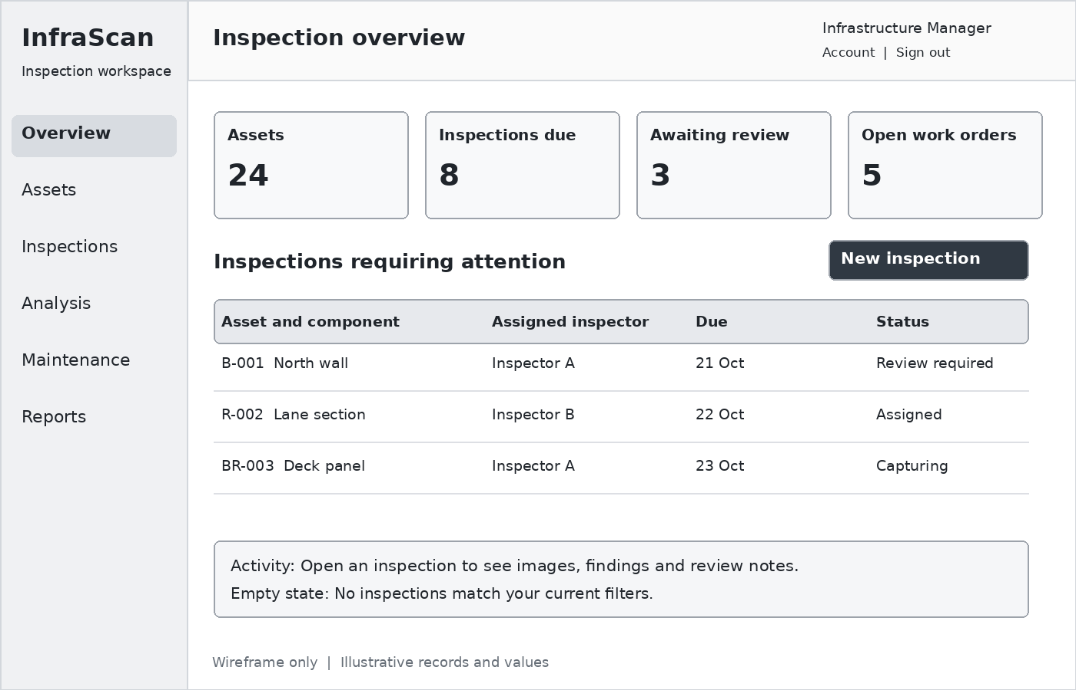
Figure 14 Low fidelity layout with illustrative records
Element or state | Expected behavior
New inspection | Open the creation flow for an accessible asset.
Inspection row | Open details, images, job status and history.
Filters and empty state | Filter by asset, due date or status; explain when no rows match.

Inspectors see their assignments. Civil engineers see the review queue. Maintenance engineers see assigned work. Administrators receive account, model and audit navigation based on permission.

09 WF03 Asset registry and details
Primary user Infrastructure Manager
A searchable asset list and a detail panel keep the permanent infrastructure record separate from each inspection. The selected record exposes its location, department and history.
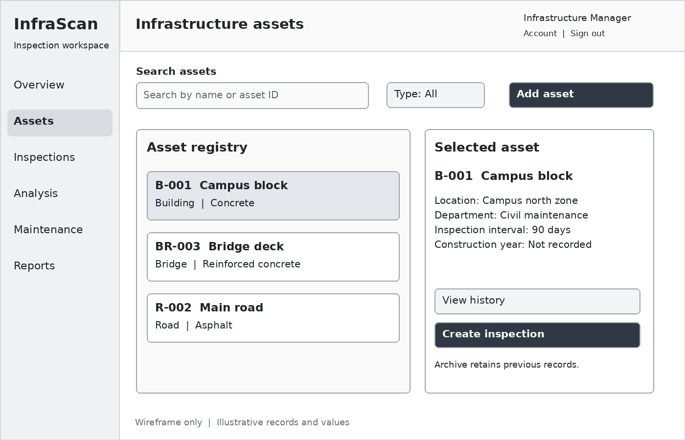
Figure 15 Low fidelity layout with illustrative records
Element or state | Expected behavior
Add or edit asset | Open a labelled form for ID, name, type, material, location, department, construction year and inspection interval.
View history | List past inspections and maintenance work in date order.
Create inspection or archive | Start a new visit or archive the asset while retaining existing evidence.

Check unique asset code, positive inspection interval and valid coordinate pairs. Missing optional details show Not recorded. A road, bridge or building is not considered damaged merely because it exists in the registry.

09 WF04 Inspection creation and image upload
Primary user Assigned Infrastructure Inspector
The flow collects the asset, surface/component, inspection date and viewpoint before uploading evidence. A manager selects the assigned inspector when creating the inspection; an inspector cannot self-assign through a hidden field.
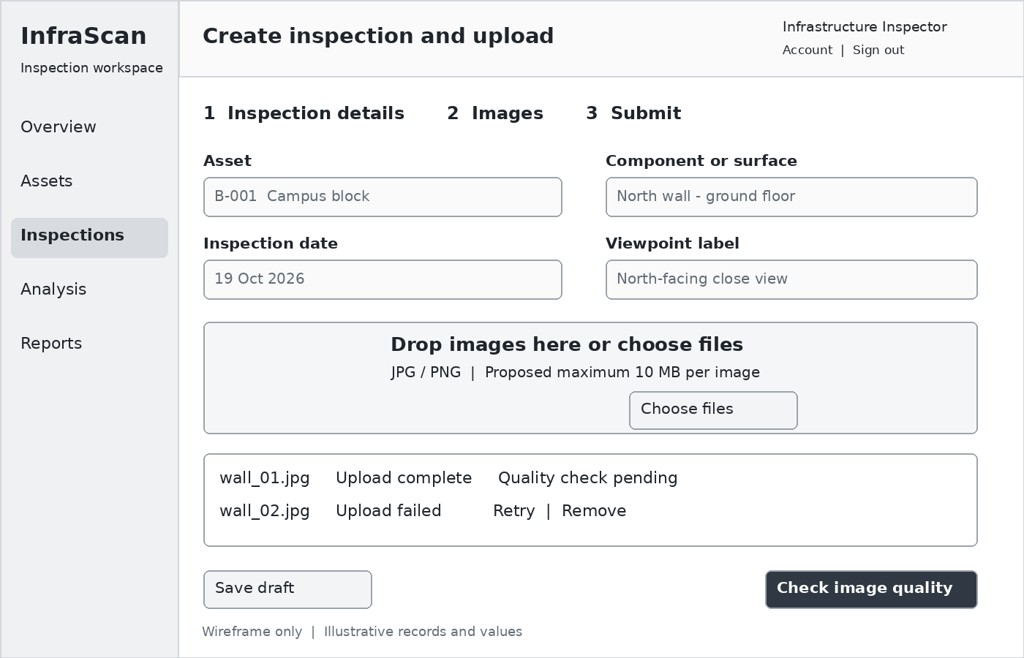
Figure 16 Low fidelity layout with illustrative records
Element or state | Expected behavior
Choose files | Preview each original, show upload progress and create a traceable image record.
Save draft | Keep entered inspection information without requiring analysis.
Retry or remove | Retry a failed transfer; remove an unsaved selection without affecting other files.

JPG/PNG and 10 MB per image are proposed UI limits, not requirements quoted from the brief. Confirm them during implementation. Validate actual file content on the server, not only the filename extension.

09 WF05 Image quality review
Primary user Infrastructure Inspector
A large original preview sits beside quality check results. A failed capture remains visible with a clear reason and corrective action. Analysis stays disabled while a blocking check is unresolved.
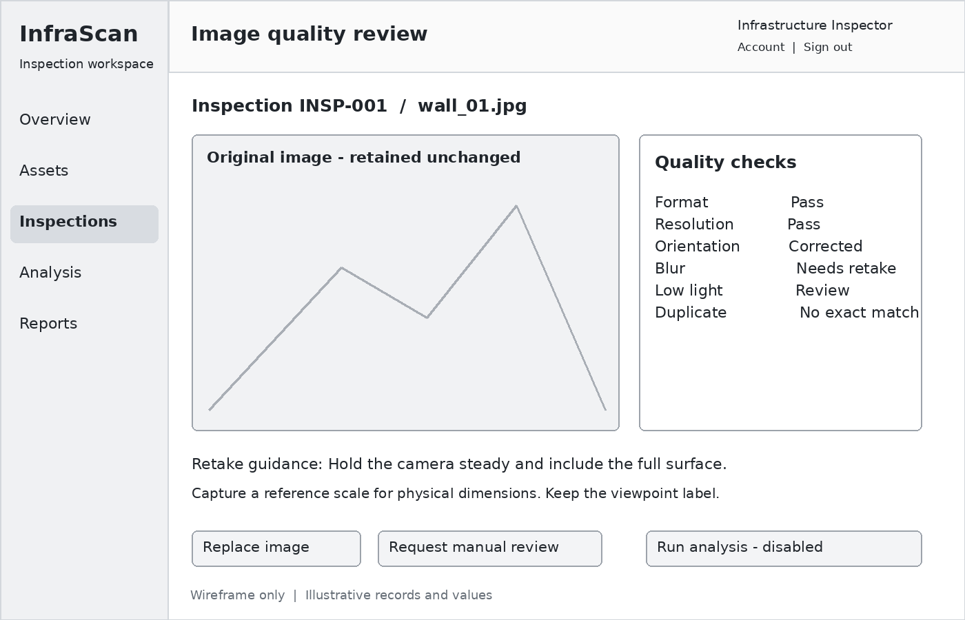
Figure 17 Low fidelity layout with illustrative records
Element or state | Expected behavior
Replace image | Capture or upload a better view; keep the rejected-image audit record.
Request manual review | Ask an authorized reviewer to assess a borderline image and record a reason.
Run analysis | Enable only for a stored and accepted image with a compatible model.

Use individual states for checking, pass, warning and failure. Mobile layouts put the preview first and checks below it. Do not infer real dimensions from camera metadata alone.

09 WF06 Analysis and engineer review
Primary user Civil Engineer
The workspace switches between original image, detection, segmentation and explainability. A finding panel displays the available outputs and their provenance. Example values in the wireframe are illustrative.
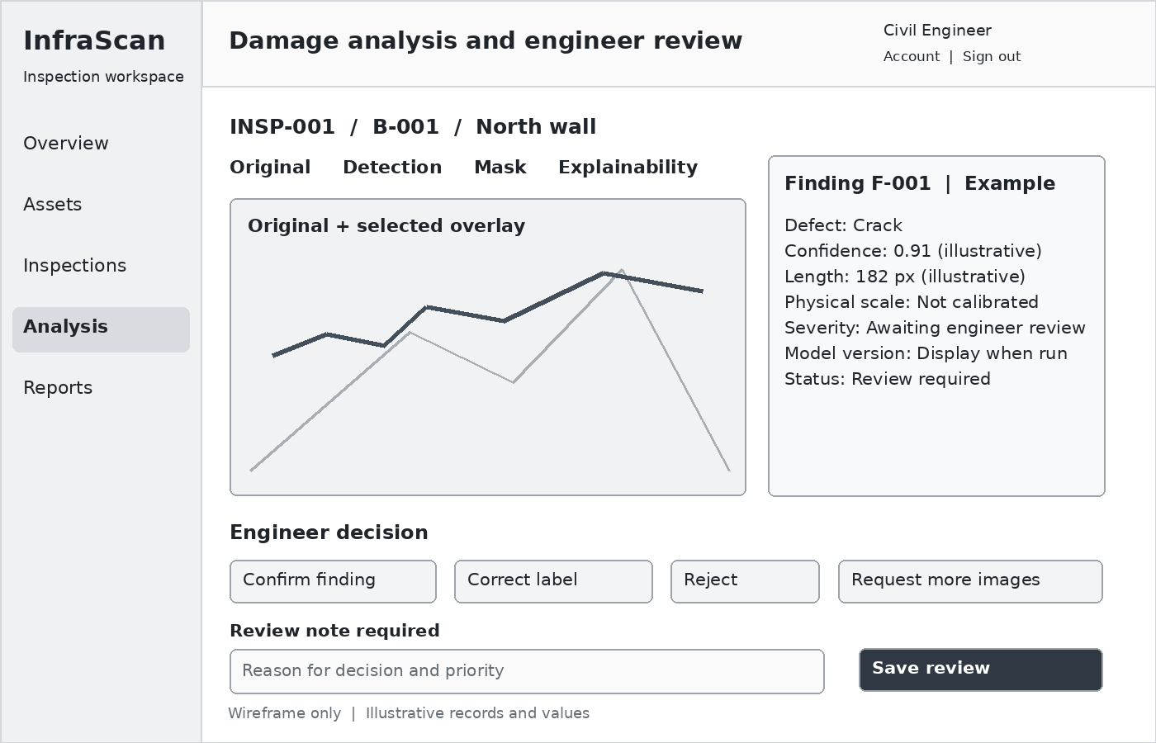
Figure 18 Low fidelity layout with illustrative records
Element or state | Expected behavior
Confirm or correct | Save the reviewed label, severity, priority and mandatory reasoning.
Reject or request evidence | Retain the AI result, append the decision and return the inspection for more evidence when needed.
Save review | Record reviewer identity and time; refresh the review queue.

Show Not calibrated for physical dimensions and Awaiting engineer review for unconfirmed severity. Empty results state No defect detected in this image, without claiming structural safety. Processing and failure states must hide stale overlays.

09 WF07 Reports and maintenance
Primary user Authorized report users and Maintenance Engineer
A draft report preview and work-order table connect reviewed evidence to follow-up work. Reports include source images, asset and inspection IDs, model versions and engineer review status.
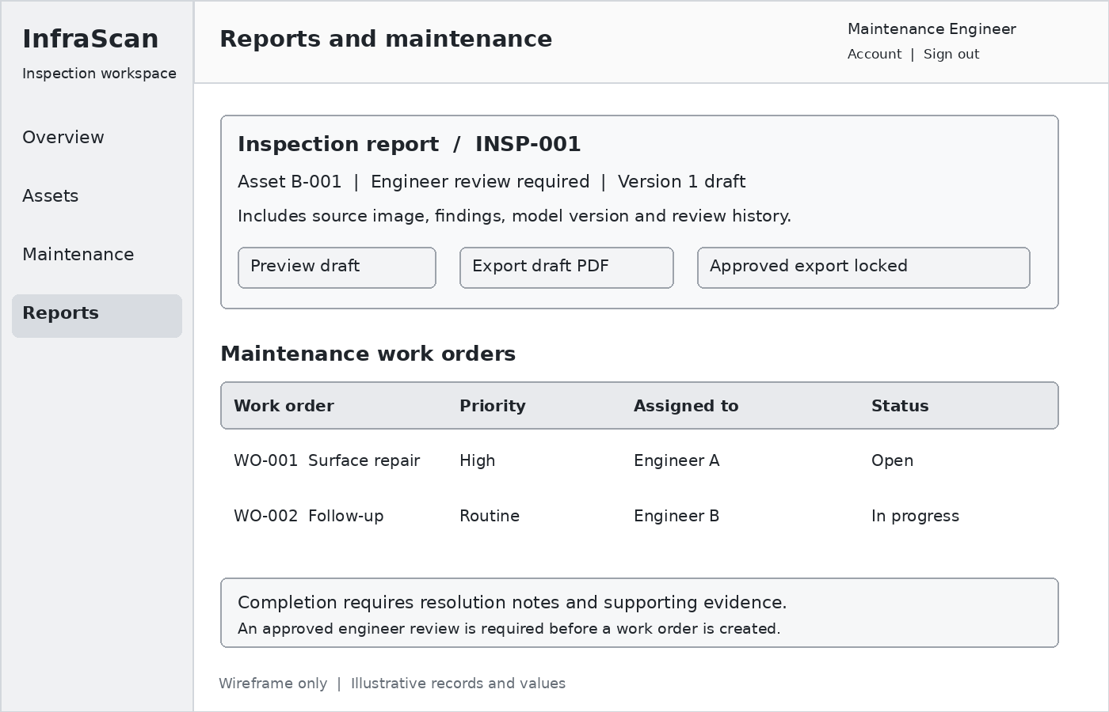
Figure 19 Low fidelity layout with illustrative records
Element or state | Expected behavior
Preview or draft export | Generate a clearly marked draft from the selected result snapshot.
Approved export | Enable only after the required engineer review and approver checks.
Update work order | Record progress, resolution notes and evidence before completion.

Managers assign work and due dates. Maintenance engineers update only assigned tasks. Export failures show Retry. The final workflow can schedule a follow-up inspection rather than overwriting the earlier inspection.

10 Frontend and backend environments
Task 10 establishes a runnable development project. The frontend uses React with an esbuild production bundle. The backend uses FastAPI, Pydantic validation and SQLAlchemy persistence. The backend serves the built interface and API from one origin, which avoids cross-origin cookie configuration in the local setup.
Component | Implemented location | Verification
React interface | frontend/src/app.jsx and style.css | npm ci followed by npm run build
Frontend output | frontend/dist/index.html, app.js and app.css | Backend serves the page and bundle
FastAPI backend | app/main.py and app/cli.py | Health route and API integration tests
Development data | SQLite database and private storage directory | Persistence and access tests
Optional database target | DATABASE_URL with PostgreSQL psycopg driver | Connection configuration supplied; PostgreSQL server not used in this local test

Project organization
app contains the backend and account setup command. frontend contains editable React source and the compiled distribution. tests contains the API suite. evidence contains test results and runtime versions. requirements.txt and requirements-dev.txt pin the executed Python dependencies. package-lock.json pins the frontend dependency tree.

Runtime and startup
Use Python 3.12 and Node.js 22 or newer. Create a virtual environment, install requirements.txt, run npm ci and npm run build inside frontend, then start uvicorn app.main:make_default_app --factory --host 127.0.0.1 --port 8000 from the project root. Open http://127.0.0.1:8000. The README includes Windows and Linux commands.
Create accounts with python -m app.cli create-user. The password comes from a prompt or INFRASCAN_ACCOUNT_PASSWORD. The seed-demo command creates five local role accounts only when explicitly run. No default account or fixed production password is created by server startup.
SQLAlchemy database engine documentation

11 Authentication and role based access
Task 11 implements account authentication with a salted scrypt password hash. A successful login creates an opaque random session token. The database stores its SHA-256 hash, user reference and expiry. The browser receives an HttpOnly SameSite Strict cookie. Sessions expire after eight hours. Logout deletes the server-side record and clears the cookie.
Role | Milestone One permissions | Object scope
Administrator | Register, edit and archive assets; assign inspections | All departments
Manager | Register, edit and archive assets; assign inspections | Own department
Inspector | View assigned work; upload and preprocess images | Assigned inspections
Civil Engineer | Read assigned inspection evidence | Assigned reviewer records
Maintenance Engineer | Read department assets and inspection evidence | Own department

Server side enforcement
The API checks the active user, role and exact asset or inspection before reading or modifying evidence. A hidden UI action is not the access-control boundary. Users cannot choose a role at login. One assigned role per account is implemented in the local prototype. The broader design supports a future user_roles relation for multiple approved roles.

Session protections
Every authenticated state-changing request requires the session CSRF value in X-CSRF-Token. The service rejects cross-origin writes. Five failed sign-ins for one email in five minutes trigger a temporary limit. Invalid login messages do not reveal whether an account exists. Disabled accounts and expired sessions receive HTTP 401.
The local HTTP setup uses COOKIE_SECURE=false. Set COOKIE_SECURE=true behind HTTPS. The prototype has no password-reset email, external identity provider or administrator web console. Account creation is a controlled local command, sufficient for this milestone authentication flow.
Evidence: tests verify login, cookie flags, password hashing, invalid credentials, rate limiting, CSRF, cross-origin rejection, logout, expiry, role restrictions, department restrictions and assignment restrictions.

12 Infrastructure asset management
Task 12 implements persistent asset creation, search, editing and archiving. The manager form records a unique code, name, asset type, material, location, inspection interval and optional construction year and coordinates. The API validates all fields and converts codes to uppercase before enforcing uniqueness.
Validation | Implemented behavior
Unique asset code | Duplicate codes, including different case, return HTTP 409
Coordinates | Latitude and longitude must be supplied together and stay in range
Inspection interval | Positive days from 1 to 3650
Department | Managers create and edit records in their own department
Archive | Retains existing inspections and images; prevents new inspections

Inspection assignments and history
A manager creates an inspection for an active asset and supplies the component, inspection date and assigned inspector. An optional civil engineer becomes the reviewer. Assignment validation requires active users with matching roles in the asset department. The inspection list preserves the link to the asset and gives authorized users access to its images.
The local inspection states cover Assigned and Capturing. Uploading an image moves the record to Capturing. Processing results live in separate versioned preprocessing runs. Later milestone states such as engineer approval and closure are part of the design and are not simulated as completed operations.

Access and traceability
Inspectors see assets through their assigned inspections. Engineers see reviewer assignments. Managers and maintenance engineers see their department. Administrators have technical access across departments, but technical administration does not grant engineering approval. Asset creation, changes, archive actions and inspection creation produce audit records.
Evidence: the API suite checks registration, field validation, duplicate codes, department access, invalid assignments, editing, archiving and retention of previously uploaded evidence.

13 Image upload and private evidence storage
Task 13 provides a multipart upload endpoint for the assigned inspector and a React file selector. The service reads the upload in bounded chunks and rejects files above 10 MB. It decodes actual content with Pillow instead of trusting the filename or browser MIME type. Only single-frame JPEG and PNG images are accepted.
Upload check | Behavior
Size | Reject more than 10 MB with HTTP 413
Decoded format | JPEG and PNG only; reject unsupported formats with HTTP 415
Dimensions | At least 32 pixels per side and at most 20 million pixels
Corrupt or unsafe content | Reject decoding errors and decompression-bomb warnings
Duplicate evidence | Same SHA-256 within an inspection returns HTTP 409
Private paths | Random server-side object keys; no user filename in the storage path

Originals and retrieval
Each accepted image record stores its original filename, detected MIME type, raw dimensions, EXIF orientation, size, checksum, uploader and inspection reference. The exact uploaded bytes remain unchanged. Image retrieval goes through authenticated API routes; the storage directory is not a public static directory.
An unauthorized or unassigned user cannot retrieve the original, preprocessed image or normalized tensor. The frontend uses the user-facing filename only as escaped React text. File content and ownership checks remain on the server. A renamed PNG with a JPG filename is recognized and served as PNG based on its decoded content.

User feedback and evidence
The interface shows completion or a plain rejection reason. Existing images and preprocessing history remain visible when another upload fails. The implementation uses a submitted/uploading state through disabled actions and a final status message; byte-by-byte upload progress is a later interface enhancement.
Evidence: tests cover preserved original bytes, SHA-256 equality, duplicate rejection, corrupt files, oversized files, tiny images, unsupported GIF content, filename/MIME mismatch and assignment access.
FastAPI file upload documentation

14 Initial image preprocessing pipeline
Task 14 implements an initial reusable image-preparation pipeline. The assigned inspector starts preprocessing after upload. Each request creates a new versioned run, so retries preserve earlier successes or failures. This milestone uses synchronous execution for bounded images. A queue and separate worker remain the target for long inference jobs.
Stage | Implemented operation | Stored evidence
Decode and validate | Recheck the stored JPEG or PNG | Format, raw dimensions and orientation
Correct orientation | Apply EXIF transpose | Original and oriented image size
Color conversion | Convert to RGB; composite transparency on white | Three color channels
Resize and letterbox | Preserve aspect ratio inside 640 by 640 pixels | Exact resized size, scales and offsets
Normalize | Convert channel-first float32 tensor with pixel / 255 | Tensor shape 3 by 640 by 640 and range 0 to 1
Save outputs | Private PNG and NPY files | Run version, status, output keys and quality measurements

Quality measurements
The pipeline calculates mean grayscale brightness and a Laplacian variance proxy at 256 by 256 pixels. Provisional flags ask for exposure review below 35 or above 230 brightness, or blur/low-texture review below 25 variance. These are demonstration thresholds, not validated engineering acceptance criteria. The UI labels flagged outputs Review required. No damage inference endpoint is enabled.
The normalized NPY tensor is a real saved array, not a placeholder. Tests read it back and check shape, float32 type and range. The PNG preview retains 0 to 255 display values. A test image of 900 by 450 pixels becomes 640 by 320 with 160 pixels of padding above and below. Original uploaded bytes remain unchanged.
Pillow image orientation documentation

14 Preprocessing provenance and failure handling

Coordinate mapping and measurements
Metadata records the raw size, EXIF orientation, oriented size, resized size, horizontal and vertical scales, and top-left padding. For a future output coordinate on the prepared image, subtract padding and divide by the corresponding scale to return to the oriented image. Apply the recorded inverse EXIF orientation before comparing with raw original coordinates.
The pipeline stores pixel measurements only. It does not estimate millimetres, crack width, structural safety or severity. Physical measurements require a verified calibration and viewpoint review in later work.

Run state and recovery
Each preprocessing run has Running, Succeeded or Failed status. A failure retains a plain reason without exposing a private filesystem path. Retrying creates a new run ID. Successful earlier runs remain accessible, and a failed image does not remove the inspection. Events record image upload, preprocessing success and preprocessing failure.

Executed verification
Scenario | Observed result
EXIF orientation 6 | A 120 by 80 JPEG becomes an oriented 80 by 120 image
RGBA PNG | Transparency composites on white and produces RGB output
Letterboxing | 640 by 640 output preserves aspect ratio and records offsets
Normalization | Saved tensor is float32 with shape 3 by 640 by 640 and values in 0 to 1
Corrupt stored source | Run becomes Failed and retains its error record
Retry after source recovery | A separate Succeeded run preserves the earlier Failed run
Unassigned user | Original, image output and tensor remain inaccessible

Milestone boundary
This pipeline prepares images for later classification, detection and segmentation. No prediction result, confidence, trained accuracy or completed engineering review is fabricated. The actual Milestone 1 outcome is a tested local capture and preparation workflow with the planning and dataset evidence needed for the next stage.

15 Acceptance checks and implementation evidence
The checks below connect the 14 Milestone 1 requirements to the completed analysis, designs and local implementation. The API test record and browser workflow record accompany the source package.
Area | Acceptance check and evidence
Objectives and workflow | Asset to inspection to image to review to maintenance flow is explicit, including retake and failure paths.
Infrastructure scope | Initial asset types and later extensions are separated; exact surface and material are recorded.
Dataset selection | Each selected source is mapped to a supported label type and licence condition.
Executed EDA | All five dataset sources are audited at the stated release coverage. Per-image evidence, object/mask counts, duplicates, checksums and issues are preserved in CSV and JSON.
Class distribution | Pixel, image and object-instance counts stay distinct. Road class counts are measured from the full release. No training score is claimed.
Architecture | React, API, worker, structured storage and private file storage have clear responsibilities.
Database design | 17 tables cover access, asset history, image quality, model provenance, review, maintenance, reporting and audit.
UI wireframes | Seven screens include permissions, required fields, loading/failure states and engineer review actions.
Frontend and backend | React bundle built; FastAPI health and static routes verified; startup guide and locked dependencies supplied.
Authentication and roles | Login/logout, session expiry, CSRF, five-role permissions and department/assignment checks pass tests.
Asset management | Create, search, edit, archive and inspection assignments work with validation and preserved evidence history.
Image upload | JPEG/PNG upload works with limits, actual-content validation, duplicate detection, checksums and private retrieval.
Initial preprocessing | EXIF correction, RGB, aspect-ratio resize, letterbox, normalized NPY tensor, quality metadata and retry history pass tests.

Supporting files
The source package contains the React and FastAPI application, compiled frontend, dependency locks, setup guide and executed test evidence. The preserved analysis evidence contains all five dataset audits, per-image and per-object results, duplicate reports, checksums, plots, the proposed SQL schema and editable wireframes. Public dataset releases are not redistributed.

Milestone One implementation verification
Tasks 10 to 14 are implemented in the local prototype. The React production bundle builds successfully and FastAPI serves it from the same origin. The automated API suite passes 26 checks. The browser workflow result is recorded in evidence/browser_smoke.json. Production hosting and trained AI models remain later milestone work.
Before model training, finish the CrackForest region mapping review and leakage checks. Complete the documented duplicate/label/box reviews, finalize engineer-reviewed severity criteria and validate image quality thresholds with representative inspection photos.

16 References and reproducibility
Project brief and dataset publisher or author sources are listed below. Dataset availability and release terms were checked on 19 October 2026. All EDA counts in this revision come from executed file-level audits. Dataset source descriptions are cited separately from the measured results.
[1] InfraScan project brief
Supplied PDF: InfraScan AI Powered Crack and Damage Assessment for Civil Infrastructure. Requirements: pages 1 to 2; modules: pages 4 to 24; Milestone 1: pages 24 to 26; evaluation and stack: pages 30 to 39.
[2] CrackForest Dataset
Cui, Limeng and collaborators. Author dataset repository. Licence: non-commercial research only. Cite Shi et al., Automatic road crack detection using random structured forests, IEEE T ITS, 17(12), 3434 to 3445, 2016.
Open source
[3] SDNET2018 dataset
Maguire, Dorafshan and collaborators. Utah State University public dataset record. Concrete surface image classification source. DOI 10.15142/T3TD19.
Open source
[4] SDNET2018 original data article
Dorafshan, Thomas and Maguire. SDNET2018 An annotated image dataset for non contact concrete crack detection using deep convolutional neural networks. Data in Brief 21, 1664 to 1668, 2018. DOI 10.1016/j.dib.2018.11.015. Source article for dataset context; class counts were independently audited in this revision.
Open source
[5] Concrete Crack Images for Classification
Ozgenel, Caglar Firat. Mendeley Data, Version 2. DOI 10.17632/5y9wdsg2zt.2. Original Version 2 RAR and publisher metadata; licence CC BY 4.0.
Open source
[6] RDD2022 official repository
Sekilab RoadDamageDetector. Author links to RDD2022 releases, labelled training structure and the four challenge categories.
Open source
[7] CRDDC 2022 data page
Challenge organizer documentation of road categories D00, D10, D20 and D40.
Open source
[8] Crack500 author project
Yang and collaborators. Pavement crack detection dataset and model. Author distribution links, split-list workflow and original paper citations.
Open source
Executed audit commit: ed57c2d96754e6c7d105805cd29aeeb3a799f267. Dependencies: Python, NumPy, SciPy, Pillow and Matplotlib. The 37 unmatched CFD images, the new audits and all per-image measurements are included in the supporting results.

17 Release verification and evidence
[9] RDD2022 Figshare Version 1 release
Publisher distribution of the full RDD2022 archive. DOI 10.6084/m9.figshare.21431547.v1. The downloaded archive is 13,264,172,619 bytes, and its MD5 matches the publisher metadata. The full image and annotation coverage is recorded in the RDD audit pages.
Open RDD2022 publisher release
Open concrete classification publisher metadata
Open author linked Crack500 source package

Archive verification
Source archive | Verification recorded
SDNET2018 outer release | Publisher MD5 matched  677411e784f194422c90f52d9ed0d7c6
Concrete classification RAR | Publisher SHA256 matched  08d7dc505a4f5a0330cee2fa2a1ae4b5b4f98bcffd0549b774caf7959bb1f02f
RDD2022 full release | Publisher MD5 matched  b62bd51d2ffcfaa76c60f234f0cc2bb3
Author linked pavement package | Downloaded through the author repository link. SHA256 and byte size are recorded in archive_checksums.json; no publisher checksum comparison was available.

How to reproduce the new EDA
Follow analysis/expanded/README.md in the supporting ZIP. It records the public source URLs, archive names, package versions and commands. Run the classification, Crack500 and RDD audit scripts, then the validation and aggregation script. No trained weights or credentials are needed.
The evidence includes image_audit.csv for each classification dataset and RDD, object_audit.csv for RDD, image_and_mask_audit.csv for Crack500, exact duplicate reports, per-dataset summary JSON, charts and actual annotation examples. Original source datasets are not redistributed in the supporting ZIP.
Release counts describe files as received. Exact duplicates, unsupported labels and potential source-group overlaps are reported rather than removed silently. The EDA establishes data readiness issues; it does not demonstrate model accuracy or physical damage severity.

