InfraScan
AI-Powered Crack & Damage Assessment for Civil Infrastructure
Milestone 1 Report (Week 1): Project Definition, Dataset Selection and Exploratory Data Analysis
Prepared by | Programme | Milestone | Date
Yashraj Ghadage | Infosys Springboard Internship | Milestone 1 (Week 1) | October 2026

1. Executive Summary
InfraScan is a proposed AI-assisted platform that detects, outlines and classifies visible cracks and surface damage in images of civil infrastructure and supports inspection reporting and maintenance planning. This report covers the Week 1 deliverables: project objectives and inspection workflow, target infrastructure types, public dataset selection, dataset structure and annotations, and exploratory data analysis (EDA). The system architecture (Section 8), database design (Section 9) and UI wireframes (Section 10) for the platform are also specified.
- Five public datasets were selected, downloaded and inspected (143,492 image files, 16.4 GB). Each supports a different task (classification, detection or segmentation) and they are not interchangeable.
- Class imbalance is present throughout: 15.1% of SDNET2018 images are cracked, crack pixels are 1.62% of CFD pixels (about 61:1 against background), and the largest RDD2022 class has four times the boxes of the smallest.
- Data-quality issues were found: duplicate images in Concrete Crack Images (4.0%) and SDNET2018, unlabelled images in CFD, and model-prediction files mixed into the Crack500 download.
- No selected dataset covers spalling, corrosion or exposed reinforcement, or tunnels, dams and retaining walls.

2. Project Objectives and Inspection Workflow

2.1 Objectives
- Detect and localise visible cracks and surface defects in infrastructure images.
- Generate pixel-level crack masks and classify crack or defect type where compatible annotations exist.
- Estimate crack length and width where scale calibration allows; otherwise report values in pixels.
- Support damage-severity assessment using documented criteria and qualified review.
- Maintain inspection history, compare conditions over time and generate inspection reports.
- Support maintenance prioritisation while leaving structural-safety decisions to qualified engineers.

2.2 Scope and limitation
This milestone covers problem definition and data understanding only; model training, the web platform and deployment are planned for later milestones. Image-based findings are decision support and do not replace an engineering inspection. The absence of detections does not prove that a structure is free of defects.

2.3 Inspection workflow
The workflow has eight stages. An engineer reviews AI findings before anything is reported, and scheduled re-inspections return to stage 1.
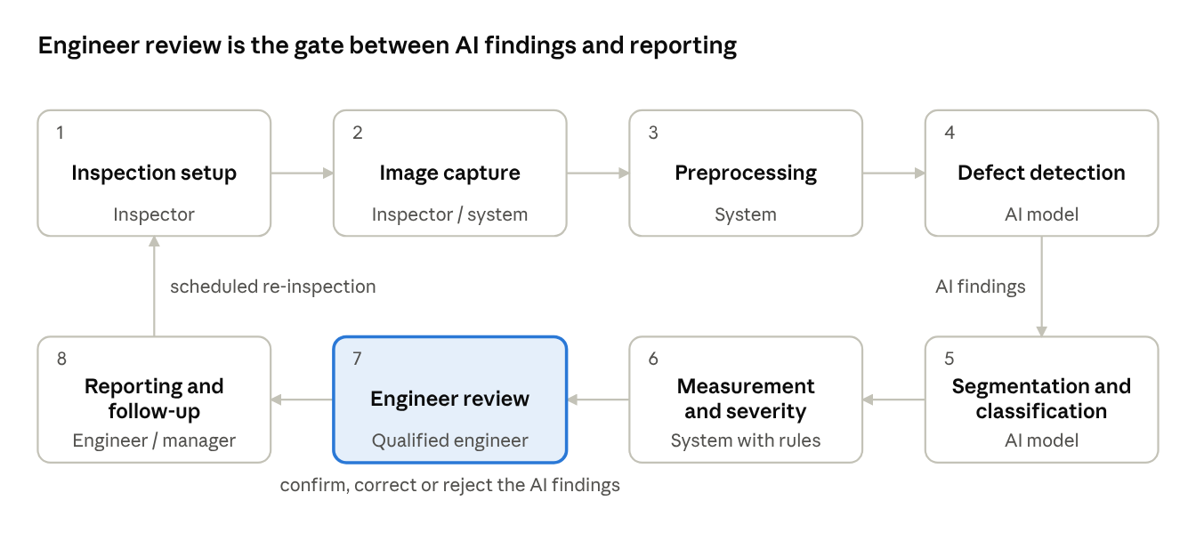
Figure 1. Inspection workflow: 8 stages, 1 review gate and 1 re-inspection loop.
Table 1. Workflow stages, outputs and responsibilities.
Stage | Activity | Output | Performed by
1. Inspection setup | Create an inspection record and select the asset | Inspection ID linked to asset | Inspector
2. Image capture | Capture or upload images; check blur, lighting, resolution, completeness | Validated images | Inspector / system
3. Preprocessing | Resize, normalise and enhance while preserving fine crack detail | Model-ready images | System
4. Defect detection | Locate defects with a detector trained on box annotations | Bounding boxes, confidence | AI model
5. Segmentation and classification | Trace crack pixels; classify crack or damage type where labels exist | Crack masks, type labels | AI model
6. Measurement and severity | Estimate dimensions (if calibrated); apply severity criteria | Measurements, severity category | System with rules
7. Engineer review | Confirm, correct or reject AI findings | Reviewed assessment | Qualified engineer
8. Reporting and follow-up | Record findings, set priority, schedule re-inspection, compare with earlier visits | Inspection report, work items | Engineer / manager

3. Target Infrastructure Types
Table 2. Target infrastructure, typical defects and public data support.
Infrastructure type | Typical visible defects | Public dataset support | Priority
Roads and pavements | Longitudinal, transverse and alligator cracks; potholes | Strong (RDD2022, CFD, Crack500) | Primary
Concrete surfaces (bridge decks, walls) | Surface cracks | Good for classification (SDNET2018, CCIC); limited for segmentation | Primary
Buildings | Wall cracks, spalling, staining | Partial (via concrete datasets) | Secondary
Bridges | Deck and girder cracks, corrosion, exposed reinforcement | Partial (SDNET2018 decks) | Secondary
Tunnels, dams, retaining walls, industrial structures | Cracks, leakage, delamination | None selected | Future work

Phase 1 concentrates on road pavements and concrete surfaces because labelled public data exists for them. Models trained on roads should not be assumed to transfer to other materials without further data and evaluation.

4. Public Dataset Selection
Datasets were assessed on task alignment (image labels for classification, boxes for detection, masks for segmentation), domain relevance, scale, annotation quality and a research-compatible licence.
Table 3. Candidate datasets (sizes from the downloaded copies).
Dataset | Domain | Size | Annotation | Task
SDNET2018 | Concrete decks, walls, pavements | 56,092 images, 256×256 px | Image-level (cracked / uncracked) | Classification
Concrete Crack Images (CCIC) | Concrete surfaces | 40,000 images, 227×227 px | Image-level (positive / negative) | Classification baseline
RDD2022 | Roads, multiple countries | 38,385 images, 65,712 boxes (published: 47,420 images) | Bounding boxes, 5 class IDs | Detection
CrackForest (CFD) | Urban road pavement | 155 images (118 with masks), 480×320 px | Pixel-level masks | Segmentation
Crack500 | Road pavement | 500 full images and 3,368 patches, each with a mask | Pixel-level binary masks | Segmentation

Table 4. Selection decision.
Role in InfraScan | Selected dataset(s) | Reason
Crack / no-crack classification baseline | SDNET2018, CCIC | Large and labelled; covers decks, walls and pavements
Defect detection (boxes) | RDD2022 | Only large multi-class detection set; includes crack types and potholes
Crack segmentation (masks) | CFD, Crack500 | Pixel-level ground truth; CFD suits fast iteration, Crack500 adds training data

A classification-only dataset cannot train a detector or segmentation network, and no selected dataset provides physical crack-width ground truth.

5. Dataset Structure and Annotations

5.1 Annotation types
Table 5. Annotation types and compatible models.
Annotation type | What it records | Compatible model
Image-level label | Whole-image class, e.g. cracked or uncracked | CNN classifier (ResNet, EfficientNet)
Bounding box and class | Approximate location and defect category | Object detector (YOLO, Faster R-CNN)
Pixel-level mask | Crack versus background for every pixel | Segmentation network (U-Net, DeepLabV3+)

5.2 Folder structure of each dataset
Structures below are those of the downloaded copies; numbers are file counts.
SDNET2018 (label = folder name, 56,092 JPEG files)
SDNET2018/
├── Decks/
│ ├── Cracked/ 2,025
│ └── Non-cracked/ 11,595
├── Pavements/
│ ├── Cracked/ 2,608
│ └── Non-cracked/ 21,726
└── Walls/
├── Cracked/ 3,851
└── Non-cracked/ 14,287

Concrete Crack Images (label = folder name, 40,000 JPEG files)
CCIC/
├── Positive/ 20,000 (cracked concrete)
└── Negative/ 20,000 (intact concrete)

RDD2022 (YOLO text labels, one label file per image)
RDD_SPLIT/
├── train/
│ ├── images/ 26,869 JPEG
│ └── labels/ 26,869 TXT
├── val/
│ ├── images/ 5,758 JPEG
│ └── labels/ 5,758 TXT
└── test/
├── images/ 5,758 JPEG
└── labels/ 5,758 TXT

CrackForest Dataset (CFD) (MAT label maps)
CrackForest-dataset/
├── image/ 155 JPEG (+ image.rar archive)
├── groundTruth/ 118 MAT (per-pixel label maps)
├── seg/ 118 SEG (segmentation files)
└── README.md

Crack500 (binary PNG masks paired with JPEG images)
CRACK500/
├── traindata/ 250 image + mask pairs (full resolution)
├── valdata/ 50 image + mask pairs
├── testdata/ 200 image + mask pairs
├── traincrop/ 1,896 image + mask pairs (cropped patches)
├── valcrop/ 348 image + mask pairs
├── testcrop/ 1,124 image + mask pairs
└── *.txt file lists

5.3 Structural notes
- CFD: only 118 of the 155 images have masks; the 37 unlabelled images are excluded from supervised work. All labelled images are 480×320 and every mask matches its image. Mask labels are 1 = background and 2 = crack (confirmed by overlay). Labels 3 and 4 occur in 22 images (0.66% and 0.0075% of pixels), are undocumented, and are treated as non-crack. The licence is non-commercial research only.
- RDD2022: the copy is a re-split in YOLO format rather than the original PASCAL VOC XML. Five class IDs occur, and no class-name file was found. The first four are assumed to be D00, D10, D20 and D40 in that order, and the fifth is unnamed; this mapping has not been confirmed, so per-class results are provisional. About 30% of label files are empty (images with no damage).
- Crack500: test result contains predictions from a published model, not ground truth, and were excluded from training, evaluation and image counts. Full images average about 2,500×1,500 px; patches average about 630×370 px.

6. Exploratory Data Analysis

6.1 Image inspection results
All 143,492 image files opened without error. Image size is uniform in the classification datasets and varies widely in RDD2022 and Crack500, which will drive the resizing strategy.
Table 7. Inventory, dimensions and duplicates per dataset.
Dataset | Images | Size (MB) | Width × height (px) | Mean brightness | Duplicates*
SDNET2018 | 56,092 | 506 | 256 × 256 | 162.6 | 13
CCIC | 40,000 | 234 | 227 × 227 | 172.8 | 1,598
RDD2022 | 38,385 | 10,560 | 512–4,040 × 512–2,044 | 129.1 | 1
CFD | 155 | 20 | 480×320 (153); 320×480 (2) | 134.9 | 0
Crack500 | 8,860† | 5,517 | 360–3,264 × 360–3,264 | n/a† | 0

* Redundant bit-identical copies (total files minus unique hashes). Identical images in different splits leak information between training and test sets. † The Crack500 count includes 3,868 masks and 1,124 prediction images, so brightness statistics are not meaningful.

6.2 Findings by dataset
- SDNET2018: uniform, well-exposed images; folder counts match the published totals exactly. Pavement texture produces dense edges in both cracked and uncracked images, so edge detection alone cannot separate the classes.
- CCIC: balanced and uniform, but about 4% of images are exact duplicates. In a 200-image sample, cracked images are slightly darker than uncracked ones, so a model could learn brightness instead of cracks.
- RDD2022: vehicle-mounted images at many resolutions; 1.71 boxes per labelled image and a median box area of about 1.5% of the image, so many defects are small.
- CFD: thin, branching cracks covering a small fraction of each image; masks follow the crack path closely. All images contain cracks, so CFD cannot measure false positives on clean surfaces, and 118 images are too few to evaluate generalisation alone.
- Crack500: coarse asphalt with stones, shadows and varied lighting; masks outline wider regions than CFD. Crack-pixel fractions have not yet been measured (Section 12).
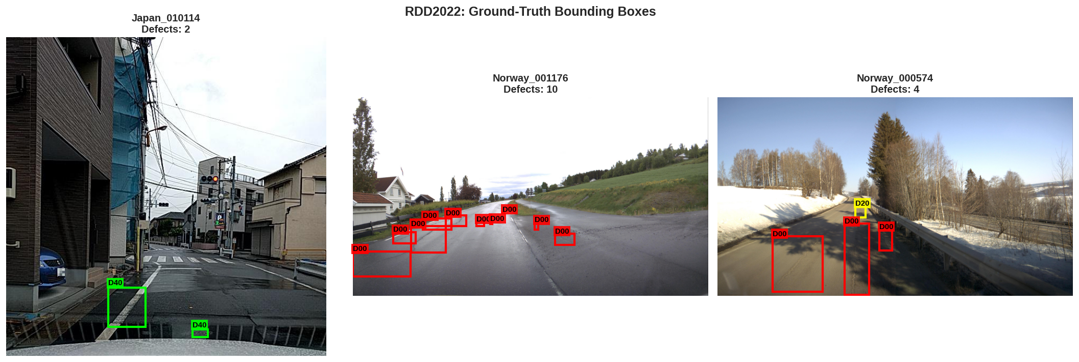
Figure 2. RDD2022 images with ground-truth boxes (class codes assumed).
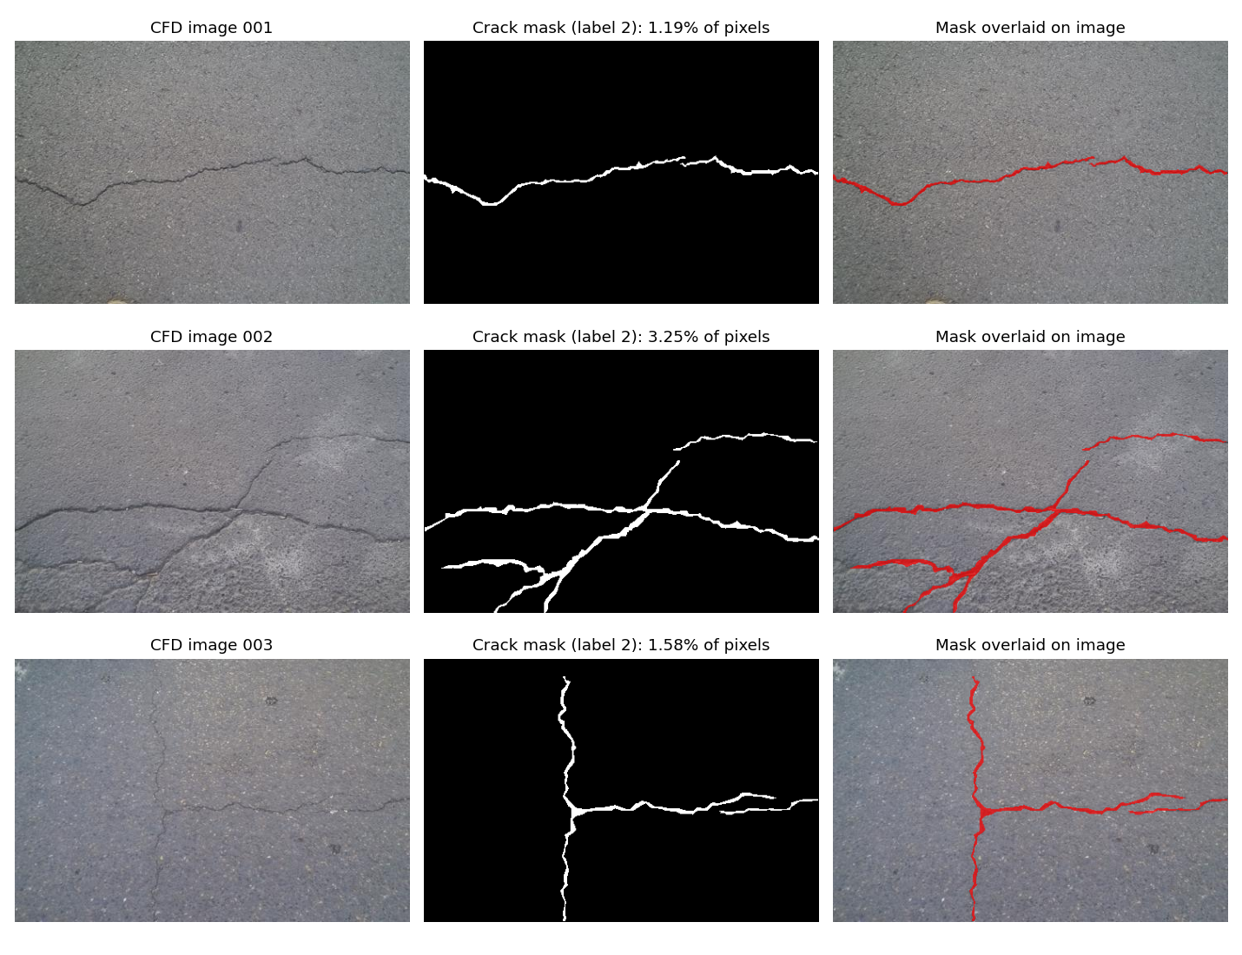
Figure 3. CFD images, crack masks (label 2) and overlays.
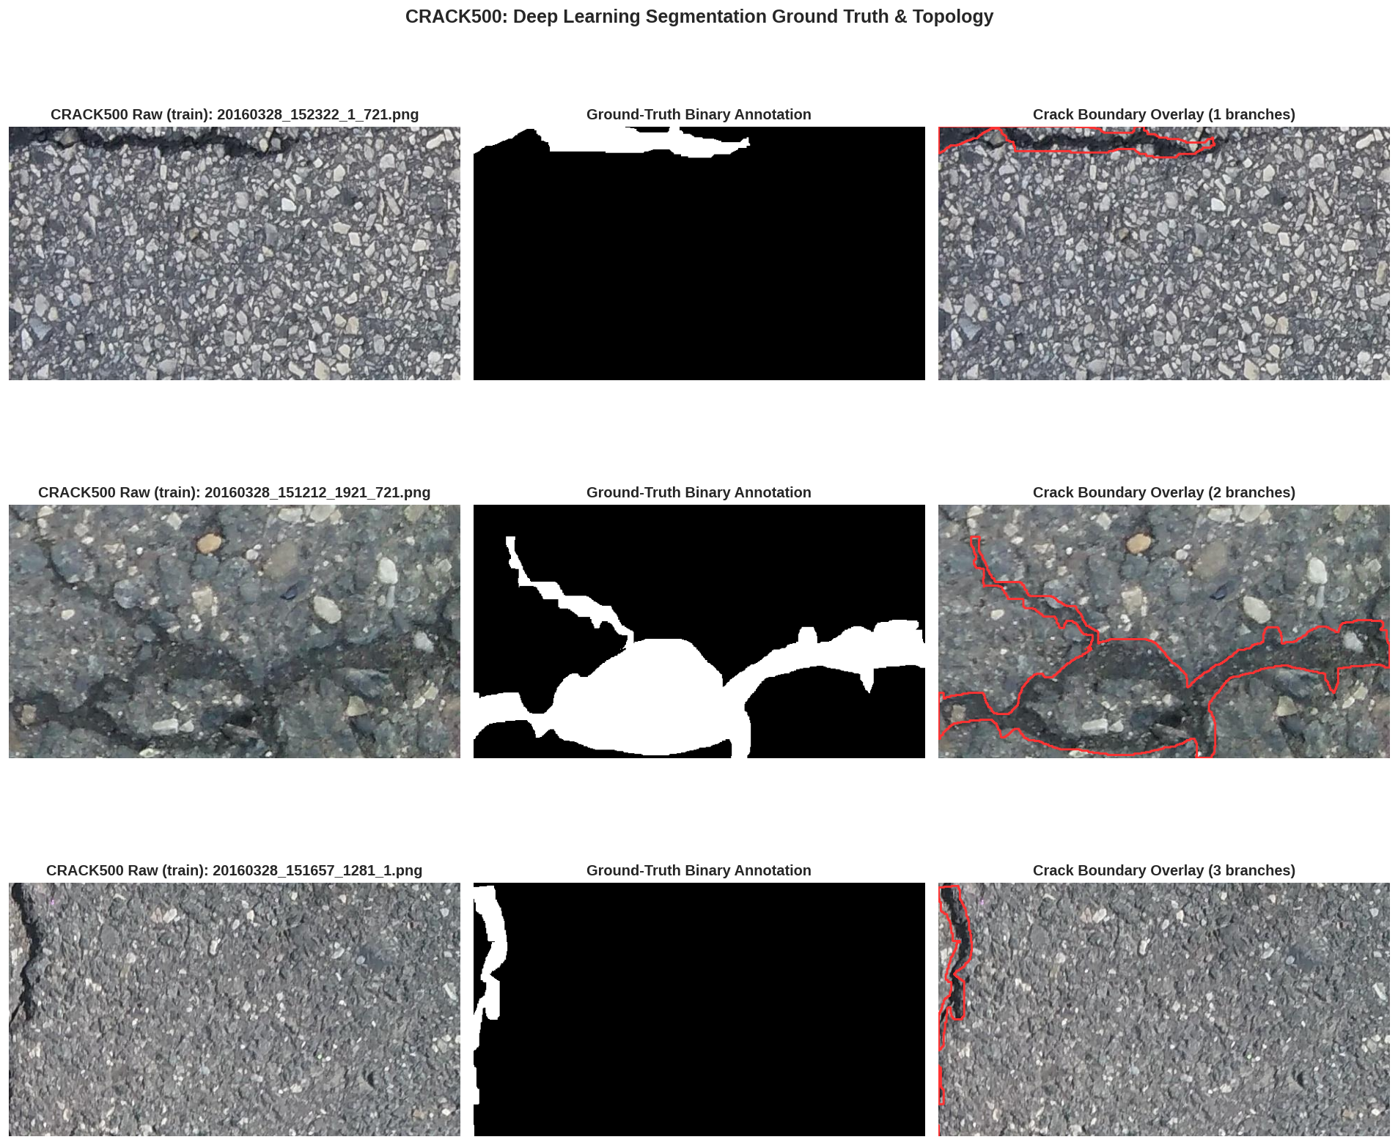
Figure 4. Crack500 samples: photograph, ground-truth mask and boundary overlay.

7. Defect Categories and Class Distribution

7.1 SDNET2018
Table 8. SDNET2018 class distribution.
Surface | Total | Cracked | Uncracked | Cracked share
Bridge decks | 13,620 | 2,025 | 11,595 | 14.9%
Walls | 18,138 | 3,851 | 14,287 | 21.2%
Pavements | 24,334 | 2,608 | 21,726 | 10.7%
All | 56,092 | 8,484 | 47,608 | 15.1%

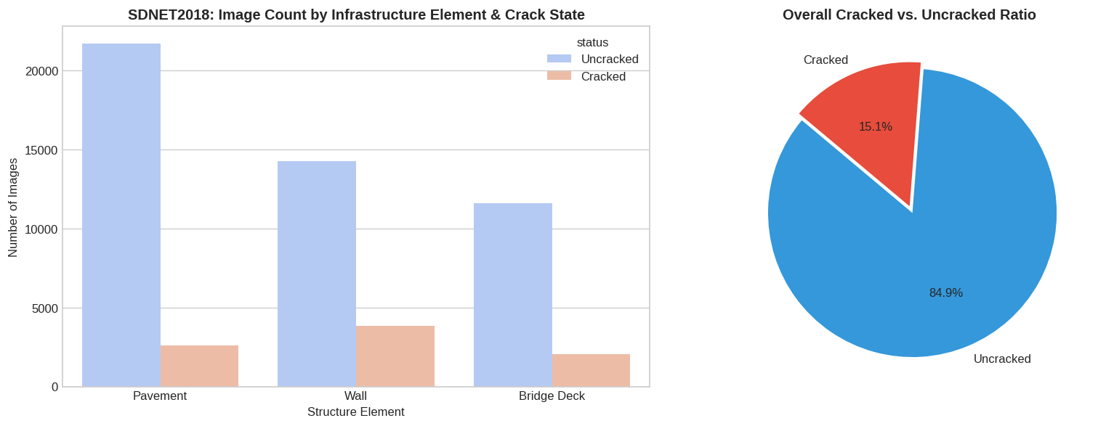
Figure 5. SDNET2018 images by structure element and crack state.

7.2 Concrete Crack Images
The dataset holds 20,000 positive and 20,000 negative images. It is balanced, which suits a baseline but does not reflect real inspections. Class counts are to be re-checked after duplicates are removed.
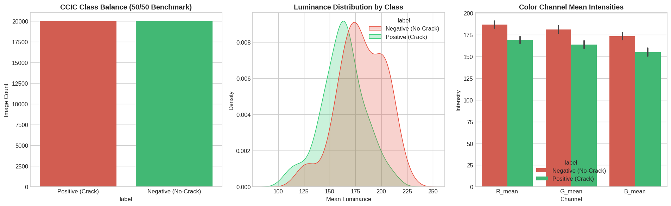
Figure 6. CCIC class balance, luminance and colour-channel means (200-image sample).

7.3 RDD2022
Table 9. RDD2022 box counts per class (class names assumed).
Class ID | Code | Damage type | Boxes | Share
0 | D00 | Longitudinal crack | 26,016 | 39.6%
1 | D10 | Transverse crack | 11,830 | 18.0%
2 | D20 | Alligator crack | 10,617 | 16.2%
3 | D40 | Pothole | 10,705 | 16.3%
4 | unnamed | Unidentified (cls4) | 6,544 | 10.0%
Total |  |  | 65,712 | 100%

One image can hold several defects, so image counts and instance counts are reported separately. About 30% of images have no boxes, which provides background examples for the detector.
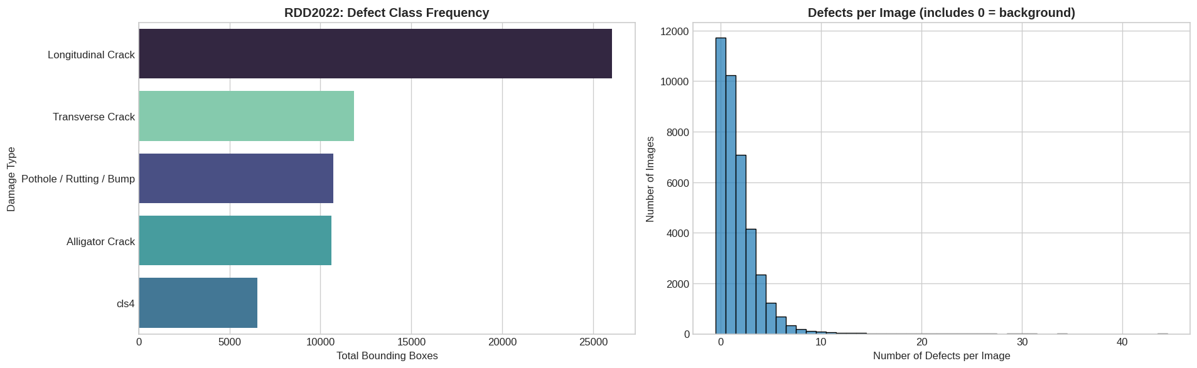
Figure 7. RDD2022 boxes per class and defects per image.

7.4 CFD and Crack500
Table 10. Pixel-level class distribution.
Dataset | Crack pixels | Background pixels | Status
CFD | 1.62% | 97.71% (plus 0.67% labels 3 and 4) | Computed from downloaded files
Crack500 | To be computed | To be computed | Pending clean re-run

CFD crack coverage per image has mean 1.62%, median 1.31%, range 0.35–6.33% and standard deviation 1.06%. Images contain 2.7 connected crack components on average (median 2, maximum 19).
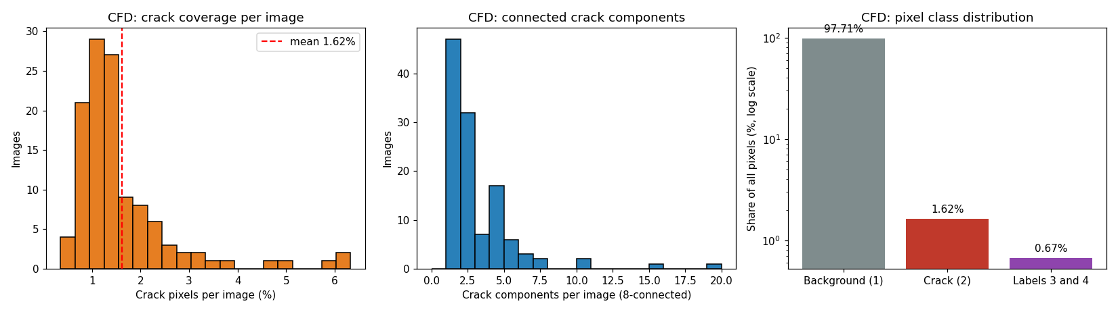
Figure 8. CFD crack coverage, connected components and pixel class distribution.

7.5 Coverage gaps against project goals
Table 11. Gaps between project goals and available labels.
Required capability | Available label | Gap
Longitudinal, transverse, alligator crack types | RDD2022 (roads only) | No crack-type labels for concrete walls or bridges
Hairline, diagonal, vertical, horizontal cracks | None | Additional annotation, or derive orientation from masks
Spalling, corrosion, exposed reinforcement | None | Additional dataset required
Crack width in millimetres | None | Calibrated images with a reference scale
Severity categories | None | Expert-defined criteria and annotation

7.6 Observations relevant to model training
- With 15.1% cracked images in SDNET2018 and 1.62% crack pixels in CFD, accuracy alone would be a misleading measure. Precision, recall, F1, IoU and Dice are the appropriate metrics, together with Dice, focal or class-weighted losses.
- Identical images in different splits would leak information between training and test sets. The 1,598 redundant copies in CCIC and 13 in SDNET2018 were identified for removal before splitting.
- Damage centres in RDD2022 cluster in the lower half of the frame, so vertical flips would produce unrealistic road images; horizontal flips, small rotations and brightness changes preserve the labels.

8. System Architecture
InfraScan is organised in layers. Users reach the platform through a web application and an optional mobile app. Requests pass through an API gateway that handles authentication, authorisation and routing, while image analysis runs in separate AI microservices. This separation lets each model be replaced, compared or rolled back without changing the rest of the system. Figure 9 follows the reference architecture in the project specification. It is a design for later milestones; no services were built in Week 1.
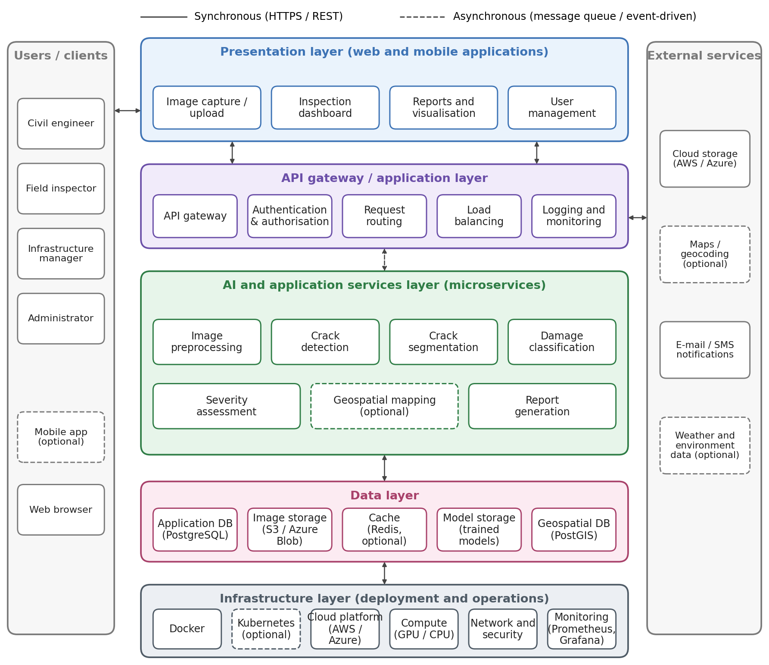
Figure 9. InfraScan layered system architecture, following the project specification.

8.1 Components and technologies
Table 12. Architecture layers, components and candidate technologies.
Layer | Main components | Candidate technologies
Users and clients | Civil engineers, field inspectors, infrastructure managers and administrators, using the web application or the optional mobile app | Web browser; React Native with Expo (optional)
Presentation | Image capture and upload, inspection dashboard, progression comparison, damage map, reports and visualisation, user management | React.js, Tailwind CSS, Chart.js, Plotly, Leaflet.js; Camera API (mobile)
API gateway and application | API gateway, JWT and OAuth2 authentication, role-based authorisation, request routing, load balancing, logging | FastAPI, REST APIs, Pydantic, SQLAlchemy
AI and application services | Image preprocessing, crack detection, crack segmentation, damage classification, severity assessment, geospatial mapping (optional), report generation | PyTorch, TensorFlow, OpenCV, scikit-image; YOLO, RT-DETR, U-Net, SegFormer; Grad-CAM, Captum
Data | Application database, image and mask storage, cache (optional), model storage, geospatial database | PostgreSQL with PostGIS; AWS S3, Azure Blob Storage or MinIO; Redis (optional); MLflow
Infrastructure and operations | Containers, orchestration (optional), GPU and CPU compute, network and security, monitoring and logging | Docker, Docker Compose, Kubernetes (optional); AWS or Azure; Prometheus, Grafana; GitHub Actions
External services | Cloud storage, maps and geocoding (optional), e-mail and SMS notifications, weather and environment data (optional) | OpenStreetMap; e-mail and SMS providers (to be selected)

8.2 Request and data flow
An inspector uploads images from the web or mobile client. The API gateway checks the user’s token and role, and the image service validates the file, stores it in object storage and records its location and metadata in PostgreSQL. Analysis is queued rather than run inside the web request, so slow GPU inference does not block the interface and failed jobs can be retried. The preprocessing, detection, segmentation and classification services read the image and write boxes, masks, measurements and the model version back to the database. The engineer reviews the results, and only reviewed findings feed the inspection report.

8.3 Design considerations
Three constraints from the project specification shape the design. AI results are stored apart from engineer decisions, so an unreviewed finding is never presented as a confirmed defect. Large files stay in object storage and the database holds references, which keeps queries fast. The performance targets (under 500 ms for standard metadata requests and under 3 seconds for single-image inference, excluding upload) are monitored through API latency, inference time and GPU use. Services are packaged in Docker containers, so they can run on AWS or Azure; the choice between the two remains open.

9. Database Design
The database stores what the InfraScan workflow produces and needs: users and their login data, the infrastructure inspected, images, AI results, engineer decisions, reports and maintenance work, and the public datasets and models behind the analysis. A relational design was chosen because every record is linked to others (an image belongs to an inspection, a detection to an image, a review to a detection). Images and masks stay in file storage; the database keeps their location and descriptive data. The design has 22 tables in four groups (Figure 10); every operational table also carries organization_id, which separates each organisation’s data.
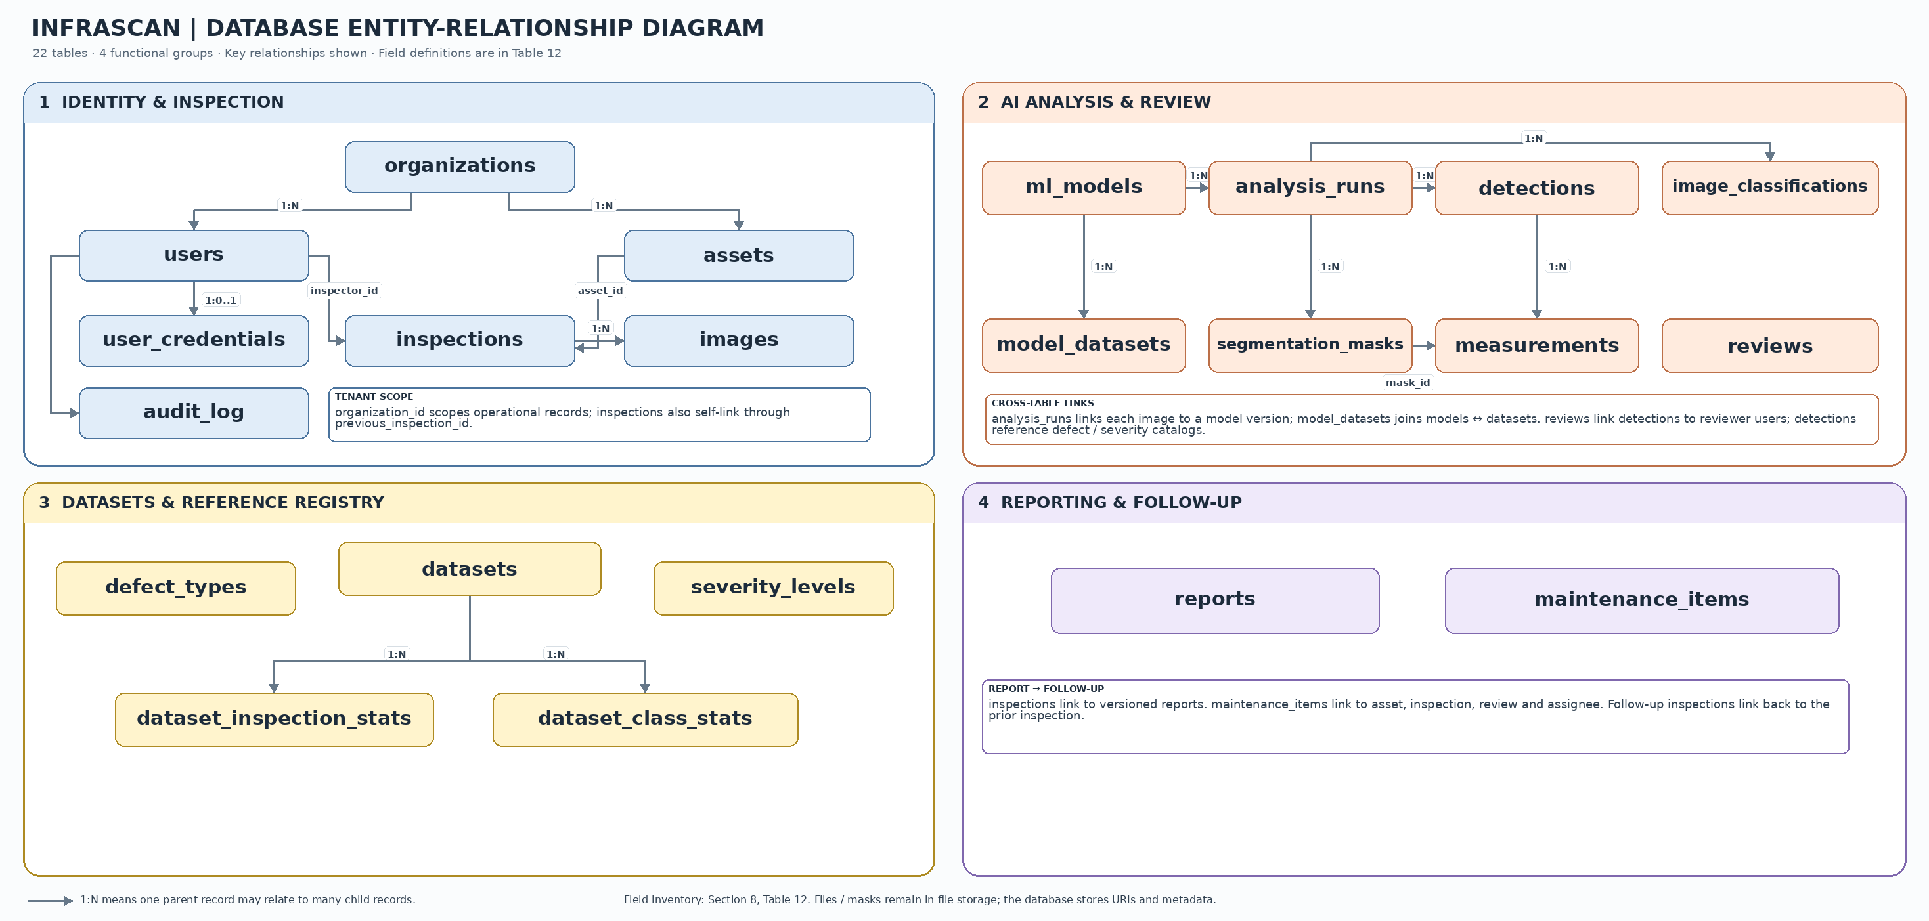
Figure 10. InfraScan database ER diagram: 22 tables in four groups.
Table 13. Data stored in each table.
Table | Data stored
users | Name, e-mail (the login name), role (inspector, engineer, manager, admin), account status, last login, optional single sign-on ID
user_credentials | Password hash (Argon2id or bcrypt; never the password itself), hash algorithm, failed-login count, lock time, multi-factor settings, reset-token hash and expiry. Needed only for local login.
organizations | Organisation name and status
assets | Name, type, material, address, latitude and longitude
inspections | Asset, inspector, date, status, next due date, link to the previous inspection
images | File location, format, size, brightness, hash (duplicate check), quality status, mm per pixel, GPS position, capture time and device
analysis_runs, ml_models, model_datasets | Which model version ran on which image; model name, version, task, metrics; datasets the model was trained on
detections, image_classifications | Defect type, confidence, bounding box (0 to 1), proposed severity; image-level cracked or uncracked result
segmentation_masks, measurements | Mask location and crack-pixel share; crack length and width in pixels or millimetres
reviews | Reviewing engineer, decision (confirmed, corrected, rejected), final defect type and severity, comment
reports, maintenance_items | Report versions and files; follow-up actions with priority, assignee, due date and status
audit_log | Who changed what and when, with old and new values (passwords and secrets excluded)
defect_types, severity_levels | Defect codes and names; severity levels with their criteria
datasets, dataset_inspection_stats, dataset_class_stats | Public datasets with licence, and their EDA statistics and class distribution

Passwords are kept only as salted hashes, in a table separate from the user profile, and are never copied to the audit log. AI results and engineer decisions are stored in separate tables, so only reviewed findings enter reports. Measurements are in pixels unless an image has a scale, and the audit log accepts inserts only. This is a design only; no database has been built. The severity levels await severity criteria, and user_credentials is needed only if the platform uses its own login instead of single sign-on.

10. User Interface Wireframes
Twelve low-fidelity wireframes were prepared to test the inspection workflow before interface development. Figure 11 shows the set, numbered 1 to 12 in workflow order. Green marks the primary action, orange items that need care, red a rejection, and grey dashed boxes image placeholders. Every AI output is labelled as decision support requiring engineer review.

10.1 Screen descriptions
Table 14. Purpose and key elements of each wireframe screen.
Screen | Purpose | Key elements and actions
1. Login and register | Secure entry to the platform | Email and password fields; log in; OAuth2 sign-in; registration and password recovery. Session timeout and audit logging apply.
2. Role dashboard and alerts | Shows each user’s work at a glance | Role selector; counts of assigned, pending, defect and high-priority items; damage trend and severity chart; recent assets with status; notification count.
3. Asset list and map toggle | Finds and filters infrastructure assets | Search; filters by type, department, status and frequency; table or map view; new asset action; a click opens the asset.
4. Asset detail | Shows one asset and its history | Asset ID, name, type, location, construction year, material and department; edit and new inspection actions; two past inspections selectable for comparison; maintenance history and linked images.
5. New inspection and image capture | Creates an inspection and uploads images | Asset, inspector and date fields; camera, gallery or drone upload; checks for format, resolution, low light, blur and duplicates; crop, rotate and orientation fixes; start AI analysis.
6. Damage analysis results | Displays AI output for review | Original and preprocessed images; bounding boxes with class; crack segmentation mask; Grad-CAM explainability overlay; crack type, length and maximum width in pixels (not calibrated); labelled as decision support only.
7. Engineer review | Records engineer decisions | AI findings overlay beside the original image; confirm, correct or reject for each finding; a reason is required for correct or reject; sign-off generates the report.
8. Progression comparison | Compares two inspections over time | Previous and current images, aligned; change in crack length and maximum width; timeline; warning that comparison needs the same viewpoint and a calibrated scale, otherwise values are in pixels.
9. Damage map | Shows defects by location | Map with markers coloured by severity and a heatmap toggle; filters by region, severity, damage type and date; hotspot summary; inspection route; map export.
10. Maintenance priority and work orders | Turns findings into tasks | Priority levels (routine, low, medium, high); urgent engineering review flagged as a review prompt, not an unsafe declaration; work-order table with status; assign, set due date and create work order.
11. Inspection report and export | Produces the inspection report | Inspection ID, asset, detected cracks, measurements, damage categories, AI confidence, model version and review status; choice of contents; export as PDF, CSV, Excel or JSON; engineer sign-off required before issue.
12. Admin console | Manages users, models and the platform | User roles, invitation and deactivation; model registry (v1.0 ResNet50 classification, v2.1 SegFormer segmentation, v3.0 multi-model); deploy, roll back and compare versions; audit log; platform health; model metrics.

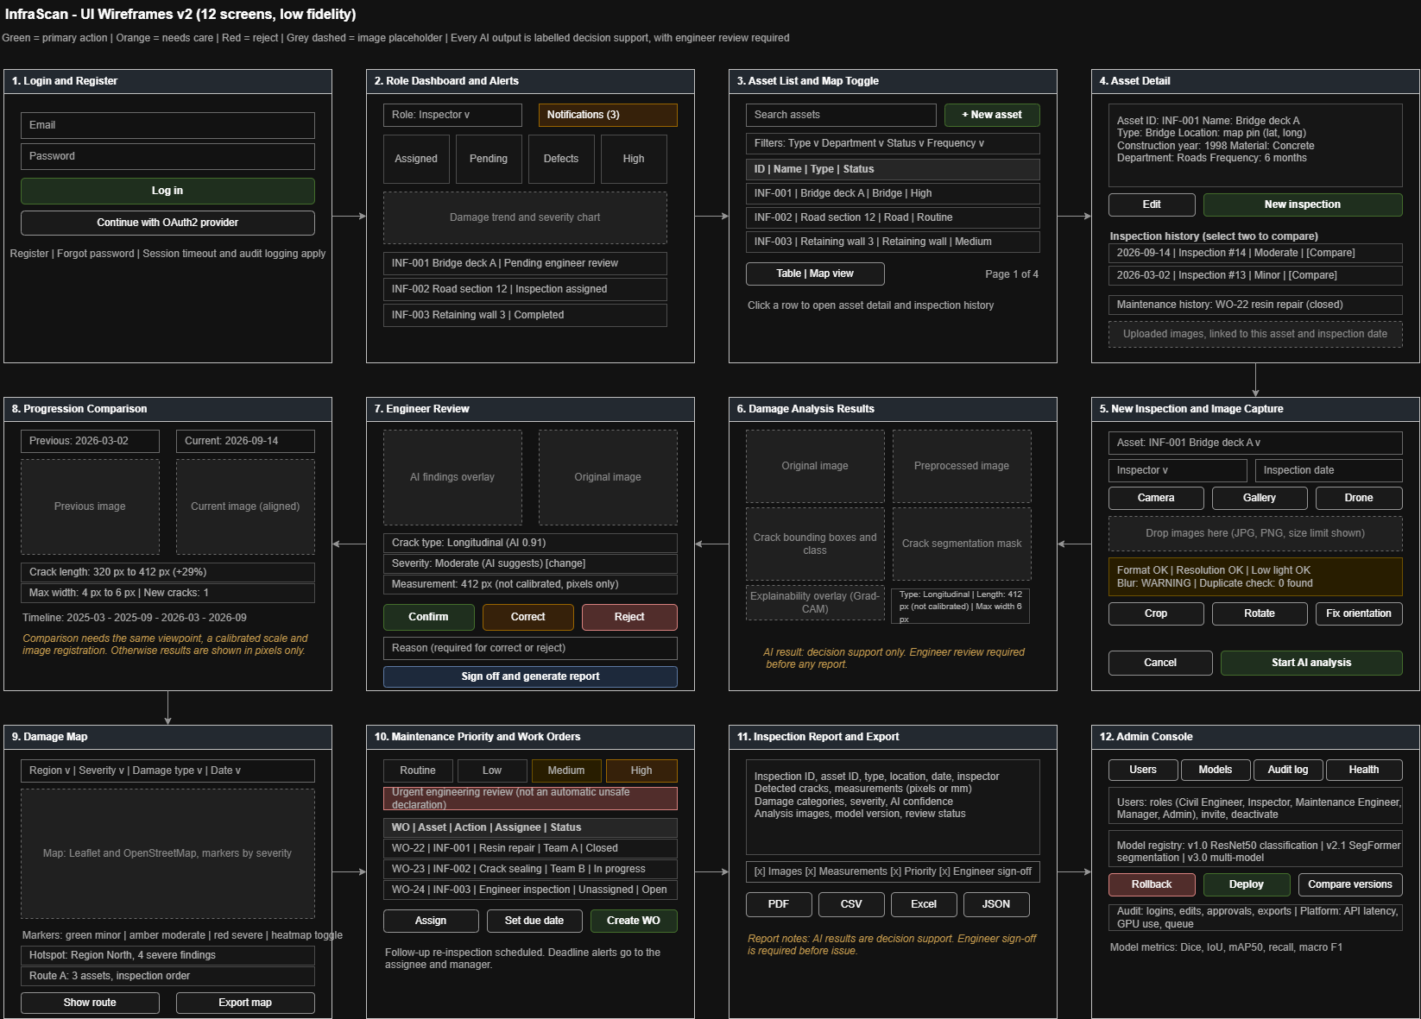
Figure 11. InfraScan UI wireframes v2: 12 low-fidelity screens.
Two points from the wireframes carry into the requirements. Critical findings are worded as a prompt for urgent engineering review rather than an automatic unsafe declaration, and every AI-generated output is labelled as decision support.

11. Risks and Mitigation
Table 15. Risk register.
Risk | Impact | Mitigation
Small segmentation set (CFD) | Overfitting, unreliable metrics | Combine with Crack500; pretrained encoders; augmentation
Road-trained models applied to concrete | Poor generalisation | Evaluate per material and report limits
Severe class imbalance | Missed cracks | Imbalance-aware losses; recall-focused evaluation
Duplicate images | Inflated test scores | Hash-based de-duplication before splitting
Unclear labels (CFD 3 and 4, RDD2022 class 4); predictions in Crack500 | Wrong masks, names or counts | Inspect samples; confirm names from source; exclude fphb_testresult
Non-commercial licences | Limits on deployment | Check each licence before commercial use

12. Conclusion and Next Steps
Week 1 defined what InfraScan should do, how an inspection flows from image capture to engineer review, and which public data supports each task. All five datasets were downloaded and inspected, and their folder structure, annotation types and class balance are documented. The main gaps are surface-damage classes, non-road infrastructure and calibrated measurement data. A 22-table database design specifies the data to be stored for users, inspections, images, AI results, engineer reviews, reports and maintenance, and how sensitive data such as passwords is protected.
- Confirmation of RDD2022 class names from the source documentation and recomputation of per-class counts.
- Measurement of Crack500 crack-pixel fractions per split directly from the mask files in the crop folders, excluding predictions.
- Removal of duplicate images and definition of the train, validation and test splits and the label mapping.
- Development of the preprocessing pipeline and the baseline classifier.
- Definition of severity criteria for the severity_levels table.
- Implementation of the database from the design in Section 9.

13. References
- Dorafshan, S., Thomas, R. J., & Maguire, M. (2018). SDNET2018: An annotated image dataset for non-contact concrete crack detection using deep convolutional neural networks. Data in Brief. https://doi.org/10.1016/j.dib.2018.11.015
- Arya, D. et al. (2022). RDD2022: A multi-national image dataset for automatic road damage detection. https://doi.org/10.1002/gdj3.260 ; data: https://doi.org/10.6084/m9.figshare.21431547.v1
- Shi, Y., Cui, L., Qi, Z., Meng, F., & Chen, Z. (2016). Automatic road crack detection using random structured forests. IEEE Transactions on Intelligent Transportation Systems. https://github.com/cuilimeng/CrackForest-dataset
- Zhang, L., Yang, F., Zhang, Y. D., & Zhu, Y. J. (2016). Road crack detection using deep convolutional neural network. IEEE ICIP. https://github.com/fyangneil/pavement-crack-detection
- Özgenel, Ç. F. Concrete Crack Images for Classification. Mendeley Data.

