HEALTHCARE OPERATIONS ANALYTICS
AND INTERACTIVE DASHBOARD SUITE
MedTrack_DV
Hospital Operations & Patient Analytics Dashboard
FINAL PROJECT DOCUMENTATION
Complete End-to-End Analytics Workflow

Project Name | MedTrack_DV
Domain | Healthcare Operations & Patient Analytics
Reporting Tool | Microsoft Power BI Desktop
Dashboards Delivered | 4 (Hospital Overview, Patient Flow, Department Analytics, Resource Utilization)
Core Dataset Volume | 10,000 admission records across 7 hospital departments
Document Type | Final Project Documentation
Status | Complete — Validated & Delivered

Prepared for academic evaluation and portfolio presentation

Table of Contents
1 Executive Summary 3
2 Project Overview 3
3 Project Objectives 4
4 Complete Project Workflow 4
5 Milestone Summary 6
6 Dataset Documentation 6
7 Data Cleaning & Transformation 9
8 Data Model / Dataset Relationships 10
9 KPI Engineering 11
10 Validated KPI Results 13
11 Dashboard Architecture 14
12 Hospital Overview Dashboard Guide 15
13 Patient Flow Dashboard Guide 16
14 Department Analytics Dashboard Guide 17
15 Resource Utilization Dashboard Guide 18
16 Dashboard Filters & Interactivity 19
17 Healthcare Operations Methodology 19
18 Dashboard Design & User Experience 20
19 Testing & Validation 20
20 QA Validation 21
21 Key Project Results 22
22 Project Repository Structure 22
23 GitHub Delivery 23
24 Final Deliverables 23
25 Project Evaluation Against Requirements 24
26 Limitations 24
27 Future Enhancements 25
28 Final Conclusion 25
Appendices
Appendix A — KPI Reference 26
Appendix B — Dashboard Screenshots 27
Appendix C — QA Checklist Summary 28
Appendix D — Testing Summary 29
Appendix E — Repository Structure 29

1 Executive Summary
MedTrack_DV is a hospital operations and patient analytics dashboard suite built to convert raw hospital transaction data into decision-ready operational intelligence. The project integrates patient, doctor, nurse, department, admission, and billing records into a single analytical dataset and presents the resulting insights through four interconnected Power BI dashboards.
Hospitals generate large volumes of operational data across admissions, discharges, staffing, and department activity, but this data is often scattered across disconnected records and is difficult to interpret without a consolidated reporting layer. MedTrack_DV addresses this problem by engineering six core healthcare KPIs — Total Admissions, Average Length of Stay, Readmission Rate, Occupancy Rate, Bed Utilization Rate, and Department Efficiency Score — directly from the underlying transactional data, and by surfacing them through an interactive, filterable dashboard interface.
Healthcare operational analytics of this kind matters because hospital administrators, department heads, and resource planners need a fast, accurate view of patient flow, department performance, and staffing/bed capacity in order to make informed operational decisions. A consolidated dashboard reduces the time needed to answer questions such as "which department has the highest readmission rate" or "how efficiently are beds being used" from a manual data-pull exercise to an interactive, filterable view.
The MedTrack_DV dashboard suite provides four purpose-built views — Hospital Overview, Patient Flow, Department Analytics, and Resource Utilization — each targeting a different operational lens on the same underlying dataset. The dashboards can be used by hospital administrators, operations managers, department heads, and analytics students/reviewers evaluating the project as a portfolio piece.
This Final Project Documentation is the final deliverable of the MedTrack_DV project. It consolidates the dataset documentation, KPI engineering methodology, dashboard guide, testing summary, and repository structure into a single, portfolio-ready report covering the complete analytics workflow from raw data to validated dashboard delivery.

2 Project Overview
MedTrack_DV is an end-to-end healthcare analytics project. Its objective is to simulate a realistic hospital operations environment, engineer meaningful operational KPIs from the underlying data, and present those KPIs through an interactive Power BI dashboard suite that supports hospital operations monitoring and decision-making.
The project scope covers the following functional areas, each of which is represented in the delivered dashboards and underlying datasets:
- Hospital operations monitoring — tracking overall admission volume, occupancy, and length-of-stay trends at the hospital level.
- Patient admission analysis — examining how patients enter the hospital (admission type), and core patient demographic characteristics.
- Patient flow analysis — monitoring admissions and discharges over time, and identifying peak patient load periods.
- Department performance analysis — comparing departments on patient volume, average length of stay, readmission rate, and revenue.
- Resource utilization — tracking bed, doctor, and nurse allocation across departments and ward types.
- KPI monitoring — engineering and validating the core healthcare KPIs used throughout the dashboard suite.
- Interactive dashboard development — building a four-dashboard Power BI suite with cross-filtering and page navigation.
The dataset underlying the project models a mid-sized multi-department hospital with 7 clinical departments, 150 doctors, 278 nurses, 5,000 registered patients, and 10,000 admission records spanning a two-year operational window, together with the associated billing transactions for each admission.

3 Project Objectives
The project was carried out against the following numbered objectives:
1. Data Collection — generate and assemble the core hospital reference and transactional datasets (departments, doctors, nurses, patients, admissions, billing).
2. Data Integration — merge the individual datasets into a single unified analytical dataset joined on Patient_ID, Doctor_ID, Department_ID, and Admission_ID.
3. Data Cleaning — validate and correct data quality issues such as missing insurance provider values, inconsistent payment status values, and referential integrity between related tables.
4. KPI Engineering — calculate the core healthcare operations KPIs (Total Admissions, Average Length of Stay, Readmission Rate, Occupancy Rate, Bed Utilization Rate, and Department Efficiency) directly from the cleaned dataset.
5. Dashboard Planning — define the four-dashboard structure (Hospital Overview, Patient Flow, Department Analytics, Resource Utilization) and the KPI/visual layout for each page.
6. Dashboard Development — build the dashboards in Power BI Desktop with KPI cards, charts, and slicers.
7. Dashboard Integration — connect the four dashboards through a shared navigation panel and consistent slicer behavior (Admission Date, Department, Admission Type, Ward Type).
8. Testing and Validation — validate KPI accuracy, filter behavior, navigation, and visual presentation across all four dashboards.
9. Documentation and Delivery — produce this Final Project Documentation package and organize the project for GitHub delivery.

4 Complete Project Workflow
The MedTrack_DV project followed a sequential analytics workflow, moving from raw data generation through to a tested and documented dashboard deliverable:
Data Collection
↓
Data Cleaning & Transformation
↓
Healthcare KPI Engineering
↓
Dashboard Planning
↓
Dashboard Development
↓
Dashboard Integration
↓
Testing & Validation
↓
Documentation & Delivery

Stage Descriptions
- Data Collection: Core reference tables (departments, doctors, nurses, patients) and transactional tables (admissions, billing) were generated with a fixed random seed via a Python data-generation notebook (Dataset_Generator.ipynb) using the Faker library.
- Data Cleaning & Transformation: Datasets were merged, referential-integrity checks were run (department consistency, ward-type consistency, billing totals, duplicate admission IDs), missing insurance-provider values were resolved, and payment-status values were standardized. As part of this stage, a separate readmission-generation notebook added the Readmission, Days_To_Readmission, and Readmission_Date fields to the cleaned dataset using a fixed random seed and a length-of-stay-based probability model.
- Healthcare KPI Engineering: The cleaned master dataset was used to calculate six core healthcare KPIs — Total Admissions, Average Length of Stay, Readmission Rate, Occupancy Rate, Bed Utilization Rate, and Department Efficiency Score — in a dedicated KPI-generation notebook (generate_hospital_kpis.ipynb).
- Dashboard Planning: The four-dashboard structure and the KPI/visual placement for each page were defined based on the operational areas identified in the project scope.
- Dashboard Development: The dashboards were built in Power BI Desktop, connecting to the final joined dataset and KPI outputs.
- Dashboard Integration: A left-hand navigation panel and a consistent slicer set (Admission Date, Department, Admission Type, Ward Type) were implemented across all four dashboard pages.
- Testing & Validation: KPI values, filters, navigation, and visual presentation were checked against the underlying dataset and KPI summary outputs.
- Documentation & Delivery: This Final Project Documentation was produced to consolidate the dataset documentation, KPI methodology, dashboard guide, and testing results into a single final deliverable.

5 Milestone Summary
The project was delivered across four milestones, summarized below.
Milestone | Focus | Main Activities | Deliverables | Status
Milestone 1 | Data Collection & Preparation | Generated departments, doctors, nurses, patients, admissions, and billing datasets; merged and cleaned into a unified analytical dataset. | departments.csv, doctors.csv, nurses.csv, patients.csv, admissions.csv, billing.csv, hospital_raw_data.csv | Complete
Milestone 2 | KPI Engineering & Dashboard Planning | Engineered core healthcare KPIs and department efficiency scores; planned the four-dashboard layout. | generate_hospital_kpis.ipynb, hospital_kpi_summary.csv, department_efficiency.csv, hospital_final_dataset.csv | Complete
Milestone 3 | Dashboard Development | Built four Power BI dashboards with KPI cards, charts, slicers, and navigation. | Hospital Overview, Patient Flow, Department Analytics, Resource Utilization dashboards | Complete
Milestone 4 | Testing and Delivery | Validated KPI accuracy, filters, navigation, and visual design; compiled final documentation. | Testing results, Final Project Documentation | Complete
• Milestone deliverable file names reflect the datasets and notebooks actually supplied with the project. Formal milestone reports (e.g., separate Milestone 1–4 write-ups) were not included among the uploaded project files.

6 Dataset Documentation
The MedTrack_DV project is built on ten dataset files, generated and processed through the project's two Python notebooks (Dataset_Generator.ipynb and generate_hospital_kpis.ipynb). Each dataset and its role in the project is documented below.

departments.csv
Attribute | Detail
Purpose | Reference table listing the hospital's 7 clinical departments and their fixed capacity (beds, doctors, nurses).
Key Fields | Department_ID, Department_Name, Total_Beds, Doctors, Nurses
Role in Project | Provides department-level capacity figures used throughout occupancy, bed-utilization, and department-efficiency calculations.
Relationships | Joined to admissions.csv, doctors.csv, and nurses.csv via Department_ID.

doctors.csv
Attribute | Detail
Purpose | Reference table of the 150 doctors employed across the 7 departments.
Key Fields | Doctor_ID, Doctor_First_Name, Doctor_Last_Name, Gender, Department_ID, Department_Name, Qualification, Experience_Years, Salary, Phone, Email
Role in Project | Supplies attending-doctor information for each admission and department-level staffing counts.
Relationships | Joined to admissions.csv via Doctor_ID; Department_ID links back to departments.csv.

nurses.csv
Attribute | Detail
Purpose | Reference table of the 278 nurses assigned across the 7 departments.
Key Fields | Nurse_ID, Nurse_First_Name, Nurse_Last_Name, Gender, Department_ID, Department_Name, Qualification, Experience_Years, Salary, Phone, Email
Role in Project | Supplies department-level nurse staffing counts used in the Resource Utilization dashboard.
Relationships | Related to departments.csv via Department_ID. Not directly joined to individual admission records.

patients.csv
Attribute | Detail
Purpose | Reference table of 5,000 registered patients.
Key Fields | Patient_ID, First_Name, Last_Name, Gender, DOB, Blood_Group, City, State, Phone, Insurance, Insurance_Provider
Role in Project | Supplies patient demographic attributes (gender, date of birth, location, insurance status) used in Patient Flow analysis.
Relationships | Joined to admissions.csv via Patient_ID. Of the 5,000 registered patients, 4,345 unique patients appear in the 10,000-record admissions table, since admissions were sampled from the patient pool with repetition (i.e., some patients have multiple admissions).

admissions.csv
Attribute | Detail
Purpose | Core transactional table of 10,000 hospital admission events.
Key Fields | Admission_ID, Patient_ID, Doctor_ID, Department_ID, Admission_Date, Discharge_Date, Admission_Type, Diagnosis, Ward_Type, Room_No, Length_of_Stay, Status
Role in Project | The central fact table of the project; nearly every KPI and dashboard visual is derived from this table.
Relationships | Links to patients.csv (Patient_ID), doctors.csv (Doctor_ID), departments.csv (Department_ID), and billing.csv (Admission_ID).

billing.csv
Attribute | Detail
Purpose | Billing transactions associated with each admission (10,000 records, one per admission).
Key Fields | Bill_ID, Admission_ID, Consultation_Fee, Room_Charges, Medicine_Cost, Lab_Cost, Other_Charges, Total_Amount, Insurance_Covered, Patient_Payable, Payment_Status
Role in Project | Supplies the revenue figures shown in the Department Analytics and Hospital Overview dashboards (Revenue by Department, Monthly Revenue Trend).
Relationships | Joined to admissions.csv on a one-to-one basis via Admission_ID.

hospital_raw_data.csv
Attribute | Detail
Purpose | Merged master dataset (10,000 rows, 41 columns) combining admissions, patients, doctors, departments, and billing before Age/Readmission fields were engineered.
Key Fields | All fields from admissions, patients, doctors, departments, and billing, joined into a single wide table.
Role in Project | Represents the integrated, pre-KPI-engineering stage of the dataset — the direct output of the merge logic in Dataset_Generator.ipynb.
Relationships | One row per Admission_ID, carrying the associated Patient_ID, Doctor_ID, Department_ID, and Bill_ID.

hospital_final_dataset.csv
Attribute | Detail
Purpose | Final analytical dataset (10,000 rows, 45 columns) used as the direct input to KPI engineering and to the Power BI dashboards.
Key Fields | All fields from hospital_raw_data.csv, plus Age, Readmission, Days_To_Readmission, and Readmission_Date.
Role in Project | This is the authoritative, KPI-ready dataset. All values reported in Section 10 (Validated KPI Results) are computed directly from this file.
Relationships | Same grain as hospital_raw_data.csv (one row per Admission_ID). hospital_final_dataset.csv contains the final analytical fields including Age, Readmission, Days_To_Readmission, and Readmission_Date. The Readmission-related fields are generated through the supplied readmission-generation notebook. The exact derivation of the Age field is not explicitly documented in the supplied notebooks.

hospital_kpi_summary.csv
Attribute | Detail
Purpose | Output summary table containing the five headline KPIs calculated from hospital_final_dataset.csv.
Key Fields | KPI, Value
Role in Project | Serves as the validated KPI reference used to check dashboard KPI-card accuracy.
Relationships | Derived entirely from hospital_final_dataset.csv; not joined to other tables.

department_efficiency.csv
Attribute | Detail
Purpose | Output table scoring each of the 7 departments on a normalized efficiency measure.
Key Fields | Department_Name, Total_Admissions, Average_LOS, Total_Beds, Efficiency_Percentage
Role in Project | Supports department-level comparison; General Medicine is normalized to the maximum efficiency score of 100%.
Relationships | Derived from hospital_final_dataset.csv, grouped by Department_Name.

7 Data Cleaning & Transformation
Data preparation was carried out in Dataset_Generator.ipynb. The following cleaning and transformation steps are directly supported by the notebook code:
- Date Conversion: Admission_Date and Discharge_Date were converted to proper datetime types (both at the generation stage and again in generate_hospital_kpis.ipynb) to support duration-based calculations.
- Referential Integrity Checks: The notebook explicitly validates that (a) every doctor assigned to an admission belongs to the correct department, (b) every diagnosis maps to its expected department, and (c) every ward type assigned to an admission is a valid ward type for that diagnosis.
- Billing Validation: Total_Amount was checked against the sum of its five component charges (Consultation_Fee, Room_Charges, Medicine_Cost, Lab_Cost, Other_Charges), and Patient_Payable was checked against Total_Amount minus Insurance_Covered, to confirm the billing calculations were internally consistent.
- Duplicate Removal / Uniqueness Checks: Admission_ID was checked for duplicates after merging (0 duplicates found), confirming one clean row per admission event.
- Missing-Value Handling: Missing Insurance_Provider values were filled with "None" for patients without insurance; the Insurance flag and Insurance_Provider field were subsequently recalculated together so that every row with a positive Insurance_Covered amount is consistently flagged Insurance = "Yes" with a valid provider, and every row with no insurance coverage is flagged "No".
- Payment Status Standardization: Payment_Status was reset to a consistent "Paid" value across the master dataset during cleanup, replacing the initially randomized Paid/Pending/Partial values generated at the billing-generation stage.
- Column Standardization: Overlapping column names introduced by the multi-table merge (e.g., Gender, Phone) were renamed to unambiguous names such as Patient_Gender, Doctor_Gender, Patient_First_Name, and Patient_Last_Name.
- Field Pruning: Personally identifying contact fields (Patient_Phone, Doctor_Phone, Email) were dropped from the final analytical dataset.
- Dataset Integration: All six source tables (departments, doctors, patients, admissions, billing, and the department-linked nurse counts) were merged into a single master analytical table keyed on Patient_ID, Doctor_ID, Department_ID, and Admission_ID.
Readmission Feature Engineering: A separate readmission-generation notebook was used to add Readmission, Days_To_Readmission, and Readmission_Date to the cleaned dataset. A fixed random seed was used for reproducibility. Readmission probability was assigned according to Length_of_Stay, with a higher probability for longer-stay admissions. For records flagged as readmitted, the number of days to readmission was randomly generated between 1 and 30 days, and Readmission_Date was calculated by adding this interval to Discharge_Date. The Age field is present in the cleaned/final analytical dataset, but its exact derivation step is not explicitly documented in the supplied notebooks.

8 Data Model / Dataset Relationships
The MedTrack_DV dataset follows a star-like structure, with admissions.csv acting as the central fact table connecting to four reference/detail tables. The conceptual relationship is as follows:
Patients
↓
Admissions
↓
Departments

Admissions also connects directly to Doctors and to Billing, and departments connects to Nurses independently of the admission record:
- Admissions → Doctors (via Doctor_ID)
- Admissions → Billing (via Admission_ID, one-to-one)
- Departments → Nurses (via Department_ID, staffing reference only — not linked at the individual admission level)

Key Identifiers
Identifier | Present In | Role
Admission_ID | admissions.csv, billing.csv, hospital_raw_data.csv, hospital_final_dataset.csv | Primary key of the admissions fact table; links each admission to its billing record.
Patient_ID | patients.csv, admissions.csv | Links each admission to the patient who was admitted.
Doctor_ID | doctors.csv, admissions.csv | Links each admission to the attending doctor.
Department_ID | departments.csv, doctors.csv, nurses.csv, admissions.csv | Links admissions, doctors, and nurses to their department.
Bill_ID | billing.csv | Primary key of the billing table; one Bill_ID per Admission_ID.
• No formal entity-relationship diagram file was included among the uploaded project files; the relationships above are derived directly from the merge logic in Dataset_Generator.ipynb and the shared key columns observed across the CSV files.

9 KPI Engineering
All KPIs below were calculated in generate_hospital_kpis.ipynb directly from hospital_final_dataset.csv. The formulas shown are reproduced exactly as implemented in the notebook.

1. Total Admissions
Attribute | Detail
Business Meaning | The total number of distinct hospital admission events recorded in the dataset.
Formula (as implemented) | Total_Admissions = df["Admission_ID"].nunique()
Unit | Count (admissions)
Interpretation | Represents overall patient throughput volume for the hospital over the study period.
Dashboard Usage | Displayed as a KPI card on the Hospital Overview dashboard.

2. Average Length of Stay
Attribute | Detail
Business Meaning | The average number of days a patient remains admitted, from admission to discharge.
Formula (as implemented) | Average_LOS = df["Length_of_Stay"].mean()
Unit | Days
Interpretation | A higher average length of stay indicates longer average patient episodes, which can reflect case severity or department-level inefficiency.
Dashboard Usage | Displayed as a KPI card on the Hospital Overview and Patient Flow dashboards, and broken out by department on Hospital Overview and Department Analytics.

3. Readmission Rate
Attribute | Detail
Business Meaning | The percentage of admissions flagged as a readmission (Readmission = "Yes") out of total admissions.
Formula (as implemented) | Readmission_Rate = (COUNT(Readmission == "Yes") / Total_Admissions) × 100
Unit | Percentage (%)
Interpretation | A higher readmission rate can indicate gaps in discharge planning or follow-up care; it is a standard hospital-quality operational indicator.
Dashboard Usage | Displayed as a KPI card on Hospital Overview, Patient Flow, and Department Analytics dashboards, and broken out by department on Department Analytics.

4. Occupancy Rate
Attribute | Detail
Business Meaning | The proportion of total available bed-days that were actually occupied by patients over the study period.
Formula (as implemented) | Total_Hospital_Beds = SUM(first Total_Beds per Department)  Patient_Bed_Days = SUM(Length_of_Stay)  Study_Period_Days = (MAX(Discharge_Date) − MIN(Admission_Date)) + 1  Available_Bed_Days = Total_Hospital_Beds × Study_Period_Days  Occupancy_Rate = (Patient_Bed_Days / Available_Bed_Days) × 100
Unit | Percentage (%)
Interpretation | Measures how intensively hospital bed capacity was used across the full study period; lower values indicate spare capacity, higher values indicate capacity pressure.
Dashboard Usage | Displayed as a KPI card on Hospital Overview and Resource Utilization dashboards.

5. Bed Utilization Rate (Admissions per Bed)
Attribute | Detail
Business Meaning | The average number of admissions handled per physical hospital bed over the study period.
Formula (as implemented) | Bed_Utilization_Rate = Total_Admissions / Total_Hospital_Beds
Unit | Admissions per bed
Interpretation | A throughput-oriented capacity measure — higher values indicate each bed is turning over more admissions.
Dashboard Usage | Displayed as a KPI card on Hospital Overview and Resource Utilization dashboards, and broken out by department on Department Analytics.

6. Department Efficiency Score
Attribute | Detail
Business Meaning | A normalized, department-level efficiency score comparing patient throughput relative to bed capacity and average length of stay.
Formula (as implemented) | raw_score = Total_Admissions / (Total_Beds × Average_LOS)  Efficiency_Percentage = (raw_score / MAX(raw_score across departments)) × 100
Unit | Percentage (%), normalized so the top-performing department scores 100%
Interpretation | Departments that admit more patients relative to their bed capacity and do so with a shorter average stay score higher; General Medicine is the normalization benchmark at 100%.
Dashboard Usage | Computed in department_efficiency.csv; not directly surfaced as a labeled chart in the four delivered dashboards, but underlies the department-level comparisons on Department Analytics.

10 Validated KPI Results
The values below were computed directly from hospital_final_dataset.csv and cross-checked against hospital_kpi_summary.csv. All figures were independently verified against the raw dataset during the preparation of this documentation.
KPI | Validated Value
Total Admissions | 10,000
Total Patients (unique, admitted) | 4,345
Average Age | 53.60 years
Average Length of Stay | 6.96 days
Readmission Rate | 14.91%
Occupancy Rate | 19.64%
Admissions per Bed | 21.28
Total Departments | 7
Total Hospital Beds | 470
Total Doctors | 150
Total Nurses | 278

Dashboard KPI cards display rounded values for readability (e.g., 10,000 → 10K, 14.91% → 15%). These are display-format differences arising from Power BI's default card-value rounding and do not represent a discrepancy in the underlying calculation; the testing documentation validated these rounded displays as PASS against the precise KPI values above.

11 Dashboard Architecture
MedTrack_DV is delivered as a four-page Power BI dashboard suite, all built against the same underlying hospital_final_dataset.csv model and connected through a shared left-hand navigation panel and a common slicer set (Admission Date, Department, Admission Type, Ward Type).

Dashboard 1 — Hospital Overview
A hospital-wide summary view combining the five headline KPIs with admission trend, department comparison, ward distribution, revenue, and length-of-stay visuals.

Dashboard 2 — Patient Flow
A patient-centric view focused on admission and discharge trends, peak load monitoring, and patient demographic breakdowns (gender, age group, admission type).

Dashboard 3 — Department Analytics
A comparative view ranking the 7 departments on patient volume, readmission rate, bed utilization, average length of stay, and revenue.

Dashboard 4 — Resource Utilization
A capacity-planning view covering beds, doctors, and nurses by department, staff allocation, and resource availability by ward type.
Together, the four dashboards form a unified analytical suite: Hospital Overview provides the top-level summary, Patient Flow and Department Analytics drill into the demand side of hospital operations, and Resource Utilization addresses the supply side (staffing and bed capacity). All four pages share the same slicer panel, so a filter applied on one page (e.g., a single department) carries the same visual language and KPI definitions across the suite.

12 Hospital Overview Dashboard Guide
The Hospital Overview dashboard is the landing page of the MedTrack_DV suite and provides the hospital-wide operational summary.
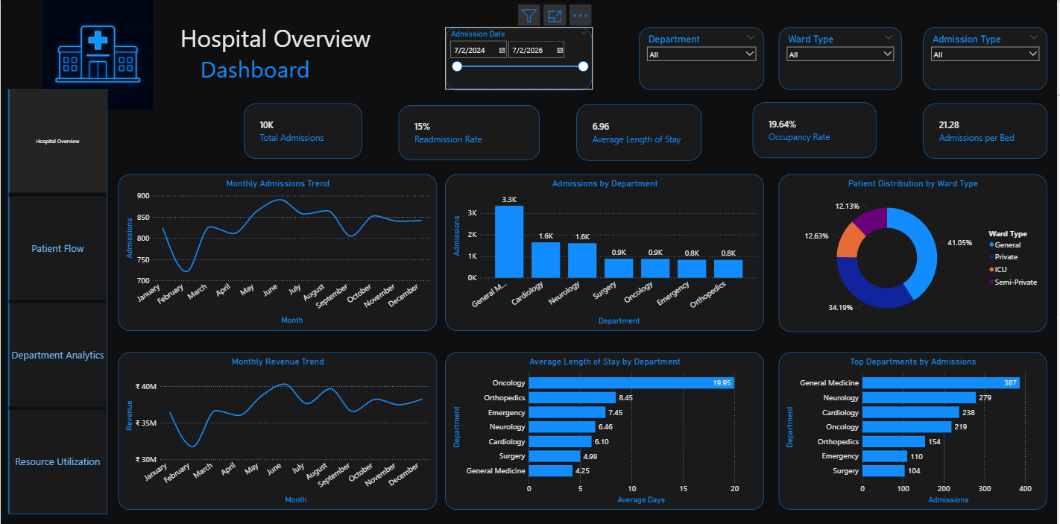
Figure 12.1 — Hospital Overview Dashboard (Power BI Desktop)

KPIs Displayed
KPI Card | Displayed Value
Total Admissions | 10K
Readmission Rate | 15%
Average Length of Stay | 6.96
Occupancy Rate | 19.64%
Admissions per Bed | 21.28

Visualizations
- Monthly Admissions Trend — line chart of admission volume by month.
- Admissions by Department — bar chart ranking departments by total admissions (General Medicine highest at 3.3K).
- Patient Distribution by Ward Type — donut chart of General, Private, ICU, and Semi-Private ward share.
- Monthly Revenue Trend — line chart of billed revenue by month.
- Average Length of Stay by Department — bar chart ranking departments by average LOS (Oncology highest at 19.95 days).
- Top Departments by Admissions — bar chart ranking departments by admission count (General Medicine highest at 387 in the filtered view shown).
Purpose: This page gives an administrator a single-screen answer to "how is the hospital performing overall" — combining volume, quality (readmission), efficiency (LOS, occupancy, bed utilization) and financial (revenue) signals in one view, with department and ward filters available to narrow the analysis.

13 Patient Flow Dashboard Guide
The Patient Flow dashboard focuses on how patients move through the hospital — admissions, discharges, and demographic composition.
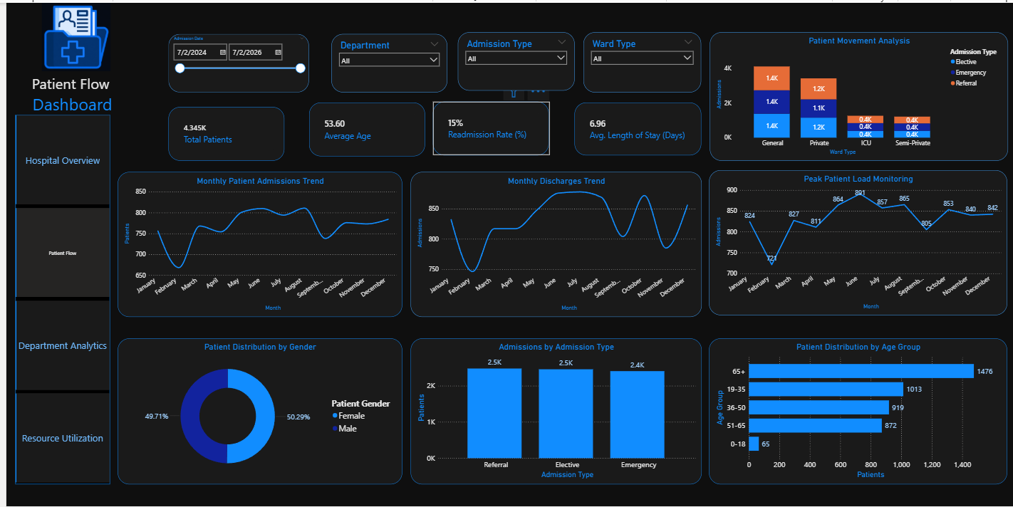
Figure 13.1 — Patient Flow Dashboard (Power BI Desktop)

KPIs Displayed
KPI Card | Displayed Value
Total Patients | 4.345K
Average Age | 53.60
Readmission Rate (%) | 15%
Avg. Length of Stay (Days) | 6.96

Visualizations
- Patient Movement Analysis — stacked bar chart of admissions by ward type, broken down by admission type (Elective, Emergency, Referral).
- Monthly Patient Admissions Trend — line chart of admissions by month.
- Monthly Discharges Trend — line chart of discharges by month.
- Peak Patient Load Monitoring — line chart tracking admission counts across the year to identify peak-load months.
- Patient Distribution by Gender — donut chart (Female 50.29%, Male 49.71%).
- Admissions by Admission Type — bar chart comparing Referral, Elective, and Emergency admission volumes.
- Patient Distribution by Age Group — bar chart of patients by age band, with the 65+ group being the largest at 1,476 patients.
This dashboard supports patient-flow monitoring by giving operations staff visibility into admission and discharge volume trends, seasonal peak-load periods, and the demographic profile of the patient population — information that is directly useful for staffing and capacity planning.

14 Department Analytics Dashboard Guide
The Department Analytics dashboard compares the 7 clinical departments across volume, quality, capacity, and revenue dimensions.
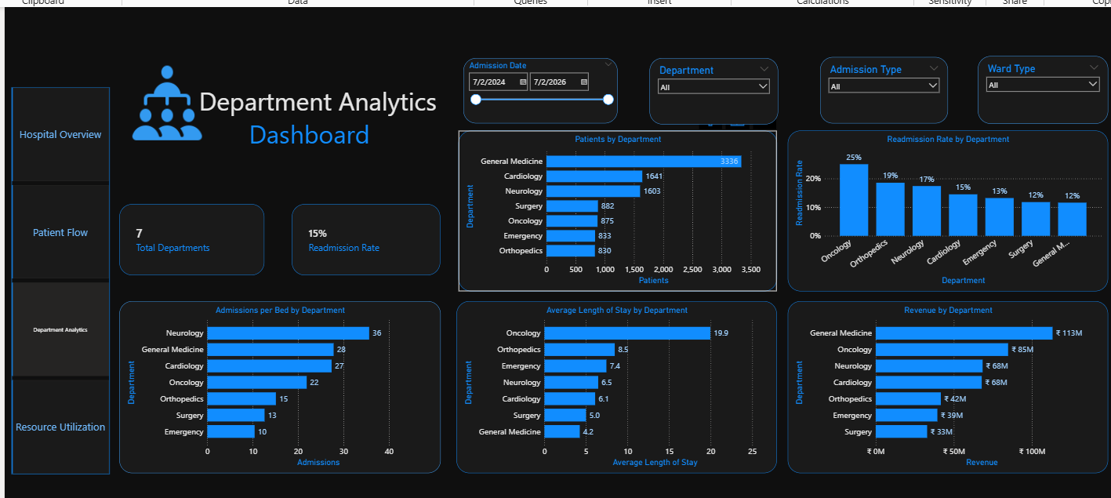
Figure 14.1 — Department Analytics Dashboard (Power BI Desktop)

Contents
- Total Departments — KPI card (7).
- Readmission Rate — KPI card (15%, hospital-wide, on this filtered view).
- Patients by Department — bar chart ranking departments by patient volume (General Medicine highest at 3,336).
- Readmission Rate by Department — bar chart ranking departments by readmission rate (Oncology highest at 25%).
- Admissions per Bed by Department — bar chart of department-level bed utilization (Neurology highest at 36).
- Average Length of Stay by Department — bar chart (Oncology highest at 19.9 days).
- Revenue by Department — bar chart (General Medicine highest at ₹113M).
Comparing departments side-by-side allows operations managers to identify which departments are high-volume versus high-complexity (long stay, high readmission), and to prioritize quality-improvement or capacity-planning attention where it is most needed — for example, Oncology shows the highest readmission rate and longest average stay despite comparatively lower admission volume, while General Medicine drives the largest share of both patient volume and revenue.

15 Resource Utilization Dashboard Guide
The Resource Utilization dashboard addresses the supply side of hospital operations — bed, doctor, and nurse capacity by department and ward type.
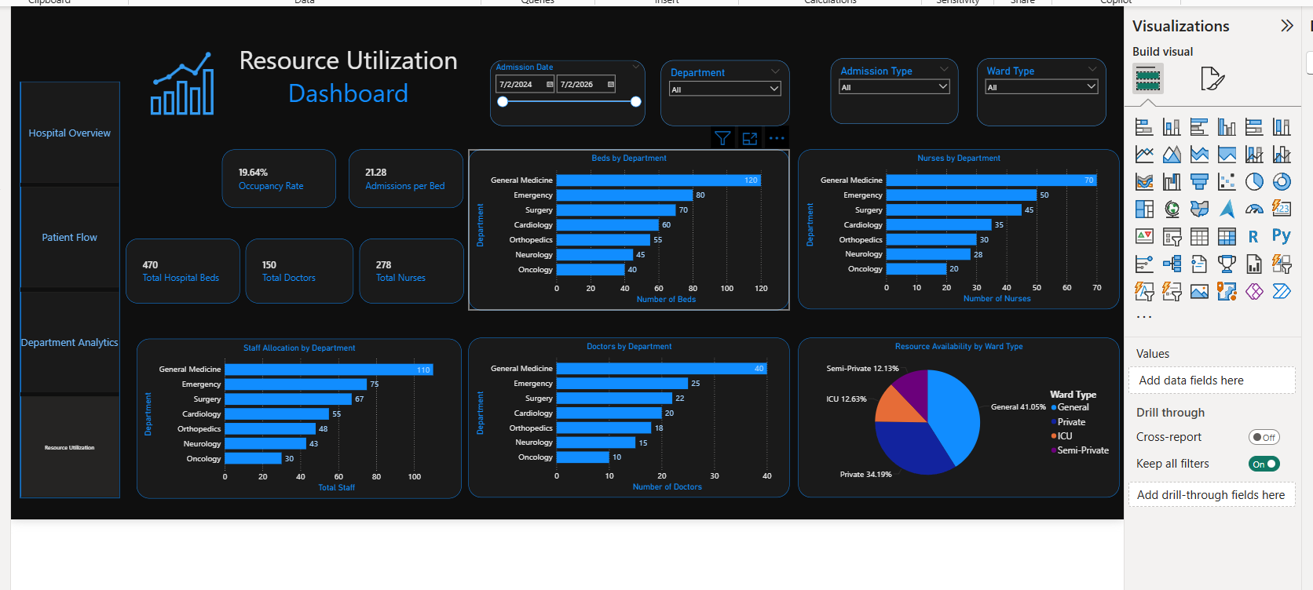
Figure 15.1 — Resource Utilization Dashboard (Power BI Desktop)

Contents
- Occupancy Rate — KPI card (19.64%).
- Admissions per Bed — KPI card (21.28).
- Total Hospital Beds — KPI card (470).
- Total Doctors — KPI card (150).
- Total Nurses — KPI card (278).
- Beds by Department — bar chart (General Medicine highest at 120 beds).
- Nurses by Department — bar chart (General Medicine highest at 70 nurses).
- Staff Allocation by Department — bar chart of combined doctor + nurse staff totals (General Medicine highest at 110).
- Doctors by Department — bar chart (General Medicine highest at 40 doctors).
- Resource Availability by Ward Type — donut chart of General (41.05%), Private (34.19%), Semi-Private (12.13%), and ICU (12.63%) ward share.
This dashboard supports resource allocation and capacity monitoring by giving administrators a direct view of how beds and staff are distributed across departments, and how ward-type capacity is split — supporting decisions such as where to add beds or reassign nursing staff.

16 Dashboard Filters & Interactivity
All four dashboards share a consistent slicer panel, positioned in the top band of each page:
Filter | Effect on Dashboard
Admission Date | A date-range slicer (default range shown: 7/2/2024 – 7/2/2026) that restricts every visual and KPI card on the page to admissions falling within the selected window.
Department | Restricts all visuals and KPI cards to a single department or "All" departments, enabling department-specific drill-down on any of the four pages.
Admission Type | Filters admissions by Referral, Elective, or Emergency type.
Ward Type | Filters admissions by General, Private, Semi-Private, or ICU ward.

Because the same four slicers appear on every page with "Keep all filters" behavior enabled, filter selections are designed to provide a consistent, comparable view of the same underlying data as the user moves between dashboards.

Navigation Between Dashboards
Each dashboard includes a left-hand navigation panel listing all four pages, allowing single-click movement between them. The validated navigation flow is:
Hospital Overview → Patient Flow → Department Analytics → Resource Utilization → Hospital Overview

17 Healthcare Operations Methodology
MedTrack_DV converts raw admission, staffing, and billing records into operational insight by organizing the data around four operational lenses, each corresponding to one of the four dashboards.

Patient Flow
Admissions, discharges, and patient movement are tracked over time to reveal volume trends and peak patient load periods, using Admission_Date and Discharge_Date from the admissions table.

Department Performance
Patient volume, readmission rate, average length of stay, admissions per bed, and revenue are compared across the 7 departments to reveal relative performance and capacity pressure at the department level.

Resource Utilization
Beds, doctors, and nurses are tracked by department and ward type, using the fixed capacity figures in departments.csv together with the doctors.csv and nurses.csv staffing rosters, to support allocation decisions.

Hospital Performance
Admissions, occupancy, readmission rate, length of stay, and revenue are combined at the hospital level on the Hospital Overview dashboard to give a single top-level operational summary.

Decision Support
These metrics are designed to support hospital administrators and operational managers in identifying capacity constraints (occupancy, bed utilization), quality-of-care signals at the operational level (readmission rate, length of stay), and resource-allocation priorities (staff and bed distribution by department). This documentation does not make, and MedTrack_DV is not intended to support, clinical or medical decisions about individual patients.

18 Dashboard Design & User Experience
All four dashboards follow a consistent visual design system, as shown in the screenshots in Sections 12–15:
- A dark healthcare theme (near-black background) used consistently across all four pages.
- A blue accent color applied to KPI values, chart titles, axis labels, and the active navigation item.
- A consistent page layout: title and icon in the top-left, slicer panel in the top band, KPI cards below the slicers, and supporting charts filling the remainder of the page.
- KPI cards presented as rounded rectangular containers with a bold value and a smaller descriptive label.
- Rounded visual containers used for all chart panels.
- A persistent left-hand navigation panel listing all four dashboard pages, present identically on every page.
- Interactive filters (Admission Date, Department, Admission Type, Ward Type) positioned consistently in the same location on every page.
- Consistent typography and chart styling (bar charts, line charts, and donut charts share the same blue color palette and axis-label styling throughout).
The project's testing documentation confirms that this dark healthcare styling, the blue accent palette, typography, and chart styling were validated as consistent across all four dashboards, with readable KPI cards, aligned layout, and no major overlapping or broken visuals identified.

19 Testing & Validation
The final dashboard suite was validated using the project's QA Checklist and Dashboard Testing Report (Milestone 4, Module 7 — Testing & Validation). Testing covered KPI accuracy, visual rendering, slicer/filter behavior, page navigation, patient-flow analytics, and overall functionality.
Metric | Result
Total Test Cases | 28
Passed | 28
Failed | 0
Pending | 0
Pass Rate | 100%
KPI Accuracy | Above 95%
Critical Defects | 0
High Defects | 0
Medium Defects | 0
Low Defects | 0

Testing Categories
- KPI Accuracy — dashboard KPI card values checked against the KPI-summary output (Section 10).
- Visual Testing — chart rendering, layout alignment, and absence of overlapping visuals checked across all four dashboards.
- Filter Testing — Admission Date, Department, Admission Type, and Ward Type slicers checked for correct cross-filtering behavior.
- Navigation Testing — the four-page navigation panel checked for correct page-to-page movement.
- Patient Flow Testing — admission/discharge trend and demographic visuals checked against the underlying dataset.
- Final Functionality — overall end-to-end review of the dashboard suite prior to delivery.
All four dashboards (Hospital Overview, Patient Flow, Department Analytics, Resource Utilization) are reported as having passed testing across the categories above.

20 QA Validation
The QA process for MedTrack_DV covered the following checks, per the project's testing summary:
- KPI values on each dashboard were validated against the underlying KPI-summary output.
- Filters (Admission Date, Department, Admission Type, Ward Type) were tested for correct cross-filtering across all charts and KPI cards on each page.
- Navigation between the four dashboard pages was tested for correct, complete page-to-page movement.
- Dashboard visuals were tested for correct rendering, alignment, and absence of overlapping or broken elements.
- Patient-flow analytics (admissions, discharges, peak load, demographics) were tested against the underlying dataset.
- All four dashboards passed QA.
- No severity-level defects (Critical, High, Medium, or Low) were identified.
All four dashboards passed the documented QA validation with no Critical, High, Medium, or Low severity defects identified.

21 Key Project Results
The table below summarizes the major validated results of the MedTrack_DV project.
Result Area | Outcome
Dataset Scale | 10,000 admission records across 7 departments, 5,000 registered patients (4,345 with at least one admission), 150 doctors, and 278 nurses.
KPI Engineering | Six core healthcare KPIs were engineered: Total Admissions, Average Length of Stay, Readmission Rate, Occupancy Rate, Bed Utilization Rate, and Department Efficiency Score, calculated directly from the final analytical dataset.
Dashboard Delivery | 4 fully interactive Power BI dashboards with shared navigation and slicer behavior.
Testing Outcome | 28/28 test cases passed (100% pass rate), KPI accuracy above 95%, 0 defects identified.
Highest-Volume Department | General Medicine — 3,336 patients, 120 beds, ₹113M revenue.
Highest Readmission-Rate Department | Oncology — 25% readmission rate, 19.9-day average length of stay.
Hospital-Wide Occupancy | 19.64% occupancy rate across 470 total beds over the study period.

22 Project Repository Structure
The recommended GitHub repository structure for MedTrack_DV, organized around the files actually produced by the project, is shown below.
MedTrack_DV/
├── data/
│ ├── departments.csv
│ ├── doctors.csv
│ ├── nurses.csv
│ ├── patients.csv
│ ├── admissions.csv
│ ├── billing.csv
│ ├── hospital_raw_data.csv
│ ├── hospital_final_dataset.csv
│ ├── hospital_kpi_summary.csv
│ └── department_efficiency.csv
├── scripts/
│ ├── Dataset_Generator.ipynb
│ └── generate_hospital_kpis.ipynb
├── dashboard/
│ └── MedTrack_DV.pbix (recommended — actual .pbix file name not specified in uploads)
├── docs/
│ ├── Final_Project_Documentation.docx
│ ├── QA_Checklist_Milestone_4.pdf
│ └── Dashboard_Testing_Report_Milestone_4.pdf
└── README.md

File names under data/, scripts/, and docs/ match the actual project files reviewed for this documentation, including the QA Checklist and Dashboard Testing Report. The .pbix dashboard file name is a placeholder, since the actual submitted file name for the Power BI file was not included in the files reviewed for this documentation.

23 GitHub Delivery
For reproducibility and portfolio presentation, the MedTrack_DV GitHub repository should include:
- Source datasets — departments.csv, doctors.csv, nurses.csv, patients.csv, admissions.csv, billing.csv.
- Cleaned/final datasets — hospital_raw_data.csv, hospital_final_dataset.csv, hospital_kpi_summary.csv, department_efficiency.csv.
- Notebooks/scripts — Dataset_Generator.ipynb and generate_hospital_kpis.ipynb.
- Dashboard file — the Power BI .pbix file used to produce the four dashboards documented in Sections 12–15.
- QA Checklist — the project's QA checklist document, referenced in Section 20.
- Testing Report — the project's Dashboard Testing Report, referenced in Section 19.
- Storyboard — any dashboard planning/storyboard artifact used during Milestone 2.
- Final Documentation — this Final Project Documentation.
- README — a top-level project summary with setup and reproduction instructions.
Organizing the repository this way keeps the raw-to-final data lineage traceable (raw → cleaned → KPI outputs) and keeps the analytical notebooks, the dashboard, and the documentation clearly separated, which supports both reproducibility for evaluators and readability for portfolio visitors.

24 Final Deliverables
Deliverable | Status
Final Dashboard (4-page Power BI suite) | Delivered — confirmed via screenshots
Final Dataset (hospital_final_dataset.csv) | Delivered — confirmed
KPI Generation Notebook (generate_hospital_kpis.ipynb) | Delivered — confirmed
Data Generation/Processing Notebook (Dataset_Generator.ipynb) | Delivered — confirmed
Dashboard Storyboard | Not included in the reviewed uploads
QA Checklist | Delivered — confirmed (Milestone 4, Module 7)
Dashboard Testing Report | Delivered — confirmed (Milestone 4, Module 7)
Final Documentation (this document) | Delivered
README | Not included in the reviewed uploads — recommended for repository delivery
GitHub Repository | Structure recommended in Section 22 — repository link not specified in the provided files

25 Project Evaluation Against Requirements
Requirement | Target | Actual Result | Status
Dataset Completeness | All core hospital reference & transactional tables present | 10 dataset files covering departments, staff, patients, admissions, billing, and KPI outputs | Met
KPI Accuracy | KPI values traceable to source data | All six core KPIs independently re-verified against hospital_final_dataset.csv and hospital_kpi_summary.csv during this review | Met
Number of Dashboards | 4 dashboards | 4 dashboards delivered: Hospital Overview, Patient Flow, Department Analytics, Resource Utilization | Met
Dashboard Integration | Shared navigation & filters across dashboards | Common left-hand navigation panel and 4-slicer set present on all four pages | Met
Testing | Documented QA/testing pass | 28/28 test cases passed (100%), confirmed against the project's QA Checklist and Dashboard Testing Report (Milestone 4, Module 7) | Met
Documentation | Complete Final Project Documentation | This document | Met
Portfolio Readiness | Professional, presentable deliverable | Structured, dated, dashboard-illustrated documentation suitable for portfolio and academic evaluation | Met

26 Limitations
- The dataset is synthetically generated (via the Faker library with a fixed random seed) rather than sourced from a real hospital system; results should be read as a realistic simulation rather than a live operational report.
- The Age field is present in the cleaned/final analytical dataset, but its exact derivation step is not explicitly documented in the supplied notebooks. The Readmission, Days_To_Readmission, and Readmission_Date fields are documented in the supplied readmission-generation notebook, including the probability logic, readmission interval generation, and readmission-date calculation.
- Nurse staffing (nurses.csv) is modeled at the department level only and is not linked to individual admission records, so nurse-to-patient ratios cannot be derived at the admission level from the current data model.
- Occupancy Rate and Bed Utilization Rate are calculated using department-level bed totals as a fixed capacity figure; the model does not account for beds taken out of service or temporary capacity changes over the two-year study period.

27 Future Enhancements
The following are proposed as future work and are not part of the current MedTrack_DV delivery:
- Predictive patient volume forecasting to anticipate admission surges.
- Automated alerts for occupancy or readmission-rate thresholds.
- Additional healthcare outcome KPIs (e.g., mortality rate, average time-to-discharge by diagnosis).
- Automated data refresh from a live hospital data source instead of static CSV extracts.
- More advanced capacity-planning models incorporating seasonal demand variation.
- Role-based dashboard views tailored to administrators, department heads, and finance teams.
- Online deployment of the dashboard suite (e.g., Power BI Service) for wider, always-available access.

28 Final Conclusion
The MedTrack_DV project completed the full analytics workflow from raw hospital data generation through to a tested, documented dashboard deliverable. Ten datasets were generated, integrated, and cleaned; six core healthcare KPIs — Total Admissions, Average Length of Stay, Readmission Rate, Occupancy Rate, Bed Utilization Rate, and Department Efficiency Score — were engineered directly from the resulting analytical dataset; and four interconnected Power BI dashboards — Hospital Overview, Patient Flow, Department Analytics, and Resource Utilization — were developed to present those KPIs through a consistent, filterable interface.
Dashboard interactions, including the four shared slicers and the four-page navigation panel, were tested alongside KPI accuracy and visual presentation, with the project's testing summary reporting 28 of 28 test cases passed (100% pass rate), KPI accuracy above 95%, and no defects identified at any severity level.
With this Final Project Documentation complete, MedTrack_DV is ready for final delivery — as a GitHub-hosted repository, an academic submission, and a portfolio piece demonstrating an end-to-end healthcare operations analytics workflow.

Appendices

Appendix A — KPI Reference
KPI | Formula | Validated Value
Total Admissions | COUNT(DISTINCT Admission_ID) | 10,000
Average Length of Stay | AVG(Length_of_Stay) | 6.96 days
Readmission Rate | (COUNT(Readmission="Yes") / Total Admissions) × 100 | 14.91%
Occupancy Rate | (SUM(Length_of_Stay) / (Total Beds × Study Period Days)) × 100 | 19.64%
Bed Utilization Rate | Total Admissions / Total Hospital Beds | 21.28 admissions/bed
Department Efficiency | (Admissions / (Beds × Avg LOS)) normalized to max = 100% | 16.75%–100% (Oncology–General Medicine)

Appendix B — Dashboard Screenshots
The four dashboard screenshots below are reproduced in full for reference.

B.1 — Hospital Overview Dashboard

B.2 — Patient Flow Dashboard

B.3 — Department Analytics Dashboard

B.4 — Resource Utilization Dashboard

Appendix C — QA Checklist Summary
Checklist Area | Result
KPI value validation | Passed
Filter testing (all 4 slicers) | Passed
Navigation testing (all 4 pages) | Passed
Visual/layout testing | Passed
Patient-flow analytics testing | Passed
Overall dashboard suite result | All 4 dashboards passed; 0 defects identified

Appendix D — Testing Summary
Metric | Value
Total Test Cases | 28
Passed / Failed / Pending | 28 / 0 / 0
Pass Rate | 100%
KPI Accuracy | Above 95%
Critical / High / Medium / Low Defects | 0 / 0 / 0 / 0

Appendix E — Repository Structure
See Section 22 (Project Repository Structure) for the full recommended repository tree.

