HOSPITAL OPERATIONS & PATIENT ANALYTICS DASHBOARD
FINAL PROJECT DOCUMENTATION
Submitted as part of the Infosys Springboard Internship Project

Details | Information
Prepared By | Mandadi Niharika Reddy
Programme | Bachelor of Technology in Computer Science and Engineering
Institution | Gayatri Vidya Parishad College of Engineering for Women, Visakhapatnam
Internship | Infosys Springboard Internship
Mentor | Shanmukha Priya
Project Title | MedTrack_DV – Hospital Operations & Patient Analytics Dashboard
Project Domain | Healthcare Data Visualization
Technology | Python, Pandas, Tableau, Git & GitHub
Project Duration | June 2026 – August 2026
Submission Year | 2026

TABLE OF CONTENTS
Acknowledgement
Executive Summary
1. Introduction
2. Project Objectives
3. Problem Statement
4. Scope of the Project
5. Project Workflow
- 5.1 Data Collection
- 5.2 Data Cleaning and Transformation
- 5.3 KPI Engineering
- 5.4 Dashboard Planning and Prototyping
- 5.5 Dashboard Development
- 5.6 Dashboard Integration
- 5.7 Testing and Validation
- 5.8 Documentation and Project Delivery
6. Tools & Technologies Used
- 6.1 Project Architecture
7. Dataset Description
8. Data Collection
9. Data Cleaning & Transformation
10. KPI Engineering
11. Dashboard Planning & Design
12. Dashboard Development
13. Dashboard-wise Explanation
- 13.1 Hospital Overview Dashboard
- 13.2 Patient Flow Dashboard
- 13.3 Department Analytics Dashboard
- 13.4 Resource Utilization Dashboard
14. Key Insights & Findings
15. Challenges Faced & Solutions
16. Testing & Validation
17. Documentation & Project Delivery
18. Conclusion
19. Future Enhancements
20. References

ACKNOWLEDGEMENT
I would like to sincerely express my gratitude to Infosys Springboard for providing the opportunity to work on the MedTrack_DV Hospital Operations & Patient Analytics Dashboard project as part of the Data Visualization Internship.
The structured modules, project milestones, learning resources, and practical assignments provided during the internship helped me gain hands-on experience in data collection, data cleaning, data analysis, KPI engineering, Tableau dashboard development, testing, documentation, and version control.
I am especially grateful to my project mentor, Shanmukha Priya, for providing continuous guidance, feedback, and recommendations throughout the project. The mentor's suggestions helped improve the project at different stages, from dataset preparation to dashboard development and validation.
Finally, I acknowledge the publicly available healthcare datasets used as the foundation of this project. Working with these datasets provided valuable practical experience in handling real-world healthcare data and transforming it into meaningful visual insights.
This project has strengthened my understanding of Python, Pandas, data preprocessing, Tableau, data visualization, KPI development, dashboard design, Git, GitHub, and healthcare analytics.

EXECUTIVE SUMMARY
MedTrack_DV – Hospital Operations & Patient Analytics Dashboard is an end-to-end healthcare data visualization project developed as part of the Infosys Springboard Internship.
The primary objective of the project is to transform hospital operational and patient admission data into meaningful visual insights that can support the analysis of hospital performance, patient flow, department efficiency, and resource utilization.
The project follows a structured analytics workflow beginning with data collection, followed by hospital selection, representative sampling, data cleaning, data preparation, KPI engineering, dashboard planning, Tableau development, testing, validation, and documentation.
The primary dataset used in the project is the Hospital Inpatient Discharges SPARCS De-Identified dataset. The original dataset contained more than two million records. Records belonging to New York-Presbyterian Hospital – New York Weill Cornell Center were selected, resulting in approximately 42,221 hospital-specific records. A representative sample of 8,000 records was created for efficient project development. After cleaning and validation, the final dataset contained 7,999 records and 32 columns.
Python and Pandas were used for data collection, profiling, cleaning, transformation, and preparation. Tableau was used to create the interactive dashboard suite, while Git and GitHub were used for version control and project delivery.
The final solution consists of four dashboards:
- Hospital Overview
- Patient Flow
- Department Analytics
- Resource Utilization
The dashboards provide KPI cards, charts, filters, comparisons, and analytical views for understanding hospital operations.
The project also completed a comprehensive testing and validation phase. 12 KPI tests were performed and all 12 passed, resulting in 100% KPI validation accuracy. Healthcare metrics, dashboard interactions, and patient-flow analytics were also validated successfully.
The completed solution demonstrates how healthcare data can be transformed into an interactive analytical platform that improves data accessibility and supports data-driven operational analysis.

1. INTRODUCTION
Healthcare organizations generate large amounts of data through patient admissions, hospital stays, departments, billing, resources, and other operational activities.
Although this information contains valuable insights, raw healthcare datasets are often difficult to interpret directly. Data visualization provides a way to convert large and complex datasets into understandable charts, KPIs, and interactive dashboards.
MedTrack_DV was developed to address this requirement by creating a centralized Tableau dashboard suite for hospital operations and patient analytics.
The project focuses on four major areas:
- Hospital performance
- Patient flow
- Department analytics
- Resource utilization
The dashboard suite enables users to examine healthcare information using KPIs, charts, filters, and comparisons.
The project combines Python-based data processing with Tableau-based visualization to create a complete analytics workflow. The project objective and scope are centered on hospital performance, patient flow, departmental efficiency, and resource allocation.
2. PROJECT OBJECTIVES
The major objectives of MedTrack_DV are:
- To collect relevant hospital and patient admission datasets.
- To identify and select appropriate hospital records.
- To create a representative dataset for dashboard development.
- To clean and preprocess healthcare data using Python and Pandas.
- To identify important healthcare performance indicators.
- To engineer KPIs related to admissions, length of stay, occupancy, bed utilization, department efficiency, and readmission.
- To analyze patient admission and patient-flow patterns.
- To analyze department-wise performance.
- To analyze hospital resource utilization.
- To develop four interactive Tableau dashboards.
- To provide useful filters and analytical interactions.
- To validate KPI calculations against verified results.
- To test dashboard interactions and patient-flow analytics.
- To document the complete project.
- To maintain project deliverables using Git and GitHub.
The project specifically translates cleaned hospital records into business-aligned KPIs suitable for dashboard consumption.
3. PROBLEM STATEMENT
Hospitals generate large volumes of patient and operational data. However, this information can be difficult to analyse when it is distributed across datasets and presented primarily in raw tabular form.
Without a centralized visualization solution, it becomes difficult to:
- Monitor patient admissions.
- Understand patient flow.
- Compare department performance.
- Monitor length of stay.
- Analyse readmissions.
- Understand bed utilization.
- Monitor hospital resources.
- Identify operational trends.
The main problem addressed by MedTrack_DV is therefore:
To transform hospital operational and patient data into an interactive Tableau-based analytics solution that provides meaningful insights into hospital performance, patient flow, department efficiency, and resource utilization.
The project addresses this problem by implementing a complete data analytics workflow from raw data collection to final dashboard delivery.

4. SCOPE OF THE PROJECT
The scope of MedTrack_DV includes the complete lifecycle of a healthcare data visualization project.
Data Scope
The project covers:
- Hospital inpatient records
- Patient demographics
- Admission information
- Length of stay
- Patient disposition
- Severity of illness
- Mortality risk
- Payment information
- Hospital costs and charges
- Department-related information
- Resource-related information
Analytical Scope
The project analyses:
- Patient admissions
- Admission types
- Emergency admissions
- Patient disposition
- Length of stay
- Readmission
- Department performance
- Bed utilization
- Hospital occupancy
- Resource availability
- Equipment utilization
- Healthcare costs
Visualization Scope
The project includes four Tableau dashboards:
- Hospital Overview
- Patient Flow
- Department Analytics
- Resource Utilization
Out of Scope
The current implementation does not include:
- Real-time Hospital Information System integration
- Live Electronic Health Record integration
- Real-time database connectivity
- Production clinical decision-making
- Advanced machine learning prediction
- Automated real-time alerts
These can be considered future enhancements.

5. PROJECT WORKFLOW
The MedTrack_DV project follows the workflow below:
Data Collection → Hospital Selection → Sampling → Data Cleaning → KPI Engineering → Dashboard Planning → Tableau Development → Testing & Validation → Documentation & Delivery
5.1 Data Collection
The project began by identifying publicly available healthcare datasets suitable for hospital operational analysis.
The primary SPARCS inpatient discharge dataset was downloaded and examined.
5.2 Data Cleaning and Transformation
The collected data was profiled and cleaned using Python and Pandas.
The process included:
- Duplicate detection
- Missing-value analysis
- Data-type validation
- Categorical standardization
- Removal of unnecessary fields
- Data consistency checks
- Statistical profiling
5.3 KPI Engineering
Healthcare KPIs were identified based on the project requirements.
The major KPIs include:
- Total Admissions
- Average Length of Stay
- Occupancy Rate
- Bed Utilization
- Department Efficiency
- Readmission Rate
The KPI engineering stage converted raw healthcare data into measurable operational indicators.

5.4 Dashboard Planning and Prototyping
Before final Tableau implementation, dashboard layouts and analytical requirements were planned.
The four dashboards were designed around specific user questions:
Dashboard | Main Purpose
Hospital Overview | Overall hospital performance
Patient Flow | Patient admission and flow analysis
Department Analytics | Department-level performance
Resource Utilization | Resource monitoring
The storyboard defined the KPIs, charts, filters, and navigation for each dashboard.
5.5 Dashboard Development
The cleaned datasets were imported into Tableau.
The dashboards were developed using:
- KPI cards
- Bar charts
- Distribution charts
- Comparative charts
- Trend visualizations
- Interactive filters
5.6 Dashboard Integration
The four dashboards were organized as one unified Tableau dashboard suite.
The dashboards provide different analytical perspectives while maintaining a consistent design approach.
5.7 Testing and Validation
The dashboards were tested during Module 7.
Testing included:
- KPI validation
- Healthcare metric validation
- Filter testing
- Multiple-filter testing
- Patient-flow validation
- Visualization consistency checks
The final QA status was PASSED, with no major dashboard issues remaining.
5.8 Documentation and Project Delivery
The final stage involves preparing:
- Final documentation
- QA checklist
- Dashboard testing report
- Tableau workbook
- Project repository
- Supporting project files
6. TOOLS & TECHNOLOGIES USED
Technology / Tool | Purpose
Python | Data collection, preprocessing and transformation
Pandas | Data cleaning and manipulation
NumPy | Numerical processing
Jupyter Notebook | Exploratory analysis and data profiling
Tableau | Interactive dashboard development
Git | Version control
GitHub | Repository and project delivery
Microsoft Word | Final documentation
Microsoft Excel | Data inspection and supporting analysis
The actual project technology stack is confirmed in the project presentation as Python/Pandas/NumPy, Jupyter, Git/GitHub, and Tableau.

6.1 PROJECT ARCHITECTURE
The project architecture follows this flow:
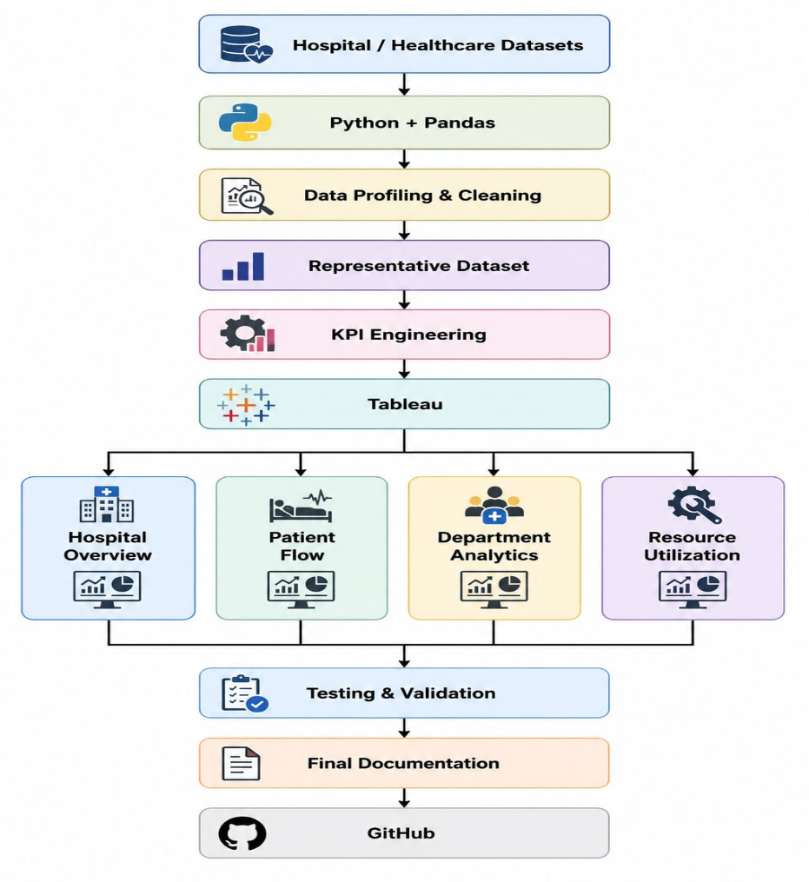

7. DATASET DESCRIPTION
The primary dataset used in MedTrack_DV is:
Hospital Inpatient Discharges SPARCS De-Identified
The original dataset contained approximately 2.1 million records.
The project filtered the data to:
New York-Presbyterian Hospital – New York Weill Cornell Center
This resulted in approximately 42,221 hospital-specific records.
A representative sample of 8,000 records was then created.
After data cleaning:
Final Dataset = 7,999 rows × 32 columns
The project presentation confirms the selection funnel from the original SPARCS dataset through hospital filtering and representative sampling.
Supporting Dataset
A hospital facility information dataset was also considered to provide additional contextual information related to healthcare facilities.
Supporting/Synthetic Data
Additional structured data was prepared for department and resource-related analytics where required by the dashboard design.

8. DATA COLLECTION
The data collection phase consisted of the following steps:
Step 1 – Dataset Identification
Relevant healthcare datasets were identified based on the project requirements.
Step 2 – Dataset Download
The SPARCS inpatient discharge dataset and supporting hospital information were obtained.
Step 3 – Dataset Inspection
The structure, columns, data types, and data quality were examined.
Step 4 – Hospital Filtering
Records belonging to the selected hospital were extracted.
Step 5 – Representative Sampling
An 8,000-record representative sample was generated.
The sampling considered important dimensions such as:
- Age Group
- Gender
- Admission Type
- Emergency Department Indicator
Step 6 – Output Generation
The processed records were saved for further cleaning and analysis.
Step 7 – Repository Organization
The resulting files were organized into the project repository.

9. DATA CLEANING & TRANSFORMATION
The cleaning process was performed using Python and Pandas.
The major activities were:
9.1 Duplicate Detection
Duplicate records were identified and removed.
9.2 Missing Value Handling
Missing values were analyzed and handled appropriately.
9.3 Data Type Validation
Important numerical and categorical fields were checked for correct data types.
9.4 Categorical Standardization
Categories such as admission type and other healthcare classifications were standardized.
9.5 Data Validation
Data ranges, distributions, and field consistency were checked.
9.6 Final Dataset
The final cleaned dataset contained:
7,999 rows
32 columns
0 duplicate rows
0 missing values
The project data-quality snapshot confirms these final values.

10. KPI ENGINEERING
KPI engineering converts raw healthcare information into measurable indicators.
The following KPIs were implemented and validated:
KPI | Purpose
Total Admissions | Measures the total number of patient admissions
Average Length of Stay | Measures the average duration of hospital stay
Occupancy Rate | Measures hospital occupancy
Bed Utilization | Measures how effectively available beds are utilized
Department Efficiency | Measures department-level operational efficiency
Readmission Rate | Measures readmission-related performance
Total Departments | Counts departments included in the analysis
Average Bed Utilization | Measures average department bed utilization
Average Department Efficiency | Measures average efficiency across departments
Total Beds | Represents the hospital's total bed capacity
Available Bed Days | Represents available capacity across bed-days
The project specifically identified Total Admissions, ALOS, Occupancy Rate, Bed Utilization, Department Efficiency, and Readmission Rate as major business-aligned KPIs.

11. DASHBOARD PLANNING & DESIGN
The dashboard suite was planned before final Tableau development.
The design principles included:
Consistency
A consistent visual theme was maintained across dashboards.
Simple Layout
KPI cards were placed prominently so important metrics could be understood quickly.
Clear Visualization
Charts were selected according to the type of analytical question.
Interactive Filtering
Relevant filters were provided to allow users to explore specific segments.
Dashboard-Specific Analysis
Each dashboard was assigned a specific operational purpose.
The storyboard established the four-dashboard structure and identified filters and visualizations for each dashboard.
12. DASHBOARD DEVELOPMENT
The final dashboards were developed in Tableau using the prepared healthcare datasets.
The dashboard suite contains:
Dashboard 1 : Hospital Overview
Dashboard 2 : Patient Flow
Dashboard 3 : Department Analytics
Dashboard 4 : Resource Utilization
The dashboards combine KPI cards, charts, filters, and comparative visualizations to provide an interactive analytical experience.

13. DASHBOARD-WISE EXPLANATION
13.1 HOSPITAL OVERVIEW DASHBOARD
Purpose
The Hospital Overview dashboard provides a high-level view of overall hospital performance.
It allows users to quickly understand patient volume, hospital utilization, admissions, department performance, and readmission-related metrics.
KPI Cards
The dashboard contains:
- Total Admissions
- Average Length of Stay
- Occupancy Rate
- Bed Utilization
- Department Efficiency
- Readmission Rate
Verified KPI Values
KPI | Value
Total Admissions | 7,999
Average Length of Stay | 5.73
Occupancy Rate | 16.74%
Bed Utilization | 72.51%
Department Efficiency | 8.93
Readmission Rate | 9.05
All six KPI values were validated successfully.
Visualizations
The dashboard provides analytical views such as:
- Age Group Distribution
- Gender Distribution
- Admission Type
- Stay Category
- Payment Typology
- Patient volume
- Department comparisons
Filters
Relevant filters include:
- Gender
- Age Group
- Type of Admission
- Stay Category
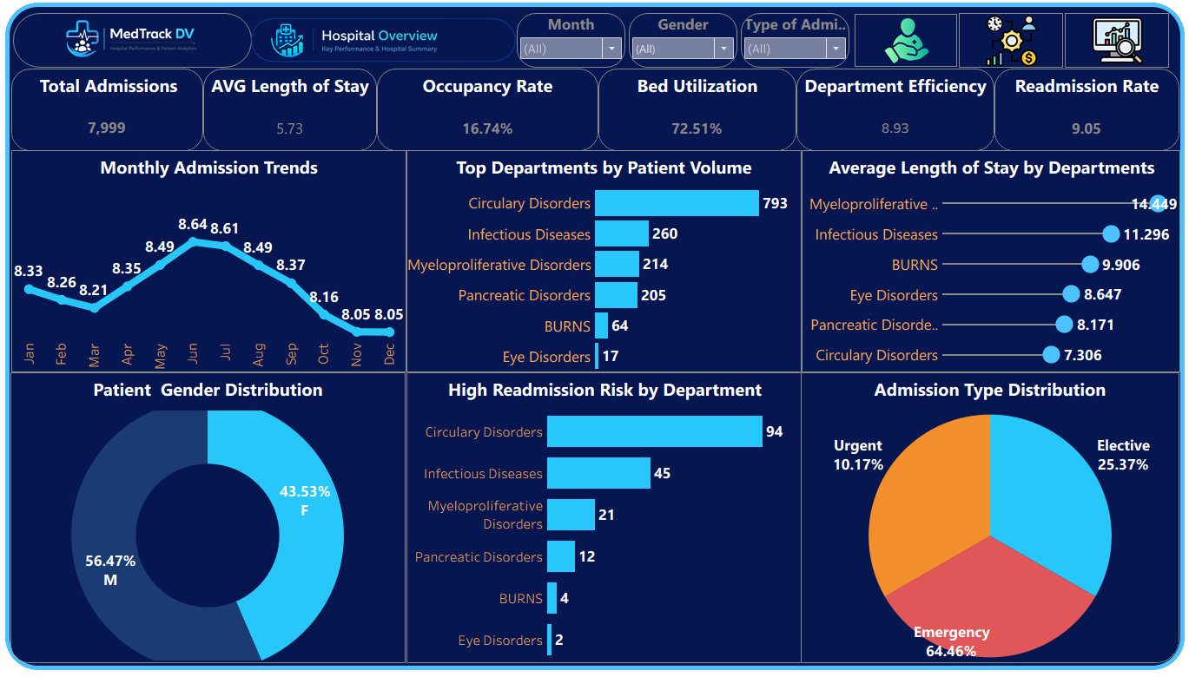
- Payment Typology

13.2 PATIENT FLOW DASHBOARD
Purpose
The Patient Flow dashboard focuses on patient movement from admission through discharge.
It helps analyse:
- Patient volume
- Patient disposition
- Admission types
- Emergency admissions
- Length of stay
- Billing
- Cost
- Severity of illness
- Readmission
Key Visualizations
- Patient Disposition Distribution
- Patient Volume by Department
- Admission Type Distribution
- Admission Type by Age Group
- Emergency vs Non-Emergency Admissions
- Average Billing by Department
- Average Length of Stay by Admission Type
- Average Cost per Day by Admission Type
- Severity of Illness Distribution
- Payment Type Distribution
- Readmission by Department
These patient-flow analyses were specifically validated during Module 7.
Filters
- Patient Disposition
- Emergency Department Indicator
- Stay Category
- Type of Admission
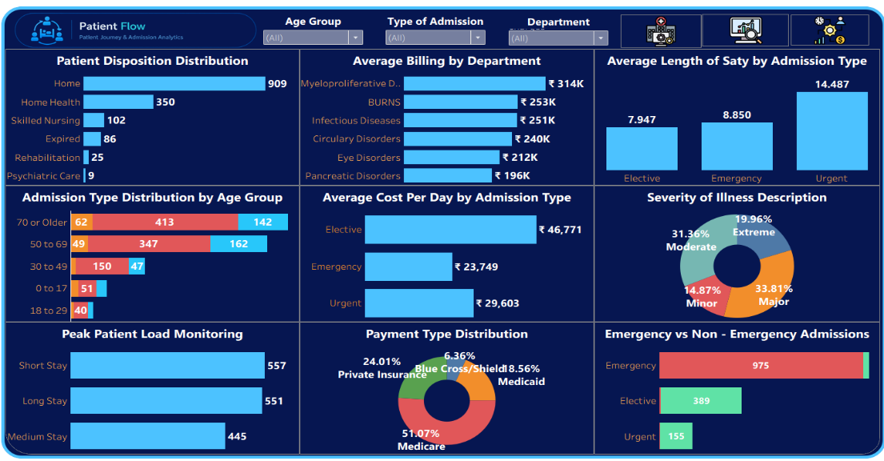
- Age Group
13.3 DEPARTMENT ANALYTICS DASHBOARD
Purpose
The Department Analytics dashboard provides department-level analysis.
It enables comparison of departments based on:
- Patient volume
- Efficiency
- Bed utilization
- Revenue
- Cost
- Length of stay
- Severity of illness
- Mortality risk
- Readmission
KPI Cards
- Total Departments
- Average Bed Utilization
- Average Department Efficiency
Verified Values
KPI | Value
Total Departments | 6
Average Bed Utilization | 72.51%
Average Department Efficiency | 8.925
These values were validated successfully during Module 7.
Visualizations
- Patient Volume by Department
- Department Efficiency
- Bed Utilization by Department
- Revenue by Department
- Average Length of Stay by Department
- Severity of Illness Distribution
- Mortality Risk Distribution
- Readmission by Department
Filters
- Department
- Severity of Illness
- Mortality Risk
- Type of Admission
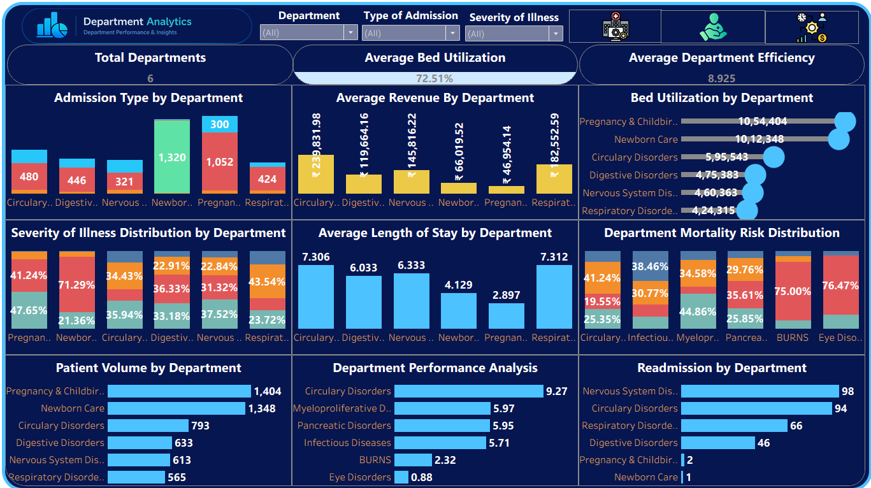
- Payment Type

13.4 RESOURCE UTILIZATION DASHBOARD
Purpose
The Resource Utilization dashboard focuses on hospital capacity and available resources.
It helps analyze:
- Total beds
- Occupancy
- Available bed days
- Resource availability
- Staff allocation
- Equipment utilization
- Severity-based cost
- Length of stay by severity
KPI Cards
KPI | Verified Value
Total Beds | 751
Occupancy Rate | 16.74%
Available Bed Days | 274,115
These KPI values were validated during Module 7.
Visualizations
- Resource Availability by Department
- Staff Allocation by Department
- Equipment Utilization
- Patient Disposition by Severity
- Average Length of Stay by Severity
- Average Cost by Severity
- Severity of Illness Analysis
Filters
- Department
- Severity of Illness
- Type of Admission
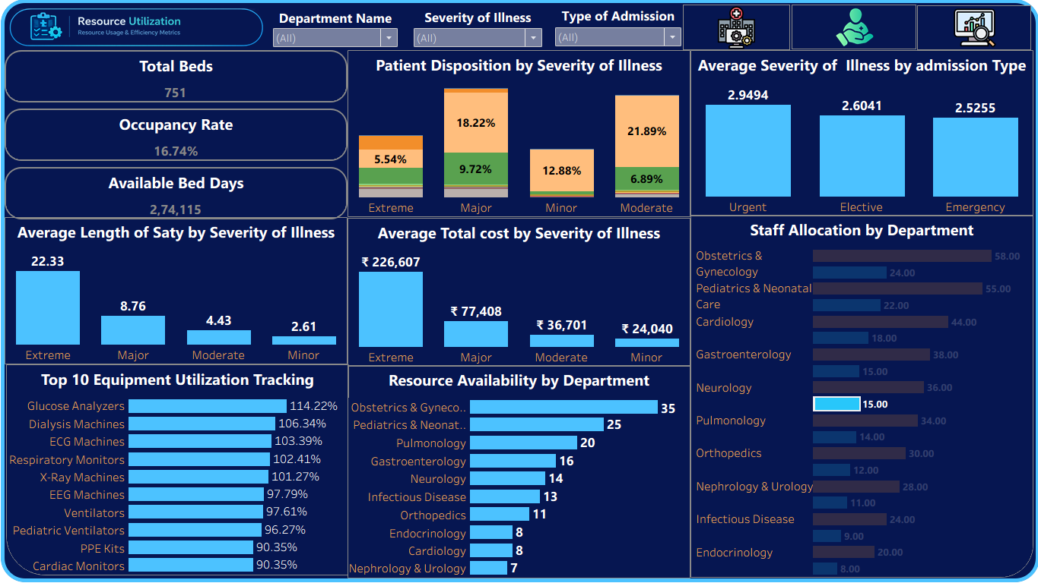
- Resource-related categories where applicable
14. KEY INSIGHTS & FINDINGS
The dashboard suite provides several important analytical benefits.
14.1 Centralized Hospital Monitoring
The Hospital Overview dashboard brings important hospital KPIs into one place, making it easier to monitor overall performance.
14.2 Patient Flow Visibility
The Patient Flow dashboard provides visibility into admission patterns, patient disposition, length of stay, emergency admissions, and readmissions.
14.3 Department Comparison
Department Analytics enables comparison between departments based on patient volume, efficiency, utilization, costs, and other performance indicators.
14.4 Resource Utilization
Resource Utilization provides a consolidated view of hospital capacity, bed utilization, staff allocation, and equipment utilization.
14.5 Standardized KPI Monitoring
The use of standardized KPIs makes it easier to consistently evaluate hospital operations.
14.6 Interactive Decision Support
Filters allow users to analyze the data from different perspectives without modifying the underlying dataset.
14.7 Improved Data Accessibility
Complex healthcare data becomes easier to understand through visual charts and KPI cards.
14.8 Data-Driven Operations
The project demonstrates how healthcare analytics can support operational monitoring and decision-making.
These findings are consistent with the project storyboard and dashboard objectives.

15. CHALLENGES FACED & SOLUTIONS
Challenge 1 – Large Dataset
Problem
The original SPARCS dataset contained more than two million records, making direct processing less efficient for the project environment.
Solution
The dataset was filtered to the selected hospital and a representative sample was created.
Challenge 2 – Data Quality
Problem
The raw data required checking for duplicates, missing values, inconsistent categories, and data-type issues.
Solution
Python and Pandas were used for profiling, cleaning, standardization, and validation.
Challenge 3 – Representative Sampling
Problem
Reducing the dataset while preserving meaningful patient and admission distributions was important.
Solution
Sampling was performed considering dimensions such as:
- Age Group
- Gender
- Admission Type
- Emergency Department Indicator
Challenge 4 – Tableau KPI Calculation
Problem
Some KPI calculations required careful aggregation because hospital-level values could be repeated across patient records.
Solution
The KPI logic was tested against the source data and corrected where necessary.

Challenge 5 – Total Beds Aggregation
During Module 7, the Total Beds KPI initially used an incorrect aggregation that produced 1,166,303 because the bed value was repeated across patient records.
The value was investigated using different aggregations. Minimum, maximum, and average were all 751, confirming that 751 represented the actual hospital bed count.
The calculation was corrected.
Final Total Beds = 751
Status: Resolved – PASS
Challenge 6 – Percentage Formatting
Average Bed Utilization was initially displayed as:
7251.10%
The underlying value was:
72.51
The formatting was corrected so that the dashboard displays:
72.51%
Status: Resolved – PASS
Challenge 7 – Git/GitHub Management
Problem
Managing Tableau workbooks, documentation files, datasets, branches, and commits required careful repository management.
Solution
Git was used for version control, while GitHub was used to maintain the project repository and milestone deliverables.

16. TESTING & VALIDATION
Testing was completed as part of Module 7.
The testing covered:
- KPI Calculation Validation
- Healthcare Metrics Validation
- Dashboard Interaction Testing
- Patient Flow Analytics Validation
16.1 KPI CALCULATION VALIDATION
A total of:
12 KPI tests
were performed.
Result
12 Passed
0 Failed
100% Validation Accuracy
The evaluation requirement was KPI accuracy above 95%.
Therefore:
Result: PASSED
16.2 HEALTHCARE METRIC VALIDATION
The following metrics were verified:
- Department efficiency
- Bed utilization
- Patient volume
- Average length of stay
- Revenue
- Cost
- Mortality risk
- Severity of illness
- Resource availability
- Equipment utilization
All tested healthcare metrics passed validation.
16.3 DASHBOARD INTERACTION TESTING
The following filters were tested:
- Department
- Type of Admission
- Severity of Illness
- Age Group
- Gender
Multiple filter selections and clearing filters were also tested.
All tested interactions passed.
16.4 PATIENT FLOW VALIDATION
Patient-flow analysis was validated for:
- Patient disposition
- Patient volume by department
- Admission type
- Admission type by age group
- Emergency vs non-emergency admissions
- Average billing
- Average length of stay
- Average cost per day
- Severity of illness
- Payment type
- Readmission
Overall Patient Flow Validation: PASS

16.5 FINAL QA RESULT
Testing Area | Result
KPI Calculation Validation | 12/12 Passed
KPI Validation Accuracy | 100%
Healthcare Metrics | PASS
Dashboard Interactions | PASS
Patient Flow Analytics | PASS
Major Dashboard Issues | None Remaining
Overall QA | PASSED
The final Module 7 testing report confirms that all major validation areas passed after the identified issues were corrected.
17. DOCUMENTATION & PROJECT DELIVERY
Module 8 focuses on organizing the final project and preparing it for delivery.
17.1 Project Documentation
The final documentation contains:
- Project overview
- Objectives
- Problem statement
- Scope
- Workflow
- Dataset description
- Data collection methodology
- Data cleaning methodology
- KPI definitions
- Dashboard guide
- Testing and validation
- Findings
- Challenges
- Conclusion
- Future enhancements
- References
17.2 Project Repository Structure
Healthcare_analytics_project/
│
├── data/
│ ├── hospital_raw_data.csv
│ ├── hospital_cleaned.csv
│ ├── hospital_profile.csv
│ ├── department_data.csv
│ └── resource_data.csv
│
├── scripts/
│ ├── data_collection.py
│ └── data_cleaning.py
│
├── dashboard/
│ ├── MedTrack_DV.twbx
│ └── medtrack_prototype.twbx
│
├── notebooks/
│ └── analysis notebooks
│
├── docs/
│ ├── QA_Checklist.pdf
│ ├── Dashboard_Testing_Report.docx
│ └── Final_Project_Documentation.docx
│└── README.md
The project presentations also document the use of separate dashboard, data, scripts, notebooks, and docs directories for reproducibility and handoff.

18. CONCLUSION
The MedTrack_DV – Hospital Operations & Patient Analytics Dashboard project successfully demonstrates the complete workflow of a healthcare data visualization project.
The project started with a large healthcare dataset and transformed it into a structured, cleaned, and analysis-ready dataset using Python and Pandas.
The prepared data was then used to engineer healthcare KPIs and develop four Tableau dashboards covering:
- Hospital performance
- Patient flow
- Department analytics
- Resource utilization
The dashboards provide an interactive way to explore healthcare information and understand operational performance.
The testing and validation phase further improved the reliability of the solution. A total of 12 KPI tests were conducted, with all 12 passing and achieving 100% validation accuracy. Healthcare metrics, dashboard interactions, and patient-flow analytics were also successfully validated.
Two issues identified during testing — incorrect Total Beds aggregation and incorrect percentage formatting — were successfully corrected and revalidated.
Overall, MedTrack_DV provides a structured foundation for hospital operational analysis and demonstrates the practical application of Python, Pandas, Tableau, data visualization, KPI engineering, testing, Git, and GitHub in a healthcare analytics context.

19. FUTURE ENHANCEMENTS
The current project can be extended in several ways.
19.1 Real-Time Hospital Data
Integrate live hospital information systems or databases to provide continuously updated dashboards.
19.2 Automated Data Refresh
Automate the process of collecting, cleaning, and refreshing dashboard data.
19.3 Predictive Analytics
Machine learning models could be introduced for:
- Admission forecasting
- Readmission prediction
- Length-of-stay prediction
- Bed-demand forecasting
- Resource-demand forecasting
19.4 Advanced Alerts
Automated alerts could be generated when:
- Occupancy exceeds a threshold.
- Bed utilization becomes critical.
- Patient volume increases significantly.
- Resource availability falls below a defined level.
19.5 Multi-Hospital Comparison
The solution could be expanded to compare multiple hospitals and healthcare facilities.
19.6 Role-Based Dashboards
Different views could be developed for:
- Hospital administrators
- Department heads
- Operations managers
- Resource managers
19.7 Mobile Dashboard
Responsive versions could be developed for mobile and tablet users.

19.8 Advanced Drill-Down
Users could move from hospital-level KPIs to department-level and eventually detailed patient-level analytical views where appropriate.
20. REFERENCES
- New York State Department of Health – Hospital Inpatient Discharges SPARCS De-Identified Dataset.
- New York State Department of Health – Health Facility General Information Dataset.
- Infosys Springboard – Data Visualization Internship Project Guidelines and Module Requirements.
- Tableau Documentation – Tableau Desktop and Dashboard Development Resources.
- Python Documentation – Python programming and data-processing resources.
- Pandas Documentation – Data manipulation and preprocessing resources.
- NumPy Documentation – Numerical computing resources.
- Git Documentation – Version control resources.
- GitHub Documentation – Repository and project collaboration resources.
- MedTrack_DV Project Files – Project datasets, scripts, Tableau workbooks, testing reports, and supporting documentation.

FINAL PROJECT STATUS
Area | Status
Data Collection | ✓ Completed
Data Cleaning | ✓ Completed
KPI Engineering | ✓ Completed
Dashboard Planning | ✓ Completed
Dashboard Development | ✓ Completed
Dashboard Integration | ✓ Completed
Testing & Validation | ✓ Passed
KPI Validation | 100%
Documentation | ✓ Completed
GitHub Organization | ✓ Completed for current deliverables
Tableau Workbook | ✓ Completed
Final Project Delivery | ✓ Completed

