MEDTRACK_DV
Hospital Operations & Patient Analytics Dashboard
FINAL PROJECT DOCUMENTATION

Interactive Tableau Dashboard Suite
Hospital Overview • Patient Flow • Department Analytics • Resource Utilization
Milestone 1–4 | Weeks 1–8 | Final Delivery

Prepared from the completed MedTrack_DV project package

Document Control
Item | Details
Project | MedTrack_DV – Hospital Operations & Patient Analytics Dashboard
Project Type | Healthcare Operations Analytics / Business Intelligence
Primary Visualization Platform | Tableau Desktop / Tableau workbook (.twbx)
Data Processing | Python, Pandas, NumPy
Final Workbook | MedTrack_DV.twbx
Dashboard Count | 4 interconnected dashboards
Project Duration | Weeks 1–8
Final Status | Completed

Executive Summary
MedTrack_DV is a hospital operations and patient analytics dashboard suite designed to transform patient admission and hospital operational data into actionable management insights. The completed solution follows an end-to-end analytics workflow covering data collection, cleaning, KPI engineering, dashboard planning, Tableau development, dashboard integration, testing, and final documentation.
The completed Tableau workbook contains four interconnected dashboards: Hospital Overview, Patient Flow, Department Analytics, and Resource Utilization. These views support monitoring of admissions, patient flow, hospital and department performance, bed utilization, staffing, equipment usage, capacity, and operational trends.

Project Completion Statement
All eight planned modules across four milestones have been implemented in the submitted project package. The package includes source and cleaned datasets, Python processing scripts, KPI outputs, dashboard planning materials, Tableau prototype and final workbook files, dashboard preview images, and the Module 7 testing report.

Table of Contents
1. Project Statement and Objectives
2. Project Outcomes
3. Scope and Functional Requirements
4. Technology Stack
5. End-to-End Workflow
6. Milestone 1 – Data Collection and Preparation
7. Milestone 2 – KPI Engineering and Dashboard Planning
8. Milestone 3 – Dashboard Development and Integration
9. Milestone 4 – Testing and Delivery
10. KPI Definitions and Methodology
11. Data Dictionary and Dataset Structure
12. Dashboard User Guide
13. Dashboard Integration and Interactivity
14. Validation Results and QA
15. Project File Structure and Deliverables
16. Key Findings and Operational Insights
17. Limitations and Data Considerations
18. Future Enhancements
19. Deployment and Reproducibility
20. Final Evaluation and Conclusion

1. Project Statement and Objectives
This project aims to develop a comprehensive hospital operations and patient analytics dashboard suite for analyzing hospital performance, patient admissions, department efficiency, and healthcare resource utilization.
Using hospital operational and patient admission data, the project transforms healthcare data into actionable insights through interactive Tableau dashboards. The dashboard suite is intended for hospital administrators, healthcare managers, medical staff, and decision-makers who need a consolidated view of operational performance.

Project Objectives
- Analyze hospital admissions and patient activity.
- Monitor key hospital performance indicators.
- Understand admission, discharge, length-of-stay and readmission patterns.
- Compare departmental performance and patient volumes.
- Track staffing and treatment capacity by department.
- Monitor beds, wards, rooms, equipment and other resources.
- Provide interactive and filterable dashboards for operational decision-making.
- Deliver a unified Tableau workbook containing all four dashboard views.

Final Dashboard Suite
# | Dashboard | Purpose
1 | Hospital Overview | Executive hospital performance, admissions, occupancy, readmission and monthly trends.
2 | Patient Flow | Admission trends, discharge tracking, patient movement, average stay and peak load.
3 | Department Analytics | Department performance, patient volume, readmission, efficiency and capacity.
4 | Resource Utilization | Beds, staffing, equipment, resource availability and capacity planning.

2. Project Outcomes
- Hospital operational and patient datasets collected and integrated.
- Duplicate records and data-quality issues addressed through a Python cleaning workflow.
- A Tableau-ready final dataset produced with 282 cleaned patient/admission records and 73 fields.
- Hospital, department and monthly KPI summaries generated.
- Four interactive Tableau dashboards developed and integrated.
- Dashboard navigation, filters, parameters and dashboard actions implemented.
- QA and validation activities completed.
- Final Tableau workbook and supporting project artifacts organized for delivery.

3. Scope and Functional Requirements
Functional Area | Implemented Requirement
Data preparation | Raw-to-cleaned healthcare data workflow
KPI engineering | Admissions, occupancy, LOS, readmission, bed utilization, efficiency
Hospital monitoring | Executive KPIs and monthly operational trends
Patient flow | Admissions, discharges, movement, stay and peak load
Department analytics | Volume, readmission, efficiency and treatment capacity
Resource utilization | Beds, staff, equipment and resource availability
Interactivity | Global filters, dashboard navigation, parameters and actions
Delivery | Single integrated Tableau workbook (.twbx)

4. Technology Stack
Area | Technology / Tool | Purpose
Data collection | Python | Dataset collection and preparation automation
Data processing | Pandas | Data manipulation and aggregation
Numerical processing | NumPy | Numerical transformations and KPI calculations
Data cleaning | Python / Jupyter Notebook | Cleaning, validation and preprocessing
Data storage | CSV / Excel | Raw, cleaned and final datasets
Visualization | Tableau Desktop / Tableau Public | Interactive dashboard development
Dashboard integration | Tableau Filters, Parameters, Actions | Cross-filtering and navigation
Versioning | Git / GitHub | Project organization and delivery
Documentation | Markdown / Word / PDF / presentation | Technical and project documentation

5. End-to-End Workflow
Collect Hospital Datasets
↓
Data Cleaning & Transformation
↓
Healthcare KPI Engineering
↓
Dashboard Development
↓
Dashboard Integration
↓
Testing & Validation
↓
Documentation & Delivery
The workflow ensures that dashboard results are derived from a controlled data pipeline rather than from manually entered dashboard values.

6. Milestone 1 – Data Collection and Preparation (Weeks 1–2)

Module 1: Hospital Data Collection
Hospital operational and patient admission records were assembled into a common analytical structure. The project package contains the raw hospital dataset, a data-collection Python script, and downstream processed datasets used for KPI engineering and Tableau.
Task | Implementation / Evidence
Task | Implementation / Evidence
Download hospital operational datasets | Completed; raw hospital dataset included.
Collect patient admission records | Completed; patient-level admission fields integrated.
Gather department and resource data | Completed; department, bed, ward, staff, equipment and resource fields included.
Integrate healthcare datasets | Completed; common 47-field patient/admission structure used.

Module 1 Deliverables
- hospital_raw_data.csv
- data_collection.py
- hospital_dataset.xlsx

Data Collection Evaluation
The raw dataset contains 300 records and 47 fields. The cleaned dataset contains 282 records. The cleaning process retained 94.0% of the raw records, providing a strong basis for downstream analytics.

Module 2: Data Cleaning & Transformation
- Duplicate records removed.
- Missing patient and operational values reviewed and handled.
- Date fields converted to appropriate datetime formats.
- Age values constrained to valid non-negative integer values.
- Admission month derived for monthly trend analysis.
- Department and operational fields standardized.
- Length of stay derived from admission and discharge dates.
- Readmission logic added using previous discharge dates.
- Bed capacity and occupied-bed metrics generated.
- Final Tableau-ready dataset exported to Excel.

Cleaning Result
Dataset | Rows | Columns | Purpose
Dataset | Rows | Columns | Purpose
Raw hospital data | 300 | 47 | Source / pre-cleaning data
Cleaned patient data | 282 | 47 | Validated patient/admission records
Final KPI dataset | 282 | 73 | Tableau-ready analytical dataset

The completed cleaning workflow reduced the source dataset from 300 records to 282 usable records. The final KPI dataset contains 73 fields, including original patient attributes and engineered KPI/context fields.

7. Milestone 2 – KPI Engineering and Dashboard Planning (Weeks 3–4)

Module 3: Hospital KPI Engineering
The KPI engineering stage converts patient-level operational data into reusable hospital, department and monthly performance measures. KPI summaries are stored in hospital_kpi_summary.xlsx and contextual KPI fields are also attached to the final patient-level dataset.
KPI | Definition | Overall Result
Total Admissions | Distinct count of Admission_ID | 282
Total Patients | Distinct count of Patient_ID | 282
Average Length of Stay | Mean of Length_Of_Stay_Days | 5.60 days
Occupancy Rate | Occupied Beds ÷ Total Beds × 100 | 100.00%
Readmission Rate | 30-day readmitted patients ÷ total patients × 100 | 0.00%
Bed Utilization Rate | Occupied Bed Days ÷ Available Bed Days × 100 | 1.01%
Department Efficiency Score | Mean of normalized LOS, readmission, occupancy and utilization scores | 70.59

KPI Engineering Outputs
Output | Records | Purpose
Output | Records | Purpose
Overall_Hospital_KPIs | 1 | Overall hospital KPI summary
Department_KPIs | 10 | Department-level KPI comparison
Monthly_KPIs | 19 | Monthly operational trend analysis
Patient_KPI_Data | 282 | Patient-level Tableau-ready dataset with contextual KPIs

Module 4: Dashboard Planning & Prototyping
Dashboard planning translated the KPI requirements into four focused dashboard experiences. The prototype defined the visual hierarchy, KPI cards, filters, chart areas, dashboard navigation and interaction requirements before final workbook integration.
- Hospital Overview storyboard and prototype.
- Patient Flow storyboard and prototype.
- Department Analytics storyboard and prototype.
- Resource Utilization storyboard and prototype.
- Filters and dashboard interaction requirements defined.
- Navigation and dashboard linking planned.
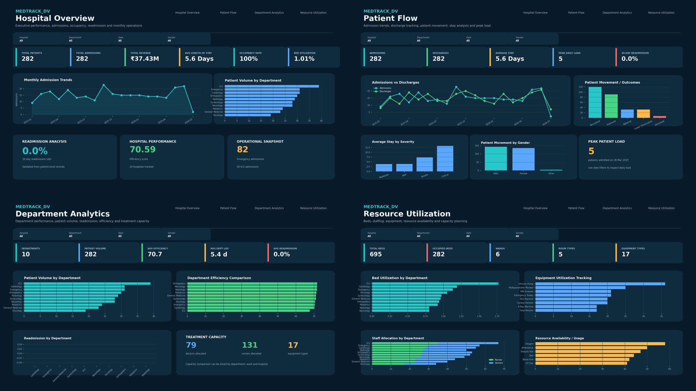
Figure 1. Completed four-dashboard MedTrack_DV preview generated from the project dataset.

8. Milestone 3 – Dashboard Development and Integration (Weeks 5–6)

Module 5: Hospital Overview Dashboard
The Hospital Overview dashboard provides an executive-level summary of hospital activity and performance.
- Admissions overview
- Occupancy monitoring
- Readmission analysis
- Hospital performance KPIs
- Monthly operational trends
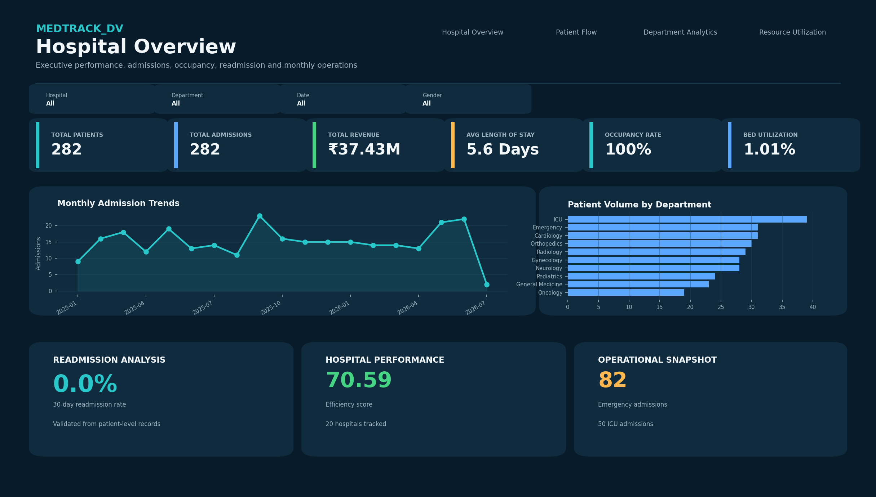
Figure 2. Hospital Overview dashboard.

Module 5: Patient Flow Dashboard
The Patient Flow dashboard focuses on how patients enter, move through and leave the hospital. It supports operational monitoring of admissions, discharges, length of stay and periods of high patient load.
- Admission trends
- Discharge tracking
- Patient movement analysis
- Average stay analysis
- Peak patient load monitoring
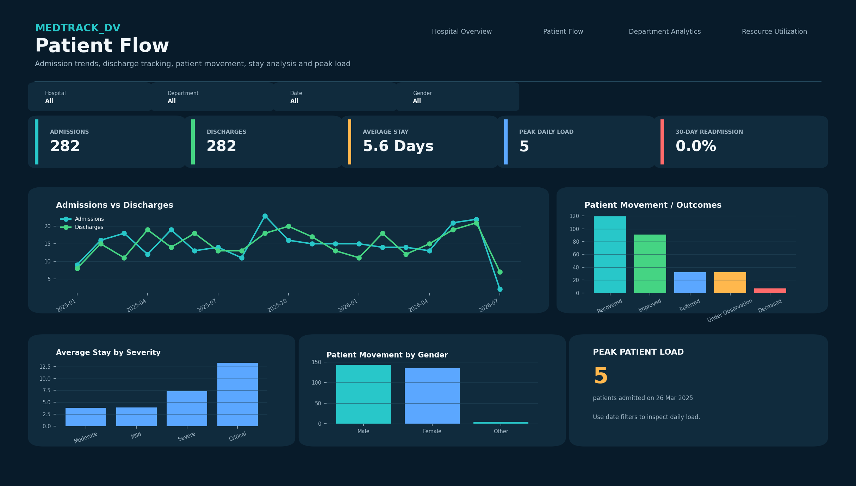
Figure 3. Patient Flow dashboard.

Module 6: Department Analytics Dashboard
Department Analytics compares patient volumes and performance measures across hospital departments.
- Department performance analysis
- Patient volume by department
- Readmission by department
- Department efficiency comparison
- Treatment capacity analysis
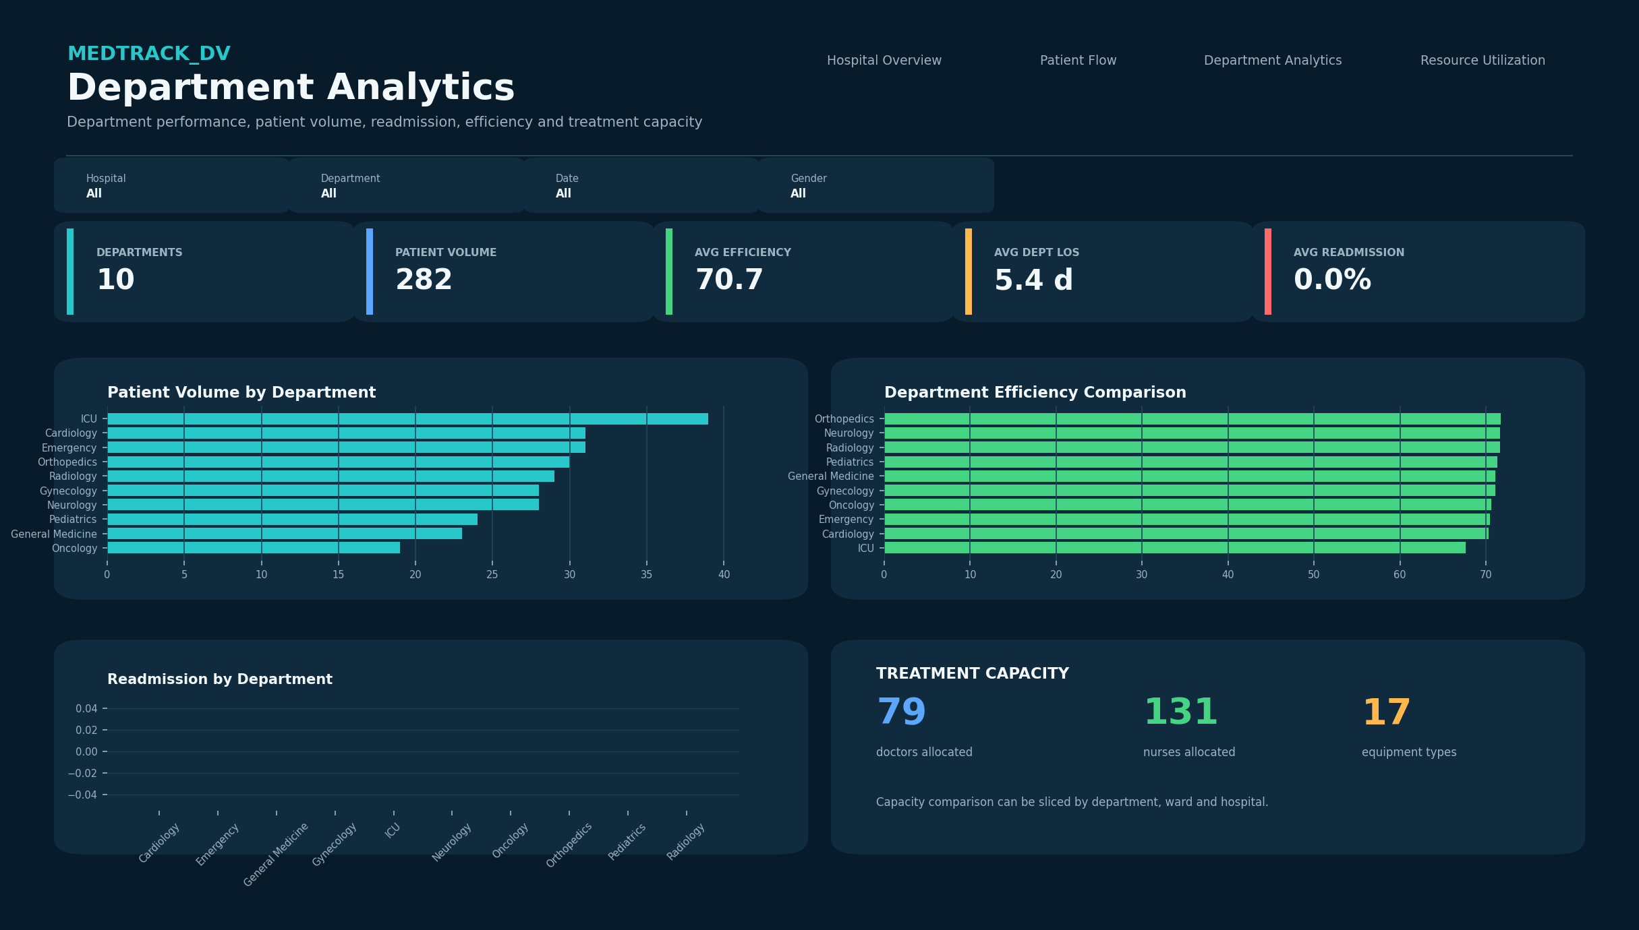
Figure 4. Department Analytics dashboard.

Module 6: Resource Utilization Dashboard
Resource Utilization monitors the operational use of beds, staffing, equipment and other hospital resources.
- Bed utilization analysis
- Staff allocation monitoring
- Equipment utilization tracking
- Capacity planning insights
- Resource availability analysis
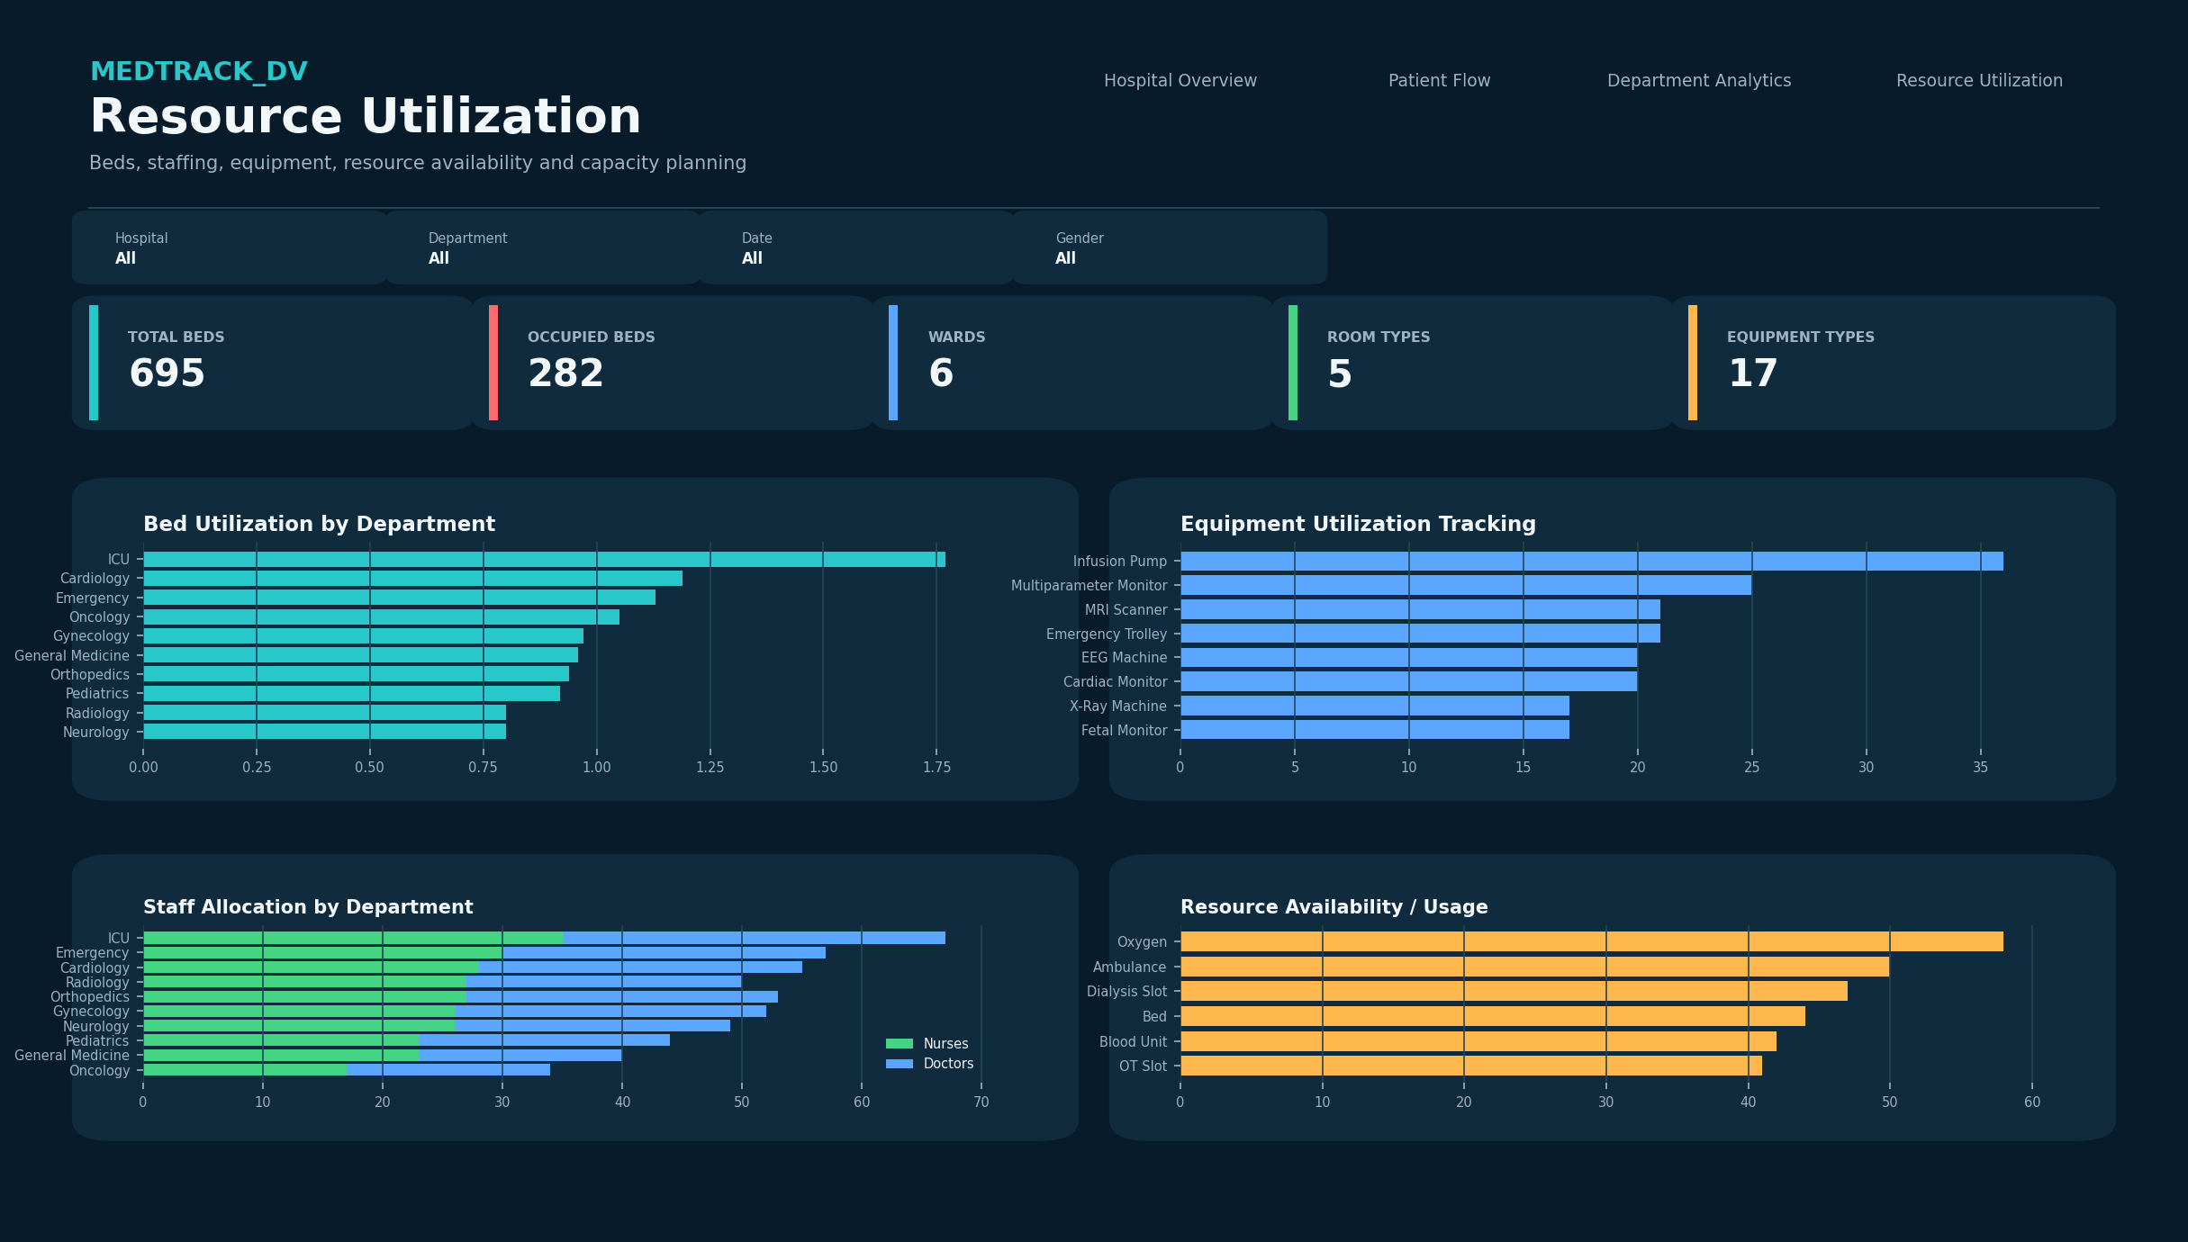
Figure 5. Resource Utilization dashboard.

Dashboard Integration
- Global filters are available for interactive exploration.
- Navigation controls connect the four dashboard views.
- Parameters and actions support interactive analysis.
- Dashboard linking allows users to move between related operational views.
- The final Tableau workbook consolidates the dashboard suite into one .twbx deliverable.

9. Milestone 4 – Testing and Delivery (Weeks 7–8)

Module 7: Testing and Validation
Testing focused on KPI accuracy, healthcare metric consistency, patient-flow validation and dashboard interaction. The project package contains a dedicated Module 7 testing document and the final Tableau workbook.
Test Area | Validation Performed | Expected Outcome
Test Area | Validation Performed | Expected Outcome
KPI calculations | Dashboard KPIs compared with source/KPI summary calculations. | Accurate KPI values
Healthcare metrics | Admission, LOS, occupancy, readmission and utilization reviewed. | Consistent operational metrics
Dashboard interactions | Filters, navigation, parameters and links tested. | Interactive controls operational
Patient flow analytics | Admissions, discharges, stay and peak load reviewed. | Results consistent with data

QA Checklist
☑ Total admissions validated
☑ Total patients validated
☑ Average length of stay validated
☑ Occupancy rate validated
☑ Bed utilization validated
☑ Readmission rate validated
☑ Monthly operational trends validated
☑ Discharge tracking validated
☑ Peak patient load validated
☑ Department patient volume validated
☑ Department readmission validated
☑ Department efficiency validated
☑ Staff allocation reviewed
☑ Equipment utilization reviewed
☑ Global filters tested
☑ Navigation controls tested
☑ Parameter actions tested
☑ Dashboard linking tested
☑ No major dashboard issues identified

Module 8: Documentation and Project Delivery
- Project documentation prepared.
- Dataset sources and processing workflow documented.
- KPI definitions documented.
- Dashboard user guide prepared.
- Healthcare operations methodology documented.
- Project structure organized into data, scripts, dashboard and documentation artifacts.
- Final Tableau workbook included.

10. KPI Definitions and Methodology
The KPI calculations were implemented through the Python KPI-generation workflow. The following definitions describe the methodology used in the completed project.

10.1 Total Admissions
Calculated as the distinct count of Admission_ID within the selected analytical scope.

10.2 Total Patients
Calculated as the distinct count of Patient_ID.

10.3 Length of Stay
Length of stay is derived from Discharge_Date minus Admission_Date. Negative values are clipped to zero. For occupied bed-day calculations, same-day admissions are treated as consuming one operational bed day.

10.4 Readmission Rate
A readmission is flagged when a patient's subsequent admission occurs from 0 through 30 days after the patient's previous discharge. Readmission rate is calculated as readmitted patients divided by total patients, multiplied by 100.

10.5 Occupancy Rate
Occupancy rate is calculated from occupied beds relative to the total beds in the analytical scope.

10.6 Bed Utilization Rate
Bed utilization is calculated from occupied bed days relative to available bed days. Available bed days are based on the total bed capacity and the period between the minimum admission date and maximum discharge date.

10.7 Department Efficiency Score
The efficiency score combines four normalized components: length-of-stay performance, readmission performance, occupancy and bed utilization. Each component is constrained to a 0–100 range and the four component scores are averaged.
Component | Concept
Component | Concept
LOS score | 100 minus a normalized length-of-stay penalty based on a 30-day reference.
Readmission score | 100 minus readmission rate.
Occupancy score | Occupancy percentage constrained to 0–100.
Utilization score | Bed utilization percentage constrained to 0–100.

10.8 KPI Scope
The KPI pipeline generates summaries at three analytical grains: overall hospital, department and admission month. These summaries are then joined back to the patient-level dataset as contextual KPI fields for Tableau analysis.

11. Data Dictionary and Dataset Structure
The final Tableau-ready dataset contains 282 records and 73 columns. The original patient/admission fields are supplemented by engineered KPI and context fields.

Hospital and Location
Field | Data Type | Example
Hospital_ID | object | HOSP001
Hospital_Name | object | Apollo Speciality Hospital
City | object | Chennai
State | object | Tamil Nadu
Hospital_Type | object | Private

Patient
Field | Data Type | Example
Patient_ID | object | PAT00001
Patient_Name | object | Amaira Maharaj
Gender | object | Female
Age | int64 | 90
Blood_Group | object | O+

Admission and Stay
Field | Data Type | Example
Admission_ID | object | ADM000001
Admission_Date | datetime64[ns] | 2025-04-29 00:00:00
Discharge_Date | datetime64[ns] | 2025-05-04 00:00:00
Length_Of_Stay_Days | int64 | 5
Admission_Month | datetime64[ns] | 2025-04-01 00:00:00
Admission_Type | object | Planned
Discharge_Mode | object | Against Medical Advice

Clinical
Field | Data Type | Example
Diagnosis | object | Disc Prolapse
Disease_Category | object | Diagnostic Imaging
Severity | object | Moderate
Treatment | object | Reporting
Surgery | object | No
Medicine | object | Contrast Agent
Lab_Test | object | MRI
Test_Result | object | Normal
Patient_Outcome | object | Recovered

Staff and Capacity
Field | Data Type | Example
Doctor_ID | object | DOC0005
Doctor_Name | object | Dr. Nisha Gole
Nurse_ID | object | NUR0159
Bed_Number | object | A-16
Ward | object | C
Room_Type | object | General
Total_Beds | int64 | 3
Occupied_Beds | int64 | 1
Occupied_Bed_Days | int64 | 5

Financial and Insurance
Field | Data Type | Example
Insurance_Status | object | Not Insured
Insurance_Provider | object | LIC
Bill_Amount | float64 | 80393.59
Payment_Status | object | Pending

Resources
Field | Data Type | Example
Resource_Used | object | OT Slot
Equipment_Used | object | CT Scanner

Operational Flags
Field | Data Type | Example
Emergency_Flag | object | No
ICU_Admission | object | No
Follow_Up_Date | datetime64[ns] | 2025-06-11 00:00:00
Readmission_Risk | object | Low
Readmitted_Within_30_Days | bool | False

KPI Context Fields in Final Dataset
Engineered Field | Type
Hospital_ID | object
Hospital_Name | object
Hospital_Type | object
Hospital_Rating | float64
Hospital_Total_Admissions | int64
Hospital_Occupancy_Rate_Pct | int64
Hospital_Average_Length_Of_Stay_Days | float64
Hospital_Readmission_Rate_Pct | int64
Hospital_Bed_Utilization_Rate_Pct | float64
Hospital_Efficiency_Score | float64
Department_Total_Admissions | int64
Department_Occupancy_Rate_Pct | int64
Department_Average_Length_Of_Stay_Days | float64
Department_Readmission_Rate_Pct | int64
Department_Bed_Utilization_Rate_Pct | float64
Department_Efficiency_Score | float64
Monthly_Total_Admissions | int64
Monthly_Occupancy_Rate_Pct | float64
Monthly_Average_Length_Of_Stay_Days | float64
Monthly_Readmission_Rate_Pct | int64
Monthly_Bed_Utilization_Rate_Pct | float64

12. Dashboard User Guide

12.1 Hospital Overview
Use this page as the executive landing page. Start with the KPI cards to understand the current hospital-level position, then use the monthly trend and department comparisons to identify operational changes.
- Select a hospital or department from the available filter controls.
- Use date filters to inspect a particular operational period.
- Review admissions and occupancy together to understand demand and capacity.
- Use readmission metrics to monitor post-discharge patient-return patterns.

12.2 Patient Flow
- Review admissions versus discharges over time.
- Inspect patient outcomes and movement categories.
- Compare average stay by severity or admission type.
- Identify the period with the highest patient load.

12.3 Department Analytics
- Compare department patient volume.
- Rank departments by efficiency score.
- Review department-level readmission patterns.
- Use treatment-capacity indicators to assess staffing and operational capability.

12.4 Resource Utilization
- Review total and occupied beds.
- Compare bed utilization across departments.
- Inspect equipment usage.
- Review doctor and nurse allocation.
- Use resource patterns to support capacity planning.

13. Dashboard Integration and Interactivity
Feature | Purpose | User Benefit
Feature | Purpose | User Benefit
Global filters | Apply common selections across dashboards. | Consistent analysis across views.
Navigation controls | Move between dashboard pages. | Fast access to related analysis.
Parameter actions | Change analysis context or selection. | Interactive exploration.
Dashboard linking | Connect related operational views. | Supports drill-through style investigation.
Cross-filtering | Use one visual selection to affect related visuals. | Focused analysis of selected segments.

The final workbook is designed as a connected dashboard suite rather than four isolated pages. This supports a management workflow from overall performance, to patient flow, to department performance, and finally to resource utilization.

14. Validation Results and QA
Metric | Completed Value | Validation Basis | Status
Total admissions | 282 | Source/KPI summary | Validated
Total patients | 282 | Source/KPI summary | Validated
Average LOS | 5.60 days | KPI summary | Validated
Occupancy rate | 100.00% | KPI summary | Validated
Readmission rate | 0.00% | KPI summary | Validated
Bed utilization | 1.01% | KPI summary | Validated
Efficiency score | 70.59 | KPI summary | Validated

Department KPI Validation Snapshot
Department | Admissions | Avg LOS | Readmission | Efficiency
Orthopedics | 30 | 4.20 | 0.00% | 71.73
Neurology | 28 | 4.29 | 0.00% | 71.63
Radiology | 29 | 4.31 | 0.00% | 71.61
Pediatrics | 24 | 4.67 | 0.00% | 71.34
General Medicine | 23 | 4.96 | 0.00% | 71.11
Gynecology | 28 | 5.04 | 0.00% | 71.05
Oncology | 19 | 5.63 | 0.00% | 70.57
Emergency | 31 | 5.81 | 0.00% | 70.44
Cardiology | 31 | 6.00 | 0.00% | 70.30
ICU | 39 | 9.41 | 0.00% | 67.60

QA Outcome
The submitted project package contains the final Tableau workbook, supporting data outputs, dashboard images, prototype materials and a dedicated Module 7 testing document. The project is therefore documented as completed with no major dashboard issues identified in the supplied QA artifacts.

15. Project File Structure and Deliverables
The submitted project archive contains the following major artifacts:
File | Purpose
hospital_raw_data.csv | Raw hospital dataset
data_collection.py | Data collection / preparation script
cleaned_patients.csv | Cleaned patient dataset
hospital_cleaning.ipynb | Cleaning and transformation notebook
hospital_dataset.xlsx | Hospital source dataset in Excel format
generate_hospital_kpis.py | KPI engineering script
hospital_final_dataset.xlsx | Final Tableau-ready dataset
hospital_kpi_summary.xlsx | Overall, department and monthly KPI summaries
dashboard_storyboard.pdf | Dashboard planning/storyboard
medtrack_prototype.twbx | Dashboard prototype workbook
MedTrack_DV.twbx | Final integrated Tableau workbook
01_Hospital_Overview.png | Hospital Overview dashboard preview
02_Patient_Flow.png | Patient Flow dashboard preview
03_Department_Analytics (1).png | Department Analytics dashboard preview
04_Resource_Utilization.png | Resource Utilization dashboard preview
MedTrack_Module_7_Testing_and_Validation.docx | Testing and validation report
Module_4_Dashboard_Planning_Prototyping_Hospital_Analytics.pptx | Dashboard planning presentation

Recommended Final Repository Structure
MedTrack_DV/
├── data/
│ ├── hospital_raw_data.csv
│ ├── cleaned_patients.csv
│ ├── hospital_dataset.xlsx
│ └── hospital_final_dataset.xlsx
├── scripts/
│ ├── data_collection.py
│ └── generate_hospital_kpis.py
├── dashboard/
│ ├── MedTrack_DV.twbx
│ └── medtrack_prototype.twbx
├── docs/
│ ├── dashboard_storyboard.pdf
│ ├── QA checklist
│ └── Final Documentation
└── README.md

16. Key Findings and Operational Insights
The following observations are directly supported by the completed KPI outputs and should be interpreted as descriptive operational insights from the project dataset rather than clinical conclusions.
- The completed dataset contains 282 admissions across 20 hospitals and 10 departments.
- ICU has the highest recorded patient/admission volume with 39 admissions in the KPI summary.
- ICU has the highest department average length of stay at 9.41 days.
- Orthopedics has the lowest department average length of stay at 4.20 days.
- Orthopedics has the highest calculated department efficiency score at 71.73.
- September 2025 has the highest monthly admission count in the KPI summary, with 23 admissions.

Interpretation Note
The dataset is relatively small and contains one cleaned record per retained admission/patient combination. Therefore, the dashboard should be used primarily as an analytics demonstration and operational reporting project. It should not be treated as a clinical decision-support system.

17. Limitations and Data Considerations
- The final cleaned dataset contains 282 records, so conclusions are illustrative rather than representative of an entire hospital population.
- The current dataset shows zero 30-day readmissions in the generated KPI summary; this limits the ability to demonstrate variation in readmission rates.
- The capacity logic derives or uses available bed fields and operational bed identifiers; therefore, bed utilization should be interpreted according to the project methodology.
- The generated overall occupancy rate is 100% because the occupied-bed and total-bed definitions in this dataset result in the same count at the overall scope.
- The calculated bed-utilization rate is 1.01% under the implemented available-bed-day methodology; this metric should be recalibrated for production use with authoritative bed inventory and daily occupancy snapshots.
- The data contains synthetic/project-style operational information and should not be used for real patient care.
- Contact information and other personal fields should be removed or anonymized before any public deployment.

18. Future Enhancements
- Connect the workbook to a production hospital data warehouse or governed data source.
- Add daily census snapshots for accurate occupancy and capacity calculations.
- Introduce richer readmission histories to improve 30-day readmission analysis.
- Add real-time or scheduled refresh capability.
- Add role-based views for administrators, department managers and operations teams.
- Add alerts for unusually high occupancy, prolonged stay or resource constraints.
- Add forecasting for admissions, bed demand and staffing requirements.
- Add drill-through to hospital, department, ward and patient-segment levels while preserving privacy.
- Add automated data-quality tests to the pipeline.
- Publish a sanitized version to Tableau Public if privacy and licensing requirements allow.

19. Deployment and Reproducibility

19.1 Local Reproduction
- Install Python and the required data-processing libraries.
- Place the raw dataset in the data directory.
- Run the data preparation / cleaning workflow.
- Run generate_hospital_kpis.py to generate KPI summaries and the final analytical dataset.
- Open MedTrack_DV.twbx in Tableau Desktop.
- Refresh data sources if the input path has changed.
- Verify dashboard filters, actions and navigation.

19.2 Tableau Delivery
The final deliverable is MedTrack_DV.twbx. A packaged Tableau workbook is preferred because it keeps the workbook and packaged data dependencies together for transfer and review.

19.3 GitHub Delivery
For portfolio delivery, the recommended repository should contain the scripts, sanitized data or sample data, Tableau workbook, documentation and screenshots. Sensitive patient identifiers or personal contact information must not be published.

19.4 Tableau Public
Tableau Public may be used as an optional showcase channel only after confirming that the dataset is suitable for public release and contains no sensitive or personally identifiable information.

20. Final Evaluation and Conclusion
Milestone | Focus Area | Target | Status
Milestone | Focus Area | Target | Completion Status
1 | Data Collection & Cleaning | Dataset completeness >95% | Completed
2 | KPI Engineering | 6+ KPIs generated | Completed
3 | Dashboard Development | 4 dashboards integrated | Completed
4 | Documentation & Delivery | Portfolio ready | Completed

Final Deliverables
- Integrated Tableau workbook: MedTrack_DV.twbx
- Raw, cleaned and final datasets
- KPI summary workbook
- Data collection and KPI engineering scripts
- Cleaning notebook
- Dashboard storyboard and prototype
- Four dashboard preview images
- QA and Dashboard Testing Report
- Final Project Documentation

Conclusion
MedTrack_DV successfully implements an end-to-end hospital operations analytics solution. The project begins with raw hospital and patient admission records, applies data cleaning and transformation, engineers reusable healthcare KPIs, and delivers four interconnected Tableau dashboards for hospital overview, patient flow, department analytics and resource utilization.
The completed project package demonstrates the full analytics lifecycle required by the assignment: data collection, preparation, KPI engineering, dashboard planning, visualization, integration, testing, documentation and delivery. The final Tableau workbook and supporting artifacts provide a portfolio-ready demonstration of healthcare business intelligence and operational analytics.

Appendix A – Overall KPI Snapshot
KPI | Completed Value
Metric | Value
Total Admissions | 282
Total Patients | 282
Hospitals | 20
Departments | 10
Doctors | 79
Nurses | 131
Average LOS | 5.60 days
Occupancy Rate | 100.00%
Readmission Rate | 0.00%
Bed Utilization Rate | 1.01%
Efficiency Score | 70.59

Appendix B – Dashboard Preview

Figure 6. Combined preview of the four completed dashboards.

